Meeting Date | 25th March 2025 |  | Agenda Item | 6.2
Meeting name | Quality and Safety Committee
Report Title | Quality & Safety Performance Report
Report Author | Meghann Protheroe, Head of Health Board Performance
Report Sponsor | Darren Griffiths, Director of Finance and Performance
Presented by | Darren Griffiths, Director of Finance and Performance
Freedom of Information | Open
Purpose of the Report | The purpose of this report is to provide an update on the current performance of the Health Board at the end of the most recent reporting period (December 2024) in delivering key local performance measures as well as the national measures outlined in the 2024/25 NHS Wales Performance Framework.
Key Issues | The Integrated Performance Report is a routine report that provides an overview of how the Health Board is performing against the National Delivery measures and key local quality and safety measures.  Key high level issues to highlight this month are as follows: -  Unscheduled Care  - Performance against the 4-hour access has deteriorated from 73.95% in November 2024 to 71.78% in December 2024.  - Performance against the 12-hour wait has deteriorated in December to 1,391 from 1,297 in November 2024.  - In December 2024, there were 616 ambulance to hospital handovers taking over 1 hour; this is a reduction of 16 compared with the previous month.  - There was a slight increase in the average number of patients who were deemed clinically optimised in December 2024 (Pathway of care delays). The average number of clinically optimised patients increased from 246 in the previous month to 257.  Planned Care  - There were no patients waiting over 52 weeks for a first outpatient appointment in December 2024.  - At the end of December 2024, there were 981 patients waiting over 104 weeks for treatment, which is an improvement of 164 from the previous month.  - In December 2024, 92.40% of patients were waiting less than 14 weeks for therapy services; this is a deterioration when compared with the figure reported in November 2024. There are 407 patients waiting over 14 weeks, all of which are in podiatry.  - In December 2024, there was a reduction in the number of patients waiting over 8 weeks for specified diagnostics. The position improved from 3,017 to 2,969. The breakdown is as follows: -  - Endoscopy= 2,328  - Cardiac tests= 636  - Other Diagnostics = 5  Cancer  - The final Single Cancer Pathway (SCP) measure of patients receiving definitive treatment in November 2024 was 66%, which is 10% higher than the figure reported in October 2024 (this measure is always reported a month in arrears due to data validation).  - 336 patients were wating in excess of 63 days as of 15/01/2025.  Mental Health  - Performance against the Mental Health Measures continues to be maintained at above target levels in December 2024 with the exception of psychological therapies.  - In December 2024, 54.1% of patients waited less than 26 weeks for Psychological Therapy. This was below the national target of 95%.  Child and Adolescent Mental Health Services (CAMHS)  - Access times for crisis performance has been maintained at 100% in November 2024.  - Neurodevelopmental Disorders (NDD) access times within 26 weeks continues to be a challenge, performance deteriorated to 27% in the month of December 2024.  - Note: S-CAMHS now included with P-CAMHS measure. Access to therapeutic interventions remains strong at 94% within 28 days. Access to assessment has deteriorated in December 2024 to 77% which is now below target levels.  Nationally Reportable Incidents  - In December 2024, there were 7 Nationally Reportable Incidents reported.  - There was one new Never Event reported in December 2024.  Patient Experience  - December 2024 data is included in this report showing 92% satisfaction through 4,747 surveys.
Specific Action Required | Information | Discussion | Assurance | Approval
Recommendations | Members are asked to:  - NOTE the Health Board performance against key measures and targets.  - NOTE that the report will evolve to include more information on the Target Intervention section.  - NOTE that work has commenced to develop and add key reporting measures for Primary and Community Care Services

QUALITY & SAFETY PERFORMANCE REPORT

- INTRODUCTION
The purpose of this report is to provide an update on current performance of the Health Board at the end of the most recent reporting window in delivering key performance measures outlined in the NHS Wales Delivery Framework and local Quality & Safety measures.

- BACKGROUND
The NHS Wales Delivery Framework sets out measures under the quadruple aims which the performance of the Health Board is measured. The aims within the NHS Delivery Framework are:

- Quadruple Aim 1: People in Wales have improved health and well-being with better prevention and self-management
- Quadruple Aim 2: People in Wales have better quality and more accessible health and social care services, enabled by digital and supported by engagement
- Quadruple Aim 3: The health and social care workforce in Wales is motivated and sustainable
- Quadruple Aim 4: Wales has a higher value health and social care system that has demonstrated rapid improvement and innovation, enabled by data and focused on outcomes

In recent years, performance management against the Performance Framework targets has been undertaken by reviewing the previous months’ performance, to reduce the reporting function during the COVID-19 pandemic. Welsh Government have now deemed it appropriate to move away from reporting performance against the ‘Quadrants of Harm’ and focus will return to providing comprehensive performance updates in line with the All-Wales Performance Management Framework 2024/25.

- GOVERNANCE AND RISK ISSUES
Appendix 1 of this report provides an overview of how the Health Board is performing against the National Delivery measures and key local measures. Mitigating actions are listed where performance is not compliant with national or local targets as well as highlighting both short term and long terms risks to delivery.

- FINANCIAL IMPLICATIONS
At this stage in the financial year there are no direct impacts on the Health Board’s financial bottom line resulting from the performance reported herein.

- RECOMMENDATION
Members are asked to:
- NOTE the Health Board performance against key measures and targets.
- NOTE that the report will evolve to include more information on the Targeted Intervention section.
- NOTE that work has commenced to develop and add key reporting measures for Primary and Community Care Services

Governance and Assurance
Link to Enabling Objectives  (please choose) | Supporting better health and wellbeing by actively promoting and empowering people to live well in resilient communities
Link to Enabling Objectives  (please choose) | Partnerships for Improving Health and Wellbeing |  | ☒
Link to Enabling Objectives  (please choose) | Co-Production and Health Literacy |  | ☒
Link to Enabling Objectives  (please choose) | Digitally Enabled Health and Wellbeing |  | ☒
Link to Enabling Objectives  (please choose) | Deliver better care through excellent health and care services achieving the outcomes that matter most to people
Link to Enabling Objectives  (please choose) | Best Value Outcomes and High Quality Care |  | ☒
Link to Enabling Objectives  (please choose) | Partnerships for Care |  | ☒
Link to Enabling Objectives  (please choose) | Excellent Staff |  | ☒
Link to Enabling Objectives  (please choose) | Digitally Enabled Care |  | ☒
Link to Enabling Objectives  (please choose) | Outstanding Research, Innovation, Education and Learning |  | ☒
Health and Care Standards
(please choose) | Staying Healthy |  | ☒
(please choose) | Safe Care |  | ☒
(please choose) | Effective Care |  | ☒
(please choose) | Dignified Care |  | ☒
(please choose) | Timely Care |  | ☒
(please choose) | Individual Care |  | ☒
(please choose) | Staff and Resources |  | ☒
Quality, Safety and Patient Experience
The performance report outlines performance over the domains of quality and safety and patient experience, and outlines areas and actions for improvement. Quality, safety and patient experience are central principles underpinning the National Delivery Framework and this report is aligned to the domains within that framework.

There are no directly related Equality and Diversity implications as a result of this report.

Financial Implications
At this stage in the financial year there are no direct impacts on the Health Board’s financial bottom line resulting from the performance reported herein.

Legal Implications (including equality and diversity assessment)
A number of indicators monitor progress in relation to legislation, such as the Mental Health Measure.

Staffing Implications
A number of indicators monitor progress in relation to Workforce, such as Sickness and Personal Development Review rates. Specific issues relating to staffing are also addressed individually in this report.

Long Term Implications (including the impact of the Well-being of Future Generations (Wales) Act 2015)
The ‘5 Ways of Working’ are demonstrated in the report as follows:
- Long term – Actions within this report are both long and short term in order to balance the immediate service issues with long term objectives.
- Prevention – the NHS Wales Delivery framework provides a measurable mechanism to evidence how the NHS is positively influencing the health and well-being of the citizens of Wales with a particular focus upon maximising people’s physical and mental well-being.
- Integration – this integrated performance report brings together key performance measures across the seven domains of the NHS Wales Delivery Framework, which identify the priority areas that patients, clinicians and stakeholders wanted the NHS to be measured against. The framework covers a wide spectrum of measures that are aligned with the Well-being of Future Generations (Wales) Act 2015.
- Collaboration – in order to manage performance, the Corporate Functions within the Health Board liaise with leads from the Service Groups as well as key individuals from partner organisations including the Local Authorities, Welsh Ambulance Services Trust, Public Health Wales and external Health Boards.
- Involvement – Corporate and Service Groups leads are key in identifying performance issues and identifying actions to take forward.

Report History |  | The last iteration of the Quality & Safety Performance Report was presented to Quality & Safety committee in October 2024. This is a routine bi-monthly report.
Appendices |  | Appendix 1: Quality & Safety performance report



Appendix 1- Quality & Safety Performance Report
January 2025

CONTENTS PAGE
 | Page numbers:
- TARGETED INTERVENTION METRICS PERFORMANCE  - Unscheduled Care  - Planned Care and Cancer  - CAMHS  - INFECTION CONTROL | 11-21  12-14  15-18  19  20-21
- HARM QUADRANT- HARM FROM COVID ITSELF  - Overview  - Updates on key measures:  - COVID cases | 22  23  23
- HARM QUADRANT- HARM FROM OVERWHELMED NHS AND SOCIAL CARE SYSTEM
- Overview  - Updates on key measures:  - Unscheduled care  - Fractured Neck of Femur (#NOF)  - Healthcare Acquired Infections  - Pressure Ulcers  - Serious Incidents  - Inpatient Falls  - Discharge Summaries  - Crude Mortality | 24-26  27-34  35-36  37-39  39  40  41  41  42
- HARM QUADRANT- REDuction in non-covid activity  - Overview  - Updates on key measures:  - Planned care  - Theatre Efficiency  - Diagnostics & Therapies  - Cancer  - Follow-up appointments  - Patient Experience  - Complaints | 43-44  45-48  49  50  51-52  53  54  55
- HARM QUADRANT- harm from wider societal actions/ lockdown  - Overview  - Updates on key measures:  - Adult Mental Health  - Child and Adolescent Mental Health | 56-57  58  59
Appendix 2: Summary of key measures by service group | 60-64
Appendix 3: INTEGRATED PERFORMANCE DASHBOARD | 65-68

- TARGETED INTERVENTION METRICS PERFORMANCE

URGENT AND EMERGENCY CARE
- Ambulance handovers over 1 hour  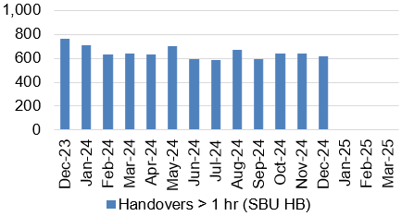  - A&E waits over 12 hours  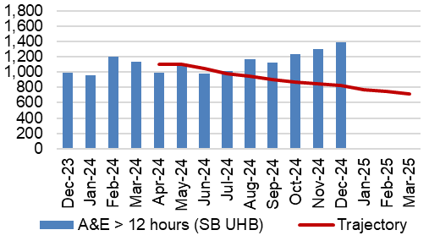  - Median time from arrival to assessment within 60 mins  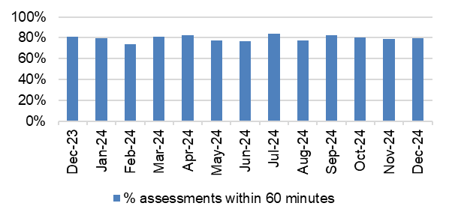  - Continuing reduction in pathway of care delays  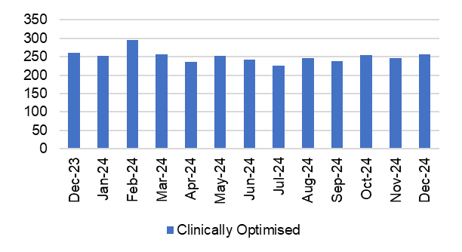  - Lost Ambulance Hours Total  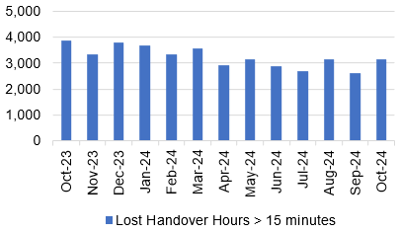  - Lost Ambulance Hours over 1 hour  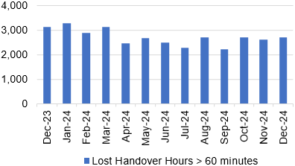 | - The number of ambulance handovers over 1 hour has reduced slightly in December 2024. The number of handovers over 1 hour decreased from 632 in November 2024 to 616 in December 2024, which is above the outlined trajectory.  - Performance against the 12-hour wait has deteriorated in-month, and it is currently performing above the outlined trajectory. The number of patients waiting over 12-hours in the Emergency Department increased to 1,391 in December 2024 from 1,297 in November 2024.  - In December 2024 79.75% of patients received their first assessment within 60 minutes of their arrival at the Emergency Department. This is an increase of 1.0% on the figure reported in November 2024 (78.72%).  - There was an increase in the average number of patients who were deemed clinically optimised in December 2024. The average number of clinically optimised patients increased slightly from 246 in November 2024 to 257 in December 2024.  - The ambulance handover lost hours rate has seen an increase in October 2024. The ambulance handover lost hours increased from 2,609 in September 2024 to 3,140 in October 2024.  *Data not updated for November 2024”  - There has been an increase in the number of lost ambulance hours over 1 hour in December 2024. There were 2,697 lost hours over 1 hour in December 2024 which is an increase of 92 compared with 2,605 in November 2024.
PLANNED CARE & CANCER
- Single Cancer Pathway  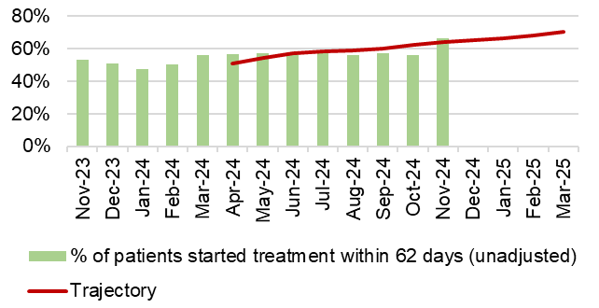  - Outpatients waiting over 52 weeks  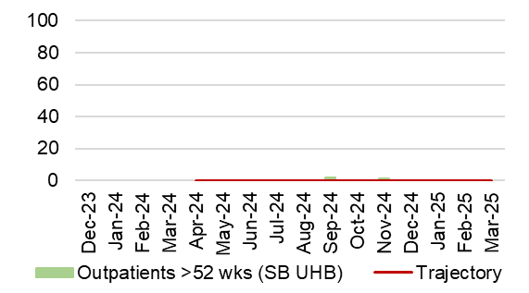  - 104 week waits – all pathways  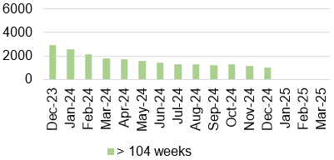  - % of patients waiting under 52 weeks (all pathways)  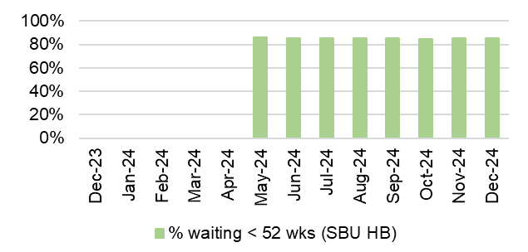  - Delayed follow ups over 100%  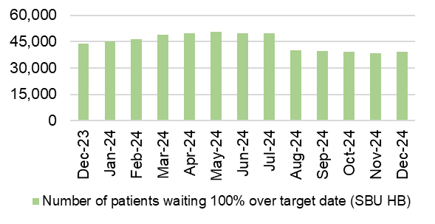  - R1 Ophthalmology  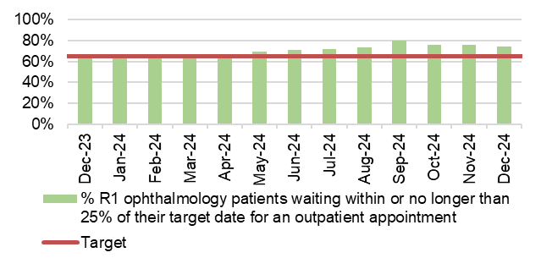  - Percentage of Patients waiting 8 weeks for a diagnostic test  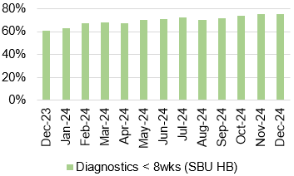  - Patients waiting 14 weeks for therapy services  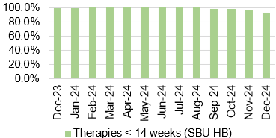 | - The final SCP performance for November 2024 was 66%, which is above the figure reported in October 2024. Performance is currently above the submitted trajectory (64%).  - There were no patients waiting over 52 weeks for a first outpatient appointment in December 2024.  - December 2024 saw an in-month reduction of 14% in the number of patients waiting over 104 weeks for treatment. The number decreased from 1,145 in November 2024 to 981 in December 2024.  - The percentage of patients waiting under 52 weeks for treatment increased slightly in-month. In December, 85.2% of patients were wating under 52 weeks, compared with 85.1% in November 2024.  - There were 39,141 patients waiting 100% over their target date in December 2024 which is a reduction when compared with November 2024. A significant improvement was seen in August 2024 due to a change in reporting requirements – all future trends will be built form August 2024.  - In December 2024 74.4% of Ophthalmology RI patients were waiting within their clinical target date or within 25% of their target date. This is a 1.5% reduction on the figure reported in November 2024.  - In December 2024, there was an increase in the percentage of patients waiting less than 8 weeks for a diagnostic test. It was maintained at 75%.  More detail on the breakdown of patients witing by diagnostic test is provided later in this report.  - In December 2024, 92.40% of patients were waiting less than 14 weeks for therapy services; this is a deterioration when compared with the figure reported in November 2024. All of the breaches were within Podiatry – the team are currently working through a recovery plan.
CAMHS
- LPMHSS assessments with 28 days and therapeutic assessment within 28 days  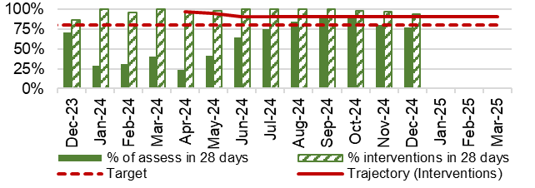  - Residents in receipt of a valid care and treatment plan  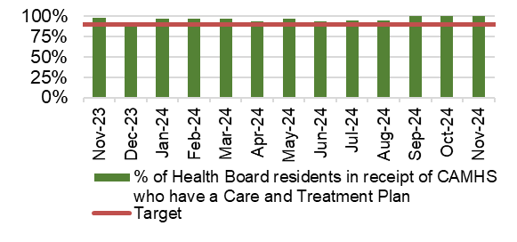 | - The percentage of routine assessments undertaken within 28 days decreased to 77% in December 2024 from 80% in November 2024.  In December 2024, 94% of therapeutic assessments were undertaken within 28 days. This is above the outlined trajectory for December 2024.  - The percentage of residents in receipt of a valid care and treatment plan remained above the 90% target, achieving 91% in December 2024.
HEALTHCARE ACQUIRED INFECTIONS (HOSPITAL ONSET)
- C. Difficile  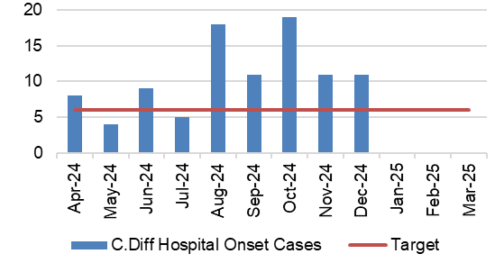  - Staph aureus  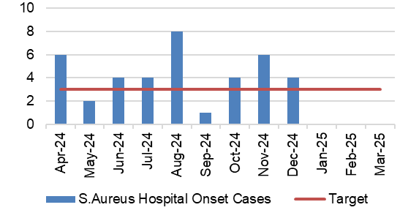  - E-coli  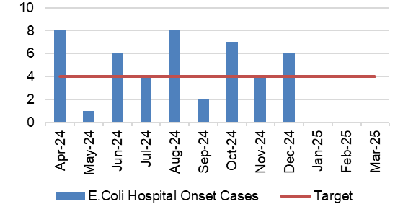  - Klebsiella  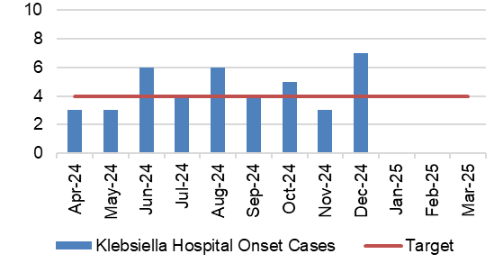 | - There were 11 hospital onset cases of C.Difficile reported in December 2024. This is the same figure reported in November 2024 and is above the target of a maximum of 6 cases per month.  - There were 4 hospital onset cases of Staph aureus reported in December 2024. This is the 2 less than reported in November 2024 and is above the target of a maximum of 3 cases per month.  - There were 6 hospital onset cases of E.Coli reported in December 2024. This is 2 more than the figure reported in November 2024 and is above the target of a maximum of 4 cases per month.  - The number of hospital onset cases of Klebsiella reported increased to 7 in December 2024 from 3 in November 2024. This is above the target of a maximum of 4 cases per month.

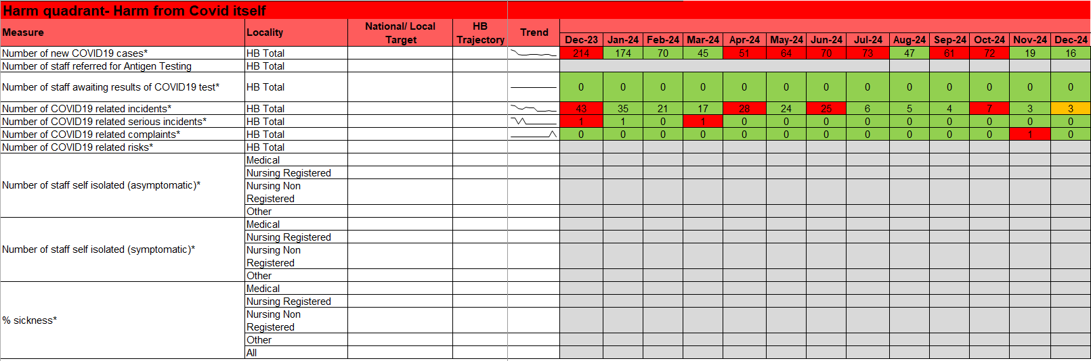

  - Updates on key measures

COVID TESTING
Description | Current Performance | Trend
1. Number of new COVID19 cases in Swansea Bay population area | 1. Number of new COVID cases  In December 2024, there were an additional 16 positive cases recorded bringing the cumulative total to 121,938 in Swansea Bay since March 2020. | 1.Number of new COVID19 cases for Swansea Bay population  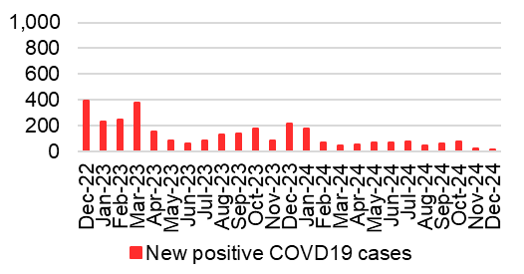

- HARM QUADRANT- HARM FROM OVERWHELMED NHS AND SOCIAL CARE SYSTEM

  - Overview
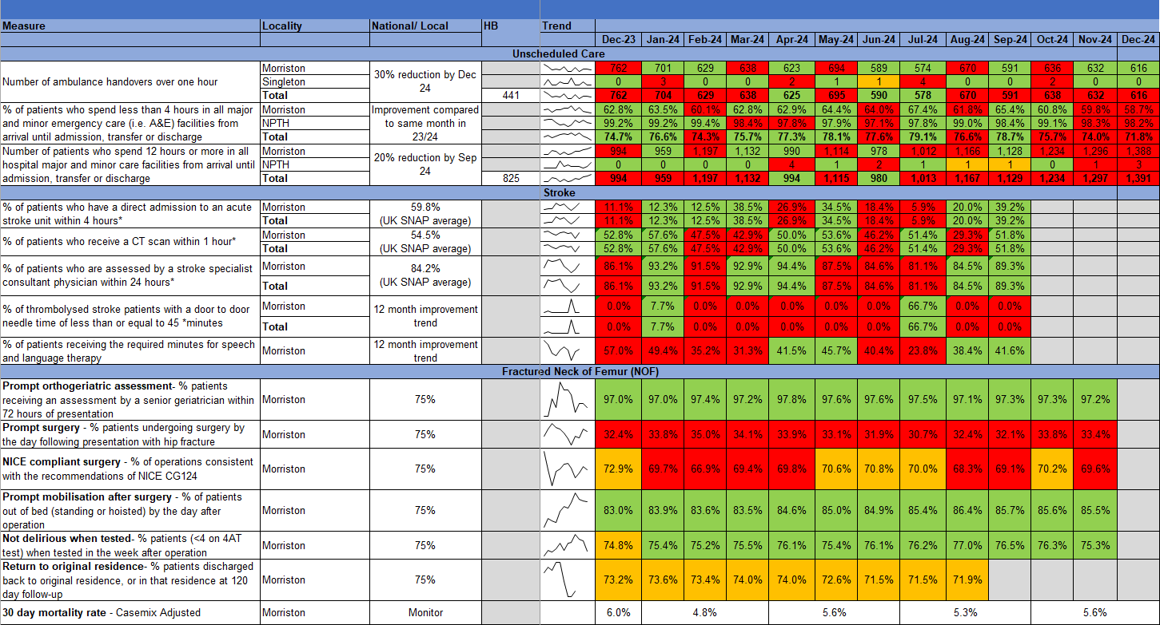

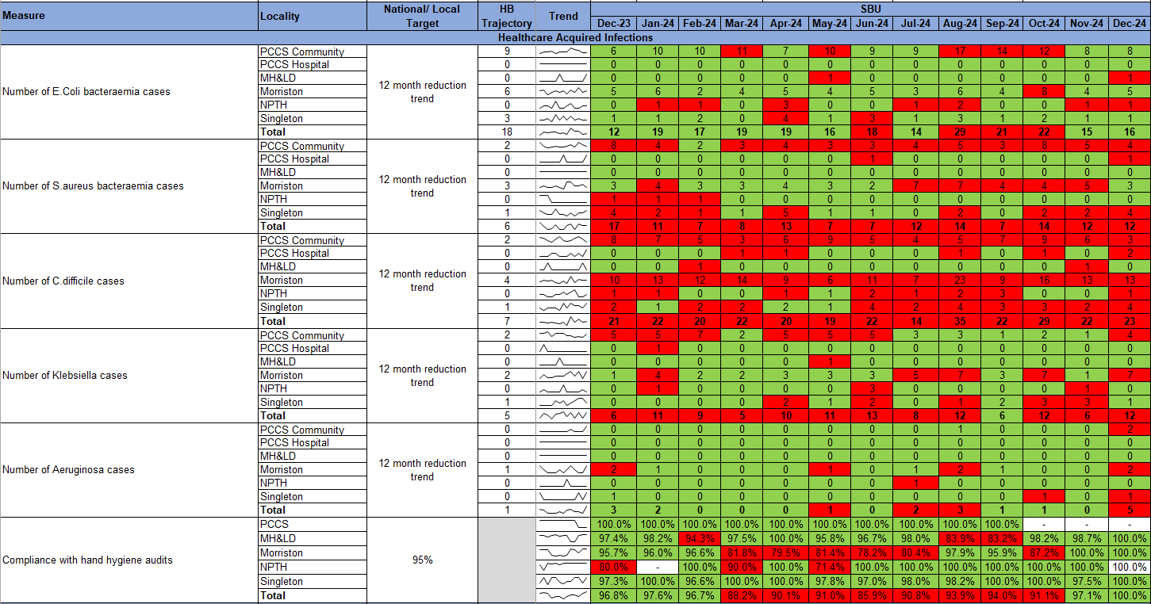

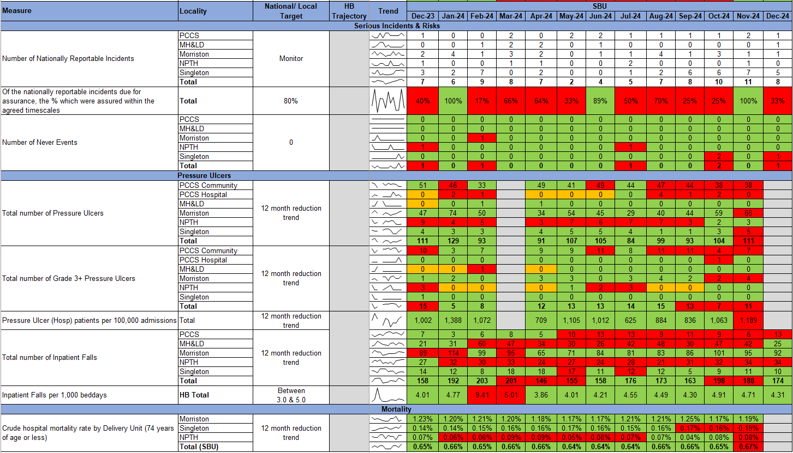

  - Updates on key measures
UNSCHEDULED CARE
Description | Current Performance
Ambulance responses  1. The percentage of emergency responses to red calls arriving within (up to and including) 8 minutes.  2. The number of ambulance calls by category.  3.The percentage of emergency responses to red calls arriving within 8 minutes (last 90 days) | In December 2024, the number of red calls responded to within 8 minutes improved to 47.6% from 46.1% in November 2024. In December 2024, the number of green calls decreased by 4%, amber calls increased by 6%, and red calls increased by 15% compared with November 2024.
 | Trend
 | - % of red calls responded to within 8 minutes    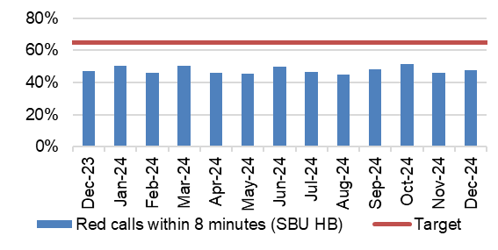 |  |  | - Number of ambulance call responses  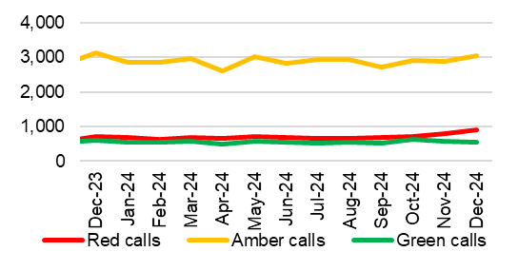
- % of red calls responded to within 8 minutes – HB total last 90 days
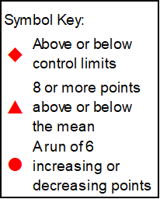
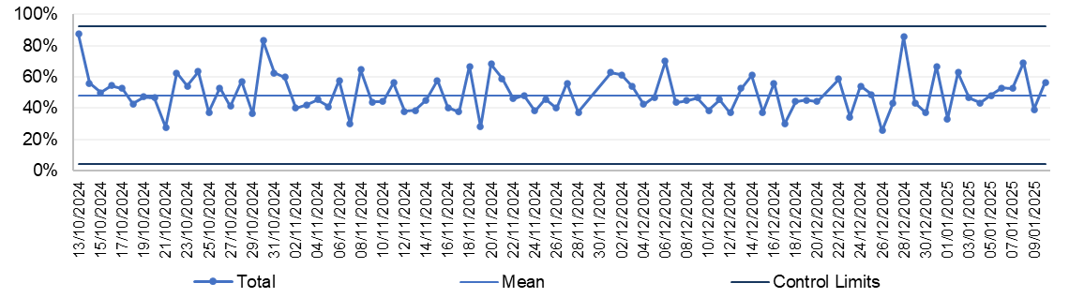

UNSCHEDULED CARE
Description | Current Performance
Ambulance handovers  1.The number of ambulance handovers over one hour  2. The number of ambulance handovers over one hour- Hospital level  3.The number of ambulance handovers over one hour (last 90 days) | In November 2024, there were 632 ambulance to hospital handovers taking over 1 hour; this is a reduction of 6 compared with 638 in October 2024. In November 2024, all handovers over 1 hour were attributed to Morriston Hospital. Additional work is currently underway to incorporate the AMU data in the ambulance handover figures.
 | Trend
 | - Number of ambulance handovers- HB total    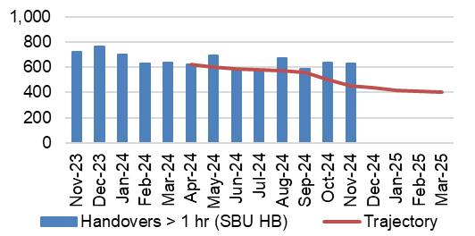 |  |  | - Number of ambulance handovers over 1 hour- Hospital level  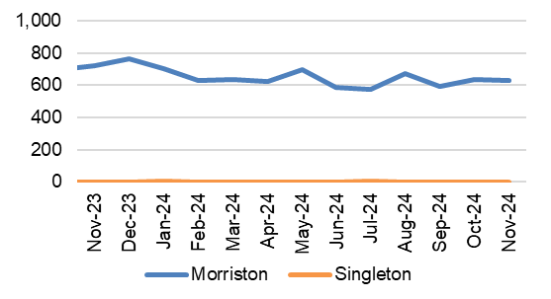
- Number of ambulance handovers- HB total last 90 days
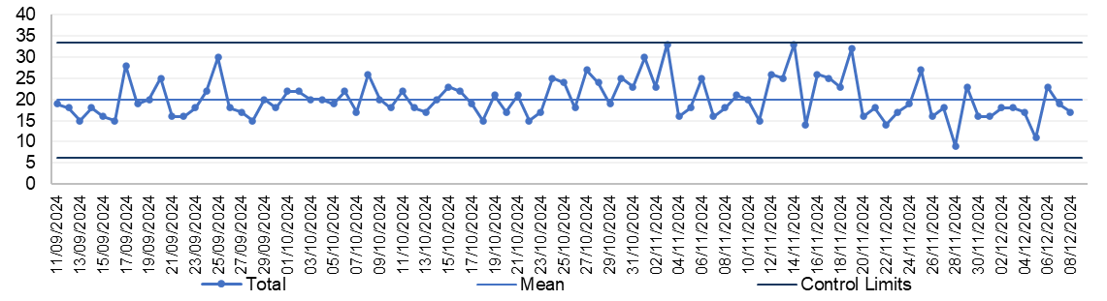
UNSCHEDULED CARE
Description | Current Performance
A&E Attendances  1.The number of attendances at emergency departments in the Health Board  2.The number of attendances at emergency departments in the Health Board – Hospital level  3.The number of attendances at emergency departments in the Health Board (last 90 days) | In December 2024, there were 11,221 A&E attendances, which is a reduction of 644 when compared to November 2024. There were 7,507 attendances to A&E at Morriston hospital and 3,714 attendances to MIU at Neath Port Talbot hospital.
 | Trend
 | - Number of A&E attendances- HB total  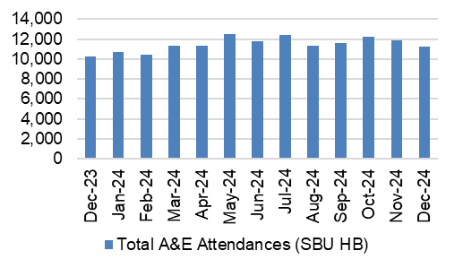 |  |  | - Number of A&E attendances- Hospital level  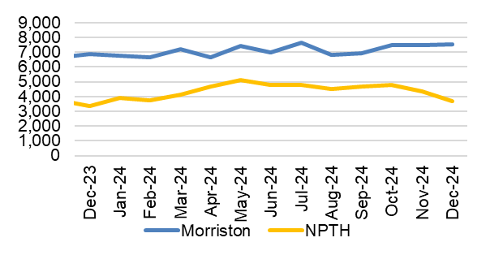
- Number of A&E attendances -HB total last 90 days

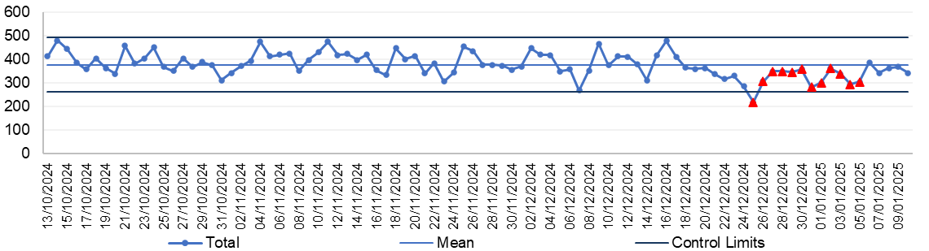

UNSCHEDULED CARE
Description | Current Performance
A&E waiting times  1.% of patients who spend less than 4 hours in all major and minor emergency care facilities from arrival until admission, transfer or discharge  2. % of patients who spend less than 4 hours in A&E- Hospital level  3. % of patients who spend less than 4 hours in A&E (last 90 days) | The Health Board’s performance against the 4-hour measure deteriorated from 73.95% in November 2024 to 71.78% in December 2024. Neath Port Talbot Hospital Minor Injuries Unit (MIU) has remained above the national target of 95% achieving 98.20% in December 2024. Morriston Hospital’s performance deteriorated between November and December 2024, achieving 58.74% against the target.
 | Trend
 | - % Patients waiting under 4 hours in A&E- HB total  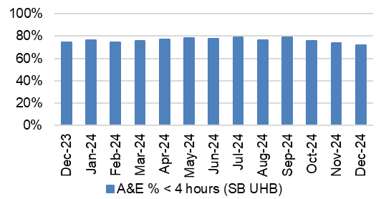 |  |  | - % Patients waiting under 4 hours in A&E- Hospital level  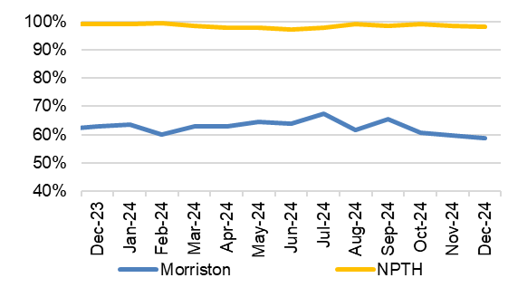
- % Patients waiting under 4 hours in A&E- HB total last 90 days
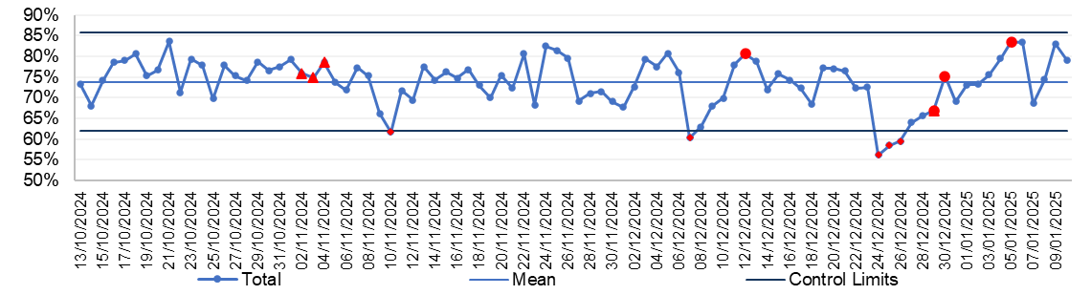
UNSCHEDULED CARE
Description | Current Performance
A&E waiting times  1.Number of patients who spend 12 hours or more in A&E  2.Number of patients who spend 12 hours or more in A&E- Hospital level  3.Number of patients who spend 12 hours or more in A&E (last 90 days) | In December 2024, performance against the 12-hour measure deteriorated when compared with November 2024, increasing from 1,297 to 1,391. This is an increase of 94 compared to November 2024. All of the patients waiting over 12 hours in December 2024 were attributed to Morriston Hospital, apart from three which were in Neath Port Talbot Hospital.
 | Trend
 | - Number of patients waiting over 12 hours in A&E- HB total |  |  | 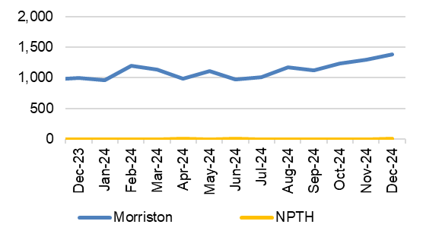  - Number of patients waiting over 12 hours in A&E- Hospital level
- Number of patients waiting over 12 hours in A&E – HB total last 90 days
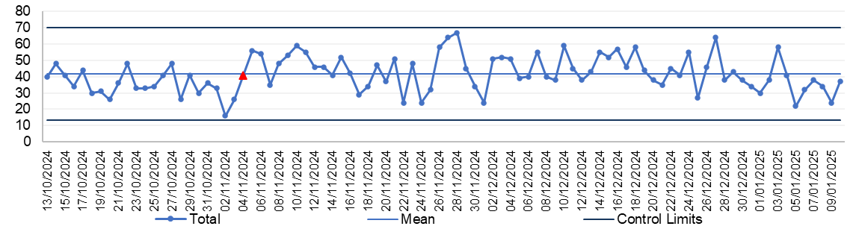

UNSCHEDULED CARE
Description | Current Performance
Emergency admissions  1. The number of emergency inpatient admissions  2. The number of emergency inpatient admissions-Hospital level  3. The number of emergency inpatient admissions (last 90 days) | In December 2023, there were 4,328 emergency admissions across the Health Board, which is 26 higher than November 2023.  Singleton Hospital saw an in-month reduction, with 33 less admissions (from 308 in November 2023), Morriston Hospital saw an in-month increase from 3,871 admissions in November 2023 to 3,923 admissions in December 2023.
 | Trend
 | - Number of emergency admissions- HB total    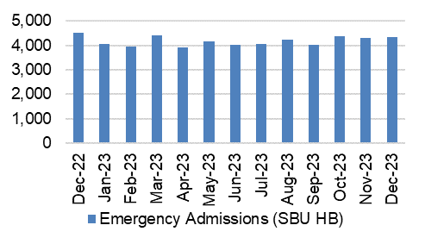 |  |  | - Number of emergency admissions- Hospital level  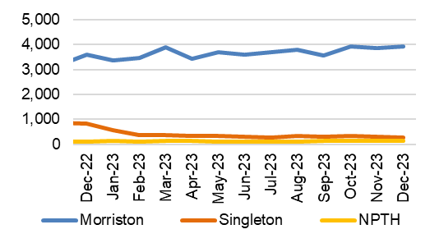
- Number of emergency admissions- HB total last 90 days
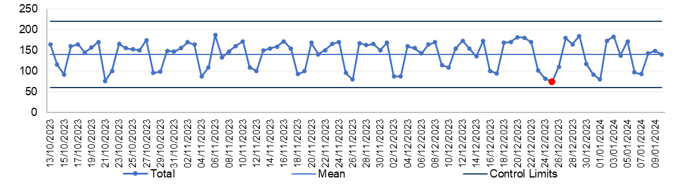

UNSCHEDULED CARE
Description | Current Performance
Critical Care- Delayed Transfers of Care (DTOC)- Morriston Hospital  1.Total Critical Care delayed discharges (hours)  2. Average lost bed days per day  3.Percentage of patients delayed:  - Up to 8 hours  - Between 8 and 24 hours  - Over 24 hours | In December 2024, there were a total of 107 admissions into the Intensive Care Unit (ICU) in Morriston Hospital, this is an increase when compared with 89 admissions in November 2024. December 2024, saw an increase in the number of delayed discharge hours from 1568.15 in November 2024 to 2150.25 in December 2024. The average lost bed days increased to 2.89 per day. The percentage of patients delayed over 24 hours decreased to 41.09% in December 2024 from 41.27% in November 2024.
 | Trend
 | - Total Critical Care delayed discharges (hours)  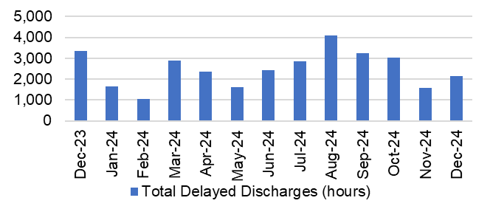 |  |  | - Average lost bed days per day  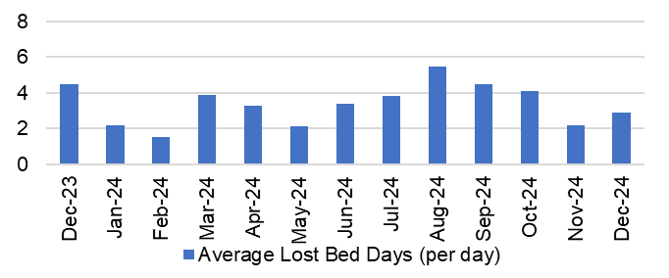
- Percentage of Critical Care patients delayed
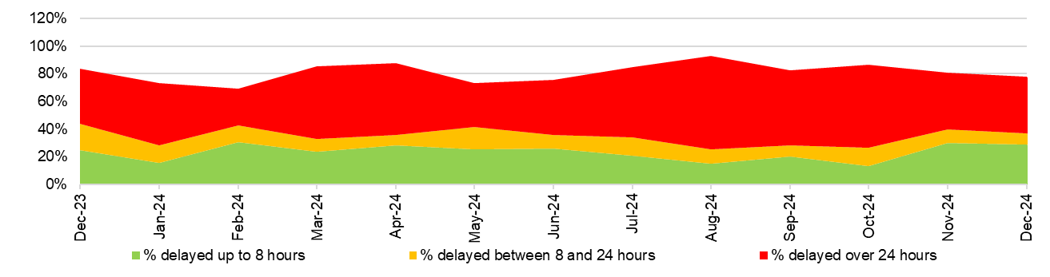
UNSCHEDULED CARE
Description |  | Current Performance | Trend
Clinically Optimised  The number of patients waiting at each site in the Health Board that are clinically optimised |  | In December 2024, there were on average 257 patients who were deemed clinically optimised but were still occupying a bed in one of the Health Board’s Hospitals.  In December, Morriston Hospital had the largest proportion of clinically optimised patients with 127, followed by Neath Port Talbot Hospital with 62.  Actions of Improvement;  Continued work is underway to implement opportunities to reduce the number of Clinically Optimised Patients in the Hospital. The implementation of the frailty model with further increase opportunities for reductions in delays. | The number of clinically optimised patients by site  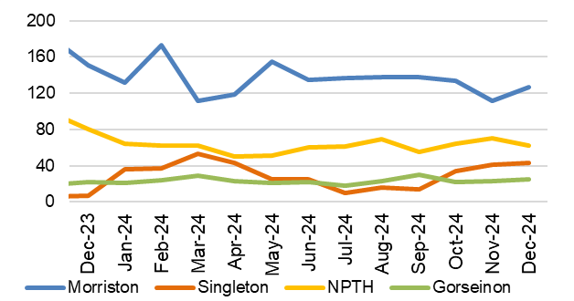
Elective procedures cancelled due to lack of beds  The number of elective procedure cancelled across the hospital where the main cancellation reasons was lack of beds |  | In December 2024, there were 35 elective procedures cancelled due to lack of beds on the day of surgery. This is 19 more cancellations than those seen in November 2024.  Of the 35 cancelled procedures, 32 were attributed to Morriston Hospital, 2 were attributed to Neath Port Talbot Hospital and 1 was attributed to Singleton Hospital. | Total number of elective procedures cancelled due to lack of beds  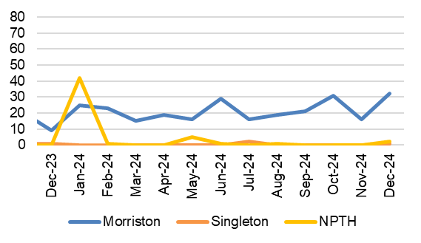
FRACTURED NECK OF FEMUR (#NOF)
Description | Current Performance | Trend
Fractured Neck of Femur (#NOF)  1. Prompt orthogeriatric assessment- % patients receiving an assessment by a senior geriatrician within 72 hours of presentation  2. Prompt surgery - % patients undergoing surgery the day following presentation with hip fracture  3. NICE compliant surgery - % of operations consistent with the recommendations of NICE CG124  4. Prompt mobilisation after surgery - % patients out of bed (standing or hoisted) by the day after operation | - Prompt orthogeriatric assessment- In November 2024, 97.2% of patients in Morriston hospital received an assessment by a senior geriatrician within 72 hours.  - Prompt surgery- In November 2024, 33.4% of patients had surgery the day following presentation with a hip fracture. This is a 2.6% improvement from November 2023 which was 30.8%.  - NICE compliant surgery- 69.6% of operations were consistent with the NICE recommendations in November 2024. This is 3.8% less than in November 2023.  - Prompt mobilisation- In November 2024, 85.5% of patients were out of bed the day after surgery. This is 3.9% more than in November 2023. | - Prompt orthogeriatric assessment  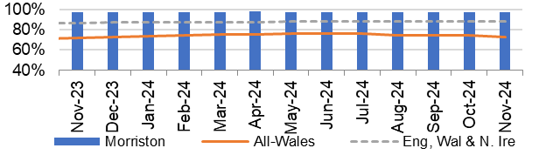  - Prompt surgery  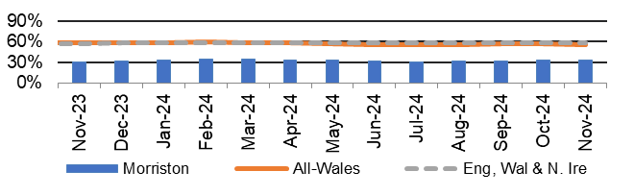  - NICE compliant Surgery  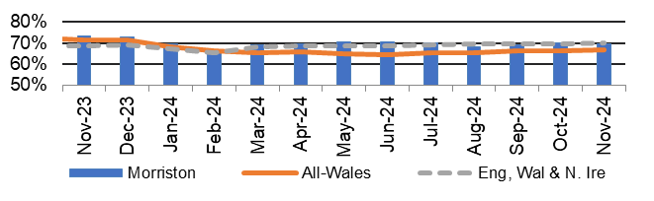  - Prompt mobilisation  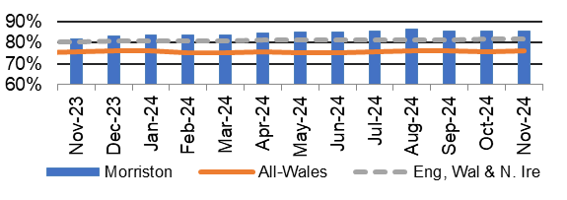
FRACTURED NECK OF FEMUR (#NOF)
Description | Current Performance | Trend
- Not delirious when tested- % patients (<4 on 4AT test) when tested in the week after operation  - Return to original residence- % patients discharged back to original residence, or in that residence at 120 day follow-up  - 30 day mortality rate (Casemix adjusted) | - Not delirious when tested- 75.3% of patients were not delirious in the week after their operation in November 2024.  - Return to original residence- 71.9% of patients in August 2024 were discharged back to their original residence. This is 1.0% less than was reported in August 2023.  - 30 day mortality rate- In Q3 24-25 the mortality rate for Morriston Hospital was 5.6%, which is 0.4% lower than the figure reported in the same period in the previous year and is 0.3% above the national average for the quarter. | 5. Not delirious when tested  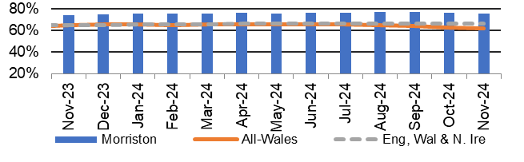  6. Return to original residence  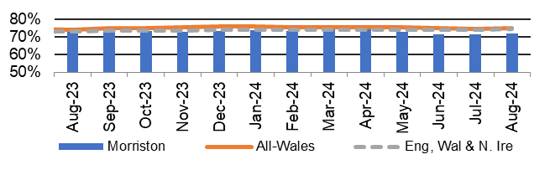  - 30 day mortality rate  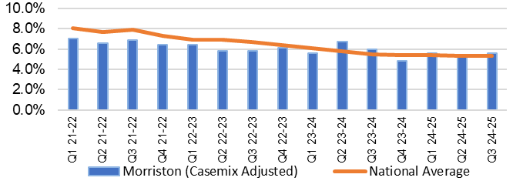
HEALTHCARE ACQUIRED INFECTIONS
Description | Current Performance | Trend
Healthcare Acquired Infections (HCAI) - E.coli bacteraemia- Number of laboratory confirmed E.coli bacteraemia cases | - 16 cases of E. coli bacteraemia were identified in December 2024, of which 8 were hospital acquired and 8 were community acquired.  - The Health Board total is currently below the Welsh Government Profile target of 18 cases for December 2024.  Actions of Improvement;  Each Service Group has developed detailed action plans which reinforce the quality and safety guidelines to support the reduction of Infection rates | Number of healthcare acquired E. coli bacteraemia cases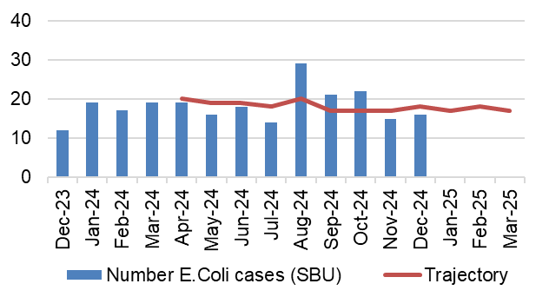
Healthcare Acquired Infections (HCAI)-  S.aureus bacteraemia- Number of laboratory confirmed S.aureus bacteraemias (MRSA & MSSA) cases | - There were 12 cases of Staph. aureus bacteraemia in December 2024, of which 8 were hospital acquired and 4 were community acquired.  - The Health Board total is currently above the Welsh Government Profile target of 6 cases for December 2024  Actions of Improvement;  Each Service Group has developed detailed action plans which reinforce the quality and safety guidelines to support the reduction of Infection rates | Number of healthcare acquired S.aureus bacteraemia cases  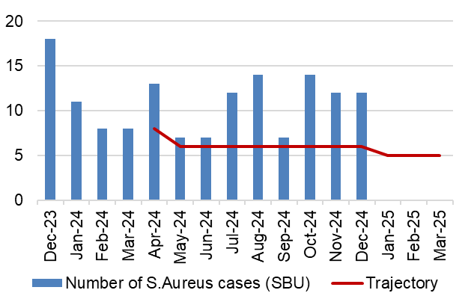
HEALTHCARE ACQUIRED INFECTIONS
Description | Current Performance | Trend
Healthcare Acquired Infections (HCAI)-  C.difficile-  Number of laboratory confirmed C.difficile cases | - There were 23 Clostridium difficile toxin positive cases in December 2024, of which 20 were hospital acquired and 3 were community acquired.  - The Health Board total is currently above the Welsh Government Profile target of 7 cases for December 2024.  Actions of Improvement;  Each Service Group has developed detailed action plans which reinforce the quality and safety guidelines to support the reduction of Infection rates | Number of healthcare acquired C.difficile cases  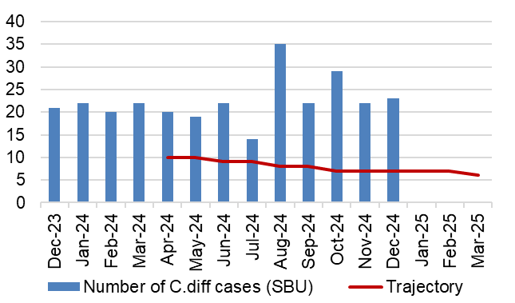
Healthcare Acquired Infections (HCAI)-  Klebsiella sp- Number of laboratory confirmed Klebsiella sp cases | - There were 12 cases of Klebsiella sp in December 2024, of which 8 were hospital acquired and 4 were community acquired.  - The Health Board total is currently above the Welsh Government Profile target of 5 cases for December 2024.  Actions of Improvement;  Each Service Group has developed detailed action plans which reinforce the quality and safety guidelines to support the reduction of Infection rates | Number of healthcare acquired Klebsiella cases  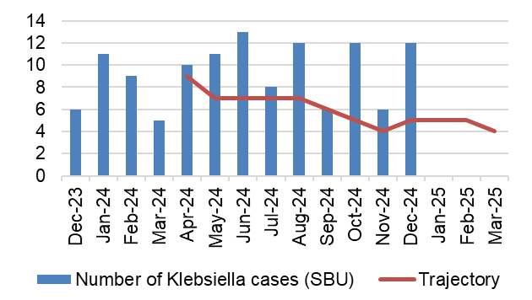
HEALTHCARE ACQUIRED INFECTIONS
Description | Current Performance | Trend
Healthcare Acquired Infections (HCAI)-  Aeruginosa-  Number of laboratory confirmed Aeruginosa cases | - There were 5 cases of P.Aerginosa reported in December 2024.  - The Health Board total is currently above the Welsh Government Profile target of 1 case for December 2024.  Actions of Improvement;  Each Service Group has developed detailed action plans which reinforce the quality and safety guidelines to support the reduction of Infection rates | Number of healthcare acquired Pseudomonas cases  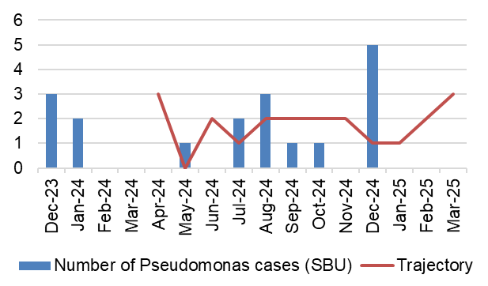
PRESSURE ULCERS
Description | Current Performance | Trend
Number of pressure ulcers  1. Total number of pressure ulcers developed in hospital and in the community  2. Rate of pressure ulcers per 100,000 admissions | - In November 2024 there were 111 cases of healthcare acquired pressure ulcers, 38 of which were community acquired and 73 were hospital acquired.  There were 11 grade 3+ pressure ulcers in November 2024, 7 of which were community acquired and 4 were hospital acquired.  - The rate per 100,000 admissions was 1189 in November 2024. | Total number of hospital and community acquired Pressure Ulcers (PU) and rate per 100,000 admissions  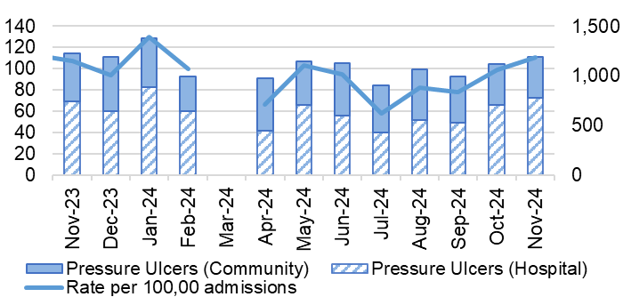
NATIONALLY REPORTABLE INCIDENTS
Description | Current Performance | Trend
Nationally Reportable Incidents (NRI’s)-  1. The number of Nationally reportable incidents  2. The number of Never Events  3. Of the nationally reportable incidents due for assurance, the percentage which were assured within the agreed timescales | - The Health Board reported 7 Nationally Reportable Incidents for the month of December 2024 to Welsh Government. The Service Group breakdown is as follows;  - Morriston – 1  - PCT -1  - Singleton - 5  - There was one new Never Events reported in December 2024.  - In December 2024, 33% of the NRI’s were closed within the agreed timescale. | 1. and 2. Number of nationally reportable incidents and never events  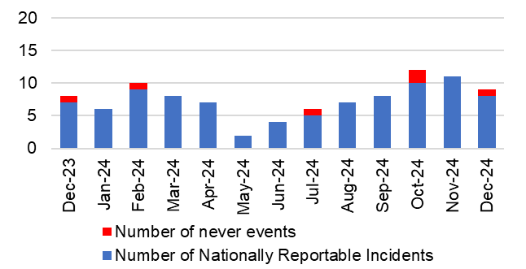  3. % of nationally reportable incidents closed within the agreed timescales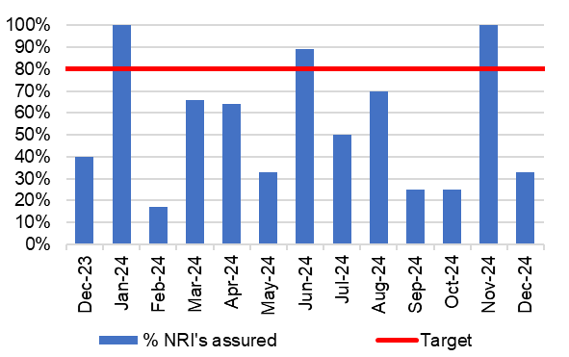
INPATIENT FALLS
Description | Current Performance | Trend
Inpatient Falls  The total number of inpatient falls | - The number of Falls reported via Datix web for Swansea Bay UHB was 174 in December 2024. This is 7.4% less than November 2024 where 188 falls were recorded. | Number of inpatient Falls  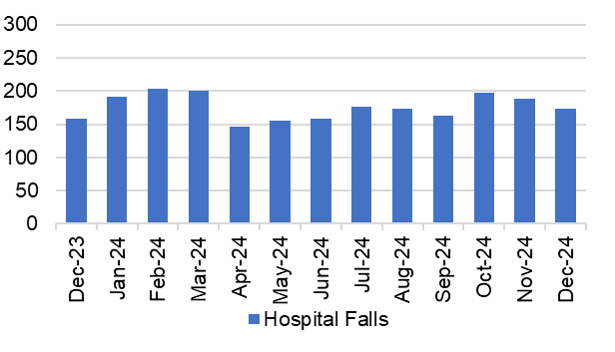
DISCHARGE SUMMARIES
Description | Current Performance | Trend
Discharge Summaries  Percentage of discharge summaries approved and sent to patients’ doctor following discharge | The latest data shows that in December 2024, the percentage of completed discharge summaries was 75%.  In December 2024, compliance ranged from 81% in Morriston Hospital to 65% in Neath Port Talbot Hospital. | % discharge summaries approved and sent  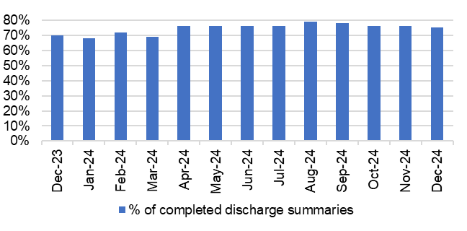
CRUDE MORTALITY
Description | Current Performance | Trend
Crude Mortality Rate | November 2024 reports the crude mortality rate for the Health Board at 0.67%, which is 0.02% higher than the figure reported in October 2024.  A breakdown by Hospital for November 2024:  - Morriston – 1.19%  - Singleton – 0.19%  - NPT – 0.08% | Crude hospital mortality rate by Hospital (74 years of age or less)  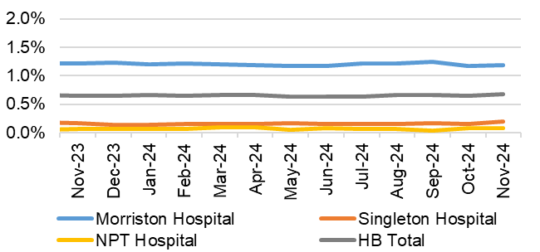
READMISSION RATES
Description | Current Performance | Trend
Readmission Rates | In December 2024, 9.17% of patients were readmitted as an emergency within 28 days of their previous discharge date. This is 1.48% higher than the figure reported in November 2024. | Emergencies readmitted within 28 days of previous discharge  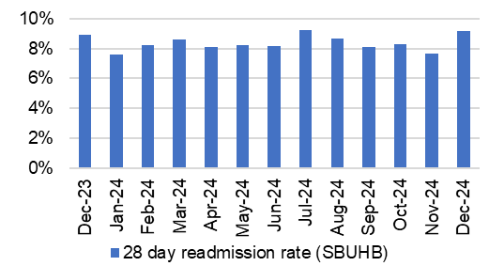
- HARM QUADRANT- HARM FROM REDUCTION IN NON-COVID ACTIVITY

  - Overview
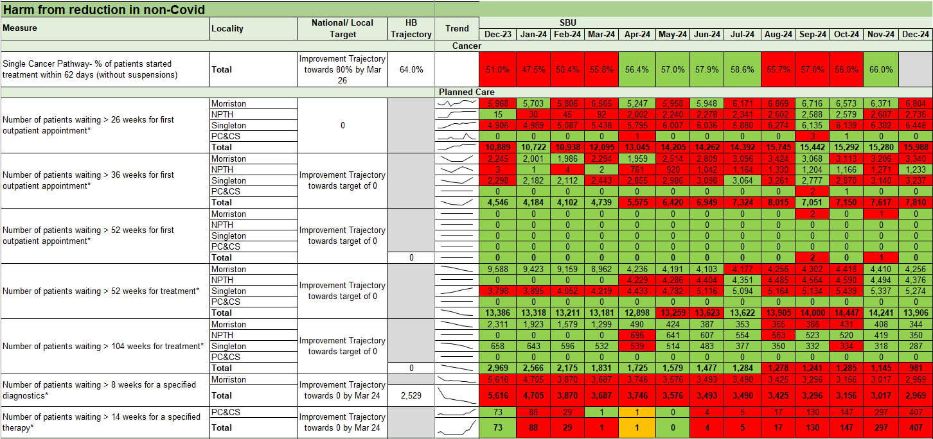

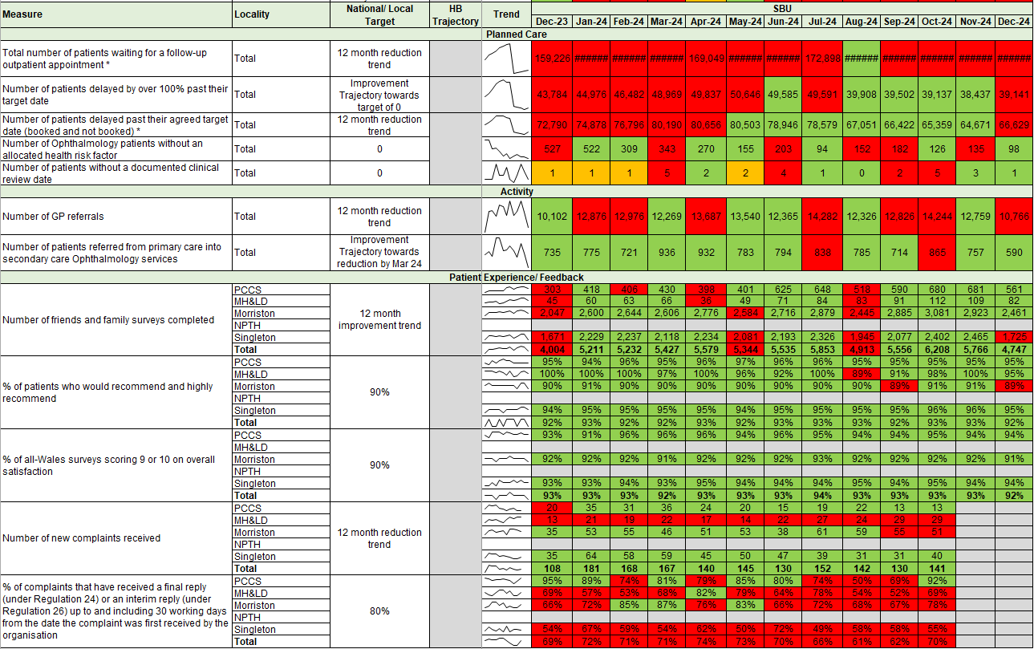

5.3 Updates on key measures
PLANNED CARE
Description | Current Performance
Referrals and shape of the waiting list  - GP Referrals  The number of Stage 1 additions per week  - Stage 1 additions  The number of new patients that have been added to the outpatient waiting list  - Outpatient activity undertaken  Total number of patients seen each month  - Size of the waiting list  Total number of patients on the waiting list by stage as at December 24 | In December 2024, there were 10,766 referrals received. This is lower than the number that was received in November 2024 (12,759). Chart 4 shows the shape of the current waiting list and Chart 3 shows the outpatient activity undertaken over the last year.
 | Trend
 | - Number of GP referrals received by SBU Health Board  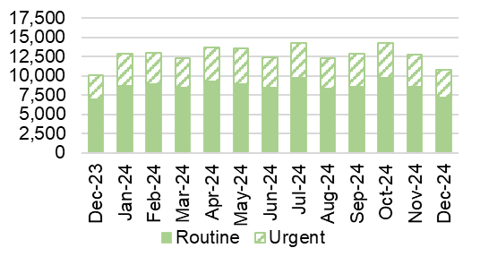 |  | - Number of stage 1 additions per week  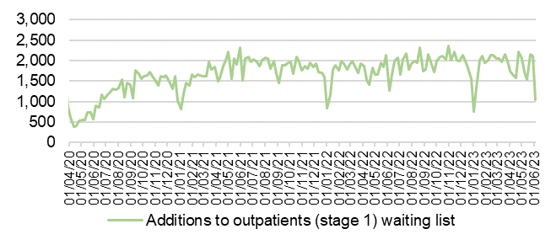
 | 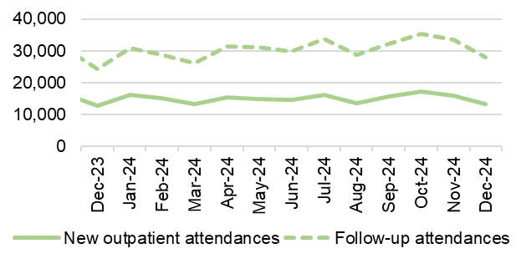  - Outpatient activity undertaken |  | - Total size of the waiting list and movement (Nov 2024)  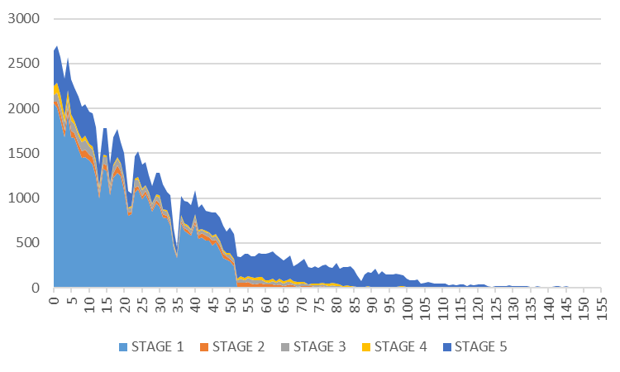
PLANNED CARE
Description | Current Performance
Outpatient waiting times  1. Number of patients waiting more than 26 weeks for an outpatient appointment (stage 1)- Health Board Total  2. Number of patients waiting more than 26 weeks for an outpatient appointment (stage 1)- Hospital Level  3. Patients waiting over 26 weeks for an outpatient appointment by specialty  4. Percentage of patients waiting less than 26 weeks | The number of patients waiting over 26 weeks for a first outpatient appointment is still a challenge. December 2024 saw a minor in-month increase of the number of patients waiting over 26 weeks for an outpatient appointment. The number of breaches increased from 15,280 in November 2024 to 15,988 in December 2024. Ophthalmology has the largest proportion of patients waiting over 26 weeks for an outpatient appointment, followed by ENT and Orthopaedics. Chart 4 shows that the number of patients waiting less than 26 weeks for an outpatient appointment, this figure has deteriorated slightly to 58.7%.
 | Trend
 | - Number of stage 1 over 26 weeks- HB total  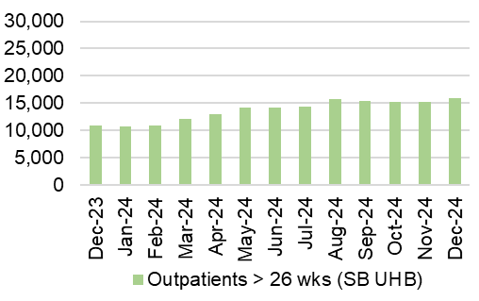 |  | - Number of stage 1 over 26 weeks- Hospital level  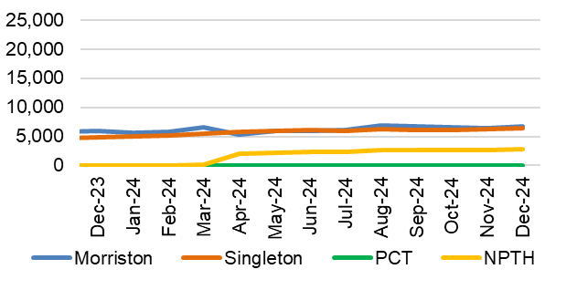
 | - Patients waiting over 26 weeks for an outpatient appointment by specialty as at December 2024  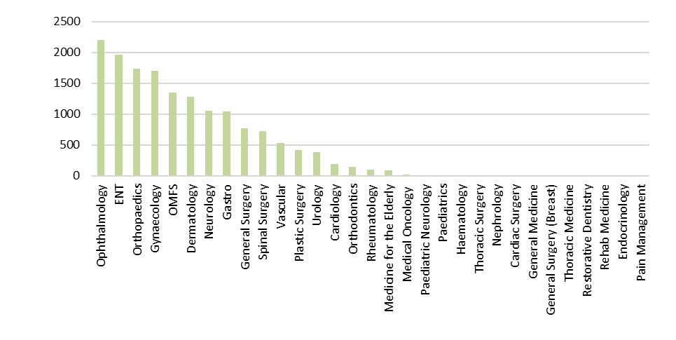 |  | 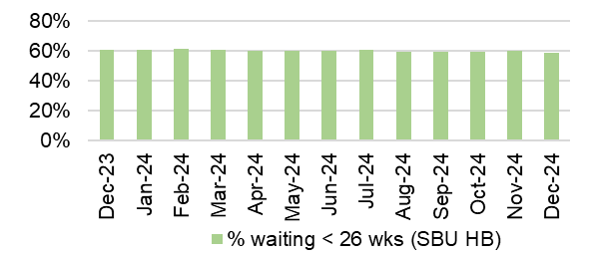  - Percentage of patient waiting less than 26 weeks
PLANNED CARE
Description | Current Performance
Patients waiting over 36 weeks for treatment  1. Number of patients waiting more than 36 weeks for treatment and the number of elective patients admitted for treatment- Health Board Total  2. Number of patients waiting more than 36 weeks for treatment  3. Number of elective admissions  4. Number of patients waiting more than 104 weeks for treatment | In December 2024, there were 7,810 patients waiting over 36 weeks at Stage 1, which is a 3% in-month increase from November 2024. 13,906 patients were waiting over 52 weeks at all stages in December 2024. In December 2024, there were 1,145 patients waiting over 981 weeks for treatment, which is a 14% reduction from November 2024.
 | Trend
 | 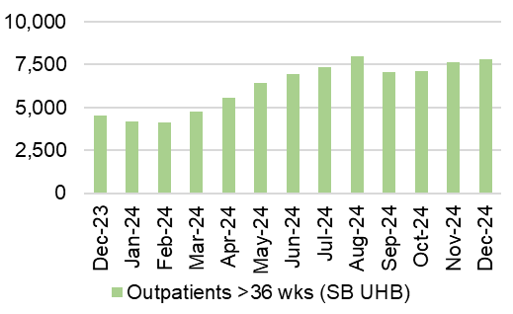  - Number of patients waiting over 36 weeks at Stage 1 |  | - Number of patients waiting over 52 weeks at Stage 1- HB total
 | 3. Number of elective admissions  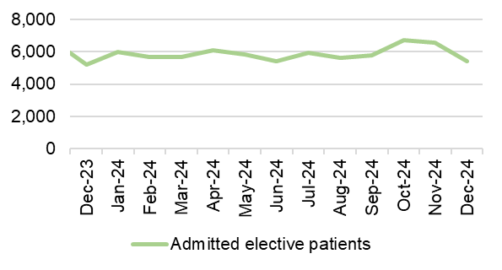 |  | 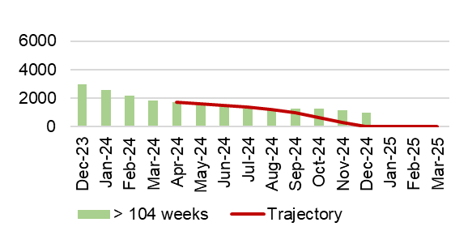  4.Number of patients waiting over 104 weeks- HB total
PLANNED CARE
Description | Current Performance
Ophthalmology Referrals  Number of patients referred into secondary care Ophthalmology services | In December 2024, there were 590 patients referred from Primary Care into secondary care ophthalmology services. This is a reduction on the number of patients referred in November 2024, which was 757. |  | Number of referrals into secondary care Ophthalmology service  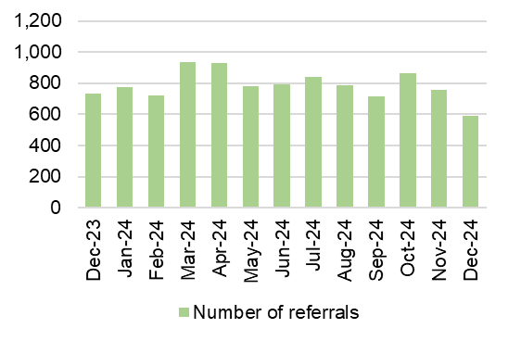
Ophthalmology waiting times  Percentage of ophthalmology R1 appointments attended which were within their clinical target date or within 25% in excess of their clinical target | In December 2024, 62.5% of Ophthalmology R1 appointments attended were within their clinical target date or within 25% of the target date.  Actions of Improvement;  A detailed Ophthalmology action plan is currently being executed which focusses on performance improvement schemes using insourcing and outsourcing resources, administrative validation and active recruitment to fill any current vacancies impacting capacity |  | Percentage of ophthalmology R1 appointments attended which were within their clinical target date or within 25% in excess of their clinical target date  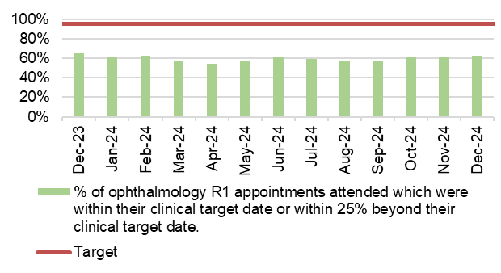
THEATRE EFFICIENCY
Description | Current Performance | Trend
Theatre Efficiency  1. Theatre Utilisation Rates  2. % of theatre sessions starting late  3. % of theatre sessions finishing early  4. % of theatre sessions cancelled at short notice (<28 days)  5. % of operations cancelled on the day | In December 2024 the Theatre Utilisation rate was 49%. This is 6% lower than the figure reported in November 2024 and is 3% lower than the figure reported in December 2023 (52%).  39% of theatre sessions started late in December 2024. This is 2% lower than the figure reported in November 2024.  In December 2024, 30% of theatre sessions finished early. This is lower than the figure seen in November 2024 and 2% lower than those seen in December 2023.  13% of theatre sessions were cancelled at short notice in December 2024. This is 2% higher than the figures reported in November 2024.  Of the operations cancelled in December 2024, 36% of them were cancelled on the day. | - Theatre Utilisation Rates  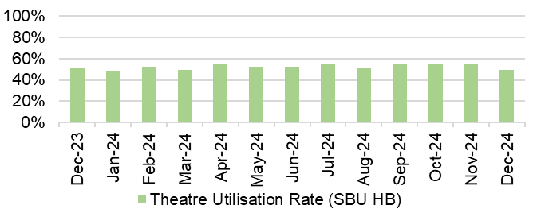  - and 3. % theatre sessions starting late/finishing  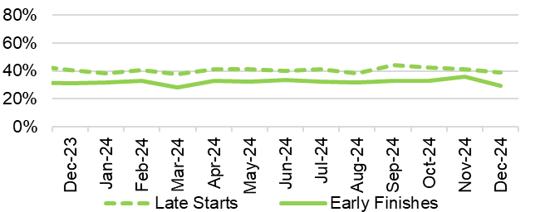  4.% theatre sessions cancelled at short notice (<28 days)  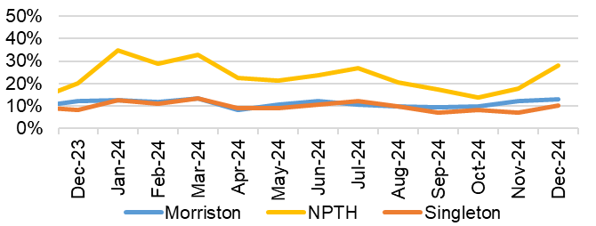  - % of operations cancelled on the day  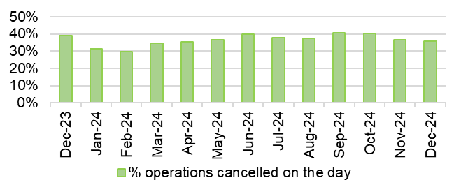
PLANNED CARE
Description | Current Performance |  |  | Trend
Diagnostics waiting times  The number of patients waiting more than 8 weeks for specified diagnostics | In December there was a reduction in the number of patients waiting over 8 weeks for specified diagnostics. It decreased from 3,017 in November 2024 to 2,969 in December 2024.  The following is a breakdown for the 8-week breaches by diagnostic test for December 2024:  - Endoscopy= 2,317  - Cardiac tests= 636^  - Other Diagnostics = 5  Actions of Improvement;  Demand and capacity work has enabled significant improvement in access times for non-endoscopic diagnostics.  Detailed demand and capacity model for endoscopy has been commissioned to ensure sustained improvement across all aspects of endoscopic diagnostics. |  |  | Number of patients waiting longer than 8 weeks for Diagnostics  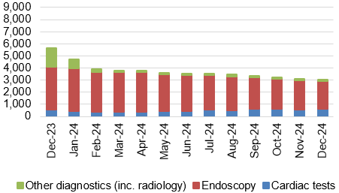
Therapy waiting times  The number of patients waiting more than 14 weeks for specified therapies | In December 2024, there were 407 patients waiting over 14 weeks for specified Therapies, which is 110 more than seen in November 2024.  - All of the breaches are currently associated with Podiatry. The service are in the process of finalising a recovery plan to manage the waiting list position. |  |  | Number of patients waiting longer than 14 weeks for therapies  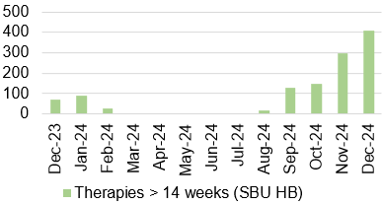
CANCER
Description | Current Performance |  |  | Trend
Cancer demand and shape of the waiting list  Single Cancer Pathway  Percentage of patients starting first definitive cancer treatment within 62 days from point of suspicion (regardless of the referral route)  Single Cancer Pathway backlog- patients waiting over 63 days | Early January 2025 backlog by tumour site: |  |  | Number of patients with a wait status of more than 62 days  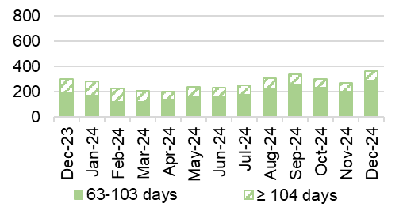
  Tumour Site | 63 - 103 days | ≥104 days
  Acute Leukaemia | 0 | 0
  Brain/CNS | 1 | 0
  Breast | 4 | 0
  Children's cancer | 0 | 1
  Gynaecological | 17 | 10
  Haematological | 7 | 6
  Head and neck | 11 | 1
  Lower GI (Exl. BSW) | 30 | 12
  BSW | 9 | 2
  Lung | 18 | 4
  Other | 4 | 1
  Sarcoma | 3 | 1
  Skin(c) | 110 | 18
  Upper Gastrointestinal | 12 | 13
  Urological | 29 | 12
  Grand Total | 255 | 81
 | November 2024 saw a slight increase in the number of patients waiting over 63 days. The following actions have been outlined to support backlog reduction;  - Targeted work is underway to prioritise patients waiting >104 days  - Milestone targets for OP access (10 days) and Decision to Treat (31 days) have also been set to reduce overall pathway waits.  - Tumour site specific plans have been developed and will be enacted through TI governance.  - Continued focus on cellular pathology  Note: backlog increased in May 2024 to reflect new reporting requirements for Bowel Screening Wales patients |  |  | Percentage of patients starting first definitive cancer treatment within 62 days from point of suspicion  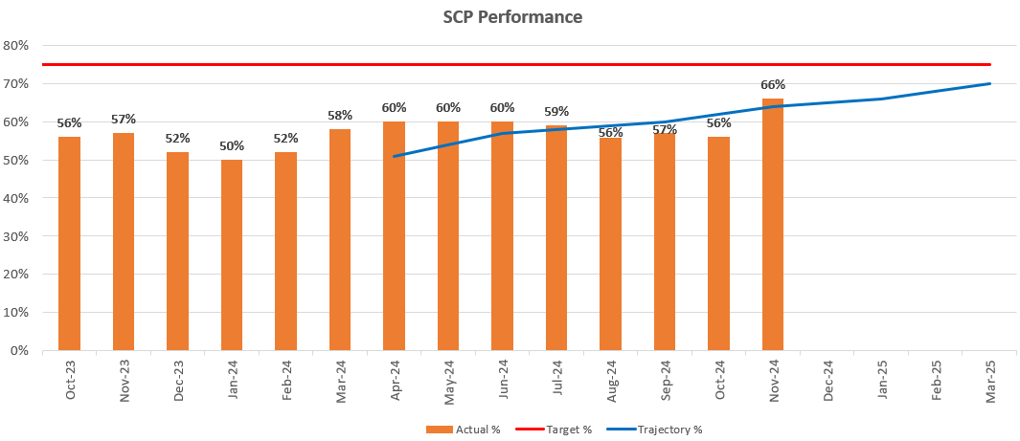
CANCER
Description |  | Current Performance | Trend
USC First Outpatient Appointments  The number of patients at first outpatient appointment stage by days waiting |  | Early December 2024 figures show total wait volumes for first outpatient appointment remain low.  Of the total number of patients waiting within the backlog, the majority of patients are waiting for treatment , closely followed by diagnostic results. | The number of patients waiting for a first outpatient appointment (by total days waiting) – Early ) January 2025  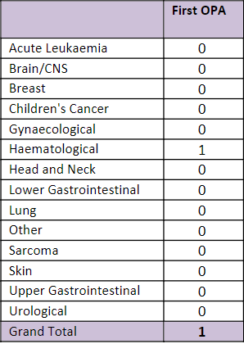
Radiotherapy waiting times  The percentage of patients receiving radiotherapy treatment |  | Radiotherapy waiting times continue to be a challenge, with only the 7 day Elective Delay target being met in December 2024. | Radiotherapy waiting times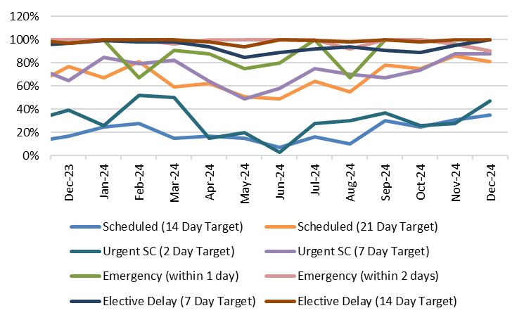
  Measure | Target | Dec-24
  Scheduled (14 Day Target) | 80% | 35%
  Scheduled (21 Day Target) | 100% | 81%
  Urgent SC (2 Day Target) | 80% | 47%
  Urgent SC (7 Day Target) | 100% | 88%
  Emergency (within 1 day) | 80% | 90%
  Emergency (within 2 days) | 100% | 90%
  Elective Delay (7 Day Target) | 80% | 100%
  Elective Delay (14 Day Target) | 100% | 100%
FOLLOW-UP APPOINTMENTS
Description | Current Performance |  | Trend
Follow-up appointments  1. The total number of patients on the follow-up waiting list  2. The number of patients waiting 100% over target for a follow-up appointment | In December 2024, there was a total of 150,165 patients waiting for a follow up outpatient appointment.  There was a total of 66,629 patients waiting for a follow-up past their target date in December 2024.  Of the 66,629 delayed follow-ups in December 2024, 13,880 had appointment dates and 52,749 were still waiting for an appointment.  In addition, 39,141 patients were waiting 100%+ over target date in December 2024.  - A significant reduction was noted in August 2024 due to a change in reporting where some specialties are excluded from monitoring going forward. Future trends will be assessed from the August 2024 position. |  | - Total number of patients waiting for a follow-up  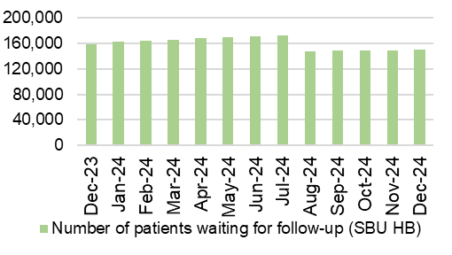  - Delayed follow-ups: Number of patients waiting 100% over target
PATIENT EXPERIENCE
Description | Current Performance | Trend
Patient experience  1. Number of friends and family surveys completed  2. Percentage of patients/ service users who would recommend and highly recommend  3. Number of Service User feedback experience responses completed and recorded on CIVICA | Health Board Friends & Family patient satisfaction level in December 2024 was 92% and 4,747 surveys were completed.  - Singleton/ Neath Port Talbot Hospitals Service Group completed 1,725 surveys in December 2024, with a recommended score of 95%.  - Morriston Hospital completed 2,461 surveys in December 2024, with a recommended score of 89%.  - Primary & Community Care completed 561 surveys for December 2024, with a recommended score of 95%.  - The Mental Health Service Group completed 82 surveys for December 2024, with a recommended score of 95%.  There were 6,876 feedback experience responses completed and recorded on CIVICA in December 2024. This is 385 more than the figure reported in November 2024. Of the responses recorded, 4,182 were targeted and 2,694 were passive. | - Number of friends and family surveys completed  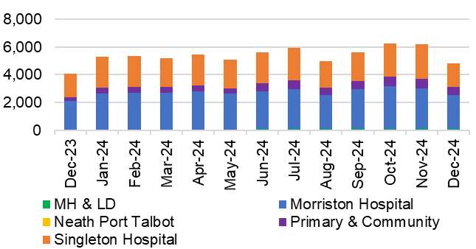  - % of patients/ service users who would recommend and highly recommend  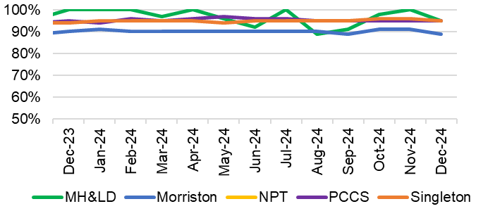  3. Number of feedback experience responses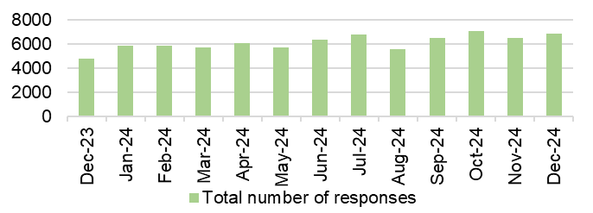
COMPLAINTS
Description | Current Performance | Trend
Patient concerns  1. Number of formal complaints received  2. Percentage of concerns that have received a final reply or an interim reply up to and including 30 working days from the date the concern was first received by the organisation | 1. In October 2024, the Health Board received 141 formal complaints; this is an improvement of 14% when compared with October 2023 figures (164).  2. The overall Health Board rate for responding to concerns within 30 working days was 70% in  October 2024, against the Welsh Government target of 75% and Health Board target of 80%.  Below is a breakdown of performance against the 30- day response target: | - Number of formal complaints received  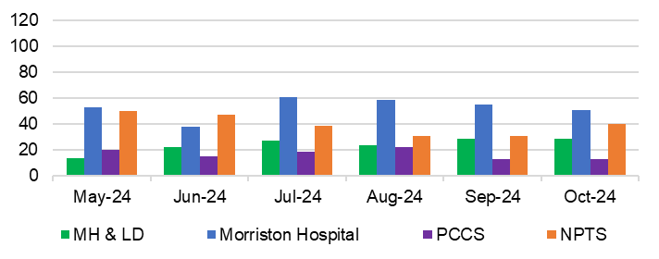  - Response rate for concerns within 30 days  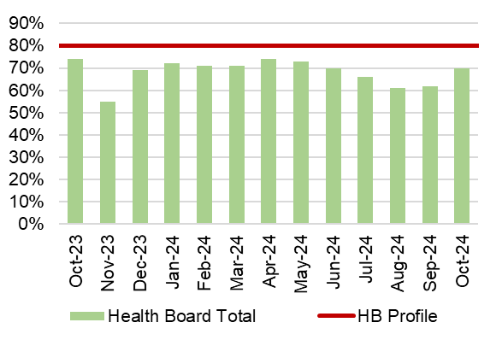
   | 30 day response rate
  Neath Port Talbot Hospital | 55%
  Morriston Hospital | 78%
  Mental Health & Learning Disabilities | 69%
  Primary, Community and Therapies | 92%
  Singleton Hospital | 55%

  - Overview
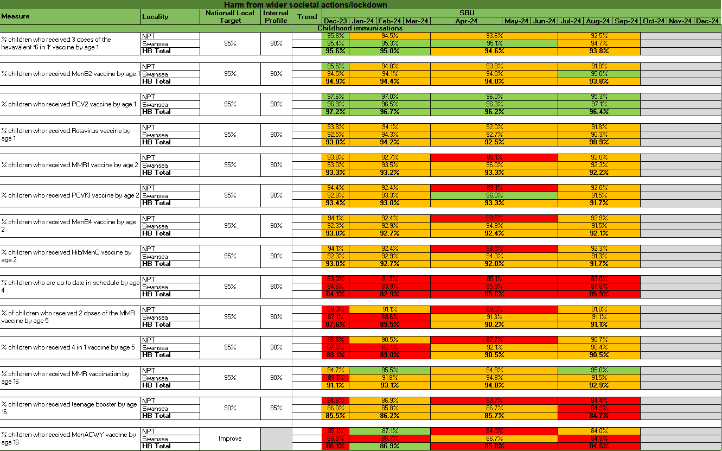
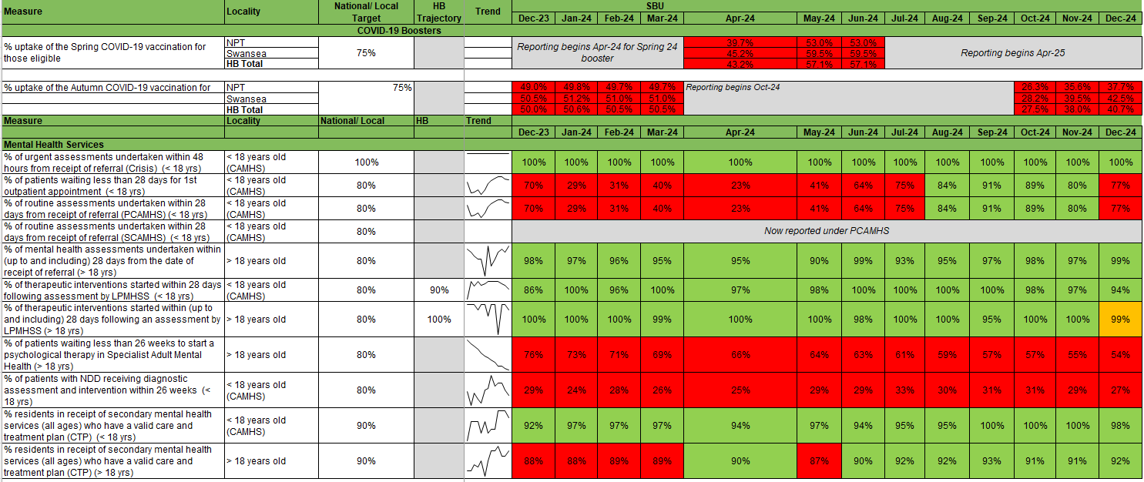

6.3 Updates on key measures
ADULT MENTAL HEALTH
Description | Current Performance | Trend
Adult Mental Health Measures:  - % of MH assessments undertaken within 28 days from the date of receipt of referral (18 years and over)  - % of therapeutic interventions started within 28 days following an assessment by LPMHSS (18 years and over)  - % of health board residents in receipt of secondary mental health services who have a valid Care and Treatment Plan (CTP) (18 years and over)  - % of patients waiting less than 26 weeks to start a psychological therapy in Specialist Adult Mental Health | - In December 2024, 99% of assessments were undertaken within 28 days of referral for patients 18 years and over.  - In December 2024, the percentage of therapeutic interventions started within 28 days following an assessment by the Local Primary Mental Health Support Service (LPMHSS) was 99%.  - 91% of residents in receipt of secondary care mental health services had a valid Care and Treatment Plan in November 2024.  - In December 2024, 54.1% of patients waited less than 26 weeks for psychological therapy. This was below the national target of 95%. | - % Mental Health assessments undertaken within 28 days from receipt of referral  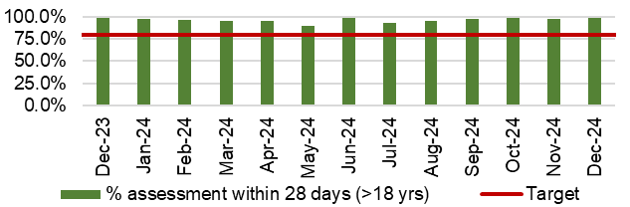  - % Mental Health therapeutic interventions started within 28 days following LPMHSS assessment  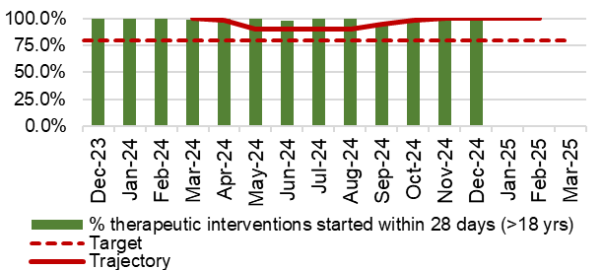  - % residents with a valid Care and Treatment Plan (CTP)  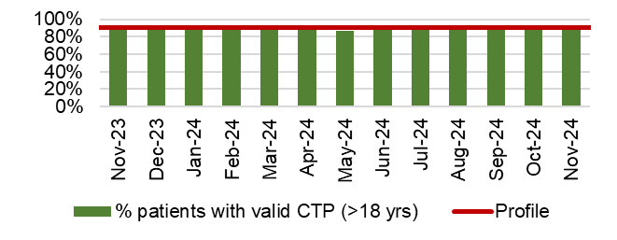  - % waiting less than 26 weeks for Psychology Therapy  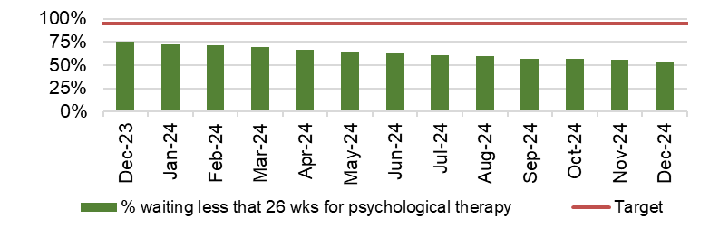
CHILD & ADOLESCENT MENTAL HEALTH (CAMHS)
Description | Current Performance | Trend
- Crisis - % Urgent Assessment by CAMHS undertaken within 48 Hours from receipt of referral  - Primary CAMHS (P-CAMHS) - % Routine Assessment by CAMHS undertaken within 28 days from receipt of referral  - Primary CAMHS (P-CAMHS) - % Therapeutic interventions started within 28 days following assessment by LPMHSS  - NDD - % Neurodevelopmental Disorder patients receiving a Diagnostic Assessment within 26 weeks  - Specialist CAMHS (S-CAMHS) - % Routine Assessment by SCAMHS undertaken within 28 days from receipt of referral | - In November 2024, 100% of CAMHS patients received an assessment within 48 hours.  - 77% of routine assessments were undertaken within 28 days from referral in December 2024 against a target of 80%.  - 94% of therapeutic interventions were started within 28 days following assessment by LPMHSS in November 2024.  - 27% of NDD patients received a diagnostic assessment within 26 weeks in December 2024 against a target of 80%.  - SCAMHS figures now included in illustration 2 and 3 combined.  *All routine assessments are now under PCAMHS* | - Crisis- assessment within 48 hours  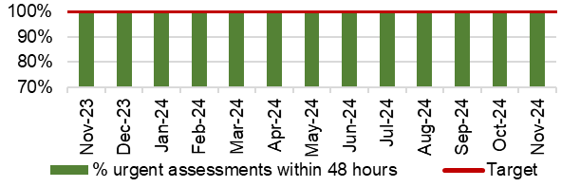  - and 3. P-CAMHS % assessments and therapeutic interventions within 28 days  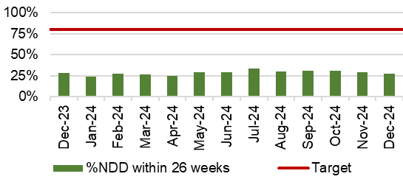  - NDD- assessment within 26 weeks

APpendix 2: Summary
The following table provides a high level overview of the Health Board’s most recent performance against key quality and safety measures by quadrant component measure.

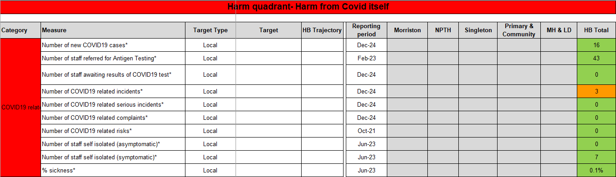

* In the absence of local profiles, RAG is based on in-month movement

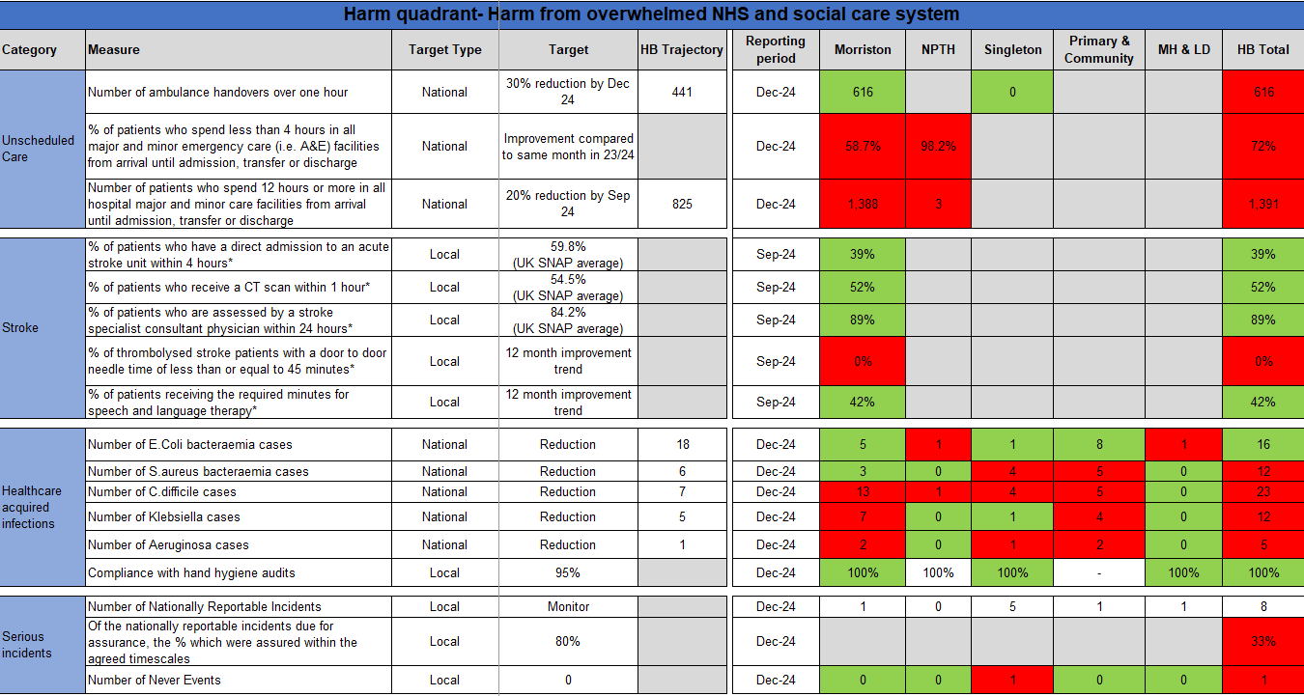

* In the absence of local profiles, RAG is based on in-month movement

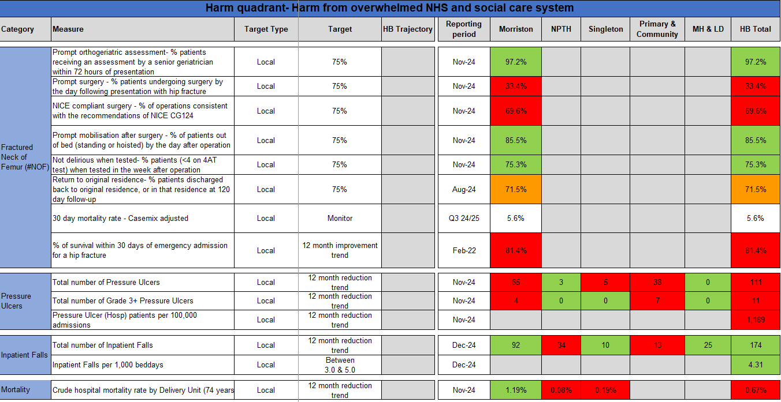

* In the absence of local profiles, RAG is based on in-month movement

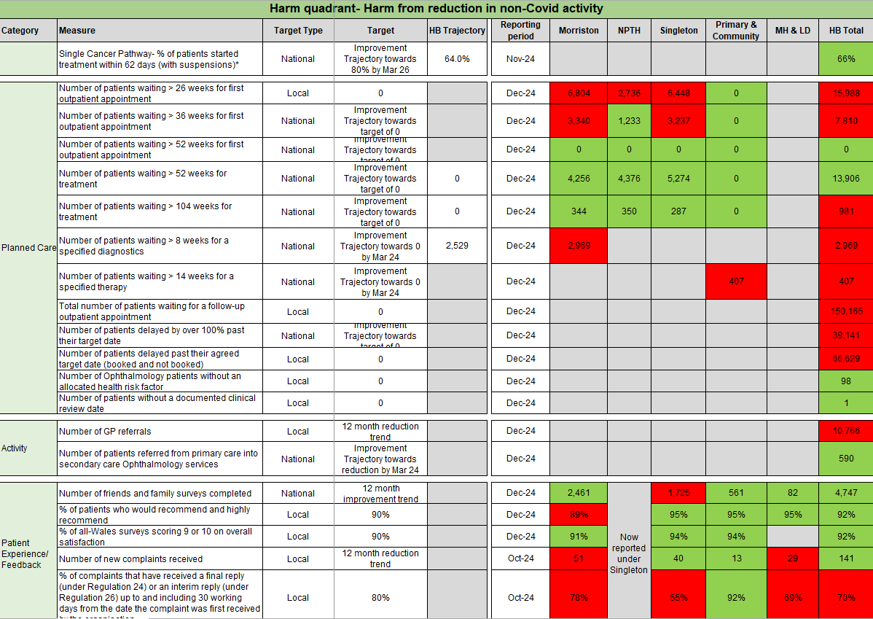

* In the absence of local profiles, RAG is based on in-month movement

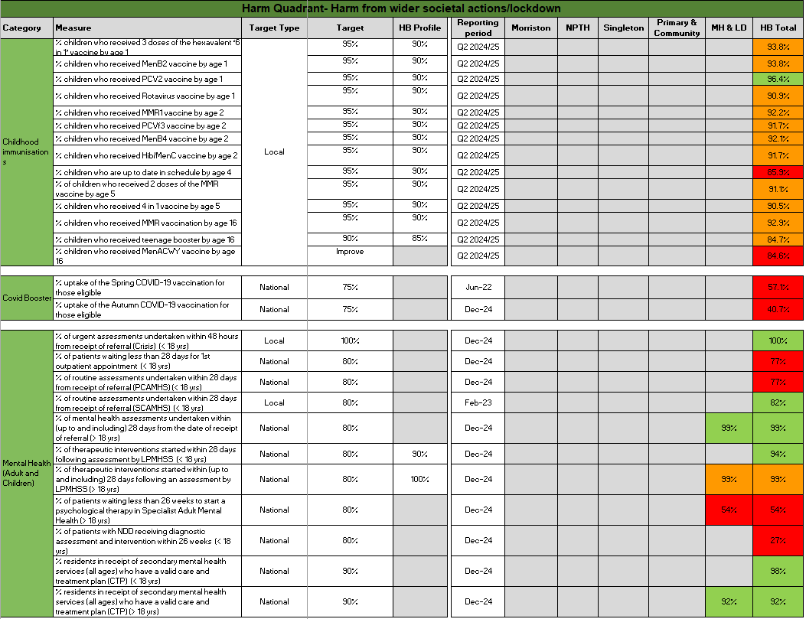

* In the absence of local profiles, RAG is based on in-month movement

Appendix 3: INTEGRATED Performance Dashboard

