Meeting Date | 25 March 2025 |  | Agenda Item |  |  | 4.1
Meeting Title | Quality and Safety Committee
Report Title | Gold Command for Maternity and Neonatal Services Progress Report
Report Author | Liz Wonnacott, Head of Service – Medical Director  Kathryn Greaves, Clinical Director for Midwifery  Dr Raj Krishnan, Deputy Executive Medical Director
Report Sponsor | Dr Richard Evans, Executive Medical Director  Hazel Powell, Interim Director of Nursing and Patient Experience
Presented by | Dr Raj Krishnan, Deputy Executive Medical Director
Freedom of Information | Open
Purpose of the Report | The purpose of the report is to set out the progress discussed as part of the gold command arrangements established for scrutiny and assurance of improvement within maternity and neonatal services.
Key Issues | - In December 2023, the health board’s maternity and neonatal services were placed by Welsh Government into enhanced monitoring;  - The escalation status followed an unannounced inspection by Healthcare Inspectorate Wales (HIW) in September 2023 during which seven areas of immediate action were identified;  - An action plan was shared with HIW, with a follow-up unannounced visit in April 2024 to review progress;  - Alongside this are other external reports and inspections which require action, as well as open incidents to be closed;  - To scrutinise and seek assurance that the work required is being undertaken, a gold command structure has been established;  - The report sets out the latest reported position against all areas of focus.
Specific Action Required  (please choose one only) | Information | Discussion |  | Assurance | Approval
Specific Action Required  (please choose one only) | ☐ | ☐ |  | ☒ | ☐
Recommendations | Members are asked to:  - ACKNOWLEDGE the work to close additional actions raised during enhanced monitoring meetings;  - BE ASSURED the HIW improvement plans are all closed and are subject to an internal governance check prior to sign-off by the gold command;  - BE ASSURED the actions to address the Health Education and Improvement Wales (HEIW) maternity and neonatal specific actions are closed;  - BE ASSURED the group has included within its remit the need to ‘horizon scan’ to look ahead to potential visits and/or reports which may require action.

GOLD COMMAND FOR MATERNITY AND NEONATAL SERVICES PROGRESS REPORT

- INTRODUCTION
The purpose of the report is to set out the progress discussed as part of the gold command arrangements established for scrutiny and assurance of improvement within maternity and neonatal services.

- BACKGROUND
In December 2023, the health board’s maternity and neonatal services were placed into enhanced monitoring by Welsh Government. This was because of concerns as to the quality and safety of the care provided raised by members of the Senedd and families who have accessed the services.

The escalation status followed an unannounced inspection by Healthcare Inspectorate Wales (HIW) in September 2023 during which seven areas of immediate action were identified. In addition, the formal report for the visit set out a number of recommendations for improvement, and an action plan was shared with HIW. HIW undertook a follow-up unannounced visit in undertaken in April 2024 to review progress and while some of work had been completed, there were still improvements required.

Alongside this are two Health Education and Improvement Wales (HEIW) targeted inspections of obstetrics and gynaecology in February and July 2024 as part of HEIW’s quality framework to identify areas working well or in need of improvement, as well as national reports which identify areas of improvement for maternity and neonatal services across the UK.

To scrutinise and seek assurance that the work required is being undertaken, a gold command structure has been established, led by the Deputy Medical Director as the senior responsible officer, supported by the Chief Operating Officer and Interim Director of Nursing and Patient Experience. Meetings are attended by members of the Singleton/Neath Port Talbot Service Group’s senior team under which sit maternity and neonatal services.

- GOVERNANCE AND RISK ISSUES
The main areas of focus for the group are enhanced monitoring, inspection action plans, open incidents, national reports and horizon scanning. Progress includes:

- Enhanced Monitoring
Senior members of the service group along with key members of the executive team meet with Welsh Government on a monthly basis to share progress to achieve de-escalation. During these meetings, actions additional to the criteria already set by Welsh Government can be allocated and these are reviewed within the gold command meetings to ensure completion. There is one outstanding action:

- Maternity dashboard – work is progressing to build and populate dashboards for maternity and neonatal services for use by the department and service group’s quality and safety groups from 1st April 2025. This will allow data to be triangulated and any themes identified for onward escalation to the health board’s quality and safety forums.

At the gold command meeting in February 2025, members reviewed the slides for the enhanced monitoring meeting which was taking place later that same week. These had been redesigned from what has previously been presented to include the action being taken to support de-escalation alongside the standard information reported. Each presentation will incorporate a different element of the de-escalation framework:

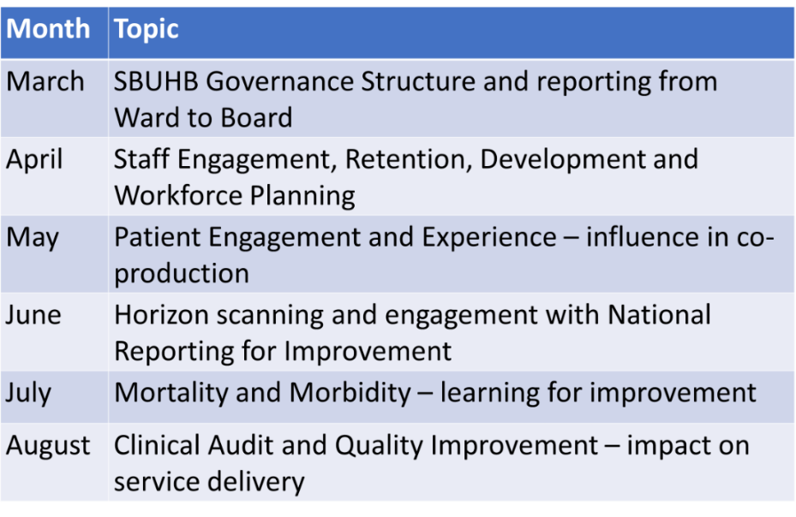

- Inspection Action Plans

- HIW Inspections
As part of the work to address the recommendations made by HIW, the 2019 HIW improvement plan and 2019 Birth Centre Improvement Plan were revisited, and both closed in full. At the February 2025 gold command meeting, it was confirmed that the 2023 and 2024 immediate and general improvement plans are also now closed.

Work is underway internally to spot check the evidence gathered to demonstrate the closure of the actions before correspondence is sent to HIW. It is anticipated HIW will return to review the progress made but no formal arrangements have been made to date.

- Health Education and Improvement Wales (HEIW)
Following the two visits earlier in 2024, an action plan is in place and the majority have been delivered and spans obstetrics and gynaecology. As reported in previous meetings, there had only been one outstanding area relevant to obstetrics, which was job planning, and all consultants now have a job plan on the Allocate system. Therefore, the action is now complete.

- Open Incidents
The service is now in a position where it is closing more incidents each month than are opened and the table below sets out the current position.

 | Maternity |  | Neonatal
 | Open | Overdue | Open | Overdue
Incidents | 80 | 60 | 8 | 4
Duty of Candour | 9 |  | 0
Concerns | 18 | 8 | 0 | 0
Redress | 34 |  | 2
Claims | 60 |  | 8

There has a been a significant improvement in the number of open incidents as there were 230 reported when the gold command group was first established in August 2024.

Of those incidents which are overdue, the majority are from August 2024 onwards, with the few prior to this complex and some subject to legal proceedings.

The clinical leads for maternity and neonatal continue to prioritise the responses to concerns, redress and claims to sign-off the responses, but the majority of the ones open are complex and part of legal proceedings, with 21 of the 36 redress claims originating from incidents.

A review of the incidents identified that the majority were reported under the category of maternity adverse outcomes. These could include stillbirths, cord prolapse or birth trauma, but the numbers for these are small. The most common incidents recorded under this theme are post-partum haemorrhage, born under 10th centile (meaning the baby is smaller than expected for its gestational age) and unexpected admissions to the neonatal intensive care unit. These are common and normally low or no harm incidents.
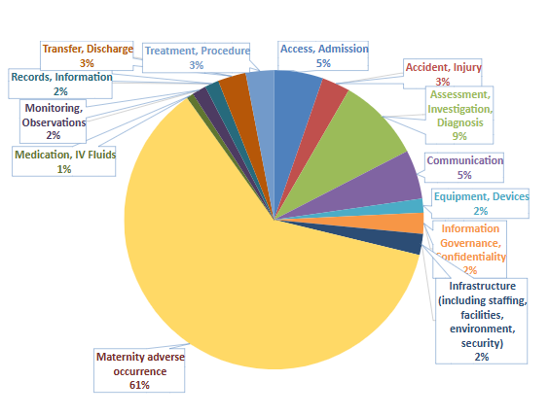

- National Reports

- MBRRACE-UK (Mothers and Babies: Reducing Risk through Audits and Confidential Enquiries across the UK) 2023
There are two reports from MBRRACE-UK currently being worked though by the service and under scrutiny by gold command.

The first being the ‘State of the Nation Report Saving Lives, Improving Mothers’ Care October 2024 Surveillance findings and lessons learned to inform maternity care from the UK and Ireland Confidential Enquiries into Maternal Deaths from thrombosis and thromboembolism, malignancy and ectopic pregnancy 2020-2022, and morbidity findings for recent migrants with language difficulties. The service has benchmarked itself against the findings and no immediate causes for concern have been identified. A report and action plan has been populated and is now in the process of being reported to the service group’s Quality, Safety and Risk Group. It has also been submitted to the clinical audit team for benchmarking and there is one action that will go through Bronze for continued improvement, but all other areas have been met.

The national MBRRACE-UK report setting out how many stillbirths and neonatal deaths have occurred is published two years in arrears, and the report for the 2023 data has now been received. As part of the report, the health board was identified as an outlier for stabilised and adjusted extended perinatal mortality (the number of stillbirths and neonatal deaths which meet the MBRRACE criteria as opposed to all stillbirths and neonatal deaths in that period) and for stabilised and adjusted neonatal mortality with a rate of 5% higher than the average for similar sized organisations.

Of these, 16 were stillborn and nine were neonatal deaths. The maternity and neonatal has reviewed these cases using the Perinatal Mortality Review Tool (PMRT) and have graded the cases accordingly based on the following:

- Grade A (no issues identified);
- Grade B (care issues identified, no impact on outcome);
- Grade C (care issues identified, which may have affected the outcome);
- Grade D (care issues identified that definitely affected the outcome).

Of all the stillbirths and neonatal deaths, the majority were graded either ‘A’ or ‘B’. The cases reviewed internally are confirmed with external peers and have confirmed the grading.

Thematic analysis and learning have been identified from the cases graded ‘C’ or ‘D’ and a standalone report on the MBRRACE-UK 2023 data was received by the Quality and Safety Committee in March 2025 to provide greater detail of the findings and resulting actions.

- Horizon Scanning
As part of the gold command’s role, it looks ahead to any potential reviews or reports relating to maternity or neonatal services. These could be regular national reports which are issued as standard or external reviews being undertaken either of the health board itself or other maternity and neonatal services from which there could be learning. There are two reports expected, the recently concluded HIW inspection on the free-standing midwifery unit and the report from Llais, an independent statutory body set up by Welsh Government for people to have their say in relation to health and social services. Llais undertook an assurance visit to the maternity services towards the end of 2024 and a report on its findings is expected. Any actions required will be discussed through the gold meetings.

In addition, the service will be undertaking a six-month review following the reopening of the free-standing midwifery unit in September 2024 to identify successes and lessons learned. This will be received by the gold command meeting in the spring 2025.

- Other Areas of Discussion
As progress continues to be made, the agenda for the gold meetings is extending more widely than the initial areas first outlined to provide further assurance:

- Risk
The health board was asked at the October 2024 enhanced monitoring meeting to provide an updated risk register at its next meeting. This was delivered in November 2024 and a discussion undertaken as to reducing the risk scores based on the progress which has been made. At the time, there were three risks currently on the health board risk register relating to maternity and neonatal services:

- Screening for Fetal Growth Assessment in line with Gap-Grow (G&G) – risk score 12
- Inability for maintaining Birthrate Plus ® complaint rosters – risk score 16
- High Quality Choices in Place of Birth – risk score 16

These have been reviewed by the service group and all three now have an agreed risk score of 12, with approval from the Risk Scrutiny Panel for these to be removed from the health board risk register as they are below the risk appetite. They will continue to be monitored by the service group and will be escalated if required.

- FINANCIAL IMPLICATIONS
There are no financial implications associated with this report.

- RECOMMENDATION
Members are asked to:
- ACKNOWLEDGE the work to close additional actions raised during enhanced monitoring meetings;
- BE ASSURED the HIW improvement plans are all closed and are subject to an internal governance check prior to sign-off by the gold command;
- BE ASSURED the actions to address the Health Education and Improvement Wales (HEIW) maternity and neonatal specific actions are closed;
- BE ASSURED the group has included within its remit the need to ‘horizon scan’ to look ahead to potential visits and/or reports which may require action.
Governance and Assurance

Link to Enabling Objectives  (please choose) | Supporting better health and wellbeing by actively promoting and empowering people to live well in resilient communities
Link to Enabling Objectives  (please choose) | Partnerships for Improving Health and Wellbeing |  | ☒
Link to Enabling Objectives  (please choose) | Co-Production and Health Literacy |  | ☐
Link to Enabling Objectives  (please choose) | Digitally Enabled Health and Wellbeing |  | ☐
Link to Enabling Objectives  (please choose) | Deliver better care through excellent health and care services achieving the outcomes that matter most to people
Link to Enabling Objectives  (please choose) | Best Value Outcomes and High-Quality Care |  | ☒
Link to Enabling Objectives  (please choose) | Partnerships for Care |  | ☐
Link to Enabling Objectives  (please choose) | Excellent Staff |  | ☐
Link to Enabling Objectives  (please choose) | Digitally Enabled Care |  | ☐
Link to Enabling Objectives  (please choose) | Outstanding Research, Innovation, Education and Learning |  | ☐
Health and Care Standards
(please choose) | Staying Healthy |  | ☐
(please choose) | Safe Care |  | ☒
(please choose) | Effective Care |  | ☒
(please choose) | Dignified Care |  | ☒
(please choose) | Timely Care |  | ☒
(please choose) | Individual Care |  | ☒
(please choose) | Staff and Resources |  | ☐
Quality, Safety and Patient Experience
The health board is dedicated to ensuring that pregnancy and childbirth is a safe and positive experience for all service users in order to support healthy life choices and to give children the best start in life. This requires safe and effective maternity and neonatal services. The actions identified by the reviews and external bodies will support the improvements needed to achieve this.
Financial Implications
There are no financial implications associated with the report.
Legal Implications (including equality and diversity assessment)
There are no legal implications associated with the report.
Staffing Implications
There are no staffing implications associated with the report.
Long Term Implications (including the impact of the Well-being of Future Generations (Wales) Act 2015)
The health board has a 10-year vision to be a high-quality organisation. Work being undertaken to address the concerns raised and to de-escalate from enhanced monitoring will not only support that vision but develop maternity and neonatal services which are safe and sustainable in the longer-term.
Report History |  | Regular report
Appendices |  | No appendices.

