Meeting Date | 25th March 2025 |  | Agenda Item |  |  | 3.6
Name of Meeting | Quality and Safety Committee
Report Title | Right Care Right Person (RCRP): Update
Report Author | Malcolm Jones: Associate Service Director for Mental Health.
Report Sponsor | Deb Lewis Chief Operating Officer (COO)
Presented by | Deb Lewis (COO) & Malcolm Jones (ASD for MH)
Freedom of Information | Open
Purpose of the Report | To provide an update following submission of initial report on the 3rd Dec 2024.  To provide an update following the implementation of phase 3 & 4 of RCRP. (Live on 10th March 2025)  To inform the Quality & Safety Committee of the work undertaken to date to enable the Health Board’s preparedness
Key Issues | Overall there is support for the principles of RCRP, however there are concerns of the speed of implementation and the inherent risks associated with the policy changes.  A number of quality & safety risks have been identified as possible impacts arising from RCRP policy, particularly in the absence of additional resources for the NHS to fill the gaps.  The RCRP principles do however present an opportunity to improve patient experiences and outcomes
Specific Action Required  (please choose one only) | Information | Discussion |  | Assurance | Approval
Specific Action Required  (please choose one only) | ☐ | ☐ |  | ☒ | ☐
Recommendations | Members are asked to:  - Acknowledge that the recommendations made in this paper on governance/ oversight of Right Care Right Person related activity within the Health Board are considered and agreed by members;  - Give consideration to the role and function of any other relevant committees in relation to RCRP, and how they are also sighted on relevant reporting; and  - Acknowledge that a named Quality and Safety lead in each SDG will receive reports relating to the monitoring of incidents and data in relation to the impact of RCRP and take these to SDG Quality and Safety groups. Each SDG QS group will be responsible for reviewing, escalating, acting on the data and initiating any further audit/deep dive of incidents and provide reporting into the corporate level patient safety and compliance group.

RIGHT CARE RIGHT PERSON: UPDATE ON PHASES 3 & 4

- INTRODUCTION

South Wales Police have implemented the RCRP policy via a phased approach. The final two phases, 3 & 4 went live on the 10th March 2025.
The following report provides:

- An overview of RCRP policy, with a focus on phases 3 & 4, from a regional perspective
- The work undertaken to enable the Health Board’s preparedness
- The concerns and risks identified

- BACKGROUND

RCRP – an overview of phases 3 & 4

RCRP is a police policy where a new threshold will be applied to the police response to calls relating to vulnerable people. It is an approach designed to ensure that people of all ages, who have health and/or social care needs, are responded to by the right person, with the right skills, training and experience to best meet their needs. Key policy drivers are:

- Police forces frequently deal with a wide variety of incidents and calls for assistance. Some of these are policing matters whilst others are in concern for welfare, conveyancing and social care issues.
- The police role often overlaps with various parts of the NHS and social care agencies.
- Substantial demand is placed on police time to deal with calls that may be better suited to other agencies.

At the core of the RCRP approach is a new threshold to assist police in making decisions about when it is appropriate for them to respond to incidents, including those which relate to people with physical and mental health care needs.

The implementation of the RCRP BY South Wales Police (SWP) is spilt into four phases as outlined below:
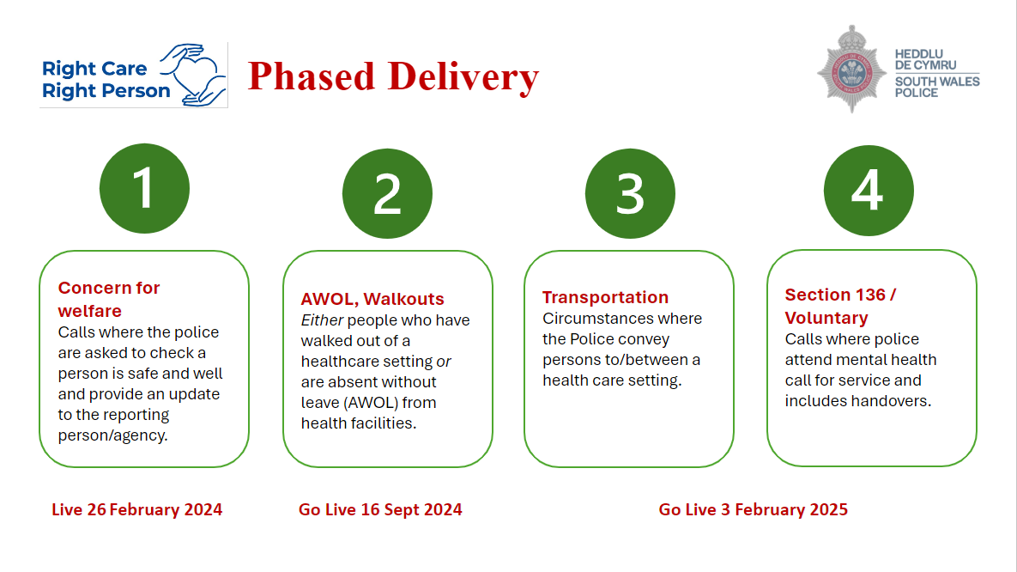

The Police have set-out that they will attend calls where:

- There is a threat to life
- There is a threat of serious harm
- Police powers are required
- A crime has occurred / suspected
- The person is a missing person

Phase 3 – Transportation (circumstances where the Police convey persons to/between a health care setting).

South Wales Police (SWP) have confirmed that implementation of phase 3 will be on the 10th March 2025. The Health Board Task & Finish Group (TFG) has been pro-active and engaged with SWP colleagues and other agencies in a series of local and regional meetings.

SWP have an existing policy that states officers should not transport patients who require transportation as a result of their physical health. SWP currently transport around 90% of section 135/136 detentions. The change will see tighter police scrutiny around police transportation of patients and data capture to challenge over reliance on police transport.

Phase 4 – s136/voluntary (calls where police attend mental health call for service and includes handovers).

SWP confirmed that phase 4 will also be implemented on the 10th March 2025. SWP will continue to work within the Mental Health Act Code of Practice, and that a joint protocol will be developed, although work on this is at an early stage.

In relation to handovers in Section 135/6 situations, the proposal in phase 4 is to identify and understand why handovers at the health-based place of safety and ED aren't being achieved in a timely fashion for the benefit of patient care. SWP will look to health partners for an expectation that handover should be possible in 1 hour. An escalation process will need to be agreed where handovers are excessively long.

The TFG have initiated work on phases 3 & 4 with a HIA workshop held on the 12th November. Representatives from Swansea and Neath Port Talbot Councils attended the workshop. The Public Health Team facilitated a discussion in relation to HIA – this mirrors the approach for phase 2, and some of the observations and conclusions made at the initial workshop were as follows:

- The scope of people who will be impacted by phases 3 & 4 is wider than phase 2, although it was noted that it is likely to have a major impact on people in acute mental health crisis, carers (including young carers) and older people, and has the potential to have an impact on community safety and resilience.
- Concern around the lack of resources within WAST and emergency departments and their ability to transport and receive patients in a timely manner
- There is already some disconnect in local policies and those of South Wales Police
- A lack of leadership and understanding nationally on the resources required to fill the ‘gap’ currently being filled by South Wales Police in relation to transportation.
- The position of the Welsh Ambulance Service is not clear and whilst SWP have confirmed that they are engaged, there doesn’t appear to be any pressure from the Welsh Ambulance Service to understand the gap.
- There are opportunities to improve the response to people in acute mental health crisis in the region, the majority of which do not proceed to admission.

The Public Health Team provided a brief of the available data in relation to the Section 135/6 element of phases 3 & 4. In summary for the 12 month period July 2023 – June 2024 are as follows:

- Total incidence of S135 and S136 cumulative = 158
- The Police Service were registered as the conveyancing method of 87% of incidents. The second highest conveyancing method was ‘not recorded’ at 9%
- Police conveyed 79% to a ‘Health based place of safety’ and 19% to A&E
- ‘Discharged from section to CMHT’ and ‘Discharge with no follow up’ were the leading outcomes at 34% each

The Health Board remain heavily reliant on SWP in relation to Transport in the context of mental health crisis and SWP identify a need to improve hand-over times within our main emergency department in Morriston Hospital and at the designated place of safety.

Mitigating actions taken to date include:
- At the request of the Chief Operating Officer, a TFG was established in June 2024 three months following the implementation of Phase 1.Representatives of the TFG include Strategy, Public Health, Quality & Safety, and a representative from each Service Delivery Group. The Group is chaired by the Associate Service Director for Mental Health. The main focus for the TFG was initially to prepare for Phase 2 and then subsequently phases 3 & 4. TFG last met on the 4th March 2025.
- Further work is taking place by the TFG on the HIA and sources of evidence and data to understand the scope of potential impacts of Phase 3 and 4. For example; we are still unclear on the full scope of transport provision that may not now meet the RCRP threshold.
- The creation of a consistent, collaborative, comprehensive section 135/136 policy. HBs to continue to work with the current policy until the new policy has been reviewed and amended
- WAST Mental Health response vehicle to be introduced; WAST MH lead to share the service descriptor and policy.
- HB has undertaken a review of the s136 suite (based at MH Unit in NPTH) and an action plan produced to reflect the changes required to improve the facility.
- SWP officers to be encouraged to utilise the professional clinical phone line.

Next steps

It is now necessary to develop and agree a clear governance framework and accountability for analysing, acting on and reporting this data on an ongoing basis which is not suitable for the temporary T&F group.

It is recommended that Digital Intelligence will develop an automated report and analysis (structure to be agreed by the TFG) utilising data from the Datix digital system, which will be sent to a named Quality and Safety lead in each Service Delivery Group (SDG) for this to be reported through SDG Quality and Safety groups. SDG QS group will be responsible for reviewing, escalating, acting on the data and initiating any further audit/deep dive of incidents, as well as escalating and reporting into the corporate QS structure as required.

As noted above - the TFG have identified that is now necessary to develop and agree a clear governance framework and accountability for analysing, acting on and reporting monitoring data on an ongoing basis which is not a suitable function for the temporary TFG.

It is recommended that the Health Board’s quality and safety governance structure is utilised to monitor and review preparedness for RCRP, implications for the HB services and review impacts and incidents that occur as a result of the RCRP. This includes quality and safety groups at both service delivery group and corporate levels.

  - GOVERNANCE AND RISK ISSUES

Governance
There is a need to develop and agree a clear governance framework for providing oversight of the TFG assessments and actions, monitoring impacts, taking required action to mitigate risk and ensure opportunities to improve patient experience and outcomes are maximised and liaison with partners.

Discussion between Strategy, Public Health and the Quality and Safety teams have led to a consensus that the Health Board’s quality and safety governance structure is best placed to provide this governance, monitor and review the data on incidents provide assurance on mitigating actions opportunities to improve patient experience. This includes quality and safety groups at both service delivery group level, and RCRP is a new policy that has impacts on the interface between policing and healthcare across the whole Health Board and all Service Delivery Groups. As it is a new policy, no existing governance arrangements are currently in place, although a number of impacts resulting from RCRP are relevant within current governance structures including: Quality and Safety; Mental Health Legislation; Population Health and Partnerships.
Risks
Key areas of risk relate to:
- Additional pressure on healthcare staff to undertake dynamic risk assessment and navigate a new police threshold for response whilst managing complex scenarios which may include absconding, risk of suicide/self-harm, violence and aggression and restraint.
- A lack of clarity on the threshold for police involvement could potentially create risk
- A lack of suitable, timely, safe transport, e.g. in situation where a person under a Section of the Mental Health Act requires safe transport
- Accountability around handovers at a place of safety in the context of Section 135/6 ( See Webley case law, which highlighted that ED could be liable in negligence law IF they agree to take on legal responsibilities and the person then absconds (RCEM, 2017).
- Compliance with the Mental Health Act 1983 and associated codes of practice
- Responsibility for provision and safety of transportation of people sectioned under the Mental Health Act and other vulnerable persons.

4. FINANCIAL IMPLICATIONS

The implementation of Right Care Right Person and the change in threshold applied for police involvement in scenarios involving health and mental health needs has significant resource implications for the NHS and social care. No known analysis of this resource requirement has been conducted in Wales and no known resource nationally or locally is currently financially allocated to respond to this policy. Health leaders in England have estimated the cost to the NHS in England could be around £260 million.
The financial implications include:
Patient transport: the full implementation of RCRP will significantly change the way the police engage and provide transportation of patients in a range of healthcare scenarios, in particular those in mental health crisis. At present the police convey 87% of people to a place of safety in relation to Section 135/6. A detailed assessment is required of the resource gap in patient transportation as a result of the policy – in particular in relation to the Mental Health Act.
Patient handover at place of safety and ED for Sections 135/6: SWP have stated that they will look to health partners for an expectation that handover should be possible in 1 hour. An escalation process will need to be agreed where handovers are excessively long and solutions proposal as to how reoccurring problems are addressed.
An analysis of nurse staffing is required to meet the standards defined within the s136 policy.

  - RECOMMENDATION

Members are asked to:
- Acknowledge that the recommendations made in this paper on governance/ oversight of Right Care Right Person related activity within the Health Board are considered and agreed by members;
- Give consideration to the role and function of any other relevant committees in relation to RCRP, and how they are also sighted on relevant reporting; and
- Acknowledge that a named Quality and Safety lead in each SDG will receive reports relating to the monitoring of incidents and data in relation to the impact of RCRP and take these to SDG Quality and Safety groups. Each SDG QS group will be responsible for reviewing, escalating, acting on the data and initiating any further audit/deep dive of incidents and provide reporting into the corporate level patient safety and compliance group.

Governance and Assurance

Link to Enabling Objectives  (please choose) | Supporting better health and wellbeing by actively promoting and empowering people to live well in resilient communities
Link to Enabling Objectives  (please choose) | Partnerships for Improving Health and Wellbeing |  | ☒
Link to Enabling Objectives  (please choose) | Co-Production and Health Literacy |  | ☐
Link to Enabling Objectives  (please choose) | Digitally Enabled Health and Wellbeing |  | ☐
Link to Enabling Objectives  (please choose) | Deliver better care through excellent health and care services achieving the outcomes that matter most to people
Link to Enabling Objectives  (please choose) | Best Value Outcomes and High Quality Care |  | ☒
Link to Enabling Objectives  (please choose) | Partnerships for Care |  | ☒
Link to Enabling Objectives  (please choose) | Excellent Staff |  | ☒
Link to Enabling Objectives  (please choose) | Digitally Enabled Care |  | ☒
Link to Enabling Objectives  (please choose) | Outstanding Research, Innovation, Education and Learning |  | ☐
Health and Care Standards
(please choose) | Staying Healthy |  | ☒
(please choose) | Safe Care |  | ☒
(please choose) | Effective Care |  | ☒
(please choose) | Dignified Care |  | ☒
(please choose) | Timely Care |  | ☒
(please choose) | Individual Care |  | ☒
(please choose) | Staff and Resources |  | ☒
Quality, Safety and Patient Experience
RCRP will have an impact on multi-agency responses to a number of vulnerable sections of society, including those experiencing a mental health crisis. Alterations to the police response threshold is likely to have a direct impact on the responses required by other agencies. In relation to phases 3 & 4 this will include conveyancing and roles and responsibilities during the execution of sections 135 & 136.
RCRP does however present opportunities for more positive interactions and an improved patient experience by the provision of more appropriate transport, prevention of detentions under the MH Act and admissions via more appropriate community based responses and earlier intervention.

Financial Implications
RCRP implementation has the potential to have significant financial implications in terms of staffing and resource allocation for Health & Social care. There is no identified additional funding for RCRP.

Legal Implications (including equality and diversity assessment)
There will be a need to clearly understand the accountability around handovers at a place of safety in the context of s135 & 136.

Scrutiny & vigilance will be required to ensure compliance with the MH Act 1983 and associated codes of practice.

Consideration of safe and secure transport arrangements for people detained under the MH Act.

Staffing Implications
Phases 3 & 4 have implications for ED and MHLD in particular. There is a risk that the proposed changes in police transport, management and handover of acutely unwell people experiencing a mental health crisis will increase the work-load on health and social care staff.

Long Term Implications (including the impact of the Well-being of Future Generations (Wales) Act 2015)
There are opportunities to improve quality, safety and outcomes for people in mental health crisis.
Report History |  | This paper provides an update on a previous report on RCRP submitted on the 3rd Dec 2024.
Appendices |  | None.

