

Meeting Date | 26 March 2024 |  | Agenda Item |  |  | 4.6
Report Title | Quarterly Clinically Optimised Patients report
Report Author | Carol Doggett, Head of Nursing, Optimising Patient Flow
Report Sponsor | Deb Lewis, Chief Operating Officer
Presented by | Deb Lewis, Chief Operating Officer
Freedom of Information | Open
Purpose of the Report | This report provides the quarterly update to the Quality and Safety Committee on the actions being taken to address the number of clinically optimised patients (COPs) in SBUHB
Key Issues | The limited capacity of Local Authority to respond to referrals in a timely manner continues to be a headline of the monthly census for Pathways of Care Delays (POCD). Neath and Port Talbot Local Authority has significant challenges and closer working relations are attempting to look at other ways of supporting each other.  Discharge to Recover and Assess (D2RA) in its truest sense, is not being practiced due to the lack of available resources in the community setting to support early discharge. This, in conjunction with patient complexity, requires patients to be assessed whilst in hospital.  Many families caring for loved ones at home independently are more frequently presenting to the Emergency Department as “not coping”. For the reasons noted above, opportunities to prevent hospital admission for these patient types is also a challenge.
Specific Action Required  (please choose one only) | Information | Discussion |  | Assurance | Approval
Specific Action Required  (please choose one only) | ☒ | ☐ |  | ☐ | ☐
Recommendations | Members are asked to:  - NOTE the report and the additional actions to address the high number of Clinically Optimised Patients (COPs) within SBUHB.

- INTRODUCTION

The committee has received previous reports outlining the main actions being taken to reduce the number of clinically optimised patients (COPs) within the Health Board’s hospital beds. This report provides an update on the current position with regards to COPs and the additional actions being taken to address the issue. This report attempts to demonstrate the impact of Pathway of Care Delays (POCDs) for people stranded in our acute system.

- Background

The COP position across the Health Board remains a significant challenge, with high numbers of patients occupying acute beds waiting to move to more appropriate settings to continue their care pathway or waiting for community support / placement.

Operational focus continues on this patient group in all hospital sites. Hospital teams are working alongside Local Authority (LA) partners and adopting an MDT approach in an attempt to overcome the delays being experienced by patients, as well as taking new approaches to supporting early decision making at ward level and getting the patients on the right route for discharge early in their stay. All wards at Morriston Hospital are using the tools available via the Productive Board Rounding and SAFER methodology along with daily COP deep-dives to overcome challenges for discharge planning for complex pathways out of hospital. Meanwhile, Singleton Hospital has supported demand by re-opening COP beds to continue to support discharge planning following transfer from the hyper acute site.

The table below shows the average number of COPs for Jan 2023-Feb 2024.

COP snapshot
Month | Site
 | Gorseinon | Morriston | NPT | Singleton | Average total
Jan | 11 | 97 | 86 | 69 | 263
Feb | 15 | 66 | 89 | 82 | 252
Mar | 13 | 87 | 79 | 83 | 262
Apr | 11 | 102 | 74 | 86 | 273
May | 22 | 105 | 76 | 76 | 279
Jun | 18 | 105 | 82 | 65 | 270
Jul | 16 | 119 | 74 | 41 | 250
Aug | 19 | 130 | 78 | 23 | 250
Sept | 14 | 157 | 85 | 11 | 267
Oct | 10 | 153 | 92 | 6 | 261
Nov | 15 | 158 | 82 | 7 | 262
Dec | 16 | 152 | 85 | 4 | 257
Jan 2024 | 16 | 142 | 69 | 14 | 241
Feb | 19 | 135 | 58 | 35 | 247

Despite the range of interventions for the Winter season (23/24) the number of COP remains at consistently high levels across the Health Board.

The trend analysis below has a correlating plotted history to explain the impact of some of these schemes on individual Service Groups. Please note this period extends from September 2022 and, therefore, demonstrates an improved position up to November 2023 with attempts to regain control in to the winter months.

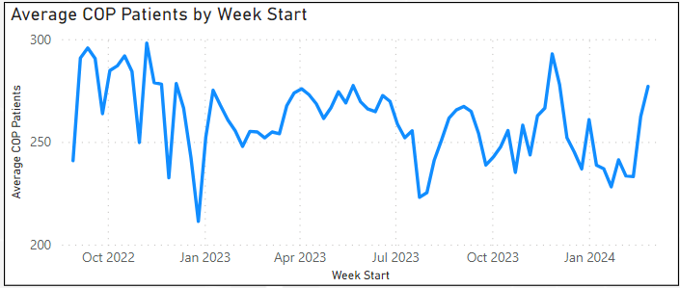
Health Board time line of events impactful on COP:
January 2023 – AMSR reconfiguration commences/ SAFER roll out/ Anglesey COP ward opened.
March – Signal V3 roll out
July – Decommissioning of step-down beds.
September – Piloting of the Integrated Discharge Hub (IDH) at the front door for one month. Realignment of Singleton based Social Workers to Morriston site. Reduction of Gorseinon Bed base (39 to 30).
October – Continuous Flow launched. Major care home provider had to close and consequently 70 residents had to be relocated across the Swansea Bay area
November - Patient Assessment Team launched (Front door IDH)
December – Gorseinon/ Bonymaen and Stepdown Beds recommissioned. MH stepdown and dedicated residential care facility opened in the region. Historical COP review meetings suspended and transformation pilot of daily deep dives and open-door surgeries started.
January 2024 – Singleton Surge (COP) opens. Junior Drs. Industrial action.
February – Singleton Surge beds planned graduated reduction in bed base with aim to close during March. Jr Drs. Industrial action. Discharge liaison nurse provision reduced to 1.6wte from 3.9 wte.
March to date – Emerging IPC issues halted closure of COP beds in Singelton and increasing capacity to enable a decant ward facility in Morriston to support environmental cleaning of affected areas.

- Additional actions to address the COPs

In addition to the initiatives and actions described and implemented in the previous papers, the Health Board continues to work with partners in local authority to address the top themes for delays in progressing discharge. The commitment from both Local Authorities has been welcome as we have changed COP scrutiny frequency from weekly to Daily in Morriston Service Group which has required a daily commitment to support a check and challenge approach to discharge planning. This is a model based on an integrated approach and would become a component of the Health Board’s vision for an Integrated Discharge hub.

Within the processes across the Health Board Service Groups patients are allocated a discharge pathway as defined by the national framework known as Discharge to recover then Assess (D2RA). However, due to the constraint of community capacity resources and patient complexity many of the COP population are not able to get home or back to their care setting to recover and then be assessed, with most assessments happening whilst in hospital before recovery. The action to overcome the pathways of care delays (PoCD) is overseen by the PoCD group and reported to Welsh government as a ministerial priority. These data submissions are monitored by the Care Access Committee, Chaired by the Minister for Health and Social Care.

The outputs of monthly census can be seen below and taken from the census returns. The priorities for improvement are highlighted in the PoCD action plan and are co-owned by this region.

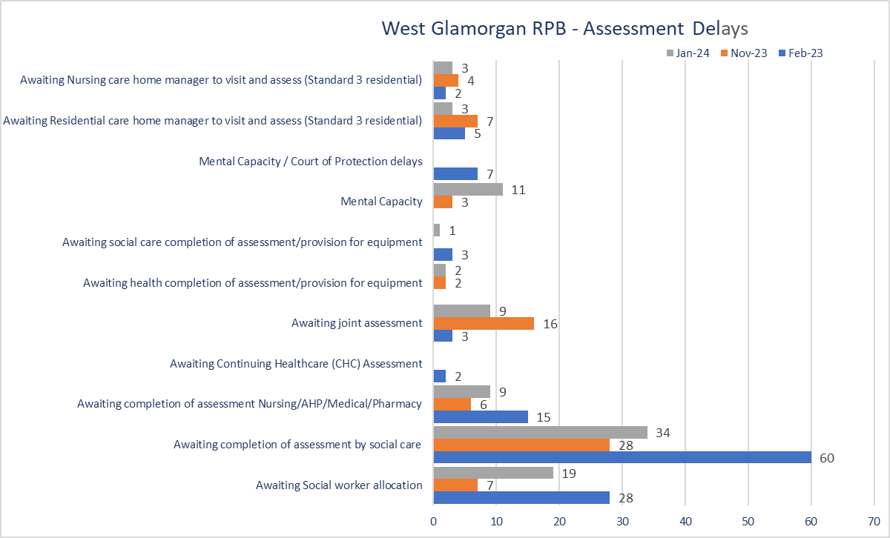
Source: Census outputs reported by National Executive

The Heat map below is what the national executive expects to see improvement on in order to support a reduction in COP set against the national parameters.

SBUHB continues to take the actions to improve the COP position, targeting a reduction in the total number of COPs across the Health Board. However, the ability to exercise D2RA in its truest sense is proving a significant challenge. The schemes aligned to the national 6 Goals programme which have the greatest impact on patient flow and experience have been noted in preview papers but for reference are listed below in brief.

- SAFER (including productive Board rounding)
- D2RA
- Pathways of care Delays – ministerial priority
- Preventing deconditioning

4.0 Recommendation

Members are asked to:
- NOTE the report and the ongoing actions to address the COPs within Swansea Bay in partnership with Local Authority.

Governance and Assurance

Link to Enabling Objectives  (please choose) | Supporting better health and wellbeing by actively promoting and empowering people to live well in resilient communities
Link to Enabling Objectives  (please choose) | Partnerships for Improving Health and Wellbeing |  | ☒
Link to Enabling Objectives  (please choose) | Co-Production and Health Literacy |  | ☐
Link to Enabling Objectives  (please choose) | Digitally Enabled Health and Wellbeing |  | ☐
Link to Enabling Objectives  (please choose) | Deliver better care through excellent health and care services achieving the outcomes that matter most to people
Link to Enabling Objectives  (please choose) | Best Value Outcomes and High Quality Care |  | ☒
Link to Enabling Objectives  (please choose) | Partnerships for Care |  | ☒
Link to Enabling Objectives  (please choose) | Excellent Staff |  | ☐
Link to Enabling Objectives  (please choose) | Digitally Enabled Care |  | ☐
Link to Enabling Objectives  (please choose) | Outstanding Research, Innovation, Education and Learning |  | ☐
Health and Care Standards
(please choose) | Staying Healthy |  | ☒
(please choose) | Safe Care |  | ☒
(please choose) | Effective Care |  | ☒
(please choose) | Dignified Care |  | ☒
(please choose) | Timely Care |  | ☒
(please choose) | Individual Care |  | ☒
(please choose) | Staff and Resources |  | ☒
Quality, Safety and Patient Experience
Extended hospital stays due to lack of capacity in out of hospital pathways have cumulative detrimental effect on patients, particularly those who are old and frail. The Health Board in partnership with the RPB are looking to avoid patients needing hospital admission via admission avoidance initiatives and supporting patients to go home, recover, rehabilitate, reable then assess long term need.

Financial Implications
None specific to this paper.

Legal Implications (including equality and diversity assessment)
No implications to note.

Staffing Implications
None specific to this paper.

Long Term Implications (including the impact of the Well-being of Future Generations (Wales) Act 2015)
Briefly identify how the paper will have an impact of the “The Well-being of Future Generations (Wales) Act 2015, 5 ways of working.
- Long Term – Earlier interventions such as virtual wards and enhanced frailty services will deliver longer term benefits with less patients requiring care packages or requiring less intense packages of care
- Prevention – Early interventions will have preventative benefits both for patients (improved health and functionality) and for healthcare providers (reduced resource requirements in the future)
- Integration – The interventions are based on multidisciplinary approach and integrated care pathways
- Collaboration – Close partnership working with Local Authorities and other care providers
- Involvement – Patient and family involvement are firmly at the centre of these pathways

Report History |  | This is an update on the previous report submitted December 2023
Appendices |  | None.

