Swansea Bay University Health Board

Patient Experience
&
Concerns Report
Quarter 3 2023/24

CONTENTS

Report Summary | Page 2
Complaints | Page 4
Complaint Themes | Page 7
Highlight Areas | Page 12
Morriston Service Group | Page 28
Neath Port Talbot Singleton Service Group | Page 33
Mental Health & Learning Disabilities Service Group | Page 38
Primary and Community Service Group | Page 43
Medical Examiners Compliments | Page 48
Ombudsman Cases & Learning | Page 49
Report Summary and Overview
COMPLAINTS | Oct | Nov | Dec
Total number of complaints received | 219 | 225 | 139
Complaints acknowledged within set timescale | 100% | 100% | 100%
Number of re-opened complaints | 10 | 10 | 9
 | Oct | Nov | Dec
Complaints responded to within agreed timescale - formal | 74% | 55% | 69%
OMBUDSMAN | Oct | Nov | Dec
Number of Ombudsman Investigations received | 1 | 1 | 0
Number of actions outstanding (within timescale) | 8 | 2 | 2
Number of actions overdue | 1 | 1 | 0
PATIENT EXPERIENCE | Oct | Nov | Dec
No. of Friends & Family surveys received | 4,879 | 5,044 | 3,985
Recommendation score | 92% | 92% | 92%
New Bespoke Surveys | 4 | 0 | 0
NATIONAL REPORTABLE INCIDENTS | Oct | Nov | Dec
Number of National Reportable Incidents reported | 5 | 8 | 7
Number of Never Events | 2 | 2 | 1

Successes | Priorities
- The overall satisfaction score for this quarter is 92%  - National digital stories, quality toolkit was launched last month and shared in this report. Harriett Stone who is head of the business change network for Digital Health Care Wales is in early discussions to deliver the digital storytelling training for NHS staff across Wales. This will be working with Prue Thimbleby and South Wales University to agree the accredited course.  - The NHS Executive have also released Childrens and Young Peoples guide for recording stories Appendix will sit with the National Toolkit.  - Once for Wales have extended the Civica Feedback system across Wales until 2027.  - Primary care SALT areas are now set up and SMS mapping is complete. We are now working with Primary care to agree next area to map across from PIMS. | - There is now a National reporting matrix for Patient experience, which all health boards report back to NHS executives and our local performance departments.  - Primary care SALT areas are now set up and SMS mapping is complete.  - We are now working with Primary care to agree next area to map across from PIMS to incorporate SMS.  - Working with the Service Groups and meeting regularly to discuss their longest open complaints to improve the overall performance
Opportunities | Risks & Threats
- We have set up monthly meetings with PALS teams across the organisation. It is an informal meeting, to discuss the alerts, and concerning issues raised by the feedback.  - We have also reinstated the ‘You said - we did’ template to service groups. The aim is to strengthen the actions taken as a result of the feedback  - SBU working with C&V, Betsi health boards and WHSSC to implement feedback for patients who use the Nuclear Medicine PET CT service.  - Once for Wales workshop held to develop a toolkit for managing complex complaints. | - We have seen an increase in the F&F paper cards. These are required to be entered in the Civica system and can take time for staff to process.  - The Editorial Board member’s numbers have reduced since the Pandemic. Recruitment campaign for new members is required.  - The increase in challenging complainants and complex complaints.

- COMPLAINTS

1. Complaints performance –
The Health Board is committed to supporting patients, relatives, and carers in resolving their concerns. Our service is visible, accessible, and impartial, with every issue taken seriously. Our aim is to provide honest and open responses in a way that can be easily understood by the recipient.

1.1 Total complaints received

The Health Board received 583 complaints in quarter 3 (Q3) of 2023/24 (October, November, December). This compares with 614 complaints in quarter 2 (Q2) of 2023/24 (July, August, September). The totals include complaints received and managed via either formal, early resolution and any re-opened complaints. Graph 1 provides a long-term view of complaints received per month.
Graph 1: Total number of complaints per month

Graph 2: Formal v Early resolution complaints per month

Graph 2 (above) shows complaints dealt with via the Formal Putting Things Right (PTR) investigation process compared with those dealt with via the early resolution investigation process, over the same period. We continue to deal with a higher proportion of complaints via the formal process, this is due to the tight timescale of two working days for early resolution complaints. Any early resolution that is not resolved within two working days, converts to a formal following guidance issued by Welsh Government.
1.2 Complaint responses within agreed timescale
Whenever a complaint is managed through the formal PTR process, the Health Board is required to investigate the complaint and write to the complainant with our findings, within 30 working days. If this target is not achievable, it is essential that the complainant is kept up to date throughout and any delays are explained.

1.2.1 Formal Investigations
The Health Board’s target is to respond to at least 85% of formal complaints within the agreed timescale. Welsh Government also issue a target for all Health Board’s to achieve at least 75% each month.

Graph 3 shows the Health Board’s performance in responding to complaints since January 2023. The Health Board performance for December 2023 was 69%.

Graph 3: Percentage of formal complaints responded to within agreed timescale

1.2 Re-opened complaints
The Health Board aims to resolve all complaints within the first response however, there are times when the complainant remains dissatisfied or needs further clarification. If the complainant writes back to the Health Board expressing their dissatisfaction, the correspondence will be reviewed by the Corporate Complaints Team and a decision made as to whether the complaint should be re-opened. This may be when the complainant feels not all issues raised in the initial complaint have been addressed or if a meeting is required.

Graph 4 shows the number of re-opened complaints per month since October 2022.
Graph 4: Number of re-opened complaints by Service Group per month

Although Morriston appear to have had a significant increase in re-opened complaints, there is no specific service, these were spread over a number of services. General Surgery and Maxillofacial had 3 each.

2. Complaints Themes

2.1 – Themes - Health Board overview
Every complaint received by the Health Board is coded in the Datix Once for Wales system against the relevant subject codes. This allows the Health Board to identify any themes in the complaints received.

Table 1 provides a breakdown of complaints received by primary subject in Q3 2023/24 compared with Q2 for 2022/23.

Table 1: Complaints by primary subject
Subject/Theme | Q2 2023/24 | Q3 2023/24
Communication Issues | 98 | 107
Appointments | 79 | 74
Clinical treatment/Assessment | 118 | 110
Admissions | 45 | 53
Attitude and Behaviour | 30 | 43
Medication | 35 | 53
Test and Investigation Results | 26 | 23
Referral | 13 | 18
Discharge Issues | 20 | 26
Environment/Facilities | 9 | 15
Monitoring/Observation Issues | 22 | 14
Equipment | 5 | 7
Personal Property/Finance | 8 | 0
Assault | 2 | 0
Confidentiality | 2 | 8
Consent | 0 | 0
Record Keeping | 5 | 7
Access (to Services) | 6 | 3
Accident/Falls | 0 | 1
Catering | 0 | 0
Cleanliness | 2 | 4
Infection Control | 4 | 1
Nutrition/Hydration Issues | 2 | 5
Other | 1 | 0
Patient Care | 4 | 5
Resources | 2 | 2
Skin Damage | 3 | 0
Privacy and Dignity | 1 | 2

Top theme; Communication;
During Q3, 153 complaints were received regarding communication. A breakdown of the sub-subjects are below – please note, some complaints include more than one of these issues.
Communication Improvement Plan;
- New training dates to be arranged with Ombudsman trainer commencing April 2024
- Training prospectus advertised on intranet for all Health Board staff to book on
- Training during consultant development programme where the importance of good and clear communication is discussed.
- Complaints/communication training sessions delivered by the Corporate team to Service Groups – this training is ongoing

Outpatient Department. Patient Experience feedback for Quarter 3. The overall score was 94%. Out of the 553 comments, 537 were positive, and 16 were negative. The wordle below highlights mainly positive comments on communication.
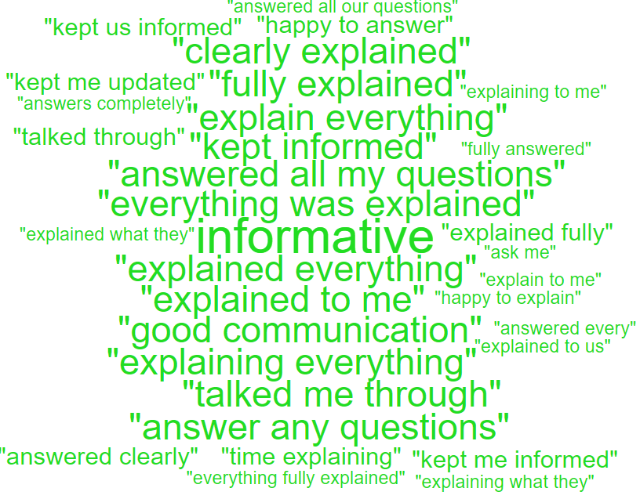
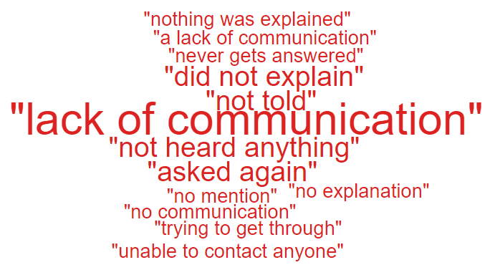

Communication;
Insufficient/Incorrect information | 135
Communication with family | 10
Communication with patient/service user | 6
Communication with External Agencies or Other NHS Organisations | 3
Communication between Services/Departments | 2

Theme 2; Clinical Treatment;
What we are doing about this?
- Outsourcing of patients to other Healthcare providers to help reduce waiting times.
- OCP theatres opened in NPT to reduce waiting times.
- Continuous Flow Model to help reduce delays and improve patient and staff experience.

- Patients waiting/delays comments for Emergency Department.
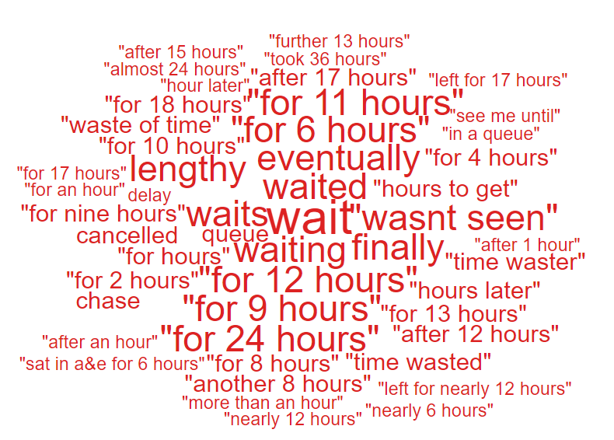
- ‘Waiting’.
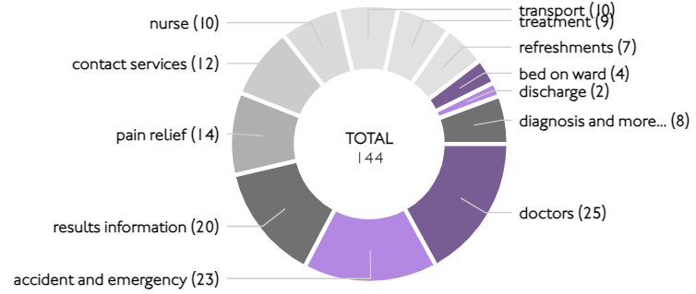

During Q3, 150 complaints were received relating to clinical treatment. A breakdown of the clinical treatment sub-subjects are below – please note, some complaints include more than one of these issues.
Clinical Treatment;
Delay/Lack of treatment or Assessment | 98
Reaction to procedure/ treatment | 21
Delay/Lack of diagnosis | 14
Incorrect diagnosis | 11

Theme 3; Appointments;
What we are doing about this?
- Outsourcing of patients to other Healthcare providers to help reduce waiting times.
- Rapid Diagnostic Centre expansion.
- Expansion of our virtual wards to widen the range of disciplines involved, so increasing the number of patients who can be treated appropriately out of hospital

All Wales questions do not have ‘appointments’ as a question set. Therefore, we searched the words delay/delays/appointment for the areas mentioned.
Here are some comments we found relating to ‘appointments’ for these areas:
- Being kept up to date with delays would be helpful
- Wait time was too long, was seen an hour after my appointment time
- Friendly staff, efficient, no delays, excellent consultant.

- Very punctual, staff very friendly.

- Friendly and polite. Even though I had arrived early, I was seen straight away.

- No waiting, got there early as worried about parking, was seen straight away for eye test and straight away by doctors. Home before actual appointment.

- It was difficult getting an appointment, but I got one eventually.

During Q3, 93 complaints were received regarding appointment issues. Many of these complaints will have more than one sub-subject, see breakdown below;
Appointments;
Delay in appointment/waiting time/transport | 51
Appointment cancelled | 25
Patient lost to follow-up | 12
Cancelled appointment/transport | 3
Location of appointment unsuitable | 3
Continuity of staff | 2

- HIGHLIGHT AREAS

As part of the Health Board’s focus on Urgent Care, Planned Care and Cancer Services the following section highlights complaints received in:
- Orthopaedics
- A & E
- General Surgery
- Cancer Services
Graph 1 below shows the number of complaints for each of these areas received per month since July 2022.
Graph 1: Complaints per month
As Orthopaedics has the highest number of complaints, a breakdown of the issues raised can be found below compared with Q2. It is envisaged with the new OCP changes Orthopaedic waiting time complaints will reduce. As you can see from the graph, there was a decrease in December compared to November.

3.1 – Orthopaedic Complaint themes
Orthopaedics Themes | Q2 2023/24 | Q3 2023/24
Admissions | 17 | 21
Communication Issues | 6 | 9
Clinical treatment/Assessment | 9 | 12
Appointments | 12 | 9
Attitude and Behaviour | 2 | 1
Referral | 2 | 4
Accident/Falls | 0 | 0
Medication | 1 | 1
Nutrition/Hydration Issues | 0 | 0
Discharge | 2 | 4
Infection Control | 0 | 0
Patient Care | 0 | 0
Post Death Issues | 0 | 0
Test and Investigation Results | 1 | 1
Personal Property/Finance | 1 | 0
Record Keeping | 1 | 0

Patient Experience Feedback: Orthopaedic Services
As Orthopaedics is classed as a ‘High Risk Area’, the Patient Experience Team have investigated the feedback for Orthopaedic Services. In total, Orthopaedic Services received 315 responses to the Friends and Family Survey during Quarter 3.

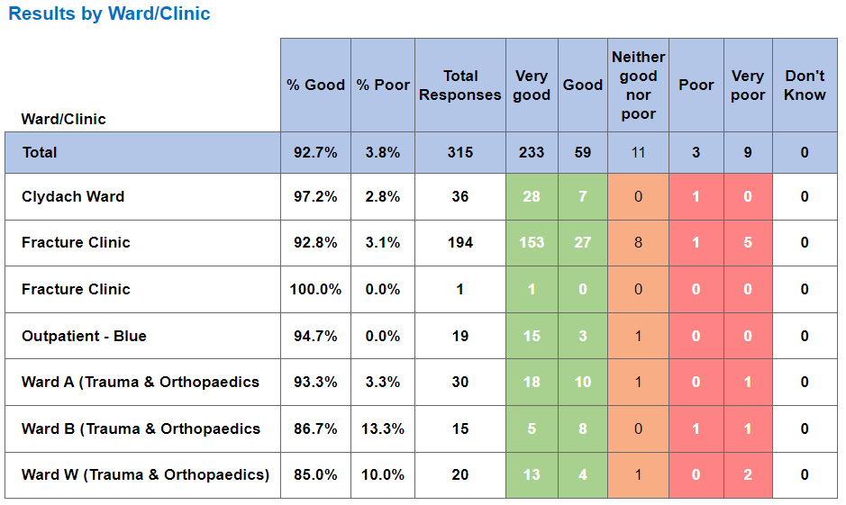

Below are the top themes for Orthopaedic services:
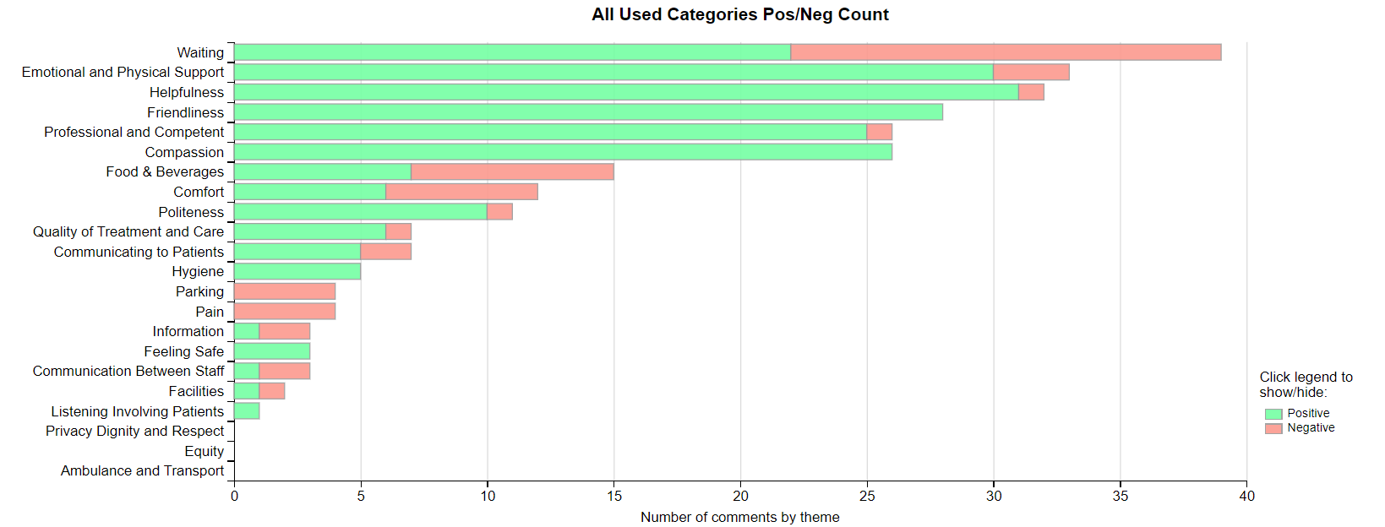

NB: We have been informed that the word ‘Pain’ and ‘Waiting’, is oversensitive and the wordles, charts are taking any word with Pain and ‘Wait/Waiting’ as a negative. Civica are aware and are rectifying. This is across Wales.

Positive Themes
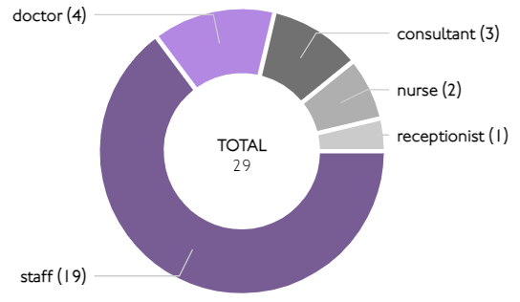
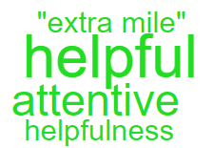
‘Helpfulness’

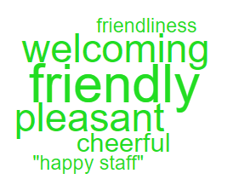
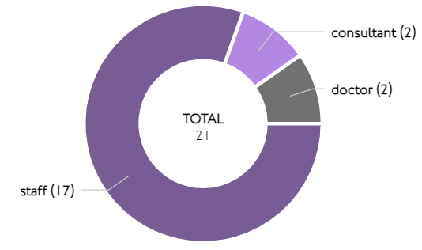
‘Friendliness’

Here are some of the positive comments we’d like to share:
- Your staff a fantastic people & very professional in every way & my utmost credit to them

- Very quick turnaround with absolutely minimal wait times throughout. Exceptionally helpful staff end to end.

- Care and consideration by all staff nursing and auxiliary staff . Ward very clean and tidy.

- Staff are so friendly at Fracture clinic in Morriston hospital and very efficient! Thank you for being so helpful.

- All medical and support staff were professional and friendly. Nothing was too much trouble. Nothing but admiration and thanks for my treatment, and care.

- The friendliness and expertise of the staff. The current system seems very streamlined and patient friendly.

- Everything was on time, seen really quickly and great level of care. Staff were great.

- Very efficient and first-class attention at the Morriston fracture clinic. Seen doctor 3 times, x-rayed twice and bones set and plastered within 2 1/2 hours. Nothing short of a miracle.

- All the staff were lovely and polite whilst doing their jobs.

- Yes, the love, attention and professional care shown by the Spinal team, ward nurses and social care assistants were excellent. I am so very grateful.

Negative Themes

The chart above highlights a few areas relating negative feedback. Here is an in-depth breakdown of these areas.
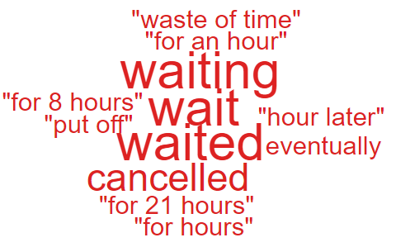
‘Waiting’

These are the comments highlighted in the above ‘Wordle’.

very long wait at A&E and assessment ward. the staff are great and never stop. the checks e.g. blood and bp are spaced out. I feel they can be done in one go. the food isn’t great.

waiting time but the amount of people there you expect to wait

was rather a long wait for my appointment but that was ok. I completely understood how slots can over run.

  - – A&E Complaints
During Q3 of 2023/24, A&E received 31 complaints, a breakdown of the issues is below;

The 8 ‘clinical treatment/assessment’ complaints all relate to delays in treatment or assessment.
Patient Experience Feedback: A&E Services
As A&E is classed as a ‘High Risk Area’, the Patient Experience Team have investigated the feedback for A&E Services. In total, A&E Services received 957 responses to the Friends and Family Survey during Quarter 3.

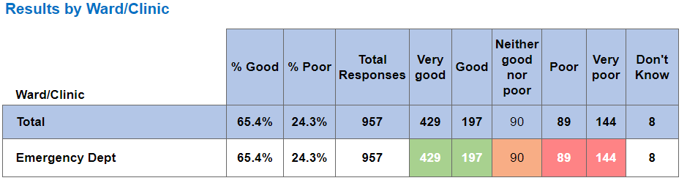

Below are the top themes for A&E services:
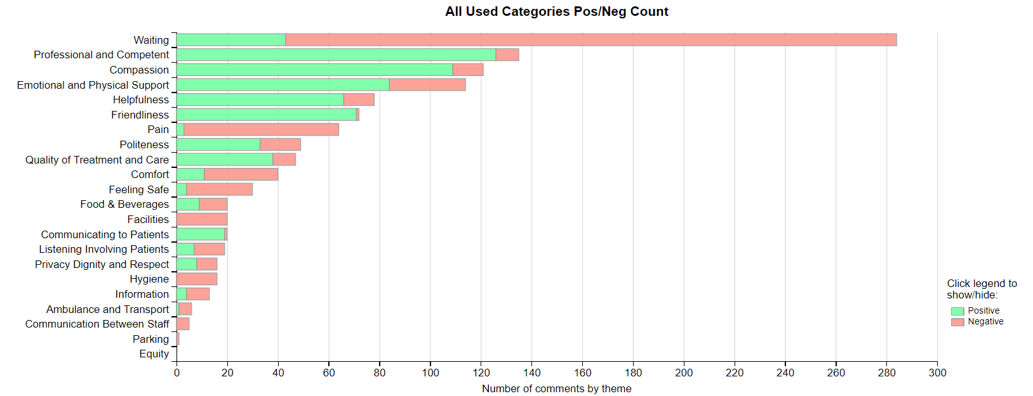

Positive Themes
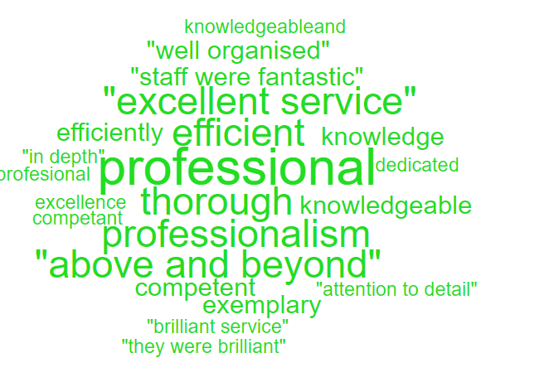
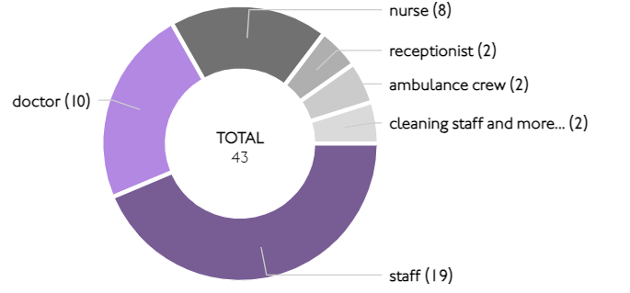
‘Professional & Competent’

‘Compassion’
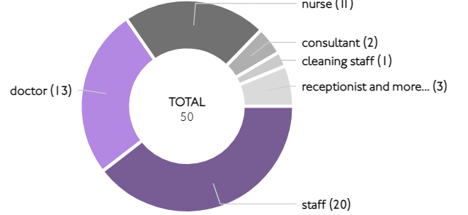
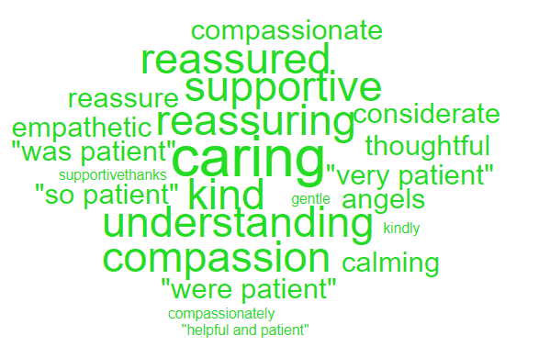

Here are some of the positive comments we’d like to share:
- I was looked after very well by everybody.

- The staff were a credit to their profession. Their training and care were fantastic.
- The staff were amazing and thoughtful from start to finish, and professional in their work.
- I had a brilliant service from the receptionist to the consultants. I think tea/ coffee and water, biscuits etc, was a brilliant thought especially for those who had been there for hours. Thank you for this. All staff treated me with respect and care I was so impressed.
- Despite being very busy each member of staff who interacted with me was patient, kind and gave me clear information. I expected the visit to take some hours (which it did 4 approximately) but went prepared for this and was happy to be treated effectively and efficiently given the context.
- Excellent junior doctor and team.
- Polite and explained everything clearly

Negative Themes

‘Waiting’ ‘Pain’
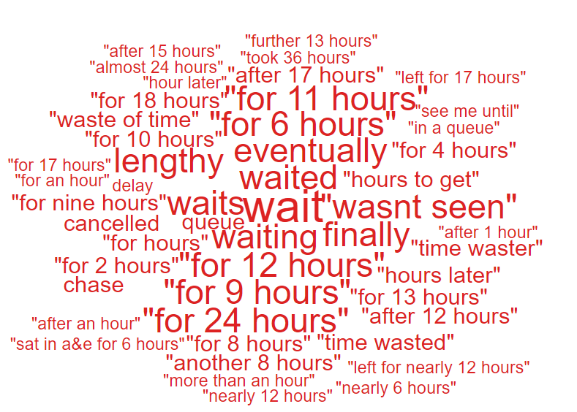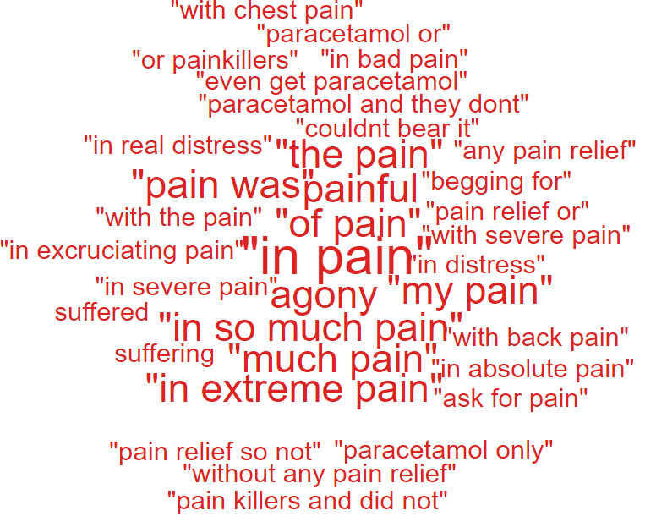

NB: We have been informed that the word ‘Pain’ and ‘Waiting’, is oversensitive and the wordles, charts are taking any word with Pain and ‘Wait/Waiting’ as a negative. Civica are aware and are rectifying. This is across Wales.

Here are the negative comments relating to A&E:
- 24hrs in A&E .Words fail me.
- I was there for 9 hours. I saw the doctors 4 times all together at 1 min intervals each. So, for the 9 hours I was there 4 minutes only mattered. The results from seeing the doctor were received straight away so no need for that long of a wait.
- The people who have heart problems should be seen immediately as I have chest pain and heart palpitations over 200 per min and I could die.

- So quick to be seen as my pain was and still is immense. Thank the nurse very much.

- The seating in the inner waiting room in A&E is extremely uncomfortable. I have 4 collapsed discs and it was very painful.

  - – General Surgery Complaints
During Q3 of 2023/24, General Surgery received 24 complaints, a breakdown of the issues is below;

Patient Experience Feedback: General Surgery
As General Surgery is classed as a ‘High Risk Area’, the Patient Experience Team have investigated the feedback for General Surgery Services. In total, General Surgery Services received 1,195 responses to the Friends and Family Survey during Quarter 3.
Below are the top themes for General Surgery services:
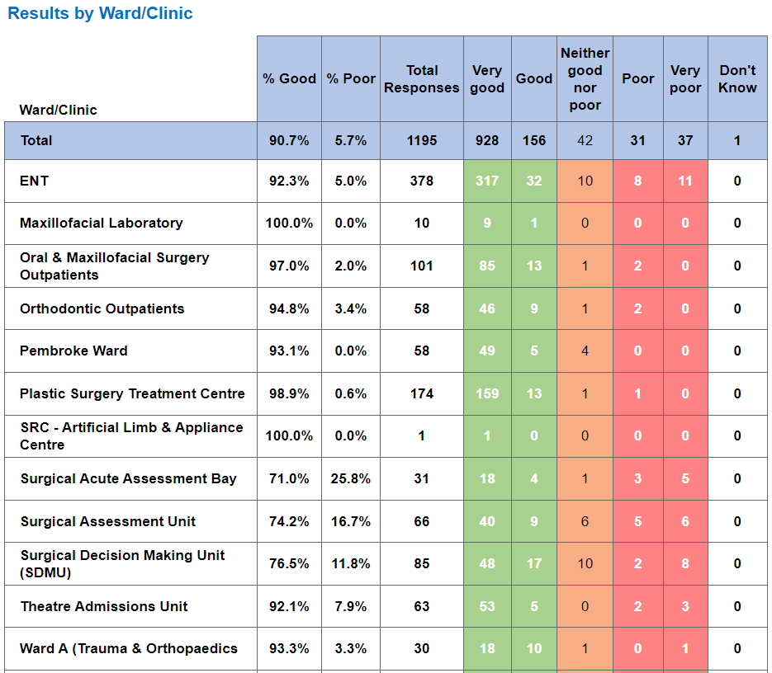
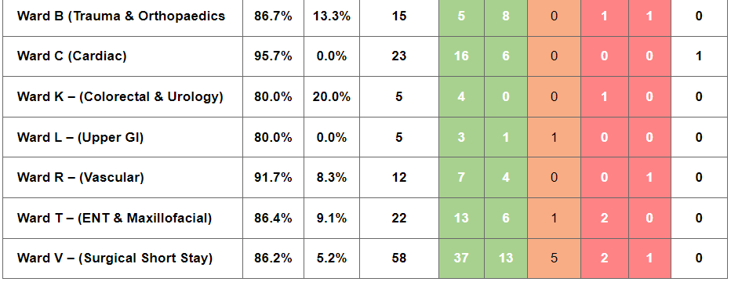
Positive Themes
‘Friendliness’
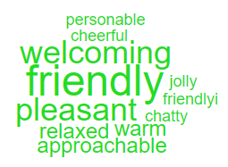
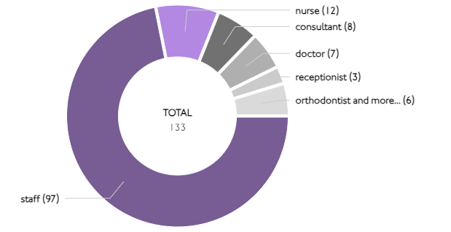

‘Helpfulness’
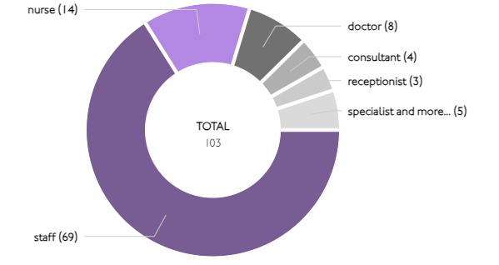
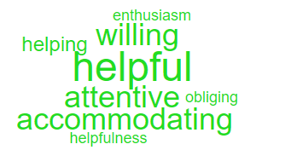

Here are some of the positive comments we’d like to share:
- We were given water when we entered the unit. People were friendly and we were given advice after the scans were reviewed.
- Patient care from the night staff post op was excellent. They really cared about my pain level and aimed to reduce any pain. Surgeon gave clear information about my op and explained how the op went after.
- The staff were very helpful and understanding.

- Clear instructions and answers from staff. Everyone was very helpful and pleasant.

- Excellent consultant , who put me at my ease and explained my treatment thoroughly .I couldn’t be in better hands

Negative Themes
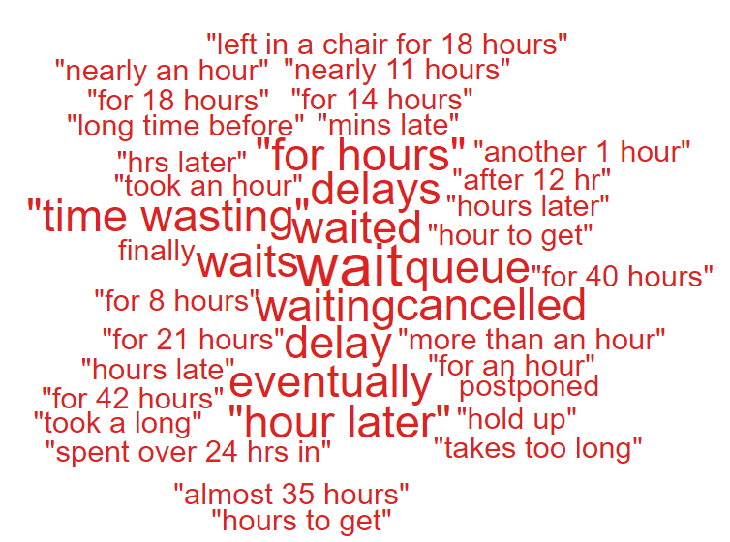
‘Waiting’
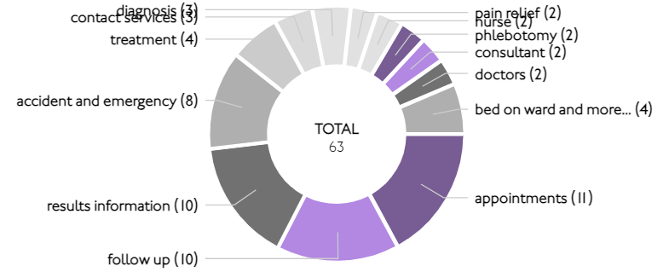

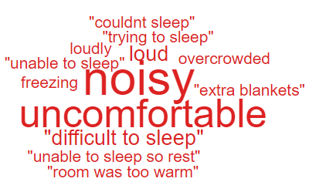
‘Comfort’
chairs were so uncomfortable while waiting.
I was in considerable pain and the seats were so uncomfortable, so it just got unbearable.
it was very useful that there was a student doctor, and that the consultant surgeon was explaining the whole procedure out loud!!

Below are some Negative comments relating to General Surgery:

- Better chair to sit
- More parking. It took 35 mins to get a space. Couldn’t find reception. Waited well over an hour after my apt time to see my consultant. Toilets absolutely reeked of sewage.

- Had to wait 3 days in waiting room to see a neurologist even though staff kept paging him to come and when he did was so rude and seemed annoyed, he had been called.
- Yes, I'd have liked to have seen the doctor I'd been waiting 5 years to see and was very disappointed when I was told I'd have to wait a further 2 years on yet another waiting list.

  - – Cancer Services Complaints
As cancer waiting times are currently a concern for the health board, a breakdown of the 12 complaints received in Q2 is below.

Patient Experience Feedback: Cancer Services
As Cancer is classed as a ‘High Risk Area’, the Patient Experience Team have investigated the feedback for Cancer Services. In total, Cancer Services received 686 responses to the Friends and Family Survey during Quarter 3.
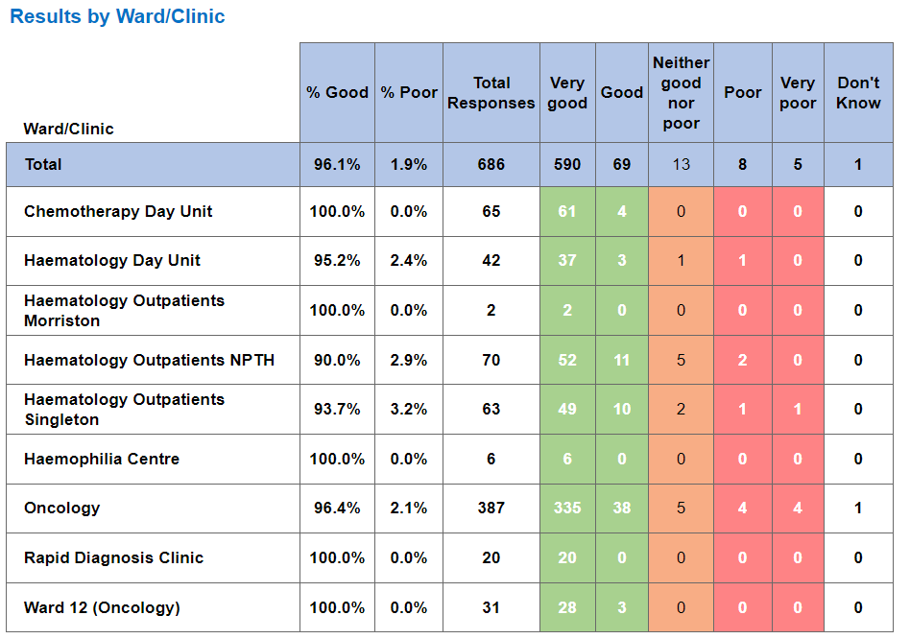
Below are the top themes for Cancer services:
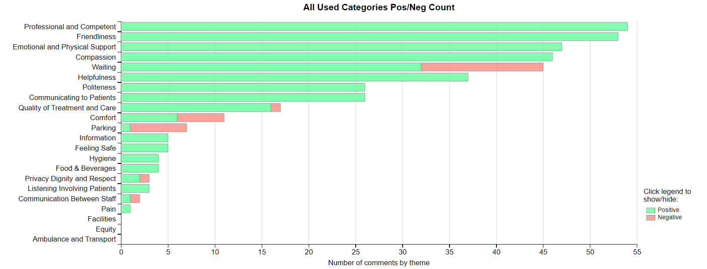
NB: We have been informed that the word ‘Pain’ and ‘Waiting’, is oversensitive and the wordles, charts are taking any word with Pain and ‘Wait/Waiting’ as a negative. Civica are aware and are rectifying. This is across Wales.

Postive Themes
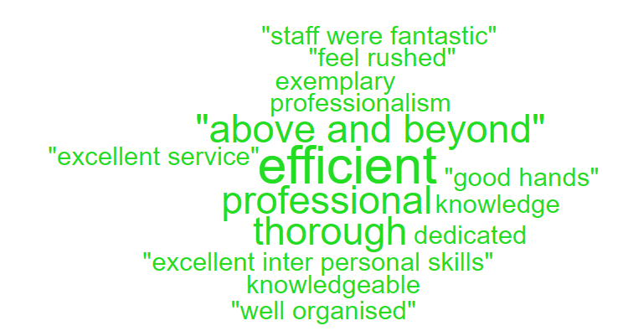
‘Professional & Competent’
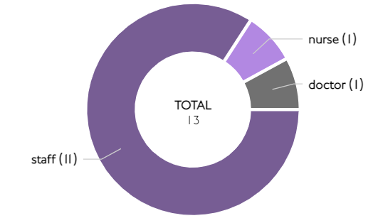

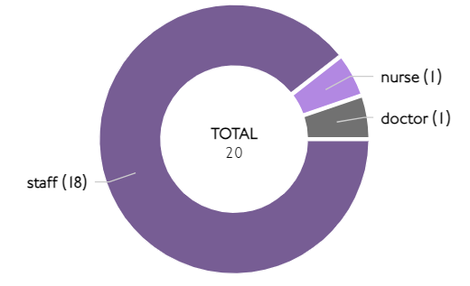
‘Friendliness’
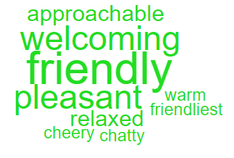

Here are some of the positive comments we’d like to share:
- Continuity of nursing staff, my fourth cycle and nice to be treated by familiar faces
- NHS staff were amazing. Explained things clearly and made me feel at ease.
- Staff were very attentive and put me at ease. A smiling face does wonders. Can’t praise them enough.
- Staff were very efficient kind courteous, and they made sure you understood everyone that they had to deal and why. They also did their best to make time for you

- From the nurses to the doctors, they were absolutely brilliant they treated me so well the care was outstanding the chap that did my scan was amazing. They were so caring lovely and so friendly they couldn’t do enough for me all were fantastic thank you so much.
Negative Themes
Looking at the chart above it highlights comments specifically related to ‘waiting’ negative feedback. Here are some examples of the comments written to give context.
‘Waiting’
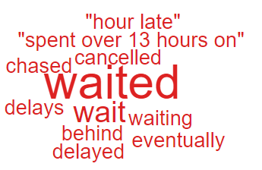

information flow within one ward! I’ve spent over 13 hours on ward waiting for a drain which supposed to be done in the morning and hasn’t happened till late afternoon.
sometimes the wait for a chair is a long but that can’t be helped as all of us are there for the same reason treatment.
my treatment was delayed coming to the ward - waited over a hour for it to come. blood bank were responsible worried I will now get a parking fine

- SERVICE GROUP COMPLAINTS, INCIDENTS, COMPLIMENTS AND PATIENT FEEDBACK HIGHLIGHTS

MORRISTON SERVICE GROUP
4.1 – Morriston Service Group complaints
Morriston Service Group received a total of 220 complaints during Q3 2023/24. Graph 1 below shows the total number of complaints received relating to Morriston Service Group since January 2023. The graph breaks the total number received down by Formal PTR, Early Resolution and Re-opened complaints.
Graph 1: Morriston Service Group complaints by month and type

Graph 2 shows the top five services that had the most complaints since January 2023. As seen in the graph, Orthopaedics received the highest number of complaints but significantly decreases since November. This is due to the change in services and Orthopaedics now being managed by Singleton.

Graph 2: Top 5 Services by month

4.2 – Morriston Service Group Incidents
Morriston Service Group reported 2364 incidents in quarter 3 (Q3) of 2023/24 (October, November, December). This compares with 2717 incidents in quarter 2 (Q2) of 2023/24 (July, August, September). Graph 1 shows the number of incidents per month broken down by severity.
Graph 1: Morriston Incidents by Severity and month

Graph 2 shows the top 5 incident types, of all incidents reported by Morriston Service Group since October – December 2023. As you can see from the graph, the number of ‘access to services’ incidents have decreased significantly since October, this is also likely to be due to the service change within Orthopaedics.

Graph 2: Top 5 incidents per month

4.3 – Morriston Service Group National Reportable Incidents
Morriston Service Group reported 8 Nationally Reportable Incidents (NRI’s) during Q3 2023/24, this compared to 8 also being reported during Q2 of 2023/24. Of the NRI’s reported, 1 x unexpected death, 1 x failure to notice deterioration, 1 x communication issues, 1 x self-injurious behaviour, 4 x treatment/procedure issues. Graph 1 shows the number of NRI’s reported per month.
Graph 1: Nationally Reportable Incidents reported per month by Morriston Service Group

4.4 – Morriston Service Group Compliments
Morriston received 207 compliments during Q3 of 2023/24. Graph 1 shows the number received per month since January 2023.

Graph 1: Morriston compliments per month

Graph 2: Morriston compliments – Top 5 Services

4.5 Morriston Service Group Patient Experience Feedback
Overall, during quarter three there were 106’360 number of patients seen under Morriston Service Group (This includes ED).

There were 6,289 Friends and Family survey returns which equates to 6% responding to the survey. Out of the 6% who responded, 89% of people stated they would highly recommend the Health Board to Friends and Family.

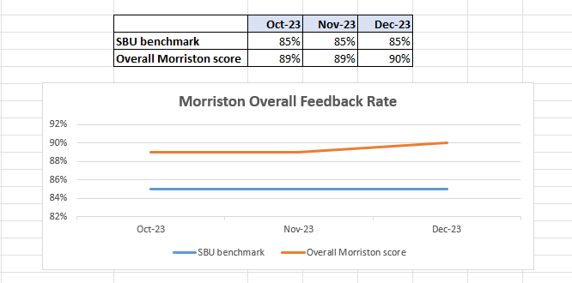

Below are the number of responses in a line graph:

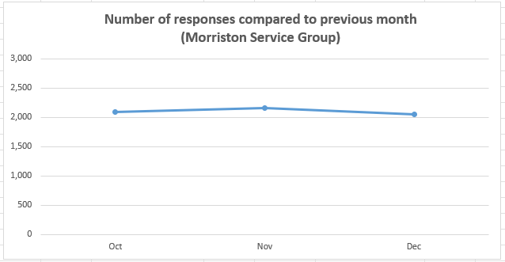

Below are the main themes mentioned for Morriston:
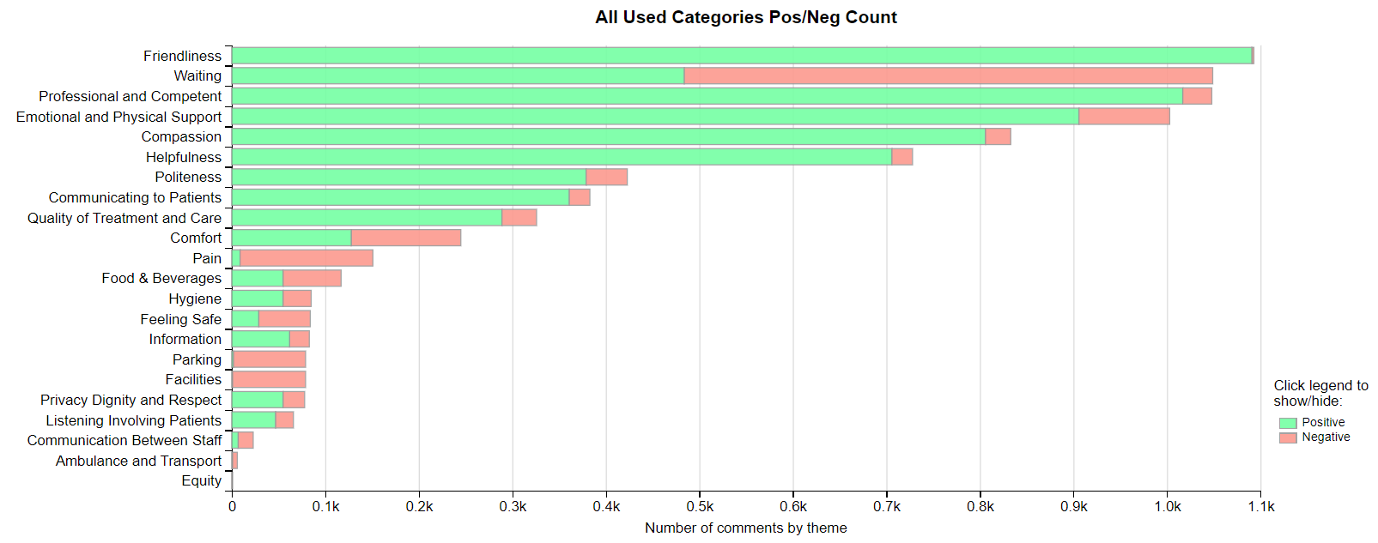
NEATH PORT TALBOT SINGLETON SERVICE GROUP
4.6 – NPTSSG Complaints
NPTSSG received a total of 153 complaints during Q3 2023/24. Graph 1 below shows the total number of complaints received relating to NPTSSG since January 2023. The graph breaks the total number received down by Formal PTR, Early Resolution and Re-opened complaints.
Graph 1: NPTSSG complaints by month and type

Graph 2 shows the top five services that had the most complaints since January 2023.

Graph 2: Top 5 Services by month

Although Gynaecology appear to receive the highest amount of complaints, they have significantly decreased in Q3 compared with Q2.
4.7 – NPTSSG Incidents
NPTSSG reported 1270 incidents in quarter 3 (Q3) of 2023/24 (October, November, December). This compares with 1240 incidents in quarter 2 (Q2) of 2023/24 (July, August, September). Graph 1 shows the number of incidents per month broken down by severity.
Graph 1: NPTSSG Incidents by Severity and month

Graph 2 shows the top 5 incident types, of all incidents reported by NPTSSG since October – December 2023.

Graph 2: Top 5 incidents per month

4.8 – NPTSSG National Reportable Incidents
NPTSSG reported 7 Nationally Reportable Incidents (NRI’s) during Q3 2023/24, this compares to 4 being reported during Q2 of 2022/23. Of the NRI’s reported 2 related to falls, 2 x stillbirths, 1 x maternal adverse occurrence, 1 x patient not consented and 1 x Never Event – missing swab. Graph 1 shows the number of NRI’s reported per month.
Graph 1: Nationally Reportable Incidents reported per month by NPTSSG

4.9 – NPTSSG Compliments
NPTSSG received 118 compliments during Q2 of 2023/24. Graph 1 shows the number received per month since October 2022.
Graph 1: NPTSSG compliments per month

Graph 2: NPTSSG compliments – Top 3 Services

4.10 NPTSSG Patient Experience Feedback
Overall, during quarter three there were 91,198 number of patients seen under Neath Port Talbot and Singleton Service Group (This includes Minor Injuries Unit).
There were 5’892 Friends and Family survey returns which equates to 6% responding to the survey. Out of the 6% who responded, 95% of people stated they would highly recommend the Health Board to Friends and Family during this quarter.

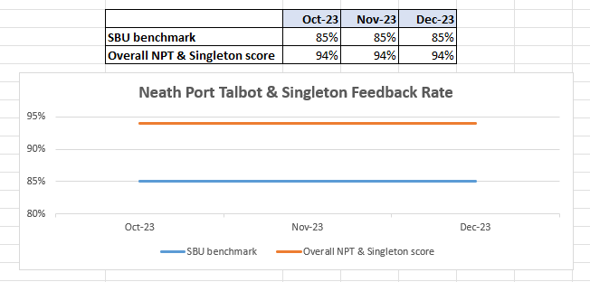

Below are the number of responses in a line graph:

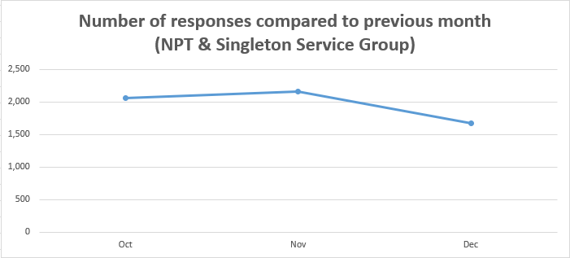

Below are the main themes mentioned for NPT & Singleton:
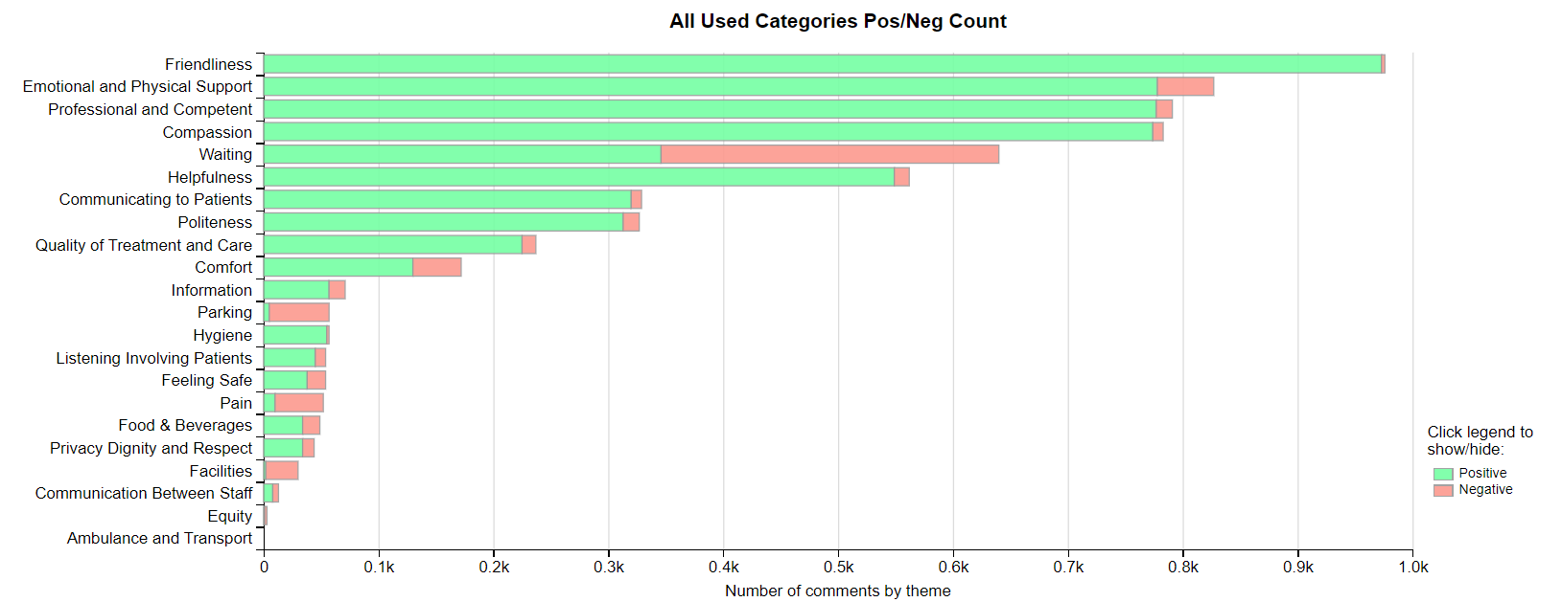
MENTAL HEALTH AND LEARNING DISABILITIES SERVICE GROUP
4.11 – MH&LD Complaints
MH&LD received a total of 60 complaints during Q3 2023/24. Graph 1 below shows the total number of complaints received relating to MH&LD since January 2023. The graph breaks the total number received down by Formal PTR, Early Resolution and Re-opened complaints.
Graph 1: MH&LD complaints by month and type

Graph 2 shows the top five areas within MH&LD that had the most complaints since October 2022. As shown in the graph, Central Clinic appear to have had an increase in complaints during September 2023.

Graph 2: Top 5 Services by month

4.12 – MH&LD Incidents
MH&LD reported 1192 incidents in quarter 3 (Q3) of 2023/24 (October, November, December). This compares with 1081 incidents in quarter 2 (Q2) of 2023/24 (July, August, September). Graph 1 shows the number of incidents per month broken down by severity.
Graph 1: MH&LD Incidents by Severity and month

Graph 2 shows the top 5 incident types, of all incidents reported by MH&LD since October – December 2023.

Graph 2: Top 5 incidents per month

4.13 – MH&LD National Reportable Incidents
MH&LD reported 2 NRI’s during Q3 of 2023/24, both of which were falls. This compares to 2 also being reported during Q2 of 2023/24.

4.14 – MH&LD Compliments
MH&LD received 5 compliments during Q3 of 2023/24. Graph 1 shows the number received per month since January 2023.

Graph 1: MH&LD compliments per month

4.15 MH&LD Patient Experience Feedback
This data is from Quarter 3.

The Mental Health and Learning Disabilities Service Group are using a different set of survey questions. The role out of the semi structured interview surveys have been managed in stages. Roll out, awareness posters and meetings with managers and teams continues.
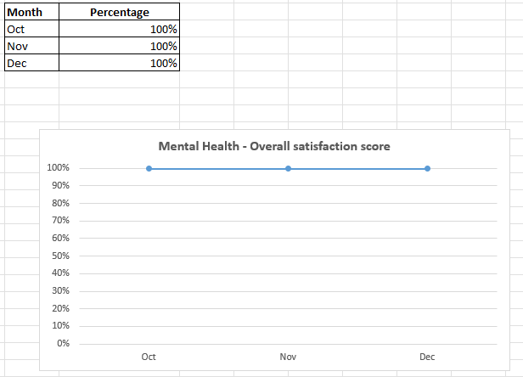
Below are the number of responses in a line graph:

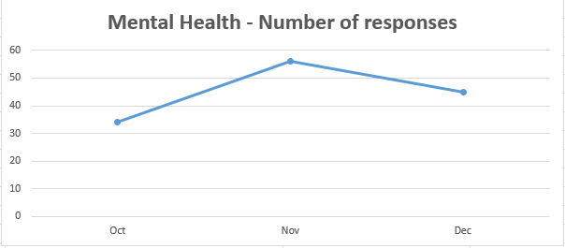

PRIMARY AND COMMUNITY SERVICE GROUP
4.16 – P&C Complaints
P&C received a total of 122 complaints during Q3 2023/24. Graph 1 below shows the total number of complaints received relating to P&C since January 2023. The graph breaks the total number received down by Formal PTR, Early Resolution and Re-opened complaints.
Graph 1: P&C complaints by month and type

The increase in formal complaints appears to be from HMP Prison Swansea. A system has been put in place whereby the prison staff send through all their complaints on a weekly basis.
Graph 2 shows the top five services that had the most complaints since January 2023. As seen in the graph, HMP Swansea appear to have received the most complaints which significantly decreased in September. Since October, they have again increased and are being received on a weekly basis.
Graph 2: Top 5 Services by month

4.17 – P&C Incidents
P&C reported 1154 incidents in quarter 3 (Q3) of 2023/24 (October, November, December). This compares with 872 incidents in quarter 2 (Q2) of 2023/24 (July, August, September). Graph 1 shows the number of incidents per month broken down by severity.
Graph 1: P&C Incidents by Severity and month

Graph 2 shows the top 5 incident types, of all incidents reported by P&C since October – December 2023.

Graph 2: Top 5 incidents per month

4.18 – P&C National Reportable Incidents
P&C reported 4 Nationally Reportable Incidents (NRI’s) during Q3 2023/24, this compares to 6 being reported during Q2 of 2023/24. The 4 NRI’s reported included 3 x unexpected deaths and 1 x pressure ulcer.
Graph 1: Nationally Reportable Incidents reported per month by P&C

4.19 – P&C Compliments
P&C received 43 compliments during Q3 of 2023/24. Graph 1 shows the number received per month since January 2023.

Graph 1: P&C compliments per month

Graph 2: P&C compliments – Top 5 Services

4.20 P&C Patient Experience Feedback
Overall, during this quarter there were 4,321 number of patients seen under Primary and Community Service Group.

There were 1,168 Friends and Family survey returns which equates to 27% responding to the survey. Out of the 27% who responded, 95% of people stated they would highly recommend the Health Board to Friends and Family during this quarter.

Patient Experience Team are currently working with I.T to automate SMS messages from the PIMS, PIMS+ platform to automate SMS survey messages to Primary Care and Therapies patients. This will increase the number of returns.

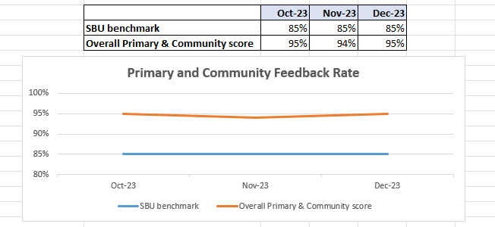
Below are the number of responses in a line graph:

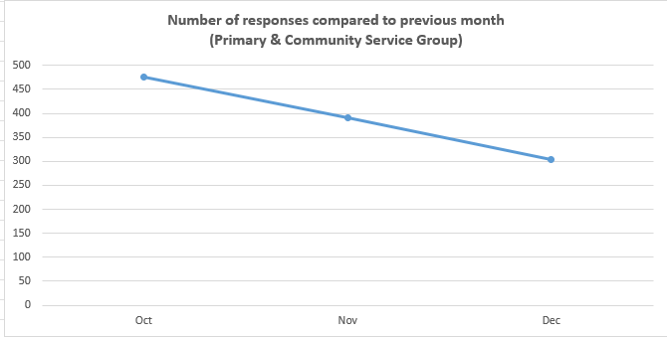

Below are the main themes mentioned for Primary & Community:
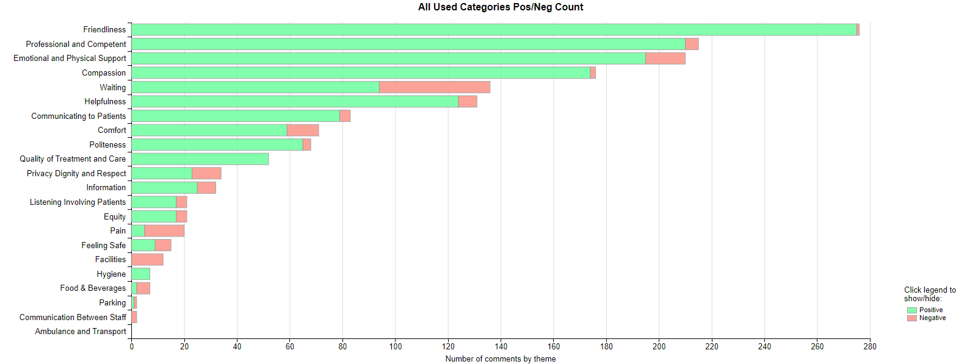

- MEDICAL EXAMINER COMPLIMENTS

5.1 ME Compliments
The Health Board has received a number of compliments from families through the Medical Examiner. This evidences the good work being done when treating these end of life patients. During Q3, approximately 108 compliments were received. A few examples are shown below;

The care from ED to the ward were amazing the doctors called her to keep her updated if she wasn't there, they were all fantastic. The communication was excellent
–Ward E, Morriston

Ward 12 were brilliant, she was very content with the care her husband received. She would like those compliments passed back to the Health Board. Ward 12, Singleton

- OMBUDSMAN CASES

6.1 Ombudsman investigations
Two new Ombudsman investigations were received during Q3 2023/24, this compares to none in Q2 2023/24. Graph 1 shows the number of investigations received per month;

Graph 1: Number of Ombudsman investigations per month

The Health Board has also received 23 decisions not to investigate from the Ombudsman during Q3. Graph 2 below shows these by month.

Graph 2: Ombudsman decisions not to investigate

There are a number of different reasons why the Ombudsman decided not to investigate these complaints, a few of these reasons are detailed below;

- Complainant advised to take legal route
- Complaint out of time
- Appropriate action already taken by Health Board
- Ombudsman not able to achieve outcome complainant is looking for

Ombudsman Wales Quarterly Newsletter - September - December 2023

The Health Board received a copy of the above and further details can be found via the following link;

Our Quarterly Newsletter – January 2024 (ombudsman.wales)

