

Meeting Date |  |  | Agenda Item |  | 3.1
Report Title | Deep Dive End of Life Care
Report Author | Sue Morgan, Senior Responsible Officer, End of Life Care  Emma Smith, Quality Improvement Information Manager
Report Sponsor | Hazel Powell, Deputy Director Nursing and Patient Experience
Presented by | Sue Morgan, Senior Responsible Officer, End of Life Care
Freedom of Information | Open
Purpose of the Report | To provide an update on the goals, methods and outcomes for the End of Life Care (EOLC) quality priority and how these will be transferred into business as usual.
Key Issues | - In 2023, Swansea Bay residents are less likely to die in hospital (49%) than residents in other part of Wales (51%) but are more likely to die in hospital than England (44%).  - Since End of Life Care has become a Quality Priority the following has been achieved:  - Education training programmes established; 25.4% of Health Board (HB) staff have been trained since January 2022.  - NACEL (National Audit of Care at the End of Life) audit 2022 showed improved results compared to 2021.  - Discussions and initial agreements by Digital to support Digital developments to support end of life care recording and sharing.  - Communications to engage the workforce and the public in understanding end of life care.
Specific Action Required  (please choose one only) | Information | Discussion | Assurance | Approval
Specific Action Required  (please choose one only) | ☐ | ☐ | ☒ | ☐
Recommendations | In order to progress EOLC Quality Priority work and embed it as business as usual, all Service Groups (SG) must engage with the improvement projects and ensure clinicians are encouraged to:  - Continue to engage with EOLC education and training.  - Increase identification of people who may be in the last six to twelve months of life, to support their information and care needs adopting:  - Ensure reporting on EOLC in the SG quality and safety groups; participate in the EOLC action log reporting and in EOLC delivery group and EOLC & Palliative steering group by September 2024.  - Each relevant clinical ward to participate in the NACEL audit process (NACEL process changing from January 2024)  - To support Service Groups to undertake this work, support is required from the Digital Team, and for improved communication to share information with staff, patients and their families.  - Provide reporting templates for investigation of incidents/complaints; audits; Mortality/Morbidity reviews; will include EOLC education needs identified.  - Digital intelligence to support data capture and analysis in line with GMOs.

Quality Priority – End of Life Care

- INTRODUCTION

The Health Board has identified End of Life Care (EOLC) as a Quality priority. This paper will outline what has been achieved so far for the EOLC Quality Priority and the focus in 2023/2024 and the actions required to incorporate this into business as usual.

- BACKGROUND

NICE Quality Standard (QS13) was updated September 2021 and covers care for adults (aged 18 and over) who are approaching their end of life. This includes people who are likely to die within 12 months, people with advanced, progressive, incurable conditions and people with life-threatening acute conditions. It also covers support for their families and carers. It includes care provided by health and social care staff in all settings. It describes high-quality care in priority areas for improvement.
- Identification - Adults who are likely to be approaching the end of their life are identified using a systematic approach.
- Advance care planning - Adults approaching the end of their life have opportunities to discuss advance care planning.
- Co-ordinated care - Adults approaching the end of their life receive care that is coordinated between health and social care practitioners within and across different services and organisations.
- Out of hours care - Adults approaching the end of their life and their carers have access to support 24 hours a day, 7 days a week.
- Support for carers - Carers providing end of life care to people at home are supported to access local services that can provide assistance.
The key to providing the right care in the right place at the right time in the last days of life is dependent upon an understanding of what matters to the individual patient and the patient’s understanding of what is the matter with them, including understanding their individual likely disease journey, and the realistic therapeutic options remaining. Advance and future care planning, alongside serious illness conversations, with health care professionals ensures that patients (and those important to them) understand how their conditions are impacting on their function and reserve and helps health care professionals understand what the patient’s priorities and preferences are.
- Enables greater autonomy, choice and control - respects the person's human rights, enabling a sense of retaining control, self-determination and empowerment.
- Enables deeper discussions and consideration of spiritual or existential issues, reflection on meaning and priorities and encourage resilience and realistic hope.
- There is greater concordance with wishes if they have been discussed, for example more people die in their preferred place of death (three in four patients who express a preference die in their preferred place of death^{v})
- Reduced unwanted or futile invasive interventions, treatments or hospital admissions, guiding those involved in care to provide appropriate levels of treatment (Six out of seven patients who engage in robust advance care planning die outside of hospital^{v})
- Enhanced proactive decision making reduces later burden on family and relieves anxiety
- Improves the quality of end of life care provided for individuals and populations and enables better planning of care, including provision by care providers
- Greater satisfaction, reduced anxiety and depression in bereaved relatives
- Economically cost-effective in reducing costs

In 2022, approximately 4,500 residents of Swansea Bay died (ONS, 2023). This is 1.2% of the population (ONS). It has been anticipated that the number of deaths will increase by 25% over the next 10 to 15 years. It is also expected the palliative care needs of an elderly population with multiple co-morbidities will increase by 42%^{iv}. Whilst residents of Swansea Bay are less likely to die in hospital (49%) than residents in other part of Wales (51%), they are more likely to die in hospital than England (44%). However, it is difficult to compare as Ty Olwen Hospice is counted within Hospital numbers as it is hosted by the Health Board along with some other HBs in Wales. ^{iii}. Despite this, there are still a considerable number of people with advanced and progressive chronic conditions for whom admission to hospital is unlikely to add any therapeutic value. If advance and future care planning had been supported earlier in the patient's journey, they may make different health care choices towards their last days of life.

It is essential that Swansea Bay develops robust values and processes in EOLC to support the population in their last year of life and to be able to deliver the right care in the right place at the right time in their last year, months and weeks of life.

- Delivery of the EOLC quality priority
Table 1: Requirements for delivery of Q&S priority
Step | Action | Requirements
 | 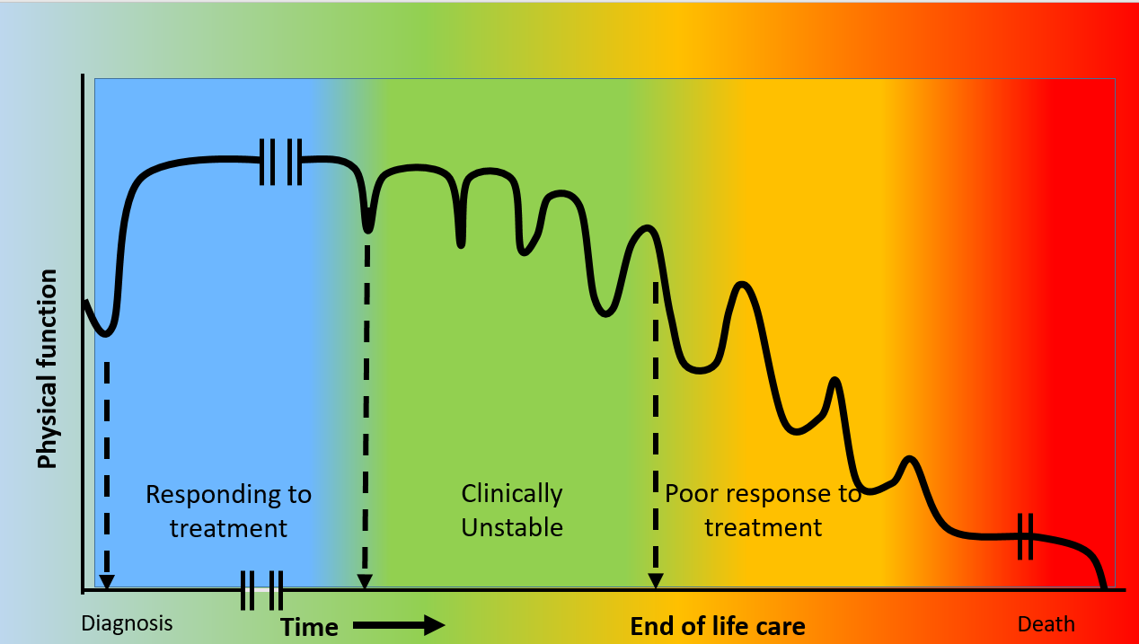
1 | Systematic clinical triggers for identifying when patients with chronic conditions are changing phase of illness from  - Stable and responsive to treatment  - Unstable  - Poorly responsive to treatment  - Dying | Clinical staff to understand Gold Standard Framework Proactive Identification Guidance (PIG) (Appendix 1)  Develop locally relevant /accepted PIG
2 | Clinicians identifying when patients are changing from one phase of illness to the next | Clinicians to understand and utilise PIG
3 | Clinicians sharing that with other clinicians and with patient and family  Highlight to GP that patient is suitable for inclusion on Primary Care Palliative Care Register | Good communications skills – and confidence in using those skills  IT systems and processes to support sharing and accessibility to information across primary and secondary care, including with GPOOH, WAST, DNs  Good functioning Primary Care Palliative Care Register at each GP surgery
4 | Sensitive communicating with patient and family about  clinical situation and what the future looks like  - What the disease journey is likely to look like  - What treatment options remain including option of no active treatment/focus on symptom control/best supportive care  - likelihood of benefit, magnitude of benefit, duration of benefit  - Likelihood of harm/burdens, magnitude of burdens, duration of burdens. Including option of no treatment  - What is important to the patient  - Identifying patient needs and planning for them | Good communication skills and confidence in using those skills
5 | Share details of conversation with other clinical teams | IT systems and processes to support sharing and accessibility to information across primary and secondary care, including with GPOOH, WAST, DNs
6 | Clinicians across all care settings to  - Identifying patient needs and planning for them (A&FCP)  - support patient to formulate preferences, with relevant understanding of remaining treatment options  - My life my wishes  - Advance decision to refuse treatment  - Record of best interest decision  - Lasting power of Attorney  - Care decision guidance for last days of life | Clinician access to detail of previous clinical conversations  Understanding of remaining treatment options  Good communication skills and confidence in using those skills  Clinician knowledge of advance and future care planning options and supporting documents  Access to A&FCP supporting documents  Patient acceptance and willingness to engage in conversation
7 | Clinicians set treatment escalation plan, with patient | Good communication skills and confidence in using those skills  Patient (and those important to them) understanding phase of illness and options available  Clinician understanding of phase of illness and treatment options available.
8 | Sharing of TEP with other clinicians | IT systems and processes to support sharing and accessibility to information across primary and secondary care, including with GPOOH, WAST, DNs
9 | Clinicians acting on A&FCP | IT systems and processes to support sharing and accessibility to information across primary and secondary care, including with GPOOH, WAST, DNs

Table 3: GMOs for 2023-24
Progress for these are detailed in different sections below
Goal | Methods | Outcomes | Target
End of Life Care (EoLC)  Increase proportion of Swansea Bay residents receiving the right care at the right place at the right time in the last year, months, weeks, days of life | Increased correct identification of people who may be in the last year of life | Increase % of deaths outside of hospital  Increase % of patients on the palliative care register | 0.40% on Palliative care register by March 2024
 | Increase Advance & Future Care Planning across all care settings | Increase in the number of advance future care plans recorded in WCP​ | 100 A&CP WCP notifications per month by March 2024
 | Increased correct identification of people who may be in the last days of life | Increase in the % and number of cases reviewed by the Medical Examiner who have a CDG Document in place​  Decrease % of deaths within 48hrs of emergency attendance | 55% of deaths with a CDG by March 2024
 | Increase the number of staff given education and training to support high quality EOLC | Increase number of staff receiving education and training in recognition and management of patients approaching EOLC from 1yr down | 3500 total staff trained (1000 within the year)
 | Identify and produce systems that support sharing of advance and future care planning across all care settings | Systems enabled to share end of life care/advance & future care planning information across platforms | At least 1 system able to share across care settings

Increased correct identification of people who may be in the last year of life

Ideally, our overall aim would be to increase the % of Swansea Bay residents dying in their preferred place of death. However, due to a lack of digital recording, it is difficult to demonstrate this; therefore, the proxy measure % of Swansea Bay residents dying outside of hospital is used. Below are the % of residents dying outside of hospital, local work has amended the proportion to include Ty Olwen as an outside of hospital death. The baseline median until June 2023 is that 55% of Swansea Bay residents die outside of hospital, with the aim to increase this by 1% by March 2024. Currently the weekly % remains around 55%.

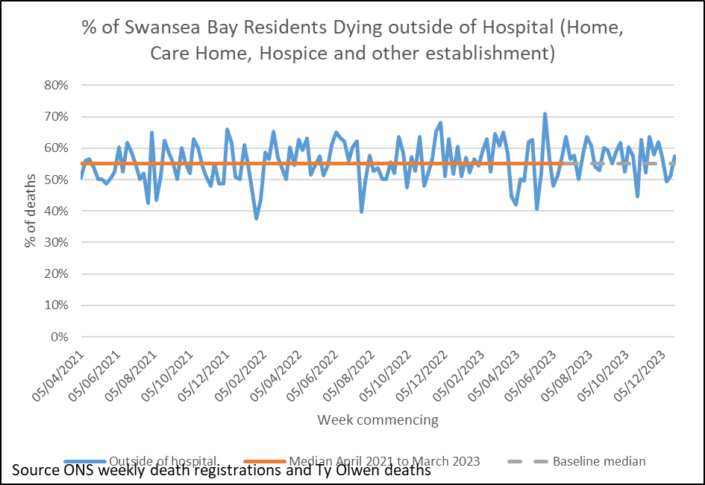

The main project within this method currently is to increase the use of the Primary Care Palliative Care Register, which forms part of the GP contract. Within Swansea Bay, the use of the Palliative Care Register has been variable. In March 2022, 0.22% of the Swansea Bay GP registered population were on the register. This ranged from 0.14% in one GP Cluster to 0.26% in another (PCIP, 2023). This information source is no longer published nationally now it is part of the GP contract.

The aim in 2023-24 is to increase to 0.40% by March 2024 to move toward the expectation that 1% of the population will be in their last year of life. The Primary Care Clinical lead for End of life care has produced guidance for the register and two monthly meetings, which in May 2023 was shared with all Swansea Bay GP Practices after being shared in LMC. This will aim to standardise the processes for adding to the Primary Care Palliative Care Register and 2 monthly MDT meetings. This project is one of the national Safe care collaborative work stream projects which will focus on maximising the use of the Primary Care Palliative Care Register, the running of MDT 2 monthly meetings and starting referrals to District Nursing team to start A&FCP discussions within three clusters; Cwmtawe, Penderi and Upper Valleys.

As part of the project we have agreed with the GP practices of the three clusters that they share their information for us to understand progress
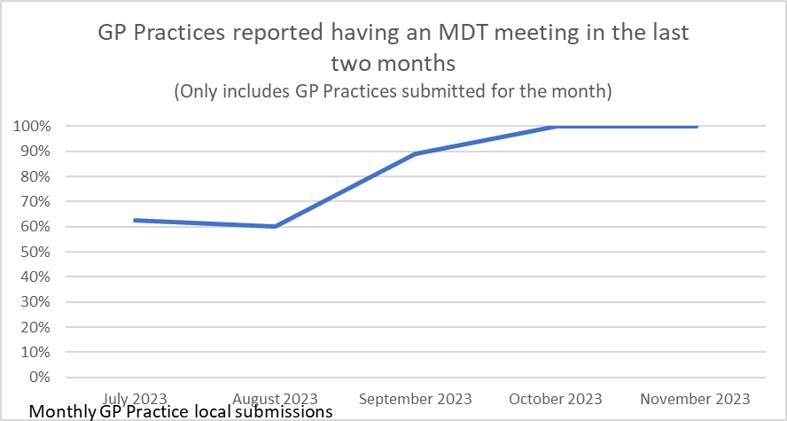
Since July 2023 there has been an increase in the % of GP Practices having a Palliative Care MDT meeting every 2 months. District Nurses and Specialist Palliative Care team are invited between 75-100% of the time. Attendance following invites is an average of 80% for District Nurses and 75% for the Specialist Palliative Care team.
Currently the % of patients on Palliative Care register is lower than the March 2022 baseline, currently at 0.11% for the three clusters combined. The work has helped to understand that there may be variances in the type of palliative patients placed on the list and a need to better understand how patients are identified to go on the list to increase the numbers of patients. The collection has shown an increase in the numbers having an Advance care plan in place from around 20% to 45% and a DNACPR from 35% to 68%.

NACEL Audit 2022-23 Key Findings

The NACEL is a national comparative audit of the quality and outcomes of care experienced by the dying person and those important to them during the last admission leading to death in acute hospitals, community hospitals and mental health inpatient providers in England, Wales and Northern Ireland.

Initial review of the NACEL audit 2022-23 and compared to 2021-22 found improvements in some areas:

- Plan in place and discussions with patient & nominated person:
  - The presence of an individualised plan of care for the needs in the last days of life is the area that Swansea Bay UHB was an outlier in the 2021 round of the NACEL audit, with only 25% of deaths being supported by an individualised plan of care. This proportion increased to 42% in the 2022.
  - There was also increase in the proportion of patients involved in that planning (20% to 38%) and those close to the person (70% to 90%)

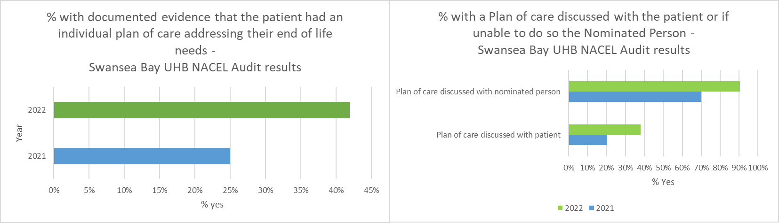

- Recognising dying until death - Acknowledgement of the dying patient was made prior to 24 hrs of death in 66% deaths in 2021 and reduced to 61% in the 2022 NACEL audit. This shows a decline however, it is possible that earlier recognition of dying in hospital facilitates patients to return to die in their usual place of residence.
- There was in increase in evidence of assessment of the common symptoms in the last days of life including assessment of pain, Swansea Bay performed higher than the national average in the 2022 round of the audit and an improvement locally from 55% to 85%
- There was an increase in the assessment of cultural, spiritual and religious needs between the 2021 and 2022 rounds of the audit, from 5% of deaths to 12.5%.
- Assessment of Emotional and psychological need increased from 7.5% to 30%. Assessment of anxiety and distress increased from 27% in 2021 to 45% in 2022.

The recommendations from the most recent NACEL audit findings review are included in the appendix (Appendix 2). These have not yet been ratified by the Palliative and End of Life Care Strategy Committee. The NACEL audit took a pause in 2023-24, and restarts in January 2024.

NACEL 2024 onwards
The format of the NACEL audit is changing for the coming year. The audit will now run continuously through the year, sampling quality of documentation of the care provided each quarter (see schedule below).

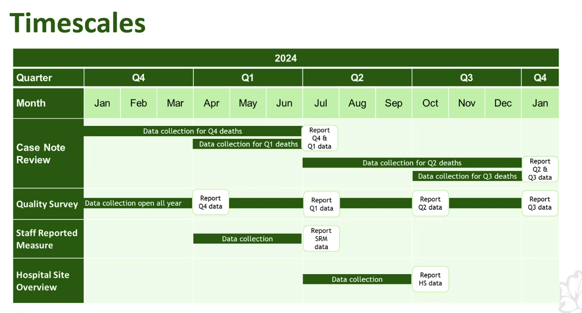
Caseload review
Each ward area within Morriston, Singleton, NPT and Gorseinon Hospitals will be required to undertake the case note review for 1/10 of the deaths in their area each quarter.

For example, based on the number of deaths over three months of October to December 2023:

Ward | Number of deaths last quarter | Number of reviews each quarter |  | Ward | Number of deaths last quarter | Number of reviews each quarter
Ty Olwen | 50 | 5 |  | Ward 12 | 11 | 1
Ward J | 39 | 4 |  | NPT Gen med B2, C &D | 11 | 1
AMU short stay | 34 | 3-4 |  | Tempest ward | 2 | 1 a year?
Ward D | 25 | 2-3

We will work with each delivery unit to ensure that the workload is distributed accordingly.
The End of life care Audit on AMAT will be a less significant requirement with the changes of NACEL for case note reviews.

Quality Survey
The relative feedback component of the NACEL audit will also be continuous over the year. We will be working closely with the Care after Death team to support those important to the dead person to participate with the audit. We have also discussed with the Medical Examiner’s team for their support in signposting the relatives of the person who died to the survey.

Staff Survey
This is being undertaken earlier than in previous rounds of the NACEL audit and therefore removes the need for us to repeat the staff survey outside of the NACEL process (which was planned in the report to Welsh Government – Appendix 2).

Hospital Overview
This is just required once through the annual process.

End of life care education and training
The Parasol team was established in 2021 and is the first and only team of its kind in Wales. Its capacity widened in January 2022 with the recruitment of an additional Clinical Nurse Specialist (CNS). PARASOL stands for: Person-centred approach, Assessment, Recognition, Approach, Sensitive, Observe and Lastly, as a framework for how they deliver and promote end of life care.

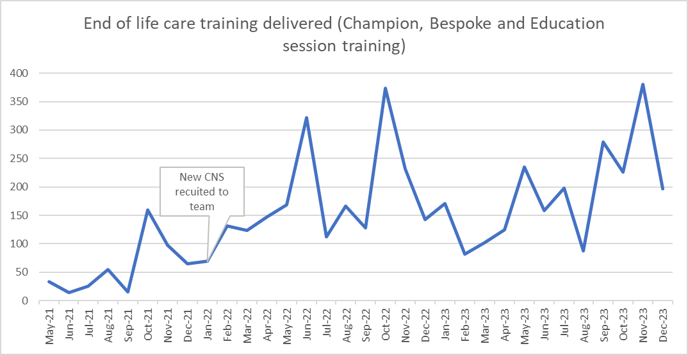
Training includes the EOLC Champion Programme, bespoke training on request of SGs and other organisations and the delivery of sessions within education and induction settings. Since starting in May 2021, the team has delivered training to 3,596 HB staff, which is over 28.6%% of our total staff. Since the recruitment of the additional CNS, the staff were able to deliver training to 25.4% of that.

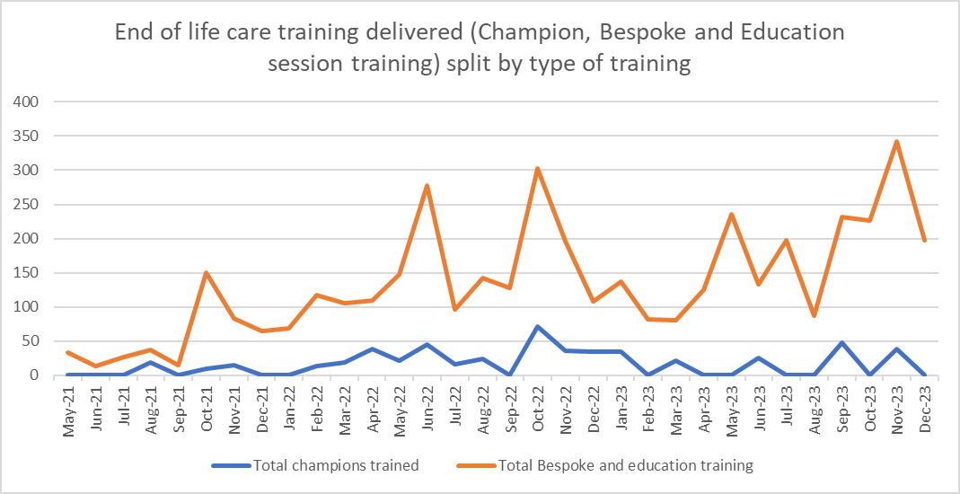
Bespoke sessions have been delivered to teams identified by all SGs. There are regular End of life sessions on Registered Nurses induction and update sessions and Health Care Support Worker (HCSW) induction and update sessions. The team delivers EOLC Sessions on Medical training – Internal Medical training, Practicing Medicine Made Easy and Mental Health training. All wards in Singleton, Morriston and Neath Port Talbot have access to EOLC Resource folders. Through these formats the team can reach many staff.
The PARASOL team received feedback from registered nurses who attended bespoke training that they would appreciate a visual tool to support setting up a McKinley T34 syringe driver post training. The PARASOL team have developed a McKinley T34 Syringe Driver Pictorial guide to support and guide clinical practice.

The EOLC champion programme has had 489 staff attend since 2021, around 64 of these were external to the HB mostly care homes and WAST.

A reflective review of the EOLC champion training in May 2023 included 10% of those who had attended the training. From the workshops, it demonstrated that some Champions need more support in their clinical areas. Some areas the Champions are promoting AFCP and CDG within their clinical areas, which needs to be correlated with the NACEL outcomes and the Medical Examiner data showing increased use in CDG. The team are continuing to deliver the training, having altered the programme for the EOL Champion Day based on feedback, where they have introduced a session on anticipatory grief. They will constantly review the education we deliver based on feedback and Datix outcomes.
The PARASOL team are supporting education and training with 10 Care Homes in Swansea Bay. Two Care Homes have identified trainers and are continuing to train their care home staff in End of Life Care, recognising dying and All Wales Guidance: Care Decisions for the Last Days of Life.

Increase Advance & Future Care Planning (A&FCP) across all care settings

Anecdotally we know that A&FCP takes place in pockets across the Swansea Bay area but there is no systematic way of how it is shared and recorded digitally and therefore this method links with the last method around Identify and produce systems that support sharing of advance and future care planning across all care settings.

Currently the only electronic measure for A&FCP available is the A&FCP notification flag in Welsh Clinical Portal (WCP). There has been an increase in notifications in recent months. A request has been made to DHCW (Digital Health and Care Wales) to help us to understand which clinical teams are contributing to the notifications on WCP. It is thought to be primarily set by Specialist Palliative Care service as they have made a renewed effort to increase use of this. However, the increase may also be linked to end of life care training delivered to specialties such as Oncology, Haematology, Care of the Elderly and the Respiratory medicine. The use of this flag is being explored as part of the Palliative Care Register project and promotion of the flag is being made to other HB services.

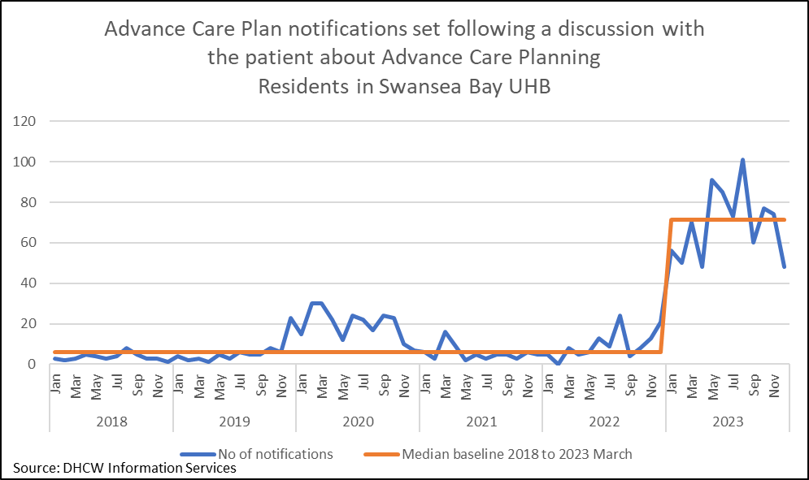

There has also been initiation of work with clinical teams to identify processes for both identification of triggers for advance and future care planning and for sharing detail between clinical teams supporting the patients, across all care setting (primary care/secondary care/WAST/ GPOOH).
The Health Board has adopted My Life My Wishes document (originated from Powys HB), which is an Advance Care Plan or Statement of Wishes. This has been shared through some of the PARASOL team training programmes, in the last nine months 450 documents have been shared. It is available on COIN and is accessed by the Virtual Wards to assist in A&FCP discussions. As patient held document, it is not possible to identify how many statement of wishes are in place.
Treatment Escalation Planning is a process for the healthcare team to record the treatment options that remain for the patient, within the context of their previous treatments and response to those treatments; their likely reserve to be able to respond to treatment options; and the patient’s preference for care. This is particularly important to support clinical decision making should the patient deteriorate when the clinical team that knows them best is not around (eg out of normal working hours).
The All Wales Treatment escalation plan (TEP) has been modified for use in Swansea Bay, and there have been a couple of attempts to support its introduction into secondary care. Unfortunately, the clinical teams have had competing demands, with the redesign of delivery of services in Morriston Hospital. There are a few clinical teams who are now keen to include TEP in their clinical work, and these are planned for the next three months.
The TEP is also relevant in the community setting. A few Care Homes within Swansea Bay have expressed an interest in using a TEP. There are plans to modify the Community TEP produced by Powys UHB for use within Swansea Bay. The project will require support of secondary care clinicians to identify remaining treatment options and GPs.
Increased correct identification of people who may be in the last days of life
The Care Decision Guidance is an All Wales guidance that supports clinical decision making and communication with the patient and those important to the dying patient, focusing on the five priorities of the dying person (One Chance to Get it Right). The five priorities of the dying person also underpins the NACEL audit, so use of the CD guidance would ensure patient needs are met. The CD guidance is available across the HB. There are plans to make it available as an electronic document (through the Welsh Nursing Care Record). However, there are no plans to make this available to District Nurses and GPs supporting people who are dying in the community setting.

Currently, the only data on the number of patients who’s care has been supported by the CD guidance in Swansea Bay is through the Medical Examiner’s office, when deaths within secondary care are scrutinised.

The baseline is 22% of hospital deaths reviewed by the Medical Examiner were supported by the CD Guidance. The aim is to increase this to 55% of hospital deaths. For this target to be met, there needs to earlier recognition of the dying person in hospital and conscious decision to “change gear” to focus on the specific needs of the dying patient (and those important to them). The education around end of life care across the Health Board will support that.

Due to access to information, we have been unable to update this information since March 2023. Work is ongoing to re-access this data from Medical Examiner.

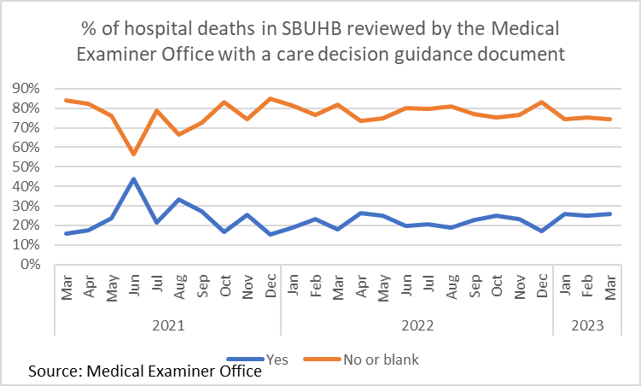

Fast track discharge for people in the last days of life
When people are recognised to be in the last days of life, application for Continuing Health Care funding to support nursing care in the community, through the Fast Track process. When people are in hospital and wish to spend their last days of life at home, discharge can be co-ordinated under the Fast Track process. Over the last two years, Swansea Bay has been proactive in gaining high standard of handover of care between hospital and community nursing teams. However, GPs have highlighted that they are often unaware of patients and their needs when fast tracked home. Discharge summaries can be incomplete and can take a few days to be processed by the GP surgery.
A recent addition to the Fast Track process is for the medical teams to contact the GP surgery to speak with the GP on call. This can be a long wait to get through to the GP surgeries, waiting in a queue. Bypass numbers have been provided for the GP surgeries in Swansea Bay, for this urgent purpose, the Discharge Liaison Nurses have been pivotal in this process.
End of life care room in Emergency Department
The hospital palliative care and ED team recognised a significant number of people were dying in ED and were often being cared for in the last days of their life in Red Trolley Bay Cubicle 5. The room was a very functional ED space – it was dark, with no window or natural light and very noisy due to an overhead tannoy.
In 2005 NHS Estates published a report ‘A Place to Die with Dignity: Creating a supportive environment’ which highlighted that the places where people die, where families are counselled after bereavement, and where friends and relatives view the bodies of their loved ones are often neglected. The King’s Fund has then further highlighted this work and also run pilot projects focusing on improving the environment of hospital areas focused on delivering end of life care and care after death.
Improving Environments for Care at End of Life: eight UK pilot sites - Waller, Dewar, Masterson, Finn - The King's Fund, April 2008 (kingsfund.org.uk)
Improving the patient experience: Environments for care at end of life, The King's Fund's Enhancing the Healing Environment Programme 2008-2010 (kingsfund.org.uk)
Using the King’s Fund projects as exemplars Karen Thomas (ED Matron) and Dr Hannah Robinson (Hospital Palliative Care Consultant) set up a working group to address the environment of Red Trolley Bay Cubicle 5. The working group included members from the Chaplaincy Team, ED staff, the Care after Death Manager and the Hospital Palliative Care and Parasol Team. The working group organised for the room to be transformed from grey to light green by the Estates Department and they also disconnected the tannoy. The working group also liaised with Dragon Signs who kindly installed a countryside wall wrap free of charge. We are currently trying to source some additional furniture for the room so that those important to the patient have more comfortable seating available.

This project has been advertised on the hospital intranet and Social Media as being based on trying to improve the general environment for all and although this has been an additional benefit it wasn’t the primary aim of the project. However, the working group recognised that Red Trolley Bay Cubicle 5 is used for a wide variety of patients and we didn’t want to cause any unintended distress to people who used this room for alternative reasons.
Most importantly of all, the changes to the room in ED have already received positive feedback from patients and those important to them.
The working group would be keen to support with other work in improving the environment for those who are dying.

Communication and engagement with HB staff and wider community

There have been a series of messages relating to EOLC shared via various online media releases between January 2023 and May 2023 including the Parasol EOLC team, the Clinical Lead for EOLC and GP lead for EOLC and the Bay Magazine release in June 2023. The EOLC Core message was released on HB screensavers in May 2023.
For the remainder of the year there will be engagement with various clinical teams and professionals including grand round. HB intranet site for End of Life Care has been created which is due to go live by the end of January 2024. The launch of the new site will be advertised and communicated out across the HB for staff awareness to have easy accessibility to obtain educational resources to guide and support care. It will also help promote the PARASOL Team along with their contact information for any advice and clinical support in any care setting that is required as well as to book or arrange training.
Dying Matters Week
Dying Matters Week is from 6th May to 10th May 2024. This year the PARASOL team will be organising events in collaboration with SBUHB Care After Death Service and Ty Olwen Volunteer Support Manager. The aim is to arrange road shows in Swansea Bay Hospital sites and to outreach to the community to raise awareness with the public. For example, an event in the Waterfront Museum as part of the Aging well Partnership and the Dementia Hub in Swansea City Centre.
Public Awareness events for Penderi Cluster and Aging Well Partnership took place in November 2023. The PARASOL Team had a stand at both events promoting Advance and Future Care Planning. Networking at these events have opened opportunities to attend further events and network with more community organisations.

- Health Board Policy supporting high quality end of life care

Over the last three months HB wide policies that relate to delivery of high quality end of life care have been reviewed.

DNACPR decision making and form completion
The All Wales DNACPR policy around when the DNACPR form could be considered valid in deciding whether to carry out an attempt at CPR changed in November 2020. The change meant that health care professionals who were able to have DNACPR conversations with patients and those important to them, could complete the DNACPR forms up to and including section 5 (not the senior responsible clinician with oversight). With the recent changes, the form could be used as a valid decision supporting tool for starting CPR, or not, in the event of a cardiorespiratory arrest.

To ensure that the decision making process is robust, Swansea Bay recognised that all health care professionals who undertake these decisions should receive the appropriate training, not just in understanding the policy but also how the mental health capacity act may impact such decision making. It has been eagerly awaiting guidance from the Chief Nursing Officer for Wales’ office and HEIW. This guidance has now become available, enabling a wider range of staff to support DNACPR decision making. The governance around training for these conversations will be included in the annual Professional Development Review and Revalidation process.

This means that health care professionals, eg senior ward and district nurses, allied health care professionals and Clinical Nurse Specialists can document the conversations that they have had with patients on the DNACPR form, and it be a valid tool to support decision making immediately.

In situations when a DNACPR form has been signed in section 5, there continues to be a requirement that the senior responsible clinician with oversight is made aware of the decision, and agree, at the earliest opportunity.

Prioritisation of use of single rooms includes care of the people in the last days of life, alongside infection control

Close working between End of life care and Infection control has supported recognition that caring for people in the last days of life can be considered when prioritising how single rooms are utilised, depending upon the level of infectiousness of an infection and the level of needs of the dying person and those close to them.

Dignity of the deceased adult
This policy has been reviewed and up-dated to ensure it aligns with the HB priority.

Availability of medications for people in the last days of life in the community
Difficulties in accessing medications for the common symptoms in the last days of life has been raised as an issue in several forums and adds to the distress of people dying and those important to the person dying.

Issues identified have been
a] the pharmacies that family members go to for the prescription do not have the medications prescribed – either because
  - they do not stock them or
  - they usually stock it but have run out or
  - there is a national shortage of the medication prescribed.
B] DNs, particularly outside of normal working hours, are not able to respond to patient needs quickly enough.

The HB has a contract with many of the community pharmacies to hold the common medications for symptoms in the last days of life. An increased awareness of which pharmacies have a contract to stock those medications more widely has started, with the details being included on COIN, in both the pharmacy/medications pages and the Palliative and end of life care pages.

Clinicians are encouraged to submit a DATIX for such episodes to help us understand the underlying issues and identify more robust solutions.

- Digital development

Digital challenges for the End of life care quality and safety priority are two-fold
a] availability of robust data
b] sharing of relevant information across all care settings and the various IT platforms that are in use

Access to data relevant to End of Life Care has been challenging. Many of the ideal measures are unavailable digitally and therefore proxy measures are used. These measures can often be reliant on organisations outside of SBUHB. Place of death is provided by the Office of National Statistics (ONS), however access is limited through licensing. It has taken some time to confirm how the data can be used in correlation with the SBUHB data and now the mortality dashboard will be updated in 2024. Data around the advance and future care planning has been limited by availability of data through DHCW. Whilst DHCW provides monthly data on the number of notifications of Advance Care Planning within WCP for Swansea Bay residents. Digital Intelligence are working with DHCW to be able to break the information down into clinical teams which will allow more targeted work to improve notifications recorded by relevant teams.

Use of the Care Decision told to support care and decision making in the last days of life is accessed from the Medical Examiner’s office. Swansea Bay is currently exploring how these data can be incorporated into the HB’s end of life dashboard. It is hoped that this support can be provided by the Care After Death Team.

The number of people on the GP Palliative Care Register represents those people who have been recognised as being in the last year of life. Access to data for number of patients included on the primary care palliative care registers is limited. It is no longer available nationally on an annual basis. Data has become more readily available through the Safe care Collaborative project, for the three Clusters involved until March 2024.

We are also dependent upon the digital teams supporting Digital System development and incorporation of this data in the data warehouse amongst competing HB priorities which has at times made progress slow.

Sharing of relevant information around end of life care across teams that are supporting the patient

It is recognised that much work supporting people in the last year of life can happen in silos, and not be visible to the other teams who may be supporting them. For example, any conversations that a GP may have with a patient, including DNACPR decision making is not automatically visible to the support in secondary care, GP OOH, WAST, 111, etc. Similarly, without specific inclusion of the detail of conversations that may take in secondary care in correspondence, it is difficult for those supporting the patient in the community to build on those conversations.

Work is being undertaken to identify clinical codes that, if used within primary care IT systems (EMIS and VISION), can be pulled across to WCP and be visible for all other service.

We are also working to encourage secondary care clinicians to include more than, Mr Jones understands his diagnosis and prognosis, in clinical correspondence.

Whilst the secondary care DMS system and automated sending of correspondence to Swansea Bay GP practices (and WCP) is fast (sent every 15 minutes), the GP surgeries’ capacity to process those correspondence is less efficient, often taking several days for the correspondence to reach the relevant GP. Work is underway to provide GP surgeries with “key phrasing, in key document areas” to support their recognition of the patients who have specific end of life care needs. For example, for the Fast track discharges, including the phrase Being Discharged for Care in the Last Days of Life within the For the GP section.

There is also work underway to identify all the IT systems that may reference A&FCP to ensure that they are aligned with each other. For example, DNACPR status may be recorded in Signal, Welsh Nursing Care record, GP systems, etc. However, there is no universal source of the truth, and if there has been a change in decision making, not process to ensure that all records are up-dated accordingly. Similar challenges exist for patient preferences, and treatment escalation considerations. Mapping that information flow will be important if we are to overcome these barriers to ensuring that the population of Swansea Bay received the right care at the right time in the right place.

Currently there is no All wales solution to sharing A&FCP including DNACPR decision making. Work is underway to explore the use of eForms to support sharing of these key conversations with other teams supporting the patient.

Syringe Driver Pictorial Guide
The PARASOL team have developed a McKinley T34 Syringe Driver Pictorial guide to support and guide clinical practice across all care settings.

- SUMMARY

The End of Life Care Quality and Safety Priority has been an essential component of the HB’s strategy development for providing the right care in the right place at the right time, through the last year of life. Positive results have already been identified through changes in care evidenced through the National Audit of Care at the End of Life, with increased evidence of assessing humanistic needs (symptom control, spiritual needs, emotional/psychological needs, hygiene/bowel and bladder care) and planning in the last days of life in the hospital setting. This has been a consequence of the increased focus on care in the last days of life and the training being provided through the PARASOL Team.

The longer terms aims are focused on building firm foundations in the last year of life, through conversations – understanding what is important to the patient and helping the patient to understand their disease journey, to support the right care in the right place in the last days of life. Changing away from what is often seen as “normal” (admission to emergency department/hospital in the last days of life) to providing end of life care in the person’s preferred place of care. There will be a period of lag between implementing change to realising the change in patient outcomes, as conversations in the last six to twelve months of life influence clinical decision making in the last days of life.

- GOVERNANCE AND RISK ISSUES

The recent internal audit of end of life care has demonstrated that there is appropriate governance and oversight arrangements are in place. Key issues are escalated and reported to Board.

The health board’s governance structures in respect of quality and safety were updated during 2022, with a number of groups being replaced. The reporting framework for EOLC includes:
- Board
- Quality and Safety Committee
- Management Board
- Quality and Safety Group
- Quality Priorities Programme Board
- Palliative and End of Life Steering Committee.

The following risks have been identified within the above forums are:

- Digital Informatics – Dashboard not yet in place effecting Service Groups ability to have access to EOLC data and therefore take accountability and influence change in a more timely way.
- Digital systems – there is limited ability to record that patients are recognised to be at end of life and any A&FCP discussions. There has been little progress made with this in 2022-23 and therefore it has been moved to the GMOs for 2023-24
- Delays in DNACPR documentation to support clinical decision due to inability to comply with All Wales DNACPR policy (completion of Section 5 by non-medical staff) - this should be resolved within the next two months as the recommendations from the Welsh Nursing Officer are implemented by the HB.

- FINANCIAL IMPLICATIONS

Through the Quality Improvement programme, there are projects that may require additional funding however, details for this will follow through individual project groups.
This may include increased community care needs if increased numbers are dying outside of hospital. If earlier A&FCP takes, place and more residents are cared for outside of hospital this could result in less demand within the hospitals such as beds and investigations.
- RECOMMENDATION

Members are asked to note the report and consider the following:
In order to progress EOLC Quality Priority work and embed it as business as usual, all Service Groups (SG) must engage with the improvement projects and ensure clinicians are encouraged to:

- Continue to engage with EOLC education and training:
  - Ensuring there are 2 members of staff per area attending the EOLC champions programme
  - Identifying areas of bespoke education needs –through action plans following incidents and complaints, audit reports, mortality and morbidity review reports and staff/service requests.
  - The aim is to have another 1000 staff attend training by March 2024.
- Increase identification of people who may be in the last six to twelve months of life, to support their information and care needs adopting:
  - Complete A&FCP discussions and documentation when recognising that patients are in their last 6-12 months of life
  - Introduce patients to My Life My Wishes document when having discussions
  - Recording of A&FCP discussions in the WCP notification to highlight the activity to other clinical teams – aim to have 100 per month across all areas by March 2024
  - Sharing of identification of last 6-12 months of life, A&FCP discussions and recommendations to GPs in usual correspondence methods
  - Utilise Treatment Escalation Plans increasing proactive decision making around setting ceilings of treatment – this is being piloted in ED & AMU in Morriston and plans for further pilots on ward D and E in Morriston. . These will continue and expand as use increases through the year.
  - Complete Care decision guidance (CDG) document when the patient has been identified in their last days of life, this is available to be used across all areas. Aim to have 55% of deaths having A CDG document by March 2024.
  - Maximise use of the Palliative care register, through recommendations to add to register, attendance of MDT meetings and referrals to District Nursing – aim to increase register to 0.40% by March 2024
- Ensure reporting on EOLC in the SG quality and safety groups; participate in the EOLC action log reporting and in EOLC delivery group and EOLC & Palliative steering group by September 2024.
- Each relevant clinical ward to participate in the NACEL audit process (NACEL process changing from January 2023

To support Service Groups to undertake this:

- Digital to deliver on internal audit recommendations to identify gaps in existing EOLC data to support development of a dashboard covering all aspects of EOLC. Digital to support IT system development to allow recording and sharing of patients recognised to be in the last year of life, palliative care register, details of conversations around A&FCP, Do Not Attempt Cardiopulmonary Resuscitation (DNACPR) and Treatment escalation plans across IT platforms and service groups.
- Communications, core EOLC group and Swansea University to support development of public facing resources to support public understanding of their conditions, care in the last year of life, advance and future care planning, treatment options. To start in October and include HB website and podcasts.
- Reporting templates for investigation of incidents/complaints; audits; Mortality/Morbidity reviews; will include EOLC education needs identified (September)
- Communications, core EOLC group and Swansea University to support development of public facing resources to support public understanding of their conditions, care in the last year of life, advance and future care planning, treatment options. To start in January 2024 and include HB website and podcasts.
- A&FCP literature made available in all ward and outpatient clinic areas.
- Core EOLC team to provide support to clinical teams to undertake EOLC audit.
- Provide reporting templates for investigation of incidents/complaints; audits; Mortality/Morbidity reviews; will include EOLC education needs identified.
- Digital intelligence to support data capture and analysis in line with GMOs.

References
- National Institute for Health and Care Excellence(NICE), 2021. End of life care for adults. https://www.nice.org.uk/guidance/qs13/chapter/Quality-statement-1-Identification
- Primary Care Information Portal (PCIP), 2023. Palliative Care Register. http://gig01srvisdlogi/pcip/rdPage.aspx?rdReport=_Menu
- Office of National Statistics (ONS), 2023. Deaths register monthly in England and Wales. https://www.ons.gov.uk/peoplepopulationandcommunity/birthsdeathsandmarriages/deaths/datasets/monthlyfiguresondeathsregisteredbyareaofusualresidence
- Bone A, et al. What is the impact of population aging on the future provision of end of life care? Populations-based projections of place of death. Palliative Medicine 2018; 32(2): 329-336
- Electronic Palliative Care Co-ordinations System (EPaCCS) Review and Benefits Summary. 2016 Greater Manchester and Eastern Cheshire Strategic Clinical Networks Accessed on line June 2023 https://www.england.nhs.uk/north-west/wp-content/uploads/sites/48/2022/05/1-EPaCCs-Benefits-Summary-final.pdf
- Once Change to Get it Right 2014 Leadership Alliance for the Care of Dying People

Governance and Assurance

Link to Enabling Objectives  (please choose) | Supporting better health and wellbeing by actively promoting and empowering people to live well in resilient communities
Link to Enabling Objectives  (please choose) | Partnerships for Improving Health and Wellbeing |  | ☒
Link to Enabling Objectives  (please choose) | Co-Production and Health Literacy |  | ☒
Link to Enabling Objectives  (please choose) | Digitally Enabled Health and Wellbeing |  | ☒
Link to Enabling Objectives  (please choose) | Deliver better care through excellent health and care services achieving the outcomes that matter most to people
Link to Enabling Objectives  (please choose) | Best Value Outcomes and High Quality Care |  | ☒
Link to Enabling Objectives  (please choose) | Partnerships for Care |  | ☒
Link to Enabling Objectives  (please choose) | Excellent Staff |  | ☒
Link to Enabling Objectives  (please choose) | Digitally Enabled Care |  | ☒
Link to Enabling Objectives  (please choose) | Outstanding Research, Innovation, Education and Learning |  | ☐
Health and Care Standards
(please choose) | Staying Healthy |  | ☐
(please choose) | Safe Care |  | ☒
(please choose) | Effective Care |  | ☒
(please choose) | Dignified Care |  | ☒
(please choose) | Timely Care |  | ☒
(please choose) | Individual Care |  | ☒
(please choose) | Staff and Resources |  | ☒
Quality, Safety and Patient Experience
EOLC Quality Priority reports to the Quality Priorities Programme Board, which reports to Quality & Safety Group and the Palliative and EOLC steering group, which reports to Quality, Safety and Patient Services Group. The overall aim is to increase proportion of Swansea Bay residents receiving the right care at the right place at the right time in the last year, months, weeks, days of life.

As focus changes towards what is important to the person, there is an expectation that patient experience will become more positive, with fewer complaints around care in the last days of life.
Financial Implications
No financial implications noted in this report.

Legal Implications (including equality and diversity assessment)
Each SG reports into the EOLC delivery group and the Palliative and EOLC steering Group. These both report to the Quality Priority Programme Board and Q&S governance structures.
Staffing Implications
EOLC medical and nursing leads have been identified for each SG and the EOLC training delivered by the Parasol team delivers EOLC champions across all SG areas, bespoke team training and induction training. The clinical lead for end of life care role is 2 days a week the remainder being clinical.
Long Term Implications (including the impact of the Well-being of Future Generations (Wales) Act 2015)
The focus of the EOLC QP work is earlier detection of someone nearing who may be in the last year/months/weeks/days of their life. This has a positive impact on the well-being of the person who is in the last year of life.
To support this activity across the HB, it is essential that, alongside the education of staff across all care settings, that there is accompanying public facing resources and conversations to both inform and reassure in supporting care in the last year of life. A positive activity promoting the right care in the right place at the right time; and not a negative activity that is focused on denying people the care and resources they would benefit from.

Better support of the dying person (and those important to the dying person) has been shown to reduce longer term mental health complications of bereavement.

The Quality Improvement programme ensures integration with partner agencies such as care homes. There is collaboration with both partner agencies and Improvement Cymru to progress QI work streams.
Report History |  | Management Board July 2023
Appendices |  | Appendix 1 - Gold standard framework guidance￼  Appendix 2 -Assurance provided to Welsh Government Re: NACEL 2022

Appendix 1 – Gold Standard Framework – Proactive Identification Guidance
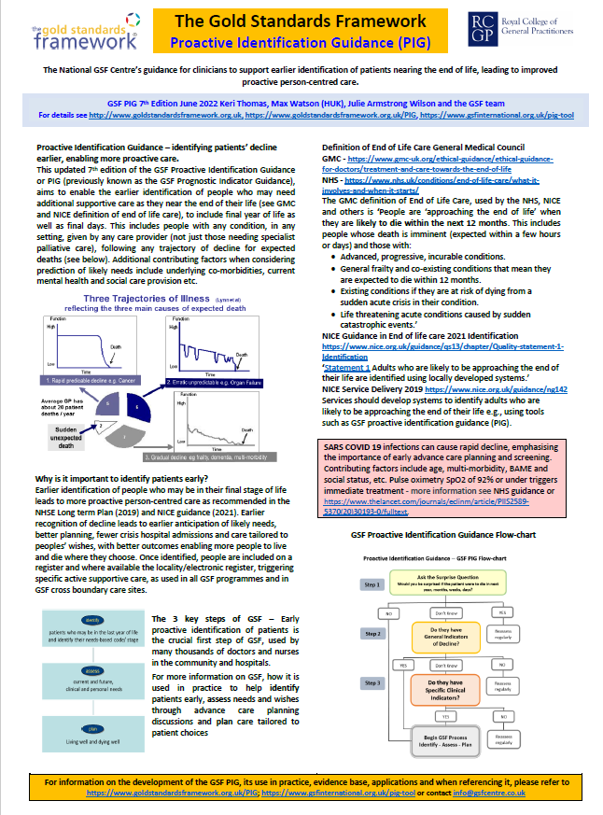

Appendix 2 – Assurance provided to Welsh Government Re: NACEL 2022
NAME OF NHS HEALTH BOARD / TRUST

National Clinical Audit & Outcome Review Programme

All health boards / trusts participating in national clinical audits and outcome reviews must electronically send a completed front page and Part A version of this form to the mailbox address below within 4 weeks of the publication of reports and, a completed Part B within 3 months to : Mailbox address : wgclinicalaudit@wales.gsi.gov.uk

Audit / Registry Title - National Audit of End of Life Care 2022

Date of published report – July 13th 2023

HB Clinical Lead / Champion – Dr Sue Morgan

PART B. Describe the actions already taken or in the process of being developed to address the key findings and recommendations above with timescale and details of named lead.

Action (provide additional detail on separate page(s) when required) | NACEL Recommendation | Timescale (incl. milestones) | Clinical Lead
Ongoing HB focus on Advance and future care planning | Advance care planning:  Individualised plan of care:  Needs of others:  Training and support:
- HB senior leadership promotion of engagement with A&FCP/recognising that patients maybe in the last year of life |  | January 2024 | Raj Krishnan and Anjula Mehta  Gareth Howells
- Development of HB accepted triggers for advance and future care planning and treatment escalations plans |  | June 2024 | Clinical leads for each chronic condition
- Promotion of early conversations around prognosis with patients and those identified as important to them following diagnosis of chronic condition – clinical teams signed up to this commitment |  | June 2024 | Clinical leads for each chronic condition / Primary Care Leads
- Promotion of early conversations around prognosis with patients and those identified as important to them following diagnosis of chronic condition – identification of methodology to measure this |  | May 2024 | Sue Morgan/Digital team
- Training around A&FCP and difficult conversations, communications skills – increase proportion of staff receiving training to 35% (Currently 21%) |  | October 2024 | PARASOL team
- Promotion of use of WCP flag for notification of A&FCP – increase by 20% (currently average of 70 per month) |  | March 2024 | Sue Morgan
- Promotion of use of WCP flag for notification of A&FCP – 75% of notifications supported by record of conversation in clinical correspondence |  | June 2024 | Clinical leads for each department
- Identification of systems for sharing A&FCP, between care settings – will require all Wales/DHCW support |  | Ongoing | Sue Morgan/Digital team
- Review of access to Specialist Palliative Care across all care settings and promotion of resources | Specialist Palliative Care: | March 2024 | Dr Gwenllian Davies
- On-going training plan for EOLC – End of Life Care Champion programme; induction programme training, bespoke training identified by clinical areas with input from incident and complaints learning | Training and support: | On-going | PARASOL team CNS Glenda Morris
- Repeat Staff survey component of NACEL outside of NACEL process | Training and support: | Jan 2024 | Dr Sue Morgan
- Promotion of Care Decision Guidance – increase use of care decision guidance within secondary care by 20% | Individualised plan of care:  Hydration and nutrition:  Needs of others: | June 2024 | All Medical and Nursing directors within Service Groups
- Promotion of Treatment Escalation Plan – TEP established within at least one clinical area | Individualised plan of care: | March 2024 | Sue Morgan
- Feedback to clinical teams across secondary care | Training and support | January 2024 | Sue Morgan

If there are resource implications in the actions detailed above are they included in the health board / trust integrated medium term plans ?
YES (please indicate as appropriate).
If the answer is No, how is the matter being addressed ?

Part B Guidance Note
The over-riding principle is that actions being taken must relate directly to the issues highlighted in Part A and, lead to clear evidence
of improvement when services are next re-audited.

Information from audits and reviews hasn’t always been used effectively in the past to improve services, but in future must directly align with organisation’s quality improvement programmes and lead to improved patient care. Information demonstrating there has been a comprehensive review of report findings which are clearly feeding into local action plans is important

Information from audits and reviews should demonstrate a pattern of year on year improvement

Bear in mind that many important improvements are often linked to relatively simple changes of procedure or process

Information provided should be focussed on addressing the audit / review findings. Organisations must resist the temptation to include information on quality improvement initiatives which have little or no direct relevance to the specific findings and recommendations listed in Part A.

Where findings confirm significant variation of services within an organisation, details of how variation is being addressed and, the learning from the best performing units is being shared should be provided. Clear evidence that report details are feeding into change across the organisation is important.

Where appropriate, organisations should also provide information to demonstrate how they are using the learning from other high performing organisations in Wales or from across the wider audit.

Issues to bear in mind:
- Health boards should take the opportunity to maximise the investment in national audits and utilise findings to direct service improvement.
- Report plans should demonstrate information from audits and reviews is part of on-going local governance
- Reports should feed into on-going MDT working across the organisation
- Information to show reports are driving/guiding change and improvement is important
- information from audits should provide evidence on ongoing year on year improvement

Overall Assessment

How would you assess your organisations progress in relation to this Audit?
Current status | Tick Status | Status Definitions
Red |  | Cause for concern. No progress towards completion. Needs evidence of action being taken.
Amber | ✓ | Delayed, although action is being taken to ensure progress.
Green |  | Progressing on schedule with clear evidence of progress.

The completed assurance pro-forma should be signed by the health board clinical lead for the audit / review and the Medical Director or their representative.

Health board / trust clinical lead for the audit / review : ………Dr Sue Morgan …………………………………………………..

Medical Director’s Office : ………………………………………………………………........................................

Date ………………………………………………………………

