
The Gold Standards Framework
Proactive Identification Guidance (PIG)
The National GSF Centre’s guidance for clinicians to support earlier identification of patients nearing the end of life, leading to improved proactive person-centred care.
GSF PIG 7th Edition June 2022 Keri Thomas, Max Watson (HUK), Julie Armstrong Wilson and the GSF team
For details see http://www.goldstandardsframework.org.uk, https://www.goldstandardsframework.org.uk/PIG, https://www.gsfinternational.org.uk/pig-tool

Proactive Identification Guidance – identifying patients’ decline  earlier, enabling more proactive care.  This updated 7th edition of the GSF Proactive Identification Guidance or PIG (previously known as the GSF Prognostic Indicator Guidance), aims to enable the earlier identification of people who may need additional supportive care as they near the end of their life (see GMC and NICE definition of end of life care), to include final year of life as well as final days. This includes people with any condition, in any setting, given by any care provider (not just those needing specialist palliative care), following any trajectory of decline for expected deaths (see below). Additional contributing factors when considering prediction of likely needs include underlying co-morbidities, current mental health and social care provision etc.  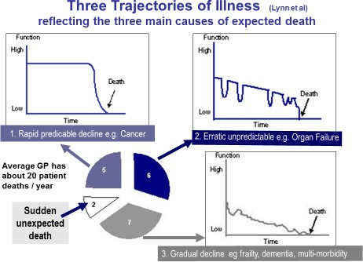  Why is it important to identify patients early?  Earlier identification of people who may be in their final stage of life leads to more proactive person-centred care as recommended in the NHSE Long term Plan (2019) and NICE guidance (2021). Earlier recognition of decline leads to earlier anticipation of likely needs, better planning, fewer crisis hospital admissions and care tailored to peoples’ wishes, with better outcomes enabling more people to live and die where they choose. Once identified, people are included on a register and where available the locality/electronic register, triggering specific active supportive care, as used in all GSF programmes and in GSF cross boundary care sites.  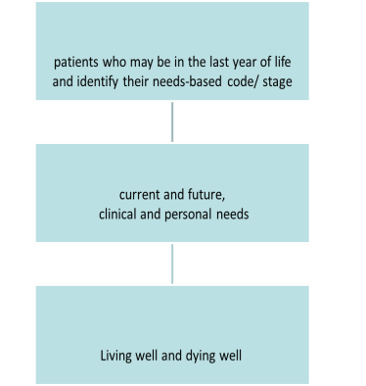    The 3 key steps of GSF – Early proactive identification of patients is the crucial first step of GSF, used by many thousands of doctors and nurses in the community and hospitals.  For more information on GSF, how it is used in practice to help identify patients early, assess needs and wishes through advance care planning discussions and plan care tailored to patient choices | Definition of End of Life Care General Medical Council  GMC - https://www.gmc-uk.org/ethical-guidance/ethical-guidance- for-doctors/treatment-and-care-towards-the-end-of-life  NHS - https://www.nhs.uk/conditions/end-of-life-care/what-it- involves-and-when-it-starts/  The GMC definition of End of Life Care, used by the NHS, NICE and others is ‘People are ‘approaching the end of life’ when they are likely to die within the next 12 months. This includes people whose death is imminent (expected within a few hours or days) and those with:  - Advanced, progressive, incurable conditions.  - General frailty and co-existing conditions that mean they are expected to die within 12 months.  - Existing conditions if they are at risk of dying from a sudden acute crisis in their condition.  - Life threatening acute conditions caused by sudden catastrophic events.’  NICE Guidance in End of life care 2021 Identification  https://www.nice.org.uk/guidance/qs13/chapter/Quality-statement-1-  Identification  ‘Statement 1 Adults who are likely to be approaching the end of their life are identified using locally developed systems.’  NICE Service Delivery 2019 https://www.nice.org.uk/guidance/ng142  Services should develop systems to identify adults who are likely to be approaching the end of their life e.g., using tools such as GSF proactive identification guidance (PIG).  SARS COVID 19 infections can cause rapid decline, emphasising the importance of early advance care planning and screening. Contributing factors include age, multi-morbidity, BAME and social status, etc. Pulse oximetry SpO2 of 92% or under triggers immediate treatment - more information see NHS guidance or https://www.thelancet.com/journals/eclinm/article/PIIS2589- 5370(20)30193-0/fulltext.  GSF Proactive Identification Guidance Flow-chart  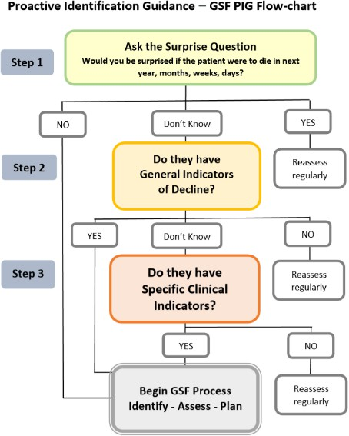
For information on the development of the GSF PIG, its use in practice, evidence base, applications and when referencing it, please refer to
https://www.goldstandardsframework.org.uk/PIG; https://www.gsfinternational.org.uk/pig-tool or contact info@gsfcentre.co.uk

STEP 1: The Surprise Question
For patients with advanced disease or progressive life limiting conditions, would you be surprised if the patient were to die in the next year, months, weeks, days?
The answer to this question should be an intuitive one, pulling together a range of clinical, social and other factors that give a whole picture of deterioration. If you would not be surprised, then what measures might be taken to improve the patient’s quality of life now and in preparation for possible further decline?
This includes proactive planning of care and treatments and offering
advance care planning and DNACPR discussions as early as possible.
STEP 2: General indicators of decline and increasing needs
- General physical decline, increasing dependence and need for support
- Repeated unplanned hospital admissions or acute crises at home
- Advanced disease - unstable, deteriorating, complex symptom burden
- Presence of significant multi-morbidities
- Decreasing activity – functional performance status declining (e.g., Barthel or Karnofsky Performance score, Rockwood) limited self-care, in bed or chair 50% of day and increasing dependence in activities of daily living
- Decreasing response to treatments, decreasing reversibility
- Patient choice for no further active treatment, focus on quality of life
- Progressive weight loss (>10%) in past six months
- Sentinel Event e.g., serious fall, carer distress, bereavement, transfer to nursing home, etc
- Serum albumin <25g/l
- Considered eligible for DS1500 payment
STEP 3: Specific Indicators related to single/multiple organ failure
- CANCER
  - Deteriorating performance status and functional ability due to metastatic cancer, multi-morbidities or not amenable to treatment – if spending more than 50% of time in bed/lying down, prognosis estimated in months
  - Persistent symptoms despite optimal palliative oncology. More specific prognostic predictors for cancer are available, e.g., PPS, IPOS,
ECOG.
- ORGAN FAILURE HEART DISEASE
  - Advanced heart failure - CHF NYHA Stage 3 or 4 with symptoms despite optimal HF therapy – shortness of breath at rest/on minimal exertion
  - Repeated admissions with heart failure – 3 admissions in 6 months or a single admission aged over 75 (50% 1yr mortality)
  - Heart failure patients with reduced ejection fraction (HFrEF) have a poorer prognosis than those with preserved ejection fraction (HFpEF)
  - Severe untreatable coronary artery or peripheral vascular disease
  - Difficult ongoing symptoms despite optimal tolerated therapy
  - Unpredictability but other indicators include age, low EF, ischaemic heart disease/arrythmias multi-morbidities including diabetes, obesity depression, hyponatraemia, high BP, declining renal function, anaemia
  - See NICE Guidance https://cks.nice.org.uk/topics/heart-failure-chronic
CHRONIC OBSTRUCTIVE PULMONARY DISEASE (COPD)
- Severe disease (e.g., FEV1 <30% predicted), persistent symptoms e.g., breathlessness despite optimal therapy, causing distress
- Recurrent hospital admissions (at least 3 in last year due to COPD)
- Hypoxia/fulfilling long term oxygen therapy criteria (PaO2<7.3kPa)
- Too unwell for surgery or pulmonary rehabilitation
- MRC grade 4/5 – shortness of breath after 100 metres on level surface
- Required ITU/NIV during admission or ventilation contraindicated
- Other factors e.g., right heart failure, anorexia, cachexia, >6 weeks steroids in preceding 6 months, despite specialist review/treatment
optimisation, requires palliative medication for breathlessness.
KIDNEY DISEASE
- Stage 4/5 Chronic Kidney Disease (CKD) deteriorating eGFR<30ml/min
- Repeated unplanned admissions (more than 3/year)
- Patients with poor tolerance of dialysis with change of modality
- Patients choosing the ‘no dialysis’ option (conservative management), dialysis withdrawal or not opting for dialysis if transplant has failed
- Difficult physical or psychological symptoms that have not responded to specific treatments
- Symptomatic Renal Failure in patients who have chosen not to dialyse or complicating other life limiting conditions – nausea and vomiting, anorexia, pruritus, reduced functional status, intractable fluid overload

LIVER DISEASE
- Advanced cirrhosis - see the Child-Turcotte-Pugh (CTP) score for chronic liver disease and cirrhosis mortality - See CTP calculator https://www.hepatitisc.uw.edu/page/clinical-calculators/ctp
- Hepatocellular carcinoma
- Liver transplant is considered potentially difficult or not amenable to treatment of underlying condition
- Other adverse factors including malnutrition, bacterial infection, raised INR, hyponatraemia
GENERAL NEUROLOGICAL DISEASES
- Progressive deterioration in physical and/or cognitive function despite optimal therapy
- No longer able to communicate basic needs
- Symptoms which are complex and too difficult to control
- Increased hospital admissions not returning to previous baseline Swallowing problems (dysphagia) leading to recurrent aspiration pneumonia, sepsis, breathlessness or respiratory failure
- Speech problems: increasing difficulty in communication and progressive dysphasia
- Mobility problems and falls increasing
- Reduced independence, needs ADL help, similar to frailty below
- Deteriorating cognition/psychiatric signs (depression, anxiety,
hallucinations, psychosis)
PARKINSONS DISEASE including the above, and more specifically -
- Drug treatment less effective or increasingly complex drug regime, less well controlled with increasing “off” periods
- Dyskinesias, mobility problems and falls
MOTOR NEURONE DISEASE including the above, and specifically -
- Episodes of aspiration pneumonia
- Low vital capacity (below 70% predicted), or initiation of NIV
STROKE
- Predicting the prognosis after acute stroke can be challenging, yet 1:20 die within 72 hours. Care should include symptomatic comfort and not to impose burdensome restrictions
- Persistent paralysis after stroke with significent loss of function, medical complications, lack of improvement or ongoing disability
- Persistent vegetative, minimal conscious state or dense paralysis Cognitive impairment/Post-stroke dementia
- FRAILTY, DEMENTIA and MULTI-MORBIDITIES
  - For older people with complexity and multiple comorbidities, with frequent fluctuations in health needs and deterioration
  - Electronic Frailty Index (0.24 or more) or Rockwood Score/ CFS 7 or above
  - Comprehensive Geriatric Assessment (CGA) includes cumulative multiple morbidities, weakness, weight loss, fatigue, advancing frailty e.g., male over 85, health problems, reduced activity and need to stay at home, needs regular help, uses stick/walker
regularly
DEMENTIA
Identification of moderate/severe stage dementia using a validated tool or Comprehensive Geriatric Assessment (CGA) of frailty, Clinical Frailty Scale (CFS), Functional Assessment Staging, Electronic Frailty Index (EFI) or Rockwood scale, identifying decline in dementia or frailty. Triggers to consider that indicate that someone is entering a later stage are:
- Unable to recognise family members or consistently unable to have meaningful conversations
- Completely dependent on others for care or unable to do ADL
- Recurrent episodes of delirium
- Aspiration pneumonia
- Urinary and faecal incontinence, and Barthel score <3
Plus: Weight loss, urinary tract Infection, skin failure or stage 3 or 4 pressures ulcers, recurrent fever, reduced oral intake
MULTI-MORBIDITIES
- Increasingly relevant in ageing population needing complex care
- 2 or more long term conditions including physical, mental, learning disability, frailty, sensory impairment, alcohol misuse
- Consider multi-morbidity approach if have frailty, physical + mental conditions, not managing ADL or treatments, using multiple services, frequent falls or crisis admissions
- See NICE Guidance - https://www.nice.org.uk/guidance/ng56 BGS - https://www.bgs.org.uk/topics/multimorbidity

The GSF Proactive Identification Guidance (PIG) June 2022 vs7 © The Gold Standards Framework Centre in End of Life Care

