Swansea Bay University Health Board

Patient Experience
&
Concerns Report
Quarter 4 2023/24

CONTENTS
Report Summary | Page 2
Complaints | Page 4
Complaint Themes | Page 8
Highlight Areas | Page 11
Nutrition & Hydration | Page 27
Morriston Service Group | Page 31
Neath Port Talbot Singleton Service Group | Page 38
Mental Health & Learning Disabilities Service Group | Page 40
Primary and Community Service Group | Page 44
Medical Examiners Compliments | Page 48
Ombudsman Cases & Learning | Page 49
Report Summary and Overview
COMPLAINTS | Jan | Feb | Mar
Total number of complaints received | 230 | 220 | 207
Complaints acknowledged within set timescale | 100% | 100% | 100%
Number of re-opened complaints | 7 | 5 | 5
 | Nov | Dec | Jan
Complaints responded to within agreed timescale - formal | 55% | 69% | 72%
OMBUDSMAN | Jan | Feb | Mar
Number of Ombudsman Investigations received | 2 | 2 | 1
Number of actions outstanding (within timescale | 27 | 6 | 7
Number of actions overdue | 1 | 0 | 0
PATIENT EXPERIENCE | Jan | Feb | Mar
No. of Friends & Family surveys received | 5,635 | 5,547 | 5,343
Recommendation score | 93% | 92% | 92%
New Bespoke Surveys | 3 | 4 | 1
NATIONAL REPORTABLE INCIDENTS | Jan | Feb | March
Number of National Reportable Incidents reported | 6 | 8 | 8
Number of Never Events | 0 | 1 | 0

Successes | Priorities
Patient Experience;  - The overall satisfaction score for this quarter is 92%  - SBU piloted the NHS Wales Digital story platform. This platform is in the Civica system and allows all HBs to place/load (level 4) digital stories for sharing and learning across Wales.  - KPIs performance data now being produced by the Civica System and sent across to NHS executive’s dashboard. Q1, Q2, Q3 already sent Q4 will follow. This is a new process across Wales for all HBs’. PE have linked with Performance colleagues and SBU quality dashboard. | Complaints;  - Working with the Service Groups and meeting regularly to discuss their longest open complaints to improve the overall performance  Patient Experience;  - Working with Primary Care leads to capture patient feedback. Project involves weekly meetings with service leads, mapping the clinics to the hierarchy.
Opportunities | Risks & Threats
Complaints;  - Once for Wales workshop held to develop a toolkit for managing complex complaints.  Patient Experience;  - SBU have submitted an application for the Royal Society for Public Health Awards 2024 ‘Championing the Public’s Health’. The submission is Digital Storytelling – The Swansea Bay Model  - Meeting with Safeguarding to develop a national survey for Looked after Children (LAC). This will be a national survey in all Civica platforms across Wales.  - All HB’s have been involved in T&F groups to develop the All Wales Peoples and Community Patient Experience Toolkit. This toolkit will be an appendix to the new Patient Experience Framework. | Complaints;  - The management of complex complaints.  Patient Experience;  - With the launch of the refreshed All Wales Patient Experience Framework (due Aug/Sept 2024), the department will be engaging with Service groups and Patient experience stakeholder groups, to explain the new changes to the surveys and reports.

- COMPLAINTS

1. Complaints performance –
The Health Board is committed to supporting patients, relatives, and carers in resolving their concerns. Our service is visible, accessible, and impartial, with every issue taken seriously. Our aim is to provide honest and open responses in a way that can be easily understood by the recipient.

1.1 Total complaints received

The Health Board received 657 complaints in quarter 4 (Q4) of 2023/24 (January, February, March). This compares with 614 complaints in quarter 3 (Q3) of 2023/24 (October, November, December). This total includes complaints received and managed via either formal, early resolution and any re-opened complaints. Graph 1 provides a long-term view of complaints received per month.
Graph 1: Total number of complaints per month

Graph 2: Formal v Early resolution complaints per month

Graph 2 (above) shows complaints dealt with via the Formal Putting Things Right (PTR) investigation process compared with those dealt with via the early resolution investigation process, over the same period. We continue to deal with a higher proportion of complaints via the formal process, this is due to the tight timescale of two working days for early resolution complaints. Any early resolution that is not resolved within two working days, converts to a formal following guidance issued by Welsh Government.
1.2 Complaint responses within agreed timescale
Whenever a complaint is managed through the formal PTR process, the Health Board is required to investigate the complaint and write to the complainant with our findings, within 30 working days. If this target is not achievable, it is essential that the complainant is kept up to date throughout and any delays are explained.

1.2.1 Formal Investigations
The Health Board’s target is to respond to at least 80% of formal complaints within the agreed timescale. Welsh Government also issue a target for all Health Board’s to achieve at least 75% each month.

Graph 3 shows the Health Board’s performance in responding to complaints since April 2023. The Health Board performance for March 2024 was 71%.

Graph 3: Percentage of formal complaints responded to within agreed timescale

1.2 Re-opened complaints
The Health Board aims to resolve all complaints within the first response however, there are times when the complainant remains dissatisfied or needs further clarification. If the complainant writes back to the Health Board expressing their dissatisfaction, the correspondence will be reviewed by the Corporate Complaints Team and a decision made as to whether the complaint should be re-opened. This may be when the complainant feels not all issues raised in the initial complaint have been addressed or if a meeting is required.

Graph 4 shows the number of re-opened complaints per month since April 2023.
Graph 4: Number of re-opened complaints by Service Group per month

The number of re-opened complaints appears to have decreased. The ethos for any complaint investigation is ‘Investigate once, Investigate well’.
2. Complaints Themes

2.1 – Themes - Health Board overview
Every complaint received by the Health Board is coded in the Datix Once for Wales system against the relevant subject codes. This allows the Health Board to identify any themes in the complaints received.

Table 1 provides a breakdown of complaints received by primary subject code in Q4 2023/24 compared with Q3 for 2022/23.

Table 1: Complaints by primary subject
Subject/Theme | Q3 2023/24 | Q4 2023/24
Communication Issues | 107 | 110
Appointments | 74 | 80
Clinical treatment/Assessment | 110 | 144
Admissions | 53 | 60
Attitude and Behaviour | 43 | 38
Medication | 53 | 43
Test and Investigation Results | 23 | 35
Referral | 18 | 25
Discharge Issues | 26 | 30
Environment/Facilities | 15 | 13
Monitoring/Observation Issues | 14 | 13
Equipment | 7 | 10
Personal Property/Finance | 0 | 4
Assault | 0 | 3
Confidentiality | 8 | 7
Consent | 0 | 1
Record Keeping | 7 | 7
Access (to Services) | 3 | 12
Accident/Falls | 1 | 4
Catering | 0 | 0
Cleanliness | 4 | 0
Infection Control | 1 | 0
Nutrition/Hydration Issues | 5 | 7
Other | 0 | 1
Patient Care | 5 | 4
Resources | 2 | 2
Skin Damage | 0 | 3
Privacy and Dignity | 2 | 0

Top theme; Clinical Treatment;
During Q4, 189 complaints were received regarding clinical treatment. A breakdown of the sub-subjects are below – please note, some complaints include more than one of these issues.
What we are doing about this?
- Outsourcing of patients to other Healthcare providers to help reduce waiting times.
- OCP theatres opened in NPT to reduce waiting times.
- Continuous Flow Model to help reduce delays and improve patient and staff experience.

Gynaecology. Patient Experience feedback for Quarter 4. The overall score was 91%. Out of the 286 comments, 261 were positive, and 25 were negative. The wordle below highlights mainly positive comments for ‘Quality of Care’ while the negative comments are relating to ‘Waiting’
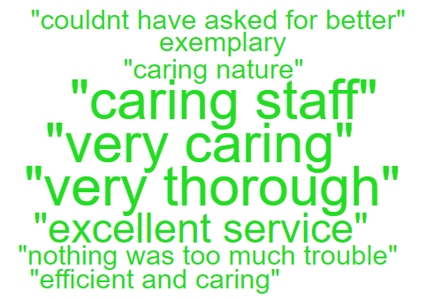
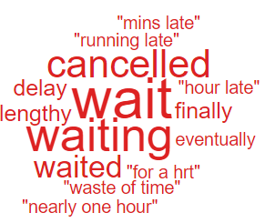
Clinical Treatment
Delay/Lack of treatment or Assessment | 127
Incorrect/insufficient treatment or Assessment | 30
Reaction to procedure/ treatment | 25
Delay/Lack of diagnosis | 20
Incorrect diagnosis | 9

Theme 2; Communication;
Communication Improvement Plan;
- New training dates to be arranged with Ombudsman trainer.
- Training prospectus advertised on intranet for all Health Board staff to book on
- Training during consultant development programme where the importance of good and clear communication is discussed.
- Complaints/communication training sessions delivered by the Corporate team to Service Groups – this training is ongoing

- Outpatient Department – Wordles relating to communication are all positive
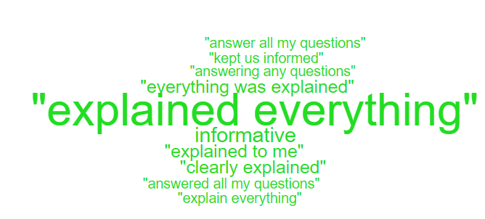

During Q4, 178 complaints were received relating to communication. A breakdown of the sub-subjects are below – please note, some complaints include more than one of these issues.
Communication Issues;
Insufficient/Incorrect information | 146
Communication with patient/service user | 19
Communication with family | 11
Communication between Services/Departments | 7

Theme 3; Appointments;
What we are doing about this?
- Outsourcing of patients to other Healthcare providers to help reduce waiting times.
- Rapid Diagnostic Centre expansion.
- Expansion of our virtual wards to widen the range of disciplines involved, so increasing the number of patients who can be treated appropriately out of hospital
All Wales questions do not have ‘appointments’ as a question set. Therefore, as an alternative a search was undertaken on the words delay/delays/appointment.
Below are some comments we found relating to ‘appointments’ for Orthopaedics:
- Delay at x-ray due to desk not manned. The radiologist took details of patients after a 25-minute wait
- The Fracture clinic was 2 hours behind and we were not informed at check in. There was no consultant and no doctors. We could hear the nurses talking who were very stressed. One doctor then saw us who barely knew the case when we were waiting for a possible cancer diagnosis, fully stressful with a child
- The service was excellent. I was only away from home for 25 hours. The driver from the non-emergency was excellent.

- You cancelled my appointment which I need urgently due to the swelling, but unfortunately you cancelled due to covid in the hospital

- I was seen quickly, lovely staff. Doctor was clear about my treatment

- Staff were polite and professional. Seen quickly

During Q4, 93 complaints were received regarding appointment issues. Many of these complaints will have more than one sub-subject, see breakdown below;
Appointments;
Delay in appointment/waiting time/transport | 66
Appointment cancelled | 18
Patient lost to follow-up | 5
Patient booked into wrong outpatient clinic | 2
Cancelled appointment/transport | 1
Location of appointment unsuitable | 1

- HIGH RISK AREAS

As part of the Health Board’s focus on Urgent Care, Planned Care and Cancer Services the following section highlights complaints received in:
- Orthopaedics
- ED
- General Surgery
- Cancer Services
Graph 1 below shows the number of complaints for each of these areas received per month since April 2023.
Graph 1: Complaints per month
As Orthopaedics has the highest number of complaints, a breakdown of the issues raised can be found below compared with Q3.

3.1 – Orthopaedic Complaint themes
Orthopaedics Themes | Q3 2023/24 | Q4 2023/24
Admissions | 21 | 28
Communication Issues | 9 | 15
Clinical treatment/Assessment | 12 | 14
Appointments | 9 | 11
Attitude and Behaviour | 1 | 2
Referral | 4 | 8
Accident/Falls | 0 | 1
Medication | 1 | 0
Nutrition/Hydration Issues | 0 | 0
Discharge | 4 | 4
Test and Investigation Results | 1 | 2

Patient Experience Feedback: Orthopaedic Services
As Orthopaedics is classed as a ‘High Risk Area’, the Patient Experience Team have investigated the feedback for Orthopaedic Services. In total, Orthopaedic Services received 311 responses to the Friends and Family Survey during Quarter 4.
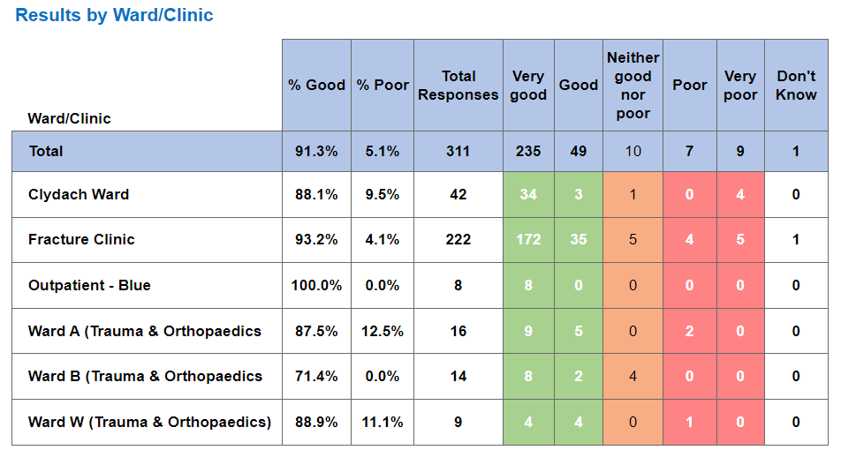

Below are the top themes for Orthopaedic services:
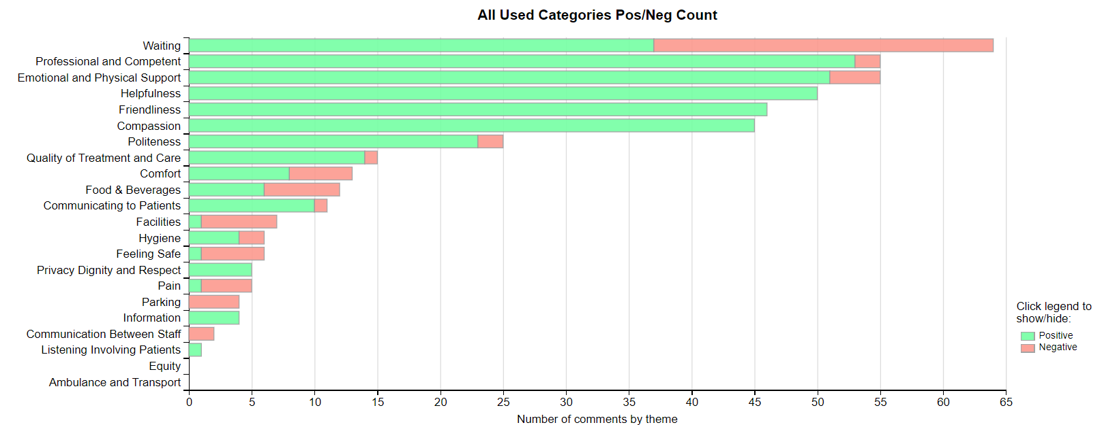
NB: The Civica system on occasions is oversensitive with the word ‘Pain’ and ‘Waiting’ and sometimes feeds these as a negative in charts and wordles. This is a national platform issue affecting all Health Boards. The overall satisfaction score is not affected by this.
Positive Themes
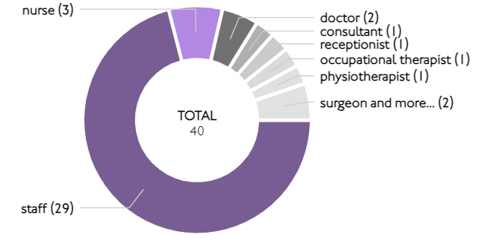
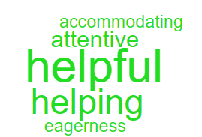
‘Helpfulness’ Sub Themes ‘Helpful’

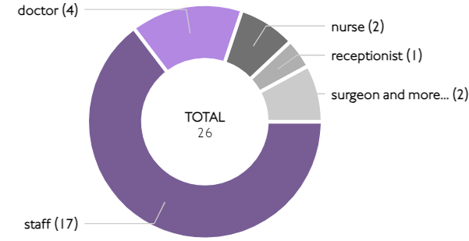
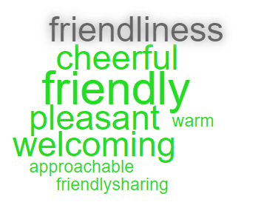
‘Friendliness’ Sub theme ;Friendly’

Here are some of the positive comments we’d like to share:
- All of the nurses on the Clydach ward were very dedicated and friendly.

- Doctor and staff very friendly and approachable.

- The friendliness of all staff, they could not do enough for me. Made me feel quite comfortable as they could.

- Fantastic care, knowledgeable staff, kind and helpful. Pre and post op care excellent. Super clean ward, pain managed well. Information well received. Lovely meals snack, bar was superb.

- Great hospital, the staff were kind & consultants were ever so kind too.

Negative Themes
The chart above highlights a few areas relating negative feedback. Here is an in-depth breakdown of these areas.

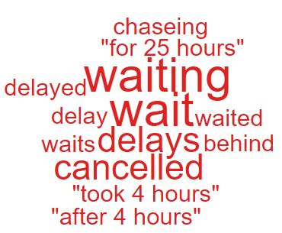
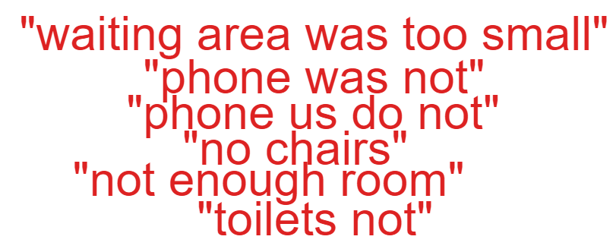
‘Waiting’ ‘Facilities’

These are the comments highlighted in the above ‘Wordles’.

- I had experienced some regular discomfort over 7weeks, lower leg was in a cast. I had repeatedly tried to ring the department inc via switchboard & the phone was not answered. I told this member of staff who then said I should have gone to a&e, something I avoided after a 26-hr inhumane wait last year.

- Clinic I attended was part of wider fracture clinic so new waiting area was too small to cope with numbers waiting. car parking also inadequate for volume of people visiting the hospital.

- My operation has been delayed and I have found the wait tiresome. I guess it’s been cancelled because there have been emergencies.

  - – ED Complaints
During Q4 of 2023/24, ED received 32 complaints, a breakdown of the issues is below
The 10 ‘clinical treatment/assessment’ complaints all relate to delays in treatment or assessment.
Patient Experience Feedback: ED Services
As ED is classed as a ‘High Risk Area’, the Patient Experience Team have investigated the feedback for ED Services. In total, ED Services received 906 responses to the Friends and Family Survey during Quarter 4.
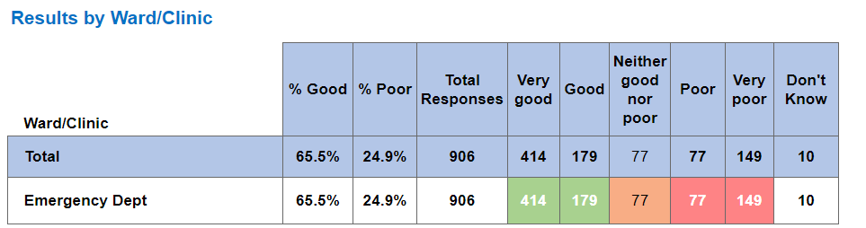
Below are the top themes for ED services:
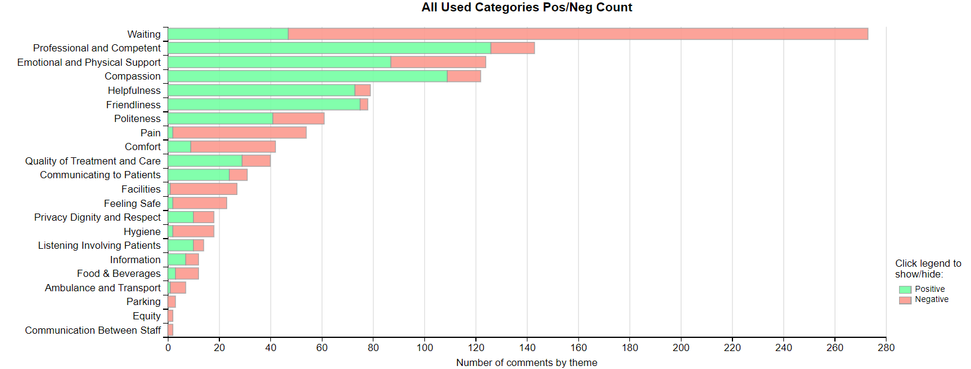
Positive Themes
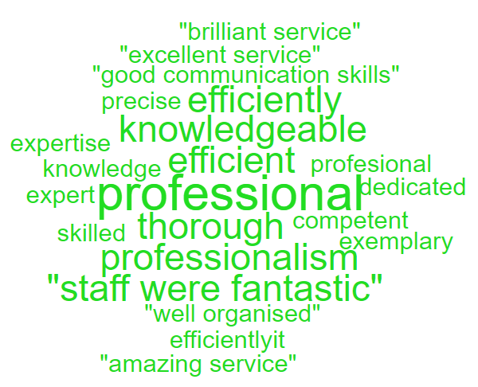
‘Professional & Competent’ Sub theme ‘Professional’
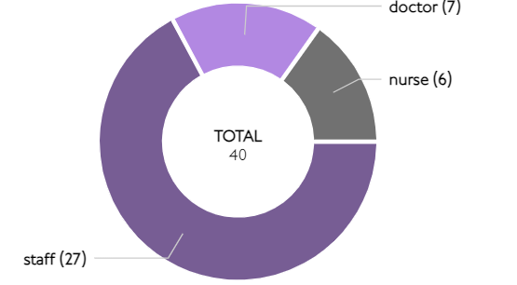

‘Compassion’ Sub theme ‘Kind’
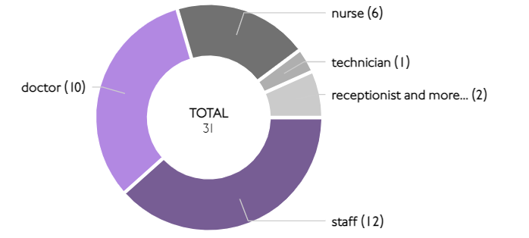
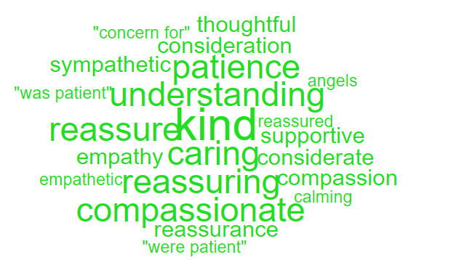

Here are some of the positive comments we’d like to share:
- The staff were extremely friendly and comforting making my A&E experience much better.

- Fabulous staff who didn’t feel you were wasting their time.
- The personnel that attended to me were courteous and professional. I also noticed this in the other staff too. The hospital environment was generally conducive.
- The receptionist was very friendly and helpful, and the nurse and consultant were very thorough and friendly !
- All staff were lovely, but the doctor really explained to me what was happening with what was going on in my body. She was fab.
- Everyone from reception to the triage nurse, health care and Dr were exceptional. They explained everything and were thorough in their assessment. Thank you.
Negative Themes
‘Waiting’
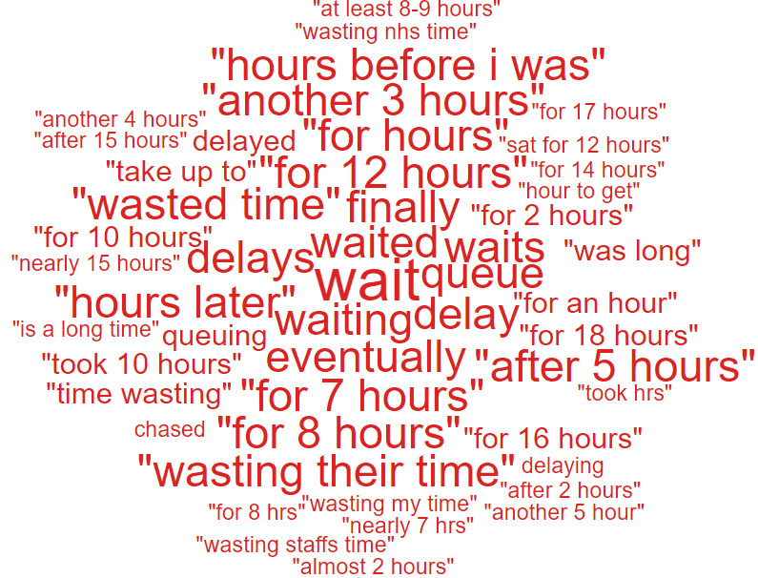

NB: The Civica system on occasions is oversensitive with the word ‘Pain’ and ‘Waiting’ and sometimes feeds these as a negative in charts and wordles. This is a national platform issue affecting all Health Boards. The overall satisfaction score is not affected by this.

Here are the negative comments relating to :
- 16 hours wait to see a doctor after a debilitating angina attack and a history of heart attack
- A ten hour wait to spend five minutes with a doctor
- Triage nurse was very impatient when I was struggling to think clearly
- Seemed a little bit disorganised at times with nurses forgetting what needed to be done next but it was very busy
- Massively it felt very disorganised after being in a car accident and having to wait several hours while people who walked in where triaged and then treated, I agree nurses and doctor/junior doctors have an incredibly difficult job, but a bit of organisation would be very beneficial, it`s hardly any wonder why people get upset whilst waiting in A&E half the time your felt forgotten

  - – General Surgery Complaints
During Q4 of 2023/24, General Surgery received 18 complaints, a breakdown of the issues is below;

Patient Experience Feedback: General Surgery
As General Surgery is classed as a ‘High Risk Area’, the Patient Experience Team have investigated the feedback for General Surgery Services. In total, General Surgery Services received 1,363 responses to the Friends and Family Survey during Quarter 4.
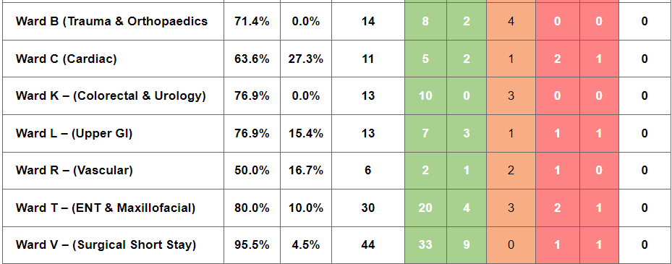
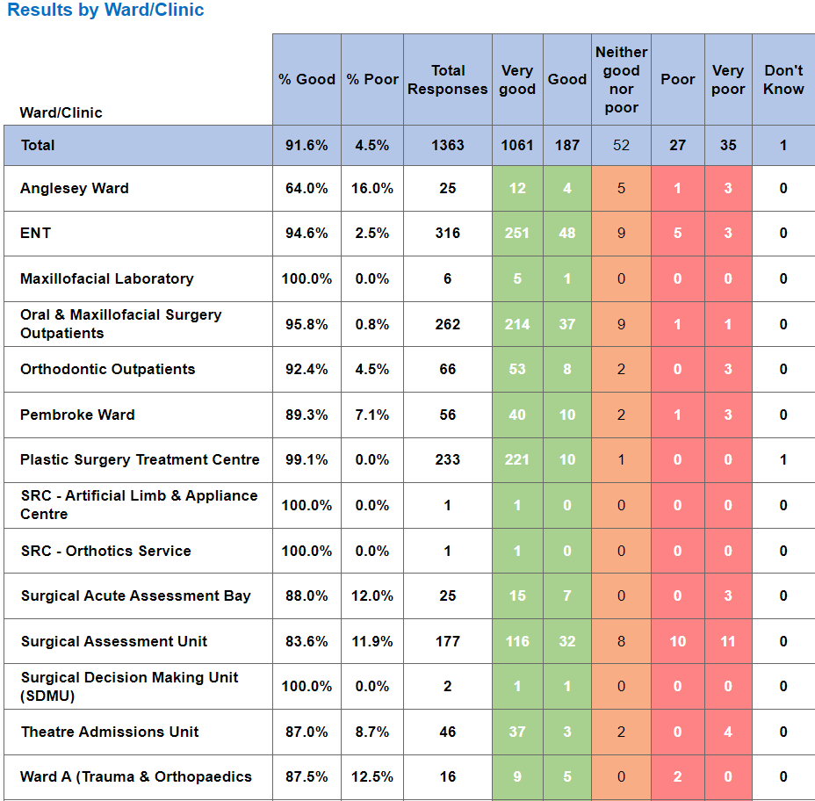

Below are the top themes for General Surgery services:
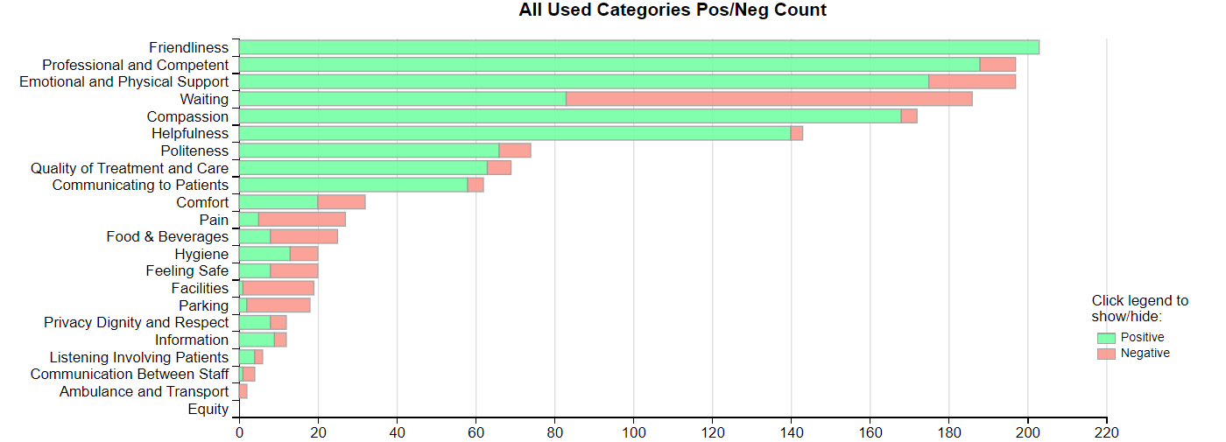
NB: The Civica system on occasions is oversensitive with the word ‘Pain’ and ‘Waiting’ and sometimes feeds these as a negative in charts and wordles. This is a national platform issue affecting all Health Boards. The overall satisfaction score is not affected by this.

Positive Themes
‘Friendliness’
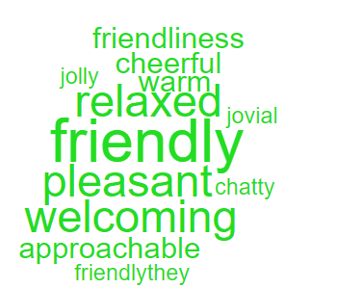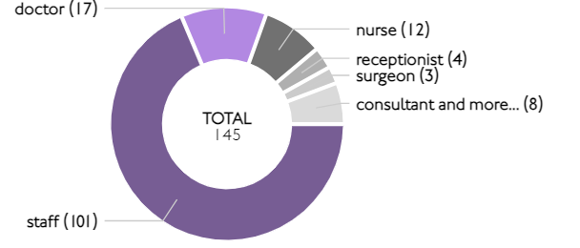

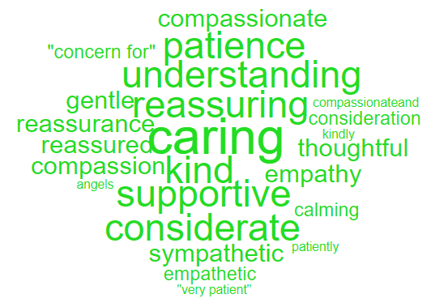
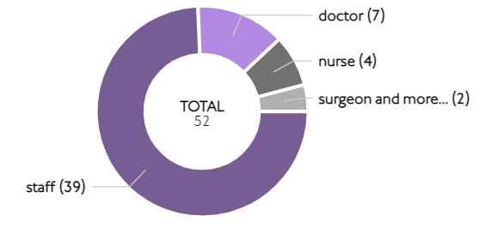
‘Compassion’

Here are some of the positive comments we’d like to share:
- The nurses and doctors are fantastic helped me so much did leave me when they know I need them
- The staff were very caring and Considerate! I was seen to rather quickly and treated immediately
- How friendly staff were. Explained everything clearly. waiting time was minimum.
- No waiting around, mum was seen as per appointment time, in fact slightly earlier. Pleasant staff and very efficient.

- The staff were friendly and I didn’t wait too long before moving to the relevant section

- The attitude of the staff was 100% . From the day I was diagnosed with cancer I am still having treatment
Negative Themes
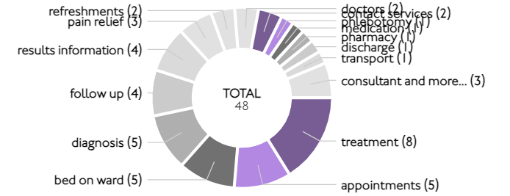
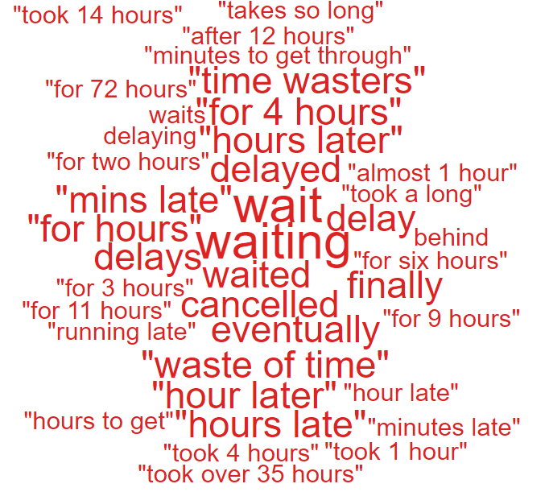
‘Waiting’

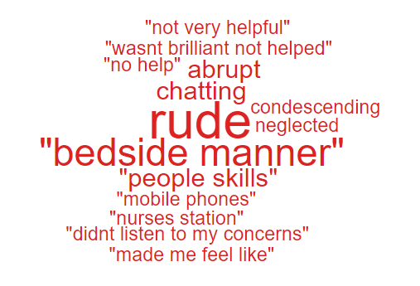
‘Emotional & Physical Support’

Below are some Negative comments relating to General Surgery:
- Keep patients in the loop. I waited 9 hours for a doctor even though there were 2 sitting in the nurse’s station.
- this surgery could have been quicker also your hospital information needs to be updated as mobile phones were stated not allowed meaning hospital staff had to make calls to relatives.
- Members of staff sitting chatting in reception area of plastic surgery department ignoring patients at counter when receptionist not in her position. very unprofessional.
- The food wasn’t very tasty.
- the ward is very noisy at night from both patients and staff had a radio on. No regard for sleeping patients. I have the utmost regard for staff who work hard.
  - – Cancer Services Complaints
Cancer complaints received in Q4 are relatively low with only 3 received therefore, there are no obvious themes.

Patient Experience Feedback: Cancer Services
As Cancer is classed as a ‘High Risk Area’, the Patient Experience Team have investigated the feedback for Cancer Services. In total, Cancer Services received 846 responses to the Friends and Family Survey during Quarter 4.
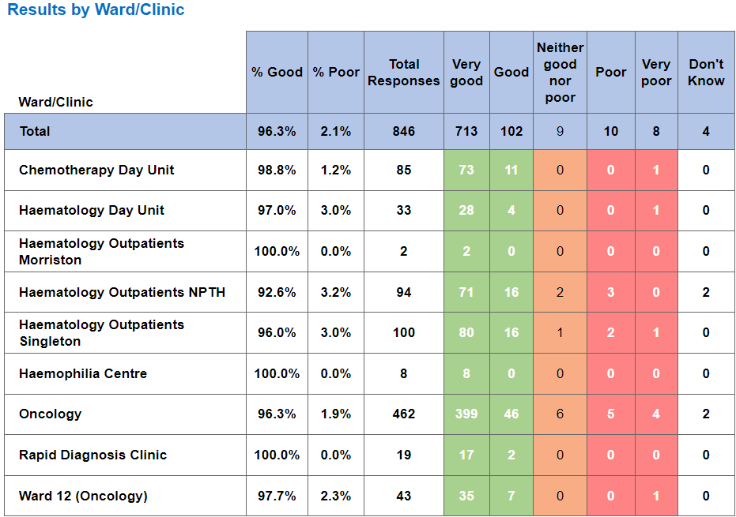
Below are the top themes for Cancer services:
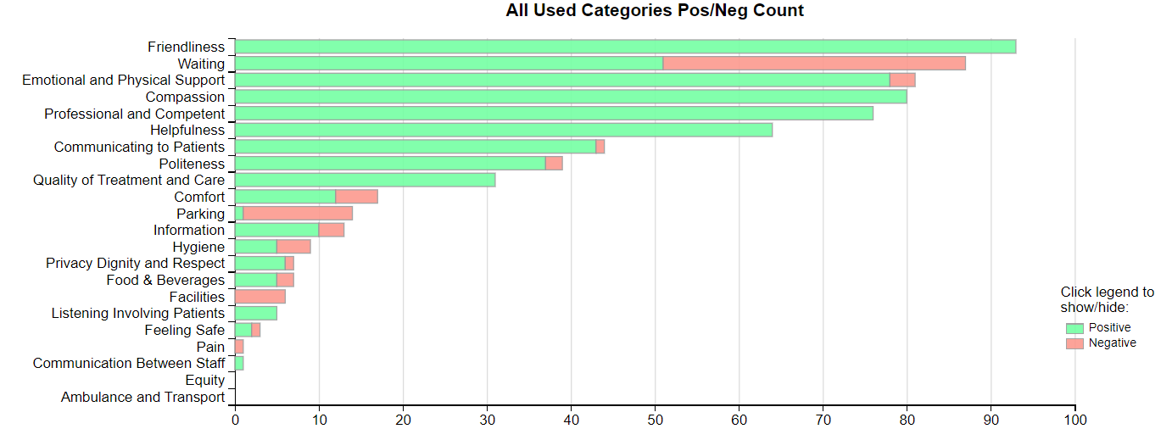
NB: The Civica system on occasions is oversensitive with the word ‘Pain’ and ‘Waiting’ and sometimes feeds these as a negative in charts and wordles. This is a national platform issue affecting all Health Boards. The overall satisfaction score is not affected by this.
Postive Themes
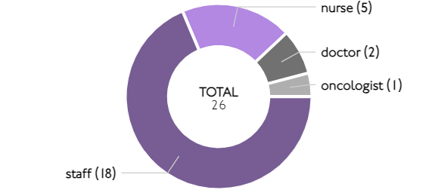
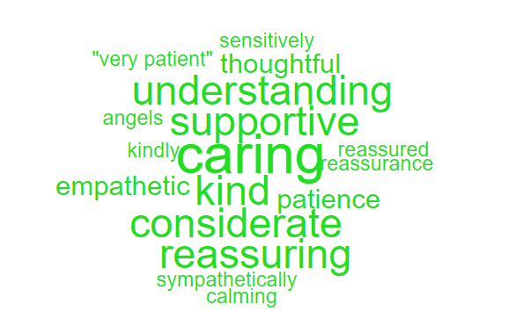
‘Compassion’

‘Friendliness’
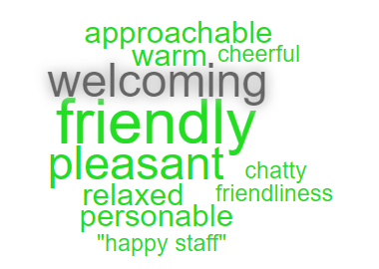
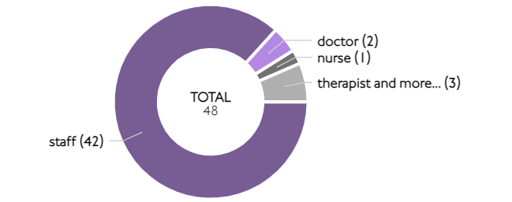

Here are some of the positive comments we’d like to share:
- The way the Dr's and nurses make you feel like nothing is too much trouble, to the receptionist making you feel welcome

- Very dedicated staff. Empathetic and very caring. Had time to listen to you.

- Everyone has been very helpful and understanding. All communication has been prompt clear. Tests and appointments have been quickly arranged.

- Exceptional overall from finding my lump, to my first chemotherapy, Dr has been exceptional, every nurse I cannot praise enough

- There appeared to be a genuine team effort by everyone in the department to get patients through , effectively and efficiently.

- I'm a cancer patient and had a concern within 24hrs had consultation with an oncologist face-to-face. You can't get better than that.

Negative Themes
Looking at the chart above it highlights comments specifically related to ‘waiting’ as negative feedback. Here are some examples of the comments written to give context.

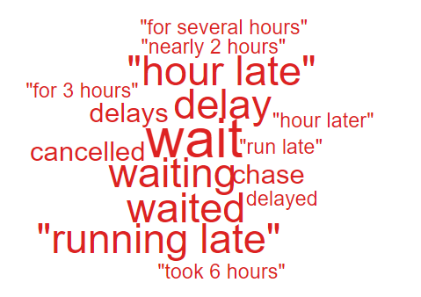
‘Waiting’
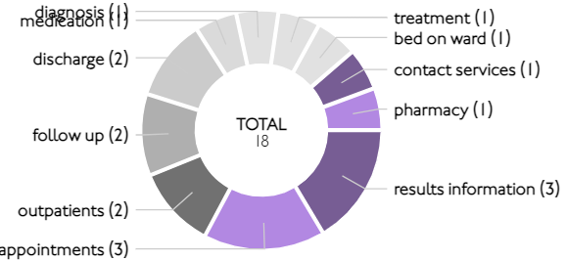

- As outpatients 2 is away from the main hospital and the wait is often quite long a coffee drinks machine would be nice
- Long wait of over 1 hour could have been kept informed what was happening
- I was waiting nearly 2 hours during tests and seeing a doctor on this occasion rather than I hour that I waited last year
- Tell people why their appointments are running late.

Nutrition & Hydration
As Nutrition & Hydration is currently one of the Health Board’s priorities, for this quarterly report please see below overview of the feedback received.
The Health Board received 12 complaints between 1st January 2024 – 31st March 2024 which involved Nutrition & Hydration issues. Please see breakdown below of what services these complaints related to;

The specific issues raised in these complaints are below (please note some of these complaints may have more than one sub-subject);
Nutrition issues;
Appropriateness of food/Dietary options | 4
Availability of nutritional supplements | 5
Patients not properly hydrated | 5

The ‘patient not properly hydrated’ issues relates to the areas below;

Patient Experience feedback – Nutrition & Hydration;

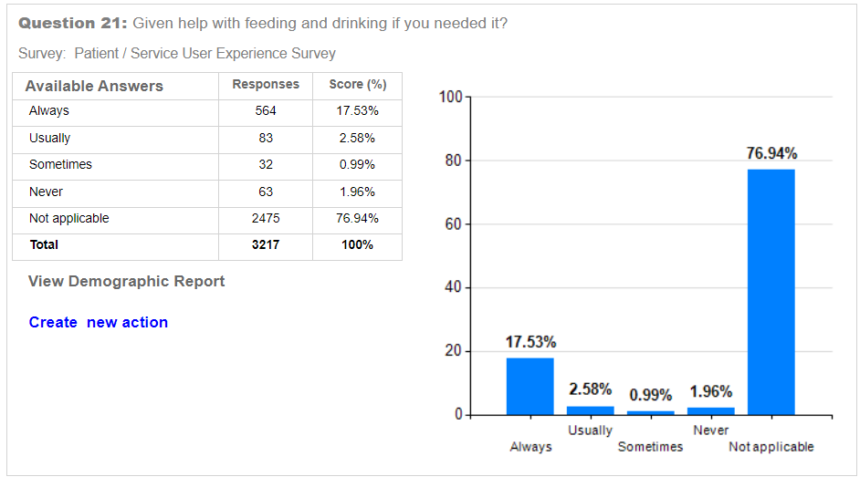

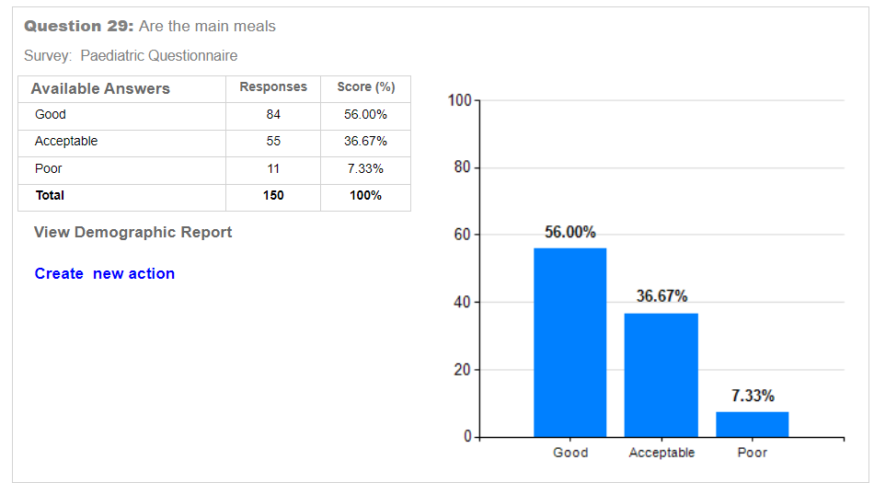
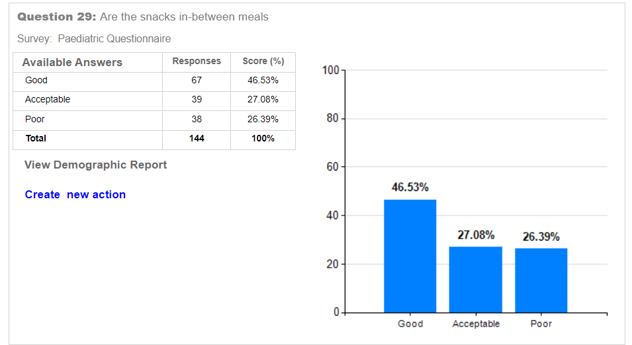
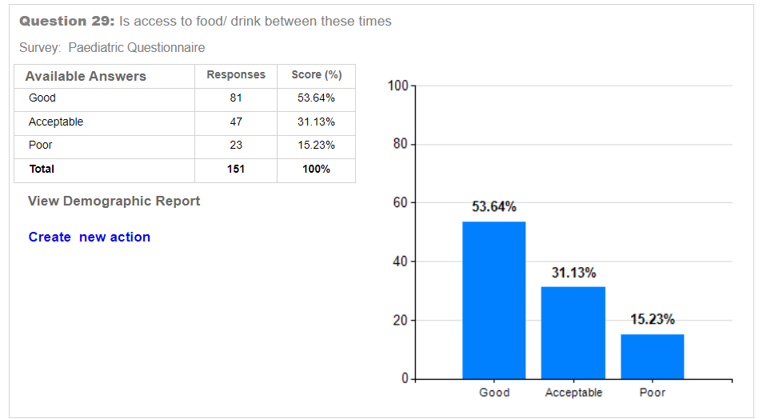
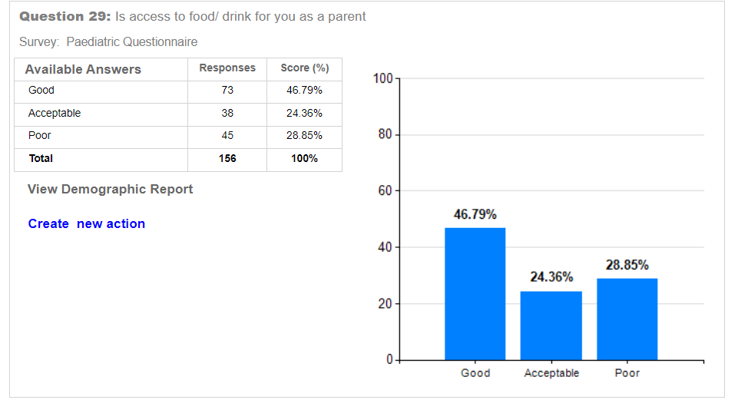
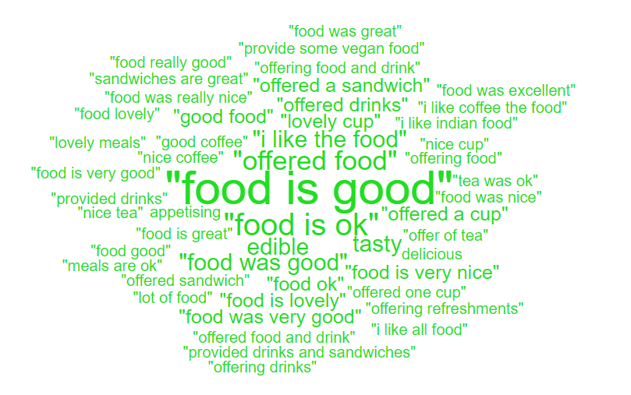

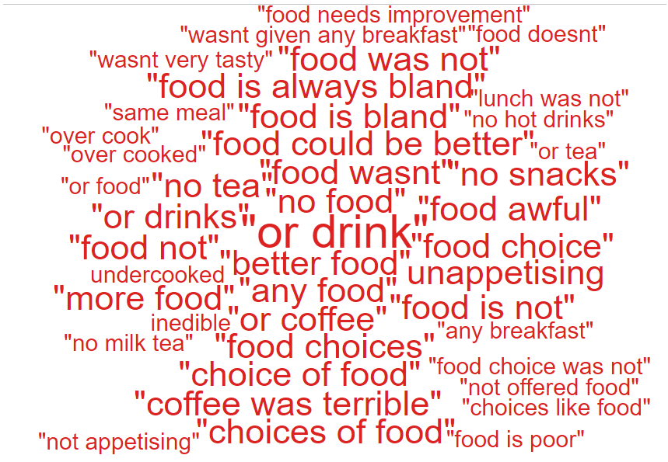
yes. the food was truly awful and a lot of the time inedible. breakfast was okay ant the roast dinners okay. soup and sandwich option when given acceptable. all other meals were over cooked unappetising and quite frankly tasteless. for one meal i was served rice which contained a large amount of uncooked raw rice grains. i appreciate that no one is admitted to hospital for the food but surely the hospital board employs a qualified cook and nutritionist who can come up with a menu that doesnt have two pasta options at the same meal time or even twice a day at different meal times.

food can sometimes look unappetising

food is bland and tasteless. improvement if cooked on the premises.

i have everything i need here. i am getting excellent care. the food is good. theres a good choice and theres always something you can eat

the staff are efficient and very attentive they respond to any requests very quickly. the food is ok and there is usually a choice

i am so pleased that everyone at the hospital helped build up my confidence. they helped me get into a wheelchair so i got my mobility back. i felt really supported here i felt at home. the food was good especially the chips
- SERVICE GROUP COMPLAINTS, INCIDENTS, COMPLIMENTS AND PATIENT FEEDBACK HIGHLIGHTS

MORRISTON SERVICE GROUP
4.1 – Morriston Service Group complaints
Morriston Service Group received a total of 200 complaints during Q4 2023/24. Graph 1 below shows the total number of complaints received relating to Morriston Service Group since April 2023. The graph breaks the total number received down by Formal PTR, Early Resolution and Re-opened complaints.
Graph 1: Morriston Service Group complaints by month and type

Graph 2 shows the top five services that had the most complaints since April 2023. Although the graph shows a reduction in Orthopaedic complaints, this is due to the change over with Service Group and Orthopaedics now sitting under NPTSSG.
Graph 2: Top 5 Services by month

4.2 – Morriston Service Group Incidents
Morriston Service Group reported 2081 incidents in quarter 4 (Q4) of 2023/24 (January, February, March). This compares with 2364 incidents in quarter 3 (Q3) of 2023/24 (October, November, December). Graph 1 shows the number of incidents per month broken down by severity.
Graph 1: Morriston Incidents by Severity and month

Graph 2 shows the top 5 incident types, of all incidents reported by Morriston Service Group since January – March 2024. As you can see from the graph, the number of ‘access to services’ incidents decreased during March. The reduction in incidents has been recognised by the Service Group although there is no apparent reason for this.

Graph 2: Top 5 incidents per month

4.3 – Morriston Service Group National Reportable Incidents
Morriston Service Group reported 8 Nationally Reportable Incidents (NRI’s) during Q4 2023/24, this compared to 8 also being reported during Q3 of 2023/24. Of the NRI’s reported, 3 x infection issues, 1 x lack of beds, 2 x clinical assessment issues, 1 x treatment/procedure and 1 x Never Event regarding retained needle/swab/ instrument/string /pack . Graph 1 shows the number of NRI’s reported per month.
Graph 1: Nationally Reportable Incidents reported per month by Morriston Service Group

4.4 – Morriston Service Group Compliments
Morriston received 279 compliments during Q4 of 2023/24. Graph 1 shows the number received per month since April 2023.
Graph 1: Morriston compliments per month

Graph 2: Morriston compliments – Top 5 Services

4.5 Morriston Service Group Patient Experience Feedback
Overall, during quarter four there were 105,122 number of patients seen under Morriston Service Group (This includes ED).

There were 8,196 Friends and Family survey returns which equates to 8% responding to the survey. Out of the 8% who responded, 90% of people stated they would highly recommend the Health Board to Friends and Family.

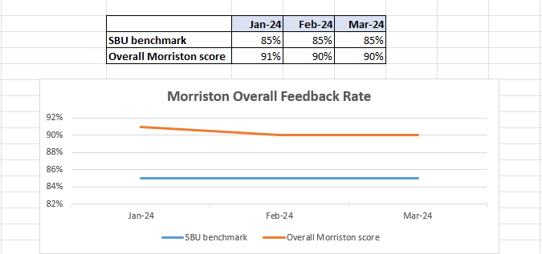

Below are the number of responses in a line graph:

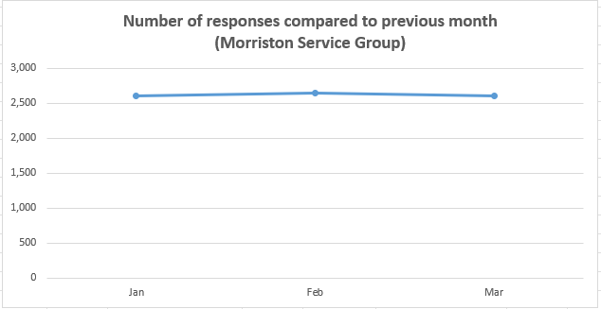
Below are the main themes mentioned for Morriston:
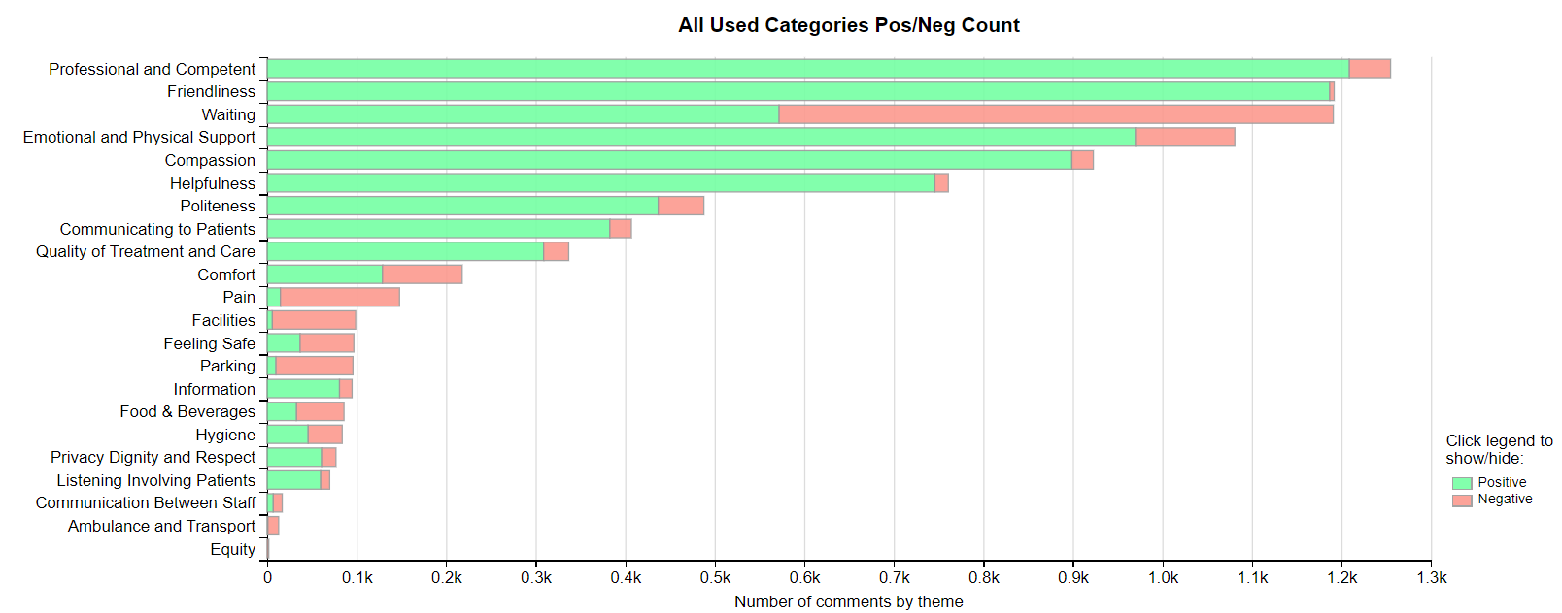
NEATH PORT TALBOT SINGLETON SERVICE GROUP
4.6 – NPTSSG Complaints
NPTSSG received a total of 241 complaints during Q4 2023/24. Graph 1 below shows the total number of complaints received relating to NPTSSG since April 2023. The graph breaks the total number received down by Formal PTR, Early Resolution and Re-opened complaints.
Graph 1: NPTSSG complaints by month and type

Graph 2 shows the top five services that had the most complaints since April 2023.
Graph 2: Top 5 Services by month

Although Orthopaedics appear to have had an increase, this is due to the change over in Service Group and the service now sitting with NPTSSG.
4.7 – NPTSSG Incidents
NPTSSG reported 1313 incidents in quarter 4 (Q4) of 2023/24 (January. February, March). This compares with 1270 incidents in quarter 3 (Q3) of 2023/24 (October, November, December). Graph 1 shows the number of incidents per month broken down by severity.
Graph 1: NPTSSG Incidents by Severity and month

Graph 2 shows the top 5 incident types, of all incidents reported by NPTSSG since January – March 2024.
Graph 2: Top 5 incidents per month

4.8 – NPTSSG National Reportable Incidents
NPTSSG reported 11 Nationally Reportable Incidents (NRI’s) during Q3 2023/24 (of which 7 related to the neonatal service), this compares to 7 being reported during Q3 of 2022/23.
Graph 1: Nationally Reportable Incidents reported per month by NPTSSG

4.9 – NPTSSG Compliments
NPTSSG received 151 compliments during Q4 of 2023/24. Graph 1 shows the number received per month since April 2023.
Graph 1: NPTSSG compliments per month

Graph 2: NPTSSG compliments – Top 5 Services

4.10 NPTSSG Patient Experience Feedback
Overall, during quarter four there were 90,332 number of patients seen under Neath Port Talbot and Singleton Service Group (includes MIU).

There were 6,710 Friends and Family survey returns which equates to 6% responding to the survey. Out of the 6% who responded, 95% of people stated they would highly recommend the Health Board to Friends and Family during this quarter.

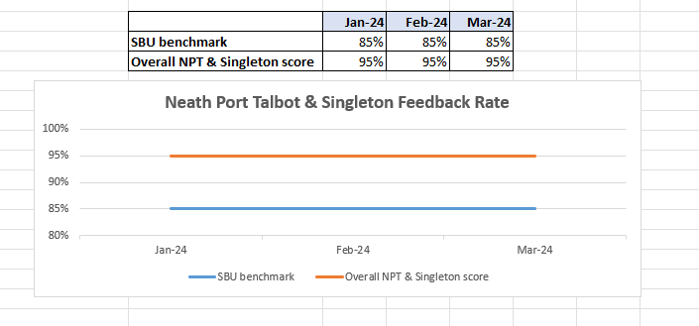

Below are the number of responses in a line graph:

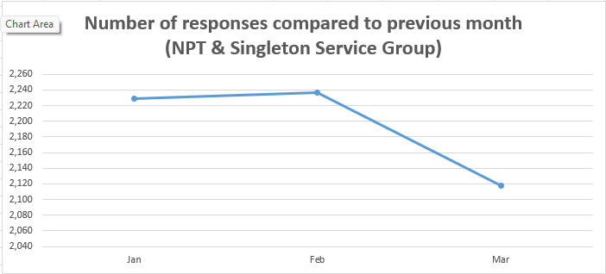

Below are the main themes mentioned for NPT & Singleton:
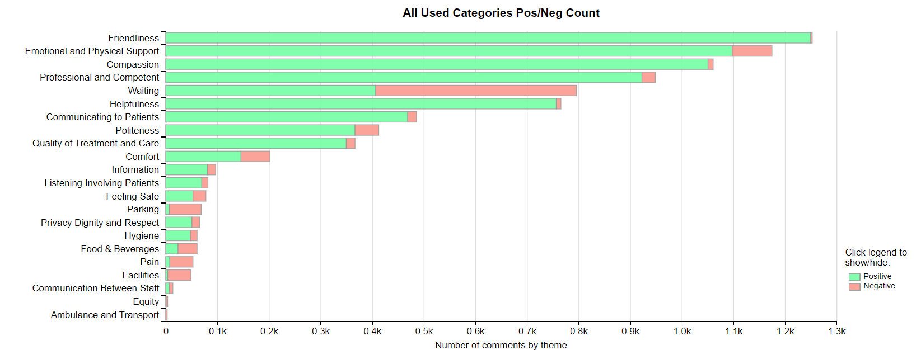
MENTAL HEALTH AND LEARNING DISABILITIES SERVICE GROUP
4.11 – MH&LD Complaints
MH&LD received a total of 75 complaints during Q4 2023/24. Graph 1 below shows the total number of complaints received relating to MH&LD since April 2023. The graph breaks the total number received down by Formal PTR, Early Resolution and Re-opened complaints.
Graph 1: MH&LD complaints by month and type

Graph 2 shows the top five areas within MH&LD that had the most complaints since April 2023. As shown in the graph, Tonna Hospital appear to have had a slight increase in complaints during March.
Graph 2: Top 5 Services by month

4.12 – MH&LD Incidents
MH&LD reported 1192 incidents in quarter 4 (Q4) of 2023/24 (January, February, March). This compares with 1192 incidents in quarter 3 (Q3) of 2023/24 (October, November, December). Graph 1 shows the number of incidents per month broken down by severity.
Graph 1: MH&LD Incidents by Severity and month

Graph 2 shows the top 5 incident types, of all incidents reported by MH&LD since January – March 2024.
Graph 2: Top 5 incidents per month

4.13 – MH&LD National Reportable Incidents
MH&LD reported 3 NRI’s during Q4 of 2023/24, 2 x falls and 1 x failure to return from leave. This compares to 2 also being reported during Q3 of 2023/24.

4.14 – MH&LD Compliments
MH&LD received 7 compliments during Q4 of 2023/24. Graph 1 shows the number received per month since January 2023.
Graph 1: MH&LD compliments per month

4.15 MH&LD Patient Experience Feedback
This data is from Quarter 4.

The Mental Health and Learning Disabilities Service Group are using a different set of survey questions. The role out of the semi structured interview surveys have been managed in stages. Roll out, awareness posters and meetings with managers and teams continues.
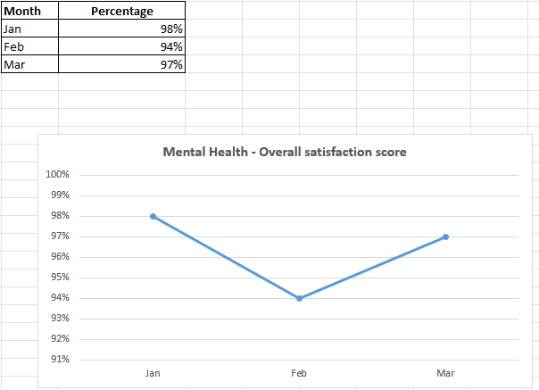
Below are the number of responses in a line graph:

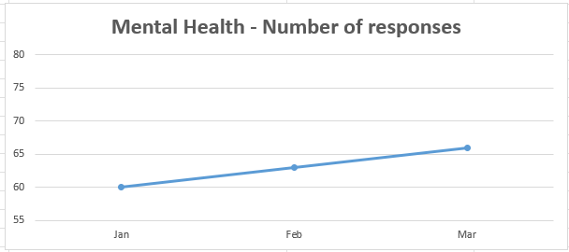

PRIMARY AND COMMUNITY SERVICE GROUP
4.16 – P&C Complaints
P&C received a total of 121 complaints during Q4 2023/24. Graph 1 below shows the total number of complaints received relating to P&C since April 2023. The graph breaks the total number received down by Formal PTR, Early Resolution and Re-opened complaints.
Graph 1: P&C complaints by month and type

Graph 2 shows the top five services that had the most complaints since April 2023. As seen in the graph, HMP Swansea appear to have received the most complaints, a system is in place whereby the Prison send their complaints to the Health Board for logging weekly. Since this process has been in place we have seen an increase.
Graph 2: Top 5 Services by month

4.17 – P&C Incidents
P&C reported 1268 incidents in quarter 4 (Q4) of 2023/24 (January, February, March). This compares with 1154 incidents in quarter 3 (Q3) of 2023/24 (October, November, December). Graph 1 shows the number of incidents per month broken down by severity.
Graph 1: P&C Incidents by Severity and month

Graph 2 shows the top 5 incident types, of all incidents reported by P&C since January – March 2024.

Graph 2: Top 5 incidents per month

4.18 – P&C National Reportable Incidents
P&C reported 2 Nationally Reportable Incidents (NRI’s) during Q4 2023/24, this compares to 4 being reported during Q3 of 2023/24. The 4 NRI’s reported included 3 x unexpected deaths and 1 x pressure ulcer.
Graph 1: Nationally Reportable Incidents reported per month by P&C

4.19 – P&C Compliments
P&C received 45 compliments during Q4 of 2023/24. Graph 1 shows the number received per month since April 2023.
Graph 1: P&C compliments per month

Graph 2: P&C compliments – Top 5 Services

4.20 P&C Patient Experience Feedback
Overall, during this quarter there were 2’586 number of patients seen under Primary and Community Service Group. There were 1,309 Friends and Family survey returns which equates to 51% responding to the survey. Out of the 51% who responded, 95% of people stated they would highly recommend the Health Board to Friends and Family during this quarter.

Patient Experience Team are currently working with I.T to automate SMS messages from the PIMS, PIMS+ platform to automate SMS survey messages to Primary Care and Therapies patients. This will increase the number of returns.

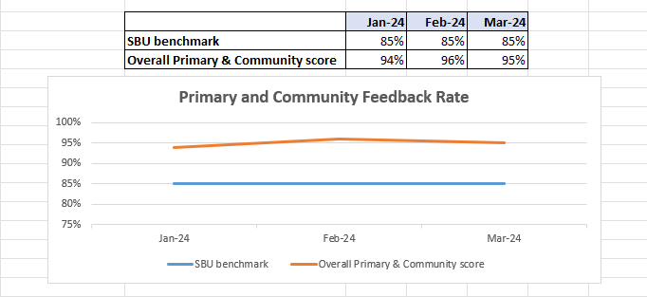

Below are the number of responses in a line graph:

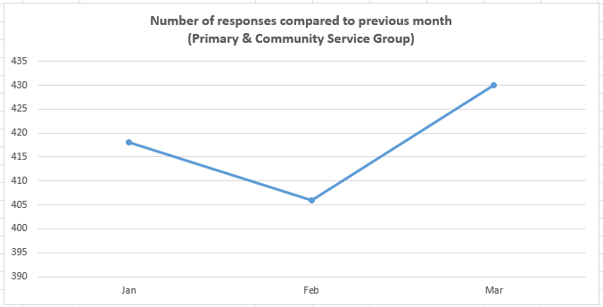
Below are the main themes mentioned for Primary & Community:
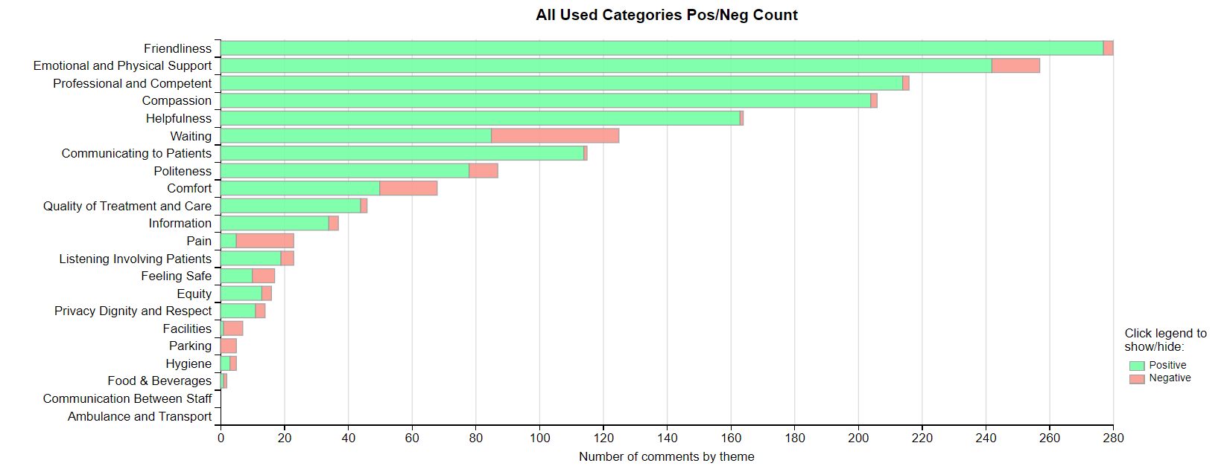
- MEDICAL EXAMINER COMPLIMENTS

5.1 ME Compliments
The Health Board has received a number of compliments from families through the Medical Examiner. This evidences the good work being done when treating these end of life patients. During Q4, approximately 174 compliments were received. A few examples are shown below;
“Care was fantastic. The staff in Ty Olwen were incredible and we would not have coped without them. They are angels.”
Ty Olwen

“The staff were amazing, they went above and beyond as a family we could not have coped without them-they looked after all of us.”
Ward 12, Singleton

“ Cannot fault anything in ED, dad and the whole family were treated with respect and dignity. Dad was treated as a human being, we all were. Palliative care was amazing. The Ambulance call handler was so lovely and amazing and even called us back after an hour. When the ambulance did arrive the crew again were amazing. Also want to thank the lady in reception in ED as we were back and fore and asking to be let in and she didn't sigh or complain once. You all do an amazing job. You couldn't do enough for us. You are marvellous, caring people.”
ED, Morriston

- OMBUDSMAN CASES

6.1 Ombudsman investigations
Five new Ombudsman investigations were received during Q4 2023/24, this compares to two in Q3 2023/24. Graph 1 shows the number of investigations received per month;

Graph 1: Number of Ombudsman investigations per month

The Health Board has also received 26 decisions not to investigate from the Ombudsman during Q4. Graph 2 below shows these by month.

Graph 2: Ombudsman decisions not to investigate

There are a number of different reasons why the Ombudsman decided not to investigate these complaints, a few of these reasons are detailed below;

- Health Board response reasonable
- Complainant not yet received response from Health Board
- Out of time
- Waiting list concern - Ombudsman not investigating as recent Public Interest recommendation is to undertake a review of the waiting list.

Ombudsman Compliance to timescales
Below is the position for Average Variance to Target for Health Board’s in April 2024. This is a measure of how Health Board’s perform against the target dates to provide evidence to comply with individual recommendations. Anything over a ‘0’ in the ‘traffic light’ formatted section is seen as days over the target date on average for the Health Board to provide compliance evidence and anything with a minus indicates the amount of days under, on average, a Health Board takes to provide evidence to comply with a target date to provide evidence to comply with a recommendation.
The NHS average for April 2024 is -8.27 compared with -2.31 in March 2024. On average compliance evidence is reaching the Ombudsman’s office nearer 8 days sooner than the target dates. However, this is likely because it’s the beginning of a new financial year and we haven’t had many recommendations falling due compared with a whole year.
Quarterly meetings have been arranged with the Ombudsman’s Compliance Officer and Complaints Standards Manager to review and discuss compliance with timescales.
Average Variance to Target March 2024 (reported 1 May 2024)
 |  | 23/24 | 24/25
Aneurin Bevan University Health Board |  | -2 | -5
Betsi Cadwaladr University Health Board |  | -2 | -5
Cardiff and Vale University Health Board |  | 0 | -12
Cwm Taf Morgannwg University Health Board |  | 2 | -
Hywel Dda University Health Board |  | -2 | -9
Powys Teaching Health Board |  | -10 | -18
Swansea Bay University Health Board |  | -1 | -1
Velindre University NHS Trust |  | 8 | -
Welsh Ambulance Services NHS Trust |  | -3 | -8
NHS Average AVT |  | -1.11 | -8.27
Ombudsman Annual Data
The Health Board is now in receipt of the Ombudsman’s annual data, the annual letter will follow. Please see below;
Local Health Board/NHS Trust | Out of Jurisdiction | Premature | Other cases closed after initial consideration | Early Resolution/voluntary settlement* | Discontinued | Other Reports- Not Upheld | Other Reports-Upheld* | Public Interest Report* | Special Report* | Total
SBUHB | 22 | 24 | 46 | 26 | 2 | 6 | 12 | 3 | 0 | 141
% share | 16% | 17% | 33% | 18% | 1% | 4% | 9% | 2% | 0%

Swansea Bay University Health Board | Complaints Received | % share
Admissions/discharge and transfer procedures | 2 | 2%
Adult Mental Health | 10 | 8%
Ambulance Services | 0 | 0%
Appointment procedures (including outpatients) | 8 | 6%
Child and Adolecent Mental Health | 0 | 0%
Clinical treatment in hospital | 55 | 42%
Clinical treatment outside hospital* | 7 | 5%
Complaints Handling | 26 | 20%
COVID19 | 1 | 1%
Continuing care | 0 | 0%
De-Registration | 0 | 0%
Disclosure of personal information / data loss | 0 | 0%
Funding | 1 | 1%
Independent Health Care providers | 0 | 0%
Medical records/standards of record-keeping | 0 | 0%
Medication > Prescription dispensing | 0 | 0%
Non-medical services | 2 | 2%
Nosocomial* | 1 | 1%
Other* | 5 | 4%
Out of Hours GP care | 0 | 0%
Parking (including enforcement and bailiffs) | 0 | 0%
Patient list issues | 6 | 5%
Poor/No communication or failure to provide information | 0 | 0%
Prisoner Care | 0 | 0%
Recruitment and appointment procedures | 0 | 0%
Referral to treatment time | 4 | 3%
Regulation and Inspection (including private sector provision) | 0 | 0%
Rudeness/inconsiderate behaviour/staff attitude | 4 | 3%
Services for People with a disability inc DFGs | 0 | 0%
Services for vulnerable adults (eg with learning difficulties. or with mental health issues) | 0 | 0%
The Ombudsman received 132 complaints received this year for Swansea Bay compared to 137 complaints received last year, the following figures are as below:
- 46 (33%) cases closed this year following consideration as opposed to 60 last year (45%) – which means no further action to be taken.
- 26 (18%) early resolutions this year compared to 22 (16%) last year – there is a drive on more of these from the Ombudsman as per the Ombudsman Plan.
- 2 (1%) discontinued this year compared with 3 (2%) last year.
- 6 (4%) not upheld this year compared with 3 (2%) last year.
- 12 (9%) reports upheld compared to 11 (8%) last year.
- 3 (2%) Public Interest Reports this year – which were the 3 Public Interest Orthopaedic Reports

Clinical treatment has dropped from 63 (46%) last year to 55 (42%) which is positive. Complaints handling complaints have increased from 16 (12%) to 26 (20%) this year. We appear to have had an increase in early settlements from the Ombudsman in relation to delayed complaint responses which would explain the increase in complaint handling complaints. Work is ongoing with the Service Groups to improve the number of long standing complaints and we hope that this will have an impact on the number taken to the Ombudsman.

