
Service Groups’ Highlight Report for
Quality and Safety Committee

Meeting Date: | June 2024
Service Group: | Primary Community and Therapies Service Group (PCTSG)
Author: | Claire Lewis, Quality & Safety Improvement Manager
Sponsor: | Sian Passey, Group Nurse Director
Presenter: | Sian Passey, Group Nurse Director
Progress Against the Quality Priorities: reduction in healthcare acquired infections; improving end-of-life care; sepsis; suicide prevention; and reducing injurious falls (as applicable).
PCTSG have developed groups and workstreams under each of the Quality Priority areas, and are currently developing a GMO approach to reporting. Reporting structures are in place with rotational reporting into PCT Quality and Safety Group.

HCAI
A detailed action plan has been developed and is currently going through approval process. The improvement plan promotes four pillars:
- Improving the culture (training and education)
- Leadership (resource and structure)
- Environment (audits and risks)
- Anti Microbial Stewardship (reduction and best practice)

12 key areas are targeted for improvement:
- Long-line collaborative project (S. Aureus reduction goal)
- Sharing best practice for wound management (S. Aureus reduction goal)
- Improving Handwashing compliance and practice
- Improving Aseptic Non Touch Technique (ANTT) compliance and practice
- IPC Newsletters and communication
- Promoting prevention of UTIs (E. coli and Klebsiella reduction goals)
- IPC Champion network
- Audits and Actions (including self-assessment of services against Professional Code of Practice for IPC)
- SMART Sampling (Antibiotic use reduction goal)
- Anti-microbial Stewardship
- C. difficile scrutiny and system reviews (C. difficile reduction goals)
- Every Contact Counts (Patient-Centric Quality Improvement)

A risk has been highlighted in relation to resource to implement and sustain the improvements outlined in the plan. The service group are currently reviewing how resource to prioritise IPC/HCAI/AMS worksteams can be supported.

Improving end of life care
A service group meeting has been established to amalgamate various workstreams in connection with end of life care. The priorities for the group under consideration include:
- scoping activities being undertaken or needed in community services
- improving the identification of people at the end of life
- ensuring people at the end of life are in the right place
- provision of medication and pain relief
- effective Advanced Care Plans (ACP)
- effective communication systems
- assessing End of Life Care in the Third Sector

The work to train end of life champions in community services and the care home sector is ongoing, as is the work to train appropriate staff to verify expected death.

The Gold Standard Framework meetings are happening in all clusters and themes and learning from those are being reviewed.

The group is now scoping how to digitally support GPs so that Palliative Care Registers and Advanced Care plans can be shared more widely in order to improve multi-disciplinary / multi-agency communication and to improve outcomes for those at the end of their life. The Specialist Palliative Care service nursing service is currently implementing an agreed improvement plan.

Pressure ulcer management
A pressure ulcer quality summit was held on 22nd February focussing on case reviews for serious incidents. The audience was health board wide and the resulting discussions are enabling the development of the GMOs for the group.

Team based fundamental of improvement training is underway to support improvement work under this priority area. This includes developing a training programme for nursing homes to improve pressure ulcer management, patient information and concordance and early interventions. The service is also reviewing the reporting process for pressure ulcers from Emergency Departments in conjunction with staff from Corporate Q&S team, and Morriston Service Group.

Falls
A falls group has been established to include representation from the Regional Partnership Board’s Older Persons workstream to scope and assess current falls prevention activities. The service group are also involved in falls / frailty projects led by the Regional Partnership Board. These activities are currently being established.

Nutrition and Hydration
A service group meeting has been established to pull together the various workstreams in connection with nutrition and hydration. This includes:
- Food tasting / food analysis review at in patient settings (Gorseinon and Ty Olwen)
- Nutrition and hydration audits and training
- Swallowing assessments
- Oral hygiene activities
- Training for care homes and health promotion activities

Initial feedback analysis from both patients and staff has revealed several challenges in relation to in-patient food, the most pressing being:
- variety, quantity and presentation of food
- ability to cater to specialist diets (eg vegan, coeliac)
- ability to provide food of specific textures (eg admissions with SLT referrals)
- ensuring 7 offers of fluid per day
- lack of audits that focus specifically on nutrition and hydration

This scoping exercise is supporting the group with prioritising the GMOs

Suicide prevention
There has been ongoing education of all staff in recognising and management suicide and engagement in the Sharing Hope project. Staff have also been provided with details on the TRiM offer. Improvement projects have been targeted at HMP Swansea quality improvement training for staff, Wales Applied Risk Research Network (WARRN) training, including train the trainer and a project scoping how to share risk information with primary care when men are released from prison.

Sepsis
Workstreams are ongoing to increase the number of patients screened for sepsis and the number of staff trained on sepsis. A project to scope NEWS and sepsis plan/policy in community settings has now finalised and work is progressing to roll this out across the community with firm escalation routes in place.

Areas of Greatest Quality Risk and Mitigating Actions
The following list includes all risks held by PCTSG scored at 20. There are currently 8 risks with a current risk score of 20 and no risks scored higher than this.

Risk and description | Trend | Mitigations
Risk 2015 – Adult level 3 weight management patients accessing the level 2 service. | ‘/-  This risk has escalated from 15 to 20 this month due to funding issues preventing progress to enhance the service. | - Group intervention being offered as first line intervention to maximise capacity in the level 2 service  - Telephone 1:1 interventions being provided for service users who are not suitable for groups  - Several members of staff trained to deliver the group intervention  - National lack of Dietetic staffing escalated to HEIW  - SBAR sent to Morriston Service group  - Risk on Morriston risk register regarding lack of L3 service
Risk 3638 – Extended waiting times for adult/paeds special care dentistry treatments. |  | - New referrals are triaged to identify clinical needs.  - Waiting lists are regularly reviewed to identified priority cases  - 2nd Harm assessment of longest waiting patients instigated.
Risk 3435 – No pharmacy technician support to Ty Olwen |  | - Prioritising key areas of pharmacy and nursing roles by nursing team  - Current ward team (Nursing, HCA and medical team) completing these tasks to a degree. However they do this in addition to their defined discipline duties and without the time and expertise of a pharmacy technician.  - Additional staff recently appointed but this has not reduced the risk score  - Bank and agency utilised
Risk 3071 (HBRR89) – Healthcare Nursing Staff levels at HMP Swansea |  | - Daily communication with the Governor about the availability and priority of healthcare nursing staff. The prison regime may be amended to reflect numbers.  - Review of skill mix and Health Board policy:  - Introduction of a pharmacy technician role who can administer drugs to support nursing establishment.  - Skill mix undertaken in the Prison to introduce Health Care Support Workers to be 2nd checkers for CD drugs and to support substance withdrawal monitoring.  - Working group being established to upskill Healthcare support workers to support the registered nurse in undertaking daytime monitoring of new arrivals who are withdrawing from alcohol or other illicit substance.  - Senior working group meetings with between Primary and community service and Mental Health Learning disability service to review clinical pathways.  - Bank and agency staff are used in a limited way when skillset allows.  - E-roster implemented and scrutinised with regular reporting to Quality and Safety and Prison Partnership Board.  - Escalation for overtime and additional hours to fill shortfalls.
Risk 3221 – Impact of case management responsibility to Therapies |  | - Capped the number of cases allocated to Therapies  - No new cases allocated  - Peer supervision  - Training  - Skill mix review  - Use of overtime / additional hours  - B4 navigator role to be explored  - Guardian service and Unions support  - Therapies to meet with Finance to explore options with regard passing finance for case management back to MHLD service group
Risk 1587 (HBRR61) – Parkway Clinic | This risk is scored as 20 on the Service Group Risk Register and 16 on the HBRR. This has been escalated for discussion at Corporate Risk Scrutiny Panel | - Consultant Anaesthetist present for every General Anaesthetic clinic.  - Assurance Documentation supplied by Parkway Clinic including confirmation of arrangements in place with WAST and Morriston Hospital for transfer and treatment of patients  - New care pathway implemented - no direct referrals to provider for GA.  - Multi -drug sedation ceased from Sep 2018 in line with WHC 2018 009  - Revised SLA/Service Specification  - HIW Inspection Visit Documentation provided to HB  - All extended GA cases require approval from paediatric specialist prior to treatment
Risk 3095 – Risk to assurance activities |  | - Prioritisation of workload and reduced activity in some assurance processes  - Escalation of concerns  - SOPs to support services carry out some activities  - Workplans, template agendas and reports for meetings  - Service and Head of Service reporting in place  - Reinforcement of work/life balance for team  - Workforce review still required
Risk 3101 – Security of Tenure of GMS premises |  | - NWSSP SES providing advice and Partners to seek independent legal advice.  - Liaison with practice continues as part of relocation proposal discussions.  - HB chaired meeting between parties to address and mitigate risk of eviction. Work to quantify necessary repairs and maintenance underway.  - Alternative site paper presented to SG MB, viable alternative still being scoped.

Patient Experience Update
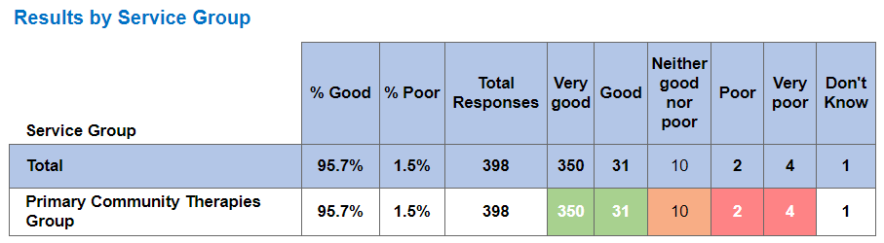

PCTSG are consistently receiving over 90% positive feedback. Although we are increasing in numbers of feedback returned, it is acknowledged that we need to strengthen feedback mechanisms for patients using primary and community services. A pilot of automating feedback requests following a consultation on PIMS has been successful in the Speech and Language Service and this is currently being rolled out to other services in PCTSG. A roadmap and plan is in place for roll out across other services; IT resource is limiting the speed at which this can be rolled out.

CIVICA automatically identifies the words ‘waiting’ and ‘pain’ as negative responses on reporting even though the statements may be positive. The patient experience team are aware of this issue and have a manual filter in place, so although this feedback is marked as negative, the comments are highlighted for services to review the positive statements.
Examples are provided below:

- kind caring informative l felt as if I was in good hands I wasn’t kept waiting.
- I had to wait for long to be seen by a specialist physiotherapist because my appointment on that day was cancelled without informing me. the specialist kindly offered a slot to see me otherwise i had wait for another appointment for maybe another few months.
- parking took a long time more spaces needed.
- we appreciate you calling and speaking to management for equipment. finally we are getting a second steady.
- nothing it probably saved my life and I’m so so grateful to the pain nurse for listening to my problems after horrific experience with GP I have a new found faith in the service
- compassionate and very kind lady helped me understand the mechanics of pain and gave me great advice in managing the pain and lowering the main painkiller I use to avoid the side effects and still get effective pain relief.
Staff Experience Update
A Senior Professional Nurse Advocate (PNA) role has recently been developed for the district nursing and wound care nurse teams. This role will offer support and guidance to nurses, supporting their wellbeing and strengthening the workforce. A survey sent out to the 340 nurses working within these teams dentified that only 43% of responders felt well supported in their role. The PNA has now commenced restorative clinical supervision sessions with the nurses to offer support and try and address any issues. Feedback from the restorative clinical supervision sessions have been positive, as can be seen in the graph below, with almost all attendees finding the sessions a safe space to discuss thoughts and feelings, and supportive for staff well being.

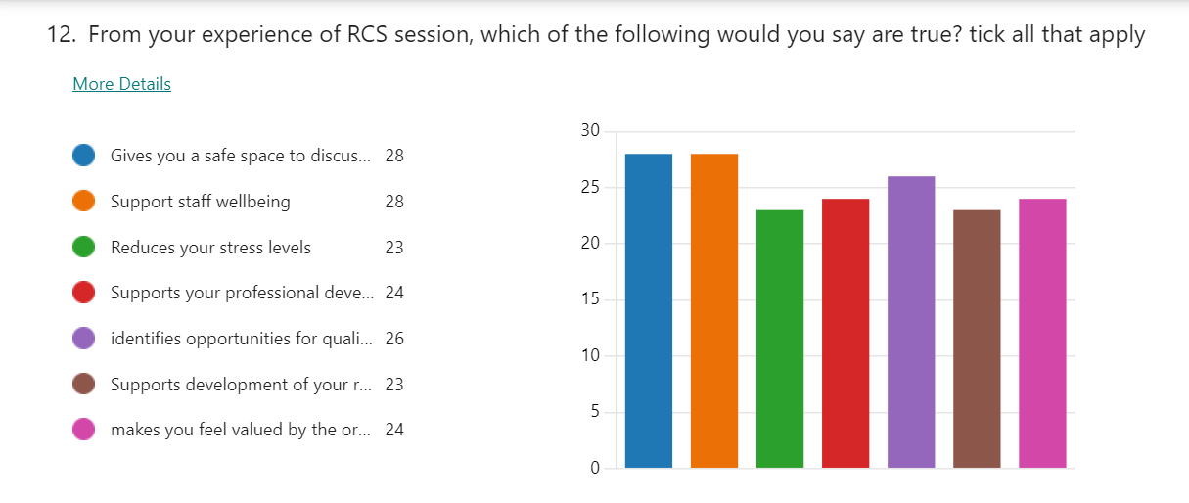
The feedback from the restorative clinical supervision sessions also indicate that this intervention may have a positive impact on staff remaining in work, as can be seen in the graph below.

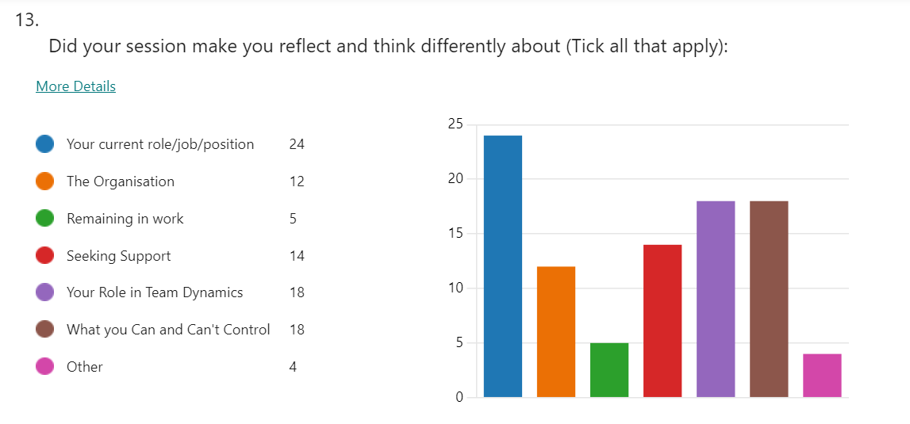

The NHS Wales Staff Survey 2023 was open for all employed staff from 16th October 2023 for a total of 6 weeks for electronic, phone submissions and paper copies, available to those staff who struggle with digital access. The survey has been co-ordinated centrally from HEIW, and has a different vision and approach compared to previous years. Collaborative working with Staff Networks and Trade Union Partners, as well as organisational leads has been at the centre. On the 4th December 2023, the final count of responses to the national survey was 2,625 (18.8%) for SBU HB. The full data set is expected to be released to PCTSG by the end of July 2024. It is envisaged that the local HR Business Partner team will then analyse these results and develop an action plan working together with senior management and trade unions. This work will be reported through the PCTSG Quality and Safety structures.

Llais Wales Reports and Action Logs
No Llais reports received.

Recommendations
The Q&S Committee members are asked to note the contents of this report.

Service Groups’ Health and Safety
Highlight Report

Summary of Health and Safety key issues since the last report to the Committee
(Reporting period: to )
Clarity on the definition of H & S risks, so cleanse and up-to-date action log can be provided.
Ongoing concerns re impact of estates on H & S
Additional assurance meeting diarised for June as several reports in May were outstanding
Challenges, Risks, Mitigation and Action being taken relating to Health and Safety issues noted above (what, by when, by who and expected impact)

Cleansed action log underway
Review of risks underway
Developing deep dive work programme
Additional assurance meeting scheduled for June

Performance Progress to include: Statutory and Mandatory Training; PADR compliance; Serious Incidents; Staffing and Sickness Levels;

PADR Compliance (03.06.24) – 85%
Mandatory Training Compliance (30.05.24) – 93%

Governance and Risk Issues to include risks relating to Health and Safety on the risk register
H&S Risk register from January to March.
Current issues for 2023-24 for the Attention of the Committee
As above
Recommendations
Members are asked to:
Note the progress made to
Develop a clear work plan around priority themes
Implement improved action log
Work underway to improve risk management

