Incidence/100,000 population | Incidence/1,000 admissions
C. difficile infection: Chart 1 | Staph. aureus bacteraemia: Chart 2
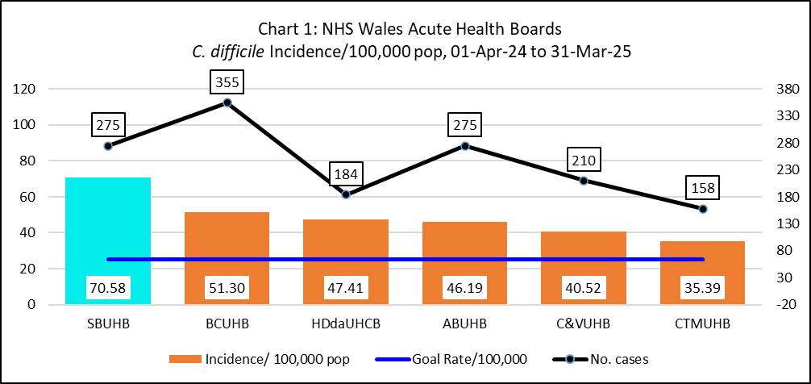 | 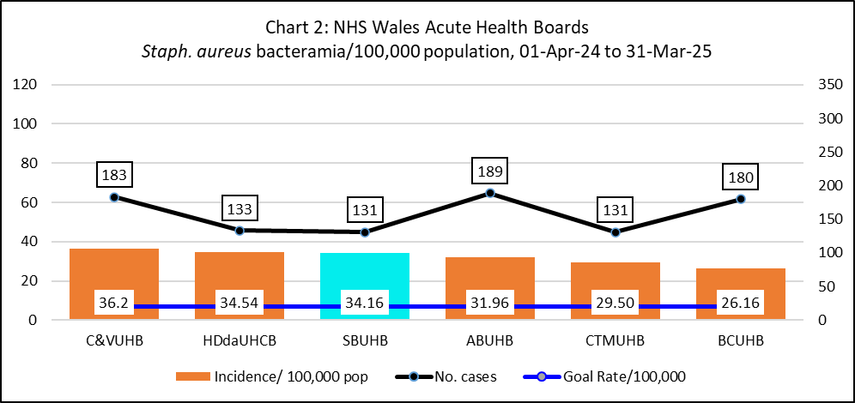
E. coli bacteraemia: Chart 3 | Klebsiella spp. bacteraemia: Chart 4
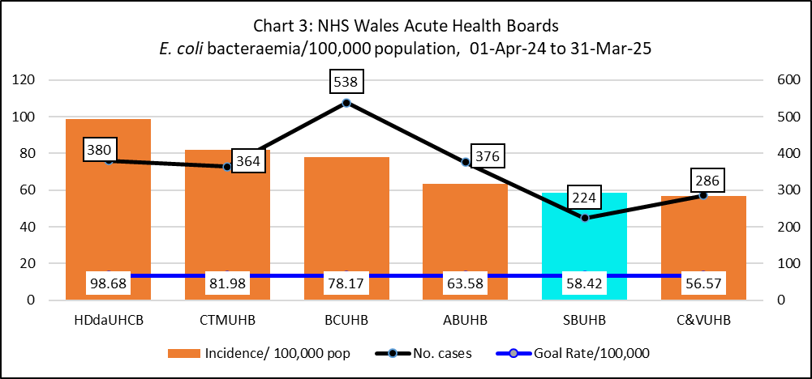 | 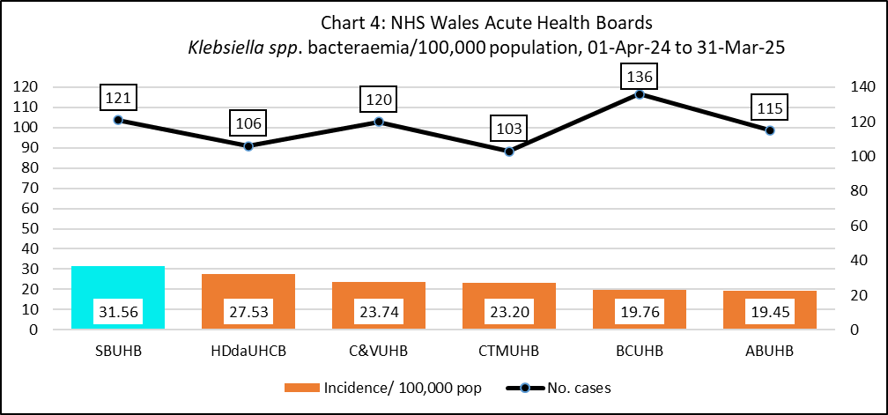

Incidence/100,000 population
Pseudomonas aeruginosa bacteraemia: Chart 5
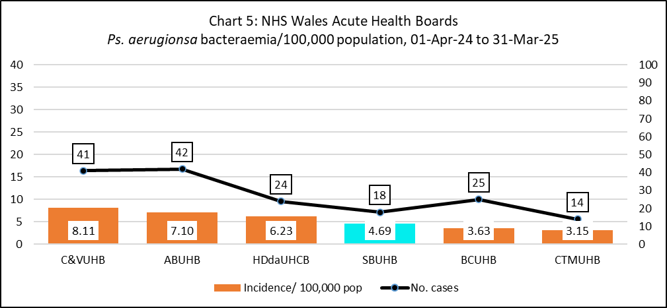

Comparison of C. difficile infection rates per 100,000 population in NHS England and NHS Wales, Financial Year 2023/24
