C. difficile
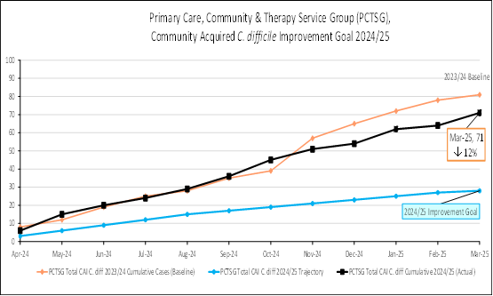 | 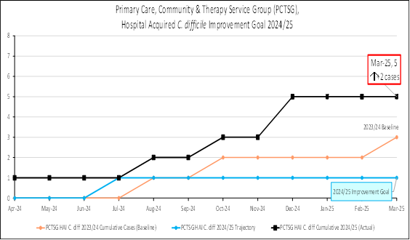
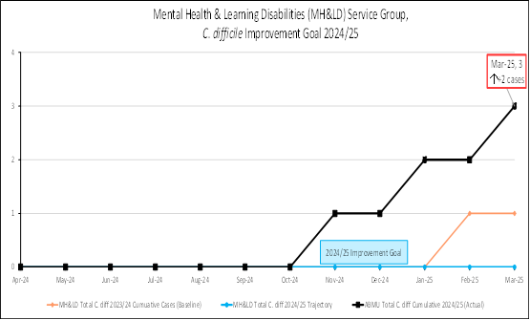 | 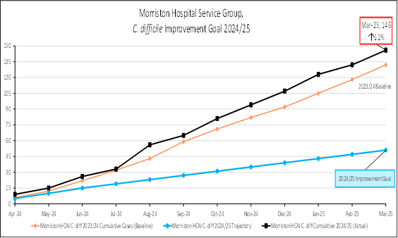
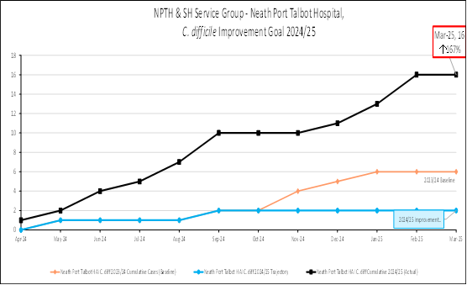 | 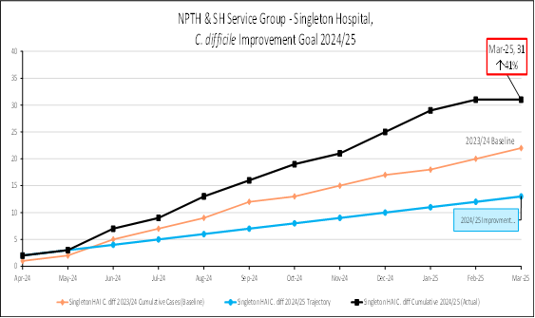

Staph. aureus bacteraemia
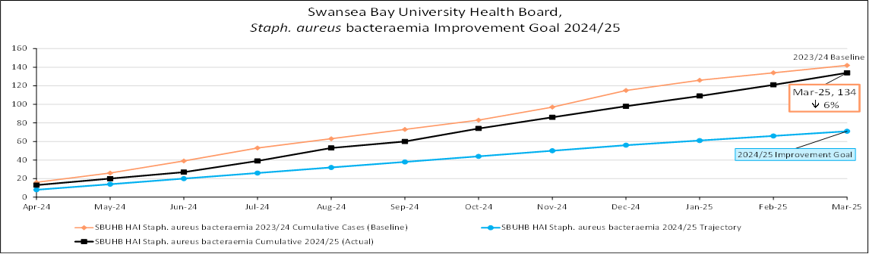
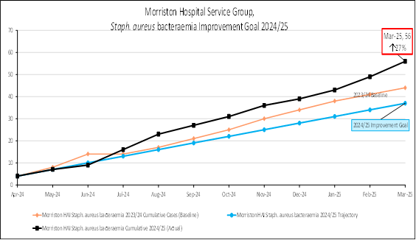
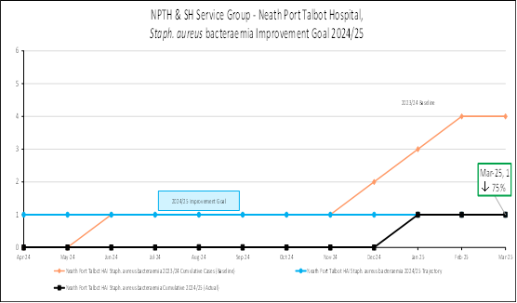

E. coli bacteraemia
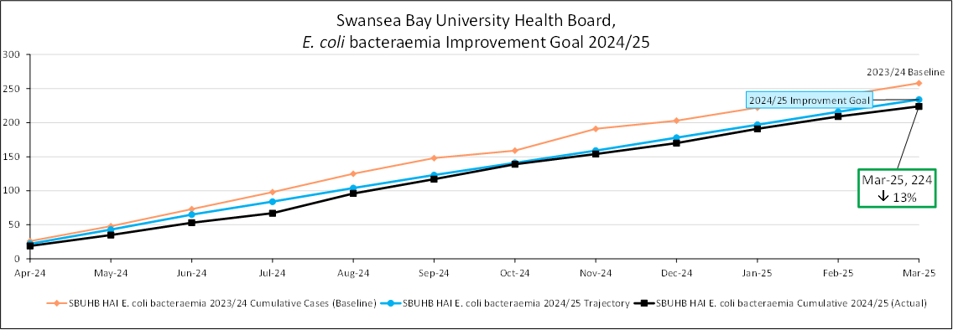
Klebsiella spp. Bacteraemia

Pseudomonas aeruginosa bacteraemia

Table 1: Service Group Annual Comparison to end of March 2025
 | CDI | SaBSI | EcBSI | KlBSI | PAER BSI
SBUHB - Total | 276 (↑10%) | 134 (↓6%) | 224 (↓13%) | 120 (↑28%) | 18 (↓14%)
PCTSG - CAI | 71 (↓12%) | 49 (↓22%) | 119 (↓5%) | 39 (↓17%) | 6 (↑50%)
PCTSG - HAI | 5 (↑2 cases) | 2 (↑2 cases) | 1 (↓1 case) | 1 (=) | 0 (=)
MH&LD – HAI | 3 (↑2 cases) | 0 (=) | 2 (↑2 cases) | 1 (↑1 case) | 0 (=)
MORR – HAI | 146 (↑11%) | 56 (↑27%) | 60 (↓26%) | 50 (↑47%) | 9 (↓10%)
NPTH - HAI | 16 (↑167%) | 1 (↓75%) | 9 (↑13%) | 6 (↑100%) | 1(↑1 case)
SH - HAI | 31 (↑41%) | 21 (↓25%) | 23 (↓23%) | 18 (↑125%) | 5 (↓60%)
Other HB Cases Identified in SBUHB | 4 cases | 5 cases | 10 cases | 5 cases | 0 cases

