Meeting Date | 26th July 2023 |  | Agenda Item |  |  | 4.2
Report Title | Quality and Safety Group Quarterly Report
Report Author | Angharad Higgins, Head of Quality and Safety
Report Sponsor | Hazel Powell, Deputy Director of Nursing and Patient Experience  Gareth Howells, Director of Nursing and Patient Experience
Presented by | Angharad Higgins, Head of Quality and Safety
Freedom of Information | Open
Purpose of the Report | To provide a Chair’s update on the Quality and Safety Group meeting of 20.6.23 and to brief Quality Management Board and the Quality and Safety Committee on progress on quality and safety work streams across the Health Board.
Key Issues | - Highlight report from Quality and Safety Group meeting 20.6.23  - Internal audit governance review of quality governance structures gave reasonable assurance  - Launch of Room 101 initiative to remove safety clutter  - Emergency Medical Retrieval and Transfer Service update  - Children’s Community Nursing Team action plan update received  - Thematic review of HIW reports presented to Patient Safety and Compliance Group  - Quality Priority monthly progress report.  - Falls rates per 1000 bed days remain below national averages.  - End of Life Care internal audit report gave reasonable assurance and National Audit of care at End of Life found improvements  - Sepsis: increased engagement and quality improvement activity within Morriston. Improvements in numbers of patients appropriately screened required in all areas, but particularly Neath Port Talbot Singleton  - Suicide Prevention- Sharing Hope project engaged with over 600 staff and shortlisted for HSJ award  - Duty of Quality Implementation update, implementation on track.  - Quality Strategy Implementation Plan update for Quarter 1, no items off track.  - Quality dashboard available in beta form, full version available for Quality and Safety Committee by Quarter Three.
Specific Action Required  (please choose one only) | Information | Discussion |  | Assurance | Approval
Specific Action Required  (please choose one only) | ☐ | ☐ |  | ☒ | ☐
Recommendations | - The group are asked to approve of the revised terms of reference for Clinical Outcomes and Effectiveness Group.  - Neath Port Talbot Singleton Service Group are required to strengthen their quality improvement and audit activity in relation to Sepsis.  - Implementation of the Duty of Quality and our Quality Strategy include actions for individuals and services across the organisation in order remain on track and members of Quality Management Board are asked to engage in this process.

- Highlight Report from Quality and Safety Group

Name of Reporting Group | Quality and Safety Group (QSG)
Date of Last Meeting | 20.6.23
Author | Angharad Higgins, Head of Quality and Safety
Summary of the Meeting
Room 101
A new initiative to reduce safety clutter across the Health Board was shared. The project provides staff with an opportunity to nominate practices or systems that impede the delivery of good quality care. Nominations will then be reviewed with a view to them being safely removed.

Emergency Medical Retrieval and Transfer Service
Quarterly assurance report received. The service reported completion of their Quality Delivery Framework for Quarter 1. The outcome of the strategic review of their services will be shared in their next report. Full report available on request.

Internal Audit review of Quality Governance Framework
The final report from the Internal Audit review was shared, noting reasonable assurance. The management action plan is on track and will be complete by September 2023. Full report included as Appendix 1.

Update on the improvement plan for the Children’s Community Nursing Team
An update report was received, giving assurance that the actions developed from the external review are on track. A follow up review is underway and the outcome of this will be reported to QSG. Routine monitoring of the action plan is undertaken within Neath Port Talbot Singleton’s quality and safety structures. Full report available on request.

Wales Fertility Institute (WFI)
A verbal update was received regarding the Gold Command Group in place to oversee WFI. Neath Port Talbot Singleton service group has established a weekly improvement group to support the service in providing assurance to the Human Fertilisation and Embryology Authority on the concerns they raised as part of their January inspection. Actions were reported as being on track. A full written report will be provided to the next meeting.

Mental Health and Learning Disabilities Review Based on the Edenfield Panorama Programme
The service have conducted a comprehensive review based on the learning from the Edenfield Panorama programme. The review provided assurance that none of the issues described in the programme were occurring in our care, but areas for improvement were identified. It was recognised that learning from the review applies to all aspects of our care and this will be presented in a Patient Safety Congress event.
Sub-Group Reports
The Patient and Stakeholder Experience Group’s June meeting was cancelled due to Industrial Action

The Patient Safety and Compliance Group reported that they had received a thematic review of learning from Health Inspectorate Wales (HIW) reviews and that this was being shared within service groups to support learning across the organisation. Issues were escalated in relation to incidents of violence and aggression towards staff and a focussed session discussing this will take place in QSG in September. Compliance with Patient Safety Notice PSN055, (which relates to the safe storage of medicines) was discussed, a task and finish group has been established to agree how to manage our response to this notification. The group also escalated concerns within Morriston Service Group regarding compliance with the Duty of Candour. This is being considered as part of a wider review governance structures.

Clinical Outcomes and Effectiveness Group (COEG) terms of reference received and approved. In was reported that audits plans within service groups appear well managed and realistic in their aspirations.

Safeguarding Report SBUHB have been involved in a Child Protection Rapid Review involving Swansea Child and Family Services undertaken by Care Inspectorate Wales, a brief summary of themes and findings will be published in June/July with a full national report being published in September 2023.

Quality Priorities Programme Board meeting postponed due to not being quorate. Next meeting July 2023.

Service Group Escalation not Previously Reported to Sub-Groups
Mental Health and Learning Disabilities no issues to escalate
Morriston National Safety Standards for Invasive Procedures (NatSSIPS 2) to be on July’s QSG agenda. Looking at soft launch in during summer months by event in September/October
Neath Port Talbot Singleton no issues to escalate
Primary Care Community and Therapies no representative in meeting

Key Decisions
- Receipt of Internal Audit review of governance and associated management action plan
- Approval of revised terms of reference for COEG.
Challenges, Risks and Mitigation
Duty of Candour Delivery of the Duty of Candour was escalated by service groups. Compliance with the Duty is monitored through the Patient Safety and Compliance Group.

WFI requirement to provide comprehensive assurance to the HFEA and the service commissioners, Welsh Health Specialised Services Committee (WHSSC). Weekly contact with WHSSC and updates to HFEA in line with their reporting requirements. Weekly WFI improvement group meeting and monthly Gold Command meetings in place.
Action Being Taken (what, by when, by who and expected impact)
Duty of Candour There is a wider piece of work being led by the Acting Director of Corporate Governance and Deputy Director of Nursing to look at quality resources across the organisation which will include looking at our capacity to deliver the Duty of Candour. In the short-term, the Health Board lead for the Duty of Candour is reviewing ‘hot spot’ areas in order to provide more targeted training and support to these teams.
WFI HFEA action plan on track and to be submitted to the HFEA by 18.7.23. This is being led by the Group Medical Director and Interim Head of Nursing within Neath Port Talbot Singleton Service Group. Post Meeting Note: WHSSC have advised that the service is to be placed at Level 3 escalation.

- Quality Priority Monthly Update Report

Members are asked to note that this reporting format is under revision and a ‘report on a page’ style report will be introduced from September 2023.
Falls Prevention

Quality Priority Goals | Methods
Falls Prevention  Reduction in harm from falls  ‘ | - HB Falls scoping exercise completed – Gap analysis to be completed with OFPSG 6/7/2023  - Improved Quality Assurance through new audit programme – OPMH has completed all sites  - Falls Policy updated – out for consultation and feedback  - Focus on Reconditioning as pan health board approach – plan agreed with service groups. Reconditioning environmental audit currently being completed – ACTIVE August launch next month with social media campaign.  - Falls Prevention Summit 2023 Part 2 18/9/2023 to coincide with Falls Awareness Week
Measures | Trajectories
- Falls per 1000 bed days | 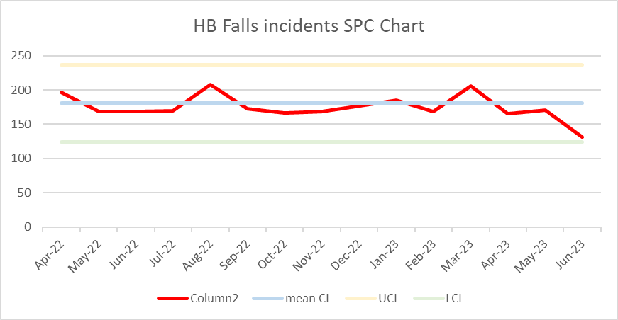
- Continued reduction in overall falls rates with significant drop off during June
- Development of Health Board Falls Strategy in progress
- Safe Care collaboration project progressing well with good engagement from local authority colleagues
End of Life Care

Quality Priority Goals | Methods
End of Life Care  Increase proportion of Swansea Bay residents receiving the right care at the right place at the right time in the last year, months, weeks, days of life | - Increased correct identification of people who may be in the last year of life  - Increase Advance & Future Care Planning across all care settings  - Increased correct identification of people who may be in the last days of life  - Increase the number of staff given education and training to support high quality EOLC  - Identify and produce systems that support sharing of advance and future care planning across all care settings
Measures | Trajectories
- % Swansea Bay UHB resident deaths outside of hospital – this measure may change due to ONS license issues nationally  - % of patients on the Palliative care register  - Number of advance & future care plan notifications in WCP  - Number and % of deaths reviewed by the medical examiner with a care decision guidance document  - % of deaths within 48hrs of emergency attendance  - Number of staff given education and training in EOLC  - Systems enabled to share end of life care/advance & future care planning information across platforms | 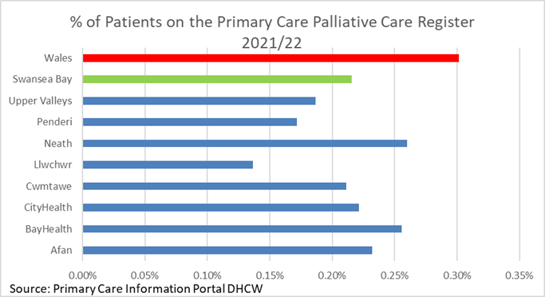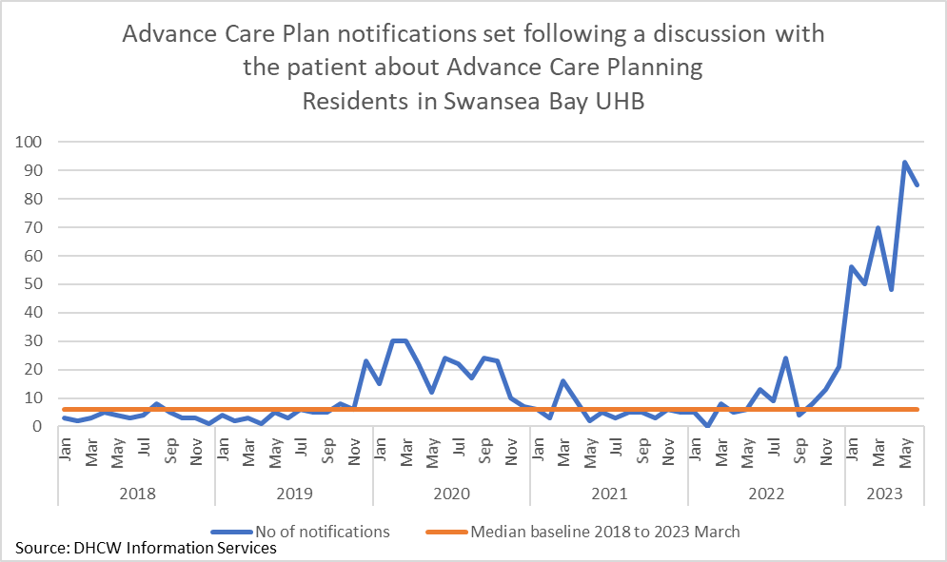  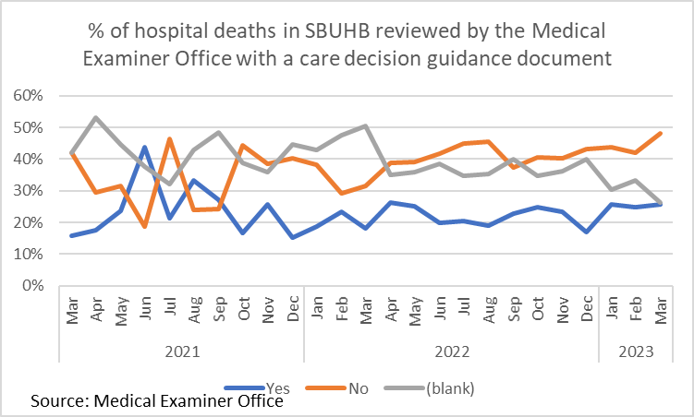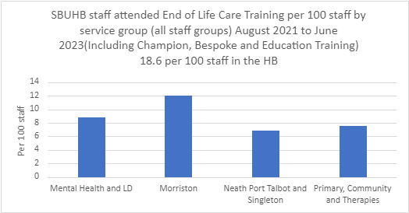
- ONS deaths access issue – Using published ONS data which groups Ty Olwen deaths into hospital, further work needed with Digital Intelligence to understand how we identify these to ensure they are group as deaths outside of hospital
- Palliative care register numbers – only available yearly. Request to participating practices in the project to share monthly data for the duration of the project.
- A&FCP notifications in WCP are increasing – request with DHCW to determine which teams this might be, there has been renewed efforts in Specialist Palliative Care.
- Care decision guidance for last days of life is promoted through the EOLC training and will be available in WNCR next year.
- Measure for in-hospital deaths within xx hrs being developed.
- Continued delivery of EOLC training through various channels - Champion, Bespoke and Education Training. Champion Training under review and information will need to be reviewed by service group (SG) due to ASMR staff changes. Bespoke training delivered on the request of SGs.
- Solution required to digital issues - need a digital dashboard developed to be accessible to all and understand potential of digital systems to support end of life care – EOLC & SPC dashboard being developed, version1 end of May 23.

Sepsis

Quality Priority Goals | Methods
Sepsis: improvement in the recognition and management of Sepsis | - Service groups providing monthly reporting on audit and improvement activity  - Establishment of trajectories for improvement for audit compliance
Measures | Progress and Trajectories
- % of patients appropriately screened for Sepsis | - Sepsis leads identified for all service groups  - Sepsis champions in place for all services  - QI project commenced in SDMU to increase rates of screening  - QI work underway on AMU to increase visibility of importance Sepsis screening  - Increase in actual numbers of patients screened  - Over 1200 engaged through Sepsis screening tool launch  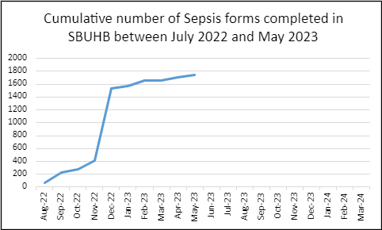
   | June 23 | July 23 | Aug 23 | Sept 23 | Oct 23 | Nov 23 | Dec 23
  % of appropriate patients screened in acute wards in Morriston, NPT, Singleton | >25%  Actual (of the reporting wards) Morriston 13%  NPTSSG 0% | >40% | >55% | >60% | >70% | >85% | >95%
  % of appropriate patients screened in AMU | >50%  Actual 25% | >70% | >80% | >95% | >95% | >95% | >95%
  % of appropriate patients screened in ED | >60%  Actual: 53% | >75% | >85% | >95% | >95% | >95% | >95%
  % wards who have access to Sepsis training and resources | >75%  June 2023 incomplete data from service groups | 100% | 100% | 100% | 100% | 100% | 100%

Suicide Prevention

Quality Priority Goals | Methods
Suicide Prevention | - Engagement in Sharing Hope project  - Delivery of training in suicide prevention across all teams
Measures | Trajectories
- Education of all available staff across the HB in recognising and managing suicide.  Continue to support and work with Swansea Multi Agency Group and other stakeholders across the HB in relation to obtaining a baseline assessment of suicide cases and map against national trends.  - Occupational Health and Wellbeing support for staff with anxiety/depression to prevent escalation in risk of suicide. | 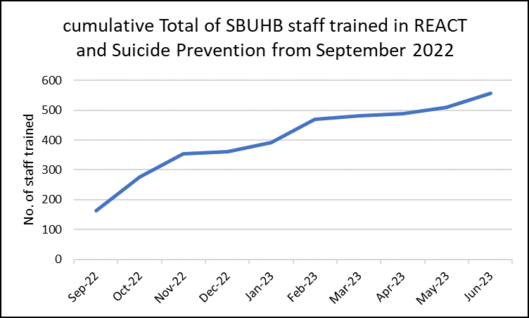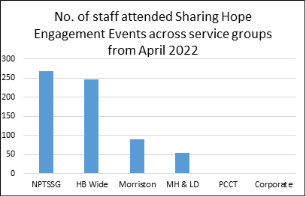
- Successful integration of REACT and Suicide Awareness training.
- Continued success of Sharing HOPE
- Planning for development of HB Suicide Strategy underway
- REACT training to be included in Managers’ Pathway
- Shortlisting for HSJ award

- Duty of Quality Implementation
Further to the paper provided to Quality and Safety Committee in April 2023 advising on our compliance with the Duty of Quality, the following provide a summary update of our position against the roadmap for delivery. The roadmap was developed by the national Doty of Quality Implementation Board as a mechanism for tracking health boards’ preparedness for the Duty and is now used internally in order for us to map our progress in implementing the Duty.
The Health Board is on track to deliver the requirements of the Duty of Quality through our quality management system and structures.

Theme | Roadmap Milestones | Status | Comments for latest update
Leadership and culture | Senior responsible leadership in place and driving implementation work |  | Lead: Director of Nursing and Patient Experience
Leadership and culture | All staff recognise and understand the organisation’s Quality vision, and their roles within it |  | Quality strategy launched 2.3.23.  Audio visual materials available on line to promote the strategy.  Lead: Head of Quality and Safety
Leadership and culture | Commitment, resources and infrastructure in place to implement Duty effectively |  | Scoping exercise of quality roles and functions across the organisation underway, there is a reporting programme to Management Board on this work with a view to new systems/ structures being developed by September 2023, along with a revised Quality Framework.  Lead:  Director of Corporate Governance, Deputy Director of Nursing and Patient Experience, Head of Quality and Safety
Decision-making | Processes and systems in place to provide demonstrable evidence that Board decisions have been made through Quality lens |  | QIA process in place. Consideration being given to reviewing board templates to reflect D of Q following completion of national work on quality impact assessments.  Lead: Director of Corporate Governance
Governance and accountability structures | Board are assured that DoQ is being considered across system |  | A Quality Hub has been established within the Health Board which combines the following quality activities; Quality Improvement; Quality Assurance, Quality Planning.  Quality Management System in place.  Quality Impact Assessment tool to be revised to reflect DofQ, following national work to develop the tool  Lead: Deputy Director of Nursing and Patient Experience. Head of Quality and Safety.
Governance and accountability structures | Routine governance documentation is DoQ-ready |  | Quality framework to be revised in line with D of Q and presented to QSG in September 2023  Lead: Head of Quality and Safety
Reporting and information (data to knowledge) | Mechanism and publication schedule / plan in place for sharing DoQ progress information externally |  | Department of Insight, Communication and Engagement (DICE) leading on comms plan to support the ‘Always on’ reporting requirement of the Duty.  Lead: Director of DICE
Reporting and information (data to knowledge) | Quality-related information escalation mechanisms in place, with plans for review and consideration at appropriate level |  | Quality dash board developed for comment. Full roll out in Quarter 3  Lead: Director of Digital
Commissioning | A clear and corporately agreed understanding of changes required to incorporate DoQ requirements into all commissioning arrangements |  | Quality reporting and escalation process in place for commissioned services, these have been reviewed in line with the D of Q
Hosting | A clear and corporately agreed understanding of changes required to incorporate DoQ requirements into hosting arrangements |  | Duty of Quality included within our commissioning arrangements
Quality Standards | A clear understanding of changes required to existing quality infrastructure and agreed programme of work to align with Quality Standards 2023 |  | Quality Standards to be reflected within the revised Quality Framework  Lead: Head of Quality and Safety
Quality management system – general | A clear understanding of, and commitment to, a quality management system, with plans in place to identify requirements and current gaps |  | Quality Management System rolled out and ongoing work through QSG and Quality Management Board to identify gaps
Communication and engagement | All staff are aware of key DoQ messages tailored to their organisation |  | WG produced video to be shared across organisation once available.  DICE working with QSI team to develop Communication Plan  Lead: Director of DICE. Head of Quality and Safety
Training and education | At least one member of Board trained, knowledgeable and able to influence Board in relation to DoQ

- Quality Strategy Implementation Plan Update- Quarter 1 Report

Delivery of the Quality Strategy is overseen by the QSG through an organisation wide implementation plan. Within the plan lead individuals are responsible for specific actions and for ensuring a timely quarterly progress reporting. The finalisation of individual leads is underway and additional actions may be added during the life span of the strategy.

A status report for each of the quality ambitions is included as an appendix. Progress is being made as follows

Safe and Reliable Care

Actions Completed | 0
Actions On Track | 9
Actions Overdue | 0
Actions Not Started | 16

As part of the roll out of the Duty of Candour we have proactively engaged with patients and their families in relation to patient safety incidents. Work is required to ensure that we have these conversations at every point where the Duty of Candour should be considered.

Through reviewing our mortality information we are now able to understand the themes within this and over the coming quarter we will begin to develop quality improvement programmes reflecting these themes.

An Organisation our Patients and Communities are Proud Of
Actions Completed | 1
Actions On Track | 10
Actions Overdue | 0
Actions Not Started | 11

Through working with DICE we are strengthening the links between our patient feedback and what our communities tell us as part of wider engagement. We are also making progress in considering the needs of seldom heard groups and this includes planning a patient safety congress on safety and inclusion and proactive work with our BME outreach team to understand the experience of women from minority communities who access our maternity care.

Empowered Staff
Actions Completed | 1
Actions On Track | 5
Actions Overdue | 0
Actions Not Started | 6

A programme of quarterly quality improvement Community of Practice events has been established, offering opportunities for individuals and teams to develop and maintain quality improvement skills and to share experience and knowledge across the organisation.
We are working closely with Improvement Cymru in revising our quality improvement training offer, to focus on increasing the number of people with the fundamental level of skills and offering more specialised quality improvement training on a team basis to support delivery of the quality priorities.
Engagement with staff as part of the Big Conversation is complete and focus sessions with leaders on becoming a high quality organistion are being held during July.
High Quality Services Now and in the Future
Actions Completed | 0
Actions On Track | 4
Actions Overdue | 0
Actions Not Started | 5

Performance against the annual plan targets for accessible services have a clear link to the quality of our care. The Chief Operating Officer has engaged with the Patient and Stakeholder Experience Group to discuss how we best communicate with patients waiting for our care so that they are supported and actively manage their conditions while they are waiting.
The Green Team programme is supporting the Quality Safety and Improvement Team in making the links between efficiencies and reduction of environmental impact.
5. Quality Dashboard Development

The quality dashboard has been launched in its Beta version for comment and feedback.

The intention of the dashboard is to provide ‘at a glance’ information for staff and board on the quality and safety of our care. The dashboard compliments information held within our performance scorecard. The dashboard allows for a ‘drill down’ from high level information to specific metrics or service areas. A screen shot of information currently available via the dashboard follows, noting that this is being developed with quality leads on a continual basis.

The Quality Dashboard will be accessible to Quality and Safety Committee members by 1.10.23.

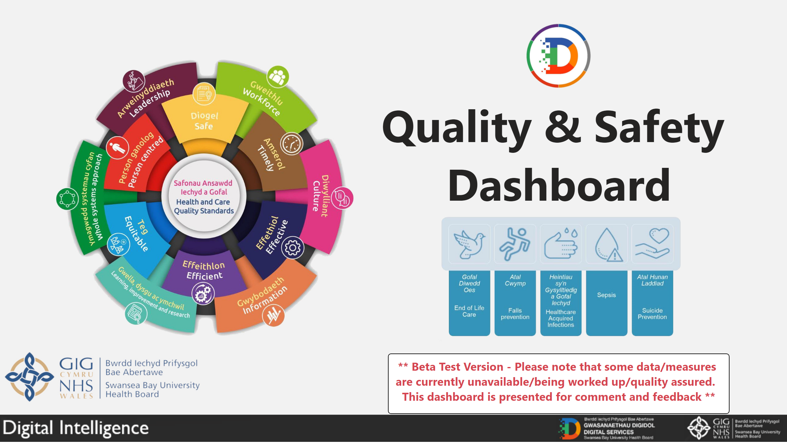

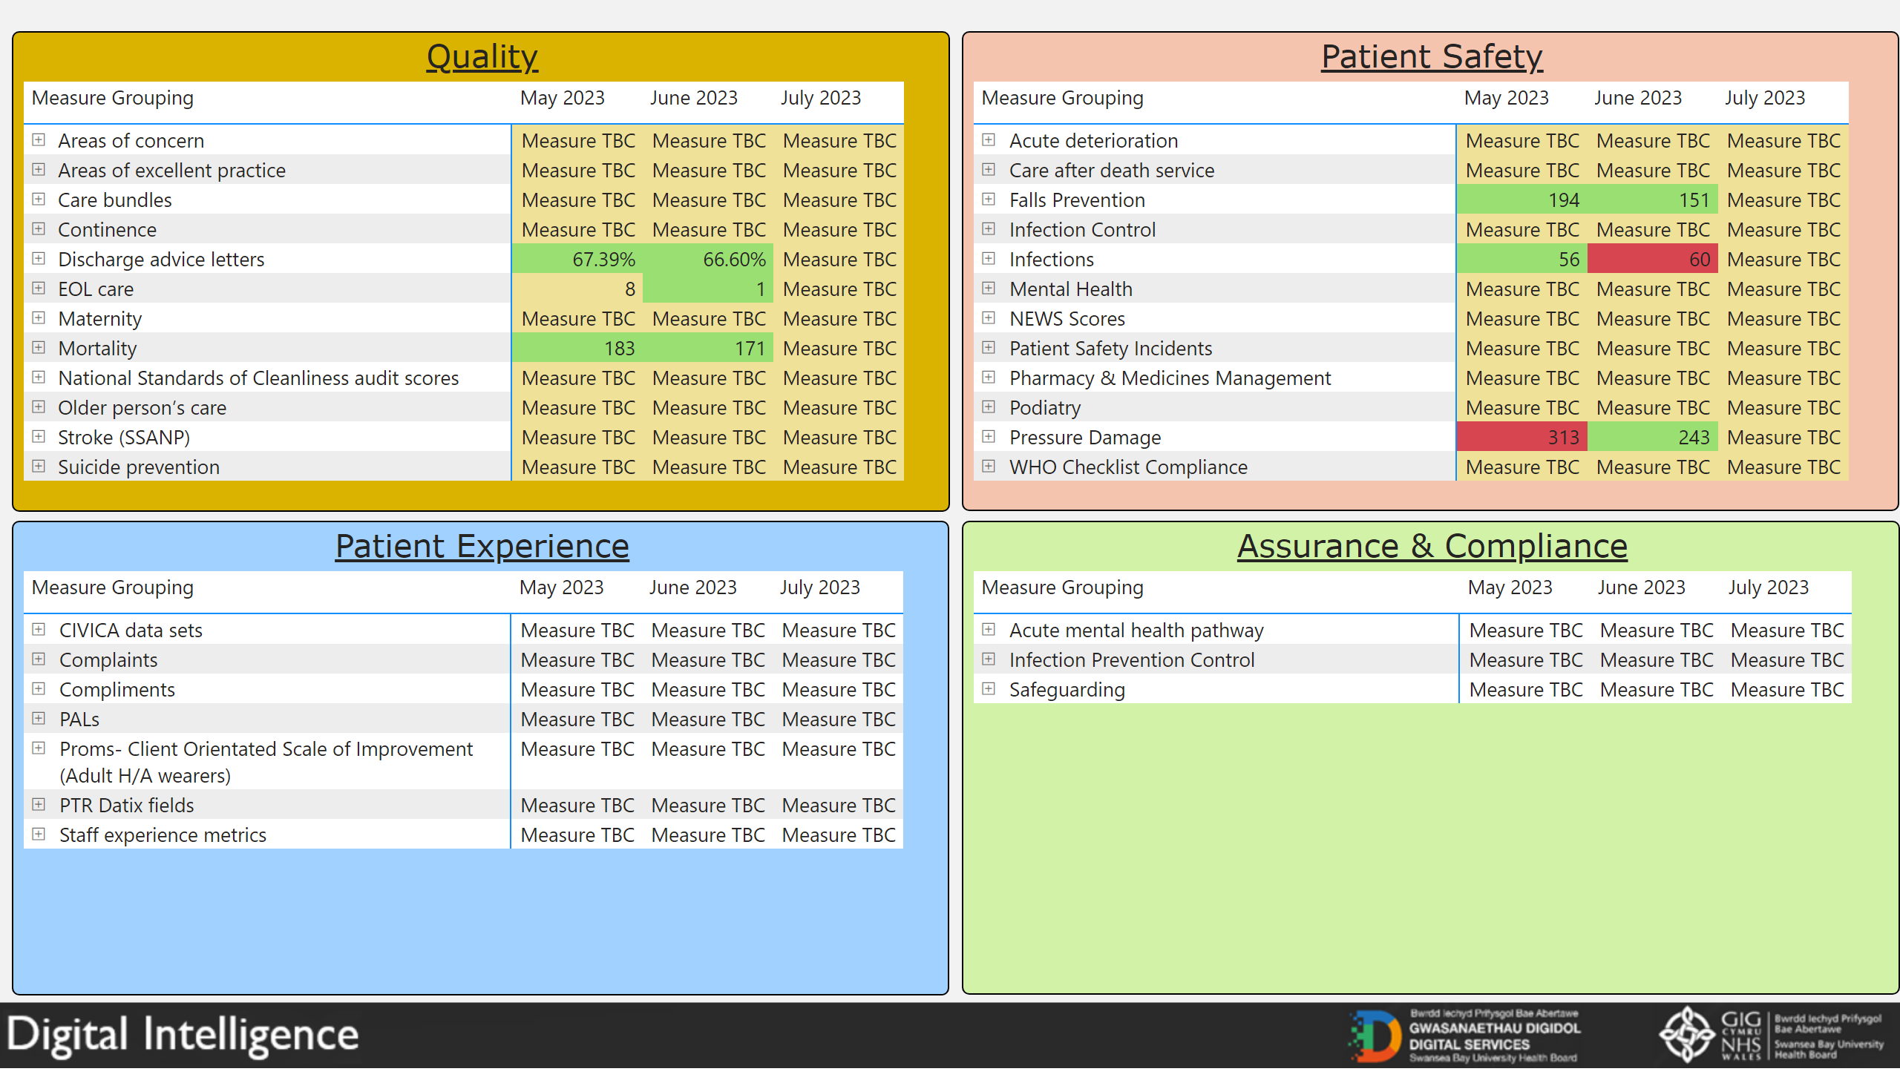

Governance and Assurance

Link to Enabling Objectives  (please choose) | Supporting better health and wellbeing by actively promoting and empowering people to live well in resilient communities
Link to Enabling Objectives  (please choose) | Partnerships for Improving Health and Wellbeing |  | ☒
Link to Enabling Objectives  (please choose) | Co-Production and Health Literacy |  | ☒
Link to Enabling Objectives  (please choose) | Digitally Enabled Health and Wellbeing |  | ☒
Link to Enabling Objectives  (please choose) | Deliver better care through excellent health and care services achieving the outcomes that matter most to people
Link to Enabling Objectives  (please choose) | Best Value Outcomes and High Quality Care |  | ☒
Link to Enabling Objectives  (please choose) | Partnerships for Care |  | ☒
Link to Enabling Objectives  (please choose) | Excellent Staff |  | ☒
Link to Enabling Objectives  (please choose) | Digitally Enabled Care |  | ☒
Link to Enabling Objectives  (please choose) | Outstanding Research, Innovation, Education and Learning |  | ☒
Health and Care Standards
(please choose) | Staying Healthy |  | ☒
(please choose) | Safe Care |  | ☒
(please choose) | Effective Care |  | ☒
(please choose) | Dignified Care |  | ☒
(please choose) | Timely Care |  | ☒
(please choose) | Individual Care |  | ☒
(please choose) | Staff and Resources |  | ☒
Quality, Safety and Patient Experience
This report outlines the work streams and structures in place across the organisation to promote the quality and safety of our care.
Financial Implications
No financial implications noted in this report.

Legal Implications (including equality and diversity assessment)
The Quality and Engagement Action sets out our responsibilities for quality and safety.
Staffing Implications
No additional implications noted within the report.
Long Term Implications (including the impact of the Well-being of Future Generations (Wales) Act 2015)
Delivery of the Quality Strategy reflects the principles of the Well-being of Future Generations Act and the Population Health Strategy through a focus on early intervention and activation in order to reduce risk of harm.
Report History |  | Quality Management Board August 2023  Quality and Safety Committee August 2023
Appendices |  | - Revised Clinical Outcomes and Effectiveness terms  of reference  - Internal audit of quality governance  - Quality and Safety Group structures  - Quality Strategy implementation plan updates for Quarter 1

