Meeting Date | 28 January 2025 |  | Agenda Item |  |  | 5.5
Name of Meeting | Quality and Safety Committee
Report Title | Maternity and Neonatal Early Warning Indicators
Report Author | Sujoy Banerjee, Associate Service Group Medical Director Kathryn Greaves, Clinical Director of Midwifery
Report Sponsor | Hazel Powell, Interim Executive Director of Nursing and  Dr Richard Evans, Executive Medical Director
Presented by | Kathryn Greaves, Clinical Director of Midwifery
Freedom of Information | Open
Purpose of the Report | The paper explains how Perinatal indicators will be monitored at the corporate and board level.
Key Issues | Quality indicators have been identified as a key performance indicator for quality by the Health Board. The paper outlines the Perinatal indicators, the governance structure and the approach to monitor the indicators in the health board.
Specific Action Required  (please choose one only) | Information | Discussion |  | Assurance | Approval
Specific Action Required  (please choose one only) | ☐ | ☐ |  | ☐ | ☒
Recommendations | Members are asked to note the report and agree the following action points and outcomes:  - Develop a maternity and neonatal dashboard to monitor the relevant metrics.  - Ensure the dashboard is monitored at the service group and departmental quality and safety meetings from March 2025  - The data to be reviewed monthly and triangulated to identify outliers and themes and escalated to quality and safety group and committee from June 2025

Maternal and Neonatal Quality Indicators

- Introduction

Quality indicators are one of a number of key quality management system (QMS) tools enabling an organisation to monitor its efficiency. The indicators help to serve as a basis for implementation of corrective measures and provide a platform for continuous quality improvement. Quality indicators built as part of the QMS strategy within the Health Board also enable the organisation to monitor outcomes in a fast and simple manner.

Quality indicators are defined on the basis of scientific concepts, own experiences, local incident data, results of literature searches, peer reviews and discussion with experts within and outside the organisation. On setting quality indicators, the numerator and denominator should be strictly defined. Once developed the indicators should be monitored continuously, including trend monitoring and detection of deviations, allowing appropriate corrective measures to be undertaken if necessary.

This paper outlines the maternity and neonatal indicators that have been developed with the Business Intelligence Team and Clinical service for board and corporate use. This will enable the organisation to monitor maternity and neonatal services continuously, including trends helping to detect deviations and implement improvement measures wherever necessary.

- Background

The need for reliable maternal and neonatal indicators have been highlighted in various national maternal safety reports. Multiple reviews have recommended the need for defined outcomes measures. In Wales, concerns regarding data collection, clinical validation, checking the accuracy of data for maternal and neonatal services were identified in the joint review by Royal College of Midwife’s and Royal College of Obstetrics and Gynaecology of Maternity services at Cwm Taf Health Board^{1.}

Implementation of quality indicators is a complex process which requires a scientific approach as well as testing and verification before routine usage. Determination of quality indicators requires thorough exploration of the processes underlying the particular service, assessment of the risk and frequency of a particular problem, and identifying the possibilities of improvement

Indicators should preferably address all activities within the organisation, but their number should not be too great as it may become an administrative burden. The number of indicators should vary and depend on where they are monitored i.e., whether monitored at Departmental, Service Group, Corporate or Board level. The majority of the indicators should be populated at Departmental level with slightly fewer at Service Group level and high-level indicators at Board and Corporate level.

Indicators when constituted should have the following attributes:

- Importance and relevance (should cover common event and problems)
- Potential for use (ability to monitor changes)
- Reliability (each indicator to have clear numerator and denominator)
- Uniform and comprehensible data collection
- Validity (indicator should be related to the problem monitored)

- Governance and Risk issues

3.1 Current Governance arrangements

Currently, the maternal and neonatal indicators are collated via different national sets (Mothers and Babies: Reducing Risk through Audits and Confidential Enquiries across the UK - MBBRACE, Perinatal Mortality Review Tool - PMRT, Neonatal National Audit Programme - NNAP, Vermont Oxford Network - VON) with delay in the release of the results for up to 24 months. This does not allow the indicators to be monitored regularly in a timely fashion. The results of these national data sets are monitored at the departmental and service group levels with the corporate team becoming aware via the Gold Command of an outlier status when reports are notified by a national body.

Maternal and neonatal indicators are monitored via a spread sheet at the divisional and service group level and via a developing Maternity and Neonatal Dashboard. However, they are not routinely monitored at the corporate level.

  - Current risk issues

Below are the maternal and neonatal incidents reported between January and November 2024.

Figure 1- Pareto chart highlighting the different incident - update

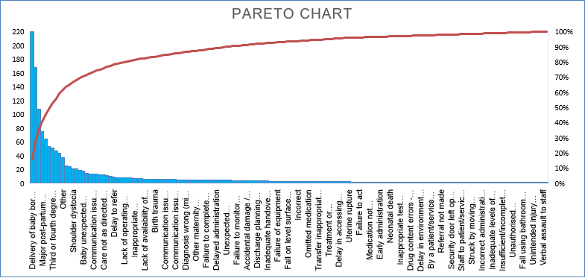

Figure 2 – Breakdown of incidents based on conditions and numbers

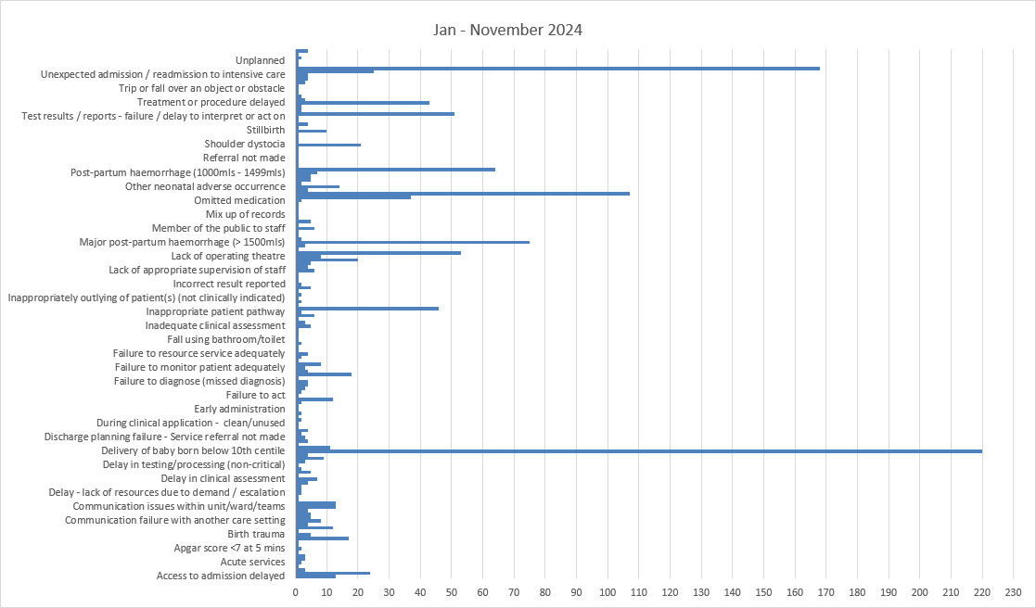

  - Limitations

The lack of agreed national indicators on a dashboard that are uniformly captured and monitored via a forum to monitor them regularly is a shortfall and hence assurance is limited at Departmental and Service Group level and corporate assurance could not be obtained.

- Executive Nursing and Medical Director’s Opinion/Key Issues to bring to the attention of the Board
4.1 Maternal and Neonatal indicators
As detailed above, the majority of the indicators should be tracked at departmental level, with fewer ones at Service group level and with a handful high level indicators at Board and Corporate level (Figure 3). This will ensure agility with the use of indicators, as these could either be toggled up or down from the corporate dashboard depending on a change in outlier status or a change in national or local priorities.

Figure 3 below – Schematic presentation of how indicators should be monitored

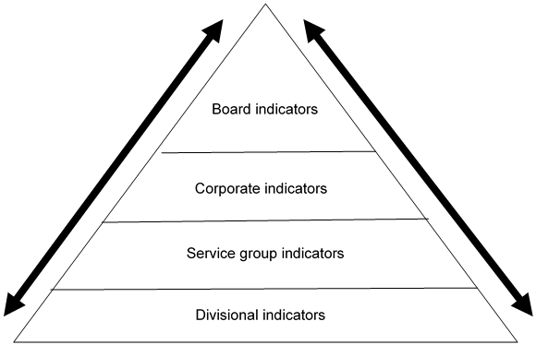

The board and corporate indicators should be high level and reflect the local priorities. The below corporate indicators were drawn up from locally reported incidents and these will be adapted with a change in priorities:

Divisional and Service Group Indicators:

- Antepartum, Intrapartum, Postpartum and Puerperal complication rate
- Percentage of 3rd or 4th degree tear post Vaginal delivery with and without instrument
- Number of still births (rolling monthly rate)
- Number of unexpected still births (rolling monthly rate)
- Perinatal mortality rate –this will be divided into still births and neonatal mortality
- Number of babies with HIE grade 2 and 3 who needed cooling (monthly)
- Seven-day re-admission rate following discharge either from neonatal or maternal needs
- Delay in induction of labour > 24hours
- Post-Partum haemorrhage ≥1500mls- 2499mls
- Neonatal Late Onset Sepsis
- Term admissions to neonatal unit

Corporate and board indicators:

- Perinatal mortality rate – same as above
- Post-partum haemorrhage ≥2500mls
- Delay in induction of labour > 24 hours
- Babies diagnosed with Hypoxic Ischaemic Encephalopathy Grade 2 and 3
- Neonatal Late Onset Sepsis
- Term admissions to neonatal unit
Currently, Maternity indictors are being developed at departmental and service group level. These will subsequently feed into board and corporate levels. It must also be noted the All-Wales National Perinatal Dashboard via the Digital Maternity Cymru is in development and local units will need to align to the data sets and data descriptors to ensure equity in data standard and measurement to support benchmarking across Wales.

  - National Perinatal Dashboard / Digital Maternity Cymru

An All-Wales Task and Finish Group were set up to work with Heath Boards Clinical Teams to define a national Perinatal Data set which would be used to support the development of a National Dashboard. This work is being considered in line with the NHS Executives development of Maternity Beacon which currently is collating six Metric across Wales. This is going through a process of socialisation among Maternity and Neonatal teams and is anticipated to be available in early 2025.

Thirty data measures have been identified and whilst this is progress there are technical concerns about how the data is collected and pulled from the data warehouse which currently is not aligning to local data intelligence. This requires a wider team which includes local Health Board Business Intelligence Teams, Digital Maternity Cymru Programme board and Digital Health Cymru Wales (DHCW) to understand why there is such a marked difference in rates. A review of the data dictionary is required to support understanding of the differences. A high level 3 measures have been agreed which include: Birth Numbers, Term and Pre-term Stillbirth, Smoking Status as a trial whilst work is undertaken to review and correct the data reporting on the larger volume data sets (30). That data set whilst still in draft includes a number of quality and outcome measures:

- Gestation at booking appointment
- Ethnicity
- Smoking status at booking
- CO Monitoring at booking
- Smoking status at birth
- BMI at booking/weight at 36 weeks/birth
- Number of registerable births
- Care type at booking (MLC/OLC)
- Onset of labour
- Number of women who give birth in – FMU/AMU/OLU/Home/Other/ BBA
- Skin to skin contact within one hour
- Breastmilk at first feed
- Breastmilk at discharge home
- Breastmilk at discharge from maternity care
- Mode of birth to include - Spontaneous vaginal birth/Vaginal breech birth/Birth by forceps or ventouse/Planned caesarean birth/Unplanned caesarean birth
- 3rd and 4th degree tears
- PPH ≥1500mls- 2499mls
- PPH ≥2500mls
- Obstetric admissions to ITU level 3 care
- Maternal death
- Preterm birth
- Term admissions to NNU
- Premature admissions to NNU
- Apgar <7 at 5 mins (term babies)
- HIE grade 2
- HIE grade 3
- Antenatal Stillbirths
- Intrapartum preterm stillbirth
- Intrapartum term stillbirth
- Early neonatal death

The national work will require the implementation of an All-Wales IT solution for Perinatal Services in Wales. Neonatal Services in Wales use Badgernet exclusively which will support the ability to benchmark across Wales more readily than the current arrangements in Maternity Services with several IT systems in use across Wales.

  - Current Perinatal Dashboard Development Progress

Even though there is a national maternity neonatal dashboard being developed it is important to have a locally developed dashboard. This will help to monitor the developments regularly and for the same purpose the maternity dashboard is currently in use helping to review monthly data to identify any outlier data sets which needs further deep dive. However, there are some limitations with the overall data set, but overall, the key metrics are available to monitor the quality and safety indicators.

The Neonatal metrics were agreed, unfortunately little progress have been made to populate the dashboard with the agreed data sets. Of the 21 metrics, 15 are still awaiting to be populated. Work was undertaken with the Neonatal Team to establish coding and reporting line against these measures. These have been revisited to improve the compliance so early warning indicators could be developed and this work is still in progress.

The expectation will be for both the maternity and neonatal dashboards to be put in use before April 2025.

  - Monitoring

The indicators will be monitored monthly as mentioned above by the departmental and service group in their quality and safety meetings. The data will be monitored on statistical process control charts and any indicators that is a cause of concern or is an outlier will have a deep dive by the department, and it will be highlighted and monitored at corporate and board level. It is worth noting there is no minimum or maximum rate for many measures in Maternity services, however this will be addressed once the national Perinatal Dashboard for Wales work is completed.

Similarly, any indicator which has improved and is no longer an outlier can be removed from the Board and Corporate level dashboard, and it will be monitored at the departmental level.

- Financial Implications

There are no financial implications identified for this plan.

- Conclusion

The development of Maternity and Neonatal indicators will enable SBUHB to monitor the quality of the service. The indicators at the different levels of the organisation will ensure monitoring is undertaken in a robust manner with majority of the indicators monitored at divisional level. This will also ensure there is consistency in the metric, as both the numerator and denominator will be defined. If variation is identified in an indicator, a deep dive will be undertaken and if improvement needs to be undertaken then a quality improvement could be implemented.

Progress against the remainder of the Neonatal data set needs to progress at pace to provide assurance, and an indication of the quality and safety of the service.
The Service groups expects that both maternal and neonatal dashboards will be ready for full use by March 2025.

- Recommendations

Members are asked to note the report and agree the following action points and outcomes:
- Support the final development of the maternity and neonatal dashboard to monitor the relevant metrics.
- Agree the board indicator set
- Ensure the dashboard is monitored at the service group and departmental quality and safety meetings from March 2025
- The data to be reviewed monthly and triangulated to identify outliers and themes and escalated to quality and safety group and committee from June 2025
Reference:

- Review of Maternity Services at Cwm Taf Health Board. REPORT OF RCOG REVIEW (gov.wales)

Governance and Assurance

Link to Enabling Objectives  (please choose) | Supporting better health and wellbeing by actively promoting and empowering people to live well in resilient communities
Link to Enabling Objectives  (please choose) | Partnerships for Improving Health and Wellbeing |  | ☐
Link to Enabling Objectives  (please choose) | Co-Production and Health Literacy |  | ☐
Link to Enabling Objectives  (please choose) | Digitally Enabled Health and Wellbeing |  | ☐
Link to Enabling Objectives  (please choose) | Deliver better care through excellent health and care services achieving the outcomes that matter most to people
Link to Enabling Objectives  (please choose) | Best Value Outcomes and High Quality Care |  | ☐
Link to Enabling Objectives  (please choose) | Partnerships for Care |  | ☐
Link to Enabling Objectives  (please choose) | Excellent Staff |  | ☐
Link to Enabling Objectives  (please choose) | Digitally Enabled Care |  | ☐
Link to Enabling Objectives  (please choose) | Outstanding Research, Innovation, Education and Learning |  | ☐
Health and Care Standards
(please choose) | Staying Healthy |  | ☐
(please choose) | Safe Care |  | ☐
(please choose) | Effective Care |  | ☐
(please choose) | Dignified Care |  | ☐
(please choose) | Timely Care |  | ☐
(please choose) | Individual Care |  | ☐
(please choose) | Staff and Resources |  | ☐
Quality, Safety and Patient Experience
The proposal will help the HB to achieve its quest to be a learning and improving organisation putting Quality at the forefront. Quality indicators will help to learn and improve the care of our patients and this paper outlines how the HB plans to achieve the same.

Financial Implications
Currently there are no financial implications of the proposal.
Legal Implications (including equality and diversity assessment)
There are no legal implications identified.

Staffing Implications
There are no staffing implications.

Long Term Implications (including the impact of the Well-being of Future Generations (Wales) Act 2015)
Report History |  | None.
Appendices |  | None.

