Meeting Date | 28 January 2025 |  | Agenda Item |  |  | 4.3
Name of Meeting | Quality and Safety Committee
Report Title | Clinically Optimised Patients report
Report Author | Emily Warren, Associate Director (Operations) & Helen St John (Head of Integrated Services)
Report Sponsor | Deb Lewis
Presented by | Emily Warren
Freedom of Information | Open
Purpose of the Report | To provide assurance on the progress of the Integrated Discharge strategy, which commenced in May 2024.
Key Issues | The Integrated Discharge Strategy, is comprised of four programmes, designed to drive forward rapid and sustainable improvements to the discharge process, reducing LOS and reducing the number of clinically optimised patients.  The strategy is comprised of:  - Programme 1: Integrated Discharge Hub  - Programme 2: Refreshed Pathways of Care Action Plan  - Programme 3: Home First Operational Improvement Plan  - Programme 4: Refreshed COP process
Specific Action Required  (please choose one only) | Information | Discussion |  | Assurance | Approval
Specific Action Required  (please choose one only) | ☒ | ☐ |  | ☐ | ☐
Recommendations | Members are asked to:  - Note progress achieved

Integrated Discharge Strategy Update Position - January 2025

- INTRODUCTION

This paper provides an updated position on the progress of the Integrated Discharge Strategy (IDS) which was established in May 2024 on a cost neutral basis. The overarching aim of the strategy is to improve discharge planning, achieving a sustainable reduction in the number of Pathways of Care Delays.

This paper provides assurance on the specific programmes within the IDS including:
- Programme 1: Integrated Discharge Hub (IDH)
- Programme 2: Refreshed Pathways of Care Action Plan
- Programme 3: Home First Operational Improvement Plan
- Programme 4: Refreshed COP Process

The strategy is being delivered as part of West Glamorgan Regional Partnership Board, Older People and Communities Board. Robust governance and collaboration between health, local authorities and Neath & Swansea CVS enables the delivery of effective integrated working.

- BACKGROUND

Since its launch in May 2024, the IDS has been focussed on enhancing discharge planning through a strong multi-agency approach. This includes better resource alignment and adherence to the D2RA principles, aiming to streamline assessments on hospital sites and ensure they are proportionate across hospital sites.

Developed to support the UEC Six Goals programme, the strategy’s objective is to facilitate a smooth transition from hospital to community care, ensuring continuity and quality in patient support post-discharge.

Programme 1: Integrated Discharge Hub

National policy direction sets out the expectation of regional Integrated Discharge Hubs (IDH) to improve coordination, efficiency and maximise existing resources. IDH’s are referenced in:
- The 50 Day Integrated Care Winter Challenge
- Hospital Discharge Guidance (Welsh Government December 2024)
- The Optimal Patient Flow Framework (Welsh Government)
- Guidance on D2RA Delivery

The was launched in July 2024 as a pilot in MGH. After the successful launch of phase 1 & 2, the IDH is now in phase 3 which included a roll out across all acute sites with a standardised approach to referral and discharge coordination into supporting statutory and non-statutory community services in line with the D2RA pathways.

Table 1: December 2024 performance
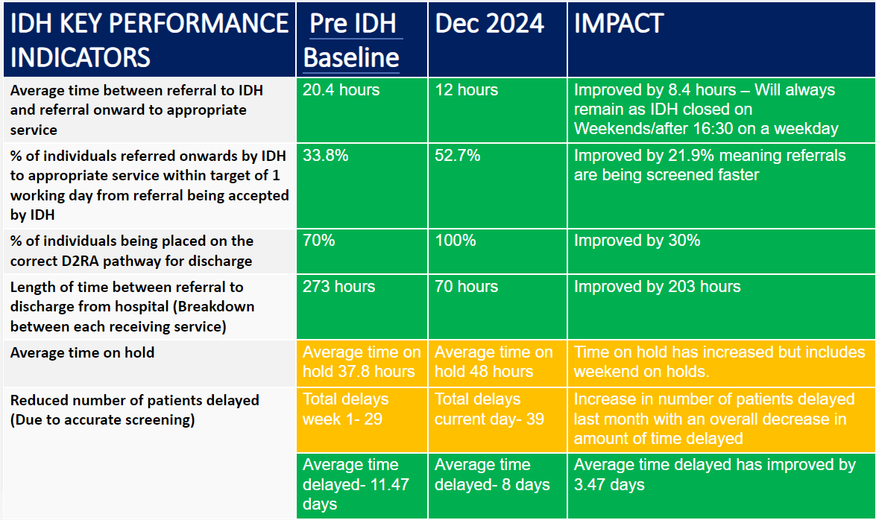

*Please note increase in patients delayed is due to a rise in Infection, Prevention and Control issues and is expected to reduce by February in line with modelling data around Flu etc.

To date, the IDH has aided in reducing delays by ensuring 100% of patients referred for supported discharge are on the correct D2RA pathway. The length of time between referral for supported discharge to actual discharge from hospital has reduced by 127 hours with a 51.72% reduction in the number of delays.

Figure 1– IDH Operational Model

Risks

The IDH has been established on a resource neutral basis, to test impact on reducing Pathway of Care Delays. Whilst initial results are positive and existing resources repurposed, without dedicated capacity there are risks to the successful operation of the IDH. As such a funding bid submitted to the Six Goals Programme and for inclusion in the West Glamorgan Region Winter Resilience Plan has been successful, with temporary funding secured until 31st March 2025. The time-limited nature of the funding secured only until 31st March 2025, presents a sustainability risk to the ongoing operation of the IDH. To address this, a clear sustainability plan is required to ensure the long-term viability that includes exploration of alternative funding sources or integration in to core services.

Programme 2: Refreshed Pathways of Care Action Plan

New Ministerial Targets require regions to achieve:
- a 15% reduction in Total POCD delays by November 2024 (and then sustained), using March 2024 as a benchmark.
- a 20% reduction in Assessment Delays by November 2024 (and then sustained),
- a 20% decrease in Total Days Delayed by November 2024 (and then sustained)

To achieve this across Swansea Bay a new Pathways of Care Action Plan has been developed. It sets out the actions all partners will take to support a sustainable reduction in delays and specific action to meet Ministerial targets by the date shown. The Action plan has been developed in partnership with all acute sites, Mental Health and Learning disabilities and Social Care, with oversight from the Regional Partnership Board.

A fortnightly assurance meeting (ROAG) has been established and ongoing work is helping to develop a dedicated plan of improvement actions by identifying the thematic issues causing the delays. System changes will be required alongside changes in investment patterns to match capacity to demand.

Current Position

An initial analysis of thematic data has indicated the following as key reasons for delay:

- Assessment Issues account for 50% of delays
- Care home placement arrangements
- Home adaptation/equipment issues

Table 1: Ranked Total Delays by Category:
Delay Category | Delays | % of Total Delays | MoM change
Assessment Issues | 121 | 50.0% | -1
Care Home placement arrangements | 53 | 21.9% | 7
Disagreements /Legislation | 24 | 9.9% | 2
Funding issues | 14 | 5.8% | -
Home care related issues | 13 | 5.4% | -2
Home adaptation/equipment issues | 7 | 2.9% | 4
Step down to recover and assess | 6 | 2.5% | -5
Housing Related Issues | 3 | 1.2% | -1
NHS Bed related issues | 1 | 0.4% | -1

It is also important to note, that Mental Health and Learning Disability data is now included for the first time, however due to the nature of their services their LOS and delays tend to be more significant than on the acute sites. Working directly with the MH/LD service group actions have been agreed to support sustainable reductions across MH & LD services.

The tables below set out the latest census activity taken from December 2024. Key messages relating to performance include:

- Total Days Delayed
  - Increased by 501 days (13,405 to 14,192). This follows a trend reversal after five consecutive months of narrowing the gap. The metric remains 2,758 days behind the target trajectory after December’s census.
  - Care home placement arrangements, Assessment Issues and Disagreements/Legislation account for the 3 leading causes of Total Days Delayed. Funding issues is fourth with 18% of days delayed, despite accounting for only 6% of delays:

Table 2: Primary Drivers of Total Days Delayed

Delay Category | Total Delays | Total Days Delayed | % of Total Delays | % of Total Days Delayed
Care home placement arrangements | 53 | 3718 | 22% | 26%
Assessment Issues | 121 | 3507 | 50% | 25%
Disagreements/Legislation | 24 | 2583 | 10% | 18%
Funding Issues | 14 | 2487 | 6% | 18%

- Total POCD Delays
  - Increased by 2 delays (240 to 242), putting the metric 42 delays behind the planned trajectory.
- Assessment Delays
  - Assessment delays stayed constant, with December’s total of 140 matching the 140 observed in November, remaining 58 delays behind trajectory.

Mitigating Actions

Service Improvements

- Appoint dedicated staff into IDH through secured funding until March 31st. This will include Therapists, Social work and admin. The expectation is quicker throughput with dedicated staff and more admin capacity to provide performance reporting on delays.

- Implemented the Clinically Safe for Transfer coding from November 20th. Continued review of use of Clinically Safe for Transfer as opposed to COP, is being undertaken to ensure data accuracy. This follows Welsh Government guidance issued in September 2024 that patients who do not require 24-hour medical cover on site and are being transferred between NHS sites (i.e., Morriston to Neath; Morriston to Gorseinon) should be defined as Clinically Safe for Transfer.

- New internal POCD Escalation Framework has been developed and will be managed by the Integrated Discharge Hub from the end of January 2024. This sets specific timeframes completion of key activities allocation of social worker, completion of assessment. This will be monitored weekly by IDH and a report provided to senior leaders.

Social Care

- Awaiting completion of assessment by social care: NPT have successfully trialled the use of AI software Magic Notes. The software auto populates patient facing notes reducing the admin burden on staff. Full roll out in Jan '25, with an anticipated reduction of 1 delay/month.
- Awaiting Social worker allocation: 2x posts now filled for hospital social team and community wellbeing team to support with NPT discharge arrangements: team going through induction with process to be live in Jan '25, with an anticipated reduction of 3 delays/month

Home care related issues:

- Awaiting start of new home care package: A dedicated review has been undertaken to provide assurance that capacity is able to meet demand and prevent any further increases in delay. The review, which completed in November found that across SBUHB we have 22 agencies, who are able to meet demand. However, the review has evidenced that an increasing number of female patients are requesting female only care, and this has led to an imbalance in available capacity as male care providers are not able to be utilised. Ongoing discussion underway with care providers.

Mental Health/Leaning Disabilities:

- Mental Capacity Delays: MCA & Cop Band 8 lead post went live in December in Morriston hospital. Working group to further review opportunity once post live. It’s anticipated that there will be a reduction of 2 delays/month.

Care Home Placement Arrangements:

- Awaiting Nursing Home availability: We are actively seeking to expand the use of the Trusted Assessment Model with Nursing Homes, using the Hengoed Court model as an exemplar to roll out. Meetings are scheduled through the local Care Home Forum Providers group in (Hengoed Court: 23.6 days COP to discharge compared to 50.2 days for other homes)

Table 3 POCD Delays & Welsh Government Trajectory (15% Reduction)

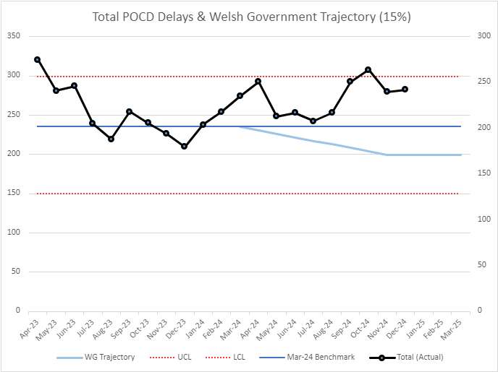

Table 4: POCD Assessment Delays & Welsh Government Trajectory (20% Reduction)

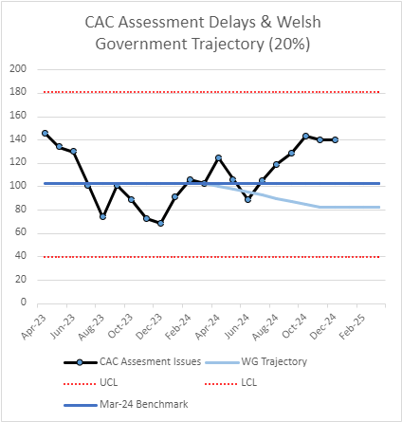

Table 5: POCD Total Days Delayed & Welsh Government Trajectory (20% Reduction)

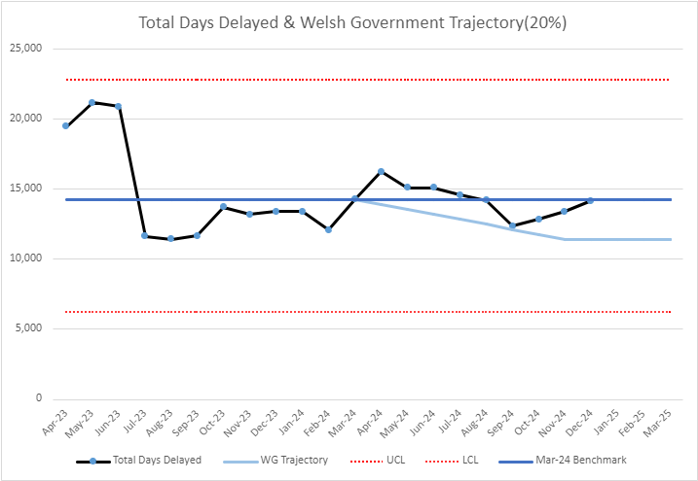

Programme 3: Home First Operational Improvement Plan

The Home First Operational Improvement Plan has been in place for 6 months with the weekly Regional Operational Assurance Group the dedicated forum to provide accountability and assurance on impact and improvement. Below are the updates categorised under the key themes:

Quality Improvement:
An Escalation Framework is currently in development to provide clear and structured guidance on escalating delays on D2RA pathways. This will be managed through the Integrated Discharge Hub but will offer a clear operating process of escalation across all SBUHB sites, creating consistency of practice and standardisation of escalation management.
The framework will detail:
- At what point to escalate delays, with low tolerance for anything over 48 hours
- Who to escalate delays to,
- What types of delays to escalate,

This initiative aims to streamline the escalation process, ensuring that the right stakeholders are informed and that appropriate actions are taken in a timely manner. Additionally, the framework will support the identification of recurring themes in delays and aim decision-making around targeted interventions and support.

Communication:
Working closely with the internal communications team a Gold Communications Campaign, which ran throughout November and December, focused on ‘Discharge’. Efforts were made to ensure both internal and external communication aligned with the campaign objectives, including:
- Promoting the earliest possible discharge to benefit patient recovery
- Highlighting the role of family bridging care in supporting transitions from hospital to home.
- Creating content for internal and external outlets on the discharge process and the importance of Home First
- Awaiting approval on a submission relating to the Integrated Discharge Hub – Phase 3 for January
This campaign played a vital role in emphasising the benefits of timely discharge for both patients and their families.

Digital:
Workshops are being planned to deliver improvements to the ward-based reporting process with the aim of improving data quality and accuracy. Objectives include:
assessing the functionality of SIGNAL against what is required, the workshop will then report any required additions or updated as identified and work with Digital colleagues:
- Development of a digital solution for the Escalation Framework
- Cleansing the current complex list of information tabs
- Optimisation of the reporting template to streamline processes and allow for data to be pulled
- Developing a training and communications package for ward staff
These digital improvements aim to increase efficiency and improve the management of operational data.

Performance
In Q1 2025 a performance review will be undertaken to determine the measures required against Welsh government, regional partnership board and POCD Action plan requirements, and create one D2RA performance score card.

A work programme will also be put in place of Pathway specific deep dives to continue to provide assurance on performance.

A subgroup will be established to evaluate and refine the information collated to support reporting to the Health Board, West Glamorgan Regional Partnership and Welsh Government. This will ensure performance data is both relevant and actionable work will be completed by March.

Workforce:
The Home First programme lead is working in partnership with Workforce and OD leads to develop a comprehensive training programme focused on:
- Workforce Planning and Sustainability
- Exploring opportunities to skill mix and development to safeguard against future staffing deficits.
The objective is to mitigate against future workforce shortages, enhance resilience, and support staff retention efforts.

Programme 4: Refreshed COP Process

Daily COP Deep Dive meetings take place for every medical ward/assessment area. New meetings have also been included for T and O and Surgery to reflect the increasing numbers of COP/Med outliers on these wards that require support. The COP meetings are solution focused and will be underpinned by the introduction of the revised internal escalation policy (currently awaiting sign off) which will support and inform ward staff in decision making about the ‘when, how and who’ to escalate delays that are preventing discharge.

The introduction of the Clinically Stable for Transfer (CST) tab on Signal has encouraged an increased focus on Pathway 1 and 3 patients, recognising that on an acute site patients may be fit for transfer internally but not clinically optimised. The introduction of CST is reflected in the table below, with the number of truly COP patients showing a marked decrease (The slight increase in the final week of December likely to a result of the Christmas/New Year BH’s)
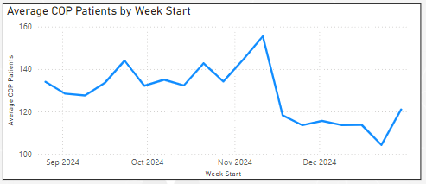

There is an increased focus on identifying D2RA pathway within 24hrs of admission and keeping the reason in bed code updated throughout a patients stay. This is enabling the patient flow and hospital ops team to identify themes around PoCD’s and focus efforts on reducing delays, working collaboratively with local authority and third sector colleagues.

Monthly site wide COP meetings take place in line with Welsh Government census reporting and are well attended by Health Board and Local Authority representatives.

- GOVERNANCE AND RISK ISSUES

Sustainability of IDH post March 31st as no resource identified

- FINANCIAL IMPLICATIONS

- Funding bid submitted to the Six Goals Programme and for inclusion in the West Glamorgan Region Winter Resilience Plan has been successful, with temporary funding secured until 31st March 2025.

- RECOMMENDATION

- To Note the progress made

Governance and Assurance

Link to Enabling Objectives  (please choose) | Supporting better health and wellbeing by actively promoting and empowering people to live well in resilient communities
Link to Enabling Objectives  (please choose) | Partnerships for Improving Health and Wellbeing |  | ☒
Link to Enabling Objectives  (please choose) | Co-Production and Health Literacy |  | ☒
Link to Enabling Objectives  (please choose) | Digitally Enabled Health and Wellbeing |  | ☐
Link to Enabling Objectives  (please choose) | Deliver better care through excellent health and care services achieving the outcomes that matter most to people
Link to Enabling Objectives  (please choose) | Best Value Outcomes and High Quality Care |  | ☒
Link to Enabling Objectives  (please choose) | Partnerships for Care |  | ☒
Link to Enabling Objectives  (please choose) | Excellent Staff |  | ☒
Link to Enabling Objectives  (please choose) | Digitally Enabled Care |  | ☒
Link to Enabling Objectives  (please choose) | Outstanding Research, Innovation, Education and Learning |  | ☐
Health and Care Standards
(please choose) | Staying Healthy |  | ☒
(please choose) | Safe Care |  | ☒
(please choose) | Effective Care |  | ☒
(please choose) | Dignified Care |  | ☒
(please choose) | Timely Care |  | ☒
(please choose) | Individual Care |  | ☒
(please choose) | Staff and Resources |  | ☒
Quality, Safety and Patient Experience
Focused on reducing POCD and improving patient experience
Financial Implications
As set out in the document
Legal Implications (including equality and diversity assessment)
None
Staffing Implications
As set out in document, consistent staffing is required to manage the IDH and support expanded HB wide function
Long Term Implications (including the impact of the Well-being of Future Generations (Wales) Act 2015)
None
Report History
Appendices |  | None

