Swansea Bay University Health Board

Patient Experience
&
Concerns Report
Quarter 3 2024/25

CONTENTS
Report Summary | Page 2
Complaints | Page 4
Complaint Themes | Page 7
Highlight Areas | Page 12
Nutrition & Hydration | Page 29
Morriston Service Group | Page 35
Neath Port Talbot Singleton Service Group | Page 40
Mental Health & Learning Disabilities Service Group | Page 44
Primary and Community Service Group | Page 50
Medical Examiners Compliments | Page 54
Ombudsman Cases & Learning | Page 55
Report Summary and Overview
COMPLAINTS | Oct | Nov | Dec
Total number of complaints received | 194 | 196 | 154
Complaints acknowledged within set timescale | 100% | 100% | 100%
Number of re-opened complaints | 13 | 5 | 5
 | Aug | Sep | Oct
Complaints responded to within agreed timescale - formal | 61% | 62% | 70%
OMBUDSMAN | Oct | Nov | Dec
Number of Ombudsman Investigations received | 0 | 1 | 1
Number of actions outstanding (within timescale) | 2 | 1 | 4
Number of actions overdue | 0 | 0 | 0
PATIENT EXPERIENCE | Oct | Nov | Dec
No. of Friends & Family surveys received | 6,208 | 6,096 | 4’747
Recommendation score | 93% | 93% | 92%
New Bespoke Surveys | 2 | 5 | 0
NATIONAL REPORTABLE INCIDENTS | Oct | Nov | Dec
Number of National Reportable Incidents reported | 9 | 10 | 8
Number of Never Events | 1 | 1 | 1

Successes | Priorities
Complaints;  - Improvement in Ombudsman variance data – responses and compliance being sent within target date  - Train the trainer session with the Ombudsman held in Cardiff - training resource to be provided to support rolling out complaints training  Patient Experience;  - The overall satisfaction score for this quarter is 93%  - SBU patients voice recordings and comments used in the Christmas Message Bulletin. | Complaints;  - Working with the Service Groups and meeting regularly to discuss their longest open complaints to improve the overall performance  Patient Experience;  - SBU has been asked by the NHS executive to become part of the National Maternity and Neonatal Survey pilot with Cwm Taff. The aim is to have surveys sent to mums at certain times throughout their care pathway. SBU has a small T&F group. The survey will be on the Civica platform. Survey to be live March 2025.  - Team continues to prepare for the New Peoples Framework, Toolkit and Questions.
Opportunities | Risks & Threats
Complaints;  - Workshops being held to discuss the re-write of the PTR guidance  Patient Experience;  - SBU has been asked by the OFW team to become a pilot (along with Hywel Dda) to implement API (Application Programming Interface-a new feature designed to enhance data access and integration capabilities for customers). This will allow Civica data to be automatically placed back to the data warehouse.  - Once for Wales Compliments work stream held. The aim is to agree a platform and coding for compliments across all HBs.  - Looked after Children (LAC) national survey development continues. There is national work ongoing regarding the survey questions, methodology and pathways. This is part of an NHS Exec roadmap. | Complaints;  - The increase in complex complaints.  - Number of overdue complaints  Patient Experience;  - Once for Wales and SBU have agreed to mandate the ED national survey questions in December. The aim is to improve our scorings and uptake rate, which are shared on the Beacon Dashboard. This will be reviewed at the end of January.

- COMPLAINTS

1. Complaints performance –
The Health Board is committed to supporting patients, relatives, and carers in resolving their concerns. Our service is visible, accessible, and impartial, with every issue taken seriously. Our aim is to provide honest and open responses in a way that can be easily understood by the recipient.

1.1 Total complaints received

The Health Board received 544 complaints in quarter 3 (Q3) of 2024/25 (October, November, December). This compares with 577 complaints in quarter 2 (Q2) of 2024/25 (July, August, September). This total includes complaints received and managed via either formal, early resolution and any re-opened complaints. Graph 1 provides a long-term view of complaints received per month.
Graph 1: Total number of complaints per month

Graph 2: Formal v Early resolution complaints per month

Graph 2 (above) shows complaints dealt with via the Formal Putting Things Right (PTR) investigation process compared with those dealt with via the early resolution investigation process, over the same period. We continue to deal with a higher proportion of complaints via the formal process, this is due to the tight timescale of two working days for early resolution complaints. Any early resolution that is not resolved within two working days, converts to a formal following guidance issued by Welsh Government.
1.2 Complaint responses within agreed timescale
Whenever a complaint is managed through the formal PTR process, the Health Board is required to investigate the complaint and write to the complainant with our findings, within 30 working days. If this target is not achievable, it is essential that the complainant is kept up to date throughout and any delays are explained.

1.2.1 Formal Investigations
The Health Board’s target is to respond to at least 85% of formal complaints within the agreed timescale. Welsh Government also issue a target for all Health Board’s to achieve at least 75% each month.

Graph 3 shows the Health Board’s performance in responding to complaints since November 2023. The Health Board performance for October 2024 was 70%.
Graph 3: Percentage of formal complaints responded to within agreed timescale

1.3 Overdue complaints

The Service groups are actively working to reduce the number of complaints that have exceeded the 30 working day timescale which is a recommendation timescale within the ‘Putting Things Right Guidance on dealing with concerns about the NHS 2011.’

The Corporate complaints team monitor the overdue complaints and send out bi-weekly reports to each Service Group requesting updates.

1.4 Re-opened complaints
The Health Board aims to resolve all complaints within the first response however, there are times when the complainant remains dissatisfied or needs further clarification. If the complainant writes back to the Health Board expressing their dissatisfaction, the correspondence will be reviewed by the Corporate Complaints Team and a decision made in conjunction with the appropriate Service Group as to whether the complaint should be re-opened. This may be when the complainant feels not all issues raised in the initial complaint have been addressed or if a meeting is required.

Graph 4 shows the number of re-opened complaints per month since January 2024.
Graph 4: Number of re-opened complaints by Service Group per month

The number of re-opened complaints appears to have decreased. The ethos for any complaint investigation is ‘Investigate once, Investigate well’.

2. Complaints Themes

2.1 – Themes - Health Board overview
Every complaint received by the Health Board is coded in the Datix Once for Wales system against the relevant subject codes. This allows the Health Board to identify any themes in the complaints received.

Table 1 provides a breakdown of complaints received by primary subject code in Q3 2024/25 compared with Q2 for 2024/25.

Table 1: Complaints by primary subject
Subject/Theme | Q2 2024/25 | Q3 2024/25
Communication Issues | 102 | 83
Appointments | 76 | 75
Clinical treatment/Assessment | 135 | 129
Admissions | 43 | 50
Attitude and Behaviour | 55 | 49
Medication | 26 | 20
Test and Investigation Results | 13 | 21
Referral | 15 | 20
Discharge Issues | 27 | 25
Environment/Facilities | 14 | 13
Monitoring/Observation Issues | 20 | 14
Equipment | 5 | 5
Personal Property/Finance | 4 | 3
Assault | 3 | 0
Confidentiality | 1 | 1
Consent | 5 | 5
Record Keeping | 1 | 0
Access (to Services) | 7 | 12
Accident/Falls | 8 | 2
Catering | 2 | 3
Cleanliness | 0 | 0
Infection Control | 1 | 1
Nutrition/Hydration Issues | 1 | 1
Other | 3 | 4
Patient Care | 0 | 0
Resources | 3 | 5
Skin Damage | 1 | 1
Privacy and Dignity | 2 | 2

Top theme; Clinical Treatment;
During Q3, 170 complaints were received regarding clinical treatment. A breakdown of the sub-subjects are below – please note, some complaints include more than one of these issues.
What we are doing about this?
- Outsourcing of patients to other Healthcare providers to help reduce waiting times.
- OCP theatres opened in NPT to reduce waiting times.
- Continuous Flow Model to help reduce delays and improve patient and staff experience.
- Unscheduled care summit held for ED
Orthopaedics. Patient Experience feedback for Quarter 3. The wordle below highlights mainly positive comments for ‘ Professional and Competent’ while the negative comments are relating to ‘Waiting’
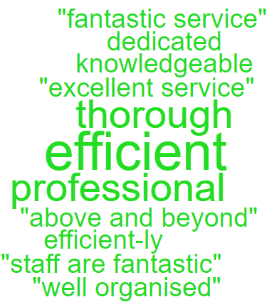
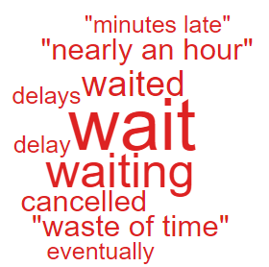

Clinical Treatment;
Delay/Lack of treatment or Assessment | 100
Incorrect/insufficient treatment or Assessment | 46
Reaction to procedure/ treatment | 28
Incorrect diagnosis | 16
Delay/Lack of diagnosis | 15
Remote clinical triage/treatment issue | 1

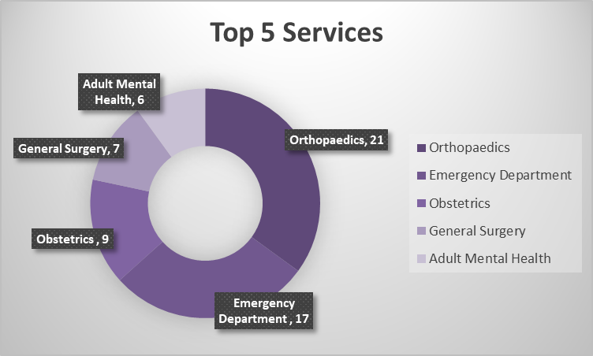

Theme 2; Communication;
Communication Improvement Plan;
- Face to face meeting held in November 2024 with Ombudsman trainer to start roll out of complaints and communication training throughout the Health Board
- Training during consultant development programme where the importance of good and clear communication is discussed.
- Complaints/communication training sessions delivered by the Corporate team to Service Groups – this training is ongoing
- Focus training undertaken by Departmental Trainer – 55 sessions delivered since January 2024 which includes Duty of Candour training, Documentation and Managing Telephone/Visitor Aggression.

- Outpatient Department – Quarter 3– Wordles relating to communication were mainly positive, there was one negative comment.
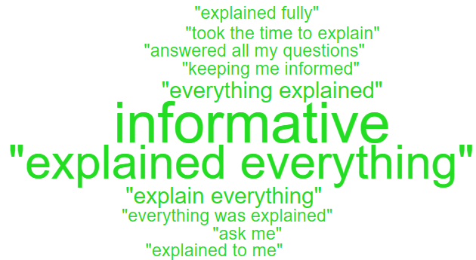

During Q3, 130 complaints were received relating to communication. A breakdown of the sub-subjects are below – please note, some complaints include more than one of these issues.
Communication Issues;
Insufficient/Incorrect information | 128
Communication with patient/service user | 13
Communication with family | 8
Communication with External Agencies or Other NHS Organisations | 2
Communication between Services/Departments | 1
Concerns relating to DNR decision | 1

Theme 3; Appointments;
What we are doing about this?
- Outsourcing of patients to other Healthcare providers to help reduce waiting times.
- Rapid Diagnostic Centre expansion.
- Expansion of our virtual wards to widen the range of disciplines involved, so increasing the number of patients who can be treated appropriately out of hospital
All Wales questions do not have ‘appointments’ as a question set. Therefore, as an alternative a search was undertaken on the words delay/delays/appointment.
Below are some comments we found relating to ‘appointments’ for Adult Mental Health in Quarter 3.
- Appointment outside depot clinic hours as I work at that time. There was some difficulty with this, but something was arranged ok with my support worker and duty.

- Listened to my needs for an appointment outside normal depot clinic hours

- A later appointment perhaps.

- The waiting times to get an appointment.

During Q3, 87 complaints were received regarding appointment issues. Many of these complaints will have more than one sub-subject, see breakdown below;
Appointment Issues;
Delay in appointment/waiting time/transport | 52
Appointment cancelled | 23
Patient lost to follow-up | 5
Cancelled appointment/transport | 2
Location of appointment unsuitable | 2
Patient booked into wrong outpatient clinic | 2
Capacity of clinics | 1

- HIGH RISK AREAS

As part of the Health Board’s focus on Urgent Care, Planned Care and Cancer Services the following section highlights complaints received in:
- Orthopaedics
- Emergency Department (ED)
- General Surgery
- Cancer Services
- Mental Health
Graph 1 below shows the number of complaints for each of these areas received per month since January 2024.
Graph 1: Complaints per month
As you can see from the graph, the number of Orthopaedic complaints has decreased which is likely to be as a result of the new theatres and the reduction in waiting lists. A breakdown of the issues raised in Q3 can be found below;

3.1 – Orthopaedic Complaint themes

Patient Experience Feedback: Orthopaedic Services
As Orthopaedics is classed as a ‘High Risk Area’, the Patient Experience Team have investigated the feedback for Orthopaedic Services. In total, Orthopaedic Services received 277 responses to the Friends and Family Survey during Quarter 3.

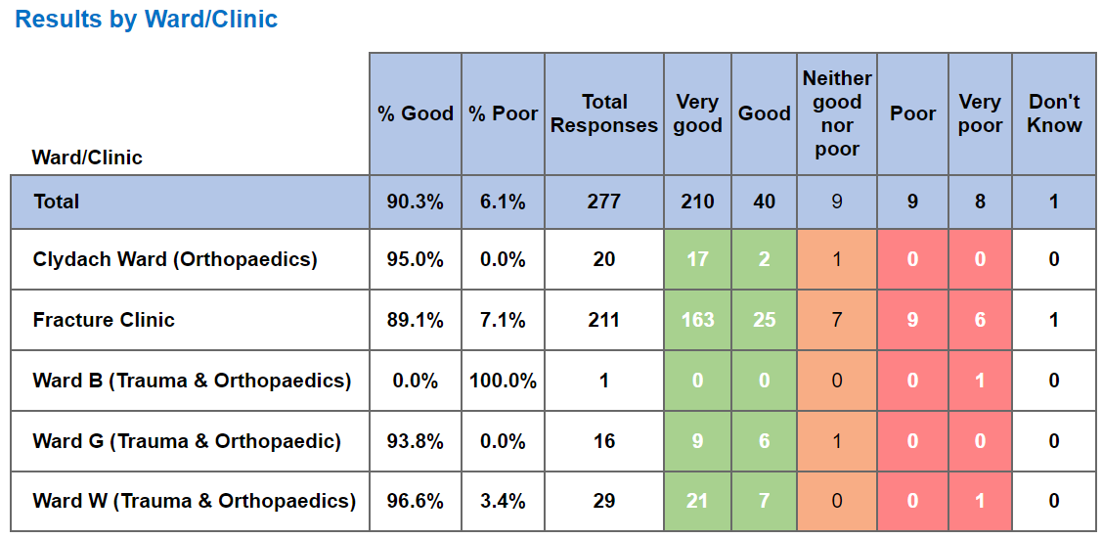

Below are the top themes for Orthopaedic services:
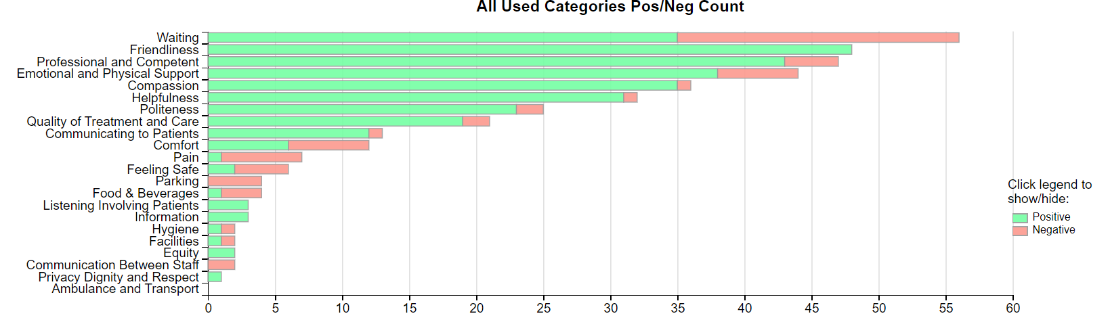

NB: The Civica system on occasions is oversensitive with the word ‘Pain’ and ‘Waiting’ and sometimes feeds these as a negative in charts and wordles. This is a national platform issue affecting all Health Boards. The overall satisfaction score is not affected by this.

Positive Theme
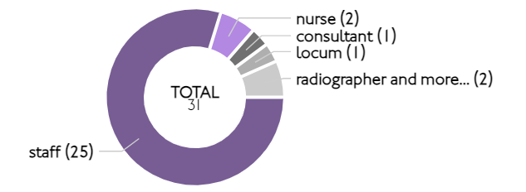
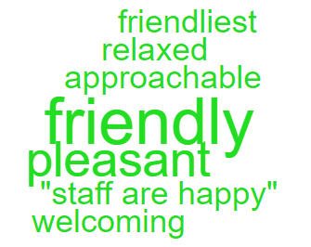
‘Friendliness’ Sub themes ‘Friendly’
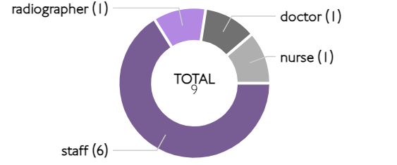
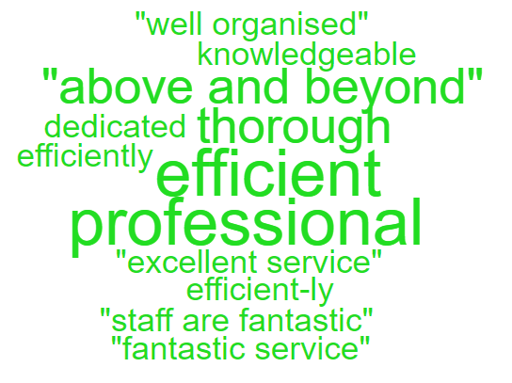
‘Professional & Competent’ Sub Theme ‘ Professional’

Here are some of the positive comments we’d like to share:
- All the staff that looked after me did it in a very professional manner.

- nurses were polite and welcoming. Friendly and polite whilst admitting me into the ward. Very professional and non-judgemental.

- Every member of staff that has worked on my recovery has gone above and beyond to ensure my recovery. They have all been so helpful and professional. Most importantly supportive and friendly. Thank you.

- My son was seen by a very nice smiley friendly doctor. There was very little waiting involved. His plaster was reset without any pain. A fantastic service.

- Had excellent service since my injury.

- The consultant along with the student staff were all brilliant. really pleasant to deal with and professional.

Negative Themes
The chart above highlights a few areas relating negative feedback. Here is an in-depth breakdown of these areas.

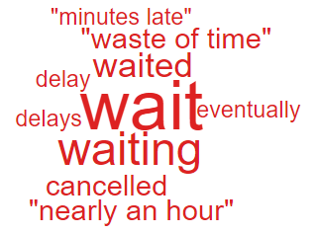
‘Waiting’ ‘Comfort’


These are the comments highlighted in the above ‘Wordles’.

- I am well looked after in general because of my condition, I need 2 staff to make me use a hoist. I have to wait quite a while sometimes - which although not the staff’s fault this is very frustrating.

- One cancelled appointment is acceptable but not 4!!!

- The receptionist was brash and rude. I offered my name and appointment time - I was informed I was not on the system. I presented my appointment letter and email received to verify my booked appointment. the receptionist went on to argue that it was not on her screen so did not exists. I remained firm and asked her to assist me as I had arranged and paid for transport for this planned appointment. the receptionist made me feel uncomfortable and was unwelcoming.

- The ward needs more staff. Better staff hygiene would be good. Sometimes they don’t wash their hands after blowing their nose. They speak quite loudly - not everyone is deaf!

  - – Emergency Department (ED) Complaints
During Q3 of 2024/25, ED received 32 complaints, a breakdown of the issues is below;

The 11 ‘clinical treatment/assessment’ complaints all relate to delays in treatment or assessment.

Patient Experience Feedback: ED Services
As ED is classed as a ‘High Risk Area’, the Patient Experience Team have investigated the feedback for ED Services. In total, ED Services received 895 responses to the Friends and Family Survey during Quarter 3.
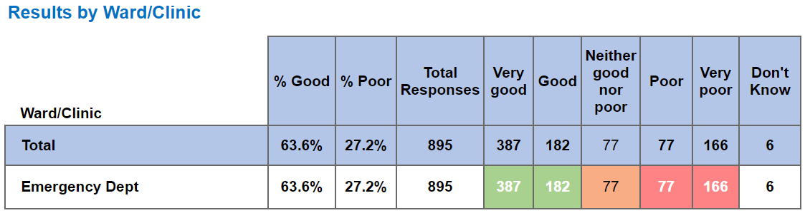
Below are the top themes for ED services:
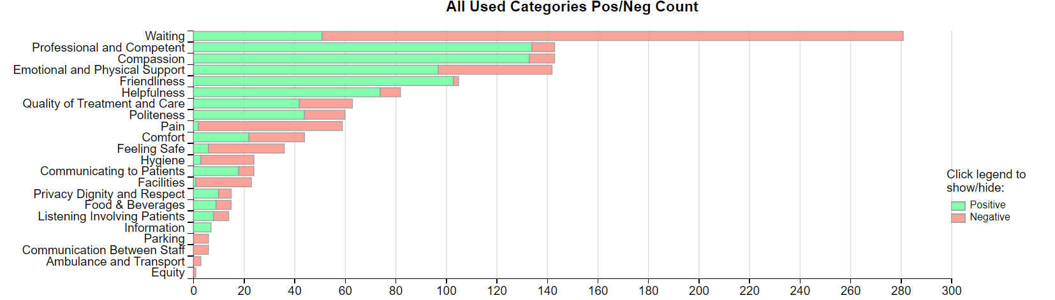
Positive Themes
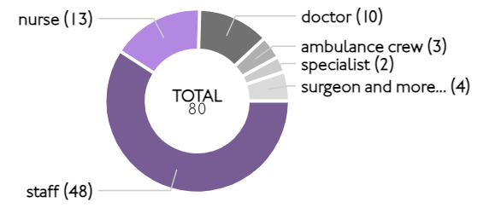
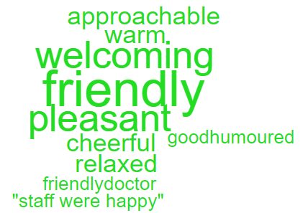
‘Friendliness’ Sub theme ‘Friendly’

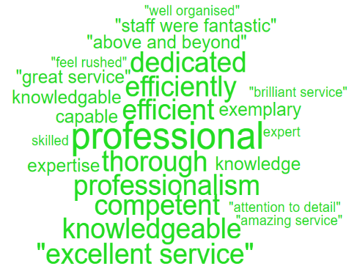
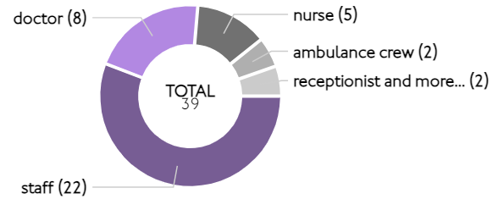
‘Professional & Competent’ Sub theme ‘Professional’

Here are some of the positive comments we’d like to share:
- I experienced a friendly and professional approach from triage nurses and doctor despite the department being very busy. I could not have received better treatment.

- Didn’t wait long. Nurse and doctor were both very friendly and knowledgeable.

- Great professionalism by all staff.

- All staff was very caring and very professional. Some went above and beyond and when you’re feeling at your worst this makes such a difference. There was a student nurse among others that really went out of her way to be helpful and caring which was much appreciated.

- Friendly and kind staff ambulance crew and 999 operator were particularly good and very thorough and supportive.

- The nurses and doctors on duty on Christmas day were brilliant. friendly cheerful and attentive. thank you.

Negative Themes
‘Waiting’
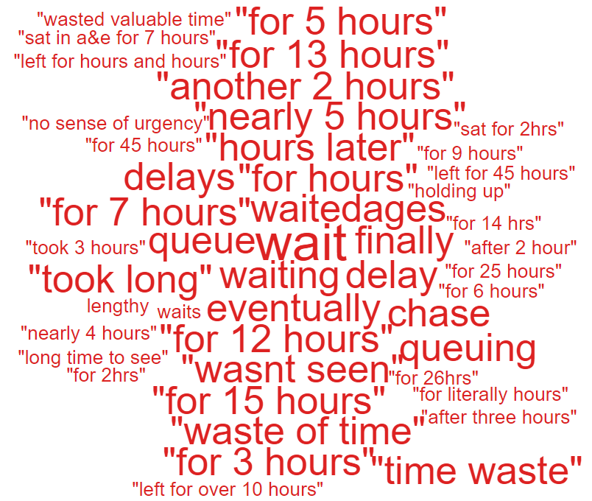
NB: The Civica system on occasions is oversensitive with the word ‘Pain’ and ‘Waiting’ and sometimes feeds these as a negative in charts and wordles. This is a national platform issue affecting all Health Boards. The overall satisfaction score is not affected by this.
Here are the negative comments relating to ED:
- 10 hours wait so I left in pain still in pain but a bit better. I had head and facial damage feels like wiped tendons in my neck after a bad fall. 12 people in waiting room, announcement of 10 hour wait.
- Having been triaged relatively early during the stay an x-ray was ordered. Had it been possible within the triage procedure for someone to review the film and discover that there was no fracture present it would have been possible for me to be discharged with advice at 2am rather than having to wait until 9am to see a doctor
- Took long time to see the doctor, my son was in pain and crying because he wanted to go home, coz it took too long, x-ray was quick, doctor took long time.
- Yes, the triage nurse I saw was more concerned with her McDonalds breakfast than my maybe broken foot and was too busy talking about a staff members gastric band from turkey. Being a registered manager of a care agency myself I didn’t appreciate this as she was my first point of conduct in hospital and didn’t reassure me at all.
  - – General Surgery Complaints
During Q3 of 2024/25, General Surgery received 27 complaints, a breakdown of the issues is below;

Patient Experience Feedback: General Surgery
As General Surgery is classed as a ‘High Risk Area’, the Patient Experience Team have investigated the feedback for General Surgery Services. In total, General Surgery Services received 3,285 responses to the Friends and Family Survey during Quarter 3.

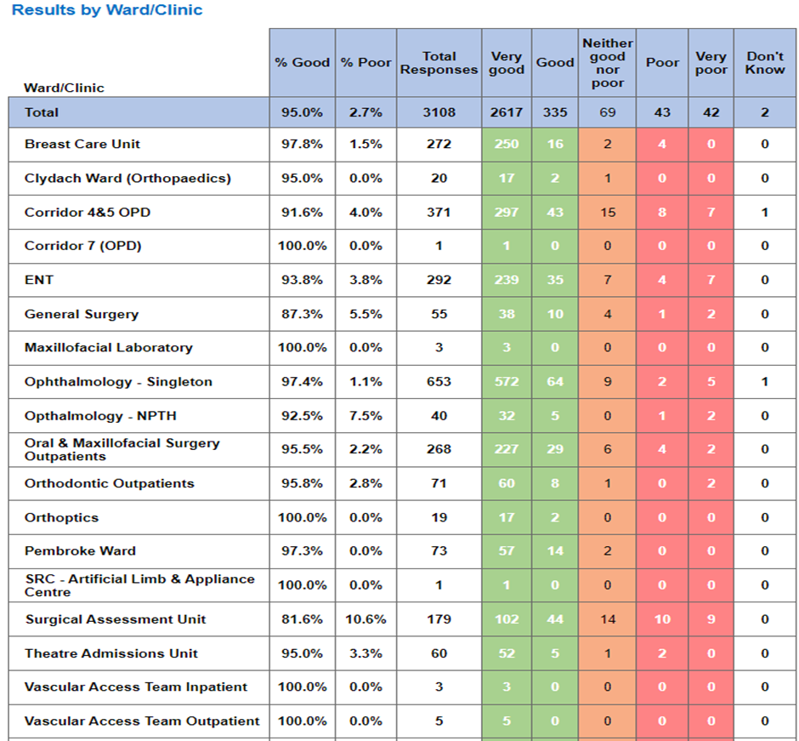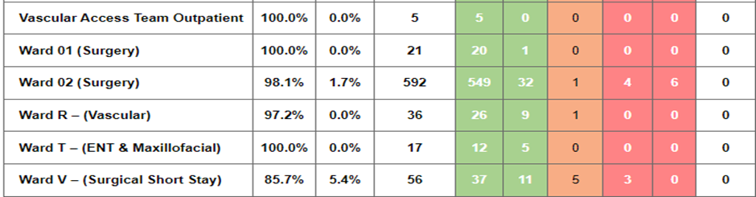

Below are the top themes for General Surgery services:
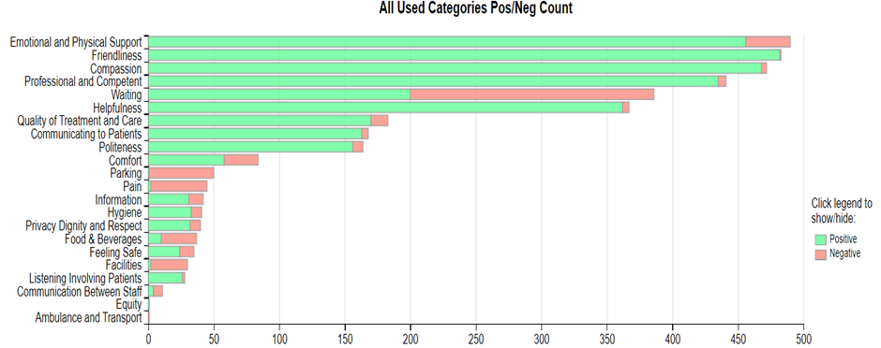
NB: The Civica system on occasions is oversensitive with the word ‘Pain’ and ‘Waiting’ and sometimes feeds these as a negative in charts and wordles. This is a national platform issue affecting all Health Boards. The overall satisfaction score is not affected by this.
Positive Themes

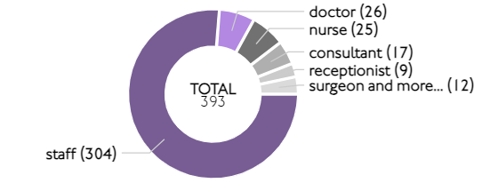
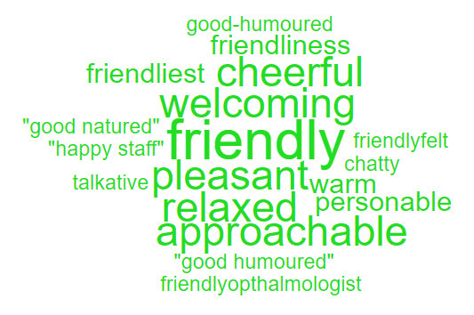
‘Friendliness’ Sub theme ‘ Friendly’

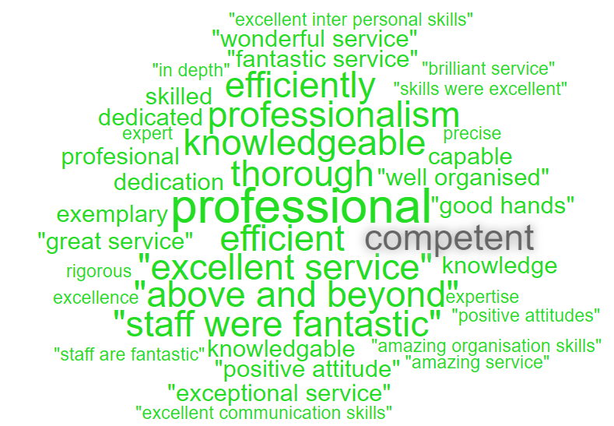
Professional & Competent’ Sub theme ‘ Professional’
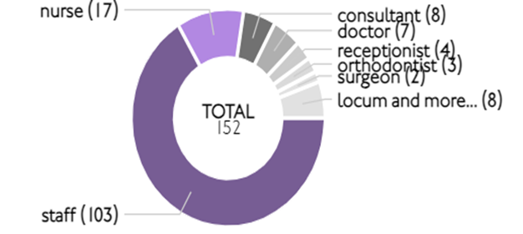

Here are some of the positive comments we’d like to share:
- Friendly cheerful staff everywhere. All areas including the toilets very clean. kept informed at what was happening all the time. excellent service.

- My unfortunate stay here was made extremely pleasant due to the care compassion and professionalism of all members of staff who were impeccable to other patients that they cared for. Sometimes in difficult circumstances.
- Made to feel relaxed during the procedure all staff attending were informative and very professional.
- Everyone was warm and helpful. The two female doctors operating on me made me feel safe and heard. They answered my questions and supported me. I arrived at 800 am and was finished by 1000 am. I appreciated the calm atmosphere. Thanks to all the team in plastic surgery.

Negative Themes
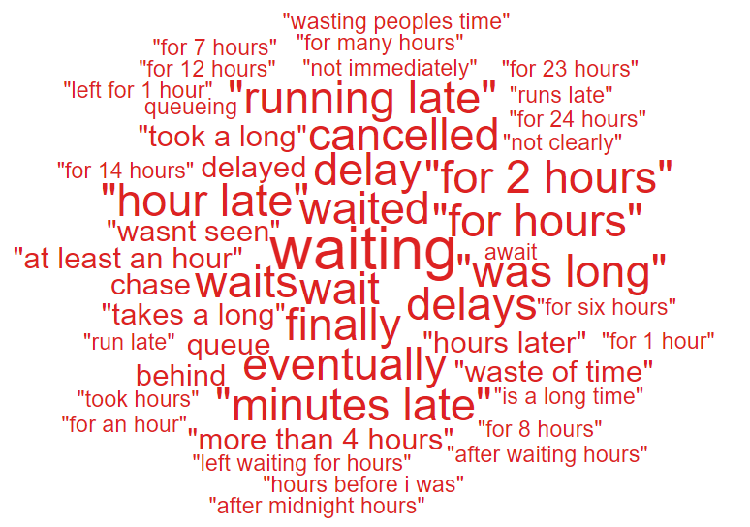
‘Waiting’ Sub theme ‘Waiting’
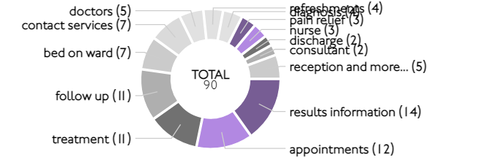

‘Facilities’
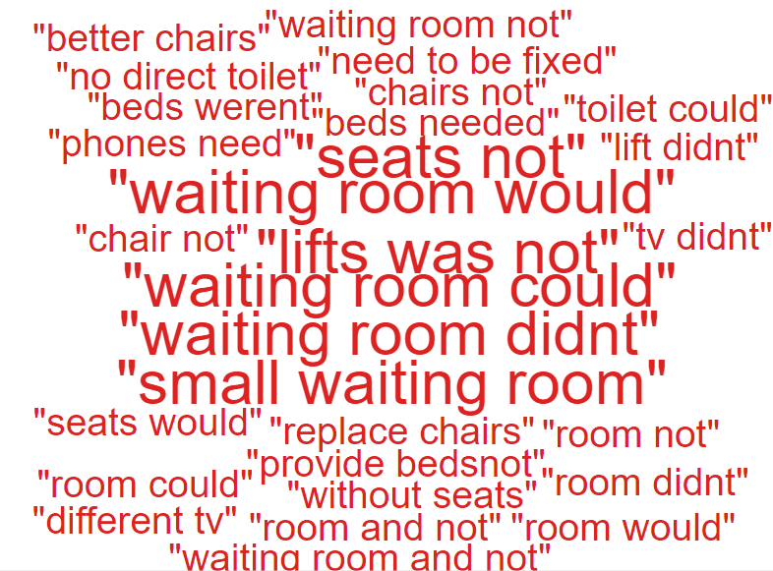

Below are some negative comments relating to General Surgery:
- Waiting experience could be improved by provision of phone signal. Anxiety builds if you have nothing to do but wait.
- As stated previously there was a long waiting period before seeing each member of staff.
- My appointment was for 1020 I eventually saw the consultant at 1235.
- It was a shame that I had to wait in a small waiting room for 35 hours before my operation that was the worst part of the experience, but it wasn’t too uncomfortable.
- The waiting time was over an hour. The healthcare assistants were gossiping loudly to each other in the waiting room and were laughing loudly. They didn’t seem professional as they should have been focussing on their work. People in the waiting room didn’t need to be hearing about the personal lives of the staff while waiting for a long time to be seen.
- The tv didn’t work.

  - – Cancer Services Complaints
Cancer complaints received in Q3 are relatively low with 10 received therefore, there are no major obvious themes however, 4 out of the 10 complaints related to clinical treatment.

Patient Experience Feedback: Cancer Services
As Cancer is classed as a ‘High Risk Area’, the Patient Experience Team have investigated the feedback for Cancer Services. In total, Cancer Services received 856 responses to the Friends and Family Survey during Quarter 3.
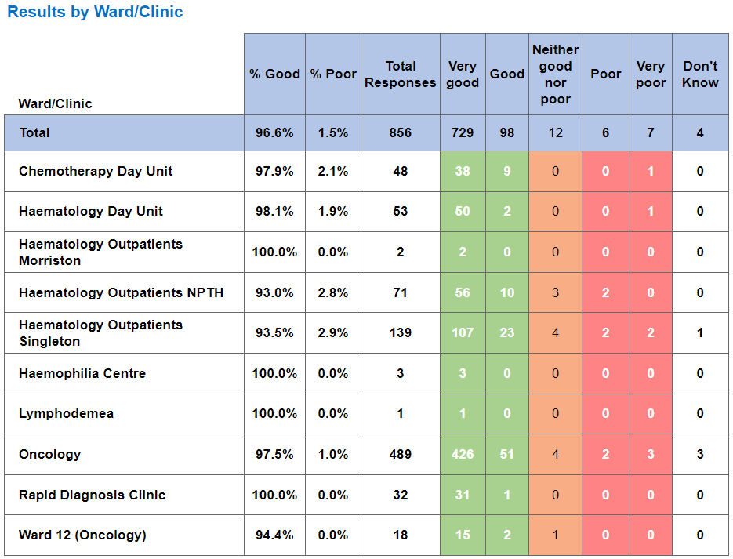
Below are the top themes for Cancer services:
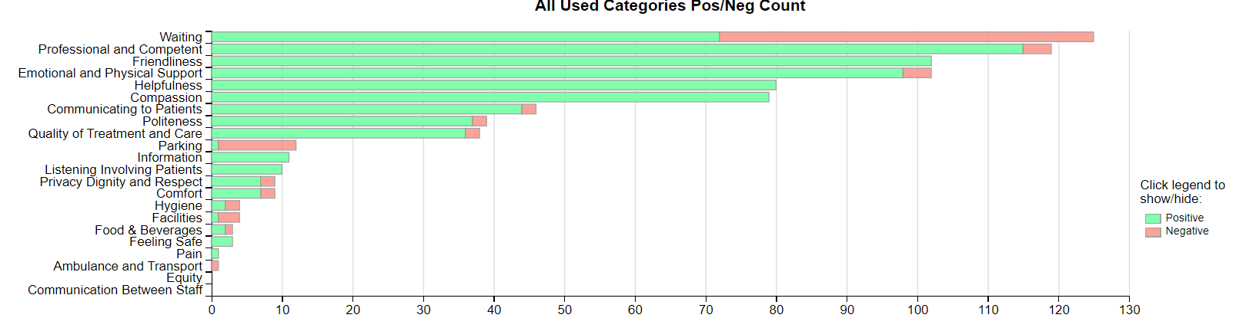
NB: The Civica system on occasions is oversensitive with the word ‘Pain’ and ‘Waiting’ and sometimes feeds these as a negative in charts and wordles. This is a national platform issue affecting all Health Boards. The overall satisfaction score is not affected by this.
Postive Themes
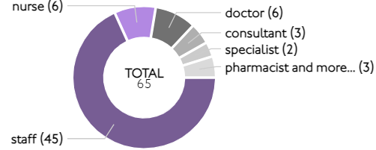
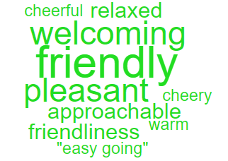
‘Friendliness’ Sub themes ’Friendly’

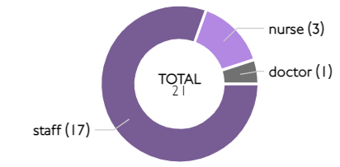
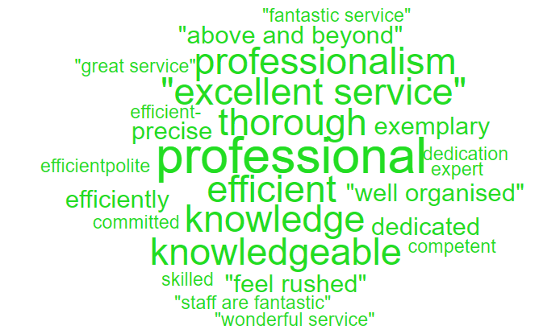
‘Professional & Competent’ Sub themes 'Professional’

Here are some of the positive comments we’d like to share:
- The professionalism and kindness of all the staff that I met. They were approachable and made me feel comfortable.

- All staff are extremely knowledgeable and helpful putting patients at ease.

- Nurses knowledgeable attentive and skilled and kind, nothing was too much to ask of a busy team.

- The way the staff go about their tasks is exemplary. Nothing is too much trouble for them, they deal with the patients with every understanding.

- The attitude of the staff was exemplary. Everybody including the receptionist were very pleasant and prepared to help in any way.

- The staff are fantastic hardworking and dedicated, they go above and beyond to provide care and service to their patients.

Negative Themes

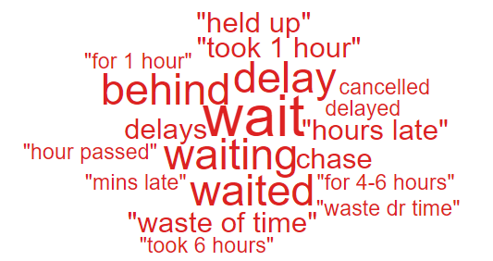
‘Waiting’

Looking at the chart above it highlights comments specifically related to ‘waiting’ as negative feedback. Here are some examples of the comments written to give context.
- Change the whole system. Waiting well over hour and a half for a simple yes or no decision and still waiting. Doing my nut in now. Not only is it affecting me so taking up time of the next patient waiting treatment.
- No, once we had the appointments it went well but the waiting to start was stressful.
- There was a delay of hour for my appointment. The explanation was fully explained. Consultant and doctor held up by over activity in the wards reflecting in delays in out patientsaff very good but pump delivery faulty causing delay.
- if possible please try to shorten the delay in the outpatients.

3.5 Mental Health Complaints
During Q3 of 2024/25, Mental Health received 86 complaints, a breakdown of the top 10 areas these relate to is shown below;

Also below is a breakdown of the issues raised within these complaints;
Appointments | 23
Attitude and Behaviour | 14
Monitoring/Observation Issues | 11
Communication Issues | 10
Clinical treatment/Assessment | 9
Discharge Issues | 5
Medication | 5
Record Keeping | 3
Environment/Facilities | 2
Referral | 2

Patient Experience Feedback: Mental Health
For our Mental Health feedback, we primarily utilise a Service/User/Carer survey that is designed to be more user-friendly. In Quarter 3, we received 303 responses, with an overall satisfaction score of 98% for the question, "Overall, how was your experience?"
Additionally, we received 3 Friends and Family responses, resulting in an average score of 68%.
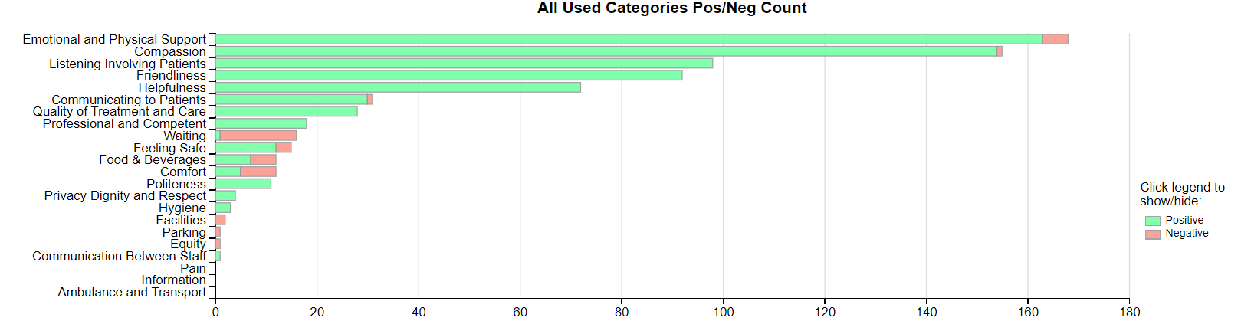
Themes

Top Themes - Positive
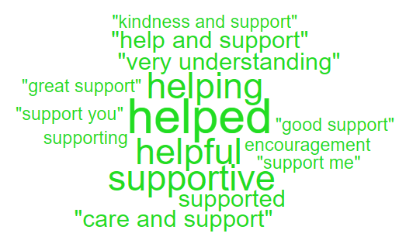
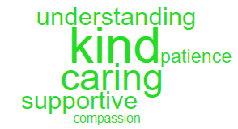
'Compassion' 'Emotional and Physical Support'

Here are some of the positive comments we’d like to share:
- All the staff on Fendrod ward have been so lovely to me and have helped me settle in. I am finding my feet now and hope to get better soon.
- My wife was on Celyn ward, and I just want to thank all the staff there for their kindness and support in looking after her, really appreciate it and thank them so much.
- I want to thank all the staff on Clyne ward for their support patience and encouragement. I now feel I am in a position to fight against my mental health. I can now see a future. Thank you.
- All the staff here are so caring and helpful. That means a lot to me with his care.
- All I have spoken to have been very kind and listened to me.

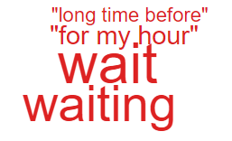
'Waiting negative' 'Comfort negative'
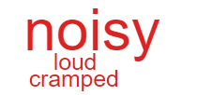

Please see below some negative comments:
- The staff are amazing they couldnt be better, people caring for us. The only thing I could say I don’t like is that the waiting area is small and is always so full cramped this triggers my tics and makes me very uneasy so I will often go and wait just outside of the building and this has caused me to miss my name being called and having to wait longer for my appt.
- The wait to see a person face to face but its ok.
- I like the staff on ward F they look after me and help. I am in a safe space. It is noisy but I am wanting to get better.
- It’s ok sometimes here but can get very noisy.
Nutrition & Hydration
As Nutrition & Hydration is currently one of the Health Board’s priorities, for this quarterly report please see below overview of the feedback received.
The Health Board received 8 complaints between 1st October 2024 – 31st December 2024 which involved Nutrition & Hydration issues. Please see breakdown below of what services these complaints related to;

The specific issues raised in these complaints are below (please note some of these complaints may have more than one sub-subject);
Appropriateness of food/Dietary options | 3
Availability of nutritional supplements | 3
Patients not properly hydrated | 2

The ‘patient not properly hydrated’ issues relate to AMU and SAU.

Patient Experience Feedback – Nutrition & Hydration.

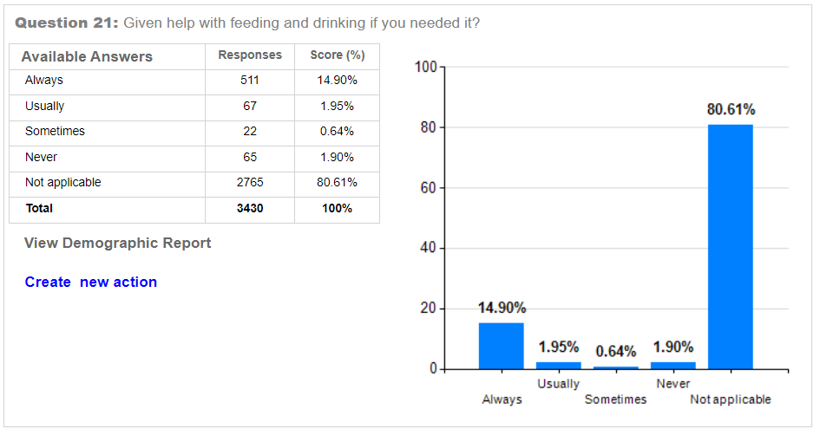

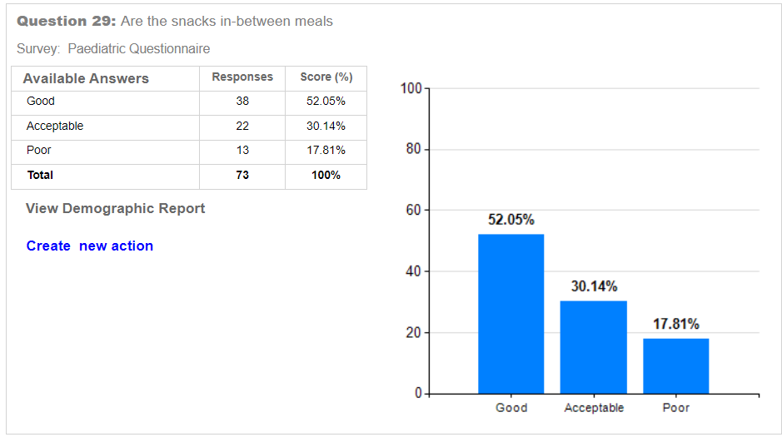

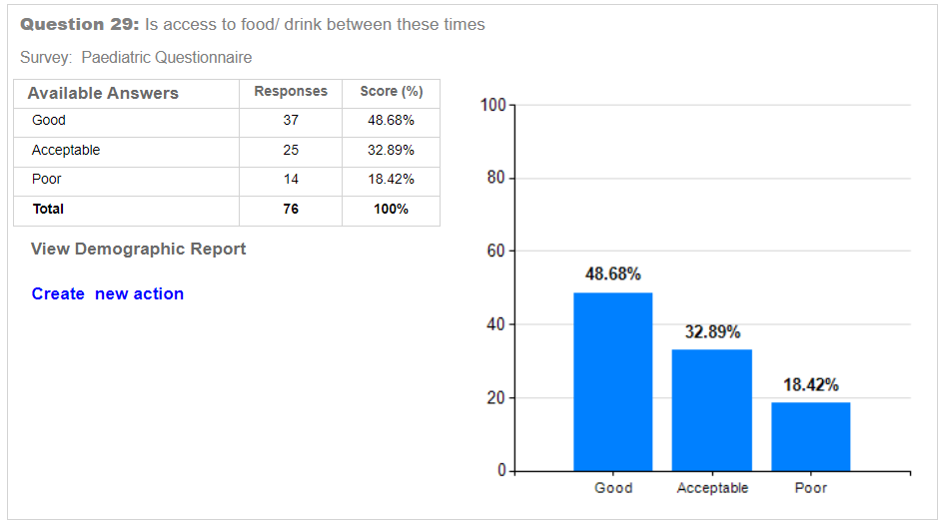
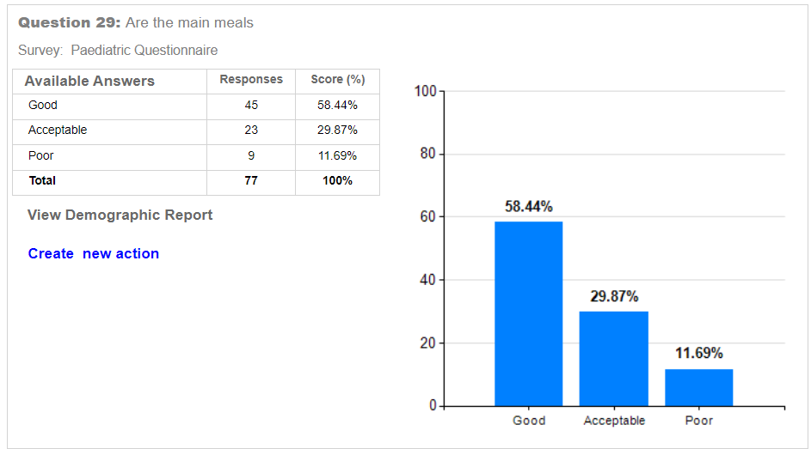
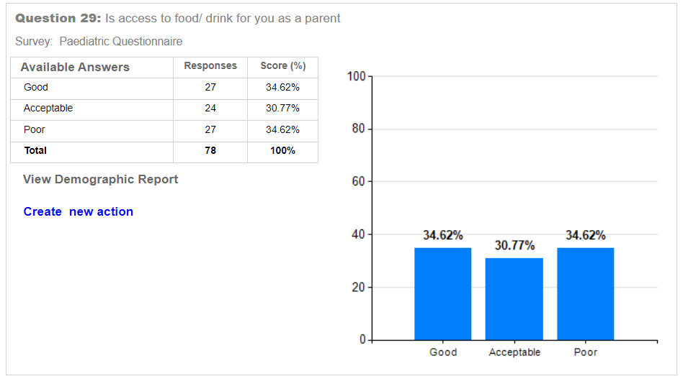

Top themes
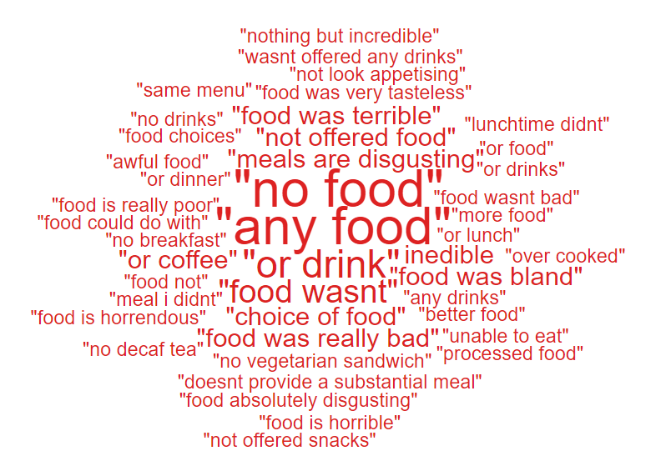
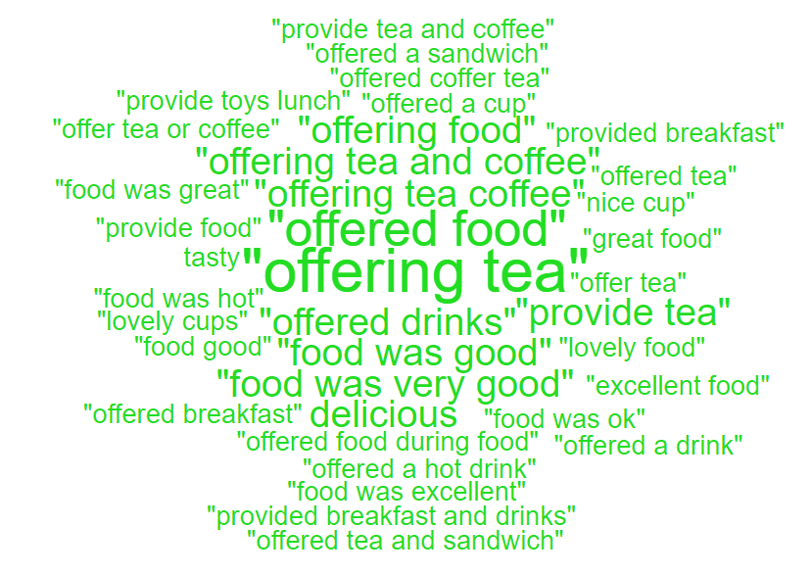
‘Positive’ ‘Negative’

Please see below some positive and negative comments:
- Upon arriving to A&E the staff were so sympathetic from checking in at reception to the triage nurses very lovely. I also was really touched by the volunteer who came around offering tea and coffee and then biscuits. It felt really kind when I was feeling so vulnerable.
- All the staff was absolutely amazing the food was great.
- Everything that was promised was delivered. Excellent medical service, excellent food and care.
- Staff were excellent with all the tests and scan they did to investigate why l collapsed. As we had been there overnight, they provided breakfast and drinks. I waiting to be admitted.
- Not offered food as a parent. Had to ask several times despite being there 24 hours. Would have been easier to be allowed access to equipment to make baby’s bottles myself.
- Too much processed food for sale in hospitals.
- The food absolutely disgusting never had one meal that was hot.
- The cooked food could do with improvement.
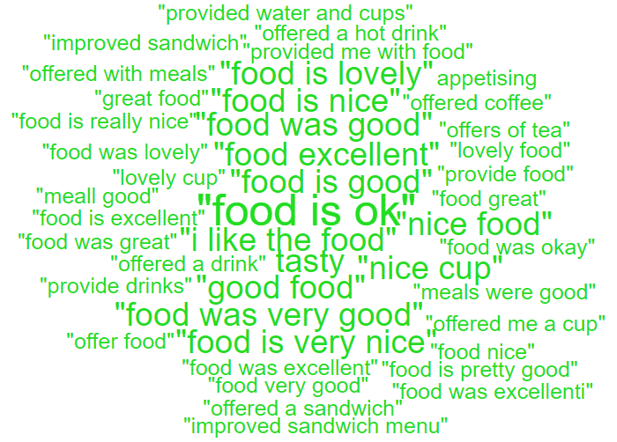

- SERVICE GROUP COMPLAINTS, INCIDENTS, COMPLIMENTS AND PATIENT FEEDBACK HIGHLIGHTS

MORRISTON SERVICE GROUP
4.1 – Morriston Service Group complaints
Morriston Service Group received a total of 212 complaints during Q3 2024/25, this compares with 243 complaints during Q2 2024/25. Graph 1 below shows the total number of complaints received relating to Morriston Service Group since January 2024. The graph breaks the total number received down by Formal Putting Things Right, Early Resolution and Re-opened complaints.
Graph 1: Morriston Service Group complaints by month and type

Graph 2 shows the top five services that had the most complaints since January 2024. Although the graph shows a reduction in Orthopaedic complaints, this is due to the change over with Service Group and Orthopaedics now sitting under NPTSSG.
Graph 2: Top 5 Services by month

4.2 – Morriston Service Group Incidents
Morriston Service Group reported 2412 incidents in quarter 3 (Q3) of 2024/25 (October, November, December). This compares with 1886 incidents in quarter 2 (Q2) of 2024/25 (July, August, September). Graph 1 shows the number of incidents per month broken down by severity.
Graph 1: Morriston Incidents by Severity and month

Graph 2 shows the top 5 incident types, of all incidents reported by Morriston Service Group since October - December 2024.

Graph 2: Top 5 incidents per month

4.3 – Morriston Service Group National Reportable Incidents
Morriston Service Group reported 5 Nationally Reportable Incidents (NRI’s) during Q3 2024/25, this compared to 6 also being reported during Q2 of 2024/25. Of the NRI’s reported, 2 diagnosis issues, 1 x Access to services or admission delayed, 1 x unexpected death and 1 x healthcare acquired infection.
Graph 1: Nationally Reportable Incidents reported per month by Morriston Service Group

4.4 – Morriston Service Group Compliments
Morriston received 132 compliments during Q3 of 2024/25. Graph 1 shows the number received per month since January 2024.

Graph 1: Morriston compliments per month

Graph 2: Morriston compliments – Top 5 Services

4.5 Morriston Service Group Patient Experience Feedback
Overall, during quarter 3 there were 107,557 number of patients seen under Morriston Service Group (This includes Emergency Department and Minor Injury Unit).

There were 8,525 Friends and Family survey returns which equates to 8% responding to the survey. Out of the 8% who responded, 90% of people stated they would highly recommend the Health Board to Friends and Family.

Below are the number of responses in a line graph:
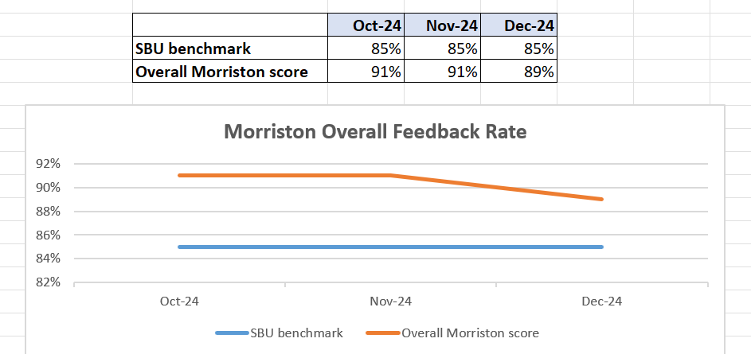

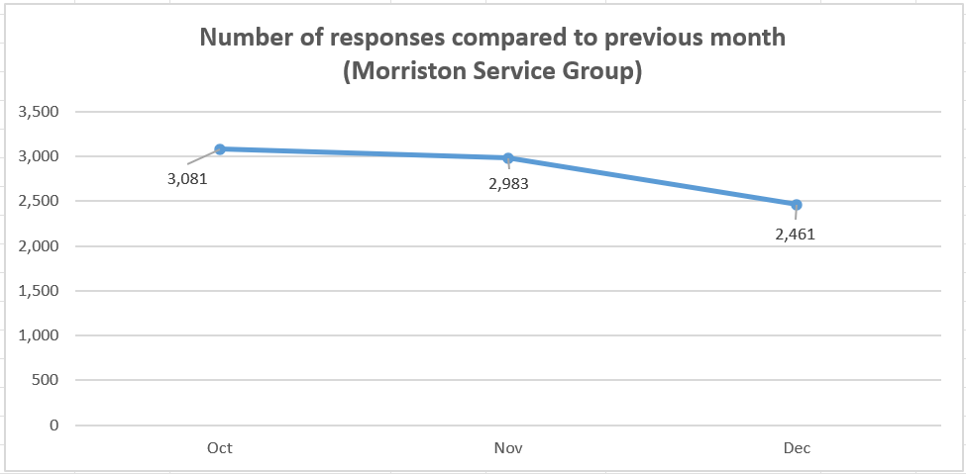

Below are the main themes mentioned for Morriston:
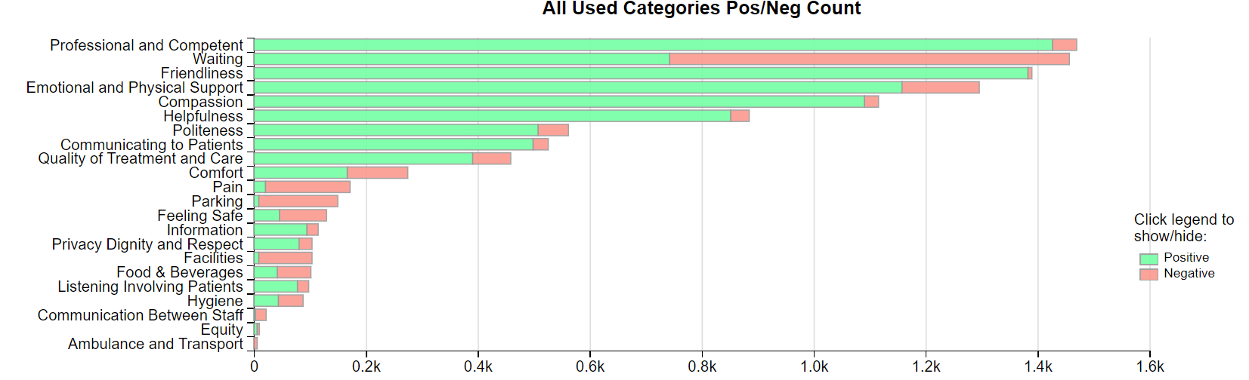

NEATH PORT TALBOT SINGLETON SERVICE GROUP
4.6 – NPTSSG Complaints
NPTSSG received a total of 145 complaints during Q3 2024/25 which was the same as Q2. Graph 1 below shows the total number of complaints received relating to NPTSSG since October 2023. The graph breaks the total number received down by Formal Putting Things Right, Early Resolution and Re-opened complaints.
Graph 1: NPTSSG complaints by month and type

Graph 2 shows the top five services that had the most complaints since January 2024.
Graph 2: Top 5 Services by month

As you can see from the graph, Orthopaedic complaints have decreased which is hopefully as a result of the new theatres and the reduction in waiting times.
4.7 – NPTSSG Incidents
NPTSSG reported 1434 incidents in quarter 3 (Q3) of 2024/25 (October, November, December). This compares with 1516 incidents in quarter 2 (Q2) of 2024/25 (July, August, September). Graph 1 shows the number of incidents per month broken down by severity.
Graph 1: NPTSSG Incidents by Severity and month

Graph 2 shows the top 5 incident types, of all incidents reported by NPTSSG since October – December 2024.
Graph 2: Top 5 incidents per month

4.8 – NPTSSG National Reportable Incidents
NPTSSG reported 19 Nationally Reportable Incidents (NRI’s) during Q3 2024/25, this compares to 11 being reported during Q2 of 2024/25. Of the NRI’s reported 5 x maternal incidents, 3 x stillbirth, 1 x maternal death, 1 x infection control incident, 2 x neonatal death, 1 x Never Event Retained Throat Pack, 1 x Never Event Treatment or procedure wrong or inappropriate, 1 x Never Event Wrong Power Lens, 1 x neonatal incident, 1 x Worsening advice - Incorrect / not provided, 1 x IUD, 1 x HIE III, 1 x CFM Probe to Head.
Graph 1: Nationally Reportable Incidents reported per month by NPTSSG

4.9 – NPTSSG Compliments
NPTSSG received 69 compliments during Q3 of 2024/25, compared with 94 during Q1. Graph 1 shows the number received per month since January 2024.
Graph 1: NPTSSG compliments per month

Graph 2: NPTSSG compliments – Top 5 Services

4.10 NPTSSG Patient Experience Feedback
Overall, during quarter 3 there were 106,342 number of patients seen under Neath Port Talbot and Singleton Service Group.

There were 6,592 Friends and Family survey returns which equates to 6% responding to the survey. Out of the 6% who responded, 95% of people stated they would highly recommend the Health Board to Friends and Family during this quarter.

Below are the number of responses in a line graph:

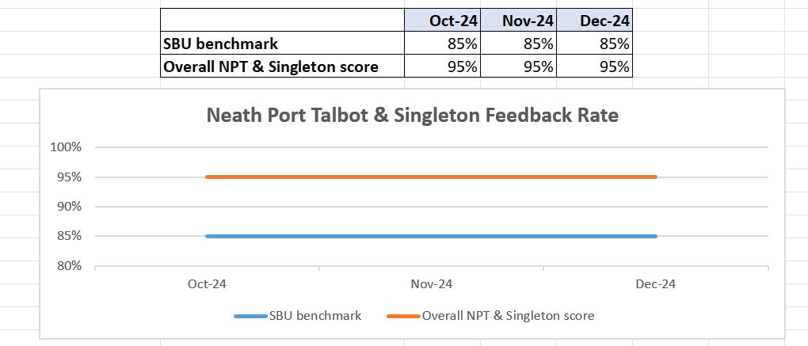
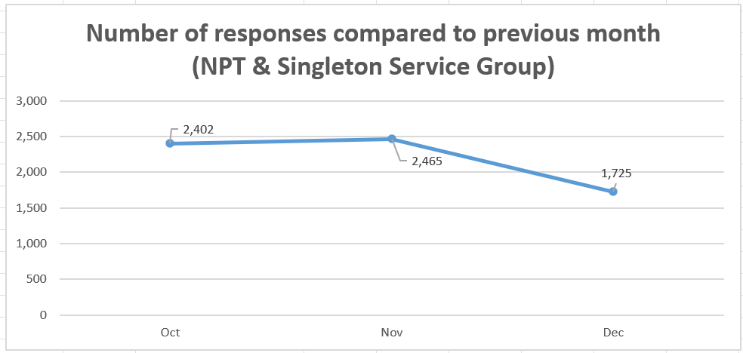

Below are the main themes mentioned for NPT & Singleton:
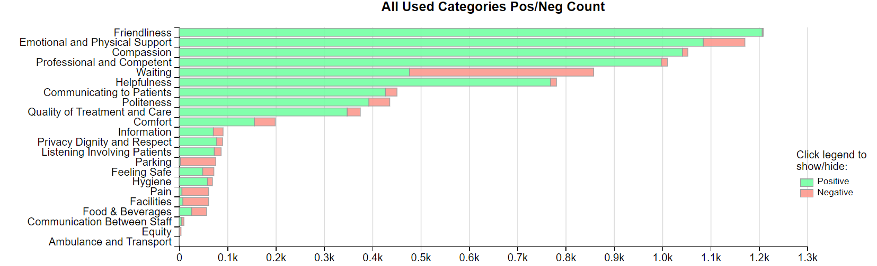

MENTAL HEALTH AND LEARNING DISABILITIES SERVICE GROUP
4.11 – MH&LD Complaints
MH&LD received a total of 86 complaints during Q3 2024/25 (October, November, December) compared with 90 during Q2 (July, August, September). Graph 1 below shows the total number of complaints received relating to MH&LD since January 2024. The graph breaks the total number received down by Formal Putting Things Right, Early Resolution and Re-opened complaints.
Graph 1: MH&LD complaints by month and type

Graph 2 shows the top five areas within MH&LD that had the most complaints since January 2024.
Graph 2: Top 5 Services by month

4.12 – MH&LD Incidents
MH&LD reported 1188 incidents in quarter 3 (Q3) of 2024/25 (October, November, December). This compares with 1105 incidents in quarter 2 (Q2) of 2024/25 (July, August, September). Graph 1 shows the number of incidents per month broken down by severity.

Graph 1: MH&LD Incidents by Severity and month

Graph 2 shows the top 5 incident types, of all incidents reported by MH&LD since October - December 2024.
Graph 2: Top 5 incidents per month

4.13 – MH&LD National Reportable Incidents
MH&LD reported 1 NRI’s during Q3 of 2024/25, compared with none reported during Q1 of 2024/25.

4.14 – MH&LD Compliments
MH&LD received 4 compliments during Q3 of 2024/25. Graph 1 shows the number received per month since January 2024.
Graph 1: MH&LD compliments per month

4.15 MH&LD Patient Experience Feedback
This data is from Quarter 3.

The Mental Health and Learning Disabilities Service Group are using a different set of survey questions. The role out of the semi structured interview surveys have been managed in stages. Roll out, awareness posters and meetings with managers and teams continues.
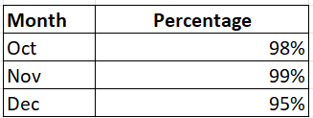

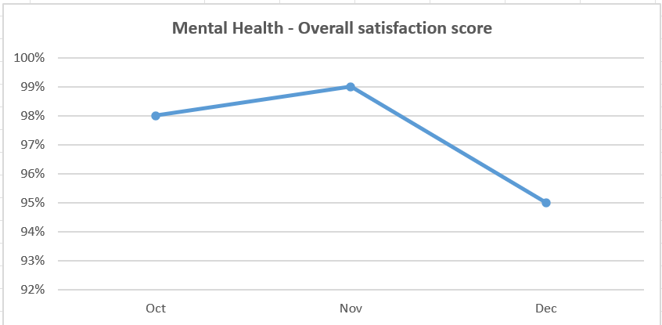
Below are the number of responses in a line graph:

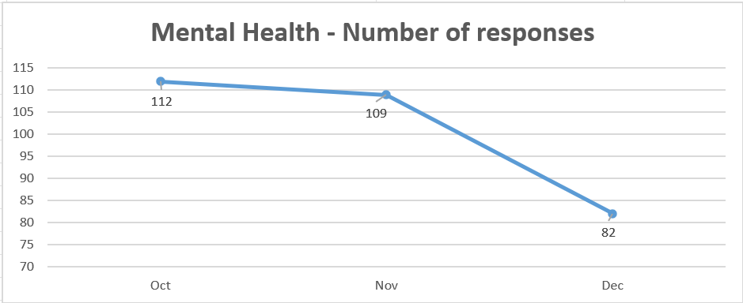

PRIMARY AND COMMUNITY SERVICE GROUP
4.16 – P&C Complaints
P&C received a total of 75 complaints during Q3 2024/25 (October, November, December) compared with 77 complaints during Q2 2024/25 (July, August, September). Graph 1 below shows the total number of complaints received relating to P&C since January 2024. The graph breaks the total number received down by Formal Putting Things Right Early Resolution and Re-opened complaints.
Graph 1: P&C complaints by month and type

Graph 2 shows the top five services that had the most complaints since January 2024.
Graph 2: Top 5 Services by month

4.17 – P&C Incidents
P&C reported 1026 incidents in quarter 3 (Q3) of 2024/25 (October, November, December). This compares with 1226 incidents in quarter 2 (Q2) of 2024/25 (July, August, September). Graph 1 shows the number of incidents per month broken down by severity.
Graph 1: P&C Incidents by Severity and month

Graph 2 shows the top 5 incident types, of all incidents reported by P&C since October – December 2024.
Graph 2: Top 5 incidents per month

4.18 – P&C National Reportable Incidents
P&C reported 4 Nationally Reportable Incidents (NRI’s) during Q3 2024/25, this compares to 3 being reported during Q2 of 2024/25. The 4 NRI’s reported in Q3 included 2 x pressure ulcer, 1 x failed diagnosis and 1 x Delay in clinical assessment.
Graph 1: Nationally Reportable Incidents reported per month by P&C

4.19 – P&C Compliments
P&C received 86 compliments during Q3 of 2024/25, compared with 74 during Q2. Graph 1 shows the number received per month since January 2024.
Graph 1: P&C compliments per month

Graph 2: P&C compliments – Top 5 Services

4.2 P&C Patient Experience Feedback
During Quarter 3, a total of 1,310 patients were seen under the Primary and Community Service Group. This figure is based solely on data recorded in the WPAS system, which is exclusively used in hospital settings. The Primary and Community breakdown in the attendance report is based on a historical managed unit rather than the current service group, which may result in discrepancies. Efforts are underway to update this.

Attendance in community settings is calculated using separate systems, which accounts for the feedback return figure below being significantly higher than the recorded number of attendees.

A total of 1,956 Friends and Family survey responses were received during this quarter, with 95% of respondents stating they would highly recommend the Health Board to their friends and family.

Patient Experience Team are currently working with I.T to automate SMS messages from the PIMS, PIMS+ platform to automate SMS survey messages to Primary Care and Therapies patients. This will increase the number of returns.

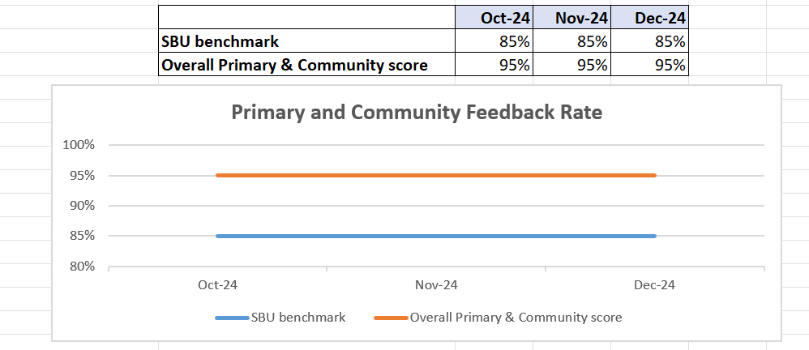

Below are the number of responses in a line graph:

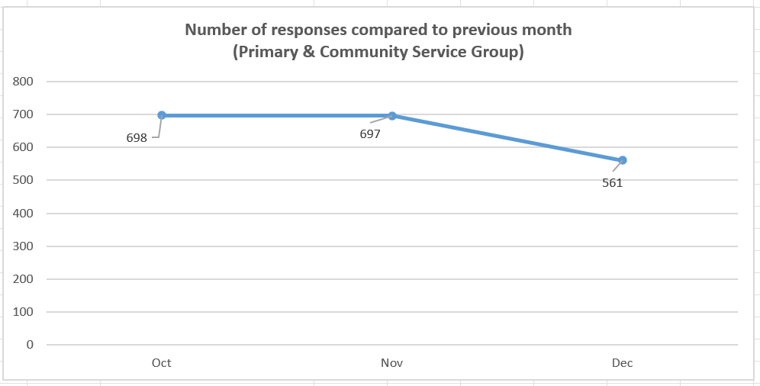
Below are the main themes mentioned for Primary & Community: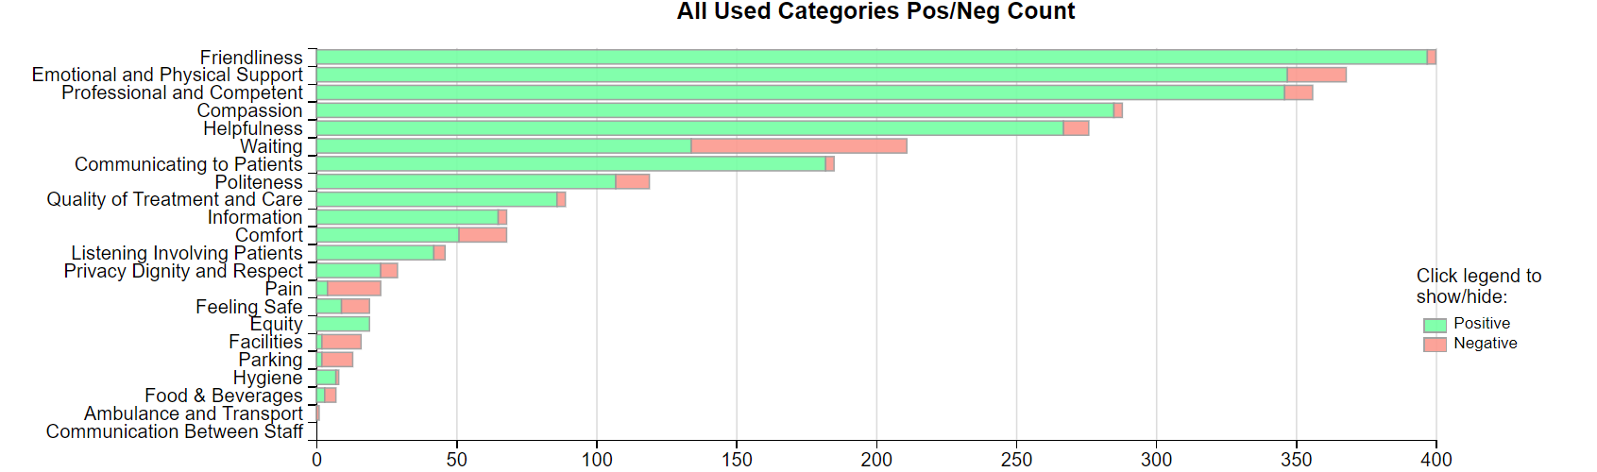
- MEDICAL EXAMINER COMPLIMENTS

5.1 ME Compliments
The Health Board has received a number of compliments from families through the Medical Examiner. This evidences the good work being done when treating these end of life patients. During Q3, approximately 82 compliments were received. A few examples are shown below;
“all involved was absolutely amazing, from the beginning to the end with palliative, team, Marie curie and the GP and district nurses they've all been great, couldn’t fault the care at all.”
District Nursing, NPT

“Everything she received was excellent. They took a lot of time with her and us. Treated with dignity, all despite the ward and themselves being very busy.”
Ward F, Morriston

“Everyone was fantastic. Everyone on Cardigan ward went above and beyond. She said there was no pressure for mum to leave the ward and they looked after her as best as they could. They could not have been any kinder.”
Cardigan Ward, Morriston

- OMBUDSMAN CASES

6.1 Ombudsman investigations
2 new Ombudsman investigations were received during Q3 2024/25, this compares to 3 in Q2 2024/25. Graph 1 shows the number of investigations received per month;

Graph 1: Number of Ombudsman investigations per month

The Health Board has also received 31 decisions not to investigate from the Ombudsman during Q3. Graph 2 below shows these by month.

Graph 2: Ombudsman decisions not to investigate

There are a number of different reasons why the Ombudsman decided not to investigate these complaints, a few of these reasons are detailed below;

- Health Board responded appropriately
- Actions taken by Health Board appropriate
- Complainant seeking financial compensation therefore, matter for the courts
- Care and treatment provided by Health Board appropriate
- No evidence of failings
- Out of time & also complainant advises they have brought a claim
- Dental or GP concerns where practice needs to respond

Ombudsman Final Report – Emergency Department (ED)
The Ombudsman issued three final reports during Q3 all relating to the Emergency Department. The three investigations were relating to different issues however, it should be noted that none of the cases were upheld. A summary of the Ombudsman findings is below;
- The Ombudsman found that the assessment and investigation symptoms by clinicians at the ED was appropriate. It also found that appropriate advice was provided at the time the patient was discharged from the ED.
- The investigation found that appropriate levels of care were delivered to the patient. When the patient attended hospital they were thoroughly assessed and the view of a cardiologist was sought regarding their treatment.
- The investigation found that the management of the patient’s condition when they were admitted to hospital on 2 January 2023 was clinically appropriate

Ombudsman Compliance to timescales
Here is the position for Average Variance to Target for Health Board’s in November 2024. As a reminder, this is a measure of how Health Board’s perform against the target dates to provide evidence to comply with individual recommendations. Anything over a ‘0’ in the ‘traffic light’ formatted section is seen as days over target date on average for the Health Board to provide compliance evidence and anything with a minus indicates the amount of days under, on average, a Health Board takes to provide evidence to comply with a target date to provide evidence to comply with a recommendation.
The NHS average for November is 0.10 compared with 1.69 in October 2024. On average compliance evidence is reaching the Ombudsman’s office on time against the target dates.
 |  | 23/24 | 24/25
Aneurin Bevan University Health Board |  | 3 | 0
Betsi Cadwaladr University Health Board |  | -2 | -1
Cardiff and Vale University Health Board |  | -1 | -3
Cwm Taf Morgannwg University Health Board |  | 15 | 33
Hywel Dda University Health Board |  | -2 | -10
Powys Teaching Health Board |  | -13 | -15
Swansea Bay University Health Board |  | 3 | -2
Velindre University NHS Trust |  | 13 | -1
Welsh Ambulance Services NHS Trust |  | - | -
NHS Average AVT |  | 1.99 | 0.10

Public Interest Reports
The Health Board received 3 Public Interest Reports on 11th January 2024 in relation to the patients wait on the Orthopaedic Waiting List. The Chief Operating Officer met with the Ombudsman and agreed to accept the content of the reports and recommendations in their entirety, including an audit of the Orthopaedic Waiting Lists. The final audit was provided to the Ombudsman in December 2024. The Ombudsman then wrote to the Health Board requesting further information regarding discrepancies between the sample selected for the audit and the scope identified in the Health Board’s letter of 16th August 2024. In its letter the Health Board said it would include:
- “All patients on the current waiting list who have had either a pathway reset or an adjustment. There are currently 777 patients on that list, which is 15% of the total waiting list.” However, the Health Board has advised it has audited 578 patients with open pathways, a shortfall of 199 patients
- “All patients that have been removed from the waiting list since April 2022. The initial list provided was from 1st April 2023 and included 1259 patients. This will be expanded to include the full year 22/23 too.” The sample of audited patients with closed pathways comprised 1251, which falls marginally short of the number from the initial list for 2023, but also does not appear to include any patients from 2022/23.

