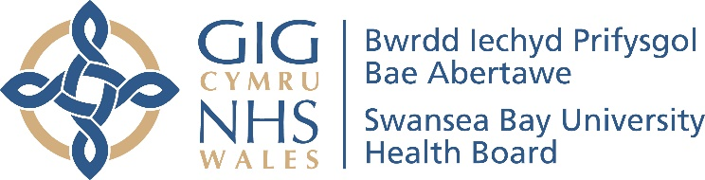
Service Groups’ Highlight Report for
Quality and Safety Committee

Meeting Date: | 28th January 2025
Name of Meeting: | Quality and Safety Committee
Service Group: | Morriston Service Group
Author: | Suzanne Holloway, Group Head Quality, Safety & Patient Experience
Sponsor: | Sue Moore, Group Service Director  Ceri Matthews, Group Nurse Director  Mark Ramsey, Group Medical Director
Presenter: | TBC
Summary of Quality and Safety issues since last report to the Committee
(Reporting period: July to December 2024)
This paper provides an update to the Quality & Safety (Q&S) Committee on matters of quality and safety overseen by the Morriston Service Group.

Quality &Safety Reporting Structures
Since July 2024, there has been a change within the organisational structure of the Service Group supported by the implementation of a formal Organisational Change Process (OCP).

The Morriston Governance Structure has been updated to reflect the following operational Divisions:
- Acute & Emergency Care and Hospital Operations (AECHO)
- Medicine
- Specialist Surgical Services Group (SSSG)
- Integrated Surgical Services Group (ISSG)
- Radiology
- Pathology

Clinical Support Services Division has been formally disbanded with Intensive Care Services and dermatology (the latter from Singleton/NPT) merging with SSSG. Theatre & Anaesthetics have moved to Singleton/NPT. Health Board-wide Radiology and Pathology Services are now separate services under the management umbrella of Morriston Service Group.

The appointment of the Divisional Management Structures (post OCP) has been completed.

Revised governance and reporting structures have been submitted to the Health Board’s Quality & Safety Group for consideration and feedback – 14/01/2025

A copy of the revised structure is attached as Appendix 1.

Delivery of Unscheduled Care is the Health Board’s and Service Group’s highest risk.
In the 6 months from July 2024 to December 2024, 70,735 patients attended emergency services within the Morriston Service Group, 43,875 at Morriston Emergency Department and 26,860 at the Minor Injuries Unit, Neath Port Talbot Hospital.

Of the total attending, 7,232 patients (10%) waited longer than 12hours to be seen. With the exception of 7 patients, all the long waiting patients were at Morriston Hospital.

The ability to initiate clinical handover of patients presenting to the Emergency Department at Morriston Hospital, via emergency vehicle transport continues to pose a risk to patients.

During 2024, the Morriston Service Group has received two formal and one informal request from His Majesty’s Coroner (HMC) under Regulation 28 of the Coroners’ (Investigations) Regulations 2013, in relation to the Prevention of Future Deaths. All three requests were as a direct result of inquest hearings associated to death in the community and clinical deterioration as a consequence of delayed access to emergency care.

In response to the three cases, requested by HMC, the Service Group on behalf of the Health Board was able to provide assurance that operational escalation was in place at the time of the incidents and that ongoing actions and learning had been taken as a result.

Delivery of Planned Care Recovery is currently scored as 20 on the Morriston Risk Register.
Delivery of the 52 weeks waiting time for a first outpatient appointment (Stage1) has been achieved and progress has been made in relation to achieving no patient waiting longer than 104 weeks for treatment (All Stages). As at 09/01/2025, there were 408 patients remaining to be seen by 31/03/2025.

A comprehensive waiting list reduction plan is in place however the main area of risk is in the delivery of Plastic Surgery, ENT and General Surgery for these 408 patients.

Outstanding Patient Safety Incidents
At the last report in July 2024, there were 1972 open patient safety incidents reported against services managed by Morriston Service Group, of which 1330 had been open more than 30 working days (101 had been reported in 2022 and 760 in 2023). The response is detailed below.

Complaints Management: Responses Waiting >30working days
During the period July to December 2024, Morriston Service Group received 330 formal complaints.

On 02/07/2024, the responses to 60 formal complaints were waiting longer than 30 working days; 2 received in 2022, 31 received in 2023 and 27 received in 2024.

As with patient safety incidents, if there is a delay in reviewing and investigating complaints and concerns raised in relation to the delivery of clinical services and overall patient experience, there is a risk that the opportunity for learning and current and future harm prevention is lost.

Independent Review – Emergency Department
Over the last 6 months, the Emergency Department at Morriston Hospital has undergone independent review on 3 occasions:

- Getting It Right First Time (GIRFT) Programme, visited on 25th June 2024.
- A Health Board Assurance Visit was undertaken on 5th September 2024
- Healthcare Inspectorate Wales (HIW) made an unannounced 3-day visit between 27th and 29th November 2024.

Feedback reports and actions plans have been received from GIRFT and the Health Board Assurance Team, and work is progressing to address issues highlighted.

An Immediate Action Plan has been received from HIW and the Health Board’s response has been accepted by HIW.

Key Themes identified across all reviews:
- Departmental environment and overcrowding
- Ambulance delays and clinical handover
- Patient flow
- Staff well-being and moral

Challenges, Risks, Mitigation and Action being taken relating to Quality and Safety issues noted above (what, by when, by who and expected impact)
Ongoing Delivery of the Urgent Emergency Care (UEC) Redesign Programme
The aim of the Programme is to drive forward sustainable change and improvement in urgent and emergency care provision, across the Morriston Hospital and the wider Health Board and is an amalgamation of multiple projects and workstreams covering the following:

- Emergency Medicine
- Same Day Emergency Care
- Frailty Service Provision
- Site Co-ordination
- Acute Medical Rotas
- Clinically Optimised Patients

The Older Persons’ Assessment and Short Stay Unit was opened at the end of June 2024 which in addition to the Same Day Emergency Care (SDEC) Service and the Acute Medical Unit provides an alternative pathway for patients presenting to the Emergency Department and funnels those who are better serviced by a frailty service into appropriate care delivery settings, including being supported at home by services such as the “Virtual” Ward and Acute Care Team.

Goal 4 of the National Strategy for Right Care, Right Place, First Time: Six Goals for Urgent & Emergency Care, Rapid response to physical or mental health crisis, focuses specifically on safe alternatives to ambulance conveyance into secondary care, thus enabling a more responsive service to patients who are in danger of losing their life or require access to time-sensitive treatment; such as that for Stroke or life-threatening injury.

There is an inherent expectation that the number of people waiting over 60 minutes between arriving by ambulance and being handed over to a clinician, reduces year on year

Clinical handover performance is monitored against the following two performance measures, on a daily basis:
- Number of ambulance handovers greater than 1hour
- Number of lost hours as a result of delayed ambulance handovers (greater than 15minutes)

Diagram1: Ambulance Handover Performance covering the period 1st December 2022 to 31st December 2024
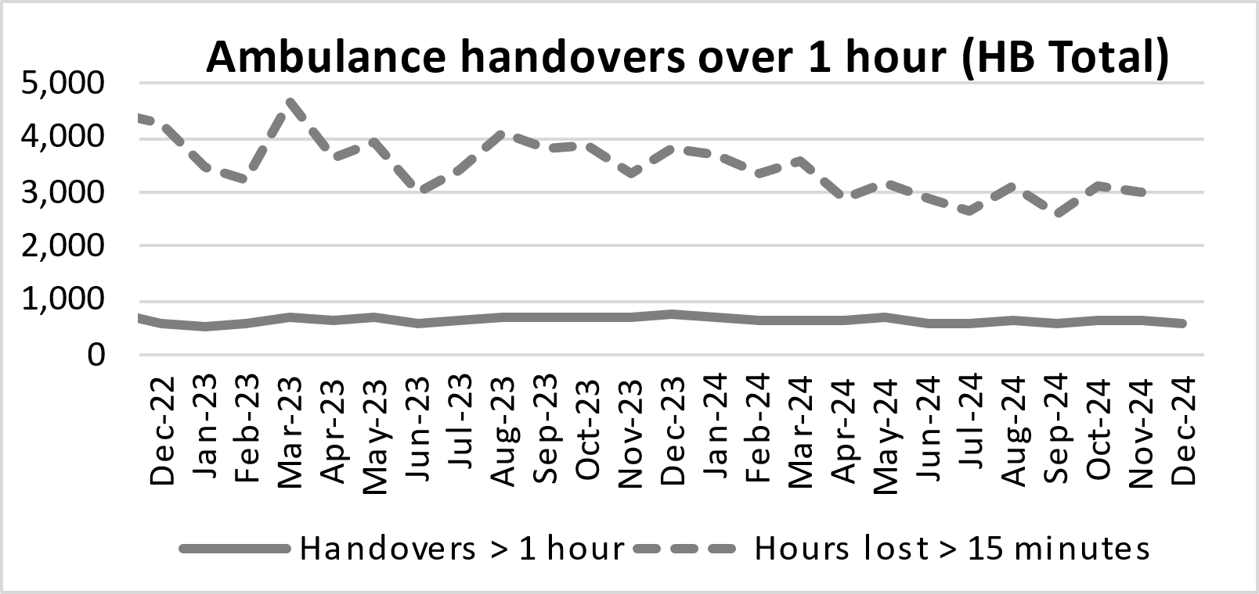
(Source: Health Board Performance Scorecard – weekly update 07/01/2025)

The above graphical representation (solid line) demonstrates the number of delayed emergency vehicle clinical handovers (>1hour) which has remained static (614 in December 2022, to 616 in December 2024) however the number of lost hours (>15mins) as a result of clinical handover delays has significantly reduced by approximately 32% over the same period.

It is fully recognised that challenges and risks within UEC are systems-wide, and delivery of a sustainable solution is via partnership working and collaboration.

Planned Care - Challenges and Constraints
Funding to deliver the target of no patients waiting longer than 104 weeks (by 31/03/2025) has been provided by Welsh Government. Available clinical resource and capacity, including theatre time and access to inpatient beds primarily at Morriston Hospital remain as constraints. The following actions have been put into place:

- Back-fill capacity ensuring that all available theatre sessions are used
- Weekend working thereby creating additional theatre sessions
- Use of clinical resource and capacity outside of NHS Healthcare within the private sector
- Comprehensive monitoring information i.e. “live” monitoring information of the status of patients waiting, including booking profiles

Actions and risks in relation to the delivery of planned care targets are monitored via the Health Board’s Planned Care Board.

Patient Safety Incidents – Ongoing Reduction in Open Incidents
Graph1 on the following page, illustrates the open incident caseload >30days for Morriston Service Group as 02/01/2025.

Graph1: Open Incident Caseload >30days, Morriston Service Group
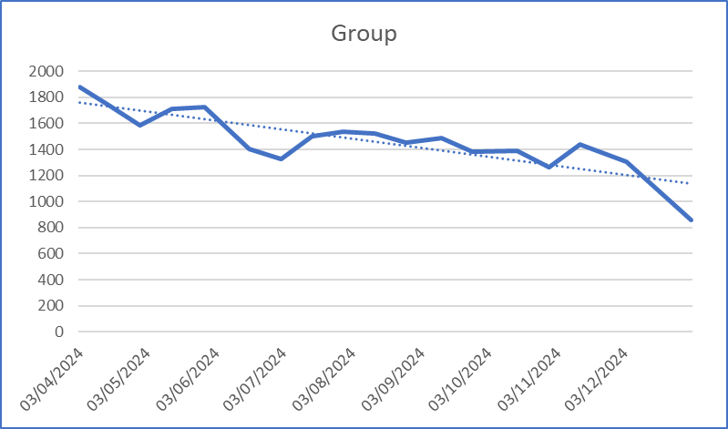

Open Incident Improvement Highlights for July to December 2024
- 101 Open incidents reported in 2022 and open at the beginning of July – are now closed.
- 465 Open Incidents reported in 2023 – have been closed (n = 760 to 295).
- Overall open incident caseload has reduced by approximately 25% (2568 to 1961) during 2024.
- All outstanding RED incidents reviewed by Group Nurse Director and Heads of Nursing 09/01/2024 – ongoing monitoring via established bi-weekly monitoring process.

Ongoing Actions
- Closure of the remaining 2023 incidents (n = 295), which have now all been open >12 months
Details of all outstanding incidents have been provided to Divisional Service Managers and Heads of Nursing and will be refreshed fortnightly – target for closure 31/03/2025.
- There are currently 213 Incidents which have a status “Awaiting Closure” including 48 open greater than 30 working days. These have been investigated fully and only need the closure date to be completed.
Details of relevant incidents provided to Divisional Service Managers and Heads of Nursing on 02/01/2025 – target date for closure 31/01/2025.

Improved Complaint Management
Graph 2 below, shows the volume of formal complaints received by acuity and performance against the 30-days response target. Current 30-days compliance (October 2024) is 78%.

Graph2: Complaint Receipt & Performance, Morriston Service Group
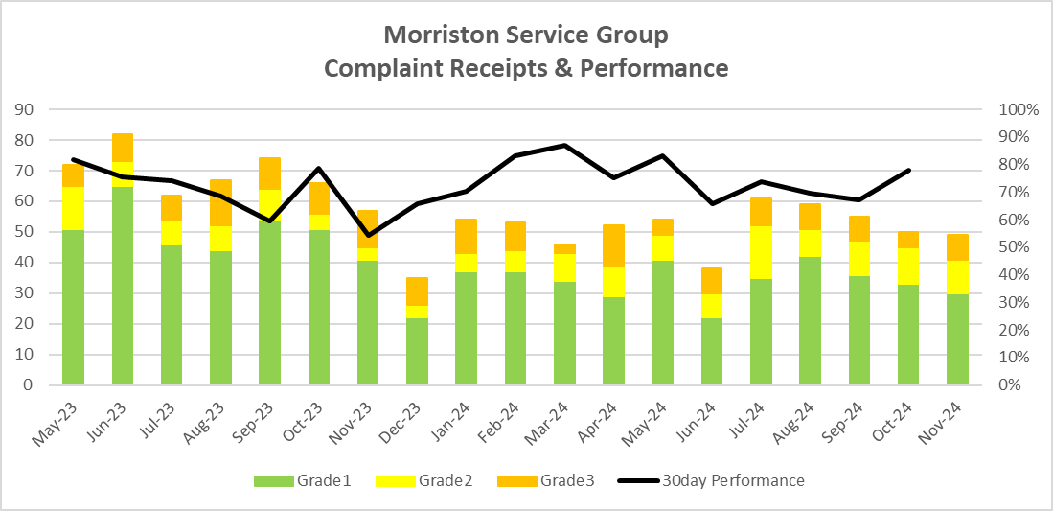
It should be noted that there has been a reduction in the number of “Putting Things Right” (PTR) complaints received in 2024 compared to 2023. This change in volume is a net impact of the full “transfer in” of acute medical service redesign (post December 2022) and Dermatology (June 2024) and the “transfer out” of waiting times and orthopaedics & spinal services (Nov 2023). Whilst there has been a reduction in volume, the proportion of higher-acuity complaints has increased and the divisional caseloads have shifted.
Since July 2024, the following targets have been achieved:
- All complaints received in 2022 have been closed.
- The number of outstanding complaints received in 2023 has been reduced from 31 to 6. There is a plan in place to resolve the outstanding 6 complaints received in 2023 by 31/01/2025 (4 responses are in Final Response and 2 are coming to the end of Investgation). Once these complaints are concluded the longest outstanding complaint for Morriston Service Group will be from April 2024.
Comprehensive complaint information has been provided to Divisional Service Managers and Heads of Nursing and will be refreshed fortnightly.
- Implementation of the Significant Care Review (SCR) process to support management of Grade 3 complaints within 30 working days. If a complaint is deemed likely to take more than 30 working days to investigate (e.g., because of multi-agency involvement or clinical complexity), the Division is encouraged to inform the complainant an early-stage.

Graphs 3.1 & 3.2 illustrate the end of December 2024 position for formal complaints waiting longer than 30 days for a response, by acuity, by division. Fifty percent of the outstanding complaints relate emergency care.

Graphs 3.1 & 3.2: Complaint Response Waiting >30days (and by Division)
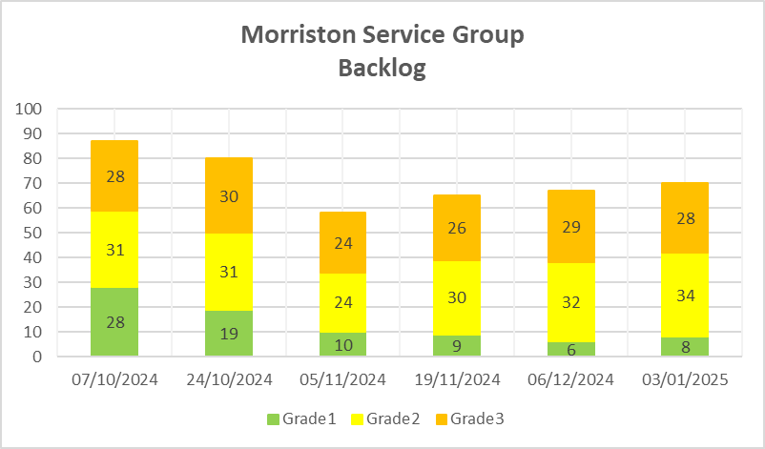 | 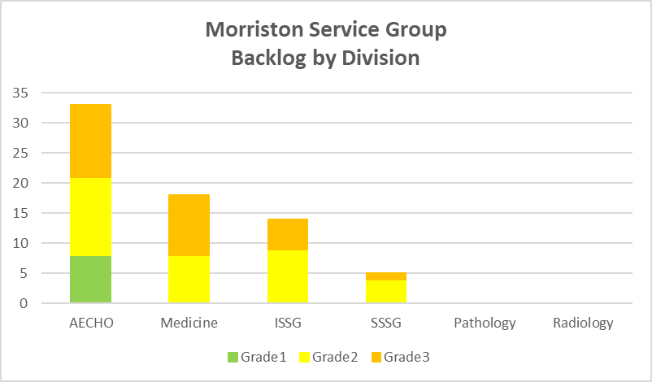

Monitoring processes have also been established to support MS/MP enquiries and re-opened complaints, which are not subject to the Putting Things Right regulations.
Comprehensive non-PTR complaint information has been provided to Divisional Service Managers and Heads of Nursing and will be refreshed fortnightly.

Independent Review – Holistic Response to the improvement of Emergency Department
The independent review of the Emergency Department at Morriston Hospital is welcomed.
Outcomes from reviews will form part of the UEC Redesign Plan and will be pulled together as part of the overall improvement agenda.
Key actions undertaken to date:
- Appointment of 3 Quality Improvement Nurses within the Emergency Department – to start 13/01/2025.
- Formal risk assessment of use of additional, temporary trolley spaces within the Emergency Department undertaken in December 2024 – including the application of control and assurance in order to maintain safety.
- Creation of a Clean Utility within the Emergency Department. This area will be lockable and provide appropriate counter-space, within the clinical footprint for IV preparation – location has been identified and minor works required – to be completed January 2025.
- Vending machines within the Emergency Department have been replaced. New machines should support the use of card payments – Completed
- Introduction of “packed lunch” style food offering within the Emergency Department – from December 2024.
- Establishment of Band 5 Feedback Group to support the development of staff and provide a means of rapid escalation of staff concerns – completed.

Progress Against Annual Plan Quality and Safety Priorities 2021/22 (as applicable)
Quality Priorities: reduction in healthcare acquired infections; improving end-of-life care; sepsis; suicide prevention; and reducing injurious falls.

Exception Updates
Reducing Healthcare Acquired Infection
Reported infections July to December 2024;
- 80 patients with HCAI C difficile  - 30 patients with HCAI Staph aureus  - 30 patients with HCAI E Coli  - 29 patients with HCAI Klebsiella  - 6 patients with Pseudomonas | 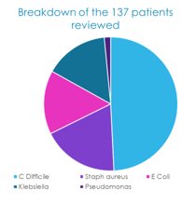

137 cases of the 175 reported have been reviewed at the weekly Morriston IPC Scrutiny Panel
Following review 70 patients were deemed to have had infection which was likely to be preventable, with a further 37 cases having some elements of preventability, on review.

This level of case review is required to the develop evidence-based quality improvement. It is also necessary for the identification of good practice that can be shared and replicated.

Key Themes identified:
- Overcrowding
- An old healthcare estate and infrastructure including a lack of sole occupancy cubicles
- Cleaning protocols (domestic and nursing)
- Antimicrobial stewardship

Actions taken:
- Appointment of Quality Improvement Senior Nurse (August 2024) who has continued to focus on infection prevention and improvement.
- Establishment and stainability of a multi-disciplinary IPC scrutiny panel which sits weekly (Tuesday lunchtime).
- HPV cleaning programme carried out from April-Dec 2024, which required 34 whole-ward moves; 20 Wards deep cleaned & HPV-decontaminated and 6 Wards UV cleaned.
- Review of cleaning standards. Cleaning proposals have been presented at IPC Gold Command and will be going to Management Board for approval.
- A Hospital Acquired Pneumonia (HAP) audit has been prioritised by the Morriston Service Group. The list of cases with a HAP diagnosis during November 2024 and the antibiotic prescription, (115 episodes to be captured by the audit tool) has been shared with the Clinical Directors with a completion date set for 17th January 2025.
Reducing Injurious Falls
The average number of inpatient falls reported monthly in 2023 was 100. This has reduced in 2024 to 90.

There were 10 patient safety incidents reported between July and December 2024, which resulted in a significant injury to the patient. In all cases, the Duty of Candour process has been triggered.

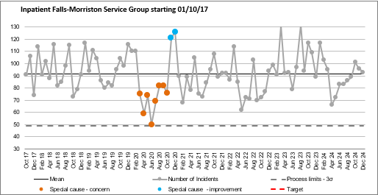

As shown in the SPC above, the pattern and number of falls at Morriston Hospital, is characterised by peaks and troughs. Previous case review has indicated that this was due to a very small number of individual patients having multiple falls whilst in hospital and as indicated previous a potential link with requirement for 1:1 nursing or enhanced observation. These numbers have reduced with the introduction of the “Bay Watch” scheme.

There is a new theme emerging specific to the urgent/emergency pathway of patients falling outside of the traditional ward/bed area and sustaining injuries which are more commonly associated to out-of-hospital events, such as facial injuries and dislocations.

As indicated above, due to the programme of HPV cleaning there has been a large number of wards moves during 2024 (this is where the entire ward has moved location, for a short period of time in order for cleaning and minor works to be carried out). This has meant that the relationship between environment and falling has been difficult to understand.

Action:
- Thematic review of the impact of the environment on in-hospital falls to be assessed – high-level outcomes of the number of reported falls indicates that ward moves have not adversely impacted on the number of in-hospital falls – work to be completed by 31/03/2025.
- Impact of the Older Person’s Assessment and Short-Stay Unit on in-hospital falls -this Unit would bring together in one location a patient population, likely to fall, however early indications suggest that this is not the case – further review work to be undertaken to be completed by 31/03/2025.

Improvement in Nutrition and Hydration
A key feature and a recurring theme in patient experience feedback within the Service Group has related to food. As described in the Service Group’s previous reports, work has been undertaken to establish ward based “Nutrition & Hydration Boards” and Ward based snack trolleys. In addition, the following initiatives are in progress:

- Morriston Nutrition & Hydration Group fully established and chaired by Head of Nursing (SSSG) – the Group meets monthly and includes the Health Board QI Lead.
- “Sip to Send” aimed at reducing pre-operative starve feedback – in place, and achieving outcome at Morriston, with a plan to roll-out across the Health Board.
- Hydration & Nutrition – food tasting moved to wards to replicate patient experience – from November 2024.
- Paediatric Menu – launched November 2024.
- ED Menu (Packed Lunch Style) – December 2024.
- Quality Improvement work has identified that the “patient voice” is currently missing – QI Project Lead currently looking for options to include patient representatives.

Progress Against Health and Care Standards
The Health Board is currently awaiting guidance in relation to the implementation of the revised national programme for Health and Care Standards.

In lieu of a formal monitoring and submission process for 2024/2025, Morriston Service Group have continued with the following actions:
- Inclusion of Health & Care Standard domains within the Group Quality, Safety & Patient Experience Work Programme, and as part of the overall governance structure – currently under review for 2025/2026.
- Adoption of the principles of control, assurance, planning and improvement, within standard quality and safety reporting templates – revised January 2025, in line with Health Board Annual Planning and Quality, Impact Assessment.
- Adoption of the Duty of Quality principles across Annual Planning and Risk Assessment.

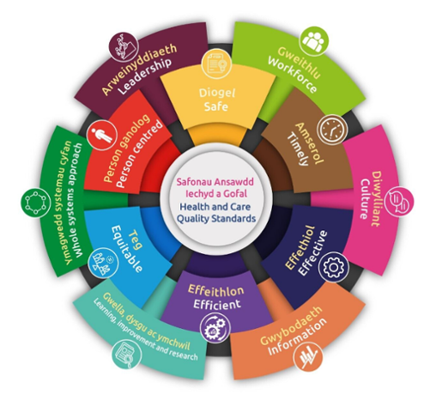

Patient Experience Update
In the 6 months between 01/07/2024 and 31/12/2024, Morriston Service Group received 16,673 patient feedback surveys.

Patient Feedback Themes
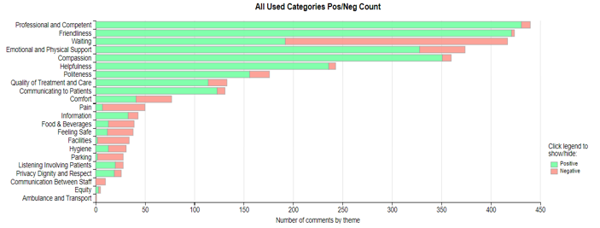
Whilst the above bar graph reflects feedback received in December 2024, the themes shown are consistent over time.

It is important to acknowledge that the vast majority of patient feedback (approximately 90%) is positive and that the professionalism and competency of our staff is consistently the primary reason for positive feedback.

Waiting/Access times continues to be the primary theme in negative feedback and Facilities, Food & Drink and Parking continue to the hot spots.

Learning from negative Waiting/Access feedback clearly indicates that understanding there will be a wait and being kept up to date is fundamental for patients and their family. Providing information in advance on what to expect on arrival at hospital for both planned and emergency care remains a priority:

- Use of pathway booklets
- Use of screen updates and Tannoy systems
- Face-to-face updates

Learning from negative feedback on food & drink highlighted an issue with some of our vending machines, which only accepted cash. These have been replaced with machines that accept contactless payment.

Examples of Positive Feedback received December 2024:

- Same Day Emergency Care – “I was seen quite quickly. Scans arranged and I've already had the results. A very good service indeed. Everyone who I came in to contact with was great.”

- Surgical Acute Assessment Bay – “I was picked up and you couldn't have treated me better. Marvellous, everything went according to book. They gave me the answer I was looking for. Everyone so polite and hard working. Perfect.”

- Theatre Admissions Unit – “The friendliness of the nurses and doctors and the time they took to explain everything.”

- Respiratory - Morriston Hospital – “I really appreciated my test results being explained in detail. Also, the reason for the changes in medication and the plan of tests/treatment going forward. My appointment was a very positive experience!”

Any Other Issues to Bring to the Attention of the Committee
None.
Recommendations
Members are asked to: Note and discuss the contents of this report.

Service Groups’ Health and Safety
Highlight Report

Summary of Health and Safety key issues since last report to the Committee
(Reporting period: July 2024 to December 2024)
Maintenance of the environment and infrastructure at Morriston Hospital continues to be the primary Health & Safety focus at Morriston Hospital.

If the Healthcare Estate is not maintained and developed in line with current and anticipated future service demand, there is a risk to the delivery of safe, sustainable clinical services within an appropriate clinical environment
Over-crowding within front-door services has been identified as a causal/contributory factor within a number of serious incidents notified to Welsh Government, in 2024, and is inherently linked to other system risks related to patient flow, within the wider healthcare system.

Challenges, Risks, Mitigation and Action being taken relating to Health and Safety issues noted above (what, by when, by who and expected impact)

Environmental/Infrastructure: Roof Repair and Maintenance
Essential repair and maintenance of part of the roof infrastructure is in progress and is linked to a comprehensive ward refresh and IPC cleaning programme.

Fire Safety Risk Review: Use of Additional Inpatient Capacity
In response to urgent and emergency care demands and in order to reduce patient safety risks within the “front door” locations at Morriston Hospital, it has been necessary to implement a process whereby additional patients are placed within ward locations, in excess of agreed baseline inpatient bed capacity.

In some cases, this has meant the creation of an additional temporary inpatient bedspace adjacent to or in front of a fire door.

As a result, the following risk has been identified:
Avoidable risk to patients and staff as a result of a failure to comply with accepted standards for fire prevention and emergency hospital evacuation plans.

However, in conjunction with the Asst. Director of Capital Planning/Health & Safety – Finance, the Service Group have developed a set of controls and assurance processes aimed at mitigating risk, with a clear objective of:

On occasion when it is necessary to create additional temporary inpatient bedspace, to ensure that robust and sufficient fire risk mitigation is established in order to maintain patient and staff fire safety as set out in the Health Board’s Fire Safety Policy (September 2023).

The risk assessment and management of additional trolley spaces within the Emergency Department was highlighted as an Immediate Action following the HIW visit to the department between the 27th and 29th November 2024.

Assurance has been provided to HIW that risk assessment of the placement of additional patients within the Emergency Department is clinically driven and that appropriate controls and assurance mechanisms are in place to ensure patient and staff safety.

HIW have confirmed that they are assured that action is in place

This action is directly linked to the development and implementation of the Patient Flow Process – draft Standard Operating Procedure (SOP) for Patient Flow was reviewed by the UEC Group on 08/01/2025, this SOP will now be linked to controls required for the use of additional temporary bed capacity.

Performance Progress to include: Statutory and Mandatory Training; PADR compliance; Serious Incidents; Staffing and Sickness Levels;

The Morriston Service Group performance shown below is as at 12/01/2025 (source ESR):

Health, Safety & Welfare | 90.21%
Violence & Aggression (Wales – Module A) | 88.66%
Fire Safety | 85.64%
Moving & Handling | 80.1%

Governance and Risk Issues to include risks relating to Health and Safety on the risk register
There are currently 15 Risks on the Morriston Service Group Risk Register associated to Health & Safety. Table1 below illustrates the risks by risk sub-type:

COSHH | 6
Violence and Aggression | 5
Fire | 1
Violence & Aggression, Lone Working | 1
Sharps | 1
Manual Handling including LOLER | 1
Grand Total | 15

Control of Substances Hazardous to Health (COSHH)
The COSHH risks highlighted on the Morriston Service Risk Register are unique to services directly managed by the Service Group; HSDU, Radiology & Pathology.

Violence & Aggression
As previously reported to this Committee the vast majority of violence and aggression incidents are perpetrated by patients on staff and this is reflected in the risks highlighted on the risk register.
Outcomes from the Annual Staff Incident Review 2024, will be shared with Committee in the July 2025 update.

Current issues for 2024-25 for the Attention of the Committee
Sadly, during 2024 there have been two fatal self-harm events on the Morriston Hospital Site. Neither event required formal notification to the Health & Safety Executive. Nonetheless, both cases can offer critical learning in the prevention of future events.
Both incidents were notified as reportable incidents and investigated by the Health Board’s Patient Safety Incident Investigation Team.
INC52606
This investigation did not identify any actions or omissions by staff at Morriston Hospital that may have prevented the circumstances leading to the patient's sad and untimely death.
However, valuable learning in relation to ligature assessment has been identified and changes to the Health Board Policy and Assessment Tool are in progress, in conjunction with the Health Board’s Health & Safety Team – it is anticipated that this will be concluded by 31/01/2025.
Compliance for ligature assessment within Ward areas at Morriston Hospital is 93.7% (December 24).
However, it is recognised that there is a need for expansion of routine assessment into public areas and this will be addressed as part of change to policy.
The outcome report has been shared with His Majesty’s Coroner and with the family of the patient and the Morriston Quality & Safety Team continue to provide full support to family.
INC61832
The final report is due shortly (before 17/02/2025). Any outcomes and actions arising from this report will be shared as required with a formal update included in the July 2025 Report.
Recommendations
Members are asked to note the content of this report.

