
Service Groups’ Highlight Report for
Quality and Safety Committee

Meeting Date: | Tuesday, 23rd January 2024
Service Group: | Primary, Community and Therapies Service Group (PCTSG)
Author: | Claire Lewis, Quality and Safety Improvement Manager
Sponsor: | Sian Passey, Group Nurse Director
Presenter: | Ceri Todd, Group Medical Director  Sian Passey, Group Nurse Director
Summary of Quality and Safety issues since last report to the Committee
(Reporting period: October to December 2023 )
This paper provides an update to the Quality & Safety (Q&S) Committee on matters of quality and safety overseen by the service group.

Q&S Reporting Structures
The quality and safety reporting structures continue to evolve for PCTSG. Workplans for 2024 and Terms of Reference for all groups are being reviewed and updated accordingly. Group self-assessment is planned to take place over the next few months. Service level governance structures are also being developed to support the quality and safety reporting into the group structures.

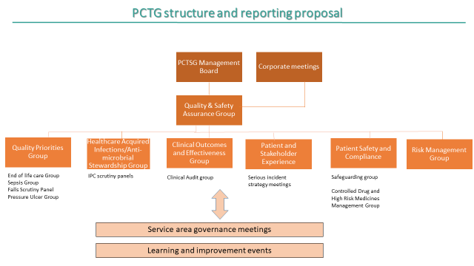

Risk management
PCTSG have developed a Risk Management Group to oversee risk management arrangements and implementation of policy to ensure consistency throughout the service group. The group also scrutinises and approves new risks added to the register and ensures regular review of risks. The group is newly formed and the draft terms of reference is below. The group reports into PCTSG Quality and Safety Assurance Group with a monthly report on 20+ risks reported to PCTSG Management Board.

Incidents
PCTSG currently has about 550 open incidents with a reducing trajectory; the number of open incidents is likely to reduce to 500 by the end of the month with a plan being developed to reduce further throughout February. Table 1 identifies the number of incidents reported and closed per month. It can be noted that an increase of incidents was noted as from August 2023, this corresponds with the transfer of Lymphoedma and Specialist Palliative Care services into the Group. Table 2 below shows the top three themes for incidents reported in December 2023; the incident themes have not changed with the transfer of the additional services in the service group. Approximately 80% of all incidents reported relate to pressure damage and over 70% of these are incidents that occurred prior to the patient being under our caseload.

PCTSG have established two standard operating procedures to support proportionate review and closure of pressure ulcer incidents:
- The governance team lead the review of incidents reported by ED to ascertain whether the patients were under PCTSG care. Incidents that were under care are referred to the relevant clinical team for review and closure. Others are closed by governance. Themes and preventative work will be considered under the pressure ulcer quality priority workstream under development.
- The governance team are supporting monthly workshops to review lower level pressure ulcer incidents, with relevant clinical staff. To date there have been two workshops which has resulted in a sharp increase in closure of incidents as seen in table 1 below; there are another two workshops planned in January. Following a review and collation of themes, incidents are either closed or referred for more in-depth investigation through scrutiny panel. This does not affect those incidents that would have progressed to scrutiny panel in any case due to their level of grading. A paper outlining themes from these incidents are to be presented through PCTSG Safety and Compliance Group in February 2023.

A Quality Summit is to be held in February to share learning around the more serious pressure ulcer incidents and the flyer for this is embedded below.

Table 1.

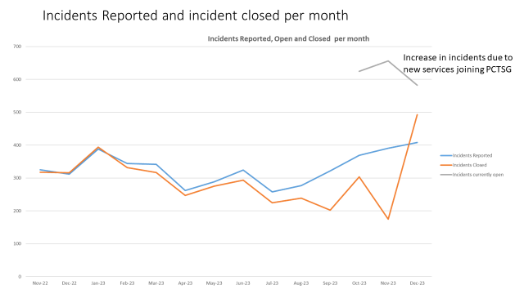

Table 2.

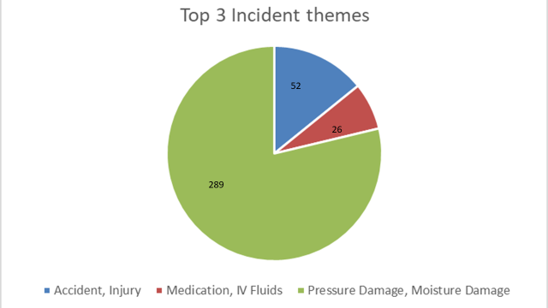

The second highest theme is around accident / injury and will relate to skin / pressure damage as well as staff injury. The service group have started to review this information with relevant workstreams being taken forward through PCTSG Health and Safety Group and Patient and Stakeholder Experience Group.

Concerns
Table 3 below shows the number of concerns and enquiries received into the service group as well as the percentage of compliance against the Health Board target. As can be seen by the table, PCTSG have consistently achieved the performance target of 80% of complaints responded to within 30 working days. A brief drop in performance for July 23 (October’s data) was a result of leave for the governance team, this also coincided with a sharp rise in complaints from the HB Practice. There were also a rise in complex complaints at this time.

An initiative was introduced in March 2023 (which impacted on performance data from January 2023) to improve complaint handling, this involved increasing the number of complaints managed by Early Resolution (ER), this initiative was successful and has become business as usual, which has supported the Group maintaining their compliance with performance targets.

Table 4 below shows themes from our complaints reported in December 2023. The majority of complaints received were from HMP Swansea and relate to medication and treatment. A project on using Buvidal as an opiate substitute therapy, which includes psychosocial intervention as well as effective prescribing, is underway and has received positive feedback from recipients. Complaint numbers and themes are monitored by the PCTSG Stakeholder and Experience Group

Table 3.

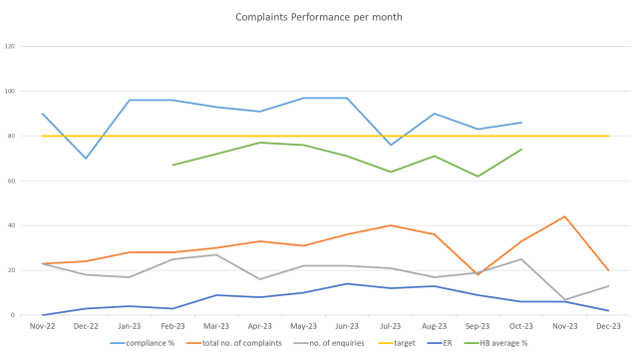

Table 4.
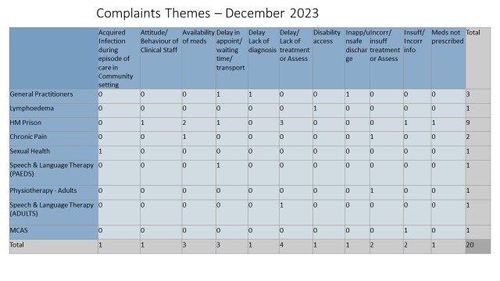

Audit
There is a structured approach to feeding the governance of audits via the PCTSG Clinical Audit Group and PCTSG Clinical Outcomes and Effectiveness Group (COEG). For 2023/24 the Audit Management and Tracking (AMaT), has been used to record clinical audits and monitor progress. Where audits have identified areas for improvement, an immediate assurance plan is requested in preparation for re-audits. Progress against audits and action plans are monitored at Clinical Audit Group. Clinical audit proposals and the annual audit plan are discussed and approved at PCTSG COEG. As of December 2023, nine audits had been completed and closed and 17 remain active for completion by the end of March 2024. Planning for 2024/25 has begun and will utilise the HB Clinical Audit Sharepoint site for registering and monitoring.

Quality and Engagement Act
Agreed high level quality indicators to collate monthly performance and theme data from incidents, complaints and patient feedback has been developed for PCTSG and is monitored at each quality and safety group. This supports the group to identify areas of good practice as well as areas for improvement. Improvement plans are put in place in response to data and risk is evaluated and managed.

Ongoing work is taking place to support Quality Improvement training throughout the service group and training dates for senior managers has been agreed for end of January 2024. PCTSG will be the first group to receive senior leadership quality improvement training from the corporate team.

A pilot has been successful to introduce automated friends and family requests following clinical appointments through the PIMMS management system. This has been piloted with Speech and Language Therapy and is due to be rolled out to other services through 2024. It is recognised that further work needs to be undertaken to support PCTSG to listen and learn from patient experience. The governance team are looking at how central roles can be developed to support this process.
A number of services are using PREMS and PROMS. This supports the collation of outcome measures for these services. PCTSG are reviewing their quality and safety reporting at service level in order to ascertain how to improve reporting on outcome measures across the services.

The service group are also exploring how best to use Quality and Equality Impact Assessments to support senior level decision making.

The Quality and Safety structures include a robust overview of duty of candour triggered incidents supporting the services to follow through the relevant processes, with strategy meetings arranged by the governance team.

All 8 Duty of Candour cases for PCTSG are open at present. Services are developing and evolving their processes for Duty of Candour as they develop their experience. As many of our services are delivered jointly, the process can be more complex than for services fully managed by the health board. The Duty of Candour incidents currently under investigation are as follows:
- Joint investigation with LA following a choking incidents for a patient who had been referred for swallow assessment. Investigation and report completed and shared through Patient and Stakeholder Experience Group. Following through on breach of duty and qualifying liability and final letter to patient’s family to be submitted. This incident is due to close.
- Four incidents relating to pressure ulcers that are under investigation. Investigation training to be provided to the DN team to support proportionate investigations and a more robust process. Duty of Candour processes are being followed.
- Three incidents relate to death in custody as HMP. A family liaison officer is in place that provides contact with the family in these events. Support to be provided to Prison Healthcare Staff to ensure robust investigation is undertaken prior to external agency investigations.

Support is available to primary care contracted and commissioned services and the service group are considering how to collate information from Primary Care in readiness for the Annual Quality Report. This work will be enhanced through the appointment of a Quality and Governance Lead that will support assurance reporting structures, feedback and shared learning. PCTSG are part of a national group reviewing how to support care homes with duty of candour.

External reviews
External reviews are monitored through PCTSG Safety and Compliance Group to ensure actions are completed. There is currently one GMS practice with actions due to be completed by end of January and the primary care team are supporting with this.

The current status on HMP Swansea combined action plan is embedded below. A task and finish group has been established in early January with the aim of developing goals and deliverables against staffing challenges, clinical pathway development and benchmarking activities.

Internal Audits
There are currently no outstanding actions from internal audit reports.

Challenges, Risks, Mitigation and Action being taken relating to Quality and Safety issues noted above (what, by when, by who and expected impact)

PCTSG Risk Management Report is attached giving an outline of all risks scored at 20+. Included in this report are the following two risks which have been highlighted as having a direct impact on quality and safety matters reported above.

Risk 3095 – risk to assurance activities due to current staffing resource within governance team. Some posts have been recruited to and staff are in process of training. The Quality and Safety Lead roles are waiting for start dates. However, further governance workforce review is required to support the expanding remit and the additional workload to support the transferred services to the group. A revised workforce plan for Governance is to be presented at PCTSG Management Board in February by the Quality and Safety Improvement Manager. This will include roles to support services with collecting patient feedback utilising a variety of tools.

Risk 3071 – Healthcare Nursing Staff Levels at HMP Swansea. The Executive Director of Nursing has established a group with first meeting in early January 2024, actions have been identified and plan being formulated. The plan will consider staffing challenges, clinical pathway development, benchmarking activities. Outcomes from the group will be reported through to PCT to Management Board.

Risk 1519 – Sustaining general medical services in the Health Board GP Practice. Medical roles have been recruited to and administrative and agency staff have been deployed to support the practice. Improvement plan is progressing. Risk remains until staff have are in role and trained.

The medical examiners process is to commence in Primary Care in April 2024 and the process is being highlighted to LMC on 16th January 2024. Consideration is being given to assurance mechanisms through PCTSG and the wider Health Board.

Progress Against Annual Plan Quality and Safety Priorities 2021/22 (as applicable)
Quality Priorities: reduction in healthcare acquired infections; improving end-of-life care; sepsis; suicide prevention; and reducing injurious falls.

PCTSG have re-established the Quality Priorities Group to ensure a centralised coordination of activity in relation to sepsis, suicide prevention, falls, end of life care, HCAI, pressure ulcer and nutrition and hydration. Leads have been identified and a Goals, methods, outcome approach for improvement plans has been implemented, this will be expanded to the new quality priority areas. The first meeting is scheduled for the end of January 2024.
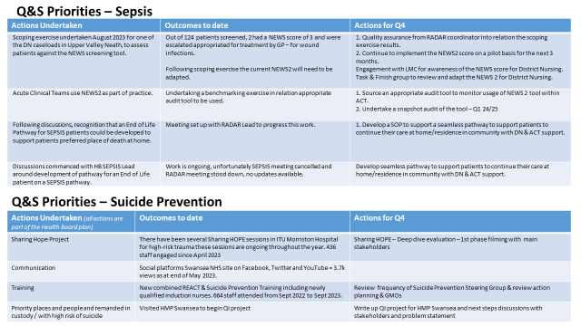

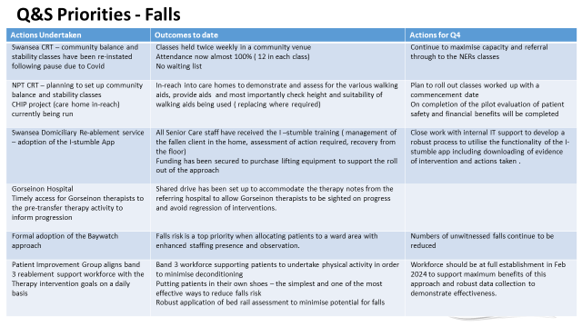

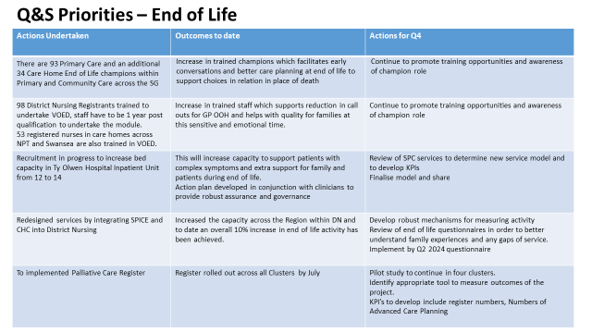

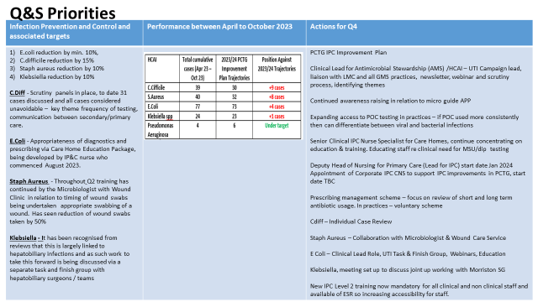

Progress Against Health and Care Standards
PCTSG are awaiting further instruction from Welsh Government and Corporate Services on reporting requirements for 2023/4. The previous self-assessment scored 3 or above on all areas of Health and Care Standards. Improvement plans outlined within this report have been formed with the Health and Care Standards in mind.
Patient Experience Update
PCTSG has an established Patient and Stakeholder Experience Group and the group continues to achieve above the 85% target for positive feedback resulting from patient experience. It is recognised that further work needs to be undertaken to improve the way services listen and learn from service users as the group received only 303 responses last month. Automated friends and family requests from PIMMs will have a positive impact.

The group has a monthly update from patients through the quality and safety structures which is evidenced in Table 7 below. Resource has been identified as an obstacle to improving patient experience activity and collation of patient stories. This is being addressed through the governance workforce review with plans to include roles that will support with patient feedback mechanisms. Also, support from Quality and Governance Leads with service level reporting will improve oversight of PREMS and PROMS data.

Themes from the feedback received in December 2023 is provided at Table 6. below. The service has identified that the data associated with the pain domain which is persistently reported as red is incorrect and Corporate are trying to rectify this. The top 3 themes identified with negative feedback relates to waiting times, comfort and professionalism. The governance team is working with services to break down the data at service level to support improvement plans. Services have been requested to submit ‘You said, we did’ reports to evidence improvement activities.

Table 5.
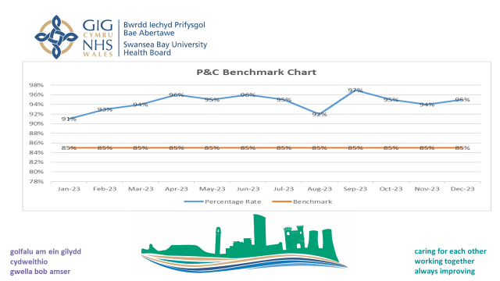

Table 6.
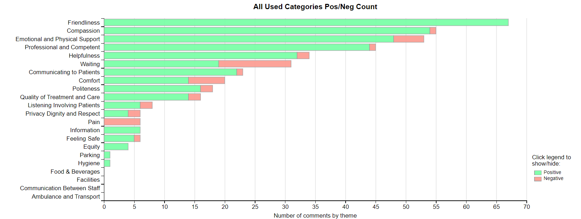

Table 7.

Person | Meeting | Title
Nursing | QSAG | Jeans Story
Health Visiting | PS&E | I don’t know where I'd be" with you.
OT | PS&E | Mental Health Service
Prison | PS&E | Opiate Substitute therapy
Nutrition & Dietetics | PS&E | Lighthouse service (children & young people weight management service)
Physiotherapy | PS&E | Impact of outreach paediatric respiratory service
Gorseinon | QSAG | Escalation of patient who developed sepsis
Speech and Language Therapy | PS&E | Gathering patient experience
 | PS&E | Hospital Mouth Care
District Nursing | PS&E | End of life care
Community Cardiology | QSAG | Cardiac rehab
OT | QSAG | Father enjoys quality family time again thanks to brain injury service
SALT | PS&E | Choking Incident

Any Other Issues to Bring to the Attention of the Committee
None at time of writing report
Recommendations
Members are asked to: Note and discuss the contents of this report.

Service Groups’ Health and Safety
Highlight Report
for
Quality and Safety Committee

Meeting Date: | Tuesday, 23rd January 2024
Service Group: | Primary, Community and Therapies Service Group (PCTSG)
Author: | Emma Williams Senior Operations Manager
Sponsor: | Sian Passey, Group Nurse Director  Emily Warren, Associate Director, Operations
Presenter: | Ceri Todd, Group Medical Director  Sian Passey, Group Nurse Director

Summary of Health and Safety key issues since last report to the Committee
(Reporting period : October to December 2023
There is a new Operations Manager in post with H&S under her remit.
The last meeting of the PCTSG H&S meeting was held on 13th December 2023. The agenda has been revised into themes to focus on the main areas of reporting. Themes include violence and aggression; fire safety management; estates risk management; assurance – escalations.
There will be a focus on risk moving forward with the establishment of a new H&S Risk group stood up which will report into the main PCTSG H&S meeting, to provide assurance around risk management. There will be discussions with Governance to potentially combine the meeting with Quality and Safety to promote attendance and ensure consistency.
There is also renewed focus on fire management and the H&S team are giving consideration to a bespoke solution as to how assurance is given with the complexity of multi-disciplinary teams across multiple sites.
There are plans for the Action Log to be revised and grouped into themes to allow for easier identification and pro-active monitoring of risks, to support service groups and provide assurance. Themes will likely include estates, staff safety and effective risk management. These themes will enable deep dives into the various areas.
With the establishment of the Operations Team, there aims to be a re-energised approach to H&S with a dedicated representative at each meeting of the Health Board’s Operational H&S Group and Fire Safety Group. The additional resource will enable papers to be collated and fed into the relevant meetings.
The Operations Team representative will act as a conduit to help the flow of risk resolution and to raise the profile of risks, such as issues with the ageing estates infrastructure, at a corporate level to facilitate equitable and timely resolution.
There will be a project management approach to H&S with the aim to establish up to date records held in a central repository to facilitate audits and compliance.

Challenges, Risks, Mitigation and Action being taken relating to Health and Safety issues noted above (what, by when, by who and expected impact)

Areas of focus where there are challenges:
- Issues relating to manual handling (as seen in serious incident data) with the Health Board struggling to resource training. Laurie Higgs is looking into this and this has been added to the risk register
- Violence and aggression guidance and training for staff
  - To develop a robust action plan including guidance relating to dealing with aggressive persons
  - Lone Working – to consider whether this is operating efficiently, especially in light of staff working in the community
  - To consider bespoke training
- To set up a risk management sub group to provide assurance to the main PCTSG H&S meeting
- To do a needs analysis on training and develop a training plan with prioritise
- Challenges around identifying responsible person on shared sites and multi-disciplinary teams. Consideration is being given to this as clarity is needed.
- Learning from best practice in Mental Health’s approach to risk management and documentation
- H&S colleagues developing a dashboard for the next meeting to manage, monitor risks and close risks
- H&S colleagues developing guidance relating to fire assessments and to ensure they are happing, especially given complexity of multiple sites such as the prison
- Security management – developing a framework/action plan covering staff protection and roles and responsibilities of key staff
- Ensuring adequate representation from Estates relating to buildings management and a clear focus in the H&S meeting - as there are a number of estates issues, especially at Gorseinon (flooding in basement and the need to move the boiler) and Cimla (freezing buildings, deteriorating roof, leaks)
- MHRA (bed rail) report – The service group is working on this with Laurie Higgs to ensure information from communities in captured. An update is going to the February meeting.
- Shared waiting areas in multi-disciplinary sites is being considered after an incident in central clinic (mental health patients waiting in same area as children). This is being reviewed.
- The repository for H&S information will undergo housekeeping to ensure accessibility and finding relevant information

All of the above will be reported on in the February H&S meeting
Performance Progress to include: Statutory and Mandatory Training; PADR compliance; Serious Incidents; Staffing and Sickness Levels;

RIDDOR Reporting:
There has been no significant increase in overall incident rates. (Table 1). As reported previously incident rates are low and only a limited number of incident domains have been subject to a more detailed analysis.

Table 1 | Month
Incident Type | Jun  2023 | Jul  2023 | Aug  2023 | Sep  2023 | Oct  2023 | Nov  2023 | Total
Aggression Patient to Staff | 1 | 5 | 2 | 1 | 1 | 1 | 11
Verbal Abuse Patient to Staff |  | 2 | 2 |  | 4 | 2 | 10
Assault Patient to Staff |  | 5 |  | 1 |  |  | 6
STF | 2 | 3 |  |  |  |  | 5
Verbal Abuse Visitor to Staff | 1 |  | 1 | 1 |  | 2 | 5
Animal | 1 | 1 |  | 1 |  | 1 | 4
Sharps | 1 | 2 |  | 1 |  |  | 4
Manual Handling patient load |  |  |  | 1 | 1 | 1 | 3
RTC |  |  |  |  | 1 | 2 | 3
Trapped by Object |  |  |  |  | 1 | 1 | 2
Struck Object | 1 | 1 |  |  |  |  | 2
Burn |  | 1 |  |  |  |  | 1
Aggression Visitor to Staff | 1 |  |  |  |  |  | 1
Security |  |  |  | 1 |  |  | 1
Sexual Harassment |  |  |  |  |  | 1 | 1
Expose to chemical substance |  |  | 1 |  |  |  | 1
Cut |  |  | 1 |  |  |  | 1
Weapon |  |  |  | 1 |  |  | 1
Expose biological substance |  | 1 |  |  |  |  | 1
Struck by Moving Object |  | 1 |  |  |  |  | 1
Grand Total | 8 | 22 | 7 | 8 | 8 | 11 | 64

Sickness data:
- Sickness in month for November 2023 was 6.23%, a slight decrease from the final October 2023 position of 6.54%.
- Cumulative sickness in November 2023 was 6.54%, which was a slight decrease from the October 2023 position of 6.55%.
- Long-term sickness decreased in month from 4.32% in October 2023 to 3.70% in November 2023.
- Short-term sickness increased from 2.22% in October 2023 to 2.53% in November 2023.
- Anxiety/stress/depression/other psychiatric illnesses and cold, cough, flu – influenza were the highest reasons for sickness absence, which accounted for over 39% of the total absences.
PADR and Mandatory training compliance:
- PADR compliance for the group was at 82.25% in December 2023, previously 80.03% in November 2023.
- Overall, statutory and mandatory compliance for the service group was above the minimum target at 92.54% in December, previously also at 92.54% in November 2023.
Governance and Risk Issues to include risks relating to Health and Safety on the risk register
2 moderate risks noted:
- 1 at Ty Olwen where a member of staff sustained muscle injury to neck and upper back whilst pushing patient in a bed, with 3 other staff, over a lip on the floor. This has been investigated – concluded that this was not a manual handing incident and ultimately down to the door. Patients cannot be pushed into the garden until a suitable ramp is purchased and Occupational therapy team have been tasked with sourcing appropriate ramp.
- 1 at Gorseinon – patient fall whilst in the toilet. Patient taken to A&E to be checked over. The incident was investigated. It was concluded that there were no staffing issues, patient has chosen to mobilise and had not used the call button to request assistance, patient had full capacity and used his own judgement. Patient had fallen whilst turning.
Current issues for 2023-24 for the Attention of the Committee
Nothing to note
Recommendations
Members are asked to:
- Note the developments and areas of focus as noted above

