

CORPORATE RISK REGISTER
December 2025

Risks allocated to the
Quality & Safety Committee

Datix ID Number: 739  Date Opened: Apr 2019 |  | Date Last Reviewed: December 2025 |  | HBR Ref Number: 4  Risk Target Date: 31/03/2026 |  | Current Risk Rating  4 x 5 = 20
Objective: Care is high quality, safe, efficient, and delivers the best possible outcomes for people in partnerships |  |  | SRR Ref:  2.4 | Director Lead: Richard Evans, Executive Medical Director  Assuring Committee: Quality & Safety Committee
Risk: Healthcare Acquired Infection (HCAI)
Risk of patients acquiring infection as a result of contact with the health care system, resulting in avoidable harm, impact on service capacity, and failure to achieve Tier 1 national infection reduction goals.
Risk Rating  (consequence x likelihood):  Inherent: 4 x 5 = 20  Current: 4 x 5 = 20  Target: 4 x 3 =12 | 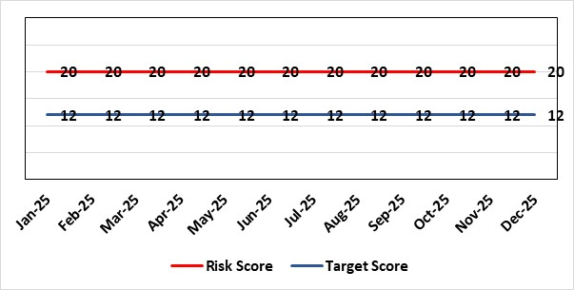 |  |  | Rationale for current score:  Health Board incidence of key Tier 1 infections per 100,000 population above All Wales rates, indicating Health Board’s population at greater risk of infection. High occupancy rates & frequent ward moves associated with increased risk of infection transmission. Lack of decant facilities compromises environment deep cleaning & decontamination and planned preventative maintenance programmes.
Rationale for target score:
Improved governance structures for IPC and antimicrobial stewardship will drive improved local ownership and embed responsibility for these priorities for all levels of staff. Adequately maintained & clean environments facilitate good IPC & minimise infection risks. Reduced occupancy & frequency of patient moves mitigate against infection transmission. Compliant ventilation systems and water safety minimise infection risks. Access to timely data on infections, training, antimicrobial stewardship, cleaning at ward/unit/practice level enables Service Groups to identify areas for focused QI programmes, drive improvement, & effectively measure outcomes.
Controls (What is currently in place to manage the risk?) |  |  |  | Further Actions (What more are we going to do to address the risk?)
- Policies, procedures, protocols and guidelines supplement the National Infection Control Manual.  - Infection Prevention & Control (IPC) related training provided programmes.  - Surveillance of infections, with early identification of increased incidence, and instigation of controls.  - Antimicrobial stewardship programmes and systems of monitoring and feedback.  - Provision of cleaning service to meet National Standards of Cleanliness. IPCT meet regularly with the Domestic service teams and the service groups to prioritise the provision of enhanced cleaning hours to areas with a high incidence of infection/outbreaks.  - Engineering controls for water safety, ventilation, and decontamination.  - Infection Prevention Improvement Plans 2025/26 for HB and Service Groups were approved by the Health Board's Infection Prevention & Control Strategic Group on 29/04/2025. Progress is reported at Service Group Infection Control Committees, Health Board Infection Prevention & Control Group, Quality & Safety Group, Quality & Safety Committee, and Management Board. These include trajectories to meet national targets and report performance against them.  - The Health Board has been escalated to Targeted Intervention for its position relating to healthcare associated infection (HCAI). Governance processes for HCAI have been revised to provide strengthened scrutiny and assurance. |  |  |  | Action | Lead |  | Deadline
 |  |  |  | Revised: Achieve 80% compliance with IPC mandatory training (Levels 1 & 2) in all staff groups. | Service Group Directors |  | 31/03/2026
 |  |  |  | Achieve reduction in Tier 1 infections to meet de-escalation criteria for intervention targets | Service Group Directors |  | 31/03/2026
Assurances (How do we know if the things we are doing are having an impact?)  - Clear Corporate and Service Group IPC Assurance Framework in place.  - Infection Prevention Improvement Plans for HB and Service Groups with progress reported at SG Infection Control Committees, HB Infection Prevention & Control Group, Quality & Safety Group and at Management Board. These include trajectories to meet national targets and report performance against them. This is also reported to Quality & Safety Committee.  - Ongoing monitoring of infection control rates.  - QI projects across the organisation Quality Improvement Project focusing on antimicrobial stewardship within MHSG _AMU; including an MDT AMS ward round reviewing choice of antibiotics and improve the outcome to switch from IV to oral administration route.  - IPC, antimicrobial, decontamination and cleaning audit programmes.  - Annual completion of IPC Level 2 mandatory training for all HB staff.  - Compliance and validation systems for water safety, ventilation systems and decontamination.  - Revised and strengthened governance structure for HCAI, including monthly meetings of Executive HCAI Scrutiny Group.  - Service group Medical Director led HCAI case review meetings take place: to determine if the infection episodes were avoidable, and to identify where improvements can be made to achieve better patient outcomes. |  |  |  | Gaps in assurance (What additional assurances should we seek?)  - High occupancy rates & frequent ward moves associated with increased risk of infection transmission. Additional beds introduced to wards as a result of the “UEC Test of Change” pilot, reducing the space between beds.  - Lack of single room availability, leading to delays in isolating patients with infections and increasing risks to patient contacts.  - Increased numbers of clinically optimised patients remaining in hospital leads to increased length of stay, increased risk of over-occupancy and over-crowding, with consequence of increasing risks of acquisition of infection.  - General infrastructure of the aging hospital estate compromises the ability to clean and decontaminate effectively.  - Antimicrobial prescribing, relating particularly to total volume of antibiotics, with the SBUHB having second highest total volume of antibiotics prescribed in primary care in Wales.  - Lack of decant facilities compromises environment deep cleaning & decontamination and planned preventative maintenance programmes.  - Varying levels of IPC responsibility embedded across all disciplines and groups, with variable medical engagement at all levels in infection prevention-related Quality Improvements programmes.  - Not all staff groups have achieved IPC Level 1& 2 training compliance.
Additional Comments / Progress Notes
17/12/2025: The HB received WHC 2025 039 Antimicrobial Stewardship and Infection Prevention and Control Improvement Goals for 2025-27 will be incorporated into the HB Improvement goals for 2026/27.
HCAI position: Tier One Target Organism Progress to end of Nov 2025.
• C. difficile – 10 hospital onset cases (target 6).
* Combined (hospital onset and community onset) cumulative total – 155 cases.
• Staph. aureus – 4 hospital onset cases (target 3).
* Combined cumulative total - 83 cases.
• E. coli - 5 hospital onset cases (target 4).
* Combined cumulative total - 193 cases.
• Klebsiella spp. - 3 hospital onset cases (target 4).
* Combined cumulative total – 77 cases.
• Pseudomonas aeruginosa (Not included within targeted interventions) * Combined cumulative total – 18 cases.

IPC training compliance target >80% is being maintained. ESR reporting compliance levels as of Nov 30th, 2025: Level 1 = 90.34%, Level 2 = 85.19%
Several QI projects are taking place across the Service Groups to reduce HCAI’s including a project to reduce urinary catheter associated infections, ward rounds to improve Antimicrobial Stewardship (AMS) and IV to oral switch (IVPOS) and additional projects are being proposed within the C. difficile collaborative.

Datix ID Number: 1043  Date Opened: Apr 2019 |  | Date Last Reviewed: December 2025 |  | HBR Ref Number: 36  Risk Target Date: TBC |  | Current Risk Rating  4 x 4 = 16
Objective: Care is delivered in partnership with our communities in safe and appropriate settings, supported by innovative digital solutions, research, development and innovation |  |  | SRR Ref:  3.4 | Director Lead: Matt John, Director of Digital  Assuring Committee: Digital, Research & Innovation Committee  For information: Quality & Safety Committee
Risk: Paper Record Storage
Lack of a single electronic record means there is greater reliance on the provision of the paper record. If we fail to provide adequate storage facilities for paper records, then this will impact on the availability of patient records at the point of care. Quality of the paper record may also be reduced if there is poor records management in some wards. There is an increased fire risk where medical records are stored outside of the medical record libraries.
Risk Rating  (consequence x likelihood):  Inherent: 4 x 5 = 20  Current: 4 x 4 = 16  Target: 3 x 3 =9 | 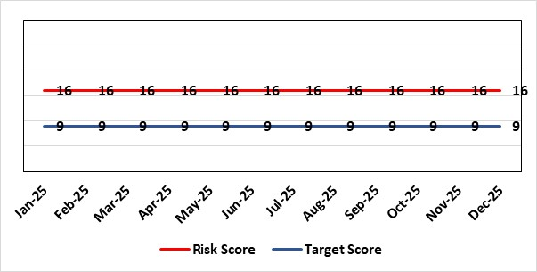 |  |  | Rationale for current score:  C - Inability to find records for patients could delay care/increase length of stay over 15 days. Could also mean patients receive incorrect treatment. Increased risk of fire where records are stored outside of the medical record libraries.  L - we know this happens from incidents raised
Rationale for target score:
C - The increased development and adoption of the digital record will reduce the need for the paper health record being available at the point of care.
L - The increased development and adoption of the digital record, the introduction of RFID and the approach to management of the paper record identified in the Business case process should reduce the amount of paper required to be stored and managed.
Controls (What is currently in place to manage the risk?) |  |  |  | Further Actions (What more are we going to do to address the risk?)
- There is a plan in place to increase the functionality of the electronic record to document patient care. The delivery of the plan is overseen by the Digital Leadership Group and progress provided to Management Board. (Supported by individual project boards as appropriate).  - Records managed by the Medical Records libraries are RFID-tagged (Radio Frequency Identification) and location tracked.  - Medical Record libraries are regularly risk assessed for fire by health and safety.  - Alternative offsite storage arrangements have been identified.  - All records must be documented on the Information Asset Register (IAR). |  |  |  | Action | Lead |  | Deadline
 |  |  |  | Allow for new process to stabilise and evaluate benefits of new centralised unit. | Head of Health Records & Clinical Coding |  | 28/02/2026
Assurances (How do we know if the things we are doing are having an impact?)  - RFID has been implemented for the acute record improving the management and storage of records  - Health Records performance reports developed in line with RFID technology  - Attainment of the Tier 1 Health Board target for clinical coding completeness which relies on the timely availability and quality of the Paper record and electronic sources  - Monitoring complaints and incident reporting.  - Electronic record is being implemented in accordance with the plan e.g. implementation of WNCR (Welsh Nursing Care Record), ETR (Electronic Test Requesting), HEPMA (Hospital Electronic Prescribing and Medicines Administration) |  |  |  | Gaps in assurance (What additional assurances should we seek?)  Investment required supporting the delivery and operational costs of the Digital strategy.  Reliance on DHCW (Digital Health & Care Wales) for delivery of the solution for a fully electronic patient record.  Impact of the Infected Blood Enquiry on the Health Boards ability to destroy notes.  Process for ensuring clinical adoption of electronic ways of working and cessation of adding information to the paper record that is already available electronically needs to be agreed and enforced by the Health Board.  Impact of the infected Blood Inquiry on the health board’s ability to destroy notes and the change in the records code of practice is being reviewed by the Director of Digital.
Additional Notes
22/12/2025 – Reviewed – no further amendments.

Datix ID Number: 1514  Date Opened: Apr 2019 |  | Date Last Reviewed: December 2025 |  | HBR Ref Number: 43  Risk Target Date: TBC |  | Current Risk Rating  4 x 4 = 16
Objective: The health board is a resilient, sustainable and responsible organisation |  |  | SRR Ref:  N/A | Director Lead: Elizabeth Rix, Executive Director of Nursing  Assuring Committee: Quality & Safety Committee  For Information: Mental Health Legislation Committee
Risk: Deprivation of Liberty Safeguards
Due to a limited resources within the MCA/DoLS (Mental Capacity Act/Deprivation of Liberty Safeguards) service (lack of Best Interest Assessor resource and signatory approval) there is a risk of failure to complete and authorise the assessments associated with Deprivation of Liberty within the legally required timescales, exposing the health board to potential legal challenge and reputational damage.
Risk Rating  (consequence x likelihood):  Inherent: 4 x 4 = 16  Current: 4 x 4 = 16  Target: 3 x 2 = 6 | 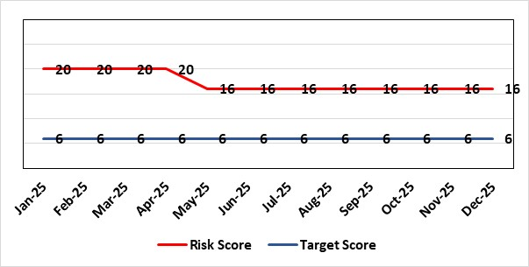 |  |  | Rationale for current score:  Multiple breaches in statutory duty  Breaches confirmed as expected at least as frequently as weekly, but not daily.  No claims received to date.
Rationale for target score:
Consequences of DoLS breaches for the Health Board will not change. With controls in place, over time likelihood should decrease.
Risk target date indicates date of review following mitigating actions
Controls (What is currently in place to manage the risk?) |  |  |  | Further Actions (What more are we going to do to address the risk?)
- Duty system in place. Duty BIA (Best Interest Assessors) scrutinise referrals and liaise with managing authority to ensure safeguards are in place to mitigate risks.  - Four signatory authorisers in place.  - Monthly Performance & Assurance Meeting  - Monthly Legislative Assurance Meeting with Group Nurse Director and Finance. |  |  |  | Action | Lead |  | Deadline
Assurances (How do we know if the things we are doing are having an impact?)  Monthly Legislative Assurance Meeting with Group Nurse Director and Finance.  Quarterly reports to Mental Health & Legislative Committee on MCA/DoLS compliance. |  |  |  | Gaps in assurance (What additional assurances should we seek?)  Current resources  - 3 substantive BIA (3 wte)  - 6 external BIA (£250 per assessment)  - 4 (band 8) signatories  - Specialist Practitioner Band 7 vacancy – out to advert.  Additional 4 WTE BIAs required to meet service demands.  Substantive BIA’s role includes additional duties compared to external BIA whose only role is to complete form 3a of the DoLS process. In addition to form 3a completion, substantive BIA also undertake the following to meet service demand (Daily Duty Rota to scrutinise referrals; Facilitate Level 3 MCA/DoLS Training; Capacity Assessments; Advice and support to Managing Bodies; Support during Best Interest Meetings)
Additional Comments / Progress Notes
20/11/2025: Breach data at the end of October reported at 3. Band 7 Specialist Practitioner appointed and going through recruitment checks. Risk score remains at 16. To review monthly.
17/12/2025: Due to breaches remaining low for last 3 months the risk is currently under review and will be discussed at the next service group RMG in January.

Datix ID Number: 1587  Date Opened: Apr 2019 |  | Date Last Reviewed: December 2025 |  | HBR Ref Number: 61  Risk Target Date: TBC |  | Current Risk Rating  4 X 4 = 16
Objective: Care is high quality, safe, efficient, and delivers the best possible outcomes for people in partnerships |  |  | SRR Ref:  2.4 | Director Lead: Deb Lewis, Chief Operating Officer  Assuring Committee: Quality & Safety Committee
Risk: Paediatric dental GA (General Anaesthetics)/Sedation services provided under contract from Parkway Clinic, Swansea. Medical Safety risk as general anaesthetics are performed on children outside of an acute hospital setting. Repatriation of service to acute site delayed due to theatre capacity which means the health board continues to commission services for delivery outside of national guidance (WHC 2018-09) attracting reputational risk. There is also an associated risk in that the diagnosing clinician does not deliver the care to the patient resulting in increased risk of need for multiple General Anaesthetics.
Risk Rating  (consequence x likelihood):  Inherent: 5 x 3 = 15  Current: 4 x 4 = 16  Target: 4 x 2 = 8 | 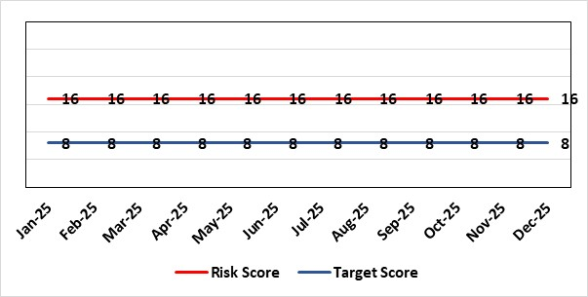 |  |  | Rationale for current score:  There is no immediate access to crash team/ICU facilities in in Parkway Clinic – the client group are undergoing GA (general anaesthetic)/sedation. Paediatric GA/Sedation services provided under contract from Parkway Clinic, Swansea continue due to lack of capacity for these patients to be accommodated in Secondary Care.
Rationale for target score:
Relocation of the paediatric general anaesthetics service [provided by Parkway Clinic] to a hospital site being treated as a priority.
Controls (What is currently in place to manage the risk?) |  |  |  | Further Actions (What more are we going to do to address the risk?)
Consultant Anaesthetist present for every general anaesthetic clinic.  Assurance Documentation supplied by Parkway Clinic including confirmation of arrangements in place with WAST and Morriston Hospital for transfer and treatment of patients  New care pathway implemented - no direct referrals to provider for general anaesthetics.  Multi-drug sedation ceased from Sep 2018 in line with WHC 2018 009  Revised SLA (Service Level Agreement)/Service Specification  HIW (Healthcare Inspectorate Wales) Inspection Visit Documentation provided to Health Board  All extended general anaesthetics cases require approval from paediatric specialist prior to treatment. |  |  |  | Action | Lead |  | Deadline
Assurances (How do we know if the things we are doing are having an impact?)  RMC (Referral Management Centre) collate referral and treatment outcome data for review by Paediatric Specialist  Regular clinical meeting arranged with Parkway to discuss individual cases/concerns  Regular clinical/ management meeting for CDS/primary care management team to discuss service pathway /concerns/issues arising. |  |  |  | Gaps in assurance (What additional assurances should we seek?)  Deputy Chief Operating Officer-led Task & Finish Group is no longer in place – it will need to be re-established to progress transfer when theatre capacity is agreed.  Pressures on the Princess of Wales special care dental general anaesthetics list and this service is considered alongside any plans for the Parkway contract.
Additional Comments / Progress Notes
06/05/2025: Health Board Management Board agreed that current contract with provider will be extended for 2+1 years whilst the Health Board explores capital bid for regional service as part of wider Paediatrics Day Case Unit
20/11/2025: This risk remains as at last update (04/08/2025).

Datix ID Number: 2159  Date Opened: September 2019 |  | Date Last Reviewed: December 2025 |  | HBR Ref Number: 64  Risk Target Date: 31/03/2026 |  | Current Risk Rating  4 X 5 = 20
Objective: Care is delivered in partnership with our communities in safe and appropriate settings, supported by innovative digital solutions, research, development and innovation |  |  | SRR Ref:  3.2 | Director Lead: Darren Griffiths, Director of Finance & Performance  Assuring Committee: Quality & Safety Committee
Risk: Health & Safety (H&S) Infrastructure
Insufficient resource and capacity of the health, safety and fire function within SBUHB to maintain legal and regulatory compliance for the workforce and for the sites across SBUHB.
Risk Rating  (consequence x likelihood):  Inherent: 5 x 4 = 20  Current: 4 x 5 = 20  Target: 4 x 3 = 12 | 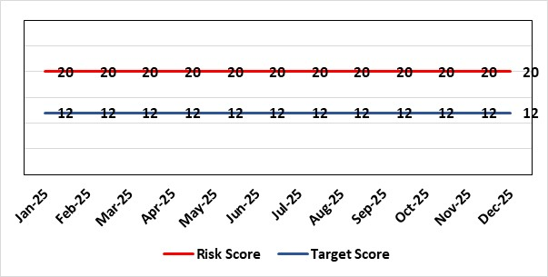 |  |  | Rationale for current score:  The Health Board received 12 Health & Safety Executive (HSE) improvement notices during 2019-20 covering various Health & Safety legal breaches covering a range of areas. There is the potential for future multiple notices for not meeting legal requirements based on current available resources. Due to retirement resources in the team has reduced and the risk level increased to 20.
Rationale for target score:
Compliance with the notices and to have sufficient resources to implement a sustainable health and safety provision to support the legal requirements of the Health Board and demonstrate that suitable resources are in place to undertake the roles and responsibilities of the department, also to undertake suitable and sufficient training, provide corporate overview/audit to ensure practices are being employed in the workplace.
Controls (What is currently in place to manage the risk?) |  |  |  | Further Actions (What more are we going to do to address the risk?)
- Assistant Director of Health and Safety in post to support strengthening and develop the H&S function to support the organisation. Business case submitted for additional resources.  - Health and Safety Operational Group and the Health and Safety Committee monitor compliance. Refreshed the Fire Safety Group with additional controls in place.  - Fire risk assessments (FRA) are being prioritised to reduce the number of FRA overdue and to bring up to date. However, due to leavers and recruitment, resource levels have fluctuated along with compliance levels that are continually monitored.  - Fire training in place and fire wardens in place  - Fire risk assessment schedule in place for the next 12 months concentrating on sleeping risk areas to maintain 100% compliance in these areas, and other non-sleeping risk areas are regularly reviewed, with the frequency of these moved to 18-monthly or 2-yearly, dependent upon the overall risk of the premises. |  |  |  | Action | Lead | Deadline
 |  |  |  | Having completed staffing structure review, next action is to work through Health Board governance processes to ensure affordability and to agree a risk-based, phased approach to implement any agreed structure going forward. | Assistant Director of Capital and H&S | 31/03/2026
Assurances (How do we know if the things we are doing are having an impact?)  - Monitoring through the appropriate group/committees (H&S committee) to receive assurance and or identify gaps for key compliance and adherence to applicable legislation.  - Site visits/tours to identify compliance and gaps in compliances. |  |  |  | Gaps in assurance (What additional assurances should we seek?)  Health and safety, capital and estates now sit under the umbrella of Finance and is currently going through a restructure, with the H&S structure also included in this and will be phased in, with a target date of 31/03/2026 for the proposed new structure to be in place. Compared to other Health Boards SBUHB does not have the same level of structures and is unable to undertake audits/inspections or provide the level of support to service groups ie cover to provide appropriate levels of training, support and auditing in all areas (Manual Handling; Violence & Aggression/Case Management; Health & Safety’ Fire Safety and Fit Testing).
Additional Comments / Progress Notes
27/08/2025: Successful conclusion to interviews [Head of H&S post], with an agreed commencement date 01/11/2025. No change in overall risk rating, with risks monitored and prioritised within current resources.
27/10/2025: Overall risks are monitored and prioritised covering Manual Handling, Violence & Aggression, Health & Safety and Fire with mitigations and action plans developed to address prioritised risks within current resources i.e. On-going discussions with Fire and Rescue to address issues raised by Mid & West Wales Fire & Rescue Service (MWWFRS), with identified mitigations planned to address ‘Your Next Patient’ challenges.
24/11/2025: Risk remains at 20, with no changes in current resources within health & safety team. We continue working with MWWFRS to mitigate the challenges of ‘Your Next Patient’ on each of the wards, with a target date of end of November 2025.

Datix ID Number: 1834  Date Opened: November 2019 |  | Date Last Reviewed: December 2025 |  | HBR Ref Number: 66  Risk Target Date: 28/02/2026 |  | Current Risk Rating  5 X 4 = 20
Objective: Care is high quality, safe, efficient, and delivers the best possible outcomes for people in partnerships |  |  | SRR Ref:  2.3 | Director Lead: Richard Evans, Executive Medical Director  Assuring Committee: Quality & Safety Committee
Risk: Access to SACT (Systemic Anti-Cancer Therapy)
The demand & complexity of planned treatment regime for cancer patients requiring chemotherapy currently exceed the available chair capacity, risking unacceptable delays in access to SACT treatment in Chemotherapy Day Unit with impact on targets and patient outcomes.
Risk Rating  (consequence x likelihood):  Inherent: 5 x 5 = 25  Current: 5 x 4 = 20  Target: 2 x 2 = 4 | 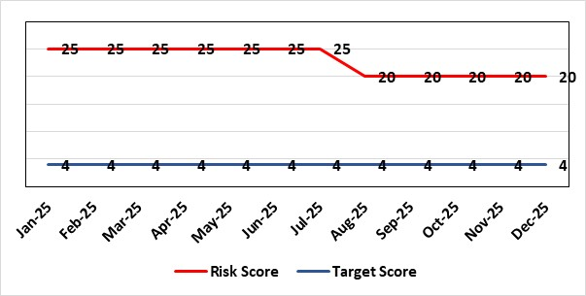 |  |  | Rationale for current score:  Demand for SACT continues to exceed current service capacity.  Ongoing workforce challenges persist within the Chemotherapy Day Unit (CDU) and Pharmacy Technical Services (PTS), impacting service delivery.  Patient waiting times remain elevated, with a continued number of breaches against SACT Key Performance Indicators (KPIs).  The introduction of new cancer diagnoses and NICE-approved treatments necessitates the implementation of additional SACT regimens, further straining resources.  Approval has been granted for additional treatment chairs, and initial recruitment to posts successful. Training of staff is essential prerequisite before this expansion can be operationalised. It is likely to take until Feb 2026 to fully train.  Improved performance from Q4 24/25 to Q1 25/26.
Rationale for target score:
Reduced delays in treatment will reduce risk of harm.
Controls (What is currently in place to manage the risk?) |  |  |  | Further Actions (What more are we going to do to address the risk?)
- Review of scheduling by staff to ensure all chairs used appropriately.  - A daily scrutinizing process in progress to micro-manage individual cases, deferrals etc.  - Changes made to prescribing & authorising processes to improve workflow for PTS reducing potential delays to supply and administration of treatment.  - Responsibility for checking bisphosphonate prescriptions in CDU moved to nursing staff to free up Pharmacy capacity allowing them to focus on key clinical tasks within Pharmacy.  - Joint project with Nuclear Medicine to streamline pathways and prioritise SACT patients appropriately halved the average time waiting for MUGA/EDTA tests required before starting SACT.  - Increased homecare capacity  - Adopted principles from UK SACT board publication: General Principles to Support Systemic anti-Cancer Therapy Aseptic Pressures September 2023 |  |  |  | Action | Lead |  | Deadline
 |  |  |  | Recruiting to posts  (dependency on recruitment process changes) | Divisional Manager (Cancer) |  | 28/02/2026
 |  |  |  | Training of new staff (full competency) | SACT Training Team / Pharmacy |  | 28/02/2026
Assurances (How do we know if the things we are doing are having an impact?)  - To support increased demand, additional funding has been secured to expand the nursing establishment, ensuring appropriate staffing levels during the unit’s core operating hours.  - Posts are currently out to advert or in the recruitment process. Once successful appointments are made and training is completed, improvements in performance are expected to be reflected in service delivery metrics.  - Waiting times are tracked against the new SACT metrics, which are based on treatment intent rather than average waiting times, providing a more outcome-focused measure. These metrics are reported through our Cancer Performance Report to Welsh Government, the Management Board, and internally via governance structures within NPTSSG, where Oncology services are hosted.  - Patient experience continues to be monitored through the Friends and Family Test and the Welsh Cancer Patient Experience Survey, in line with our Putting Things Right (PTR) procedures.  - The SBU Capacity Task and Finish Group meets monthly to analyse demand and capacity gaps. Common delay themes are identified and reviewed monthly, with a quarterly report presented to the SACT Consultant Meeting and the Divisional Business Meeting to inform service planning.  - Current breach trends are primarily linked to CDU capacity constraints and SACT booking delays, as evidenced in quarterly reporting. Work is ongoing to explore new models of care in addition to the approved posts to address these issues.  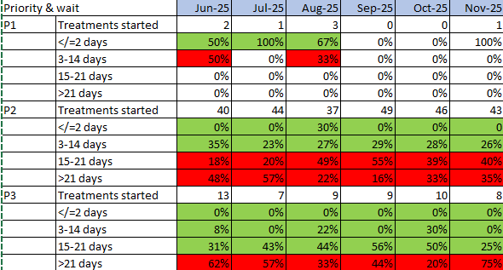  Welsh SACT performance metrics – P2 to start within 14 days. P3 to start within 21 days |  |  |  | Gaps in assurance (What additional assurances should we seek?)  Workforce requirements have and continue to be mapped to identify the additional capacity needed to meet both current and projected future demand for SACT services. While initial funding has been secured to support the first phase of this work, it does not guarantee the sustainability of future capacity. This marks the beginning of a phased approach to workforce planning and service development
Additional Comments / Progress Notes
16/12/2025
Performance remains steady and improved on this time last year
Performance might dip due to Christmas break but measures in place to mitigate against risk
Risk score discussed regularly – no change at present
Some issues remain with backfill of pharmacy posts, timeline for completion of training may need to be reassessed.
Nursing posts to be determined (band 3/4) but will require less training so should not have same impact on ability to increase capacity.

Datix ID Number: 1418  Date Opened: February 2020 |  | Date Last Reviewed: December 2025 |  | HBR Ref Number: 69  Risk Target Date: See Target Rationale |  |  | Current Risk Rating  5 X 4 = 20
Objective: Care is high quality, safe, efficient, and delivers the best possible outcomes for people in partnerships |  |  | SRR Ref:  2.7 | Director Lead: Deb Lewis, Chief Operating Officer  Supporting Director: Elizabeth Rix, Executive Director of Nursing  Assuring Committee: Quality & Safety Committee
Risk: Issues related to adolescent patient admission to adult mental health inpatient wards
Risk of inappropriate settings resulting in 'Safeguarding Issues'. The Welsh Government has requested that Health Boards identify Secondary Care in -patient facilities for the care of adolescents- in Swansea Bay University Health Board Ward F NPT hospital is the dedicated receiving facility with one bed identified.
Risk Rating  (consequence x likelihood):  Inherent: 2 x 3 = 6  Current:5 x 4 = 20  Target: 2 x 3 = 6 | 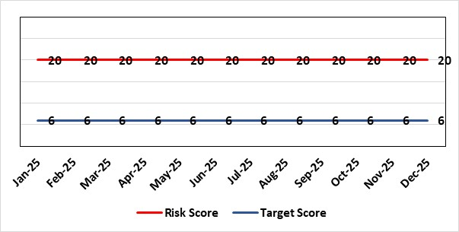 |  |  | Rationale for current score:  Every health board is required to have an admission facility for adolescent Mental Health patients. Whilst ward F has been identified as the single point of access in SBU and provides access to a bed for adolescent admissions if available at the time of request it is a mixed sex adult ward. Therefore, the facilities are less than ideal for young patients in crisis.
Rationale for target score:
The longer-term aim for the Health Board remains to create an admission facility for adolescent Mental Health patients but this will not be possible until the new Adult Inpatient Unit is built.
Controls (What is currently in place to manage the risk?) |  |  |  | Further Actions (What more are we going to do to address the risk?)
Safeguarding Training for Staff, Joint protocol with Cwm Taf LHB [CAMHS] currently subject to review, Local SBUHB policy on providing care to young people in this environment. This includes the requirement for all such patients on admission to be subject to Level 3 Safe and Supportive observations.  Only Adolescents within 16-18 age range are admitted to the adult ward.  The health board works with CAMHS to make sure that the length of stay is as short as possible. |  |  |  | Action | Lead | Deadline
 |  |  |  | Next service group review of effectiveness of current controls. | Head of Nursing (Mental Health) & Clinical Directors | 01/02/2026
Assurances (How do we know if the things we are doing are having an impact?)  Individual Rooms with en Suite Facilities, Joint working with CAMHS, monitoring of staff training, Monitoring of admissions by the MH&LD SG Legislation Committee of the Health Board. The ongoing issues with the risks presented by the use of this has recently been raised at an all-Wales level with Welsh Government and a formal review is anticipated. The Service Group continues to flag the risk particularly in light of Ward F being identified as the SPOA for AMH in the Health Board which has resulted in an increase in acuity and a greater concentration of individuals who are experiencing the early crisis of admission - this has served to increase the already identified risks for young people in the environment. |  |  |  | Gaps in assurance (What additional assurances should we seek?)
Additional Comments / Progress Notes
18/11/2025: No change. Admissions have been infrequent.
17/12/2025: No change to the current arrangements and controls. Requirement for adult inpatient new build to accommodate appropriate facilities. Currently being reviewed under the MH Transformation Programme. There has been a marked reduction in admissions of young people to adult inpatient wards since 2024. Score has been reinstated to 20 on SDG Risk in line with All Wales position and given the critical clinical risks should an admission be required.

Datix ID Number: 1832  Date Opened: May 2021 |  | Date Last Reviewed: December 2025 |  | HBR Ref Number: 80  Risk Target Date: 31/12/2025 |  | Current Risk Rating  4 x 5 = 20
Objective: Care is high quality, safe, efficient, and delivers the best possible outcomes for people in partnerships |  |  | SRR Ref:  2.1 | Director Lead: Deb Lewis, Chief Operating Officer  Assuring Committee: Quality & Safety Committee
Risk: Transfer of Clinically Optimised Patients
Risk that we fail to significantly reduce the number of Clinically Optimised Patients in hospital beds. A deficit in the availability of appropriate community / domiciliary care results in unacceptable delays in discharging patients from acute hospital beds. As a result, patients can decompensate and never gain the independence that could have been available from an early discharge.
Lack of access to same day domiciliary care/emergency placements in the community hinders ability to avoid admission and associated harms.
Risk Rating  (consequence x likelihood):  Inherent: 4 x 5 = 20  Current: 4 x 5 = 20  Target: 4 x 2 = 8 | 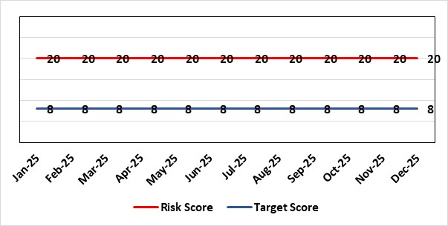 |  |  | Rationale for current score:  - Sustained levels of clinically optimised patients (COPs) leading to overcrowding within ED, use of inappropriate or overuse of decant capacity in ED and delays in accessing medical bed capacity, clearly emerged as themes.  - Constraints in relation to all patient flows out of Morriston to a more appropriate clinical setting, identified and included in an expanded risk.  - Delay in discharge for clinically optimised patients can result in deterioration of their condition.  - Increase in demand for Pathway 1.
Rationale for target score:
Targeted reduction of Clinically Optimised patients remains a priority for the HB in order to minimise risk of avoidable harm to patients within the HB and in the wider community.
Controls (What is currently in place to manage the risk?) |  |  |  | Further Actions (What more are we going to do to address the risk?)
- One of the measures under targeted intervention is to see a reduction in pathway of care delays, which specifically supports the reduction in the number of clinically optimised patients.  - Review is undertaken on a patient-by-patient basis – with explicit action agreed in order to progress transfer to appropriate clinical setting.  - Critical constricts in relation to access/time delays for social workers and assessment for package of care and social placement  - Weekly escalation meetings are held with health and social service colleagues to ensure the requirements of the patients are reviewed and patients are pulled through the system where possible.  - Planned transfer of 30 COP patients (Pathway 3) from Morriston to Singleton 5th Jan 26 to enable closure of the AMU surge area reliant on a temporary workforce model. |  |  |  | Action | Lead |  | Deadline
 |  |  |  | Work programme and governance structure agreed by local partnership (health board & local authorities) to work up sustainable D2RA model. | Associate Director UEC |  | 31/03/2026
 |  |  |  | Formal agreement through Communities and Older Persons Board to proceed to OCP for health employees to deliver the D2RA hub and recruitment into Swansea LA, with a limited offer from NPT LA. | Service Group Director (PCT) |  | 31/01/2026
Assurances (How do we know if the things we are doing are having an impact?)  - Patient level dashboard allows breakdown by delay type  - Regular (weekly) COP reviews and escalations  - Shared vision with NPT & Swansea LA CEOs agreed and governance structure with Executive Directors for sign off  - POCD reporting into the UEC and Communities and Older Persons Boards. |  |  |  | Gaps in assurance (What additional assurances should we seek?)  Capacity and demand exercise required to inform reshaping of community services
Additional Comments / Progress Notes
12/05/2025: Action previously completed: The Care Action Committee (CAC) focus on reducing the impact of clinically optimised patients within acute hospitals. The Health Board engaged with the work from the CAC and currently developing the Winter Plan for 24/25, of which reducing COPs will be a key focus. This work is being taken forward by the Associate SGD PCTS to ensure cross-boundary support.
Integrated Discharge hub now established from within existing resources following a successful test of change. Positive turnaround of patients from front door services reducing admission demand and long-term care demand. Roll-out of true Discharge to Recover then Assess (D2RA) principles/ activity planned in conjunction with Local Authority partners to improve timeliness of all discharges (which will positively impact COP position)
17/07/2025: Action complete: Reintroduce D2RA Principles across the Health Board with external consultancy support
16/10/2025: See HBR1 for update on related actions (‘Test of Change’ and advanced D2RA work; discharge improvement sprint (focusing on COP wards) to free up bed capacity/ improve flow across Morriston site; refresh of the Optimal Hospital Flow Framework at Board Rounds via sustainable ward-level discharge coaching and support.) Exploring a revised model of COP management health board wide.
19/11/2025: POCD are being reviewed by Deloitte. CW has agreed with DL that there will not be an OCP because there are no substantive posts in the IDH.
18/12/2025: Process mapping, capacity and demand of Pathway 2 supported by Deloitte in progress. Audit of Pathway 2 bed utilisation being undertaken 18/12/25 – planned workshop Jan 26 to consolidate findings and agree work programme to re-engineer Pathway 2 bed pool.

Datix ID Number: 2561  Date Opened: May 2022 |  | Date Last Reviewed: December 2025 |  | HBR Ref Number: 85  Risk Target Date: 31/07/2026 |  | Current Risk Rating  4 x 5 = 20
Objective: The health board is a resilient, sustainable and responsible organisation |  |  | SRR Ref:  N/A | Director Lead: Christine Morrell, Director of Therapies & Health Sciences  Assuring Committee: Quality & Safety Committee
Risk: Non-Compliance with ALN Act
There is a risk of the Health Board not fulfilling the statutory requirements of the Additional Learning Needs and Education Tribunal (Wales) Act 2018 (the ALN Act) within the timescales that are required under the ALN Act, resulting in non-compliance with these duties.
The Health Board has a digital infrastructure that provides data regarding its compliance with its statutory duties under Sections 65 and 20 of the ALN Act. These duties relate to the timely provision of information to support Education planning and decision-making (Section 65), and to timely decision-making about relevant Health provision followed by delivery of this provision where it is found to be required (Section 20). Data for 2025 shows there are breaches against both duties with a high level of frequency (as at July 2025, breaches are generally occurring on an approximately daily basis). Data is not currently reliably captured with regard to the Health Board fulfilling its duty to secure (deliver) additional learning provision where this is identified following a Section 20 referral, so assurance regarding this duty is limited.
In addition to the above:
- The Health Board is currently unable to provide assurance with its duty to notify Education of pre-school children with probable ALN under Section 64 of the legislation. This risk is caused by process and data quality issues.
- The Health Board has not established a process by which it fulfils its legal duties for post-16 learners in partnership with local Further Education Institutes. There is a need to establish this process.
Potential consequences of the risk of the Health Board not fulfilling the statutory requirements of the ALN Act within the timescales required are: non-compliance with statutory duties; parent / carer and young peoples' dissatisfaction leading to complaints and legal challenge; reputational impact; and children failing to access the multi-agency support that they need with their learning needs, leading to poor outcomes.
Risk Rating  (consequence x likelihood):  Inherent: 5 x 5 = 25  Current: 4 x 5 = 20  Target: 2 x 3 = 6 |  |  |  | Rationale for current score:  2025 compliance data shows that the Health Board is breaching multiple statutory duties (duties under both Sections 65 and 20 of the ALN Act) with a high level of frequency (approximately daily). The Health Board is currently unable to provide assurance regarding compliance with its legal duties under Section 64 of the Act,  The risk consequence is major (multiple breaches of a statutory duty - 4) and the likelihood is expected (breaches occurring approximately daily - 5), hence the current risk score of 20.
Rationale for target score:
As the ALN Act is new legislation, there remains some ongoing likelihood of risk events during the initial phases of implementation, though with lessened consequences as a result of mitigating actions.
Controls (What is currently in place to manage the risk?) |  |  |  | Further Actions (What more are we going to do to address the risk?)
- Designated Educational Clinical Lead Officer (DECLO) is in post, providing a single point for direction and co-ordination of the Health Board’s activity under the ALN Act. The post is a statutory requirement.  - Operational processes through which the Health Board fulfils its statutory duties under the ALN Act are in place.  - Health Board ALN Steering Group has been established, with ALN Operational Group working under the governance of this,  - There is close and ongoing collaborative working with Local Authority Education partners, including their involvement in the ALN Steering and Operational Groups as noted above.  - Activity is planned to develop a clear understanding of the causes of the current risk and to identify the actions required to mitigate the risk. This activity will be progressed within the relevant Service Groups’ ALN governance structures with oversight of the ALN Steering Group. |  |  |  | Action | Lead |  | Deadline
 |  |  |  | Revise processes through which the Health Board fulfils its duty under Section 64 of the ALN Act and ensure that accurate and reliable data is available. | DECLO |  | 28/02/2026
 |  |  |  | Establish process through which Health Board fulfils its legal duties with local college partners | DECLO |  | 31/03/2026
 |  |  |  | Ensure ALN performance metrics are embedded in all relevant Service Groups’ governance structures, with strengthened accountability arrangements | DECLO |  | 31/03/2026
Assurances (How do we know if the things we are doing are having an impact?)  - The Health Board has a digital infrastructure to monitor compliance  - There is regular reporting on compliance with the ALN Act that is now data-informed through the Patient Safety and Compliance Group.  - The Health Board has an ALN Steering Group, chaired by the Deputy Director for Allied Health Professions and Health Sciences, ensuring oversight at a senior level within all impacted operational and corporate areas. The Health Board also has an ALN Operational Group, chaired by the DECLO, to co-ordinate activity required to address the risk. The Operational Group has an ALN workplan and reports are made to the Steering Group regarding progress |  |  |  | Gaps in assurance (What additional assurances should we seek?
Additional Comments / Progress Notes
22/12/2026: Activity is ongoing to strengthen governance and accountability arrangements for ALN Act compliance through operational Service Groups. Service Group updates will be provided to the ALN Steering Group, chaired by the EDAHPHS, in January 2026. The previous action regarding securing longer-term business and project management support has been removed as this is not directly linked to ALN Act compliance. There has been some delay in progressing work involving local colleges and adult Health Board services, and consequently the deadline for one action has been adjusted,

Datix ID Number: 3071  Date Opened: November 2022 |  | Date Last Reviewed: December 2025 |  | HBR Ref Number: 89  Target Risk Date: TBC |  | Current Risk Rating  4 x 5 = 20
Objective: The health board is a great place to work where all staff feel valued and work together towards a common goal |  |  | SRR Ref:  4.1 | Director Lead: Elizabeth Rix, Executive Director of Nursing  Supporting Director: Deb Lewis, Chief Operating Officer  Assuring Committee: Quality & Safety Committee
Risk: Healthcare Nursing Staff Levels at HMP Swansea
There is a risk that the men in HMP Swansea will not receive the appropriate standard of care. This is because the nursing establishment within the prison no longer fully meets the changed demographics and numbers of men being detained. The maximum operational capacity of the Prison can reach circa 480 men. The Health Board investment into the Prison is based on delivering services to 250 men. This was also highlighted as a risk in the June 2022 HIW governance review. In addition, there is no head room built into the Prison nursing establishment, so periods of sickness, leave and study render the roster short.
Risk Rating  (consequence x likelihood):  Inherent: 4 x 5 = 20  Current: 4 x 5 = 20  Target: 2 x 2 = 4 | 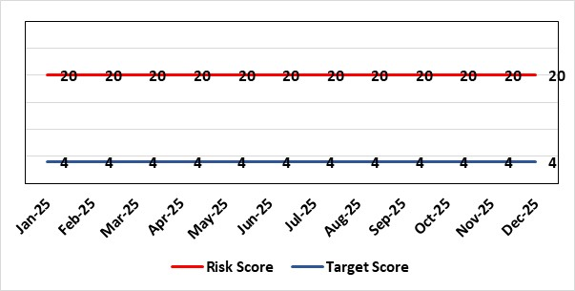 |  |  | Rationale for current score:  Consequence major – unable to fully deliver on the recommendations of HIW due to low healthcare staffing numbers, further impacted during periods of sickness or absence as no headroom. Recommendations also raised in Prison & Probation Ombudsman reports. Likelihood expected – suboptimal care provided on a daily basis.
Rationale for target score:
Consequence minor – With sufficient staffing numbers the prison will be able to deliver on HIW recommendations and fully implement the actions in the Health Delivery Plan. Likelihood unlikely – With full establishment and headroom, suboptimal care is less likely.
Controls (What is currently in place to manage the risk?) |  |  |  | Further Actions (What more are we going to do to address the risk?)
Daily communication with the Governor about the availability and priority of healthcare nursing staff.  Pharmacy technician role established – can administer drugs to support nursing establishment.  Agreed that Health Care Support Workers to be 2nd checkers for CD drugs and to support substance withdrawal monitoring (awaiting accreditation).  Bank and agency staff are used in a limited way, when skillset allows.  E-roster implemented and scrutinised with regular reporting to Service Group Patient Safety & Compliance Group.  Escalation for overtime and additional hours to fill shortfalls. |  |  |  | Action | Lead |  | Deadline
 |  |  |  | Review of staffing in prison. Royal College of Psychiatrists Substance Misuse and Mental Health Baseline assessment completed – analysis of outcome and agreement of further action next. (Following financial deep dives) | Deputy Head of Nursing |  | 31/01/2026
Assurances (How do we know if the things we are doing are having an impact?)  Prison feedback and complaint process  Progress reporting on action plans through Service Group PS&C Group, and Health Board Q&S structures (via Patient Safety & Compliance Group). |  |  |  | Gaps in assurance (What additional assurances should we seek?)  Implementation and reporting of clinical audits. Audit framework for HMP Swansea in development - Clinical Pathways/Audits and Health Promotion groups taking forward.
Additional Comments / Progress Notes
19/11/25 - 2 WTE band 6 appointed, 3.5 WTE band 5 posts submitted to TRAC for approval. Reduction in variable pay noted. HMP position paper was not presented at PCT operational board on 28/10/25,this report highlights a programme of work to address recommendations from the Healthcare Needs Assessment (HNA) 2024 and QHNSMH 2024 (Quality Network for Prison Mental Health Services – Royal College of Psychiatrists) and Healthcare Inspectorate Wales (HIW) 2022 Inspection recommendations, await date to present.
30/12/25 – Approval for 3.5 WTE Band 5 agreed on 29/12/25, will now follow recruitment process. Continued scrutiny with rosters for use of variable pay, it is noted that this will improve once 3.5 WTE Band 5 are in post. DHON and NGD to meet early January 2026 to review workforce.

Datix ID Number: 3516  Date Opened: October 2023 |  | Date Last Reviewed: December 2025 |  | HBR Ref Number: 94  Risk Target Date: TBC |  | Current Risk Rating  4 x 3 = 12
Objective: Care is high quality, safe, efficient, and delivers the best possible outcomes for people in partnerships |  |  | SRR Ref:  2.7 | Director Lead: Deb Lewis, Chief Operating Officer  Assuring Committee: Performance & Finance Committee  For information: Quality & Safety Committee
Risk: CAMHS failure to meet required standards of performance
The CAMHS service is unable to meet the required level of performance due to workforce deficits in the team across all staff groups including medics, psychological therapies and nursing. Data quality review has been completed and new processes are in place to ensure it is accurate.
Links to other CAMHS risk register entries: (Ref: 3373 (ADHD)/ 3346 open / 3350 open)
Risk Rating  (consequence x likelihood):  Inherent: 4 x 5 = 20  Current: 4 x 3 = 12  Target: 3 x 3 = 9 | 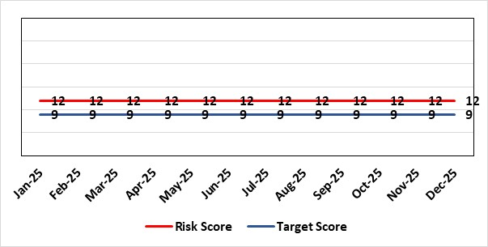 |  |  | Rationale for current score:  Marked improvement in the performance against the Mental health Measure for CAMHS. Data validation for new patients complete. Current risk score 12 in view of improved performance however this reflects the fragility in the workforce to deliver sustained performance. Work is still ongoing within CAMHs to maintain and improves the situation.
Rationale for target score:
The rationale for the target score is linked to successful recruitment and more timely access to services for children and young persons which will reduce risk.
Controls (What is currently in place to manage the risk?) |  |  |  | Further Actions (What more are we going to do to address the risk?)
Ongoing recruitment into nursing and medical staff groups. Psychology and Therapies are fully recruited.  Use of temporary agency workforce in nursing at premium pay rates to sustain current levels of performance  Recent appointment into psychological therapies lead posts.  -Exploring fixed term appt of Band 5 psychological therapies support staff to improve performance. |  |  |  | Action | Lead |  | Deadline
 |  |  |  | Continued efforts at recruitment.  Recovery Plan in place. | Associate Service Director |  | 31/01/2026
Assurances (How do we know if the things we are doing are having an impact?)  As above with controls.  -Monthly CAMHS Directorate meeting in place where performance and workforce are scrutinised  -Reporting into Weekly Business Team and MH & LD management board.  - Mental Health Division Quarterly Performance Review  -Reporting into SBU Performance & Finance Committee and IQPD (Integrated Quality & Performance Delivery) meeting with Welsh Government |  |  |  | Gaps in assurance (What additional assurances should we seek?)
Additional Comments / Progress Notes
11/12/2025
CAMHS 1a: remains generally consistent.
CAMHS Part 1B:
Recruitment to vacancies has been successful, however additional vacancies and maternity leave weakens the capacity pool to almost pre-recruitment levels
Despite this, the recovery plan roll out is underway, which includes changes to the delivery of the initial therapeutic offer for 1:1 intervention, which enables young people to commence support more quickly.
This has resulted in 3 months of small, but consistent improvement in the Part 1B performance irrespective of staffing challenges, which is now at 66% (Submitted for Nov 2025)
Weekly meetings continue over booking and utilisation of capacity and using our staffing resource as flexibly as possible

Datix ID Number: 443  Date Opened: May 2025 |  | Date Last Reviewed: December 2025 |  | HBR Ref Number: 104  Risk Target Date: 31/03/2027 |  | Current Risk Rating  4 x 5 = 20
Objective: Care is delivered in partnership with our communities in safe and appropriate settings, supported by innovative digital solutions, research, development and innovation |  |  | SRR Ref:  3.4 | Director Lead: Matt John, Director of Digital  Assuring Committee: Digital Data & Innovation Committee  For information: Quality & Safety Committee
Risk: Failure to meet Tier 1 targets in Clinical Coding Completeness
Because: The volume of new inpatient episodes exceeds the available clinical coding staff capacity; There are difficulties recruiting and retaining a sufficient number of trained clinical coding staff to address the gap, and clinical information is not always of sufficient quality or completeness electronically (such as DALs) to support swift coding.
There is a risk that: Clinical notes for inpatient episodes will not be coded in a timely way.
Resulting in: The non-achievement of the Tier 1 Welsh Government target (which is that 95% of inpatient activity should be coded within 30-days of discharge); Insufficient coded data to support effective service planning for population health needs; Inadequate data being available for mortality review/quality and safety purposes, with increased risk of failure to spot variance that are negatively impacting levels of patient care and potentially causing avoidable deaths; Negative impact on accuracy of analysis to understand how resources are being allocated and used at Health Board level and national level (programme budgeting); Delays in claiming casemix sensitive contract lines with JCC, Hywel Da and Cwm Taff (circa 70m per annum value in total) due to lack of coding data.

Risk Rating  (consequence x likelihood):  Inherent: 3 x 4 = 12  Current: 4 x 5 = 20  Target: 4 x 3 =12 | 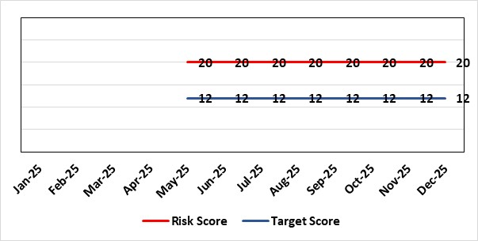 |  |  | Rationale for current score:  C - Insufficient coding data will negatively impact service planning for population health needs and inadequate data being available for mortality review/quality and safety purposes. This could result in failures at spotting patterns of variance that are negatively impacting levels of patient care and potentially causing avoidable deaths.  Clinically coded activity is also used to understand how resources are being allocated and used at Health Board level and national level (programme budgeting), and therefore a reduction in coding completeness will impact on the accuracy of this analysis. It is also used to claim casemix sensitive contract lines with JCC, Hywel Da and Cwm Taff of circa 70m per annum with lack of coding data impacting on the timeliness in making these claims.  L - Tier 1 target is currently not being met on a regular basis.
Rationale for target score:
C - Insufficient coding data will negatively impact service planning for population health needs and inadequate data being available for mortality review/quality and safety purposes. This could result in failures at spotting patterns of variance that are negatively impacting levels of patient care and potentially causing avoidable deaths.

Clinically coded activity is also used to understand how resources are being allocated and used at Health Board level and national level (programme budgeting), and therefore a reduction in coding completeness will impact on the accuracy of this analysis. It is also used to claim casemix sensitive contract lines with JCC, Hywel Da and Cwm Taff of circa 70m per annum with lack of coding data impacting on the timeliness in making these claims.

L – Increase in what can be coded electronically, unit centralisation, greater staff retention and the development of an auto-coding model will lead to increased capacity and a reduction in likelihood for targets not being met.
Controls (What is currently in place to manage the risk?) |  |  |  | Further Actions (What more are we going to do to address the risk?)
- A three-year coding modernisation plan has been approved by executive board on 26th February 2025. This plan will see the implementation of an auto-coding solution and a re-banding of the clinical coding department within existing budgets to attain Tier 1 targets by 27/28.  - The coding management team assess the staffing complement on a daily basis to ensure resources are deployed in the most efficient and effective manner, in line with demand and clinical coding priorities.  - There is a comprehensive training programme in place for new Trainee Coders.  - The Clinical Coding Departments raise incidents when clinical information is missing from the patient’s health records and prevents the activity being coded in a timely manner. These incidents are highlighted at the Directorate Business Meetings held on a monthly basis as part of the Clinical Coding Key Performance Indicators.  - Clinical coding staff performance continues to be monitored and discussed during the monthly Clinical Coding Managers Meetings, which are chaired by the Head of Health Records & Clinical Coding, and an update is also reported and presented on the Health Board Performance Scorecard.  - An App has been developed by Digital Intelligence that shows any relevant data relating to a patient episode from different systems including Signal, TOMs, EPOA and DAL in one place. This will reduce the number of systems a clinical coder needs to log into. |  |  |  | Action | Lead |  | Deadline
 |  |  |  | Auto-coding Model in production with Neurology Day-Case Episodes | Head of Digital Intelligence Programmes |  | 30/12/2025
 |  |  |  | Auto-coding model in production for two specialties | Head of Digital Intelligence Programmes |  | 28/02/2026
 |  |  |  | Additional working from home days to be added for staff due to increase in electronic coding opportunities. | Head of Health Records & Clinical Coding |  | 31/12/2025
Assurances (How do we know if the things we are doing are having an impact?)  - Attainment of the Tier 1 Health Board target for clinical coding completeness which relies on the timely availability and quality of the paper record and electronic sources. Coding 95% of in-patient activity within 30 days of discharge is a tier 1 Welsh Government target that is currently not being achieved regularly within SBU – with an average of circa 74% for 24/25. Performance is reported to Digital Business Meeting every 3 months, and to Digital, Data, Research & Innovations Committee via a Coding Paper.  - Episodes are coded from paper and electronic sources; the ability to code from electronic sources improves the timeliness & accuracy; approximately 52,000 episodes of 150,000 episodes are coded from electronic sources currently. This is reported to Digital Business Meeting every 3 months, and to Digital, Data, Research & Innovations Committee via a Coding Paper.  - An Audit has been carried out by NHS Wales Assurance and Audit Services of the Coding Department was completed in June 2024 with a result of limited assurance. In response a twelve-point action plan was developed of which one action remains which is the escalation of the coding risk to the Health Board Risk register. |  |  |  | Gaps in assurance (What additional assurances should we seek?)  - Investment required supporting the delivery and operational costs of the Digital strategy.  - Replacing qualified coders who have left the department with trainees reduces productivity - the only mitigation against this is an auto-coding product to increase productivity and re-banding across coding department to put staff at same bandings as NHS England and help staff retention – the investment required for this is yet to be funded.  - The Quality of Discharge Summary provision and standard of clinical information available at the point of coding requires improvement to assist with prompt and accurate coding.  There continues to be missing clinical information at the point of coding, preventing accurate and timely coding.  - Incomplete DALs.
Additional Comments / Progress Notes
Supplementary Notes:
- Coding 95% of in-patient activity within 30 days of discharge is a tier 1 Welsh Government target that is currently not being achieved regularly within SBU – with an average of circa 74% for 24/25.
- Contract coders and overtime have been used to achieve that 75% average which has stopped due to the current financial situation of the Health Board.
- Retaining and recruiting qualified coding staff is a big challenge due to higher bandings in England and the availability of digitised record to allow home working.
- 6 WTE qualified coders have been lost to English Health Boards or DHCW in the last 3 years due to higher bandings with a further 2WTE retiring. This has resulted in circa 44% of the current coding WTE being trainees/unqualified. Currently, there are 5 qualified coder vacancies (June 2025).
Progress Notes:
08/12/2025 – Auto-Coding Model date has been amended to December - currently in final testing ahead of potential go-live week commencing 8th December.

Datix ID Number: 3114  Date Opened: May 2025 |  | Date Last Reviewed: December 2025 |  | HBR Ref Number: 105  Target Date: TBC |  | Current Risk Rating:  4 x 4 = 16
Objective: Care is delivered in partnership with our communities in safe and appropriate settings, supported by innovative digital solutions, research, development and innovation |  |  | SRR Ref:  3.3 | Director Lead: Matt John, Director of Digital  Supporting Director: Chris Morrell, EDAHPHS  Assuring Committee: Digital, Data & Innovation Committee  For information: Quality & Safety Committee
Risk: Significant increased cost for the replacement Pathology System LIMS
If the new Laboratory Information Management (LIMS) system is not live before 31st March 2026 then there will be significant additional cost across NHS Wales which could impact the Health Board’s financial plans in 2025/26 and 2026/27. Costs would have to be covered to avoid pathology losing access to the current LIMS system resulting in the inability of pathology to deliver diagnostic results and blood transfusion services across all Health Board services including emergency, acute, primary and community services.
Risk Rating  (consequence x likelihood):  Inherent: 5 x 5 = 25  Current: 4 x 4 = 16  Target: 4 x 1 = 5 | 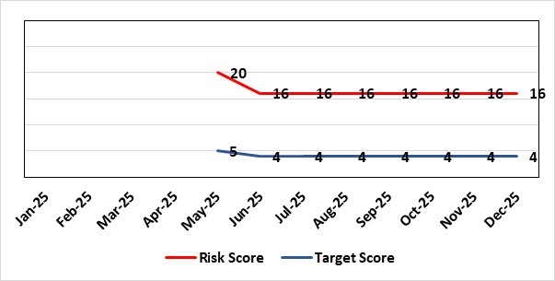 |  |  | Rationale for current score:  Consequence – Additional costs could be in region of approximately £1m for the Health Board depending on the length of delay  Likelihood – probable (10-50% chance currently) – due to being off-track on project and lack of confirmed back-up plan.
Rationale for target score:
Consequence as above
Likelihood will be negligible if effective system / mitigations put in place in time
Controls (What is currently in place to manage the risk?) |  |  |  | Further Actions (What more are we going to do to address the risk?)
Configuring and testing the new LIMS system with the aim of go-live with all disciplines before 31st March 2026  SBUHB Pathology services are working in collaboration with other Health Boards and Trusts to share configuration and testing as part of a national programme. The project has agreed a go-live of Cellular Pathology in November. However, national replanning is still underway for other disciplines (Microbiology, Andrology, Blood Sciences and Blood Transfusion) to secure go-live dates before 31st March 2026 when funding for the national programme ends. The two months allocated by the national programme for User Acceptance Testing has been extended to over 12 months as the number of defects in the system remains high. There remain significant defects to be addressed by the supplier, most notably for Blood Sciences with over 400 defects – over 300 of which must either be resolved or worked around before go-live.  Pursuing only a ‘Minimal Viable Product’ to avoid scope-creep  SBUHB Pathology Services are only seeking to pursue a safe replacement system, known as a ‘Minimal Viable Product’. This is to eliminate the possibility of testing timescales being extended. Other Health Boards and Trusts report they are following the same approach.  Challenging the supplier and Digital Health and Care Wales for their technical delivery  The supplier is responsible for addressing any defects identified during testing. Digital Health and Care Wales (DHCW) are responsible for delivering some of the technical integrations (in addition to co-ordinating the national programme). The SBUHB Project Team, through the programme governance, challenge the supplier and DHCW to deliver on their commitments. |  |  |  | Action | Lead |  | Deadline
 |  |  |  | Determine what additional local costs may be attracted due to extending the project from 31st December 2025 until 31st March 2026 and how these could be funded. | SBUHB Project Team |  | 31/12/2025
 |  |  |  | Continue to work in collaboration with other NHS Wales organisations to challenge supplier delivery and secure go-live dates before 31st March 2026. | SBUHB Project Team |  | 31/03/2026
 |  |  |  | Determine what additional local costs may be attracted due to extending the project into financial year 26/27. | Head of Digital Planning |  | 31/03/2026
Assurances (How do we know if the things we are doing are having an impact?)  National Programme Board  SBUHB, together with all Health Boards, Trusts and the supplier belong to the national LIMS Programme Board.  The Programme Board receives updates on Digital Health and Care Wales progress towards procuring extended licenses, or a replacement of, the current remote access software.  The Programme Board receives updates on testing activities, including metrics showing the number of outstanding system issues. It is chaired by the Executive Director of Allied Health Professions and Health Science for Aneurin Bevan University Health Board.  SBUHB Project Team  A Project Manager is in place to manage the SBUHB Project Team on daily basis.  Operational Delivery Network LIMS 2.0 Sub-Group  SBUHB work in regional partnership with Hywel Dda University Health Board (HDUHB) and hold a joint, monthly Operational Delivery Network LIMS 2.0 Sub-Group, which receives reports from the SBUHB and HDUHB Project Managers, along with Programme Managers from the supplier and Digital Health and Care Wales.  This group is jointly chaired by the SBUHB Clinical Lead for Laboratory Medicine and HDUHB Head of Pathology Service, who are also Senior Responsible Officers for the SBUHB and HDUHB projects.  Morriston Management Board  The SBUHB project regularly reports progress to the Morriston Management Board.  Digital, Data, Research and Innovation Committee  The SBUHB project regularly reports progress to the Digital, Data, Research and Innovation Committee. |  |  |  | Gaps in assurance (What additional assurances should we seek?)  Meeting the costs of extending the project and access to the current LIMS  A national mitigation plan was previously proposed that would enable go-lives of all SBUHB pathology disciplines by 31st December 2025. The national programme has since reported they have extended the programme until 31st March 2026.  Welsh Government have confirmed they will cover the £1.6m cost of the mitigation plan that would fund the programme until 31st December 2025.  Digital Health and Care Wales are seeking to cover a further £0.87m of national costs not previously included in the mitigation plan, that would fund national components of the programme until 31st March 2026.  The SBUHB project needs to determine what additional local costs may be attracted due to extending the project from 31st December 2025 until 31st March 2026 and how these could be funded.  Resource Constraints  All available staff are committed to the programme, with no external resources readily available. This has contributed to the programme’s red RAG status.
Additional Comments / Progress Notes
User Acceptance Testing sign-off
User Acceptance Testing across Wales was originally expected to take place across the two months of September and October 2024. However, a significant number of issues in the system, coupled with partial delivery of integrations between the LIMS and national systems managed by Digital Health and Care Wales, were identified early in the process. Maintaining the availability of Pathology staff to undertake testing across an extended duration, alongside maintaining service delivery, has also been challenging.

User Acceptance Testing has been extended to, depending on the pathology discipline, around twelve months. Go-lives have not been delayed by the same amount and the decreased duration between the end of User Acceptance Testing and go-live puts additional pressure on the project:
 | Previously | Currently
Duration of User Acceptance Testing | 2 months | 12 months
Duration between User Acceptance Testing sign-off and go-live | 3 months | 1 month

Business Continuity
The Health Board’s current Business Continuity Plan to address a failure in digital pathology systems is to revert back to paper based reporting, which is unsustainable and would only be effective over a very short-term period (days).

Blood Transfusion services in other part of Wales
SBUHB Blood Transfusion are the only Blood Transfusion service in Wales that have successfully migrated onto the current LIMS system. Other Blood Transfusion services use other legacy systems and will potentially be impacted after the 15th December 2025 in other ways (e.g. by having to extend support for their existing legacy systems).

Pathology resource for testing
Testing is reliant on the knowledge and skills of Health Board staff whose availability is limited, having to manage testing alongside normal service delivery. With a national shortage of Biomedical Scientists, there is no readily available external resource to support this process.

11/11/2025 – The pathology Operational Delivery Network LIMS sub-group chair has written to the LIMS national programme chair to request that the Backup Plan and the costs estimated within it be revisited given the increasing likelihood that go lives will take place in the new financial year.
09/12/2025 - Costs shared with 9th December 2025 Programme Board show a cost after 31st March 2026 of £3.3m per quarter, with £0.4m of those costs apportioned to SBUHB.

Risk Score Calculation

For each risk identified, the LIKELIHOOD & CONSEQUENCE mechanism will be utilised. Essentially this examines each of the risks and attempts to assess the likelihood of the event occurring (PROBABILITY) and the effect it could have on the Health Board (IMPACT). This process ensures that the Health Board will be focusing on those risks which require immediate attention rather than spending time on areas which are, relatively, a lower priority.

