Meeting Date | 05 February 2026 |  | Agenda Item |  |  | 2.4
Name of Meeting | Quality and Safety Committee
Report Title | Highlight report: Prevention of Suicide
Report Author | Lynnette Thomas, Assistant Director – Health Improvement and Wider Determinants  Hugo van Woerden, Deputy Director of Public Health
Report Sponsor | Professor Dr Gillian Richardson, Interim Executive Director of Public Health
Presented by | Kimberley Cann, Consultant in Public Health
Freedom of Information | Open
Purpose of the Report | The report highlights the need for a strategic approach in terms of activity to prevent suicide and/or self-harm through appropriate governance and partnership structures that are best placed to drive forward progress.
Key Issues | - To provide an update on the most recent data on deaths by suspected suicide and the mid and west Wales position.  - To provide context on the most recent national policy position.  - To provide an update on progress following a local multi-agency conference in February 2025 on new draft governance arrangements for overseeing suicide prevention and self-harm within a local context.
Specific Action Required  (please choose one only) | Information | Discussion |  | Assurance | Approval
Specific Action Required  (please choose one only) | ☒ | ☐ |  | ☐ | ☐
Recommendations | Receive the update and note ongoing early cross sectoral work as required by the national Suicide Prevention and Self-Harm strategy.

HIGHLIGHT REPORT – PREVENTION OF SUICIDE

- INTRODUCTION
This paper provides an update on national and local developments relating to suicide prevention and self-harm (SPSH) and outlines the emerging strategic direction for Swansea Bay University Health Board (SBUHB). Significant national policy changes, the establishment of new research and delivery infrastructure, and local preparatory work collectively create an opportunity for the Health Board to strengthen its leadership role across the regional system.
Members are asked to note progress to date, consider the implications of the updated national strategy, and support the proposed next steps to ensure cohesive delivery across partners.

- BACKGROUND
2.1 Data on suicide prevention

Public Health Wales published the Annual Report: Deaths by suspected suicide 2024-25 at the end of November 2025. This is based on Real Time Suspected Suicide Surveillance (RTSSS) and is regularly revised.
- There were 440 deaths by suspected suicide of Welsh residents who died in or outside of Wales, giving a rate of 16.8 per 100,000 people. The rates in 2023/24 and 2022/23 were 13.4 (352 deaths) and 13.7 (359 deaths) respectively. The rate in 2024/25 was statistically significantly higher than in 2023/24 and 2022/23. This could be because of a real increase in the rate of suspected suicides in Wales or it could be because of increased reporting into RTSSS during 2024/25.

- Males accounted for 77% of deaths by suspected suicide. The age-specific rate was highest in males aged 35-44 years (41.8 per 100,000).

- The rate of suspected suicides in 2024/25 was over twice as high in residents in the most deprived (19.9 per 100,000) and next most deprived areas (22.1), compared with residents in the least deprived areas (9.3).

- The rate of deaths by suspected suicide in people who were reported to be unemployed was 150.8 per 100,000, which was over 12 times higher than in any other employment status group.

- 61% of people were reported to have had a mental health condition, 55% had a history of previous self-harm, and 29% were known to mental health services.

- 31% of the deaths by suspected suicide were in people who were known to the Police in the previous 6 months.

- Analysis of the first three years of RTSSS data has shown some differences in patterns of mode of death, domestic abuse and other associated factors between males and females.
- Figure 1 outlines deaths by suspected suicide, based on the region of residence. The rate of suspected suicides was not statistically significant from the all-Wales rate (16.8) in Mid and West Wales (18.0) and North Wales (17.3). Over the last 3 years the rates in each of the three regions were not statistically significantly different year on year.
Figure 1: Deaths by suspected suicide, by region of residence
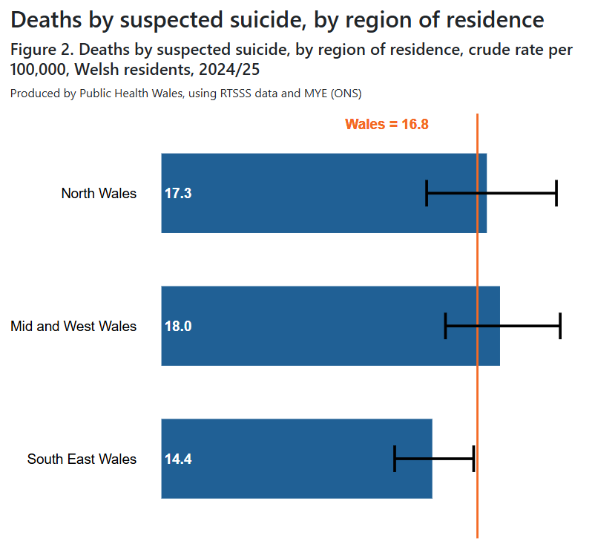
- Figure 2 outlines the deaths by suspected suicide, by health board area of residence. The rates in Swansea Bay University Health Board had a lower (but not statistically significantly lower) rate than the all-Wales rate. In Swansea Bay University Health Board the rate was higher, but not statistically significantly higher, than in 2023/24, but not than in 2022/23.
Figure 2: Deaths by suspected suicide, by health board area of residence
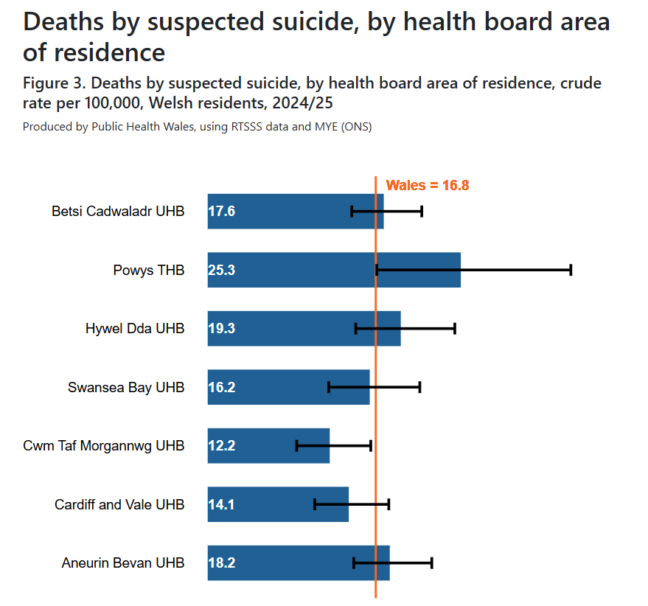
- Collecting and sharing data via RTSSS allows action to prevent future deaths by suspected suicide to be taken in a timely way, by providing up to date intelligence to users on national and regional patterns.

- Deaths by suspected suicide are reported to Public Health Wales before a Coroner’s inquest. It is anticipated that the number of deaths by suspected suicide may be higher than the number of suicides as determined by a Coroner, as some deaths by suspected suicide may be found to have a different cause following a Coroner’s investigation and inquest.

2.2 Policy context

In May 2025, Welsh Government published The Mental Health and Wellbeing Strategy 2025–2035. The strategy sets out key priorities over ten years ‘People in Wales will live in a country which promotes, supports and empowers them to improve their mental health and wellbeing, and will be free from stigma and discrimination’.

The Welsh Government launched a new 10-year Suicide Prevention and Self-Harm Strategy (2025–2035) at the same time, supported by a three-year Delivery Plan (2025–2028). The Strategy sets out six overarching objectives:
- Listening and learning
- Preventing
- Empowering
- Supporting
- Equipping
- Responding
It identifies specific priority groups at heightened risk, including middle-aged men for suicide and young women aged 15–19 for self-harm. This represents a strengthened national focus on both targeted preventative action and early intervention.

2.3 National level
The National Suicide and Self-Harm Team (NHS Performance and Improvement) was established to ensure consistent, evidence-based national implementation, with responsibilities including shared standards, workforce support, and coordination across Health Boards. They work collaboratively across Wales to support delivery of the national strategy and ensure consistency, coordination, and shared learning across regions. The national strategy recognises three regional suicide and self-harm prevention forums, which aim to improve integration and co-ordination across all sectors and to oversee local implementation. The groups are expected to help local leaders and organisations in developing local assessments and strategies and should build productive relationships with the local Mental Health Partnership Boards.

2.4 Mid and West Wales region
The Mid & West Wales Regional Suicide and Self Harm Forum includes Swansea Bay University Health Board, Hywel Dda University Health Board and Powys Teaching Health Board. Their current work programme includes:

- Developing a suite of protocols:
- S.O.P Rapid Response to suicide events
- Cluster Guidance
- Locations of concern guidance

- Workforce development
- Learning outcomes: undergraduate/pre-registration programmes
- Suicide awareness eLearning module
- Self-Harm E learning module - due to be published soon
- Responding to People Affected by Suicide or Suspected Suicide – CPD training for touch point organisations supporting people affected by suicide. The roll out is via a train the trainer model.

2.5 Swansea Bay
On 13 February 2025, a Suicide and Self Harm Prevention conference was held. The conference was a collaboration between West Glamorgan Regional Partnership Board (RPB) partners and wider stakeholders across Neath Port Talbot and Swansea, including the third sector. Over 100 participants attended on the day, and the main priorities included:
- Early intervention - identifying those in need
- Adequate and accessible training and awareness-raising
- Funding and accountability to provide equitable and consistent person-centred support and intervention
- Co-production, including those with lived experience
- Multi-agency service design and responsiveness
- The creation of an information/data sharing system.

Following the conference, colleagues from Swansea Bay University Health Board Public Health and Planning and Partnerships teams have been working with local and national colleagues to identify and create a new governance framework for multi-agency stakeholders. The draft governance framework is in Figure 3.

Figure 3: Draft Swansea and Neath Port Talbot Suicide Prevention and Self Harm Governance
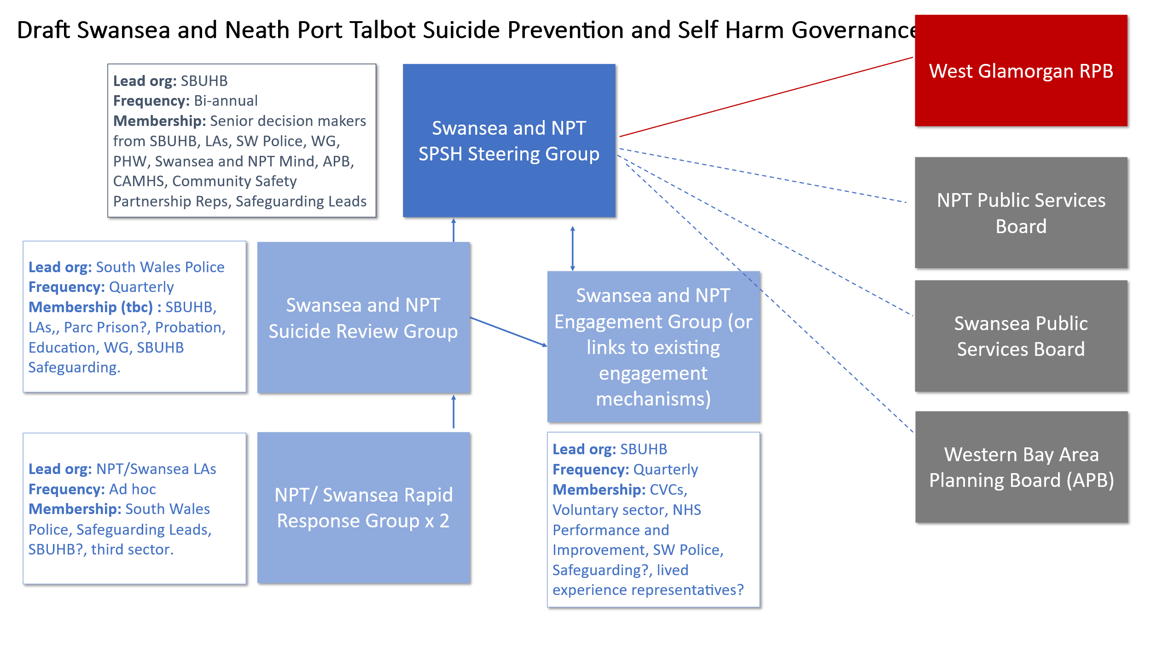
2.5.1 Swansea and Neath Port Talbot Suicide Prevention and Self-Harm Steering Group
The Swansea and Neath Port Talbot Suicide Prevention and Self-Harm Steering Group will bring together statutory partners with responsibility for delivering the local suicide prevention and self-harm strategy across Swansea and Neath Port Talbot at a strategic level.

The steering group will serve as the primary coordination and delivery mechanism for implementing the Welsh Government’s Suicide and Self-Harm Prevention Strategy (2025–2035) at the local level. It will ensure that activity is:

- Informed by evidence and stakeholder experience
- Coordinated across sectors
- Aligned with national and regional priorities.
- Aligned with existing Partnerships and Services
- Communicated with all partners and stakeholders.

The national guidance promotes a whole-system, trauma-informed approach that requires collaboration across statutory services, voluntary sector organisations, and communities. The Welsh Government vision is that: “The annual rates of suicide in Wales will continuously decrease. People who self-injure, self-poison, who have suicidal ideation or have attempted suicide will feel safe and understood. They will belong to informed and compassionate communities and will be able to access support and services which meet their needs when and where they need them.”

The steering group will formally report to West Glamorgan Regional Planning Board West Glamorgan Regional Partnership Board via its Strategic Advisory Board 2: Wellbeing and Learning Disability & Emotional Wellbeing and Mental Health, and indirectly to the Swansea and NPT Public Service Boards and Area Planning Board. This strategic alignment will ensure that suicide and self-harm prevention are integrated within broader mental health strategy and partnerships. It is intended that the steering group will be active from early 2026.
2.5.2 Swansea and Neath Port Talbot Suicide Review Group

The Swansea and Neath Port Talbot Suicide Review Group will receive and analyse data and information in relation to completed and suspected suicides with an aim to support improvements in policies, systems and practice. South Wales Police have agreed to chair the Review Group.
2.5.3 Swansea and Neath Port Talbot Rapid Response Groups

The Swansea and Neath Port Talbot Rapid Response Groups provide a rapid, multi-agency response to managing the consequences of critical incidents. They respond to suspected suicides, significant attempts or sudden deaths of a person under 21 years.

2.5.4 Swansea and NPT Engagement Group
Engagement with the third sector and people with lived experience will be key. This will either be conducted through a group comprised of third sector / voluntary agencies or through existing SBUHB engagement mechanisms. The intention is to report sector insights, data, and feedback to the SPSH steering group.

- GOVERNANCE AND RISK ISSUES

3.1 Governance Considerations
The new national framework requires each Health Board to adopt a clear governance model for suicide and self-harm prevention. This includes:
- A coherent local SPSH Framework
- Multi-agency leadership arrangements
- Robust oversight of system-wide pathways, performance, and risk
- Clear linkage to national governance structures and research activity.

Local governance arrangements are in train to meet these expectations.

3.2 Key Risks and Issues
The following risks have been identified:
- Leadership and coordination – Due to the multi-agency requirements of this approach, it has been necessary to identify the correct governance arrangements. A distributed leadership model has been proposed, with different teams and organisations leading on different elements. This will need to be monitored closely to ensure that there are no gaps in system-wide leadership which could limit coherent delivery and create variation in practice. The Public Health team will support the coordination within the multisector space but there is currently no administrative support.
- Capacity and resource constraints – There are capacity and resource constraints on all organisations and teams involved and no dedicated/allocated funding or staff to support this additional work. There may be pressures on clinical, public health, and community services that may affect implementation pace.
- Data and Intelligence Limitations:
Fragmented data flows restrict the ability to monitor trends, identify emerging risks, and evaluate interventions. The creation of the Suicide Review Group should help to mitigate this.

These risks will require structured mitigation within the forthcoming SPSH action plan.

- FINANCIAL IMPLICATIONS

There are no immediate direct financial commitments arising from this update report. However, the following future financial considerations are likely:

- Capacity Requirements - Delivery of a multi-agency SPSH action plan will require dedicated coordination capacity within SBUHB and across partners. The SBUHB Public Health team is very small compared to other Health Board teams and administrative capacity within the core team is stretched. To fulfil this brief adequately, funding for a Band 7 Coordinator within the Public Health team to support this work and wider mental health prevention will be necessary. All work is currently additional to existing resources and capacity.
- Potential commissioning across partners - As the local model develops, there may be opportunities to fund prevention initiatives from the West Glamorgan Regional Planning Board or associated pots.

Further financial requirements will be assessed as part of the development of the 2026–2028 local SPSH Action Plan.

- RECOMMENDATION

Receive the update and note ongoing early cross sectoral work on the Suicide Prevention and Self Harm Prevention governance, capacity constraints for the new workstream and impacts on other priorities.

Governance and Assurance

Link to Enabling Objectives  (please choose) | Supporting better health and wellbeing by actively promoting and empowering people to live well in resilient communities
Link to Enabling Objectives  (please choose) | Partnerships for Improving Health and Wellbeing |  | ☒
Link to Enabling Objectives  (please choose) | Co-Production and Health Literacy |  | ☒
Link to Enabling Objectives  (please choose) | Digitally Enabled Health and Wellbeing |  | ☒
Link to Enabling Objectives  (please choose) | Deliver better care through excellent health and care services achieving the outcomes that matter most to people
Link to Enabling Objectives  (please choose) | Best Value Outcomes and High Quality Care |  | ☒
Link to Enabling Objectives  (please choose) | Partnerships for Care |  | ☒
Link to Enabling Objectives  (please choose) | Excellent Staff |  | ☐
Link to Enabling Objectives  (please choose) | Digitally Enabled Care |  | ☒
Link to Enabling Objectives  (please choose) | Outstanding Research, Innovation, Education and Learning |  | ☐
Health and Care Standards
(please choose) | Staying Healthy |  | ☒
(please choose) | Safe Care |  | ☐
(please choose) | Effective Care |  | ☒
(please choose) | Dignified Care |  | ☐
(please choose) | Timely Care |  | ☐
(please choose) | Individual Care |  | ☒
(please choose) | Staff and Resources |  | ☒
Quality, Safety and Patient Experience
The paper outlines what is needed to progress the suicide and self harm agenda from a population health perspective. Implementation of an effective preventative, population health approach will lead to a more effective impact on suicide & self-harm rates.
Financial Implications
The paper notes that investment is required to progress this work, but it is currently being managed within existing resources and capacity.
Legal Implications (including equality and diversity assessment)
None.
Staffing Implications
This additional work is being conducted at present within existing resources.
Long Term Implications (including the impact of the Well-being of Future Generations (Wales) Act 2015)
Reducing the incidence and inequalities in suicide and self-harm supports The Well-being of Future Generations (Wales) Act 2015. In particular, the Well-being Goals of a more equal Wales and a healthier Wales.
Report History |  | Quality and Safety Committee, Prevention of Suicide & Self-Harm, 19 December 2023
Appendices |  | None

Annual Report: Deaths by suspected suicide 2024-25 - Public Health Wales
Mental health and wellbeing strategy 2025 to 2035
Understanding: a suicide prevention and self-harm strategy
Suicide prevention and self-harm strategy: delivery plan 2025 to 2028
https://www.sshp.wales/en/learning-and-development-resources/learning-for-undergraduate-pre-registration-and-pre-qualifying-health-and-social-care-students-in-wales/
https://www.sshp.wales/en/suicide-awareness-module/

