Meeting Date | 05 February 2026 |  | Agenda Item |  |  | 4.5
Name of Meeting | Quality and Safety Committee
Report Title | Tackling Diabetes Together Improvement Plans
Report Author | Julie Morse, Strategic Planning Manager  Kimberley Cann, Consultant in Public Health  Naveen Uddin, Advanced Information Analyst
Report Sponsor | Dr Richard Evans, Executive Medical Director
Presented by | Dr Richard Evans, Executive Medical Director
Freedom of Information | Open
Purpose of the Report | The purpose of the report is to set out the health board’s position in relation to the Diabetes 8 Care Standards and the national Tackling Diabetes Together programme.
Key Issues | - Numbers of patients diagnosed with diabetes continue to increase in Swansea Bay University Health Board (SBUHB). Estimates suggest the prevalence of diabetes may rise to 10% of the Welsh population by 2035.  - Public Health Wales has implemented the Tackling Diabetes Together (TDT) Programme in collaboration with NHS partners. This programme aims to address health inequalities that contribute to the risk of developing diabetes and ensure better management of the condition.  - SBUHB has signed up to the TDT Programme and is working to improve the position in relation to the Diabetes 8 Care Standards.  - SBUHB needs to develop preventative approaches to tackle the determinants that affect the prevalence of diabetes in our population.
Specific Action Required  (please choose one only) | Information | Discussion |  | Assurance | Approval
Specific Action Required  (please choose one only) | ☐ | ☐ |  | ☒ | ☐
Recommendations | Members are asked to:  - ACKNOWLEDGE the continuing increase in numbers of patients diagnosed with diabetes in Swansea Bay;  - ACKNOWLEDGE the implementation of the Public Health Wales Tackling Diabetes Together Programme, to which Swansea Bay has signed up and formulated an improvement plan;  - ACKNOWLEDGE the re-establishment of the Diabetes Planning and Development Group to take forward the work required.
TACKLING DIABETES TOGETHER IMPROVEMENT PLANS

- INTRODUCTION
The purpose of the report is to set out the health board’s position in relation to the Diabetes 8 Care Standards and the national Tackling Diabetes Together programme.

- BACKGROUND
While Type 1 diabetes affects around 16,000 people in Wales and cannot be prevented, more than 190,000 people have type 2 diabetes, which can be prevented or delayed by modifying existing risk factors for this disease. There has been a steady increase in the number of adults with diabetes in Wales over the last 15 years, mostly due to an increase in type 2 diabetes. Estimates suggest that diabetes may affect 1 in 10 of the population by 2035 - a 56% increase in patients living with diabetes.

Mortality associated with diabetes is increasing and is higher in those living in the most deprived areas of Wales. It has increased at a faster rate in the most deprived quintile of the population in recent years, which cannot be attributed to the impacts of COVID.

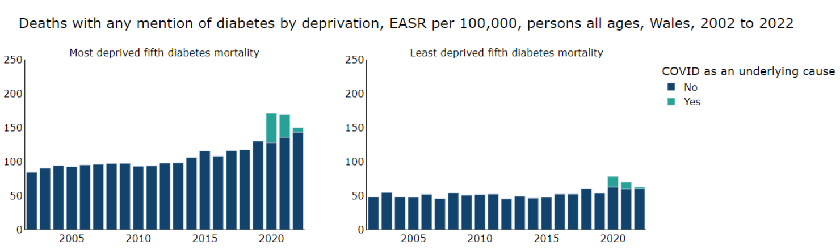

People living with diabetes are more likely to be admitted to hospital than those without and in 2021/22, more than 1 in 10 patients admitted to hospital in Wales had diabetes. Diabetes can cause many complications resulting in loss of vision, kidney failure, heart attack, stroke and limb amputations. Limb loss is a serious complication and mortality rates post amputation are worse than those for most cancers. Approximately 10% of the NHS budget is spent on people with diabetes.

People with diabetes require significant support from NHS services to help manage the condition. Tackling Diabetes Together offers support to people who are at highest risk of diabetes and the introduction of new remission services for newly diagnosed people who may be able to reverse the development of the condition.

Public Health Wales has implemented the Tackling Diabetes Together [TDT] Programme in collaboration with NHS partners. The programme aims to address health inequalities that contribute to the risk of developing diabetes and ensure better management of the condition. SBUHB has signed up to the TDT Programme and has been working to improve the health board’s position in relation to the Diabetes 8 Care Standards.

- GOVERNANCE AND RISK ISSUES
The TDT programme has six work streams:

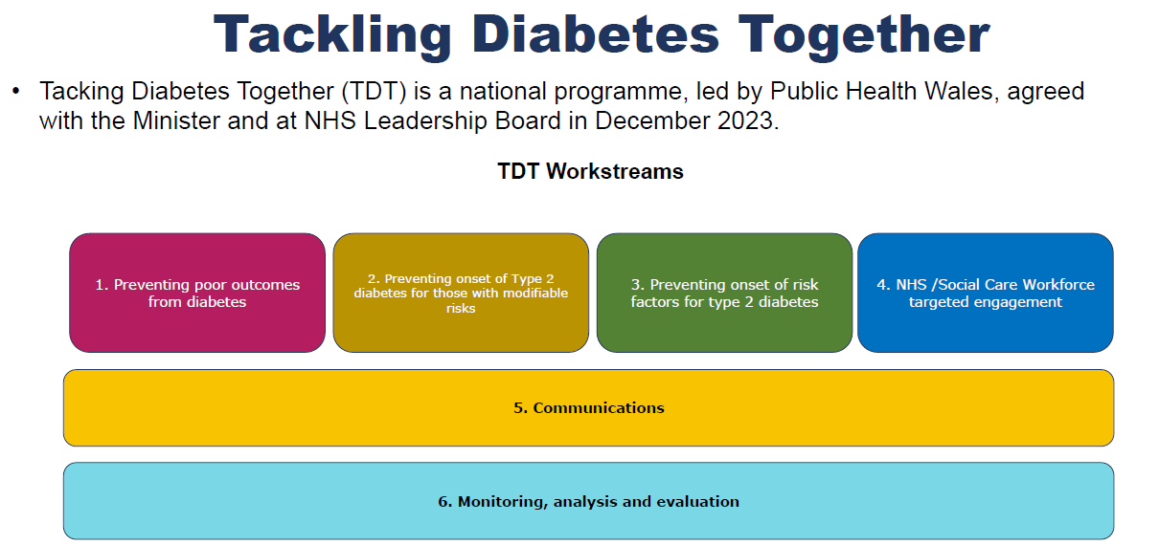

SBUHB is implementing a four-year plan to improve the its position in relation to diabetes management and treatment improvement. The work aligns with the two key strategic objectives of the TDT programme

- Having more people live well with diabetes measured through a reduction in complications such as amputations by December 2028
- Stopping the prevalence of type 2 diabetes increasing by Dec 2028

TDT also aligns with SBUHB’s Population Health Strategy and our approach to tackling health inequity and shifting focus on to prevention to improve the health and wellbeing of the population.

3.1 SBUHB Current Position
In 2024, 7.8% of people registered with a GP in SBUHB had diabetes – this means around 26,000 people in SBUHB are living with diabetes. There has been a 5% increase in the number of patients diagnosed in SBUHB in the last 3 years – around an additional 1,300 patients (based on 2021-2024 data). As seen across Wales, prevalence of diabetes is significantly higher in men than in women in SBUHB. There were around 14,500 men diagnosed with diabetes in SBUHB in 2023 compared to around 11,400 women.

In 2022, SBUHB had the second highest rate of major lower limb amputations in patients with type 2 diabetes of the health boards in Wales (102 per 100,000 patients). And the second highest rates of minor lower limb amputations (219 per 100,000 patients). In 2022/23 over 75% of diabetic inpatients on the amputation pathway in SBUHB were classed as emergency admissions, with an average length of stay of 25 days and an average cost of £23,000 per inpatient spell. SBUHB also has the highest rates of admission for diabetic ketoacidosis as the primary diagnosis compared to other the health boards for patients diagnosed with type 2 diabetes.

However, the overall rate of emergency admissions for type 1 and type 2 diabetes has been decreasing in SBUHB in recent years, as has been seen across Wales.
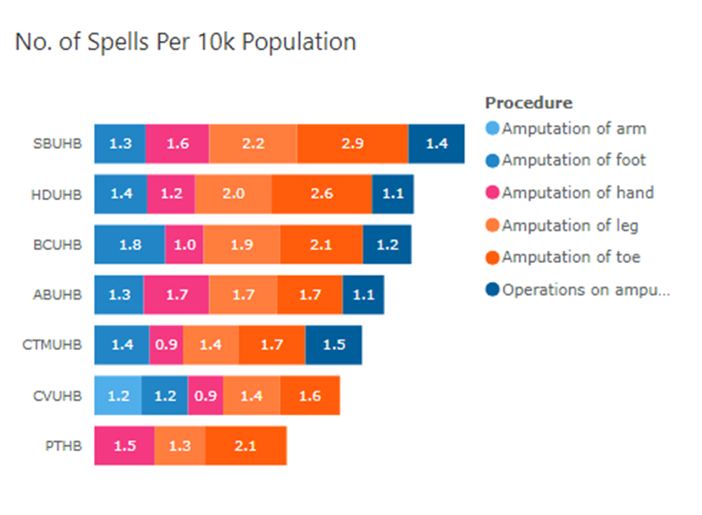
3.2 Diabetes Planning & Development Group
The Diabetes Planning & Development Group [DPDG] was established to focus on improving compliance with the eight diabetes care standards; action plans highlight:

- Health inequalities, particularly related to patient engagement in the management of their condition
- Education in self-management, via standardised communications
- Streamlining and improvement of data flows, mapping optimal pathways
- Ensuring robust access points for patients

Following on from the work programme set out by the One Bay Way programme, the goal is to work towards the implementation of a more sustainable community model, rebalancing resources into early intervention and prevention. The Diabetes Planning and Development Group is taking the lead on planning for improvements, supported by Executive, GP and Consultant leadership.

3.3 Eight Care Standards
One of the health board’s key priorities over the next five years as part of the Tackling Diabetes Together programme is improving its position against the eight care standards. Each health board is assessed against eight annual care standards as noted below:

- HbA1c (Blood Tests)
- Blood Pressure.
- Cholesterol Level.
- Kidney Function.
- Urine Albumin.
- Foot Surveillance.
- BMI (Height and Weight)
- Smoking Status

The eight care standards are annual checks that an individual should receive to ensure the risk of complications is minimised. Any complications detected early will allow intervention to reduce progression. The treatment targets are checks to ensure risk factors are effectively addressed, particularly for complications such as kidney disease, cardiovascular disease, amputations or stroke and to address risk factors such as obesity or smoking. Overall, the aim is to improve patient outcomes and ensure patients with diabetes live healthier and longer.

The health board has taken a number of strategic and operational actions to improved performance against the eight care standards in addition to signing up to the Tackling Diabetes Together programme. As mentioned above, the internal planning group, the DPDG, is in place and is attended by key stakeholders from the health board, primary care Clusters, the Wales national TDT programme and Diabetes UK.

Type 1 Type 2
SBUHB | 25.30% | 46.04%
Wales | 23.33% | 46.59%
[data from NHS Wales diabetes insights & variation Atlas as at November 01 2025]

Improvement in data reporting has shown a greatly improved SBUHB position in relation to the compliance with the Type 1 care process performance. It is anticipated that improved data flow from the health board’s secondary IT system will have contributed to this improvement, as well as focused efforts by GP Clusters to improve compliance. The eight care standards are part of the cluster and health board IMTP prioritisation work and is included in the Population Health Strategy. This includes pathway mapping and a value-based healthcare approach using baseline practice level performance data as a point on which to build.

The graph below shows current performance against each of the care processes – as at Nov 01 2025.

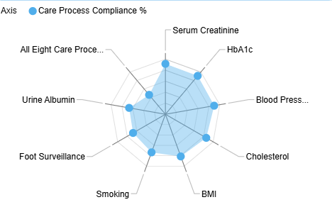

3.4 Regional Working
A regional Whole Systems Approach (WSA) to healthy weight team has been established and is working across Swansea Bay and Hywel Dda UHBs to develop system capability & capacity. The team is bringing together organisations and communities in the local area to build a collective understanding of how the local food environment shapes people’s opportunities to maintain a healthy weight, and where best to intervene within the system to achieve long-terms system change - one in which our environment promotes and supports healthy weight.

This approach goes beyond traditional partnership working. It means looking at the complex interaction of all the various parts of the system – from food sourcing and procurement, affordability of food, access to green and blue spaces, plus planning decisions and active travel options.

Over the past 18 months the Whole Systems Approach to healthy weight team have been working with the five Public Services Boards of Swansea, Neath Port-Talbot, Carmarthenshire, Ceredigion and Pembrokeshire through a series of engagement activities and workshops. In December 2024 this resulted in a collective agreement to focus on access to food (availability and affordability) as a collaborative priority for system-wide action across the region. Subsequently, a joint workshop with Swansea and Neath Port Talbot Public Services Boards has narrowed that focus further and they have agreed to take forward public food procurement as a collaborative priority. A regional learning network for systems has been co-designed and launched and aims to build the capacity and capability of stakeholders in applying system tools and approaches in their work. More recently, a 2050 vision for the regional food environment has been co-designed with partners and stakeholders. The collective vision of ‘a sustainable and resilient food system and nutritious food for all’ will guide the regional systems approach moving forward.

3.5 Approach to Prevention
In prediabetes, weight loss has been shown to delay the onset and decrease the risk of type 2 diabetes, while in established type 2 diabetes weight loss has been shown to improve glycaemic control, with severe calorie restriction even reversing the progression of the disease. SBUHB has a range of weight management services available for both adults and children and young people. There are challenges around the limited capacity of the Level 2 adult weight management services compared to demand for the services and unlike other health boards in Wales, SBUHB does not have a substantially funded Level 3 adult weight management service, with a limited digital offer funded through Prevention and Early Years Welsh Government Grant funding. There is work happening across the Health Board on developing the Adult Weight Management Pathway, using a One Bay Way Approach, but there is a lack of substantive funding identified for the development of the adult weight management pathway.

Smoking is also an important risk factor, identification of smoking status is one of the 8 Care Standards. People who smoke have an increased risk of developing type 2 diabetes. People who have diabetes and who smoke have a higher risk of developing complications including diabetic neuropathy and cardiovascular complications, and have higher morbidity rates. In Swansea Bay nearly 14% of adults are smokers, with smoking known to be more prevalent in people living in deprived areas. People living with diabetes should be offered support to quit smoking through the Help Me Quit smoking cessation service, and work should be done across SBUHB to support smoke-free becoming the norm.

3.6 Governance
The DPDG has set out the plans required to deliver improvement against the 8 Diabetes Care Standards – with particular focus on foot checks and urine test checks. Progress will be reported to the Quality & Safety Committee, with key achievements and issues for escalation to also be reported up to the Management Board.

The Executive Medical Director is the Senior Responsible Office for the DPDG, and is looking to establish a wider and more strategic-level governance structure to support the DPDG (which plays an important operational role in delivering diabetes improvement).

3.7 Risks
The diabetes pathway is not supported by robust data capture – data is input into differing systems across the health board and only GP data is fed into the National Diabetes Audit for onward reporting. It is also difficult for all clinicians to have timely access to patient information for speedy decision making. The Group has been working with Digital colleagues to try to work through a local solution.

The DPDG is developing proposals (in line with national guidance) with the aim of providing significant benefits by shifting care from reactive, hospital-based treatment to proactive prevention and management within the community setting. This model will require investment to resource the consultant and nursing elements but will release resource benefits. It is expected that the model will provide greater cost-effectiveness by:

- Lower rates of amputation and diabetic retinopathy
- Reductions emergency admissions associated with diabetes
- Achieving blood pressure and cholesterol targets in the care process model significantly reduces the risk of heart attacks and strokes
- Effective blood sugar management can prevent or slow the progression of kidney and eye diseases.
- Reduced referrals into Secondary Care
- Reduction in Follow Up Not Booked numbers
- Reduction in hospital admissions associated with diabetes
- Shorter lengths of stay for people with diabetes – earlier supported discharge

This will continue to be worked through by the DPDG until it is ready for more formal discussion.

- FINANCIAL IMPLICATIONS
The cost of a community model is currently being worked through.

- RECOMMENDATIONS
Members are asked to:
- ACKNOWLEDGE the continuing increase in numbers of patients diagnosed with diabetes in Swansea Bay;
- ACKNOWLEDGE the implementation of the Public Health Wales Tackling Diabetes Together Programme, to which Swansea Bay has signed up and formulated an improvement plan;
- ACKNOWLEDGE the re-establishment of the Diabetes Planning and Development Group to take forward the work required.
- ACKNOWLEDGE the focus on improving current performance against 8 care processes.

Governance and Assurance

Link to Enabling Objectives  (please choose) | Supporting better health and wellbeing by actively promoting and empowering people to live well in resilient communities
Link to Enabling Objectives  (please choose) | Partnerships for Improving Health and Wellbeing |  | ☒
Link to Enabling Objectives  (please choose) | Co-Production and Health Literacy |  | ☐
Link to Enabling Objectives  (please choose) | Digitally Enabled Health and Wellbeing |  | ☒
Link to Enabling Objectives  (please choose) | Deliver better care through excellent health and care services achieving the outcomes that matter most to people
Link to Enabling Objectives  (please choose) | Best Value Outcomes and High Quality Care |  | ☒
Link to Enabling Objectives  (please choose) | Partnerships for Care |  | ☒
Link to Enabling Objectives  (please choose) | Excellent Staff |  | ☒
Link to Enabling Objectives  (please choose) | Digitally Enabled Care |  | ☒
Link to Enabling Objectives  (please choose) | Outstanding Research, Innovation, Education and Learning |  | ☐
Health and Care Standards
(please choose) | Staying Healthy |  | ☒
(please choose) | Safe Care |  | ☐
(please choose) | Effective Care |  | ☒
(please choose) | Dignified Care |  | ☐
(please choose) | Timely Care |  | ☒
(please choose) | Individual Care |  | ☒
(please choose) | Staff and Resources |  | ☒
Quality, Safety and Patient Experience
The Health Board’s improvement plans relating to diabetes will help to reduce the number of patients developing type 2 diabetes and to better manage patients living with diabetes. The aim is also to bring more patients on board with their own management of their condition, this relieving pressure on the healthcare system, especially the secondary care system.

Financial Implications
Noted above

Legal Implications (including equality and diversity assessment)
None expected.

Staffing Implications
None expected – apart from the one HCSW role funded by Public Health Wales TDT programme

Long Term Implications (including the impact of the Well-being of Future Generations (Wales) Act 2015)
Collaboration: Delivering a coherent Tacking Diabetes Together programme requires collaboration across secondary and primary care in addition to collaboration with partners from across the region.
Long Term: The programme is a long-term programme that the Health Board is committed to delivering.
Integration: Providing an integrated response across the Health Board and Clusters is integral to delivering Tackling Diabetes Together.
Prevention: Preventing diabetes and preventing people with the condition from worsening are key objectives of the programme.
Involvement: Involving patients in the care of their condition is a key objective of the programme.

Report History |  | Nil.
Appendices |  | Nil.

Figures for patients diagnosed with type 1 diabetes are too small to reliably estimate.

