


Meeting Date | 27 February 2024 |  | Agenda Item |  |  | 4.3
Report Title | Quality Metric (Target) breaches in Radiotherapy
Report Author | Nicki Davies, Radiotherapy Services Manager
Report Sponsor | Raj Krishnan, Interim Executive Medical Director
Presented by | Raj Krishnan, Interim Executive Medical Director
Freedom of Information | Open
Purpose of the Report | This paper is submitted to inform the Quality and Safety Committee of the mitigating actions that have been developed in relation to delays in accessing the CT Simulator detailed in Health Board Risk Register ~HBR67 currently with a reduced risk of 15 to avoid escalation in the future.
Key Issues | The main factor to the number of breaches is access to the CT Simulator (please see top 5 breaches table below). A Business Case was submitted and approved by the Business Case Assurance Group (BCAG) in 2023 to recommission the old CT Simulator in the department as a temporary short term solution until a new CT Simulator is installed. The associated work was completed at the end of 2023 and old CT-simulator came online from January 2024. Alongside this funding has been approved to begin the design process for the purchase and installation of a new CT Simulator.
Specific Action Required  (please choose one only) | Information | Discussion |  | Assurance | Approval
Specific Action Required  (please choose one only) | ☐ | ☒ |  | ☒ | ☐
Recommendations | Members are asked to:  - NOTE the main cause of radiotherapy breaches is access to the CT simulator;  - NOTE the reintroduction from January 2024 of the old CT simulator to mitigate the risk of a single point of failure by only having one machine available;  - NOTE the work to identify joint funding with Hywel Dda University Health Board for the old CT-simulator for 2024-25 while the capital business case for an additional new machine is developed.
Quality Metric (Target) breaches in Radiotherapy

- INTRODUCTION

This report sets out to assure the Quality and Safety Committee that measures have previously and continue to be put in place to mitigate against the risk associated with the CT Simulator (CT-Sim) which continues to contribute to the breaches in the Quality Metrics.

- BACKGROUND

The Radiotherapy Department is part of the South West Wales Cancer Centre, providing Radiotherapy to the South West Wales population. The centre currently provides planned and emergency treatment Monday-Friday and an on-call service at weekends for emergency treatment only.
The recent Linac (linear accelerator) Replacement program, where the department has seen significant investment, has improved the treatment capacity allowing the introduction of Hypofractionation (delivery of fewer but larger doses of radiotherapy) for a number of treatment sites. This has seen our linac capacity rise from 2,000 patients to 2,400 patients. However, the planning and CT scanning demand has risen to 2,700 (as some patients have to be rescanned and re-planned during their treatment). Most centres in England treating more than 2,000 patients have a 2nd CT-Sim
A CT-Sim planning scan is an essential component of the Radiotherapy patient pathway, with all but the most palliative patients requiring a complex scan, which involves manufacture of radiotherapy masks, deep inspiration breath-hold coaching, tattooing, laser alignment and immobilisation positioning
The department has seen the demand for CT scans rise from around 1,600 pre-Covid and hypofractionation, to 2,700 post the introduction of hypofractionation. This includes a number of patients that have to be re-planned and have their treatment adapted prior to or during their Radiotherapy. Historically not all patients required a CT scan - now it is standard of care for all patients, with some requiring more than one.
At the same time as this increased demand for CT-Sim scans, the Wales Time to Radiotherapy performance metrics have reduced from 21 days to 14 days. This is a core Quality Metric for Cancer Centre performance monitored by Welsh Government.
- GOVERNANCE AND RISK ISSUES
Recent approval to recommission the Old CT Scanner has provided some resilience, increasing CT scan slots, however these slots do not have the option of Surface Guided Radiotherapy and/or 4D scanning. This limits the use of hypofractionation, thereby potentially detrimentally affecting linac capacity. The recommissioned CT Scanner is only available up until the end of 2024 as all manufacture support is formally terminated. More fundamental improvement is needed to achieve an acceptable Radiotherapy Performance. Current performance is 21% for the 14 day pathway. The re-introduction of the old CT-Sim from January 2024 will increase our performance to 36% at a minimum and more importantly provide resilience.

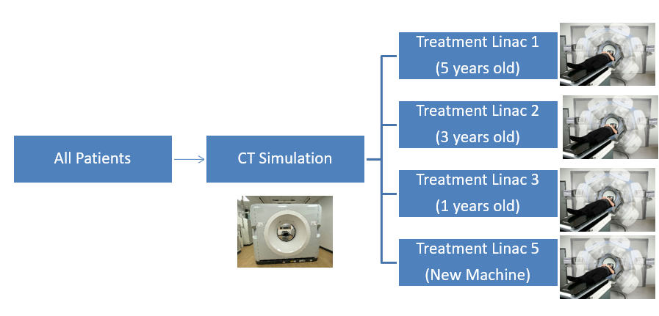
Ideally a CT scan would be accessed in 2 days however current waiting times for each tumour site comprise:

Treatment Site | Wait for CT (days)
Anus | 5.5
Bladder | 3.5
Brain | 6.2
Breast IMRT | 5.5
Breast SCF | 5.5
Breast VMAT | 5.5
Gynae | 5.0
FT H&N | 3.2
H&N Bilat | 5.8
H&N Unilat | 5.0
Lung | 7.0
SABR Lung | 4.1
Lymphoma | 5.8
Misc | 3.6
Oesophagus | 9.4
Pancreas | 3.8
PPN | 14.6
Prostate | 17
Prostatectomy | 9.2
Rectum | 9.4
Sarcoma | 6.1

An extremely important point to note is that having a single CT-Sim scanner for all patients needing Radiotherapy, means there is a single point of failure within the pathway. Whenever the scanner is out of use, no patients can be scanned and therefore commence their Radiotherapy pathway. Should we experience a significant outage, patients would be unable to start their treatment, which has been the case recently and had a profound impact on our radiotherapy performance.
Recent Wales Cancer Network Peer Review and the Health Inspectorate Wales Inspection both raised the issue of needing a 2nd CT-Sim to ensure resilience in service.

During 2023, the Radiographers worked extended hours/weekends when required to reduce the waiting time backlogs, however this is not sustainable and was only a short term solution with staff wellbeing being impacted.

New equipment in the department has enabled the department to reduce the risk score, however, the main issue preventing further reduction at present is the access to CT Simulator.
The recent work on recommissioning the Old CT-Sim, along with the support from staff, will alleviate the capacity issues, with the machine now being clinical from January 2024), and will reflect an improvement in the statistics within the next month or so.
The current recommissioning is only funded until the end of the financial year, and work is ongoing to ensure funding from Hywel Dda to allow this to continue until the end of 2024.
The Risk score is on the agenda for the next Radiotherapy Management Meeting to discuss reducing further.
Please see more detailed analysis below which demonstrates the Radiotherapy breaches during 2023, with CT being the main contributory factor, along with other issues impacting performance.

Graph one: demonstration of overall performance throughout 2023 for scheduled treatment and elective delay.

Graph two: demonstration of overall performance throughout 2023 for Urgent symptom control and Emergency treatment. Emergency treatment is rarely below the two day target, however following the CT breakdown, a dip is evident.

Graph three:
- Treatment Capacity has been less of an issue following the installation and clinical availability of Linac 5 however the backlog created due to CT breakdown did impact on this towards the end of the year.
- Plan not localised is far less of an issue than has been previously and continues to improve with the additional consultants in the department.
- CT breakdown is due mostly to the extended breakdown in May 2023.
- Replan required fluctuates and cannot be controlled. (this is usually where the patient requires a new plan which can often be out of the control of the department (weight Loss, tumour changes etc))

Graph four:
- The main issues are CT breakdown, CT capacity and Treatment capacity.
- Treatment capacity has been improved by the new equipment over the last few years.
- Impact on CT breakdown at the end of May 2023 is clear.
- This further impact on Capacity can be seen the following months.
- August usually sees a dip in demand due to consultant annual leave etc. but this was not evident in 2023 due to new appointments.
- The knock on with treatment capacity is seen October to December 2023
This demonstrates clearly that with the recommissioned CT Simulator risk will be reduced, this is however a short term measure and continued work on the purchase and installation of a new CT Simulator (as planned) is the main solution in mitigating this risk.

- FINANCIAL IMPLICATIONS
The financial implications of continuing to use the recommissioned CT have been covered until the end of the current financial year. Work is ongoing to ensure this can continue to be covered by both Swansea Bay and Hywel Dda until the end of 2024, whilst simultaneously working on the Capital case for Welsh Government and revenue for the new CT going forward.

- RECOMMENDATION
Members are asked to:
- NOTE the main cause of radiotherapy breaches is access to the CT simulator;
- NOTE the reintroduction from January 2024 of the old CT simulator to mitigate the risk of a single point of failure by only having one machine available;
- NOTE the work to identify joint funding with Hywel Dda University Health Board for the old CT-simulator for 2024-25 while the capital business case for an additional new machine is developed.

Governance and Assurance

Link to Enabling Objectives  (please choose) | Supporting better health and wellbeing by actively promoting and empowering people to live well in resilient communities
Link to Enabling Objectives  (please choose) | Partnerships for Improving Health and Wellbeing |  | ☐
Link to Enabling Objectives  (please choose) | Co-Production and Health Literacy |  | ☐
Link to Enabling Objectives  (please choose) | Digitally Enabled Health and Wellbeing |  | ☐
Link to Enabling Objectives  (please choose) | Deliver better care through excellent health and care services achieving the outcomes that matter most to people
Link to Enabling Objectives  (please choose) | Best Value Outcomes and High Quality Care |  | ☒
Link to Enabling Objectives  (please choose) | Partnerships for Care |  | ☒
Link to Enabling Objectives  (please choose) | Excellent Staff |  | ☒
Link to Enabling Objectives  (please choose) | Digitally Enabled Care |  | ☐
Link to Enabling Objectives  (please choose) | Outstanding Research, Innovation, Education and Learning |  | ☐
Health and Care Standards
(please choose) | Staying Healthy |  | ☒
(please choose) | Safe Care |  | ☒
(please choose) | Effective Care |  | ☒
(please choose) | Dignified Care |  | ☒
(please choose) | Timely Care |  | ☒
(please choose) | Individual Care |  | ☒
(please choose) | Staff and Resources |  | ☒
Quality, Safety and Patient Experience
The quality, safety and patient experience of all radiotherapy treatment can only be assured by working towards a department with resilience in its service. The recommissioned CT is providing this as short term measure until a new CT has been installed.
Financial Implications
The purpose of this paper is to assure the board that mitigating factors are in place (recommissioning) in the absence of a long term solution. This has been funded until the end of the current financial year. Further funding will be required going forward in securing long term solutions this Business Case has been written and discussed with Hywel Dda for their contributions prior to submitting to relevant health boards.
Legal Implications (including equality and diversity assessment)
Work is ongoing with Hywel Dda regarding funding to ensure equitable access to radiotherapy treatment for all in the South West Wales Cancer Centre.
Staffing Implications
Staff have already been recruited to the initial agreed posts in the Business Case for recommissioning the old CT Simulator. Further staff will be required with the future business case with no issues anticipated.
Long Term Implications (including the impact of the Well-being of Future Generations (Wales) Act 2015)
Should the work on long term solutions not continue for any reason there would be an inability to provide the service requires and meet the quality metrics. This would have a detrimental impact on not only patients but also the staff involved in their care.
Report History |  | First report to the committee
Appendices |  | No appendices

