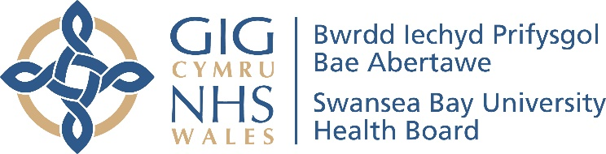
Service Groups’ Highlight Report for
Quality and Safety Committee

Meeting Date: | 27th February 2024
Service Group: | Morriston Service Group
Author: | Suzanne Holloway, Head of Quality, Safety & Patient Experience
Sponsor: | Sue Moore, Group Service Director  Dr Mark Ramsey, Group Medical Director  Ceri Matthews, Group Nurse Director
Presenter: | TBC
Summary of Quality and Safety issues since last report to the Committee
Key Quality and Safety Issues

Access to unscheduled care services (including the Minor Injuries Unit) Performance:
This is scored as 25 on the Morriston Risk Register

In the 3 months from October to December 2023, a total of 32,239 new attendances were recorded at Morriston Emergency Department (ED) and NPT Minor Injuries Unit (20,895@ Morriston and 11,344 @NPT).

Of the total new attendances, 24,364 patients were seen within 4 hours (75.6%).

Of those not seen within 4hours, 3,170 patients waited 12hours or more.

11,722 patients were admitted as emergencies in the 3-month period.

Acute Medicine Redesign:

As reported previously, the implementation of the acute medicine redesign programme has been completed, with all acute medicine services moved to Morriston Service Group. This move has created the following direct access point, for speciality patients, directing them away from the ED:

- Acute Medical Unit (AMU),
- Surgical Decision-Making Unit (SAU),
- Same Day Emergency Care (SDEC) Unit.

Both AMU and SAU have been visited independently by both the NHS Wales Transformation Team and Llais, who have identified several important and valuable representations which have now been developed in action plans for both AMU and SAU.

The following headline actions have been identified:

- Meet with the Directors and volunteers from Llais to discuss outcomes
- Undertake analysis of patient-level data – identifying delay reasons in the patient pathway.
- Re-visit service footprint to enable single point of access and appropriate clinical triage into AMU and SDEC.
- Review clinical streaming and establish a combined discharge service.
- Undertaken workforce and rota review to allow senior clinical intervention and decision-making.
- Review frailty pathway.
- Review ED flow to SDEC/AMU.
- Ensure staff engagement to ensure part of any planned transformation.

Copies of the Reports and Action Plans are included in the Appendices

Planned Care Recovery
This is scored as 20 on the Morriston Risk Register

As previously reported, there has been a significant improvement in the number of patients waiting over 26 weeks for their first appointment (Stage1), with a target set that no patient should never wait longer than 52 weeks for their first appointment. This target has been achieved despite the volume of referrals into acute secondary care remaining relatively stable.

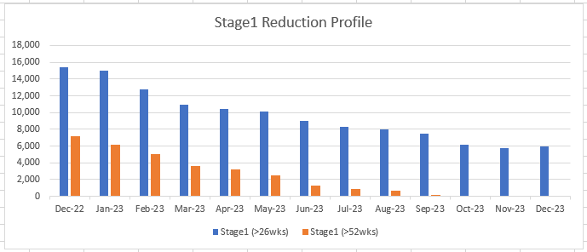

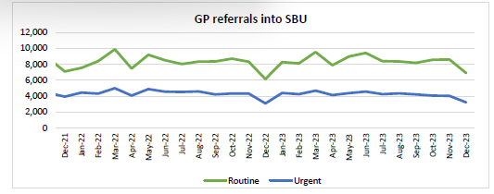
In addition, the above national outpatient target, targets for the reduction of patients waiting 104weeks for inpatient/day case treatment (all stages) have also been set. (97% by December 2023, and 99% by March 2024).

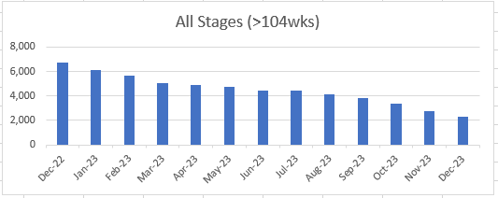

To achievement national targets the following local targets have also been developed.
Local Targets:
- Commitment to treat patients waiting >208 weeks (all Stages) by end of March 2024
- Commitment to treat patients waiting >156 weeks (all Stages) by end of June 2024
- Stretch target to treat patients waiting >104 weeks (all Stages) by end of March 2025

Actions
- Bi-weekly performance scrutiny meetings are now held with the Transformation Team and chaired by Deputy Chief Operating Officer, monitor progress against the targets.

Access to Cancer Services
Access to cancer services is scored at 25 on the Morriston Risk Register

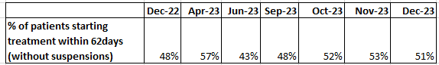

Cancer waiting times are managed across the Health Board to ensure that complex patient pathways which cross over Service Group boundaries are fully reviewed and monitored. The proportion of patients waiting longer than 62days to commence their definitive treatment continues to be stubbornly low and are managed across the Health Board.

Key Objectives
- Achievement of 10 day wait for 1st OPA or 21 day one-stop clinic.
- Achievement of a decision to treat (DTT) by day 31 of the pathway.
Actions:
- Performance scrutiny meetings have been established where waiting times are managed on a patient-by-patient basis.
- Tumour specific actions plan have been developed and are actively monitored.

Challenges, Risks, Mitigation and Action being taken relating to Quality and Safety issues noted above (what, by when, by who and expected impact)

Open Incidents
Under the NHS (Concerns, Complaints and Redress Arrangements) (Wales) Regulations 2011, incidents should be investigated within 30-working days (unless reported to the NHSE where the timeframe may be 30/60/90/120 working days).
As of 6th February 2024:
- 18,580 Incidents have been reported on Datix since 04/04/2022 and assigned to Morriston Hospital Service Group.
- Out of this total – 15,897 have been closed (86%).
- Of the remaining open incidents 2,683 – 2,207 have been open more than 30days and 476 open for 30 days or less.

It is acknowledged that the number of open incidents is too high
(This issue is Health Board wide and was discussed at the Health Board’s Patient Safety & Compliance meeting on 01/02/2024)
 | Nov 23 | Dec 23 | Jan 23
Total Number of Incidents reported in Month | 775 | 702 | 763
Total number of Incidents Closed in Month | 711 | 663 | 737
Number of Incidents that remain open as at 30/01/2024  (Based on date of reporting) | 276 | 229 | 474

Observation/Comment
Currently the rate of incident closure is being exceeded by the number of new incidents opened.

Actions to reduce volume of open incidents:
- Develop Service Group based reduction plan (as agreed in Patient Safety & Compliance Group) – to be presented at next HB Patient Safety & Compliance meeting March 2024.
- Review open organisational, staff and public incidents (487) to ensure that they are appropriately assigned and can be dealt with – as per planned trajectory below

- Establish a weekly standardised report to pick up all non-patient incidents for review and ensure current incidents are appropriately assigned within 5 working days – Completed
- Review of resource allocation within the Morriston Q&S Team consider options in relation to allocating a dedicated resource to across all Q&S workstreams including incident management – by 31/05/2024.

Duty of Candour (DoC): Position as at end of January 2024
Duty of Candour Triggered - Current Status | MSG | Health Board Total
Awaiting Closure | 8 | 17
Closed | 22 | 64
Management review/Make it safe plus | 13 | 22
New Incident | 1 | 1
Under Investigation | 24 | 69
Total | 68 | 173
Risk
- Complex process which cuts across multiple pieces of legislation and investigation requirements
- The introduction of Duty of Candour legislation has not been resourced nationally or locally and has created additional pressure and demand not only within Service Group Q&S Teams but also across clinical staff.
Actions
To support the ongoing delivery of Duty of Candour and other proportionate investigations an extraordinary training session was undertaken on Saturday 18th November 2023. The training was aimed at nursing staff (Ward Managers and Matrons) – approximately 50 members of staff attended the all-day session, which included a focus on Duty of Candour management.

The impact of this training session has yet to be realised with feedback reflecting a need for some additional practical training, using case examples. Further training to fill this gap is being developed.

Risks
Interventional Radiology: Update
As reported in October 2023, there was significant risk to the intervention radiology service due to sickness of a single-handed consultant. Temporary mitigation was put into place utilising support from the South East Wales Vascular Intervention Radiologists Network.

The staff member has now returned to work but is currently not undertaking vascular work. The agreement to for the Network to provide support expired on 15/02/2024, however out of hour cover is being maintained via a service level agreement until 31/03/2024.

Actions
- Secure ongoing network support to deliver service – Executive Medical Director Office leading
- Development of medium- to long-term plan to support service delivery including locum and substantive options – Service Leads.

Lack of dedicated Tissue Viability Nurse based at Morriston Hospital: Update

The future Tissue Viability Service is being scoped by the Unit Nurse Director for Singelton/NPT, with an advert for an additional Tissue Viability Nurse currently pending.
The Unit Nurse Directors for both Morriston and Singleton/NPT are currently reviewing and working through bed contracts. It is anticipated that the new contract will be in place in the autumn

New Risks
There have been 8 New Risks scored 20 and above reported in Qtr3 are summarised in the table below.

Risk | Score | Current controls/mitigation
Risk Ref: 3561  Risk service provision due to failure of equipment - nephroscope | 20 | - Additional two scopes secured on loan
Risk Ref: 3570  Risk of serious harm / death to patients due to lack of emergency transport between sites after hours | 20 | - Monitor reported incidents and outcomes for patients
Risk Ref: 3579  Risk of harm to kidney stone service delivery/patients due to failure of lithotripsy equipment | 20 | - Full maintenance/repair contract in place until Dec 2024
Risk Ref: 3584  Risk of increased mortality and morbidity as a direct consequence of AMU overcrowding | 20 | - Escalation policy in place.  - Additional capacity introduced during peak demand.
Risk Ref: 3592  Risk of SDEC services not functioning due to lack of flow through to AMU | 20 | - Max. overflow capacity agreed.  - Additional nursing staff to monitor overflow patients.  - Daily escalation to site meetings.
Risk Ref: 3601  Risk to cleft service due to equipment failure/non-replacement (surgical microscope) | 20 | - Shared use of ENT microscope  - Secure loan equipment
Risk Ref: 3616  Risk of being unable to perform auricular prostheses as no current supplier of craniofacial implants | 20 | This is a consequence of a UK/Worldwide supply problem.  - Implants to be supplied on a patient specific prescription – requiring HB approval
Health & Care Standard Standard 6.3 - Listening and Learning from Feedback

Never Events
There have been two Never Event reported relating to Morriston Delivery Unit since the previous report.
- INC39732 Wrong Sided Chest Drain (Dan Danino Ward) – October 2023 investigation ongoing (The patient has suffered no long-term effect from the incident and was discharged +2days).
- INC40617 Retained Guidewire (Clinic based Medicine, Singleton) – October 2023 draft report pending sign-off (Guidewire removed on removal of drain – no harm caused to patient).

(Please note that the never events reported to Committee in October relating to Theatres and Anaesthetics have now transferred to Sing/NPT as part of service transfer).

Serious Incidents (SI)
Morriston Delivery Unit has 16 open SI investigations or which 3 are overdue.
Current themes are:
- Unexpected Death
- Failure to Diagnose
- Infection Control Outbreak
Actions:
- Fortnightly director-led monitoring/review meetings were established several years ago.
- Review of open serious incident to ensure that point of contact has been established with patient/family

Complaint Performance: Response within 30 days
As indicated within previous reports number and acuity of complaints received and managed by Morriston Service Group as significantly changed as a result of the acute service redesign process.

Whist it is acknowledged that as well as Medicine and Pathology transferring in to Morriston; Orthopaedics, Anaesthetics and Theatres have transferred out and are now managed by Singleton/NPT, however this has not been a like-for-like transfer. There a significant increase in the proportion of complaints alleging moderate harm.
 | 2022 | 2023 |  | 2022 | 2023
General Medicine* | 78 | 168 | Orthopaedics | 196 | 189
Grade 1 | 48 | 101 | Grade 1 | 171 | 165
Grade 2 | 15 | 29 | Grade 2 | 16 | 10
Grade 3 | 15 | 38 | Grade 3 | 9 | 14
‘* General Medicine includes AMU, SDEC, Gastro, Respiratory and Endoscopy
In addition, the unfunded introduction of Duty of Candour and Medical Examiner legislation during 2023 has resulted in a significant increase in the volume of cases requiring an explicit/compliance-based investigation process, and which has impacted on resources available for complaint management.
Compliance with the 30-day target:
- 74% for October 2023.
- 44% for November 202.

Short-, medium- and long-term staffing deficits in both Q&S Team and PALS Team have impacted on 30-day performance (November 2023 to January 2024)
Actions:
- Development of a complaint backlog reduction plan – by 28/02/2024
- Monthly Complaints Workload Brief provided to Service Directors – beginning of the month setting out workload – re-established from Feb 2024
- Progress against 30day performance monitored on a weekly basis – in place
- Agreement on escalation process to support reduction plan - Established
- Weekly escalation reported of all critical amber cases to divisional teams – by 28/02/2024
- Introduction of SOP for case review of all amber and above concerns – Completed
- Recruitment to PALS Team – Completed Feb2024
- Recruitment to 2 wte Band 4 vacancies in Q&S Team – by end of 30/06/2024
- Review of baseline requirement vs current capacity within Q&S Team – by 30/04/2024

Progress Against Annual Plan Quality and Safety Priorities (as applicable)
Quality Priorities: reduction in healthcare acquired infections; improving end-of-life care; sepsis; suicide prevention; and reducing injurious fall; Pressure Ulcer Prevention (new for 2023/24); Nutrition & Hydration (new for 2023/24)
Exception Updates
Reducing Health Care Acquired Infection
High Level Performance
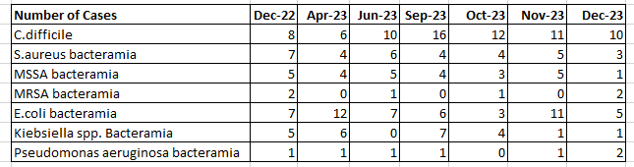

Key Updates
Following an increasing case trend, a hospital wide C difficile outbreak came to light at the end of December 2023, with 10 patients sharing the same whole genome sequencing. (24% increase year on year). Additional cases have been identified since those identified in December 2023. There have been eighteen different clinical areas associated with the cases and not all cases have an obvious link or overlap in location and time.

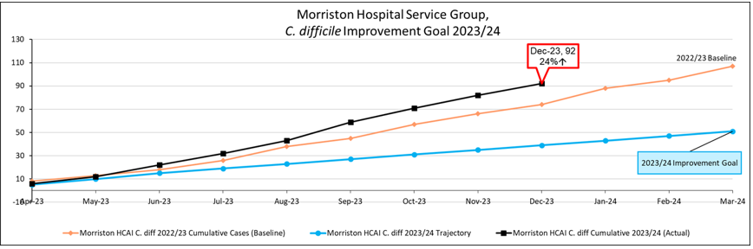

Actions:
- A Weekly bronze level control outbreak meeting was established in December 2023 when the outbreak was declared, with regular updates provided to the executive team.
- A new assurance audit has been implemented and peer reviews will be undertaken using this tool.
- The DHoN who has a lead role in IP&C has had her role further enhanced to allow her to lead on a dedicated and focused piece of work regarding the current challenges across Morriston Hospital

Further aspects need to be explored as a matter of urgency
- Creation of a decant ward area
- Dedicated cleaning set against national standards
- Rapid decontamination/cleaning team to support timely bed turnaround times.
- Reduce the overcrowding/ overcapacity in inpatient areas
- Reduce the number of additional patients on wards
- Introduce a guideline to support essential patient bed moves between in patient areas.

5 E coli bacteraemias reported in December, this is a significant decrease, compared to the 11 that were reported in November. (5% increase year on year)

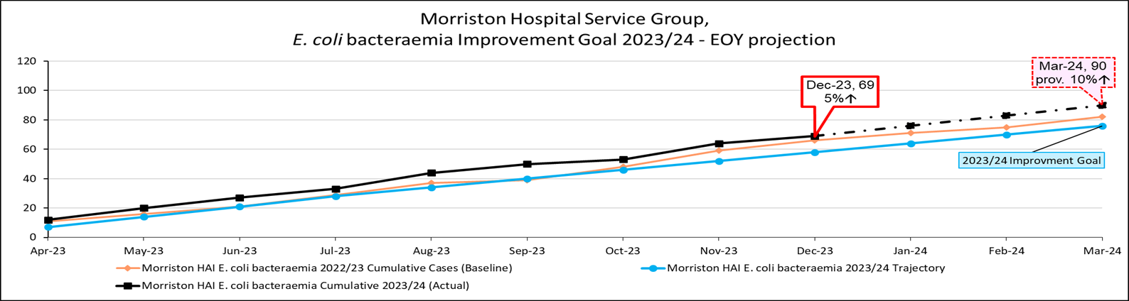
Learning and Themes from Case Scrutiny
- 18% of E. coli cases attributed to Hepato-biliary infection; this appears to be a reducing picture as a source.
- Missed opportunities for sepsis screening.
- Delay in sending urine samples.
Actions
- Weekly case review of all confirmed hospital acquired infections – established and ongoing
- Management of infection outbreak (bronze process), including assessment and 4D cleaning of all areas involved – established and ongoing.

Continued reduction of reporting of Klebsiella BSI cases (19% reduction yr on yr)
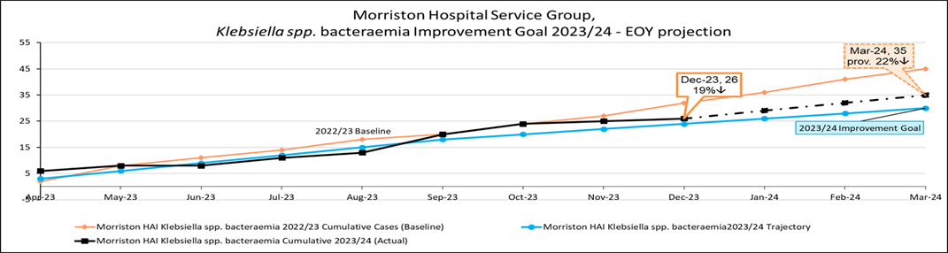

Significant reduction in cases of Staph. aureus bacteraemia (40% year on year) and Pseudomonas aeruginosa bacteraemia (53% year on year)
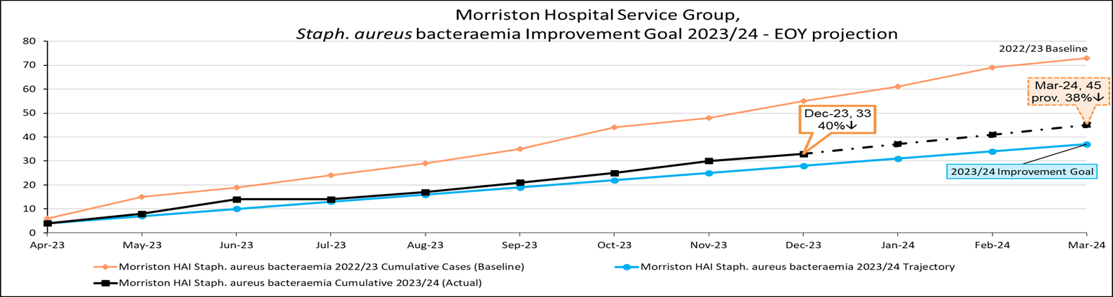
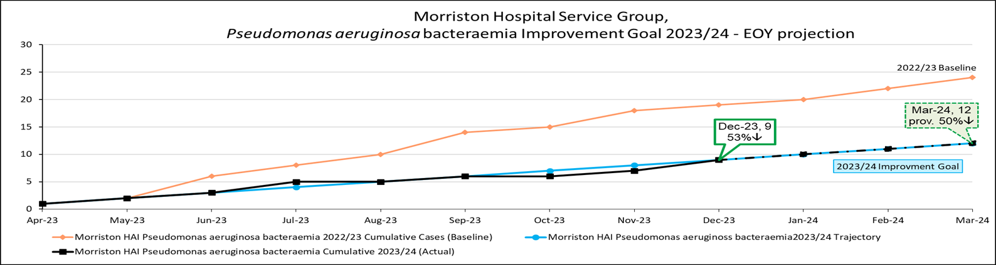
A detailed report received by the Morriston Quality, Safety and Patient Experience Group, in January 2023 is included in the appendices.

End of Life Care
The Morriston Hospital Service Group has hosted the Health Board’s Care After Death Service (CADS) implementation programme (Phase1) since January 2022. The key objective of the service being the adoption of the National Bereavement Framework for Wales across the Health Board.

A service update was received by the Morriston Quality, Safety & Patient Experience Group in January 2024 – a copy of the presentation received is included in the appendices.

Key Achievement
- First (and only) HB in Wales with a Care After Death Service and the only HB that is actively delivering on the Framework & Pathways
- Only HB in Wales (and most of UK) not impacted by winter pressures, with no deceased transferred to alternative hospitals/contract funeral director storage and only minimal use of on-site additional storage.
- Full secondary care implementation of Medical Examiner review process.

Ongoing Objectives
- Greater expansion into community, work scheduled to support GPs & Primary Care with Medical Examiner roll out.
- Development of policies with mortuary services and greater collaboration.
- Re-write of literature - inclusive for Paediatric and Neonatal deaths. - funding secured
- Start-up of Staff Bereavement Support Group in conjunction with Workforce and OD.
- Undertaking “deep dive” into local minority groups and support required. - ongoing
- Development of policies relating to the Dignity of the Deceased Patient Collaborative work with end-of-life teams.

Issues & Risks
- Lack of appropriate accommodation at Morriston Hospital to see bereaved families in person.
- Lack of provision for clinical support for the bereaved

Sepsis
In the Service Group Report to the Q&S Committee in October 2023, an update on the introduction of a Health Board sepsis screening tool was provided. A focus for the implementation at Morriston Hospital was in the Surgical Decision-Making Unit (SDMU) – with a target of achieving 90% by end of March 2024.

A “Plan Do Study Act” (PDSA) Project has been undertaken with a focus on training, process and staff commenced in September 2023. Significant progress has been achieved with weekly audits showing more than 90%.
The methodology used on SDMU has subsequently been rolled out to the Acute Medical Unit (AMU) and “hot spot” medical wards.
Detail outcomes of the project are included in the Appendices

Reducing Injurious Falls
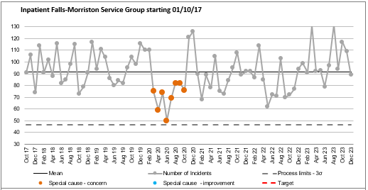

The average number of inpatient falls reported monthly is 92, however it is important to note that not all falls are injurious.

As shown in the SPC above, the pattern and number of falls at Morriston Hospital, is influenced by peaks and troughs. Previous case review has indicated that this was influenced by individual patients having multiple falls whilst in hospital and as indicated previous a potential link with requirement for 1:1 nursing or enhanced observation.
Action:
- Further case review is required for the past 6 months to establish whether multiple falls are a factor or whether there are new factors emerging which influence the peaks in incident reporting – by 31st May 2024
- Review criteria and roles & responsibilities for 1:1 and enhanced observations to prevent fall events – in Progress with HB Falls QI Lead.
- Thematic review of all reported falls in non-inpatient areas - by 31st May 2024.
- “Bay Watch” Evaluation – to assess impact and plan evidence-based development of the next phase of the programme – Established to be completed by 30th June 2024.
- Revision of monthly case review process to ensure that all inpatient fall event reported as “moderate harm” or above are reviewed as part of the Duty of Candour process and scrutinised - Established

Improvement in Nutrition and Hydration
In addition to addressing identified key quality priority areas of:
- Training to support naso-gastric feeding.
- Training to support total parental nutritional skills requirements.
- Development and implementation of nutrition and hydration champions.

A key feature and a recurring theme in patient experience feedback within the Service Group has related to food. As part of a multiple disciplinary approach. As described in the Service Group’s October report, work has been undertaken to establish ward based “Nutrition & Hydration Boards” and Ward based snack trolleys. In addition, the following workstreams are being explored:
- Review Patient Choice: are there vegetarian/vegan and religious based food offerings available? – Food Tasting Session undertaken October 2023.
- Should/could be encourage families to bring in own food – information leaflet? – peer review both within and outside the Health Board.
- Review options of using sustainable cutlery and crockery rather than plastic.
- Establish Sunday as the day to record patient’s weight as part of clinical monitoring.

Medicines Management
As advised in the October 2023 report, Morriston Service Group has adopted Medicines Management as a local quality priority.

Previous all incidents involving insulin, controlled drugs, anticoagulation or where harm has occurred were reviewed monthly in retrospect. In line with other scrutiny processes (as in infection control and falls) this review process has now been updated. A scrutiny panel is now held every two months where fully investigated incident cases are presented and peer reviewed in order to identify thematic learning and build an active improvement programme.

As an outcome two Quality Improvement Programmes have been set-up:
- The first is reviewing the provision of critical end of life medications – this programme is being undertaken in conjunction with Palliative Care (at consultant level) with nursing support
- The second is looking at avoidable wastage of medication – this programme is being undertaken jointly between Pharmacy and Nursing

A progress update will be provided in the next Morrison Unit report.

Patient Experience Update
2,600 items of Patient Experience were received in January 2024
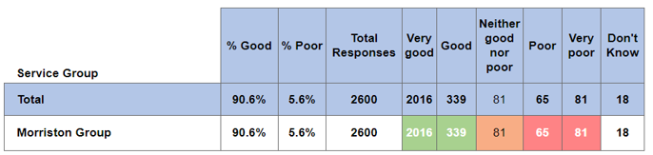

Morriston Delivery Unit has been consistently receiving above the 85% recommendation benchmark since June 2023.

Patient Experience Feedback: Themes January 2024
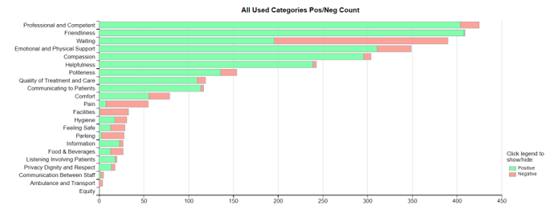
- Waiting/Access times continues to be the primary theme in negative feedback. With Pain potentially being flagged as a result.
- Facilities, Food & Drink and Parking continue to the hot spots for negative feedback.
- There was overwhelming positive feedback for staff professionalism and competency.

Examples of Feedback Received
Emergency Department A&E – Morriston Hospital
The staff were extremely friendly and comforting making my A&E experience much better.

ENT – Morriston Hospital
The consultant and her ENT Team were absolutely SUPERB. The Medical student was delightful, and the Nurse assisting was also really lovely, courteous, and thoughtfully kind. The reception staff at the desk in the department were also so very helpful.

Cyril Evans Ward – Morriston Hospital
I was admitted with an irregular heart beat and the service from 111 through to being clerked in at reception at hospital to the triage nurse and resulting urgency by the A&E / cardiology departments was absolutely brilliant. A big thank you to all the staff (no names required) as I know it’s one big team. I can now think of having a happy new year knowing you have my back.

Jill Rowe – Ambulatory Unit – Morriston Hospital
Both women doing the procedure went the extra mile to calm me down and make me feel as comfortable as possible before doing the procedure.

Any Other Issues to Bring to the Attention of the Committee
No additional issues

Recommendations
Members are asked to note the report and acknowledge actions in place and progress to mitigate harm.

Appendices – TO BE FOUND IN THE RESOURCE SECTION ON ADMIN CONTROL
Service Groups’ Health and Safety
Highlight Report

Summary of Health and Safety key issues since last report to the Committee
(Reporting period: October to December 2023)
Maintenance of the environment and infrastructure at Morriston Hospital continues to be the primary Health & Safety focus at Morriston Hospital.

The issue of clutter in corridors is ongoing with a lack of dedicated storage, particularly for large items of equipment such as beds.

Considerable work has been undertaken to re-establish a Fire Plan at Morriston to reflect the environmental changes that have taken place over the last 3yrs.

Challenges, Risks, Mitigation and Action being taken relating to Health and Safety issues noted above (what, by when, by who and expected impact)

Environmental/Infrastructure: Roof Repair and Maintenance
Essential repair and maintenance of part of the roof infrastructure has been is required for sometime and has resulted in leaks and water ingress into clinical and non-clinical areas.

Anglesey Ward has been allocated to be used as a temporary decant facility in order to support remedial works
Actions:
- A comprehensive programme of works has been developed and is being actioned
- Roof works above Ward V have been completed and work has now moved to the roof above Ward T.

Hospital Building Notice (HBN) Compliance
In order to ensure that Morriston Hospital is fit for purpose there is a need to increase the number of cubicles and increase the space between beds in order to comply with current HBN requirements. Work to facilitate this is being planned.

The risk in achieving HBN compliance is a potential reduction in bed capacity

In order to mitigate and loss of capacity Anglesey Ward will be developed into a dedicated Frailty Unit and bring back on line additional beds.

Repurposing of Tawe Ward
The construction of Tawe Ward within the Main Entrance to the hospital was integral to the response to the COVID-19 pandemic. The location is currently being used as a Discharge Lounge.

In order to mitigate some of the issues highlighted above the following actions are in place to reuse the location currently occupied by Tawe Ward.
- Development of a dedicate and purpose-built Discharge Lounge
- Re-establishment of outpatient facility or waiting
- Area for dedicated storage

Petrol Fumes
Ambulance fumes entering the Main Hospital and the Emergency Department continue to be raised as a concern by patients and staff

Action: Parking spaces outside AMU and ED have been re-designated for ambulances, these spaces are marked. In order to fully utilise the area quotes are being sought to install charging points.

Performance Progress to include: Statutory and Mandatory Training; PADR compliance; Serious Incidents; Staffing and Sickness Levels;

Org L5
130 Morriston Service Group - Dir | Assignment Count | Achieved
NHS|CSTF|Fire Safety - 2 Years| | 4320 | 3727 | 86.27%
NHS|CSTF|Moving and Handling - Level 1 - 2 Years| | 4320 | 3480 | 80.56%
NHS|CSTF|Violence and Aggression (Wales) - Module A - No Specified Renewal| | 4320 | 3846 | 89.03%
NHS|MAND|Violence Against Women, Domestic Abuse and Sexual Violence - 3 Years| | 4320 | 3406 | 78.84%
Training Compliance: Mandatory Health & Safety Training

The table above shows positive progress against key mandatory training requirements.
Reporting of Injuries, Diseases and Dangerous Occurrences Regulations (RIDDOR) Incidents
Two RIDDOR incidents have been reported during the review period
- A staff member slipped whilst on duty and sustained an injury which required in excess of 7days sick leave
Action: Staff member to be support in line with policy to ensure a safe return to work
- A staff member sustained a needlestick injury with a potential exposure to high-risk biological fluids
Action: Incident being managed via Occupational Health
RIDDOR Training
RIDDOR reporting is a statutory duty placed on the Health Board and managers must recognise where an accident at work results in absence which falls under the RIDDOR criteria The Service Group has trained 47 managers and supervisors in RIDDOR reporting. With further training sessions for managers and supervisors planned January – March 2024.

Fire Plan/Training
The Morriston Fire Safety Group has been reviewed and re-established with the following key objectives:
- All ward areas have an identified member of staff who acts as a fire warden for the area - Completed
- All fire wardens undergo location-based fire training – 70% have been trained with further training planned in February and March 2024

Governance and Risk Issues to include risks relating to Health and Safety on the risk register
There are currently 44 risks on the Morriston Hospital Risk Register relating to Health & Safety or Environment, Estate and Infrastructure. With a breakdown by category shown below:
COSHH | 4
Decontamination/Sterilisation | 1
Environment | 27
Estates | 1
Fire | 1
Health and Safety Executive | 1
Sharps | 1
Transport | 2
Violence & Aggression, Lone Working | 1
Violence and Aggression | 5
Grand Total | 44

As indicated above site wide maintenance continues to be a challenge, with limited decant capacity a barrier to the speed of completion of works required to maintain patient and staff safety.

Current issues for 2024-25 for the Attention of the Committee
Review of Same Day Emergency Care (SDEC) Corridor
As featured within the earlier Quality & Safety Report there has been considerable focus on the emergency medical pathway via the Acute Medical Unit (AMU) and SDEC. In addition to patient pathway review, focused work on the use and design of the corridor areas is also under review and considerable.

The aim of this work is to ensure that all areas are fir for purpose and are safety for use by both patients and staff.

Work to ensure that the environments/health & safety impact of individual locations will be included within over-arching improvement work.

“Black Box Testing”
The purpose of a black box test is to measure the resilience of emergency systems within the hospital. In order to undertake the test, there is a planned power switch off to allow emergency, “back-up” systems to take-over.

A series of Black Box tests is currently being planned for Morriston Hospital – further information and detail will be available closer to date.

Recommendations
Members are asked to note the report and acknowledge actions in place and progress to mitigate harm.

