

HEALTH BOARD RISK REGISTER
QUALITY & SAFETY COMMITTEE RISKS
January 2023



Datix ID Number: 738  Health & Care Standard: 5.1 Timely Care |  | HBR Ref Number: 1  Risk Target Date: 31/03/2023 | Current Risk Rating  5 x 5 = 25
Objective: Best Value Outcomes from High Quality Care |  | Director Lead: Inese Robotham, Chief Operating Officer  Assuring Committee: Performance and Finance Committee  For information: Quality & Safety Committee
Risk: Access to Unscheduled Care  If we fail to provide timely access to Unscheduled Care then this will have an impact on quality & safety of patient care as well as patient and family experience and achievement of targets. There are challenges with capacity/staffing across the Health and Social care sectors. |  | Date last reviewed: January 2023
Risk Rating  (consequence x likelihood):  Initial: 4 x 5 = 20  Current: 5 x 5 = 25  Target: 3 x 4 =12 | 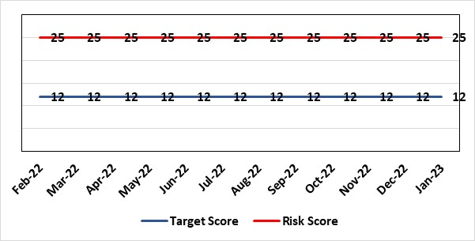 | Rationale for current score:  Post wave 2 of COVID 19 Morriston and Singleton have experienced a steady increase in emergency demand to pre-covid levels. Capacity is limited due to covid response and therefore remains a high risk. Current score raised due to increasing pressures. Recent implementation of All Wales Immediate Release Protocol puts additional pressure on already overcrowded ED dept.
Level of Control  = 50% |  | Rationale for target score:  Our annual plan is to implement models of care that reflect best practice. This will improve patient flow, length of stay and reduce emergency demand.
Date added to the HB risk register
26.01.16
Controls (What are we currently doing about the risk?) |  | Mitigating actions (What more should we do?)
- Programme management office in place to improve Unscheduled Care.  - Daily Health Board wide conference calls/ escalation process in place.  - Regular reporting to Executive and Health Board/Quality and Safety Committee.  - Increased reporting as a result of escalation to targeted intervention status.  - Targeted unscheduled care investment of £8.5m in the annual plan, including a new Acute Medical Model focused on increasing ambulatory care.  - Development of a Phone First for ED model in conjunction with 111 to reduce demand.  - 24/7 ambulance triage nurse in place  - Joint WAST Stack review by GP and APP (Advanced Paramedic Practitioner)  - OPAS (Older People’s Assessment Service) have undertaken training with nursing homes (on management of patient falls) & set up direct contact details with nursing homes  - Frailty short-stay unit re-established  Additionally, actions to improve the discharge of clinically optimised patients (risk HBR80) expected to assist with patient flow, are anticipated to free capacity to assist to address this risk HBR1 also. |  | Action |  | Lead | Deadline
 |  | Increase of hours in SDEC planned. |  | SGD (Morriston) | 31/03/2023
 |  | OPAS – exploring internal & external funding options |  | SDEC Clinical Lead | 31/01/2023
 |  | Looking to extend to non-surgical fractures – options to resource being quantified and will be presented to CEO for consideration. |  | PCT MD | 31/01/2023 (funding approval target)
 |  | AMSR programme due to be implemented in December 2022 – subject to OCP. |  | COO | 01/12/2022  1st phase commenced as planned 5th December.  Completed
 |  | Second phase AMSR has commenced. |  | COO | 23/01/2023 (Full implementation) Completed
Assurances (How do we know if the things we are doing are having an impact?)  - New Urgent & Emergency Care Board is meeting monthly. |  | Gaps in assurance (What additional assurances should we seek?)  The need to deliver sustained service.
Additional Comments / Progress Notes
21/09/2022: Evaluation concluded – shared staff side 8/9. Project now planning the implementation phase. Linked to AMSR risk. 3 Actions completed - OPAS developing a proposal to assess elderly patients at home. Introduce Band 6 navigator role in ED for better streaming of patients. Five-day in-reach by virtual wards will commence in August.
24/10/2022: A go/no go gateway for AMSR is scheduled on 16th November 2022. Action completed - Re-establish short stay unit on ward D at Morriston. Realign wards to specialties at Morriston Hospital including short stay unit on Ward D.
06/01/2023: Review of roles & service models in order to increase SDEC working hours and throughput of patients sustainably is complete – expect increase to come into effect after end of January, following movement of staff resource from Singleton. Morriston have set up a workstream to review SAFER discharge - SAFER rollout has commenced starting with AMU at Morriston. It was reviewed by national team and commended as good practice. Ten-week rollout plan in place. AMU opened on 5th December. Weekend take in Singleton is transferring from 6th January. Full implementation planed from 23rd January. Primary care group are reviewing FNOF pathway and the use of virtual wards to reduce length of stay has started on limited basis. Breaking the Cycle week planned for w/c 7th November 2022 was completed.
07/02/2023: Whilst AMSR has been implemented further work is ongoing on increasing out of hospital capacity. Bed decommissioning group has been set up chaired by the CEO. First meeting took place on 23/01/2023 and the paper is expected at Management Board in March.

Datix ID Number: 739  Health & Care Standard: 2.4 Infection Prevention & Control & Decontamination |  | HBR Ref Number: 4  Risk Target Date: 31st March 2023 |  | Current Risk Rating  4 x 5 = 20
Objective: Best Value Outcomes from High Quality Care |  | Director Lead: Gareth Howells, Executive Director of Nursing  Assuring Committee: Quality and Safety Committee
Risk: Risk of patients acquiring infection as a result of contact with the health care system, resulting in avoidable harm, impact on service capacity, and failure to achieve Tier 1 national infection reduction goals. |  | Date last reviewed: January 2023
Risk Rating  (consequence x likelihood):  Initial: 4 x 5 = 20  Current: 4 x 5 = 20  Target: 4 x 3 =12 | 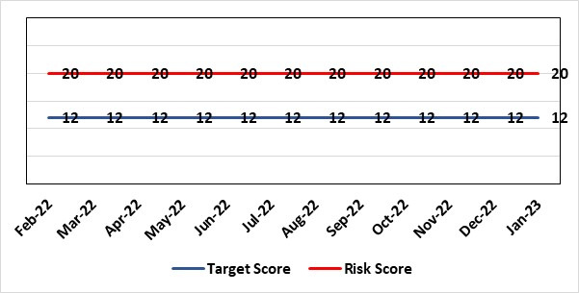 | Rationale for current score:  Health Board incidence of key Tier 1 infections per 100,000 population above All Wales rates, indicating Health Board’s population at greater risk of infection. High occupancy rates & frequent ward moves associated with increased risk of infection transmission. Lack of decant facilities compromises environment deep cleaning & decontamination, and planned preventative maintenance programmes.
Level of Control
= 40%
Date added to the HB risk register
January 2016
Date added to the HB risk register  January 2016 |  | Rationale for target score:  Improved governance structures for IPC and antimicrobial stewardship will drive improved local ownership and embed responsibility for these priorities for all levels of staff. Adequately maintained & clean environments facilitate good IPC & minimise infection risks. Reduced occupancy & frequency of patient moves mitigate against infection transmission. Compliant ventilation systems and water safety minimise infection risks. Access to timely data on infections, training, antimicrobial stewardship, cleaning at ward/unit/practice level enables Service Groups to identify areas for focused QI programmes, drive improvement, & effectively measure outcomes.
Controls (What are we currently doing about the risk?) |  | Mitigating actions (What more should we do?)
- Policies, procedures, protocols and guidelines supplement the National Infection Control Manual.  - Infection Prevention & Control related training provided programmes.  - Surveillance of infections, with early identification of increased incidence, and instigation of controls.  - Infection Prevention Improvement Plans, monitored by Infection Control Committee and Management Board.  - Provision of cleaning service to meet National Standards of Cleanliness.  - Engineering controls for water safety, ventilation, and decontamination. |  | Action | Lead |  | Deadline
 |  | Drive improvements in prudent antimicrobial prescribing | Cons. Antimicrobial Pharmacist |  | 31/03/23
 |  | Develop ward to board Dashboard on key Tier 1 infections | HoN IP&C & Digital Intelligence |  | 31/03/23
 |  | Achieve compliance with IPC mandatory training | Service Group Triumvirates |  | 31/03/23
 |  | Reduce Key Tier 1 Infections to no more than WG maximum quarterly profile | Head of Infection Control |  | 31/03/23
Assurances (How do we know if the things we are doing are having an impact?)  - Clear Corporate and Service Group IPC Assurance Framework in place.  - Infection Prevention Improvement Plans for HB and Service Groups with progress reported at SG Infection Control Committees, HB Infection Control Committee and at Management Board. These include trajectories to meet national targets and report performance against them. This is also reported to Quality & Safety Committee.  - Ongoing monitoring of infection control rates.  - IPC, antimicrobial, decontamination and cleaning audit programmes.  - Compliance and validation systems for water safety, ventilation systems and decontamination. |  | Gaps in assurance (What additional assurances should we seek?)  - High occupancy rates & frequent ward moves associated with increased risk of infection transmission.  - Lack of decant facilities compromises environment deep cleaning & decontamination, and planned preventative maintenance programmes.  - Lack of robust system for Board oversight regarding IPC and ANTT training compliance due to ESR limitations.
Additional Comments / Progress Notes
Progress update re Tier 1 infection reduction goals - 31/10/22 - cumulative infection cases 01 April – 31 October 2022:
• C. difficile - 112 (cumulative profile - 57 maximum) • Staph. aureus bacteraemia - 95 (cumulative profile - 45 maximum)
• E. coli bacteraemia - 159 (cumulative profile - 148 maximum) • Klebsiella spp. bacteraemia - 58 (cumulative profile - 43 maximum)
• Pseudomonas aeruginosa bacteraemia - 26 (cumulative profile - 13 maximum)

Datix ID Number: 840  Health & Care Standard: 5.1 Timely Care |  | HBR Ref Number: 16  Risk Target Date: 31/03/2023 | Current Risk Rating  5 x 4 = 20
Objective: Best Value Outcomes from High Quality Care |  | Director Lead: Inese Robotham, Chief Operating Officer  Assuring Committee: Performance and Finance Committee  For information: Quality & Safety Committee
Risk: Access and Planned Care  There is a risk of harm to patients if we fail to diagnose and treat them in a timely way. |  | Date last reviewed: January 2023
Risk Rating  (consequence x likelihood):  Initial: 4 x 4 = 16  Current: 5 x 4 = 20  Target: 4 x 2 = 8 | 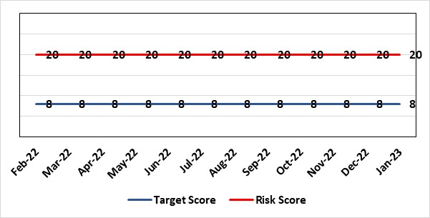 | Rationale for current score:  All non-urgent activity was cancelled due to response to the Covid-19 pandemic and has increased the backlog of planned care cases across the organisation. Whilst mitigating measures such as virtual clinics have been put in place new referrals are still being accepted which is adding to the outpatient backlog particularly in Ophthalmology and Orthopaedics. The significant reduction in theatre activity during the pandemic increased the number of patients now breaching 36 and 52 week thresholds.
Level of Control
= 90%
Level of Control  = 90% |  | Rationale for target score:  There is scope to reduce the likelihood score to reduce the overall risk to an acceptable level. The Risk target date indicates when we expect to see some reduction in waiting lists – albeit the overall risk level may remain as work continues.
Date added to the HB risk register
January 2013
Controls (What are we currently doing about the risk?) |  | Mitigating actions (What more should we do?)
- Post Covid 19 the focus is on minimising harm by ensuring that the patients with the high clinical priority are treatment first. The Health Board is following the Royal College of Surgeons guidance for all surgical procedures and patients on the waiting list have been categorised accordingly.  - There is a bi-weekly recovery meeting for assurance on the recovery of our elective programme.  - Specialty level capacity and demand models set out the baseline capacity and identify solutions to bridge the gap. Non-recurring pump – prime funding is available to support initial recovery measures. Fortnightly performance reviews track progress against delivery.  - A focused intervention is in train to support to the 10 specialties with the longest waits.  - Long waiting patients are being outsourced to the Independent Sector  - Additional internal activity is being delivered on weekends (via insourcing)  - Planned care trajectories developed and submitted to WG as part of IMTP.  - Governance process put in place to monitor performance against trajectories internally, and with Welsh Government.  - External & internal validation has commenced.  - A 10 bedded orthopaedic ward was created at Morriston Hospital in December to address the longest waits in the specialty that can only be operated on at Morriston. |  | Action |  | Lead | Deadline
 |  | External & internal validation has commenced. Impact to be reviewed during October 2022. Internal and external validation commenced. |  | Deputy COO | 31/03/2023  Closed and ongoing
 |  | Work ongoing with Finance colleagues to establish the funding allocation for elective recovery for 2023/24. |  | Deputy COO | 31/03/2023
Assurances (How do we know if the things we are doing are having an impact?)  - Weekly meetings in place to ensure patients with greatest clinical need are treated first. |  | Gaps in assurance (What additional assurances should we seek?)
Additional Comments / Progress Notes
21/09/22: Trajectories have been revised and show more favourable position but are still falling short of ministerial ambition. The Service Groups jointly with Deputy COO are looking at further efficiency opportunities. Action completed - Exploring options to maximise efficiency and productivity through validation and efficient use of existing capacity.
19/10/22: External validation of longest waiting patients is about to commence. Impact to be monitored.
24/10/2022: Planned Care will be part of enhanced monitoring arrangements with Welsh Government. We are awaiting the template to agree remedial actions.
15/12/22 The Health Board is on target to exceed the trajectories for both 52 week and 104 weeks agreed with Welsh Government. A review of the risk rating will be undertaken at the next Planned Care Recovery Board in January 2023.
Two actions closed - Morriston Service Group is looking at a plan for dedicated elective orthopaedic bed capacity at Morriston site. Recovery trajectory has been reviewed and shows further improvement – awaiting final signoff.
07/02/2023: The trajectory submitted to WG has been exceeded to date and the expectation is that we will exceed the end of March projection.
Ten ring-fenced orthopaedic ward beds at Morriston will deliver 500 procedures per year going forward.

Datix ID Number: 1514  Health & Care Standard: Safe Care 2.1 Managing Risk & Promoting Health & Safety |  | HBR Ref Number: 43  Risk Target Date: 30th September 2022 |  | Current Risk Rating  3 x 5 = 15
Objective: Best Value Outcomes from High Quality Care |  | Director Lead: Gareth Howells, Executive Director of Nursing  Assuring Committee: Quality and Safety Committee
Risk: Due to a lack of Best Interest Assessor resource, there is a risk of failure to complete and authorise the assessments associated with Deprivation of Liberty/Liberty Protection Safeguards within the legally required timescales, exposing the health board to potential legal challenge and reputational damage. |  | Date last reviewed: January 2023
Rationale for current score:
Although processes have been planned in order to reduce the breach position they have yet to be fully implemented. The impact is yet to be realised. The position will be reviewed next month.
Risk Rating  (consequence x likelihood):  Initial: 4 x 4 = 16  Current: 3 x 5 = 15  Target: 3 x 2 = 6 | 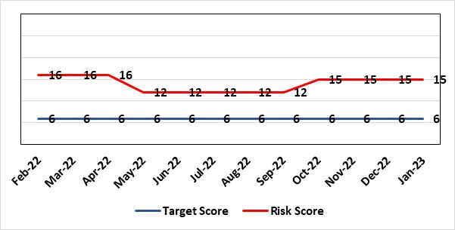
Level of Control  = 40% |  | Rationale for target score:  Consequences of DoLS breaches for the Health Board will not change. With controls in place, over time likelihood should decrease.
Date added to the HB risk register
July 2017
Controls (What are we currently doing about the risk?) |  | Mitigating actions (What more should we do?)
Additional supervisory body signatories in place – this is being undertaken as overtime using additional WG funds.  Additional funding received from WG to manage the backlog of DoLS assessments, support changes to service model and implementation of LPS.  DoLS assessments are being undertaken via a number of difference sources to address the backlog;  - Liquid Personnel Agency – 250 assessments commissioned using WG money April 2022.  - External BIA’s payment to be increased from £120 to £250 (utilising substantive recurring funding) to encourage a large cohort of BIA’s to undertake role.  - 2 BIA’s to be appointed (using WG money) band 6 WTE. Interviewing 23.01.2023. This would reduce the need for agency BIA’s.  - Overtime agreed utilising WG money for health board BIA’s to undertake DoLS assessments to reduce backlog.  - DoLS database updated and DoLS dashboard in place, monitoring applications and breaches via dedicated BIAs and Admin.  - Delivery of DOLS Action plan reviewed monthly.  - Regular reporting to Mental Health and Legislative Committee (MHLC).  - Monthly reporting to Unit Nurse Director and Finance on DoLS breaches.  - Health Board presence at National and regional meetings relating to DoLS / LPS.  - Increased IMCA services to support increased BIA resource.  - Current MCA practice reviewed to support MCA DoLS issues in practice. |  | Action | Lead |  | Deadline
 |  | Business case for revised service model (cannot be finalised prior to WG consultation) | Head of Nursing LPS |  | 27/03/2023
 |  | Agency commissioned to support backlog of assessments | GND Primary and Community |  | Ongoing
 |  | Overtime agreed to fund sign off from nurse assessor team to process the backlog assessments | GND Primary and Community |  | Ongoing
 |  | Agreement for 2 full time band 6 BIA to be funded by SBU Corporate utilising WG monies. Submitted onto TRACS 15.11.2022. Interviewing 23.01.2023. | Head of Nursing LPS |  | 28/02/2023
Assurances (How do we know if the things we are doing are having an impact?)  Regular scrutiny at Service Group and Safeguarding Committee and by DoLS Internal Audit; monitoring via DoLS Dashboard this will provide real-time accurate data.  Update report to MHLC, impact of backlog of DoLS breaches and new LPS implementation.  Monthly updates with Unit Nurse Director and Finance. |  | Gaps in assurance (What additional assurances should we seek?)
Additional Comments / Progress Notes
22.11.2022 – Risk level remains at 15. Current DoLS backlog for on 22nd November 2022 is 30. Liquid Personnel are completing on average 20 per month. Fortnightly meetings are taking place with the agency to request further allocation of BIA’s. External BIA’s and substantive BIA’s are completing 10-15 per month. On average 60 referrals are received on a monthly basis in which 30 are granted. The breach time is approximately 6 weeks. Agreement made by SBU Corporate Team for the following to help assist with the DoLS backlog and transition to LPS utilising WG monies.
- 1 x band 5 senior administrator to support the training and data development needs 18mths fixed term post
- 2 x band 6 BIA permanent posts
- 1 x band 6 Clinical Nurse Educator post to support training delivery in practice including the future Welsh Government training resources 18mths fixed term post part time.
The above have been submitted to TRACS and waiting to go live.
23/11/2022 - Addendum to 22.11.2022. Risk is that the delay and time to staff starting, will lead to a significant underspend in the allocated funding. Task and Finish group to be chaired by the Director of Nursing and Patient experience is to commence December, to consider the future requirements to manage MCA services across the Health Board.
13.12.2022 - Risk level remains at 15. Current DoLS backlog for on 19th December 2022 is 49. Liquid Personnel (LP) are completing on average 10 per month. To date 200 assessments have been completed by LP with funding in place for additional 50. Fortnightly meetings are taking place with the agency to request further allocation of BIA’s. External BIA’s and substantive BIA’s are completing 10-15 per month. On average 60 referrals are received on a monthly basis in which 30 are granted. The breach time is approximately 6 weeks.
16.01.2023 - First LPS task and finish group 19th Jan 23. Interview for BIAs 23.01.2023 (2 vacancies advertised) Still awaiting confirmation of LPS start date from WG.
19.01.2023 - Risk level remains at 15. Current DoLS backlog for on 31st December 2022 is 27. Liquid Personnel (LP) are completing on average 10 per month. To date 200 assessments have been completed by LP with funding in place for additional 50. Fortnightly meetings are taking place with the agency to request further allocation of BIA’s. External, in house and substantive BIA’s are completing 10-15 per month. On average 60 referrals are received on a monthly basis in which 30 are granted. The breach time remains at approximately 6 weeks. 2 WTE band 6 BIA’s being interviewed 23.01.2023 to increased HB DoLS Team. Funding for posts are sitting in Corporate Nursing utilising WG funding but will sit managerially within the DoLS Team in Long Term Care. Task & Finish Groups to commence this month chaired by Director of Nursing to explore LPS structure.

Datix ID Number: 1563  Health & Care Standard: Safe Care 5.1 Access |  | HBR Ref Number: 48  Risk Target Date: 31st March 2023 | Current Risk Rating  4 x 3 = 12
Objective: Best Value Outcomes from High Quality Care |  | Director Lead: Sian Harrop-Griffiths, Director of Strategy  Assuring Committee: Performance and Finance Committee, Health Board  For information: Quality & Safety Committee
Risk: Failure to sustain Child and Adolescent Mental Health Services |  | Date last reviewed: January 2023
Risk Rating  (consequence x likelihood):  Initial: 4 x 4 = 16  Current: 4 x 3 = 12  Target: 4 x 2 = 8 | 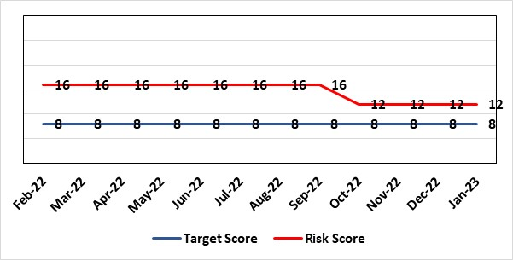 | Rationale for current score:  Difficulties with sustainable staffing affecting performance. Due to improvements being made within the service the current score is on track to be reduced next month.
Level of Control  = 50% |  | Rationale for target score:  New service model and improved performance.
Date added to HB the risk register
31/05/2018
Controls (What are we currently doing about the risk?) |  | Mitigating actions (What more should we do?)
- Performance Scrutiny - is undertaken at monthly commissioning meetings between Swansea Bay & Cwm Taf Morgannwg University Health Boards. Improved governance - ensures that issues and concerns are discussed by all interested parties including local authorities to support the network identify local solutions.  - New Service Model was established by Summer 2019 which gave further stability to service.  - Staffing of service is being strengthened & supplemented by agency staff  - External support secured to determine future delivery arrangements and more immediate performance improvements.  - Following a service review, and option appraisal, the Health Board approved the preferred option – to repatriate Swansea Bay CAMHS at its September Board meeting. |  | Action |  | Lead | Deadline
 |  | The ongoing utilisation of agency staff to fill vacancies has been agreed via the commissioning arrangements and the Service have had ongoing agency workers in the service since April. The Service will continue to look for opportunities for agency to support the service. |  | Assistant Director of Strategy | 01/04/2023
 |  | Repatriation of Service to SBUHB |  | Assistant Director of Strategy | 01/04/2023
 |  | CAMHS Implementation Plan to be progressed in line with the agreed timelines to manage demand & capacity and improve waiting times. |  | Assistant Director of Strategy | Ongoing (multiple milestones)
Assurances (How do we know if the things we are doing are having an impact?)  As a result of focussed work, the vacancy rate has improved considerably. Utilisation of agency will continue to improve the backlog, and support the trajectories received.  % Patients waiting < 28 days  The number of referrals reduced to 138 in August, compared to 259 in May when referrals were at their highest this year. The proportion of referrals redirected/not accepted has increased in August to 55% reflecting the average for 21/22.  The number of patients on the waiting list at the end of August has decreased from 324 in May to 100. The current waiting time for assessment as at 23rd September, is included within the table below. |  | Gaps in assurance (What additional assurances should we seek?)
  Team | Total waiting | Waiting >28 days | % compliance | Average wait (weeks)
  CAMHS Swansea Bay | 100 | 31 | 69% | 2.7
Additional Comments / Progress Notes
Update 22.02.2022 - Potential for repatriation of CAMHS service from Cwm Taf Morgannwg HB being considered through commissioning additional external support to review.
Action complete 01.04.22 - Improvement plan has been shared by CTM and is monitored monthly. Action to mitigate the risk to young people waiting is being taken including utilisation of the third sector for support. An update went to the performance & finance committee in March.
Update: August 2022 – work has been progressed to develop options for the repatriation of CAMHS, and these are due to be reviewed by Management Board in August. A service specification has been drafted, and engagement is ongoing. Trajectories have now been received aligned to the schemes in the Improvement Plan – these will be monitored via the monthly commissioning arrangements.
Update: September 2022 – Service Specification complete and preferred option confirmed for future repatriation of service to Swansea Bay UHB. Recommended that risk is downgraded in October 2022. Two actions completed - Service Specification being developed. Engagement on Specification is now complete, document has been finalised and endorsed by CTM and SBUHB via the commissioning arrangements in place. Board to consider future delivery arrangements. Option appraisal complete – preferred option approved by Management Board and by Health Board members at the September meetings.
21.11.2022 – Action complete – The Network is seeking to recruit agency staff to fill existing and upcoming vacancies to ensure that core capacity is maximised.

Datix ID Number: 1761  Health & Care Standard: Timely Care 5.1 Access |  | HBR Ref Number: 50  Risk Target Date: 31/03/2023 |  | Current Risk Rating  5 x 5 = 25
Objective: Best Value Outcomes from High Quality Care |  | Director Lead: Inese Robotham, Chief Operating Officer  Assuring Committee: Performance and Finance Committee  For information: Quality & Safety Committee
Risk: Access to Cancer Services A backlog of patients now presenting with suspected cancer has accumulated during the pandemic, creating an increase in referrals into the health board which is greater than the current capacity for prompt diagnosis and treatment. Because of this there is a risk of delay in diagnosing patients with cancer, and consequent delay in commencement of treatment, which could lead to poor patient outcomes and failure to achieve targets. |  | Date last reviewed: December 2022
Risk Rating  (consequence x likelihood):  Initial: 4 x 5 = 20  Current: 5 x 5 = 25  Target: 4 x 3 = 12 |  | Rationale for current score:  Risk score updated based on being off trajectory for SCP and Backlog increasing.
Level of Control  = 70% |  | Rationale for target score:  Target score reflects the challenge this area of work present the Board and where small numbers of patients impact on the potential to breach target.
Date added to the HB risk register
April 2014
Controls (What are we currently doing about the risk?) |  | Mitigating actions (What more should we do?)
- Tight management processes to manage each individual case on the Urgent Suspected Cancer Pathway. Enhanced monitoring & weekly monitoring of action plans for top 6 tumour sites.  - Initiatives to protect surgical capacity to support USC pathways have been put in place  - Additional investment in MDT coordinators, with cancer trackers appointed in April 2021.  - Prioritised pathway in place to fast track USC patients.  - Ongoing comprehensive demand and capacity analysis with directorates to maximise efficiencies. This will form part of the remit of the Cancer Performance Group.  - Weekly cancer performance meetings are held for both NPTS and Morriston Service Groups by specialty.  - The top 6 tumour sites of concern have developed cancer improvement plans – weekly monitoring arrangements have been put in place.  - Additional work being undertaken as part of diagnostic recovery and theatre recovery workstreams.  - Endoscopy contract has been extended for insourcing. |  | Action | Lead |  | Deadline
 |  | Phased and sustainable solution for the required uplift in endoscopy capacity that will be key to supporting both the Urgent Suspected Cancer backlog and future cancer diagnostic demand on Endoscopy Services. | Service Group Manager |  | 31/03/2023
 |  | Expand OMF & colorectal operating capacity. | Deputy COO |  | 31/03/2023
Assurances (How do we know if the things we are doing are having an impact?)  Backlog trajectories updated at Management Board and will be going to Performance & Finance Committee in August. Cancer Performance Group established to support execution of the services delivery plans for improvements and meeting regularly. |  | Gaps in assurance (What additional assurances should we seek?)  Performance and activity data monitored, but delays to treatment continue while sustainable solutions found.
Additional Comments / Progress Notes
21/09/2022: PFC received the trajectories and tumour site specific recovery plan. Endoscopy capacity remains a constraint and updated recovery plan is to be presented at Management Board in October. Action completed - Demand & capacity plans worked through for top 6 tumour sites.
24/10/2022: Cancer will be part of enhanced monitoring arrangements with Welsh Government. We are awaiting the template to agree remedial actions.
22/11/2022 Further enhanced SCP specific D&C plans will be produced in Qtr 4 to inform sustainable service delivery plans for 2023/24
06/01/2023: WG template received for enhanced monitoring & includes performance against cancer trajectories.
07/02/2023: A detailed recovery plan is due to go to the Board in March 2023.

Datix ID Number: 146  Health & Care Standard: Effective Care 3.1 Clinically Effective Care |  | HBR Ref Number: 58  Risk Target Date: 31/03/2023 |  | Current Risk Rating  4 x 4 = 16
Objective: Excellent Patient Outcomes |  | Director Lead: Inese Robotham, Chief Operating Officer  Assuring Committee: Quality and Safety Committee
Risk: Failure to provide adequate clinic capacity for follow-up patients in Ophthalmology results in a delay in treatment and potential risk of sight loss. |  | Date last reviewed: January 2023
Risk Rating  (consequence x likelihood):  Initial: 4 x 3 = 12  Current: 4 x 4 = 16  Target: 4 x 2 = 8 | 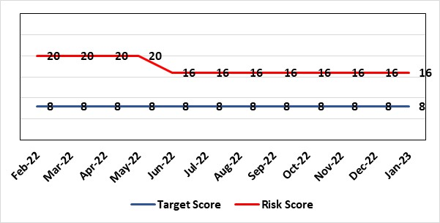 | Rationale for current score:  Risk rating increased to 20 in July 2020 due to Covid-19 pandemic but has now been decreased due to the progress made by the department to reduce the number of delayed followed appointments.
Level of Control  = 40% |  | Rationale for target score:  Mitigation plan via outsourcing of work to optometrists where possible and re-introduction of pre-covid capacity levels.
Date added to the HB risk register
December 2014
Controls (What are we currently doing about the risk?) |  | Mitigating actions (What more should we do?)
- All patients are categorised by condition in order to quantify issue.  - Community optometry scheme successfully implemented to reduce number of diabetic retinopathy patients on follow up list.  - Scheme developed for assessment of glaucoma patients by community optometrists for virtual review by consultant ophthalmologists to reduce follow up backlog.  - Outsourcing of cataract activity to reduce overall service pressures. |  | Action | Lead |  | Deadline
 |  | An overall Regional Sustainability Plan to be delivered | Service Group Manager Surgical Specialties |  | 31/03/2023
Assurances  (How do we know if the things we are doing are having an impact?)  - Deputy COO holds Gold Command meetings on a monthly basis to monitor progress. |  | Gaps in assurance  (What additional assurances should we seek?)  Regular liaison with patients on extended waiting list/times and validation.
Additional Comments / Progress Notes
12/09/2022 – Risk reviewed and no further updates.
22/11/2022 – The number of follow up patients without an appointment continues to decrease from 6,148 in July to 5,353 at the end of October.
15/12/2022 – There has been an increase in the number of follow up 7,411 at the end of November partially to the increase in new patients being seen. However there is still a trajectory of improvement through to March 2023.
07/02/2023: Longer-term regional recovery options are being explored jointly with Hywel Dda.

Datix ID Number: 1587  Health & Care Standard: 3.1 Safe and Clinically Effective Care |  | HBR Ref Number: 61  Risk Target Date: 31st May 2023 |  | Current Risk Rating  4 X 4 = 16
Objective: Identify alternative arrangements to Parkway Clinic for the delivery of dental paediatric GA services on the Morriston Hospital SDU site consistent with the needs of the population and existing WG and Health Board policies. |  | Director Lead: Inese Robotham, Chief Operating Officer  Assuring Committee: Quality and Safety Committee/Strategy Planning and Commissioning Committee
Risk: Paediatric dental GA/Sedation services provided under contract from Parkway Clinic, Swansea. Medical Safety risk GAs performed on children outside of an acute hospital setting. |  | Date last reviewed: January 2023
Risk Rating  (consequence x likelihood):  Initial: 5 x 3 = 15  Current: 4 x 4 = 16  Target: 4 x 2 = 8 | 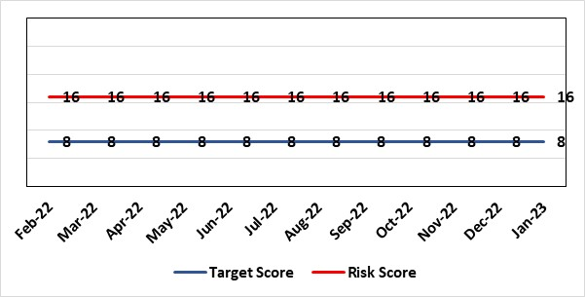 | Rationale for current score:  There is no immediate access to crash team/ICU facilities in in Parkway Clinic – the client group are undergoing G/A/sedation. Paediatric GA/Sedation services provided under contract from Parkway Clinic, Swansea continue due to lack of capacity for these patients to be accommodated in Secondary Care.
Level of Control  = 60% |  | Rationale for target score:  Relocation of the paediatric GA service [provided by Parkway Clinic] to a hospital site being treated as a priority.
Date added to the HB risk register
4th July 2018
Controls (What are we currently doing about the risk?) |  | Mitigating actions (What more should we do?)
Consultant Anaesthetist present for every General Anaesthetic clinic.  Assurance Documentation supplied by Parkway Clinic including confirmation of arrangements in place with WAST and Morriston Hospital for transfer and treatment of patients  New care pathway implemented - no direct referrals to provider for GA.  Multi-drug sedation ceased from Sep 2018 in line with WHC 2018 009  Revised SLA/Service Specification  HIW Inspection Visit Documentation provided to HB  All extended GA cases require approval from paediatric specialist prior to treatment |  | Action | Lead |  | Deadline
 |  | Transfer of services from Parkway. | Interim Head of Primary Care |  | 31/05/2023
Assurances (How do we know if the things we are doing are having an impact?)  RMC collate referral and treatment outcome data for review by Paediatric Specialist  Regular clinical meeting arranged with Parkway to discuss individual cases/concerns  Regular clinical/ management meeting for CDS/primary care management team to discuss service pathway /concerns/issues arising  Roll out of new pathway to encompass urgent referrals  T&F Group established to lead transfer from community centre to MHSDU. |  | Gaps in assurance (What additional assurances should we seek?)  ToR for the task and finish group should continue to include consideration of the pressures on the POW special care dental GA list and this service is considered alongside any plans for the Parkway contract.
Additional Comments / Progress Notes
25.04.2022: Current position reviewed at Senior Management Board April 2022. Extension agreed until 31st May 2023 due to current theatre challenges. Agree repatriation remains a priority and to be included in theatre planning. Deputy COO to re-establish TFG. 29.07.2022: T&F group to be re-established in September 2022.
23.08.2022: Reviewed at HoS meeting - PCT planning with service director in Morriston Hospital. No change to risk at present.
12.09.2022: Risk reviewed and no further updates. 22.11.22 No change to situation. 15.12.22: No change

Datix ID Number: 1605  Health & Care Standard: 3.1 Safe and Clinically Effective Care |  | HBR Ref Number: 63  Risk Target Date: 31st December 2022 |  | Current Risk Rating  4 X 4 = 16
Objective: Screening for Fetal Growth Assessment in line with Gap-Grow (G&G) |  | Director Lead: Gareth Howells, Executive Director of Nursing  Assuring Committee: Quality and Safety Committee
Risk: There is not enough Ultrasound capacity within Swansea Bay UHB to offer all women serial ultrasound scan screening in the third trimester in line with the UK perinatal Institute Growth Assessment Programme (GAP). Welsh Government mandate fetal growth screening in line with the GAP programme. There is significant evidence of the increased risk for stillbirth or neonatal mortality/morbidity (hypoxic ischaemic encephalopathy (HIE)), where a fetus is growth restricted (IUGR) and/or small for gestational age fetus (SGA). Identification and appropriate management for IUGR/SGA in pregnancy will lead to improved outcomes for babies. |  | Date last reviewed: January 2023
Risk Rating  (consequence x likelihood):  Initial: 4 x 3 = 12  Current: 4 x 4 = 16  Target: 3 x 4 = 12 | 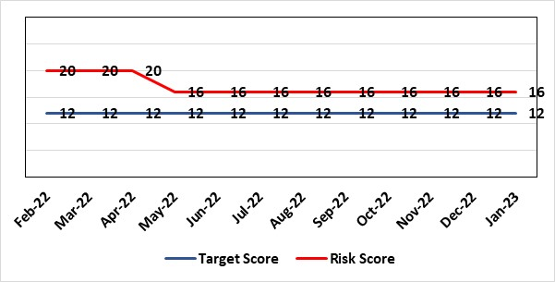 | Rationale for current score:  Although the frequency of stillbirth is low the health board are up to 10% above the national rate for stillbirth as published by MBRRACE.  Although infrequent when IUGR/SGA baby is stillborn or diagnosed hypoxic ischaemic encephalopathy (HIE) which is deemed avoidable this impacts on:  - the wellbeing of families  - can lead to high value claims  - loss of reputation and adverse publicity for the health board.  See also Progress Notes below
Level of Control
= 60%
Date added to the HB risk register  1st August 2019 |  | Rationale for target score:  When the service is able to provide third trimester ultrasound scan in line with GAP recommendations we will be providing care in line with evidence based best national practice as mandated by Welsh Government.
Controls (What are we currently doing about the risk?) |  | Mitigating actions (What more should we do?)
All staff are required to complete the GAP e-learning on an annual basis. Compliance is monitored via the Training & Education forum. All staff have received an email to present their certificate for 2021/22  A local policy is in place to identify the priority risk factors for the offer of serial growth scans while there is not enough capacity  Health board maternity ultrasound group convened to develop future services  Training 4 midwives for an advanced practice role in ultrasound scanning to reduce capacity gap  Introduction of midwife third trimester scan service will increase USS capacity by a minimum 2,200 scans per annum (50 scans per week/44 weeks) commencing April 2022  Two midwives have commenced Ultrasound training course in UWE January 2022, in order to ensure sustainable service provision  Two additional ultrasound rooms are fully equipped toward increased scan capacity |  | Action | Lead |  | Deadline
 |  | All staff to submit GAP training certificates by 31/12/2022 | Deputy Head of Midwifery |  | 31/01/2023
 |  | Administration for midwife sonographer clinics to be secured to ensure streamlined service | Maternity service business manager |  | 31/12/2022
 |  | Complete the governance framework for third trimester scanning to include CPD programme | Deputy Head of Midwifery |  | Completed
 |  | Two midwives to complete UWE course December 2022 | Deputy Head of Midwifery |  | 31/01/2023
Assurances (How do we know if the things we are doing are having an impact?)  The third trimester ultrasound capacity will increase by a minimum 2200 scans per annum in year one increasing to 4400 in year 2. The detection rate of IUGR/SGA will increase leading to improved antenatal management plans and intrapartum planning. We will report a reduced rate of stillbirth and/or neonatal mortality/morbidity with improved management of IUGR/SGA babies.  The administration support for the service will be fully functional. |  | Gaps in assurance (What additional assurances should we seek?)  Assurance of maintaining a sustainable third trimester ultrasound service.
Additional Comments / Progress Notes
04/08/2022 - Trainee midwifery sonographers will not be able to complete their training by September because their competencies cannot be signed by this time.
24/10/2022 – Due to service pressures the T&E group have prioritised completion of GAP training for community midwives and midwife sonographers. Extension to year end for all staff. The lack of administration support for the ultrasound service means the increased capacity forecast is not fully achieved as sonographers provide own administration tasks.
16/12/2022 – One trainee sonographer who commenced training in January 2022 is on long term sick and an extension for completion of training has been granted. One permanent midwife sonographer also long term sick.

Datix ID Number: 329  Health & Care Standard: 3.1 Safe and Clinically Effective Care |  | HBR Ref Number: 65  Risk Target Date: 31st December 2022 | Current Risk Rating  4 x 5 = 20
Objective: Digitally enabled Care |  | Director Lead: Gareth Howells, Executive Director of Nursing  Assuring Committee: Quality & Safety Committee
Risk: Misinterpretation of cardiotocograph and failure to take appropriate action is a leading cause for poor outcomes in obstetric care leading to high value claims. The requirement to retain maternity records and CTG traces for 25 years leads to the fading/degradation of the paper trace and in some instances traces have been lost from records which makes defence of claims difficult. |  | Date last reviewed: January 2023
Rationale for current score:
The K2 central monitoring system has been purchased by the health board however is not yet installed. A project team is being established to ensure oversight of installation and training. Full use of the system will be available from December 2022 when the risk will reduce as appropriate.
Risk Rating  (consequence x likelihood):  Initial: 4 x 4 = 16  Current: 4 x 5 = 20  Target: 4 x 2 = 8 |  | Rationale for target score:  A central monitoring station will enable senior clinicians to support decision making across the service, and from home, leading to senior involvement in management decisions toward improved outcomes. All CTG traces will be stored electronically and therefore will not fade and cannot be lost.
Level of Control
= 50%
Date added to the HB risk register
31st December 2011
Controls (What are we currently doing about the risk?) |  | Mitigating actions (What more should we do?)
All staff receive annual training in fetal surveillance as mandated by Welsh Government.  SBU have appointed a midwife and obstetric lead for training and development of staff  Compliance with training is reported annually in 2021/2022 the training year has been extended due to the service ability to release staff for training  A “fresh eyes” protocol in place requiring intrapartum CTG classification hourly by two clinicians which is monitored via audit of records  A “jump call” policy is available to request additional support where there is disagreement over CTG classification  CTG prompt labels in use to support staff with CTG categorisation. |  | Action |  | Lead | Deadline
 |  | Fetal surveillance leads to set up training team for transition to use of electronic labour record. TNA analysis to be completed for all staff |  | Fetal surveillance leads | 31/12/2022
 |  | For the project Board to complete a risk assessment to manage the changeover from paper based to electronic monitoring to ensure all risks are captured |  | Project Board | 28/02/2023
 |  | Arrange backfill for fetal surveillance midwife secondment to maintain training and reflections |  | Deputy Head of Midwifery | 30/12/2022
Assurances (How do we know if the things we are doing are having an impact?)  All Wales Fetal Surveillance Standards for 6hrs Fetal Surveillance Training per year |  | Gaps in assurance (What additional assurances should we seek?)  Assurance all staff are able to transition to a new way of working
Additional Comments / Progress Notes
07/10/2022 - Demonstration for staff on Monday 10th October, rolling out training in Oct/Nov. Implementation by the end of December 2022.
24/10/2022 – Fetal surveillance midwife appointed to MAT/NEO safety programme for 6 months. Backfill TBA.
19/12/2022 - Fetal surveillance midwife shortlisted, and interviews planned for 22/12/2022.

Datix ID Number: 1834  Health & Care Standard: 5.1 Timely Care |  | HBR Ref Number: 66  Risk Target Date: 31st January 2023 | Current Risk Rating  5 X 3 = 15
Objective: Best values outcomes from high quality care |  | Director Lead: Richard Evans, Executive Medical Director  Assuring Committee: Quality and Safety Committee
Risk: The demand & complexity of planned treatment regime for cancer patients requiring chemotherapy currently exceed the available chair capacity, risking unacceptable delays in access to SACT treatment in Chemotherapy Day Unit with impact on targets and patient outcomes. |  | Date last reviewed: January 2023
Risk Rating  (consequence x likelihood):  Initial: 5 x 5 = 25  Current: 5 x 3 = 15  Target: 2 x 2 = 4 | 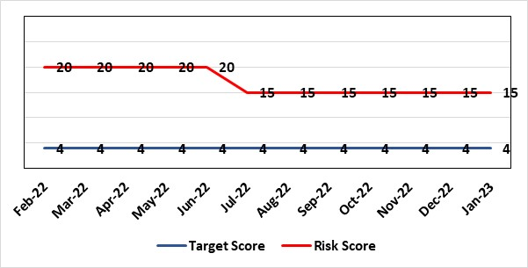 | Rationale for current score: Risk reduced to 15 (July) – last 3 months have now consistently delivered 100 additional patients per month via CDU.
Level of Control
=
Date added to the HB risk register  30/11/2019 |  | Rationale for target score:  Reduced delays in treatment will reduce risk of harm.
Controls (What are we currently doing about the risk?) |  | Mitigating actions (What more should we do?)
Review of CDU by improvement science practitioner was completed in 2020. Resulted in change to booking processes to streamline booking process and deferral.  Review of scheduling by staff to ensure all chairs used appropriately.  Business case endorsed by CEO for shift of capacity to home care to be considered by the Management Board  A Daily scrutinizing process in progress to micro manage individual cases, deferrals etc |  | Action | Lead | Deadline
 |  | Relocation of SACT linked to AMSR programme and phase 2 of home care expansion case brought forward | Service Director Lead for Cancer | 31st March 2023 (dependant on AMSR moving)
Assurances (How do we know if the things we are doing are having an impact?)  Additional funding agreed to support increase in nurse establishment to appropriately staff the unit during its main opening hours. Additional scheduling staff also agreed.  Pre-assessment process has been separated from start date in an attempt to fill deferral slots at short notice where possible.  Improved communication between MDT to streamline booking and deferral process.  Continue to monitor patient experience via friends and family and under our PTR procedures.  Monitoring our waiting times against new SACT metrics, which is a measure based on treatment intent and is no longer reported as average waiting time so is more linked to expected outcomes etc. This performance metric is included in our Cancer Performance report we send to WG and Management Board and internally via governance arrangements with NPTSSG where Oncology services sit. |  | Gaps in assurance (What additional assurances should we seek?)  Capital & Revenue assumptions & resources for second business case for increasing chair capacity in 2022/23 to meet increased demand.
Additional Comments / Progress Notes
12/09/22 - We continue to see stabilising of CDU waiting times although there remains operational concerns with specific points in pathways effecting efficiency and effectiveness of delivery linked to aseptic and consultant workload pressures. We monitoring monthly compliance of SACT WCN reports. Which shows slight deterioration performance in August compared to July, but still average waiting remains around 3wks.
02/11/22 – Action closed - Paper to support extended day working every Saturday. Action closed as now not taking forward.
We now have in place, SACT bi-monthly reports demonstrating oncology SACT waiting times performance to support ongoing improvements in pathway. We will use this report to continue to be assured regarding SACT treatment waiting times.
Action closed as no longer taking forward - Business Case for phase 2 home care expansion based on moving further treatments to community service. Paper with CEO for comments, prior to going to BCAG.
13.12.22- Continue to deliver 100 additional patients per month and average waiting times remain at 3wks. Next SACT Bi-monthly report with analyse of breach information to support ongoing improvements in pathways is next due in January.
17.01.2023 - Weekly monitoring of the waiting times and breaches has been implemented.
December 2022 breaches have increased from 41 to 43 due to staffing deficits and Bank holidays; however, average waiting times continues to be 3 weeks
3 chairs have re-opened post-covid, increasing chair capacity further.

Datix ID Number: 89  Health & Care Standard: 5.1 Timely Care |  | HBR Ref Number: 67  Risk Target Date: 31st October 2022 | Current Risk Rating  5 X 3 = 15
Objective: Best values outcomes from high quality care |  | Director Lead: Richard Evans, Executive Medical Director  Assuring Committee: Quality and Safety Committee
Risk: Clinical risk-target breaches in the provision of radical radiotherapy treatment. Due to capacity and demand issues the department is experiencing target breaches in the provision of radical radiotherapy treatment to patients. |  | Date last reviewed: January 2023
Risk Rating  (consequence x likelihood):  Initial: 4 x 4 = 16  Current: 5 x 3 = 15  Target: 2 x 2 = 4 | 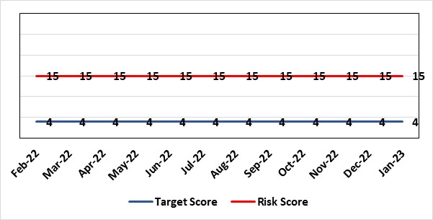 | Rationale for current score:  Waiting times deteriorating for elective delays patients, particularly prostates discussed in Oncology business meeting. Current Risk reduced to 15. At present 70 patients to be outsourced which increases capacity. New Linac building work underway, which will increase capacity in near future.
Level of Control
=
Date added to the HB risk register  30/11/2019 |  | Rationale for target score:  Reduced delays in treatment will reduce risk of harm
Controls (What are we currently doing about the risk?) |  | Mitigating actions (What more should we do?)
Capacity for treatment increased across the department with investment in Linac replacement programme.  CT business case submitted for temporary weekend working to increase the capacity for CT scanning. |  | Action |  | Lead | Deadline
 |  | New Linac required – Linac case agreed with WG |  | Service Manager Cancer Services | 01/04/2023  (on track)
Assurances  (How do we know if the things we are doing are having an impact?)  Performance and activity data is being monitored and monthly data shared with radiotherapy management meeting and cancer board. It is also now included in scorecard. |  | Gaps in assurance  (What additional assurances should we seek?)  Performance and activity data monitored, but delays to treatment continue while sustainable solutions found.
Additional Comments / Progress Notes
13.09.22 - Wait Times have dipped in August with the biggest contributing factor being late localisation. Demand- After 2 months of high demand, the levels returned to a more ‘normal’ level in August. It will be interesting to see if this was due to consultant leave and if the demand returns to higher levels once everyone is back. Demand for breast treatment has seen the highest rise over the past 12 months with a 39% increase (325 pts increasing to 451 pts). Capacity- August was a very busy month on the linacs as we treated the high levels of demand seen in July. With four matched linacs in operation we were able to start 206 courses of treatment, almost matching our previous highest record.
03.10.22 - Lin 5 building work has begun. Capacity increasing should be full capacity by end December 2022. Action completed - Operationalise plans for offering hypo fractionated prostate treatment.
13.12.22- Lin 5 work continues with no delays remain on track for increased capacity for start of Jan 23.
18.01.23 - Building work complete. Delivery of Linac 7.1.23. Commissioning has begun, clinical Summer 2023.
CT Capacity increases being explored through temporary weekend working/ new CT purchase.

Datix ID Number: 1418  Health & Care Standard: 5.1 Timely Access |  | HBR Ref Number: 69  Risk Target Date: 31st January 2023 |  | Current Risk Rating  5 X 4 = 20
Objective: Best values outcomes from high quality care |  | Director Lead: Inese Robotham, Chief Operating Officer / Gareth Howells, Executive Director of Nursing  Assuring Committee: Quality & Safety Committee
Risk: Risk issues related to adolescent patients being admitted to Adult MH inpatient wards- Inappropriate settings resulting in 'Safeguarding Issues' The WG has requested that HBs identify Secondary Care in -patient facilities for the care of adolescents- in Swansea Bay University Health Board Ward F NPT hospital is the dedicated receiving facility with one bed identified. |  | Date last reviewed: January 2023
Risk Rating  (consequence x likelihood):  Initial: 2 x 3 = 6  Current:5 x 4 = 20  Target: 2 x 3 = 6 | 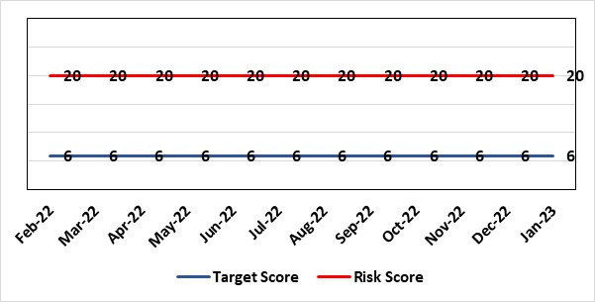 | Rationale for current score:  Every health board is required to have an admission facility for adolescent MH patients. Whilst ward F has been identified as the single point of access in SBU and a dedicated bed is ring-fenced for adolescent admissions it is a mixed sex adult ward. Therefore the facilities are less than ideal for young patients in crisis.
Level of Control
=
Date added to the HB risk register  27/02/2020 |  | Rationale for target score:  The longer term aim for the HB remains to create an admission facility for adolescent MH patients.
Controls (What are we currently doing about the risk?) |  | Mitigating actions (What more should we do?)
Safeguarding Training for Staff, Joint protocol with Cwm Taf LHB [CAMHS] currently subject to review, Local SBUHB policy on providing care to young people in this environment. This includes the requirement for all such patients on admission to be subject to Level 3 Safe and Supportive observations.  Only Adolescents within 16-18 age range are admitted to the adult ward.  The health board works with CAMHS to make sure that the length of stay is as short as possible. |  | Action | Lead |  | Deadline
 |  | Next service group review of effectiveness of current controls. | MH&LD Head of Operations & Clinical Directors |  | 31st March 2023
Assurances (How do we know if the things we are doing are having an impact?)  Individual Rooms with en Suite Facilities, Joint working with CAMHS, monitoring of staff training, Monitoring of admissions by the MH & LD SG legislative Committee of the HB. The ongoing issues with the risks presented by the use of this has recently been raised at an all Wales level with Welsh Government and a formal review is anticipated. The Service Group continues to flag the risk particularly in light of Ward F being identified as the SPOA for AMH in the HB which has resulted in an increase in acuity and a greater concentration of individuals who are experiencing the early crisis of admission - this has served to increase the already identified risks for young people in the environment. |  | Gaps in assurance (What additional assurances should we seek?)
Additional Comments / Progress Notes
24/10/2022 – No change. Next review date assigned.

Datix ID Number: 2595  Health & Care Standard: 3.1 Safe and Clinically Effective Care |  | HBR Ref Number: 74  Risk Target Date: Subject to Review |  | Current Risk Rating  5 X 4 = 20
Objective: Best Value Outcomes from High Quality Care |  | Director Lead: Gareth Howells, Executive Director of Nursing  Assuring Committee: Quality and Safety Committee
Risk: Delay in Induction of Labour (IOL) or augmentation of Labour  Delays in IOL can introduce avoidable risk and unnecessary intervention which can lead to poor clinical outcome for mother and/or baby. Delays in IOL lead to increased complaints and decreased patient satisfaction. |  | Date last reviewed: January 2023
Risk Rating  (consequence x likelihood):  Initial: 4 x 4 = 16  Current: 5 x 4 = 20  Target: 2 x 3 = 6 |  | Rationale for current score:  Delay in IOL is a frequent occurrence in maternity care (all delays are linked to the RR) and is multifaceted including;  High acuity / Maternity staffing levels / Neonatal staffing levels  While adverse outcomes as a result of delay in care are infrequent, there may be long term consequences for mother and/or baby leading to high value claims. Avoidable harm is damaging to the reputation of the HB and can lead to adverse media coverage.
Level of Control
= 60%
Date added to the HB risk register
30th April 2021
Date added to the HB risk register  30th April 2021 |  | Rationale for target score:  IOL delays are minimal with increased patient flow, increased patient satisfaction and prevent avoidable poor outcomes
Controls (What are we currently doing about the risk?) |  | Mitigating actions (What more should we do?)
IOL rate is static at around 30%. Maintain a maximum number of IOLs on a daily basis with emergency slot.  Daily obstetric consultant ward round to review all women undergoing IOL. Ongoing/regular monitoring by cardiotocograph for fetal wellbeing during IOL on hold. Labour ward coordinator and labour ward obstetric lead ensure women on ward 19 for IOL are factored into daily planning of workload on labour ward. Obstetric consultant review when IOL on hold for appropriate pan of care. The MDT (Obstetric, Neonatal and Midwifery) consider individual risk factors and Escalation Policy is implemented. Neighbouring maternity units are contacted to ask if they are able to support by accepting the transfer of women.  Daily acuity is gathered and sent to the senior midwifery management team who can anticipate potential problems and support the clinical team. The matron of the unit is contacted in office hours and the senior midwife manager on call is contacted out of hours. If required midwifery staffing are redeployed including the specialist midwives and the community midwifery on call team. |  | Action | Lead |  | Deadline
 |  | Prepare midwifery workforce paper to present recommendation for future staffing levels in the obstetric unit to ensure adequate staffing each shift. | Deputy Head of Midwifery and Director of Nursing (Head of Midwifery to be appointed for interim) |  | 30/03/2023
 |  | Complete Birthrate+ Cymru assessment for future workforce needs on the obstetric unit. | Head of Midwifery |  | 30/01/2023
 |  | Manage Critical midwifery Staffing (HBRR ref 81) to minimise disruption in IOL delay. | Deputy Head of Midwifery and Lead Midwife Governance |  | 28/02/2023
Assurances (How do we know if the things we are doing are having an impact?)  There will be minimal delays in IOL. We will reduce the number of clinical incidents related to this risk. We will receive fewer complaints related to IOL as women’s experience will be improved. We will not report avoidable harm related to IOL process. |  | Gaps in assurance (What additional assurances should we seek?)  Workforce plan in preparation to include review of staffing on the Obstetric unit to reduce risk related to midwifery staffing and high acuity
Additional Comments / Progress Notes
24.10.22 – Ongoing monitoring of outcomes when delayed IOL. Birthrate+ Cymru due to report November 2022. Midwifery workforce position paper with CEO for comment prior to presentation to Executive Board. 19/12/22 - Birthrate+ report received November 2022. Senior Midwifery team to present to the Board in 2023. Risk to be linked to mitigating actions and controls within HBRR 81.
06/01/2023 - Head of Midwifery retired. Interim post released. Birthrate+ report received, to meet with team to finalise report as missing information regarding antenatal assessment unit admissions. Nursing Director supporting Senior team with future workforce plan.

Datix ID Number: 2521 (& COV_Strategic_017)  Health & Care Standard: 2.4 Infection Prevention and Control (IPC) and Decontamination |  | HBR Ref Number: 78  Risk Target Date: 31st March 2023 |  | Current Risk Rating  3 x 4 = 12
Objective: Best Value Outcomes from High Quality Care |  | Director Lead: Richard Evans, Executive Medical Director  Assuring Committee: Quality & Safety Committee
Risk: Nosocomial transmission  Nosocomial transmission in hospitals could cause patient harm; increase staff absence and create wider system pressures (and potential for further harm) due to measures that will be required to control outbreaks. |  | Date last reviewed: January 2023
Rationale for current score:
11.08.2022 – Risk reduced to 12. Reasoning: (1) incidence reducing in the community (2) incidence reducing in hospital (3) current variants associated with low mortality in vaccinated population (4) communication to families to notify that cases which resulted in patients death (reported on the death certificate) are starting to be reviewed with a small number of cases reaching outcome stage, none so far resulting in legal / redress cases.(5) remains high priority work for all HBs and NHS Trusts.
Risk Rating  (consequence x likelihood):  Initial: 5 x 4 = 20  Current: 3 x 4 = 12  Target: 3 x 4 = 12 | 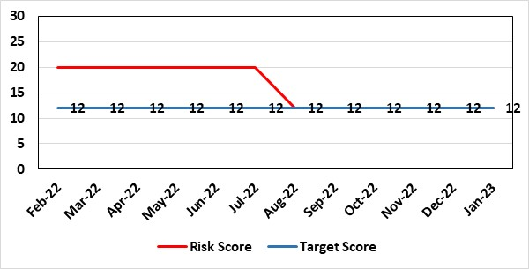
Level of Control  = 40% |  | Rationale for target score:  Measures in place will require regular review and scrutiny to ensure compliance. Levels of community incidence or transmission may change and the HB will need to respond. Vaccination programme on going but not complete.
Date added to the HB risk register
May 2021
Controls (What are we currently doing about the risk?) |  | Mitigating actions (What more should we do?)
A nosocomial framework has been developed to focus on:  - prevention and (b) response.  Preventative measures are in place including testing on admission, segregating positive, suspected and negative patients, reinforcing PPE requirements, and a focus on behaviours relating to physical distancing. As part of the response, measures have been enacted to oversee the management of outbreaks.  Process established to review nosocomial deaths. Audit tools developed to support consistency checking in key areas re: PPE, physical distancing. Testing on admission dashboard in use. Further guidance on patient cohorting produced. |  | Action | Lead |  | Deadline
 |  | Following dissolution of Gold and Silver COVID command structures, the function of monitoring nosocomial spread and implementing preventative actions will be taken on by the IP&C committee. | Executive Medical Director & Deputy Director Transformation |  | Monthly ongoing
 |  | Nosocomial Death Reviews using national toolkit. Need to ensure outcomes are reported to the HB Exec and Service Groups with lessons learnt | Executive Medical and Nursing Director |  | 31/03/2024  Requires on going updates until conclusion of reviews
Assurances  (How do we know if the things we are doing are having an impact?)  Monitor Outbreaks throughout the HB / Review Nosocomial Deaths and lessons learnt |  | Gaps in assurance  (What additional assurances should we seek?)  Audit compliance of sustainable IPC practices and training compliance  Implement lessons learnt from outbreaks and death reviews.
Additional Comments / Progress Notes
The HB has started to contact families to notify them followed up by written information on the process.
Working with the DU to standardise processes within each HB.
Scrutiny Panels established and commenced in September to feedback lessons learnt to Service Groups and estimate level of harm.
Legal and Risk services have been involved in overseeing the process and are assured of the process.
Board updated on a regular basis with progress.
1.11.2022 – 667 cases under review so far with 15 reaching conclusion and moving to final letter / outcome with families.
Lessons learnt being shared throughout the HB. Scrutiny panels for complex cases and where harm is identified being established.
Process funded until March 2024, currently working on cases in wave one.
16.1.2023 - Pathway review completed with outcome letter to families agreed and responses now increasing with completion of wave 1 buy Wednesday, the number of investigations / responses need to double by April to match timelines to complete up to wave 4 cases.
Lessons learned through the review now has a clear feedback for relatives in the outcome letter, Q&S groups to feedback to service groups and exceptions via ICC up to Exex team.
Number of live cases in wave 5 are reaching their peak. ITU attendances remain low for COVID.

Datix ID Number: 1832  Health & Care Standard: : 3.1 Safe and Clinically Effective Care |  | HBR Ref Number: 80  Risk Target Date: 31/03/2023 | Current Risk Rating  4 x 5 = 20
Objective: Best Value Outcomes from High Quality Care |  | Director Lead: Inese Robotham, Chief Operating Officer  Assuring Committee: Quality & Safety Committee
Risk: If the health board is unable to discharge clinically optimised patients there is a risk of harm to those patients as they will decompensate, and to those patients waiting for admission.
 |  | Date last reviewed: January 2023
Risk Rating  (consequence x likelihood):  Initial: 4 x 5 = 20  Current: 4 x 5 = 20  Target: 4 x 2 = 8 |  | Rationale for current score:  - Sustained levels of clinically optimised patients (COPs) leading to overcrowding within ED, use of inappropriate or overuse of decant capacity in ED and delays in accessing medical bed capacity, clearly emerged as themes.  - Constraints in relation to all patient flows out of Morriston to a more appropriate clinical setting, identified and included in an expanded risk.  - Delay in discharge for clinically optimised patients can result in deterioration of their condition.
Level of Control
= 25%
Date added to the HB risk register
May 2021
Date added to the HB risk register  May 2021 |  | Rationale for target score:  Targeted reduction of Clinically Optimised patients remains a priority for the HB in order to minimise risk of avoidable harm to patients within the HB and in the wider community.
Controls (What are we currently doing about the risk?) |  | Mitigating actions (What more should we do?)
- Clinically optimised numbers are monitored and reviewed weekly by the MDU. Delays are reported and escalated to try to ensure timely progress along a patient's pathway.  - Review on a patient by patient basis – with explicit action agreed in order to progress transfer to appropriate clinical setting.  - Critical constricts in relation to access/time delays for social workers and assessment for package of care and social placement – lead times in excess of 5 weeks.  - Patient COVID-19 status has added an additional level of complexity to decision making.  - The health board has procured 63 additional care home beds to provide additional discharge capacity. |  | Action |  | Lead | Deadline
 |  | Proposal to go to Management Board in March 2023. |  | Senior Project Director | 31/03/2023
Assurances (How do we know if the things we are doing are having an impact?)  - Patient level dashboard allows breakdown by delay type  - Close management of utilization of additional care home beds |  | Gaps in assurance (What additional assurances should we seek?)
Additional Comments / Progress Notes
21/09/22: Detailed presentation on the length of stay reductions and admissions avoidance schemes was received by Management Board 21/09/2022. Progress against delivery will be monitored by Management Board on a bi-weekly basis. 2 Actions completed - A dedicated task & finish group to be established to develop plans to close 90 contingency beds, as per AMSR plan. A plan will be presented to Management Board in September. Two focused groups established to look at different categories of COPs and provide senior oversight. To commence in August.
24/10/2022: Actions completed: Deputy COO identified as lead for length of stay reduction and admission avoidance and has put in place a weekly oversight framework; CEO met with clinical leads to explore further opportunities for changing pathways with the aim of reducing length of stay.
22/11/2022: COP escalation rounds now complete and Integrated Discharge Hub implemented to coincide with MADE week. Analysis being reviewed w/c 28/11/22.
06/01/2023: Action complete: COO and Medical Director met with WAST MD to review current pathways into ED with aim to identify opportunities for admission avoidance. Health Board has received Welsh Government letter from Chief Medical Officer and Chief Nursing Officer with regarding to discharge arrangements and it has been circulated to all clinicians to aid decision-making. Action: Primary care group are looking at FNOF pathway and use of virtual wards to reduce length of stay – Started on a limited basis.
07/02/2023: Action completed: First meeting held of specific bed decommissioning programme to look at decommissioning of contingency beds at Singleton hospital.

Datix ID Number: 2788  Health Care Standards: 7.1 Workforce |  | HBR Ref Number: 81  Risk Target Date: 31st December 2022 |  | Current Risk Rating  5 x 5 = 25
Objective: Best value outcomes |  | Director Lead: Gareth Howells, Executive Director of Nursing  Assuring Committee: Quality & Safety Committee  For Information: Workforce & OD Committee
Risk: Critical staffing levels – Midwifery  Vacancies and unplanned absences resulting from Covid-19 related sickness, alongside other long term absences including maternity leave, have resulted in critical staffing levels, which undermine the ability to maintain the full range of expected services safely, increasing the potential for harm, poor patient outcomes and/or choice of birthplace. Poor service quality or reduction in services could impact on organisational reputation. |  | Date last reviewed: January 2023
Rationale for current score:
Pressure on staffing increased at the end of June 2022 as a result of increasing short term sickness, particularly COVID-19 related - 12.24wte midwives are absent due to COVID-19 which equates to 7.6% of the overall clinical midwifery workforce. Vacancies exist within the service however and two rounds of recruitment for Band 6 midwives have failed to fully appoint to the vacancies available. A third round of recruitment is progressing to interview stage. Some aspects of service provision have been suspended in order to ensure resource is best directed to support safe provision. Increased to 25.
Risk Rating  (consequence x likelihood):  Initial: 4 x 5 = 20  Current: 5 x 5 = 25  Target: 4 x 4 = 16 | 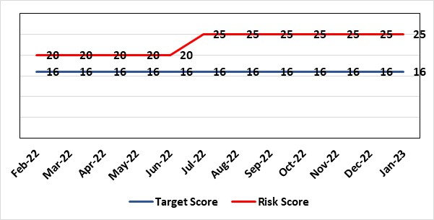
Level of Control  = % |  | Rationale for target score:  It is intended that through actions currently identified to address vacancies we can reinstate services fully and reduce the likelihood of the need to suspend elements further.
Date added to the risk register
12/10/2021
Controls (What are we currently doing about the risk?) |  | Mitigating actions (What more should we do?)
- All midwives are working at the hours they require up to full time.  - Specialist midwives and management redeployed to support clinical care as required  - Birth rate plus Intrapartum acuity tool completed 4 hourly to guide safe service provision and escalation;  - Escalation meeting now daily to review rotas and reallocate staff as required – this is Director led  - Morning safety huddle for community midwifery teams  - Additional shifts offered via Bank, additional hours and overtime – targeted enhanced overtime rates offered for 3 weeks (from 24/06/2022) with authorisation of Executive Director of Nursing and subject to daily review. Plus enhanced bank rate offered to registered midwives.  - Utilisation of off-contract midwifery agency authorised by Executive Director of Nursing (from 24/06/2022) – prospective bookings in place to end of January 2023.  - Six Graduate midwives employed October 2022  - Open advert for recruitment on TRAC  - On-Call Manager Rota in place.  - Medical team support used when required.  - Continue to suspend services in the FMU at NPT.  - International recruitment campaign initiated with MEDACS.  - Offer of additional support worker shifts particularly in the postnatal area for additional support for women  - Absences in senior roles supported mitigated as follows: Head of Safeguarding supporting the governance team; Temporary extension of Interim Midwifery Matron post to support oversight of the governance team; Retired Head of Midwifery mentoring new Deputy Head; Intrapartum Lead Midwife (Cwm Taf) is supporting development of future workforce requirements; WG offer of advice/support where required.  - Regular communication with stakeholders includes: Early warnings to Welsh Government; Verbal and formal communication with CHC; Internal communications on home births, RCM updates; weekly staff briefings and bulletins. |  | Action | Lead |  | Deadline
 |  | Complete workforce paper with HR and finance to establish vacancy position and develop vacancy tracker going forward. Support for Cwm Taf secured to develop this. | Head of Midwifery |  | 30/12/2022
 |  | Review the role and capacity of the HCSW to maximise registered midwife capacity. | Deputy Head of Midwifery |  | 31/01/2023
Assurances (How do we know if the things we are doing are having an impact?)  We will be able to maintain safe staffing rotas and women and families will receive safe and effective care wherever they chose to birth. We will report increased staff satisfaction. We will have a reduction in complaints to the service. we will have reduced sickness rates. We will be able to effectively support secondments for staff development without depleting the clinical service. Long term sickness and maternity leave will not impact on our ability to sustain staffing levels within the clinical areas. The following assurance mechanisms in place currently:  Birth-rate Plus Intrapartum acuity tool completed 4 hourly  Daily Director-led midwifery staff escalation meetings which considers sickness & other absences and daily review of safety and quality outcomes. The Group Head of Quality Safety & Risk is supporting daily oversight of Datix incidents (commenced July 2022). Red flag events are monitored and reported in accordance with NICE Guidance 2021:  • Cancelled elective caesarean sections;  • Missed or delayed care;  • Delayed or cancelled induction of labour;  • Delay of 2 hours or more between admission for induction of labour and beginning of process;  • Delay of 30 minute or more between presentation and triage. |  | Gaps in assurance (What additional assurances should we seek?)  Incorporate Birthrate+ Cymru required staffing levels when available.  To restructure the management SIP for robust management and governance including succession planning for management roles in line with RCM recommendations  Evidence has shown midwifery led intrapartum services have high value from reduced intervention rates and improved satisfaction/experience as well as financial benefits as births in midwifery led intrapartum care has lower financial cost to obstetric unit births. SBU are reporting an increase in the caesarean section rates year on year.  The ability to recruit graduate midwives to the commissioned numbers.
Additional Comments / Progress Notes
14/10/2022 - 5 x Band 5 Midwives commenced induction in October 2022. Meeting held with Community Midwives 13.10.22 - action plan presented and agreed for rotation of midwives to community posts. ..... Band 6 have commenced in October 2022. Suspension of home birth and NPT Birth Centre remains in place with a fortnightly review. Centralised community midwifery service in place. Use of agency and bank midwifery staff approved by the Executive Team until end of January 2023. Rolling recruitment for midwives on TRAC.
Options for overseas recruitment being considered.
24/10/2022- Homebirth and FMU birth remain suspended. Six of thirteen commissioned graduate midwives able to commence employment immediately. Two actions complete – recruitment for Band 6 midwives. Recruitment for Band 8a Lead Midwife for Intrapartum Services.
16/12/2022 – Recruitment to backfill secondments for Practice Development Midwife, Fetal Surveillance Midwife and for Interim Matron for community services undertaken in December 2022. The development of additional roles to assist with workforce including Band 5 Service support manager and Band 8a transformational workforce midwife fixed term for one year. Head of Midwifery retiring in January 2023.

Datix ID Number: 2554  Health & Care Standard: Standard 5.1 Timely Access |  | HBR Ref Number: 82  Risk Target Date: 1st December 2023 |  | Current Risk Rating  4 x 4 = 16
Objective: Best Value Outcomes from High Quality Care |  | Director Lead: Richard Evans, Executive Medical Director  Assuring Committee: Performance & Finance Committee  For Information: Quality & Safety Committee, Workforce & OD Committee
Risk: Risk of closure of Burns service if Burns Anaesthetic Consultant cover not sustained  There is a risk that adequate Burns Consultant Anaesthetist cover will not be sustained, potentially resulting in closure to this regional service, harm to those patients would require access to it when closed and the associated reputational damage. This is caused by:  - Significant reduction in Burns anaesthetic consultant numbers due to retirement and long-term sickness  - Inability to recruit to substantive burns anaesthetic posts  - The reliance on temporary cover by General intensive care consultants, and Consultants from the Morriston General on-call and Paediatric Anaesthesia rotas, to cover while building work is completed in order to co-locate the burns service on General ITU  - Reliance on capital funding from Welsh Government to support the co-location of the service |  | Date last reviewed: January 2023
Risk Rating  (consequence x likelihood):  Initial: 4 x 3 = 12  Current: 4 x 4 = 16  Target: 3 x 1 = 3 | 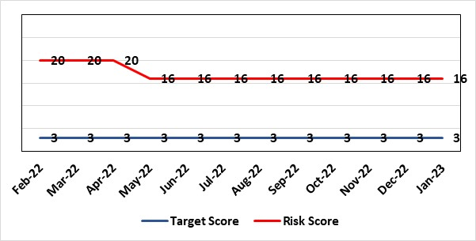 | Rationale for current score:  This risk was increased due to closure of the Burns Unit due to staffing levels, and reduced from 25 to 20 having secured the agreement of the general ITU consultants to provide cross-cover while enabling capital works are completed. Propose reduce risk to 16 now and reduce to 12 when funding confirmed by WG.
Level of Control  = |  | Rationale for target score:  This is a small clinical service with staff with highly specialised skills. While a small service may always be vulnerable to challenges (eg staff) the intention will be to operate a more resilient clinical model that is supported by other clinical groups.
Date added to the HB risk register
December 2021
Controls (What are we currently doing about the risk?) |  | Mitigating actions (What more should we do?)
- The general ITU consultants, and some Consultants from the Morriston General and Paediatric Anaesthetists to support the Burns service on a temporary basis, supporting the remaining burns anaesthetic colleagues to provide cover for the Burns service.  - The agreement reached is that they will cover the current Burns Unit on Tempest ward at Morriston hospital for 6-9 months while capital work is underway on general ITU to enable co-location of the service.  - Capital works will be completed by mid-2023 to co-locate the burns patients within the GICU footprint.  - WHSSC as commissioners of the service have been kept fully informed, as has the South West (UK) Regional Burns Network  - Other UK burns units have ICU co-located with Burns ICU, removing the need for dual certified consultants |  | Action | Lead |  | Deadline
 |  | WG have agreed funding in principle for capital works to progress. Scoping document submitted to WG and discussions ongoing about expediting a decision on an outline/full business case. | Morriston Service Group |  | 30th November 2023
Assurances (How do we know if the things we are doing are having an impact?)  Effect on patients of the temporary closure of the burns service in Swansea is mitigated by maintaining an urgent assessment/stabilisation service for patients in Wales with severe burns, with onward transfer for inpatient care to another unit in the UK following the initial assessment.  The service reopened fully on 14/02/2022. |  | Gaps in assurance (What additional assurances should we seek?)
Additional Comments / Progress Notes
11.08.22 – EMD has secured agreement for continued support of the Burns service by anaesthetics and critical care pending the completion of capital works. While there is willingness to provide that cover, staffing vulnerabilities remain in those clinical areas.
21.11.22 Consultant cross-cover remains in place, reliant on cross-cover from general critical care and anaesthetics.
17.01.23 No change to consultant cover, which remains reliant on cross-cover from general critical care and anaesthetics. A business case for the strategic and capital investment of £7.3m has been completed and will be presented to the Board on the 26th January.

Datix ID Number: 3036  Health Care Standards: 4.1 Dignified Care, 2.1 Managing Risk & 7.1 Workforce |  | HBR Ref Number: 84  Risk Target Date: 31st December 2022 |  | Current Risk Rating  4 x 4 = 16
Objective: Best value outcomes |  | Director Lead: Richard Evans, Executive Medical Director  Assuring Committee: Quality & Safety Committee
Risk: Cardiac Surgery – A Getting It Right First Time review identified concerns in respect of cardiac surgery (including patient pathway/process issues) that present risks to ensuring optimal outcomes for all patients. Potential consequences include the outlier status of the health board in respect of quality metrics, including mortality following mitral valve surgery and aortovascular surgery. This has resulted in escalation of the service by WHSSC. |  | Date last reviewed: January 2023
Risk Rating  (consequence x likelihood):  Initial: 5 x 5 = 25  Current: 4 x 4 = 16  Target: 4 x 3 = 12 | 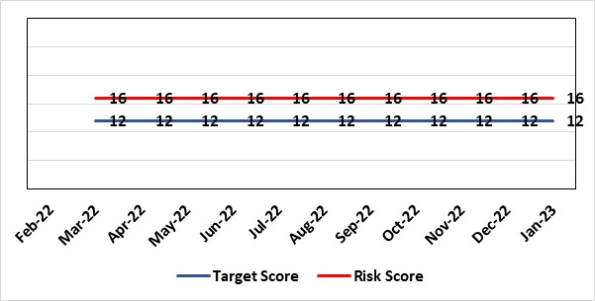 | Rationale for current score:  De-escalation of service by WHSSC from Stage 4 to Stage 3  Assurance of processes in place through implementation of the improvement plan.
Level of Control  = % |  | Rationale for target score:  Cardiac surgery is frequently high-risk surgery and an element of risk will remain.
Date added to the risk register
March 2022
Controls (What are we currently doing about the risk?) |  | Mitigating actions (What more should we do?)
- Invited Service Review by Royal College of Surgeons to advise on outcomes, good practice and areas for improvement;  - Implementation of local action plan to address areas of concern; widespread engagement among clinicians in the department.  - All surgery is now only undertaken by consultants and mitral valve repair surgery is undertaken by two mitral valve specialists; a third consultant undertakes mitral valve replacements as agreed with WHSSC.  - Complex heart valve MDT established to make decisions on appropriate surgery including MV repair and MV replacement and to direct to the appropriate consultant.  - Internal review of deaths following mitral valve surgery.  - High Risk MDT implemented, outcome decision documented on Solus.  - Dual surgeon operating mandated for complex cases (determined by the MDT) to improve outcomes.  - MDT discussion to be undertaken for all patients who develop deep sternal wound infections.  - Quality & Outcomes database established capture case outcome metrics in real time. |  | Action | Lead |  | Deadline
 |  | Develop actions for improvement as advised by RCS | Executive Medical Director |  | 31st January 2023
Assurances (How do we know if the things we are doing are having an impact?)  - An improvement plan has been developed in conjunction with WHSSC and agreed. Progress is monitored by Gold Command arrangements.  - Quality & Outcomes database established capture case outcome metrics.. |  | Gaps in assurance (What additional assurances should we seek?)  Assurance sought via RCS Invited Review on outcomes and governance in the department
Additional Comments / Progress Notes
11/08/22 – Additional visit from RCS to review an individual surgeon’s outcomes. Verbal feedback received with no immediate patient safety concerns. Report from site visit still awaited. Regular escalation meetings with WHSSC note continued improvement is systems and processes in the service.
21/11/22 Report received from RCS and action plan developed. WHSSC acknowledge improvements and will consider de-escalation on receipt of the report.
17/01/22 – WHSSC did not de-escalate in December 2022. Further information being provided by Executive Medical Director.

Datix ID Number: 2561  Health & Care Standard: Effective Care 3.1 Safe & Clinically Effective Care |  | HBR Ref Number: 85  Risk Target Date: 30th September 2023 | Current Risk Rating  4 x 5 = 20
Objective: Best value outcomes |  | Director Lead: Christine Morrell, Director of Therapies & Health Sciences  Assuring Committee: Quality & Safety Committee
Risk: Non-Compliance with ALNET Act  There are risks to the Health Board’s ability to meet its statutory duties and establish the effective collaborative arrangements required by the ALN Act, which is being implemented through a phased approach.  This risk is caused by:  - Lack of staff resource needed to carry out the additional work needed to comply with the ALN Act for operational services, especially those in the PCST Service Group. The size of the gap in terms of staff resource is now better understood.  - Issues around multi-agency working which may impact on levels of demand on operational services, and on existing SLAs through which the Health Board delivers some services to partner LAs.  - Implementation of the Act for those of above compulsory school age (post-16) commences in September 2023, though transition planning will commence from September 2023. Significant preparedness work is required to mitigate the risks this will present.  - Multiple pressures for operational services are impacting on capacity / engagement of leads within impacted services to progress tasks that need to be undertaken to mitigate the risks.  - Project management post required to support and co-ordinated implementation activity is due to end in March 2023. If this post is not extended, this will impact progress.  Potential consequences of this risk are: parent / carer and young peoples' dissatisfaction leading to complaints, Educational Tribunals and Judicial Reviews (this is new legislation with many points of ambiguity and is highly likely to be legally ‘tested’); reputational impact; and children failing to access the multi-agency support that they need with their learning needs, leading to poor outcomes. |  | Date last reviewed: January 2023
Rationale for current score:
Risk score reflects that while controls are in place, there are multiple areas of risks (relating to compliance with legislation; governance and assurance; workforce and OD; and sustainable services); and high probability (especially given multiple risk areas) of at least one of these areas of risk being realised. Caused by implementation timetable for the ALN Act, slippage against plan and need for strengthened governance (as described in ‘Risk’ section).

Risk Rating  (consequence x likelihood):  Initial: 5 x 5 = 25  Current: 4 x 5 = 20  Target: 2 x 3 = 6 | 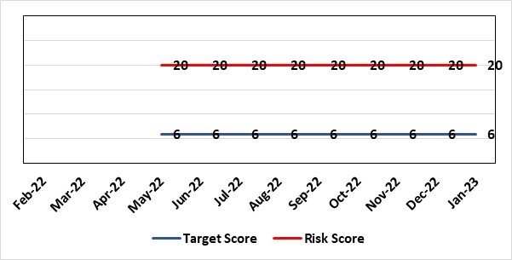 | Rationale for target score:  As the ALN Act is new legislation, there remains some ongoing likelihood of risk events during the initial phases of implementation, though with lessened consequences as a result of mitigating actions.
Level of Control
=
Date added to the HB risk register
14/05/2022
Controls (What are we currently doing about the risk?) |  | Mitigating actions (What more should we do?)
- Progressing the necessary work within an appropriate structure (see under ‘ACTIONS’) are constrained by financial and/or service delivery pressures.  - DECLO (Designated Educational Clinical Lead Officer) is in post - this is a statutory requirement.  - Health Board ALN Steering Group has been established, with structure agreed for Operational Group working under the governance of this  - Work is being progressed with Local Authority partners to ensure that activity relating to the ALN Act is grounded in a shared vision and principles to support collaborative working.  - Initial operational processes relating to statutory processes (through which Local Authorities access Health Board involvement) have been established and are in effect and work is being progressed with partners to refine operational approach.  - Advice has been received from WG to resolve key areas of particular ambiguity relating to Health Board duties under the Act.  - Regarding demand / capacity and staffing resource challenges, WG has a phased implementation timetable for the Act for the period through to summer 2024. From summer 2024, the Act will be fully in ‘delivery as usual’. The phased implementation offers partial short-term mitigation of the risks.  - Awareness has been raised at Board level through Development session and thrice-yearly updates are provided to the Quality and Safety Committee.  - A multi-agency group supported by the national ALN post-16 Implementation Lead has been formed to progress key activity in relation to post-16 implementation. |  | Action | Lead | Deadline
 |  | Work with Performance colleagues to ensure greater visibility in Performance and Q&S dashboards of data relating to compliance with statutory duties. | DECLO | 31/03/2023
 |  | Work with Informatics colleagues to ensure robust data regarding compliance with statutory duties. | DECLO | 31/03/2023
 |  | Work with LA colleagues to establish future SLA arrangements for Paediatric Therapies services and to establish the impact of any changes on the Health Board. | Interim Head of Speech & Language | 28/02/2023
 |  | Ensure continuation of ALN Project Management post. | DECLO | 31/03/2023
Assurances (How do we know if the things we are doing are having an impact?)  - There is regular reporting in respect of the ALN Act through the Patient Safety and Compliance Group.  - ALN Steering Board has been established, ensuring oversight at a senior level within all impacted operational and corporate areas.  - DECLO meets regularly with ADOTHS / DoTHS of the 3 health boards of South-West and Mid Wales for update and assurance.  - National ALN Reform Steering Group has been formed and will include Health representation (SBU Deputy DOTHS). This will provide a national forum for consideration of risks. |  | Gaps in assurance (What additional assurances should we seek?  - Extent of gap in staffing resource (gap between work required and capacity available) has been provisionally quantified, but data is imperfect and there remains some uncertainty. This is in a context where demands will increase significantly over the next year.
Additional Comments / Progress Notes
20.12.2022 – Approval of, and ensuring progress against, the ALN Workplan by the ALN Steering Group remains outstanding, and the deadline has been modified. December Steering Group meeting was a short meeting only due to other pressures and a full discussion regarding this is scheduled for January. It is anticipated that resource implications of the ALN Act will continue to be a barrier against making the progress that is required, leading to continuing breaches of statutory duties, and that this will need to be escalated to Welsh Government. Work to strengthen data quality re: compliance data, with support of Informatics, is making good progress. Activity to establish future SLA arrangements for Paediatric Therapies is progressing. The future SLA model is close to finalisation with Neath Port Talbot, while appraisal of options is taking place with Swansea.
24.01.2023 – Compliance against statutory requirements of the ALN Act remains poor, with the Health Board breaching its statutory duties in the majority of cases. Detailed ALN Project Plan has now been discussed and approved by ALN Steering Group on 24.01.2023. There is commitment to progress the workplan and that ownership of the different workstreams within the plan will be held by relevant operational leads. Work with Informatics continues to make good progress in developing accurate compliance data that is readily-visible to service leads. It is anticipated that this will support improved performance. The ALN Project Management post is due to end in March 2023. If not extended, this will present significant risks to progress. Two actions closed - Finalise ALN work plan to be progressed by the ALN Operational Group, including allocation of leads to individual work streams and have plan approved through ALN Steering Group. Discussion in Steering Group to explore solutions to ongoing capacity / engagement issues that are slowing progress on tasks needed to mitigate risks.

Datix ID Number: 3110  Health Care Standards: 4.1 Dignified Care, 2.1 Managing Risk & 7.1 Workforce |  | HBR Ref Number: 88  Target Risk Date: 31/01/2023 | Current Risk Rating  4 x 5 = 20
Objective: Best value outcomes |  | Director Lead: Inese Robotham, Chief Operating Officer  Assuring Committee: Performance & Finance Committee  For Information: Quality & Safety Committee
Risk: Non-delivery of AMSR programme benefits  There is a risk that the Acute Medical Service Re-Design (AMSR) programme may not deliver the expected performance & financial benefits in a timely way. The principal potential causes of this risk are: workforce (OCP and recruitment requirements), capacity constraints linked to significant number of clinically optimised patients (COP), financial affordability linked to 90 beds in Singleton hospital that are due to close in Q3 2023. |  | Date last reviewed: January 2023
Risk Rating  (consequence x likelihood):  Initial: 4 x 5 = 20  Current: 4 x 5 = 20  Target: 4 x 4 = 16 | 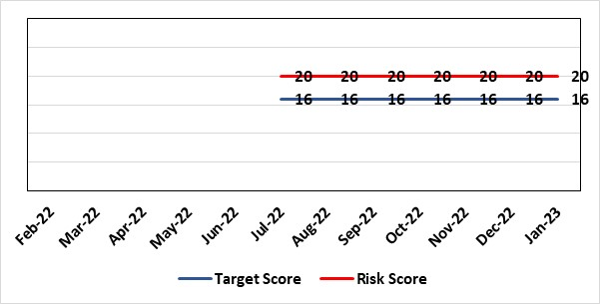 | Rationale for current score:  Current score reflects the size and complexity of the programme. Whilst partial benefits of the programme have been realised, operational performance fluctuates mainly due to continuous high numbers of clinically optimised patients (See risk #80). Sustained improvement needs to be experienced prior to reduction in score.
Level of Control  = % |  | Rationale for target score:  When measures identified are implemented it is anticipated that this will increase the likelihood of success.
Date added to the risk register
July 2022
Controls (What are we currently doing about the risk?) |  | Mitigating actions (What more should we do?)
- AMSR Programme Board reporting to UEC (Urgent & Emergency Care) Board  - Dedicated workstreams & workstream leads – all work streams have weekly assurance meetings where the sub groups provide updates on their specific tasks  - OCP (Organisational Change Policy) workstream – supporting staff engagement  - Workforce workstream – Focus on recruitment & retention. Dedicated sub groups with recruitment trackers and action plans.  - AMU (Acute Medical Unit) model workstream - focus on development of the operating policy for the AMU, including the interaction with the admitting units, WAST and specialist wards. Triage process has been agreed – system same as Emergency Department. Draft Standard Operating Procedure (SOP) created.  - SDEC (Same Day Emergency Care) collaborative workstream – focus on further development of SDEC model. SOP developed, focusing on hospital pre admission, data sessions to assist with finalising pathways.  - Specialist wards workstream – focus on role & operating model of specialist wards and interfaces. Agreement on patient criteria with preference of sub-acute /round rounds for singleton wards/ SOP template for all wards. Future – dedicated sub group on Discharge and flow hosting a work shop to standardise process across the health board & internal flow from Morriston to Singleton and Neath.  - Estates workstream focus on capital work.  - Communications – Project team have employed Freshwater to assist with communications for the programme. Focusing on shop floor communication across all hospitals with use of storyboards and TV screens providing updates at main entrances.  - Governance arrangements agreed for go / no go gateways via management board  - Assurance to Performance & Finance Committee (PFC) and (Quality & Safety Committee (QSC) and escalation to Health Board if required. |  | Action |  | Lead | Deadline
 |  | The costs of service transfer will be met through transformation of out of hospital pathways. Should savings not be fully identified, by December 2022, there will be an increased CIP commitment in 2023/24. Review to be undertaken in December 2022. A dedicated project to decommission contingency beds to commence in January 2023 with envisaged completion date of end September 2023. Progress to be reviewed at halfway point in May 2023. |  | Senior Project Director | 31/05/2023
 |  | External post-implementation review by Meridian planned to commence in February. Feedback planned for |  |  | 10/03/2023 (tbc)
Assurances (How do we know if the things we are doing are having an impact?)  Regular gateway reviews via Management Board  Assurance to PFC and QSC and escalation to Health Board if required. |  | Gaps in assurance (What additional assurances should we seek?)  Capacity and capability gaps to support the programme and drive forward actions and provide adequate assurance. Operational site pressures impacting on AMSR programme deliverables. Lack of progress in reducing bed occupancy for medicine patients.
Additional Comments / Progress Notes
21/09/2022: Project is planning the implementation phase. Two main risks remain: Workforce and Capacity. Workforce risk is managed through a dedicated workstream looking at both local and international recruitment. See HBR1 in respect of LOS & capacity. 4 Actions completed - Workforce plan to be presented at the Management Board in September. Robust OCP process; consultation end date was 29/07/2022. Targeted programme for reduction of COP focussing on improved operational efficiency (reduced length of stay improved discharge processes), implementation of Discharge-to-Assess and effective utilization of existing community capacity, strategic partnership solutions with Local Authority partners. Two focused groups established to look at different categories of COPs and provide senior oversight.
24/10/2022: A go/no go gateway for AMSR is scheduled on 16th November 2022.
06/01/2023: Action complete - A go/no go gateway for AMSR was scheduled for 16th November 2022 - Decision was Go and phase 1 implemented on 5th December. Additional go/no go review happened in extraordinary Management Board on 4th January with decision to proceed with 2nd phase of AMSR – Phase 2 commenced.
07/02/2023 – Action completed - Full centralisation of acute medical take at Morriston hospital.
3rd Go/No Go meeting of Management Board on 18/01/2023 for final 3rd phase of AMSR. Since then implementation has concluded as planned.

Datix ID Number: 3071  Health Care Standards: 4.1 Dignified Care, 2.1 Managing Risk & 7.1 Workforce |  | HBR Ref Number: 89  Target Risk Date: 31/03/2023 | Current Risk Rating  4 x 5 = 20
Objective: Excellent Staff - To be able to deliver quality care and treatment to the men in HMP Swansea equivalent to that provided in the community. |  | Director Lead: Gareth Howells, Executive Director of Nursing (lead) / Inese Robotham, Chief Operating Officer (support)  Assuring Committee: Quality & Safety Committee
Risk: Healthcare Nursing Staff Levels at HMP Swansea  There is a risk that the men in HMP Swansea will not receive the appropriate standard of care. This is due to the fact that the nursing establishment within the prison no longer fully meets the changed demographics and numbers of men being detained. The maximum operational capacity of the Prison can reach circa 480 men. The Health Board investment into the Prison is based on delivering services to 250 men. This was also highlighted as a risk in the recent HIW governance review. |  | Date last reviewed: January 2023
Risk Rating  (consequence x likelihood):  Initial: 4 x 5 = 20  Current: 4 x 5 = 20  Target: 2 x 2 = 4 | 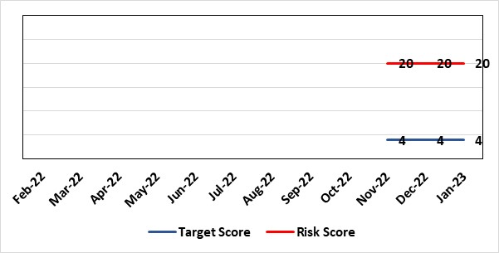 | Rationale for current score:  Consequence major – unable to fully deliver on the recommendations of HIW due to low healthcare staffing numbers, further impacted during periods of sickness or absence as no headroom. Likelihood expected – suboptimal care provided on a daily basis.
Level of Control  = % |  | Rationale for target score:  Consequence minor – With sufficient staffing numbers the prison will be able to deliver on HIW recommendations and fully implement the actions in the Health Delivery Plan. Likelihood unlikely – With full establishment and headroom, suboptimal care is less likely.
Date added to the risk register
30/11/2022
Controls (What are we currently doing about the risk?) |  | Mitigating actions (What more should we do?)
Daily communication with the Governor about the availability and priority of healthcare nursing staff. The prison regime may be amended to reflect numbers.  Review of skill mix and Health Board policy:  - Introduction of a pharmacy technician role who can administer drugs to support nursing establishment.  - Training Health Care Support Workers to be 2nd checkers for CD drugs.  The Health care charges can only focus on clinical aspects, performance, assurance and health promotion work is not prioritised.  Bank and agency staff are used in a limited way, when skillset allows.  E-rosta implemented and scrutinised with regular reporting to Quality and Safety and Prison Partnership Board.  Escalation for overtime and additional hours to fill shortfalls.  Short term, PCTG has identified up to £100k non recurrent money, until the 31st March to increase recruitment in the highest risk areas and to fund absence as there is no ‘head room’ built into the funding to provide absence cover. This non recurrent funding ceases on 1st April 2023 and has been highlighted to the executive. |  | Action | Lead | Deadline
 |  | Undertaking financial exercise to identify £100k across the group to support the nursing establishment uplift. | Deputy Group Nursing Director | Complete (for 2022/23 year)
 |  | Business case developed included in IMTP and representation made to WG and HB for additional funding. | Head of Nursing & Community Services | 03/04/2023
 |  | Through Prison Partnership Board exploring opportunities to implement the recommendations of HIW and Health Delivery Plan. | Deputy Group Nursing Director | 31/03/2023
Assurances (How do we know if the things we are doing are having an impact?)  Prison feedback and complaint process  Progress reporting on action plans through Health Board Q&S structures. |  | Gaps in assurance (What additional assurances should we seek?)  Implementation and reporting of clinical audits. Audit framework for HMP Swansea in development.
Additional Comments
Jan 2023: Action Complete: Undertaking financial exercise to identify £100k across the group to support the nursing establishment uplift. The health board has approached the WG to seek additional funding for the prison. Short term, PCTG has identified up to £100k non recurrent money, until the 31st March to increase recruitment in the highest risk areas and to fund absence as there is no ‘head room’ built into the funding to provide absence cover. This non recurrent funding ceases on 1st April 2023 and has been highlighted to the executive.

Risk Score Calculation

For each risk identified, the LIKELIHOOD & CONSEQUENCE mechanism will be utilised. Essentially this examines each of the risks and attempts to assess the likelihood of the event occurring (PROBABLILITY) and the effect it could have on the Health Board (IMPACT). This process ensures that the Health Board will be focusing on those risks which require immediate attention rather than spending time on areas which are, relatively, a lower priority.

