Highlight Report to Management Board

Name of Reporting Group | Quality and Safety Group
Date of Last Meeting | 16.1.23
Author | Angharad Higgins, Interim Head of Quality and Safety
Sponsor | Gareth Howells, Director of Nursing, Hazel Powell, Deputy Director of Nursing
Presenter | Gareth Howells, Director of Nursing
Appendices | Appendix 1: Summary of progress against Quality Priorities  Appendix 2: Quality Priorities Work Programme
Summary of the Meeting
This report provides a monthly update position on the work of the Quality and Safety Group, the Quality Priorities Programme Board is a sub-group of the Quality and Safety Group and for this reason it is proposed that this and future reports include an updated position on progress against each of the priorities.

Standardised Terms of Reference
Following a process of standardisation, terms of reference for the Quality and Safety Group (QSG), Patient and Stakeholder Experience Group (PSEG) and Patient Safety and Compliance Group (PSC) were agreed.

Quality and Safety Risk Report
There are currently 8 risks in relation to quality and safety scored at 20 or above. Updates from risk managers will be reported through future meetings,

Quality Strategy Update
The draft Quality Strategy is being presented to Board for approval on 26.1.23.
An implementation plan will be developed to deliver the strategy and this will be progressed through QSG sub-groups.

The Quality Strategy launch event is planned for March 2nd 2023.

Patient and Stakeholder Experience Group update
- A focus session on PROMS was held in the last meeting, how we include PROMS in our reporting will be progressed by the Patient Feedback Team.
- Triangulation of patient and staff experience: a working group is being established chaired by the Assistant Director of Insight, Engagement and Fundraising.
- An update on how we communicate with patient waiting for our care was received and the group will take forward commitments within the Quality Strategy to improve how we communicate with patients whilst they are waiting for services.

Patient Safety and Compliance Group
Issues for escalation were reported by Morriston Service Group,
- Reporting of pressure damage and a concern regarding potential duplication, this will be taken forward through the Pressure Ulcer Prevention Strategic Group (PUPSG).
- No assurance audits undertaken in the month. Tool under development for paediatric areas. Unannounced audits planned for February.
- The increased risks within unscheduled care, in particular through the Emergency Department (ED), the service group risk register reflects this, the risk is in relation to the acuity of patients attending the ED along with the demand on the department. Action against this is reported through the Risk Management Group.
- The positive work in delivering the Health Inspectorate Wales (HIW) ED action plan was noted.

Clinical Outcomes Effectiveness Group
Minutes of latest meeting received.
Discussions relating to the following were held and will be pursued through the group medical directors.
- Leadless pacemakers
- Left Atrial Appendage Occlusion
Clinical audit- service group medical directors asked to confirm that they are going to deliver their projects.

Safeguarding
Report received. Notes increase in number of attempted hangings in November, but this had not been the case in December.

Quality Priorities Programme Board
Updates included as Appendix 1. Sepsis priority is providing direct report to Management Board meeting and therefore reported separately for this period.

The January meeting of the Quality Priorities Programme Board will be dedicated to agreeing our quality priorities for the current year and how we sustain improvements for our current priorities.

Issues for Escalation from service groups (which have not been raised within QSG sub-groups)

Mental Health and Learning Disabilities
- On-going serious incident which is currently at pre-inquest stage
- Patient absconding incident under investigation
- Potential Information Governance breach and reputational issue due to previous patient recently self-publishing book referring to their time in our care
- Staffing pressures being across the service

Primary Care, Community and Therapies
New risk within Sexual Health services due to their software company entering into liquidation. The service group are putting appropriate mitigation in place.

Morriston
Ongoing work with WAST (Welsh Ambulance Services NHS Trust) in relation to off-load issues. This is reflected in the service group risk register.

Neath Port Talbot Singleton
No issues raised.

Key Decisions
- Standardised terms of reference agreed for QSG, PSEG and PSC
- Volunteer Services will report into PSEG
Challenges, Risks and Mitigation
Quality Priorities
- There is a high risk to delivery of the Falls Prevention priority due to the problems with the interface between ward metrics and DATIX, meaning that ward level falls incident data is not readily available. This is an all-Wales issues, which is also affecting other areas of patient safety. Progress has been made with informatics to build a local work around for short term use – this remains in progress.
- End of Life Care (EOLC): discussions being held to identify mitigation to risk regarding digital intelligence and recording of EOLC planning.

Action Being Taken (what, by when, by who and expected impact)
Quality Priorities
- Falls risk being progressed as part of national discussions regarding Once for Wales
- Meeting arranged with Digital Intelligence regarding recording of discussions relation to EOLC
- Meeting sought with workforce and OD regarding sustaining Suicide Prevention training in the longer term
Service Group Actions Required
Quality Priority | Action Required | Leads | Timescale | Impact
Falls Prevention | - Contribution to Falls Summit outlining Qi work underway within groups to reduce harm from falls | Service group Falls QP lead | 28.2.23 | Sharing of good practice
End of Life Care | - Development of plans to improve training compliance | - Service Group EOLC QP leads | 30.11.22 (overdue) | Improved knowledge of EOLC, resulting in increased use of Care Decision Tool and improved compliance with NACEL audit fields.
Suicide Prevention | - Develop plans to increase number of staff trained | Service group Suicide Prevention QP lead | 31.12.22 (overdue) | Increased awareness of suicide

Financial Implications
None

Recommendations
Members are asked to:
- Note the update from the Quality and Safety Group
- Receive the report on progress against the Quality Priorities, as outlined in Appendix 1.
- Receive an update on the Sepsis quality priority in a future report

Appendix 1 Quality Priority Updates

Quality Priority Goals | Methods
Falls Prevention  Reduction in harm from falls | - Review and update Overarching steering Group members  - Launch of Regional Falls Prevention Community Taskforce  - Improved Quality Assurance through new audit programme  - HB Training programme to be agreed
Measures | Trajectories
- Falls per 1000 bed days
- Continued reduction in overall falls rates
- Overarching Falls Prevention Strategic group with revised TOR and membership launched Dec 2022
- Falls summit planned for Q4 2022/2023
- Community falls prevention to be area of focus for 2023 with engagement with safe care collaborative

Quality Priority Goals | Methods
End of Life Care  Improved management of End of Life Care in hospital and community settings | - Review findings of National Audit of Care at End of Life (NACEL):  - Build in feedback mechanism from HB mortality Reviews,  - All Patients to be recognised and receive EOLC throughout HB  - Ensure training in recognition and management of patients approaching EOLC from 1yr down: Review of Mandatory and Statutory training to ensure EOLC adequately provided, >95% staff compliance
Measures | Trajectories
- % of hospital deaths reviewed by the Medical Examiner with a DNACPR  - % of hospital deaths reviewed by the Medical Examiner with a plan for end of life  - % hospital deaths reviewed by the Medical Examiner with a care decisions guidance document in place  - % staff trained in EOLC | 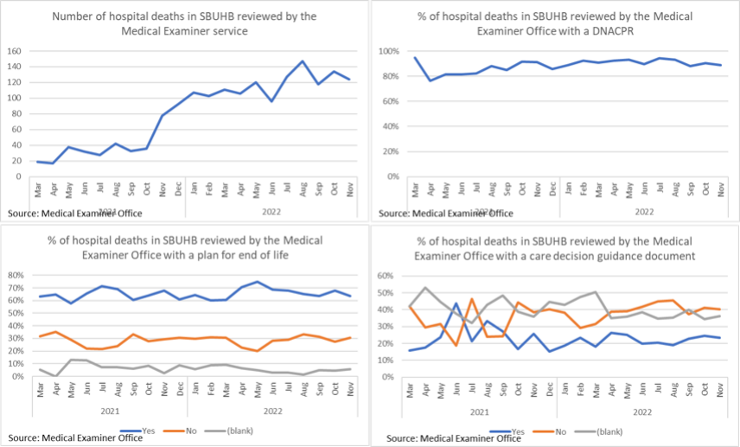
- Solution required to digital issues
- Limited medical engagement

Quality Priority Goals | Methods
Suicide Prevention | - Engagement in Sharing Hope project  - Delivery of training in suicide prevention across all teams
Measures | Trajectories
- Education of all available staff across the HB in recognising and managing suicide.  Continue to support and work with Swansea Multi Agency Group and other stakeholders across the HB in relation to obtaining a baseline assessment of suicide cases and map against national trends  - Occupational Health and Wellbeing support for staff with anxiety/depression to prevent escalation in risk of suicide  - Remove ligature risks across all HB premises | 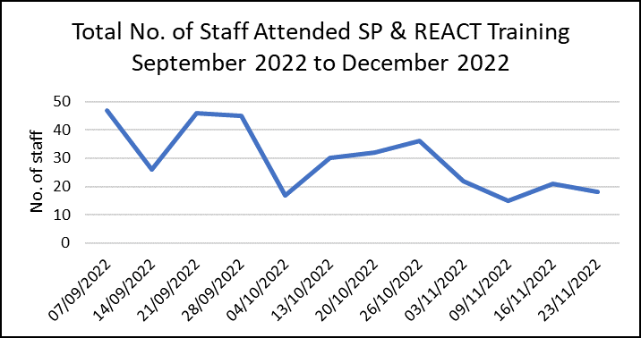
- Successful integration of REACT and Suicide Awareness training
- Continued success of Sharing Hope
- Planning for development of HB Suicide Strategy underway
- REACT training to be included in Managers’ Pathway

Appendix 2: Quality Priority Work Programme Updates
Falls Prevention

Senior Responsible Officer | Elizabeth Davies
Project Manager | Eleri D’Arcy
Quality Improvement Leads | Sheena Morgan
Annual Plan Goals
- Increase patient safety by reducing number of inpatient injurious falls to 195 or below per month, representing a 10% reduction in falls from the 2021/22 injurious falls rates.
- Achievement of inpatient falls per 1000 bed days below national average of 6.6
Evidence Base
NICE CG161Falls in older people: assessing risk and prevention National Audit of Inpatient Falls (NAIF) recommendations:
- Multifactorial risk assessment of older people who present for medical attention because of a fall, or report recurrent falls in the past year
- Multifactorial interventions to prevent falls in older people who live in the community
- Multifactorial risk assessment of older peoples’ risk of falling during a hospital stay
- Multifactorial interventions to prevent falls in inpatients at risk of falling
Summary of Progress Against Outcomes
December progress position | Falls Per 1000 Bed Days | Number of Falls
Mental Health and LD | 4.3↓ (20% reduction compared to Nov 2022) | 18 ↓ (18 % reduction compared to Nov 2022)
Morriston | 4.3↑ (7.5% increase compared to Nov 2022) | 88↑(19 %increase compared to Nov 2022)
NPTSSG | 4.7↑(8% increase compared to Nov 2022) | 61↓ (10 % reduction compared to Nov 2022)
PCCT | 5.1 ↑ (104% increase compared to Nov 2022) | 6 ↑(100% increase compared to Nov 2022)
SBUHB* | 4.3↓ (2% reduction compared to Nov 2022) | 177↑ (5.5% increase compared to Nov 2022)

- Continued reduction in overall HB falls rates.
- Sustained reduction in falls rates within MH&LD service group.
- The overarching Falls Prevention Steering group has revised TOR and membership in order to increase impact and engagement
- Regional Falls Prevention Community Taskforce now meeting regularly
- QI projects all progressing with data analysis ongoing. Ward focus work stream due to be completed March 2023.

Critical Success Factors (CSF)
- CSF | Accountable individual Tier 1(Director Level) | Accountable Individual Tier 2 (Head of Service, Senior Matron) | Measurement Tool | Baseline | SMART Target | Service Group Updates | HB Progress
Compliance with multi-factoral risk assessment in in-patient settings | Group Nurse Directors | Heads of Nursing | WNCR audit (where used)  Ward Metrics | Baselines to be established for each Service Group and provided in August report. | 100% by 31.12.22 | Mental Health and LD  Audit currently being completed on application of MRFA. | QA programme being developed – WNCR data unavailable and issues with functionality nationally. Issue raised with WNCR project lead.
Morriston
Morriston have now transitioned to WNCR
NPTSSG
WNCR measures compliance with completion on the nursing record
PCCT
In use – awaiting data
Establishment of programme of QI support to areas of high incidence in order to undertake tests of change | Programme Manager | Heads of Nursing  Falls QI Lead | QI activity reports | Current activity ad hoc and hot co-ordinated | Programme developed and tested in two ward areas by 31.12.22 | Mental Health and LD  QI project of sleep hygiene identified – work in planning stage | The Falls QI leads are working with service groups to apply QI methodology to their work, current work includes the Delta Project in PCCT and the Bay Watch project in Morriston.  Regional Falls prevention Taskforce launched 17/11/2022.  Falls summit in planning phase – to be held Q4 2022/2023  See programme of works
Morriston
Baywatch roll out delayed due to AMSR – planned end of Jan 2023.
NPTSSG
Falls audit completed in Ward 3. Audit tool shared with lead nurse for comment.
PCCT
Workshop delayed to be rescheduled post-Falls summit.
Increase availability of information and training to staff in order to improve their skills and awareness in falls reduction | SRO  Head of Workforce and OD  Head of Communication | Project Manager | Training records from targeted training events  Number of intranet features  Podcast downloads | Ad hoc training provided, no co-ordinated approach | Two targeted training events held by 31.10.22  Two intranet items by 31.12.22  Podcast download target to be developed | Mental Health and LD  ESR training information shared. | Additional Falls Brief Intervention Training being held in Feb 2023 – available all to all clinical community staff.  ESR data not validated and not reflective of compliance of training available.
Morriston
ESR training information shared and training needs discussed within service group falls group.
NPTSSG
ESR training information shared.
PCCT
Task group established within service group to
- Identify training needs
- Review provision
- Achieve 100% of patient facing staff trained in falls awareness by end of October 2023

Risks to Delivery
- There is a risk to delivery of this priority due to the problems with the interface between ward metrics and DATIX, meaning that ward level falls incident data is not readily available. This is an all-Wales issues, which is also affecting other areas of patient safety. Progress has been made with informatics to build a local work around for short term use – this remains in progress. No update yet received.

End of Life Care

Senior Responsible Officer | Sue Morgan Clinical Lead
Project Manager | Tracy Rowe (part time)
Quality Improvement Leads | Emma Smith  Samantha Scott

Annual Plan Goals
- Improve the compliance and recognition of End of Life Care
Evidence Base
NICE Quality Standard 13 End of life care for adults covers care for adults (aged 18 and over) who are approaching their end of life.
The five priorities for care of the dying person are:
- That the possibility (that a person may die within the next few days or hours) is recognised and communicated clearly, decisions made and actions taken are in accordance with the person’s needs and wishes, and these are regularly reviewed and decisions revised accordingly.
- Sensitive communication takes place between staff and the dying person, and those identified as important to them.
- The dying person, and those identified as important to them, are involved in decisions about treatment and care to the extent that the dying person wants.
- The needs of families and others identified as important to the dying person are actively explored, respected and met as far as possible.
- An individual plan of care, which includes food and drink, symptom control and psychological, social and spiritual support, is agreed, co-ordinated and delivered with compassion.
Summary of Progress against outcomes
Measures for the priority have been developed and there has been positive engagement from Digital Intelligence with this work.
We now have a dashboard of information available on a HB and service group level. This work will enable service groups to put in place targeted improvement plans.
There focus of current work is to complete the NACCEL audit
At an organisational level, there needs to be consideration of EOLC within all of our clinical planning remains, including AMSR.
Critical Success Factors (CSF)
CSF | Accountable individual Tier 1(Director Level) | Accountable Individual Tier 2 (Head of Service, Senior Matron) | Measurement Tool | Baseline | SMART Target | Service Group updates | HB Progress
Medical engagement with EOLC throughout service groups, demonstrated through medical EOLC champions within each service | Group Medical Directors | Clinical Directors | Service Group reports | Not available | 50% of services with at least one EOLC champion within Medical Team by 31.10.22, to increase to 100% by 31.12.22 | Mental Health and Learning Disabilities  No detail of medical leads provided | Analysis of training information shows limited training of medical teams across all service groups.
Morriston
No detail of medical leads provided
NPTSSG
The service group has identified EOLC from Oncology, representation required from breadth of service group divisions.
PCCT
Medical engagement within service group, specific work SMART target for contractors to be developed
All areas of SBUHB appropriately utilising the All Wales Care Decision guidance to support care in the last days of life, | Group Medical Directors | Clinical Directors | NACEL  Clinical audit programme | Not available | Development of audit plan by 30.9.22  >70% compliance by 31.10.22  > 85% compliance by 31.12.22 | Mental Health and Learning Disabilities | All service groups are asked to complete the EOLC HB audits and to provide their named leads of the Clinical Lead for EOLC.
 |  |  |  |  |  | Morriston
 |  |  |  |  |  | NPTSSG
 |  |  |  |  |  | PCCT
Engagement in NACEL audit | Group Medical Directors | Clinical Directors | SRO report | Not available | Named individual from each Service Group to have actively supported NACEL audit 30.9.22 | Mental Health and Learning Disabilities  Findings of Round 3 being reviewed by MH and LD Clinical Audit sub-group.  Service group is a member of national NACEL MH group. | Round 4 NACEL audit underway.
 |  |  |  |  |  | Morriston Named leads for NACEL audit identified and supporting | Round 4 NACEL audit underway.
 |  |  |  |  |  | NPTSSG  No lead provided. | Round 4 NACEL audit underway.
 |  |  |  |  |  | PCCT  No lead provided. | Round 4 NACEL audit underway.
Staff are trained in EOLC | Group Nurse and Medical Directors | Heads of Nursing/ Clinical Directors | Service Group reports | Not available | 95% of relevant staff trained. | Mental Health and Learning Disabilities  1.9 % of staff have been booked onto EOLC training | Training data processed and provided for service groups individually.
Morriston
6% of staff have been booked onto EOLC training
NPTSSG
5 % of staff have been booked onto EOLC training
PCCT
2.1% of staff have been booked onto EOLC training

Risks to Delivery
- There is a risk to delivery through limitations of our digital intelligence systems to record discussions relating to EOLC. Meeting arranged with DI to explore solutions.

Senior Responsible Officer | Stephen Jones Chair Suicide Prevention Group
Project Manager | Jayne Whitney
Quality Improvement Leads | Emma Smith  Samantha Scott
Annual Plan Goals
Suicide Prevention - early recognition of anxiety and depression leading to risk of suicide
Evidence Base
Nice quality Statements 189
Statement 1 Multi-agency suicide prevention partnerships have a strategic suicide prevention group and clear governance and accountability structures.
Statement 2 Multi-agency suicide prevention partnerships reduce access to methods of suicide based on local information.
Statement 3 Multi-agency suicide prevention partnerships have a local media plan that identifies how they will encourage journalists and editors to follow best practice when reporting on suicide and suicidal behaviour.
Statement 4 Adults presenting with suicidal thoughts or plans discuss whether they would like their family, carers or friends to be involved in their care and are made aware of the limits of confidentiality.
Statement 5 People bereaved or affected by a suspected suicide are given information and offered tailored support
Summary of Progress against outcomes
Sharing Hope- 149 people engaged in programme in October, 13 different projects underway

Suicide awareness and prevention training- 115 people trained in October

Critical Success Factors (CSF)from December 2023.
CSF | Accountable individual Tier 1(Director Level) | Accountable Individual Tier 2 (Head of Service, Senior Matron) | Measurement Tool | Baseline | SMART Target | Service Group Updates | Health Board Progress
Delivery of Sharing Hope project to provide creative outlet for staff at risk of suicide | SRO | Project Manager  Sharing Hope lead | Engagement within project  Completion of artistic project  Funder evaluation report | New project | > 100 participants to engage with project during its duration (2 years)  >90% of participants within project to report positive benefit at completion of project |  | 149 staff engaged October  Sharing Hope film  - As of end of October 2022 – 377 views  - Article and film launched for public viewing on 4th October 2022  - Social platforms Swansea NHS site on Facebook & Twitter  - 70 likes – 15 comments, 49 shares on Facebook  - 10 likes – 8 shares on Twitter  - 2.9 k views via the YOUTUBE link
Staff trained in suicide prevention | SRO | Project Manager  Service Group Leads | Number of staff trained | REACT : 1739 at end June 22  Basic Suicide Awareness and Prevention: 703 end June 22 |  |  | Total trained up to October 2022- 874
Staff able to access timely emotional wellbeing support | Head of Wellbeing | Wellbeing Team | Number of staff accessing support who have had suicidal thoughts in past 7 days | 11 staff reporting suicidal thoughts in past 7 days (1.1.22-31.5.22) | To be developed |  | Reported having suicidal thoughts in the previous 7 days- 11.9% of referrals.
Staff able to access information on community resources to support wellbeing | SRO | Project Manager | Creation of resource directory | New project | Directory in place and accessible via intranet |  | Directory in development, in partnership with Hafal (3rd sector organisation)

Risks to Delivery
- There is a risk of being unable to measure impact within this priority due to the lack of real time information on suicide rates, this will be considered as part of the review of GMOs.

