



Meeting Date | 23 February 2023 |  | Agenda Item |  |  | 3.1
Report Title | Healthcare Acquired Infections Update Report
Report Author | Nicola Lewis, Interim Matron, Infection Prevention & Control
Report Sponsor | Gareth Howells, Executive Director of Nursing & Patient Experience
Presented by | Delyth Davies, Head of Nursing, Infection Prevention & Control
Freedom of Information | Open
Purpose of the Report | This paper provides the Committee with an update on the Health Board’s progress against Tier 1 infections and against the Infection Improvement Plan.
Key Issues | - The Health Board will not achieve the 2022/23 infection reduction expectations for C. difficile, and bacteraemias caused by Staph. aureus, Klebsiella spp. and Pseudomonas aeruginosa. To achieve the infection reduction expectation for E. coli bacteraemia, there could be no more than 27 further bacteraemia between February and the end of March.  - The incidence per 100,000 population of Staph. aureus bacteraemia and Pseudomonas aeruginosa bacteraemia remains the highest in Wales; the second highest for both Klebsiella spp. bacteraemia and C. difficile; and the third lowest incidence for E. coli bacteraemia  - An update on the progress of the Rapid Improvement Programme in Morriston Hospital Service Group, particularly in relation to C. difficile and Staph. aureus bacteraemia. Days between cases are shown in Appendix 2.  - There has been an 87% reduction in E. coli bacteraemia in Neath Port Talbot.  - Tier 1 infections have been increasing over a number of months in Singleton Hospital. The Service Group need to undertake a deeper review of the increasing trends, and identify and agree mitigation.  - Service Group Expectations for Improvement have been communicated to all Service Groups.
Specific Action Required | Information | Discussion |  | Assurance | Approval
Specific Action Required | ☐ | ☐ |  | ☒ | ☐
Recommendations | Members are asked to:  - NOTE the progress against the tier 1 infections to 31/01/2023;  - NOTE Service Group progress in relation the Infection Improvement Plan, including Morriston’s Rapid Improvement Programme to 31/01/23;  - AGREE Service Group Expectations for Improvement;  - AGREE the proposed actions related to the overarching Infection Improvement Plan.

Infection Prevention and Control Report

 |  | Agenda Item |  | 3.1
Freedom of Information Status |  | Open
Performance Area | Healthcare Acquired Infections Update Report
Author | Nicola Lewis, Interim Matron, Infection Prevention & Control
Lead Executive Director | Gareth Howells, Executive Director of Nursing & Patient Experience
Reporting Period | 31 January 2023 |  | Report prepared on |  | 07/02/2023
Summary of Current Position
This paper will present a summary of the overarching position in relation to the number of cases of infection within the Health Board, and by Service Group, to the end of January 2023.
Health Board and Service Group progress against the Tier 1 infection reduction goals to the end of January 2023 is shown in Appendix 1.
A summary position for the Health Board is shown in the table below, identifying the cumulative position for the financial year 2022/23, the monthly case numbers, and the average monthly goal.
Table 1: Health Board Summary Position for January 2023
Infection | Cumulative Cases to end of January 2023 | Monthly total:  January 2023 | Average monthly reduction goal (max.)
C. difficile (CDI) | 169 | 22 | <8 (annual maximum: <95 cases)
Staph. aureus bacteraemia (SABSI) | 126 | 10 | <6 (annual maximum: <71 cases)
E. coli bacteraemia (EcBSI) | 224 | 20 | <21 (annual maximum: <251 cases)
Klebsiella spp. bacteraemia (Kl BSI) | 88 | 11 | <6 (annual maximum: <71 cases)
Ps. aeruginosa bacteraemia (PAERBSI) | 38 | 4 | <2 (annual maximum: <21 cases)
A summary position for Service Groups is shown in the table below, identifying the number of cases in the reporting month, with cumulative totals for the financial year to date shown in brackets.
Table 2: Service Group Summary Position for January 2023 (cumulative)
 | CDI | SABSI | EcBSI | KlBSI | PAERBSI
PCTSG - CAI | 7 (59) | 2 (50) | 12 (138) | 6 (43) | 2 (13)
PCTSG - HAI | 0 (2) | 0 (0) | 0 (2) | 0 (0) | 0 (0)
MH&LD – HAI | 0 (0) | 0 (0) | 0 (1) | 0 (0) | 0 (0)
MORR – HAI | 11 (74) | 2 (51) | 5 (47) | 4 (27) | 1 (15)
NPTH - HAI | 2 (4) | 0 (3) | 0 (2) | 0 (2) | 0 (1)
SH - HAI | 2 (30) | 6 (22) | 3 (34) | 1 (16) | 1 (9)

Progress against Infection Prevention Improvement Plan to 31.01.23
- The Health Board will not achieve the 2022/23 infection reduction expectations for C. difficile, and bacteraemias caused by Staph. aureus, Klebsiella spp. and Pseudomonas aeruginosa. To achieve the infection reduction expectation for E. coli bacteraemia, there could be no more than 27 further bacteraemia between February and the end of March. The current monthly average is 22 case/month.
- The incidence per 100,000 population of Staph. aureus bacteraemia and Pseudomonas aeruginosa bacteraemia remains the highest in Wales; the second highest for both Klebsiella spp. bacteraemia and C. difficile; and the third lowest incidence for E. coli bacteraemia.
- The year-on-year comparison (April 2022 – January 2023) for the Health Board, and by Service Group, for each of the Tier 1 infections is shown in the table below (Neath Port Talbot Hospital and Singleton Hospital are shown separately):
 | CDI | SABSI | EcBSI | KlBSI | PAERBSI
SBUHB | 2% | 6% | 7% | 7% | 100%
Morriston Hospital | 3% | 38% | 12% | 13% | 50%
Singleton Hospital | 19% | 4% | 55% | 14% | +7 cases
Neath Port Talbot Hospital | 20% | +2 cases | 87% | ≡ | ≡
MH & LD | 0 cases | 0 cases | 1 case | 0 cases | 0 cases
PCTG Gorseinon Hospital | +1 case | 0 cases | ≡ | 0 cases | 0 cases
PCTG Community acquired | 20% | 14% | 14% | 23% | 117%

- Cases of Tier 1 infections are higher in Morriston than in the other acute hospitals, accounting for 67%, 67%, 55%, 60% and 60% respectively of all hospital attributed cases of C. difficile, Staph. aureus bacteraemia, E. coli bacteraemia, Klebsiella bacteraemia, and Pseudomonas bacteraemia. This will reflect the patient mix, complexity and acuity of patients cared for in Morriston in particular. The centralisation of all acute medical intake in Morriston from January is expected to have an impact on this proportion over the coming months.

Update on Infection Prevention Improvement Plan
Service Group Improvement Progress
Acute Care Service Groups
Morriston Hospital Rapid Improvement Programme
- There was an increase in the number of C. difficile cases in January. Potentially, this is associated with a period of high incidence of acute respiratory infection (ARI).
- ARI activity and associated outbreaks across the Health Board have decreased towards the end of January, although the related impact on C. difficile is likely to continue over coming months.
- Results of Whole Genome Sequencing received in January indicated three possible C. difficile transmission events: one on AMU involving two patients; another on Ward V involving two patients; and the third on Ward B involving two patients. These incidents occurred in November and December. Incident meetings are reviewing the patient pathways to identify possible routes of transmission and discuss and agree mitigations required.
- The Morriston improvement lead has been working with wards to improve compliance with universal skin decolonisation using 2% chlorhexidine wash cloths, as practice was previously identified as variable. During January, there was a decrease in the number Staph. aureus cases to two cases in the month. The universal use of decolonisation wash cloths will need to be applied consistently to determine whether this will have a sustained impact on infection reduction.
- Days between cases of C. difficile infection and Staph. aureus bacteraemia on the rapid improvement wards, to 31st January 2023, are shown in Appendix 2.
- The Service Group continues to hold infection scrutiny panels and feeds back lessons learned through a number of forums, including Clinical Cabinet. Fortnightly scrutiny meetings continue with the Executive Nurse and Medical Directors.
- Renal services are working with Capital Planning to develop a business case for a water treatment plant to serve Cardigan Ward. If granted, the project would increase the dialysis capacity on the ward. This would provide a similar model of care to renal inpatient wards in other renal centres across the UK. Also, it would reduce the requirement to transfer inpatients three times weekly to the dialysis unit, and would reduce mixing inpatient and outpatient dialysis patients. This would improve the experience of patients and reduce potential risks of infection transmission. Additionally, patients would not have to move to the dialysis unit during ward closures caused by outbreaks of infection.
- It has been agreed with Morriston Service Group Directors that the secondment of Joanne Walters, Infection Prevention & Control (IPC) Matron, into the Morriston Infection Improvement Lead post will be extended to 31st March 2023.

Neath Port Talbot and Singleton Hospitals (NPTH&SH) Service Group
- The Service Group continues to hold infection scrutiny panels and to update monthly the Executive Nurse and Medical Directors.
- Neath Port Talbot has seen an 87% reduction in E. coli bacteraemia cases over the past 10 months. The Service Group will review whether there have been specific initiatives that may have impacted this reduction.
- In Singleton Hospital, there was a sharp increase in cases of Staph. aureus bacteraemia in January, with at least 50% of those being line associated. Other Tier 1 infections have been increasing over a number of months and there has been discussion with the Service Group of the requirement for a deeper review of the increasing trends, and to identify and agree mitigation.

Primary Care, Community & Therapies Group
- Monthly scrutiny meetings continue in Primary Care and the Service Group. Recent increases in cases of community associated infections has resulted in escalated monitoring, and an increase in frequency of updates to the Executive Nurse and Medical Directors to twice monthly.
- The Service Group has developed an electronic Significant Event Analysis data collection tool, utilising Microsoft Forms, to collate responses from General Practices and Care Homes on community-associated cases of C. difficile infection. These process has been incorporated within communications sent to General Practices for each case of C. difficile, for completion and return to the Service Group within 14 days. This process is intended to facilitate analysis and identification of themes for learning.

Service Group Expectations for Improvement:
With the Tier 1 infections being above infection reduction trajectories, the expectation of Service Groups is that they ensure a continued focus on the following key actions:
- Continue attendance at the Executive led Service Delivery Group review meetings;
- Maintain focus on Service Group governance processes (via Service Group IPC committee);
- Undertake a clinical review of individual cases to identify lessons learnt and if infections were avoidable/unavoidable;
- A focus on reducing antimicrobial prescribing; with identification of services with high usage or reduced compliance with Start Smart Then Focus;
- The universal use of 2% chlorhexidine wash cloths to reduce risk of skin colonisation with Staph. aureus and multi-drug resistant bacteria;
- A focus on reducing the number of infections in our areas of highest incidence, and ensuring the clinical leaders in those areas are aware of their role and responsibilities in HCAI reduction;
- Compliance with mandatory IPC-related training, including ANTT and improved ANTT competence assessments;
- Ensuring clinical areas are clean and patient care equipment checks are taking place at recommended frequencies, e.g. mattress checks undertaken at patient discharge and weekly intervals;
- The appropriate evidence-based bundles of care are fully implemented (e.g. over 40% of Staph. aureus bacteraemia is line-associated);
- Continued focus on Service Group-specific areas of action, e.g. PCTG and Care Homes, NPTH & SH Service Group and Oncology.

Update on Infection Prevention Improvement Plan
Progress against the IPC improvement plan is as follows:
- An ANTT task and finish group has been established, with representatives from each Service Group in order to drive improvement in training compliance.
- Excellent progress has been made by Digital Intelligence during January to work through issues that were causing inconsistencies in data. Issues had related to the translation of scientific infection onset definitions into a digital script. These have been resolved and the process has moved to the report testing stage to establish and develop robust instructions for use and training presentations on the use of the dashboard.
- Capital Planning continue with plans for future dedicated decant facilities as part of the Morriston site reconfiguration. The most recent update from Planning is that enabling work for the modular ‘decant’ wards is scheduled to commence during 2023/24, with the majority of the work estimated to be completed through 2024/25.

Challenges, Risks and Mitigation
- Current pressures on Health Board services, both in the community and in hospitals, continues to be extreme, as are the pressures on providing social care packages. The demand for unscheduled acute care remains high, leading to increased demand for inpatient beds. There are increasing numbers of medically fit for discharge patients, increased length of stay, and staff shortages, all of which increase risks of delivering safe patient care.
- The age and condition of the estate is a challenge, and planned preventive maintenance is not possible without the provision of dedicated decant facilities.
- The Infection Prevention & Control Nursing (IPCN) Team has held a Band 7 post to provide an additional resource to the Immunisation Team at a time of high demand for that service. The recent announcement of a National Immunisation Framework will, it is hoped, be accompanied by Welsh Government funding. Once this funding is confirmed, the Band 7 IPCN post will be released for advertisement and recruitment.
- The redirection of a Band 6 IPCN post from secondary care to Primary Care and Community (whilst also maintaining an input for Mental Health and Learning Disabilities) does impact on the IPCN support for secondary care.
- The secondment of the Infection Prevention & Control Matron to support the rapid improvement programme at Morriston has been extended until 31st March 2023. Although this allows the Matron to focus only on improvement work, the operational workload of the IPC Matron continues to be shared across the remaining senior IPC Team.
- The increase in ARI seen over winter months are likely to have an ongoing impact on C. difficile incidence within the Health Board. In previous years, the Health Board has seen an increase in the numbers of C. difficile cases approximately 8 to 12 weeks after the peak of the respiratory viruses. There are a number of studies on the co-seasonality of C. difficile and influenza, pneumonia and other respiratory viruses, with one study estimating that there could be an impact on C. difficile for up to 6 months.
Actions in progressing Infection Prevention Improvement Plan (what, by when, and by whom)
Action: With data validation completed, the reporting function of the Dashboard will be reviewed and instructions for use and training developed. Target completion date: 28.02.23. Lead: Head of Nursing IP&C and Corporate Digital Intelligence Partners.
Action: Roll-out of Digital HCAI Dashboard. Target completion date: 31.03.23. Lead: Head of Nursing IP&C and Corporate Digital Intelligence Partners.
Financial Implications
A Department of Health impact assessment report (IA No. 5014, 20/12/2010) stated that the best estimate of costs to the NHS associated with a case of Clostridioides difficile infection is approximately £10,000. The estimated cost to the NHS of treating an individual cost of MRSA bacteraemia is £7,000 (the cost of MSSA bacteraemia could be less due to the availability of a wider choice of antibiotics). In an NHS Improvement indicative tool, the estimated cost of an E. coli bacteraemia is between £1,100 and £1,400, depending on whether the E. coli is antimicrobial resistant. Estimated costs related to healthcare associated infections, from 01 April 2022 to the end of January 2023 is as follows: C. difficile - £1,690,000; Staph. aureus bacteraemia - £882,000; E. coli bacteraemia - £255,100; therefore, a total cost of £2,827,100

Recommendations
Members are asked to:
- NOTE the progress against the tier 1 infections to 31/01/2023;
- NOTE Service Group progress in relation the Infection Improvement Plan, including Morriston’s Rapid Improvement Programme to 31/01/2023;
- AGREE Service Group Expectations for Improvement;
- AGREE the proposed actions related to the overarching Infection Improvement Plan.

C. difficile
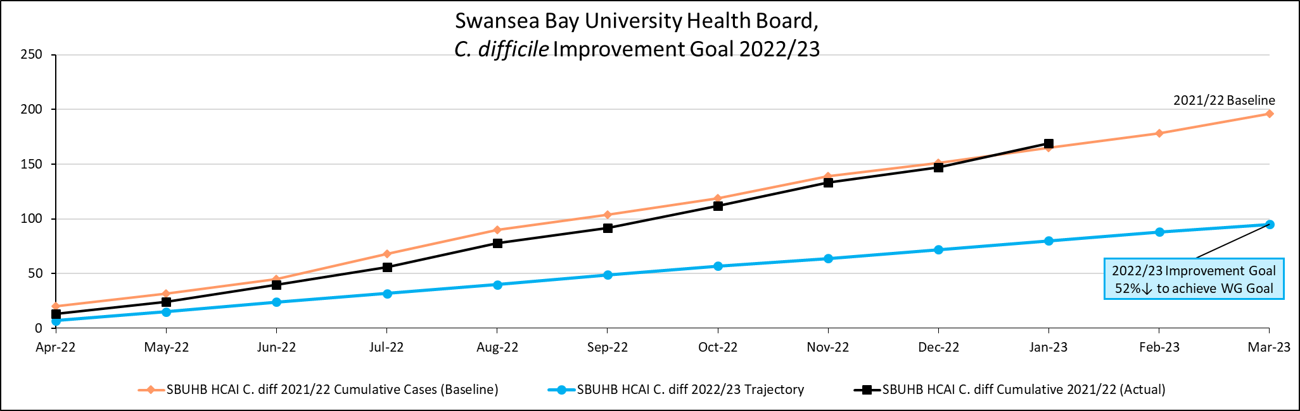
2% yr-on-yr

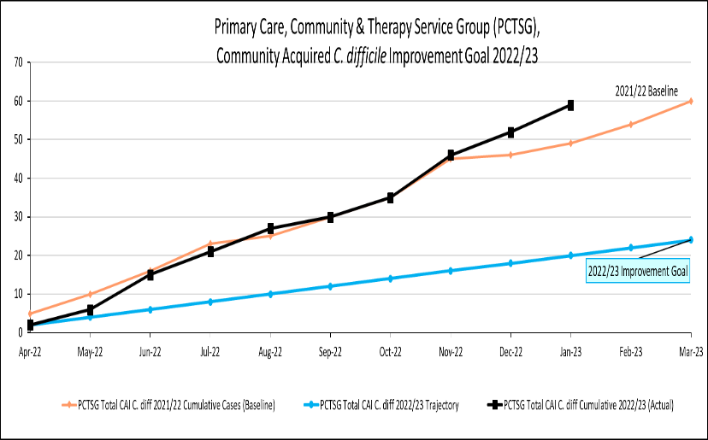 | 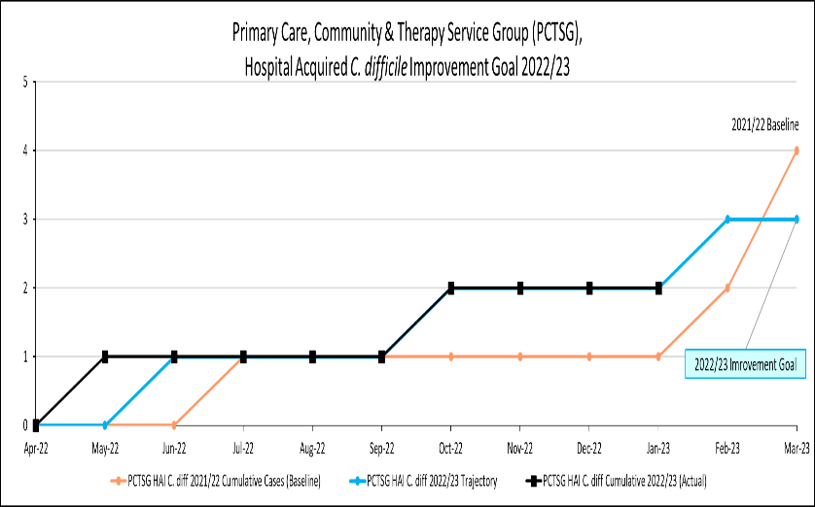
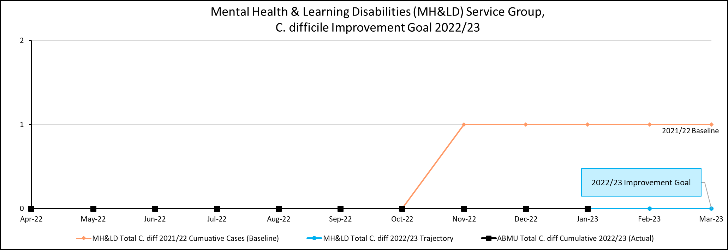 | 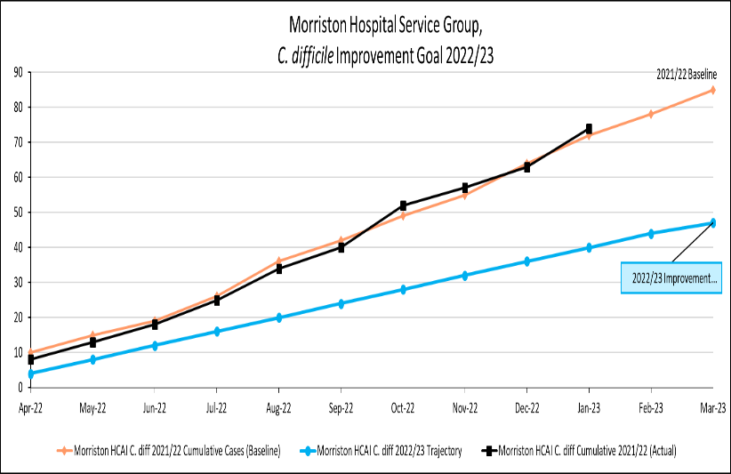
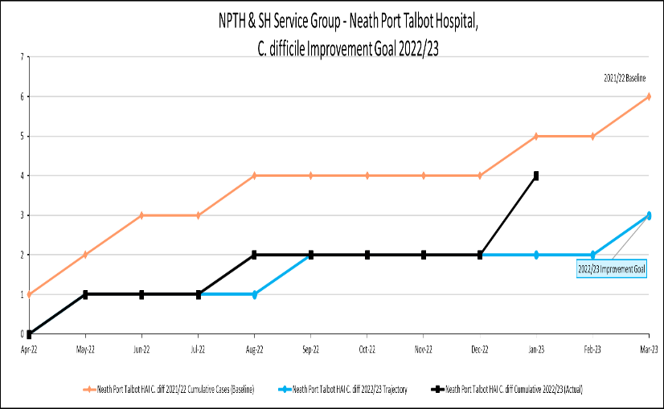 | 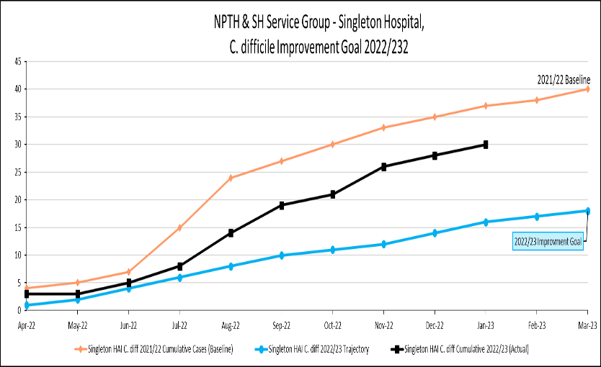

Staph. aureus bacteraemia
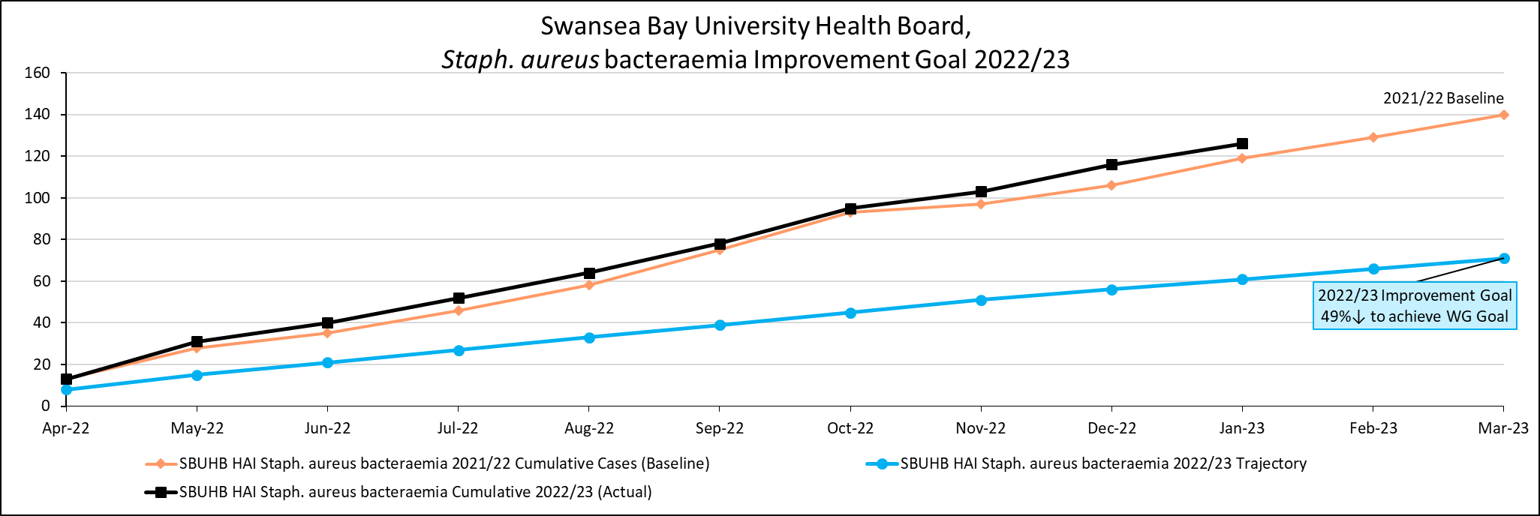
6% yr-on-yr

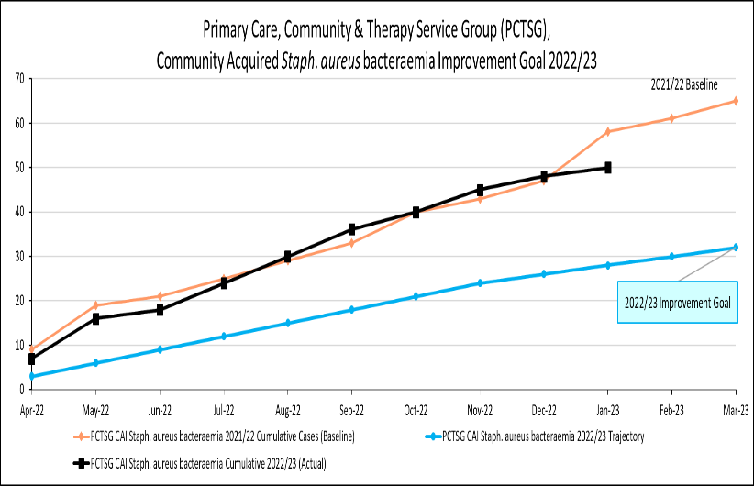 | 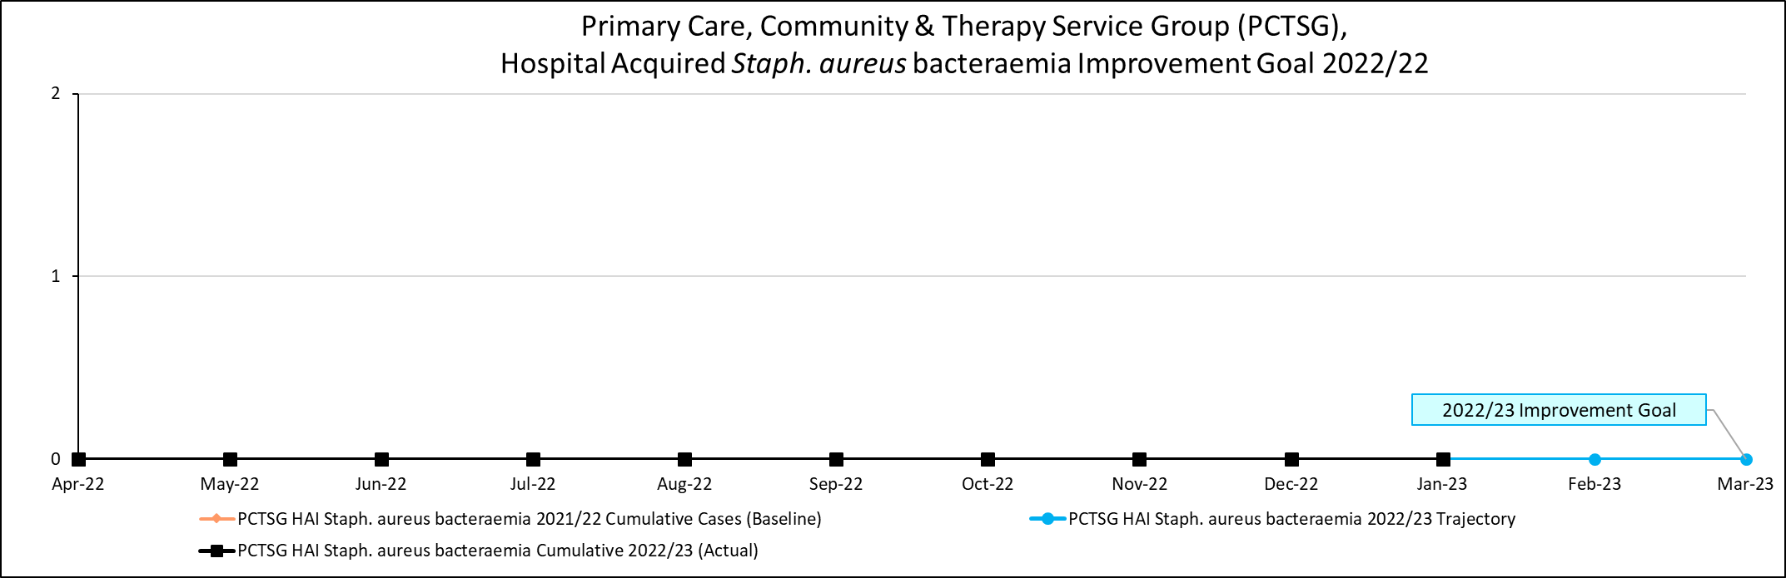
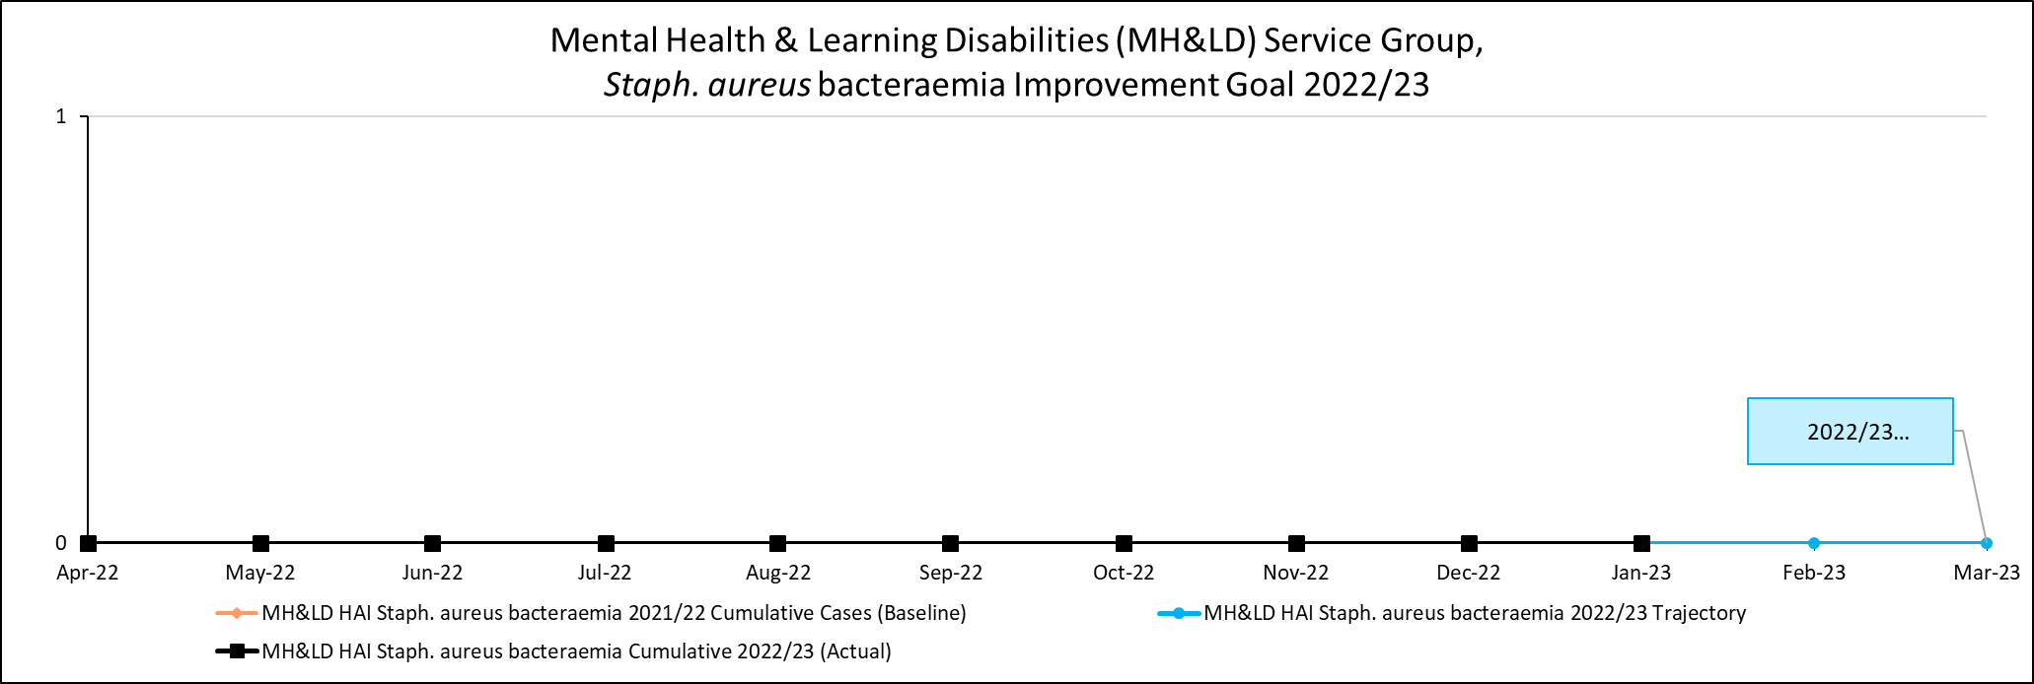 | 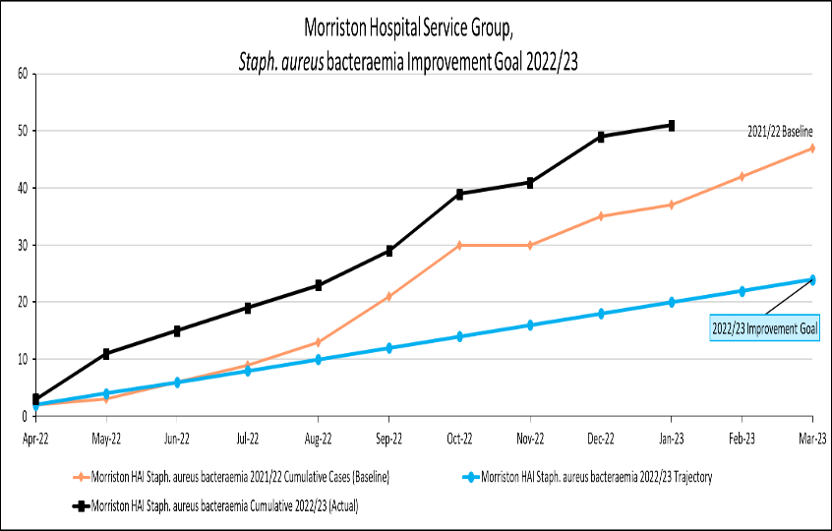
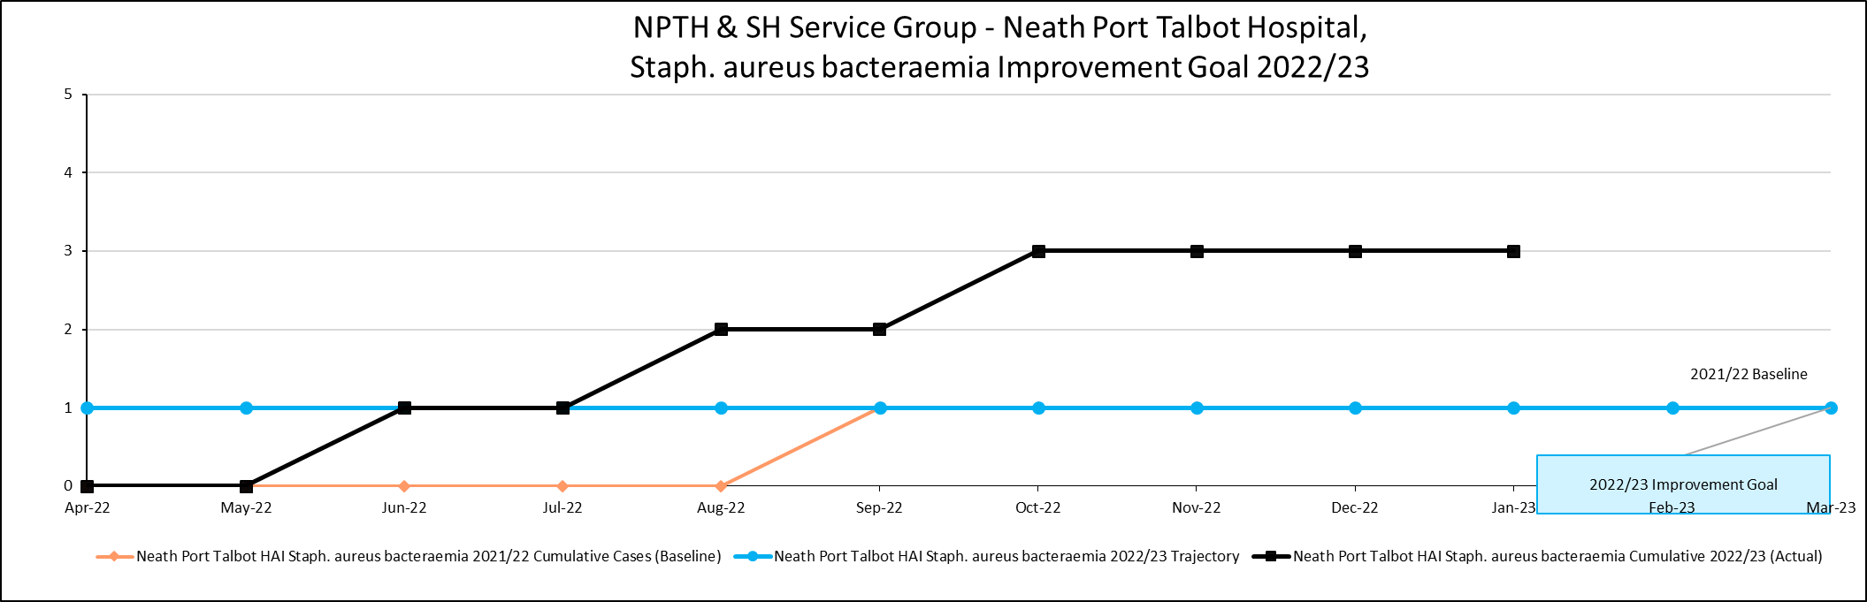 | 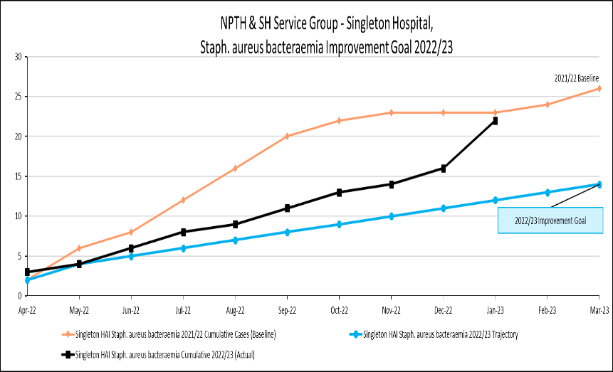

E. coli bacteraemia
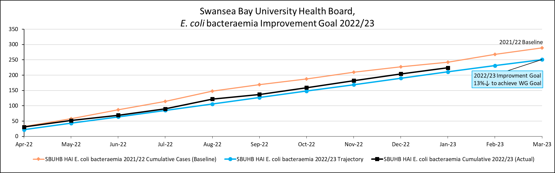
7% yr-on-yr

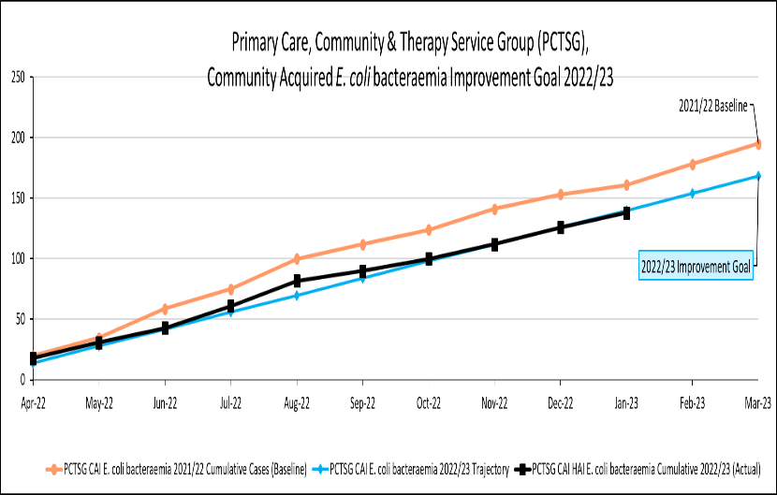 | 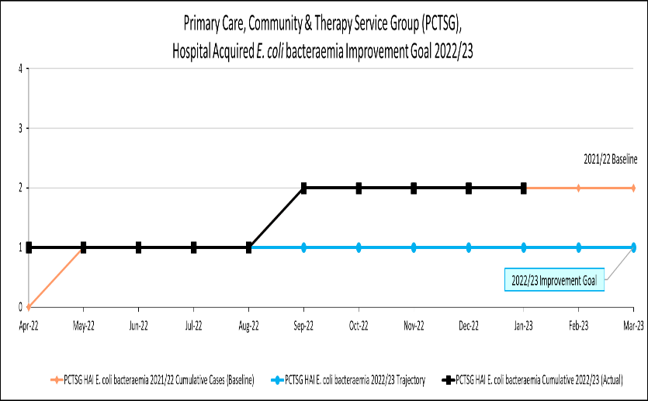
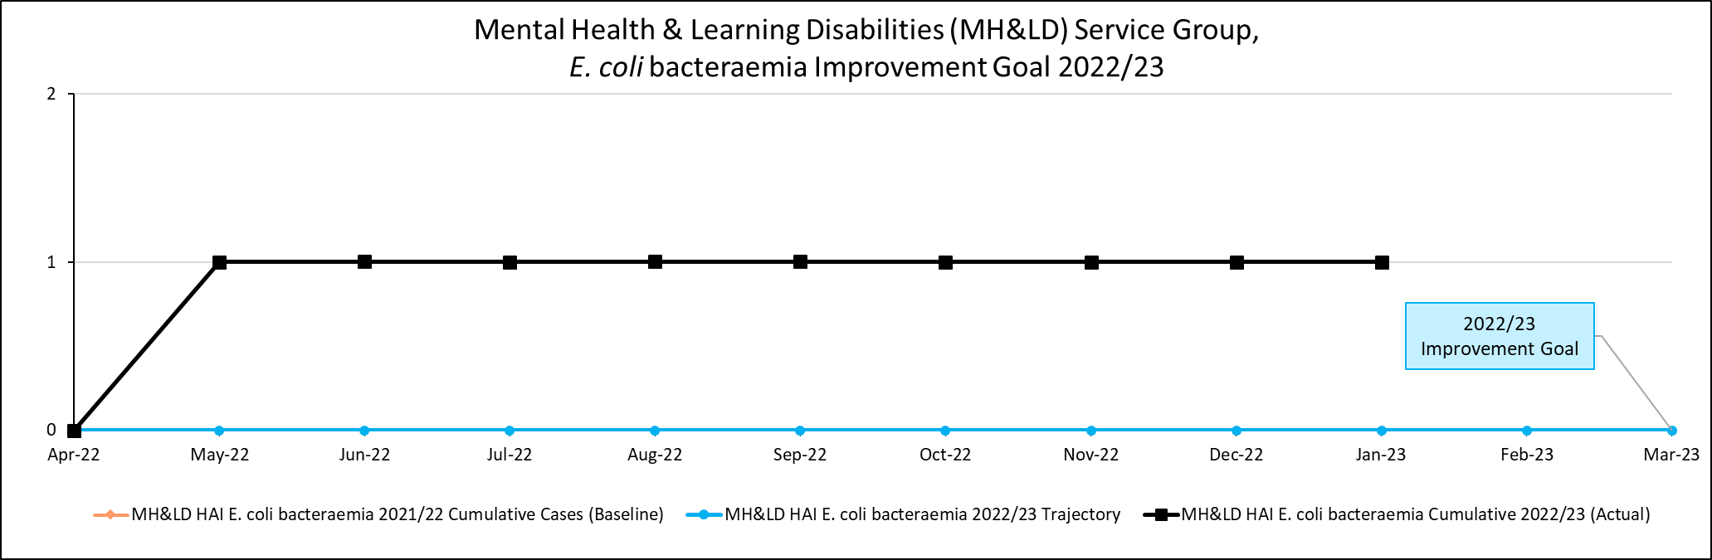 | 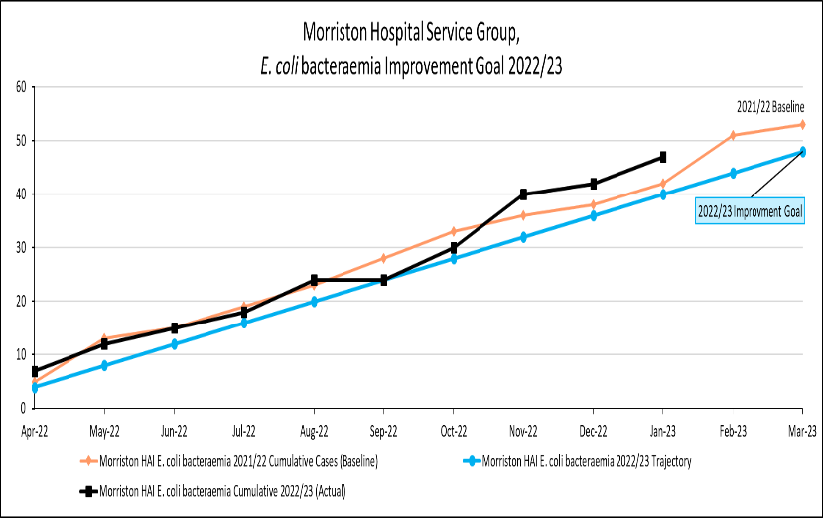
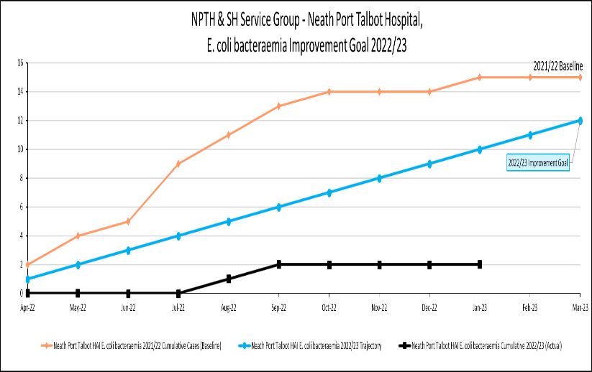 | 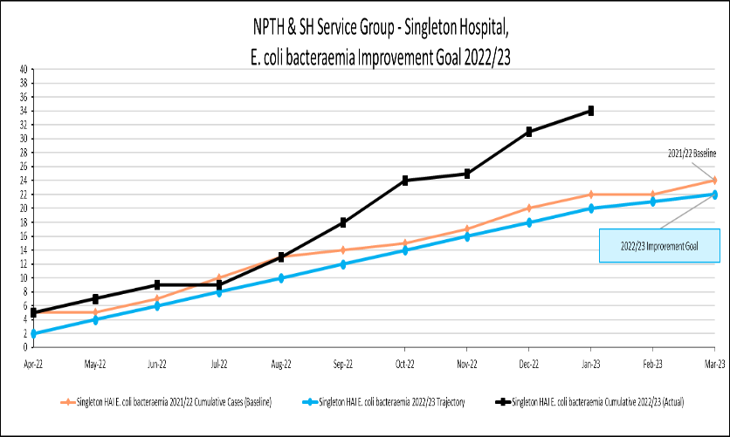

Klebsiella spp. bacteraemia
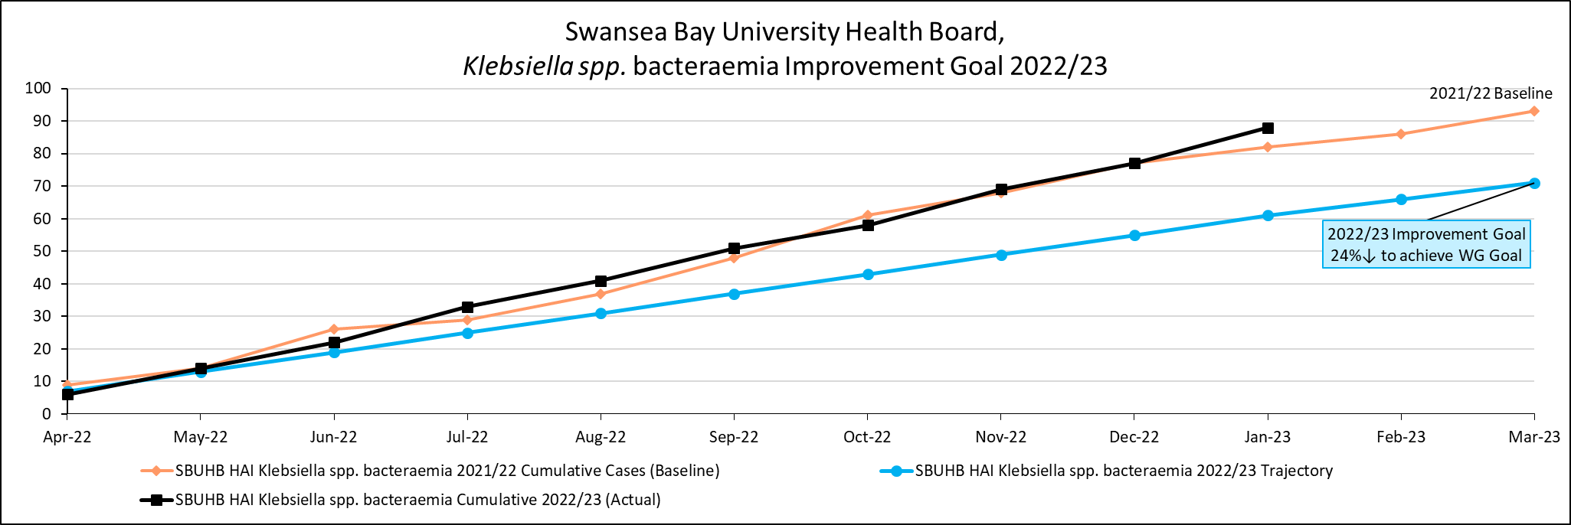
7% yr-on-yr
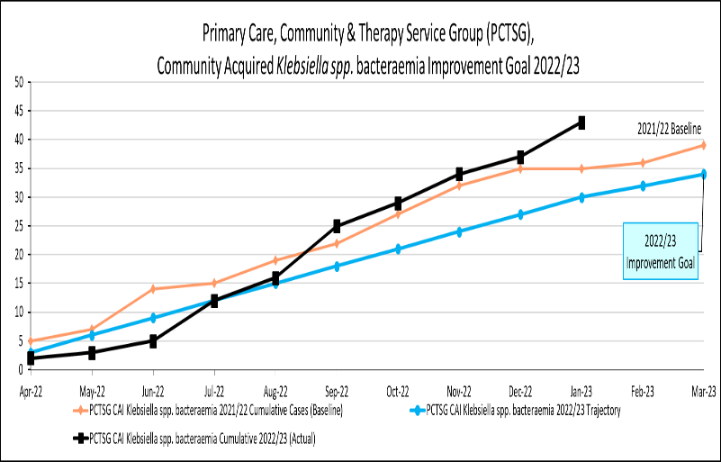 | 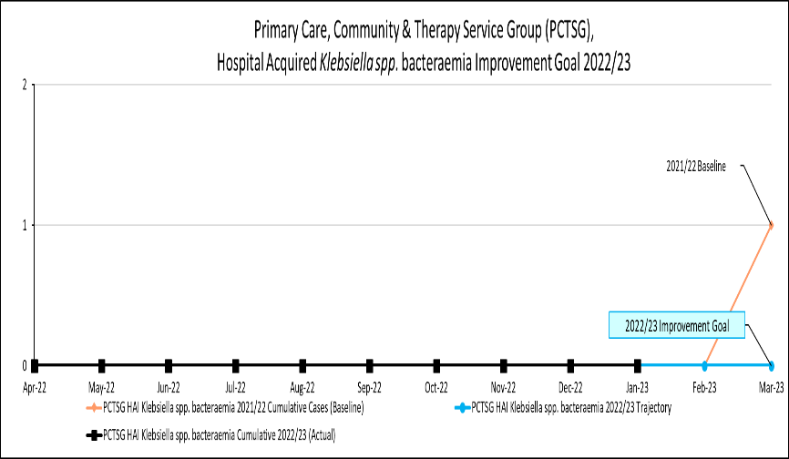
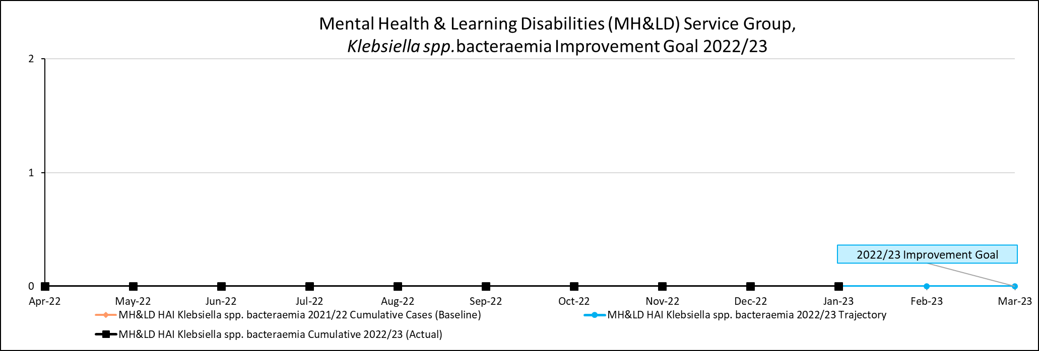 | 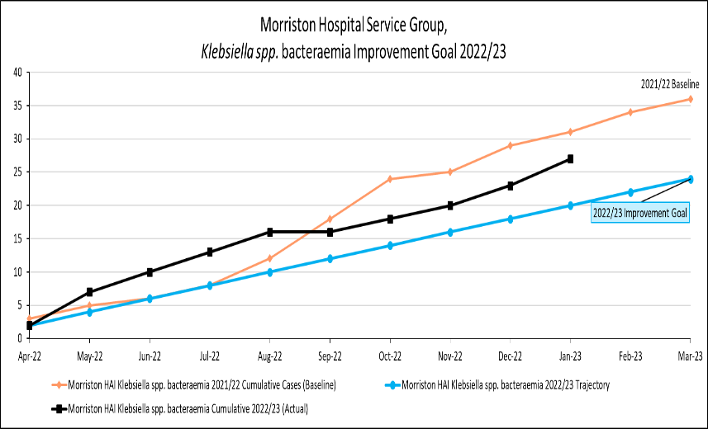
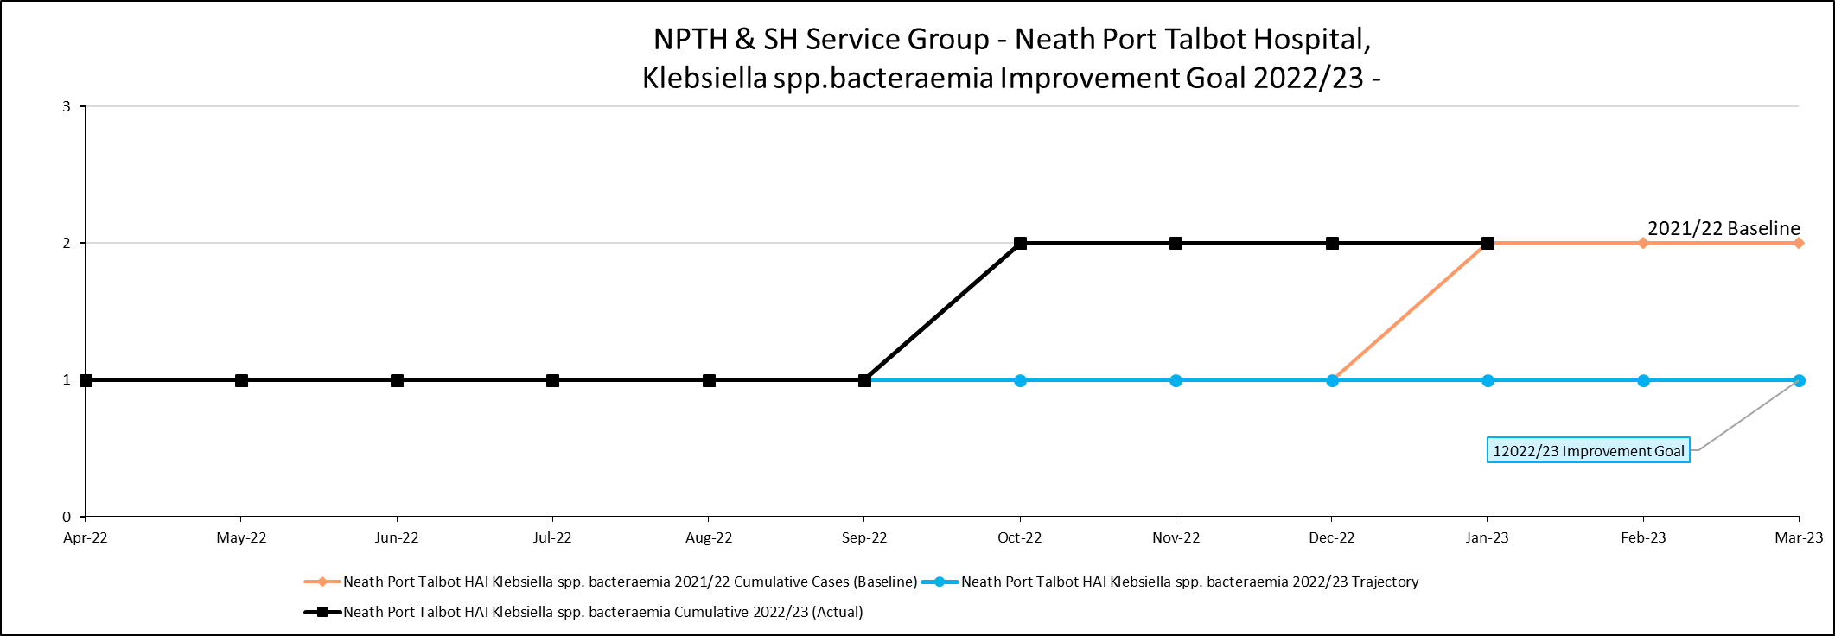 | 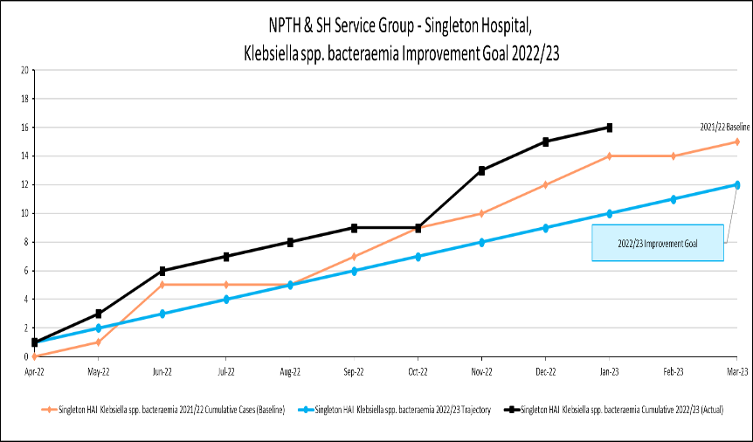

Pseudomonas aeruginosa bacteraemia
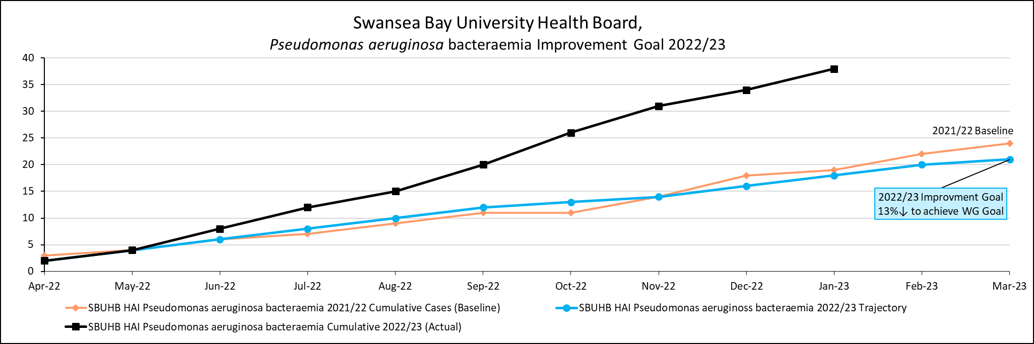
100% yr-on-yr

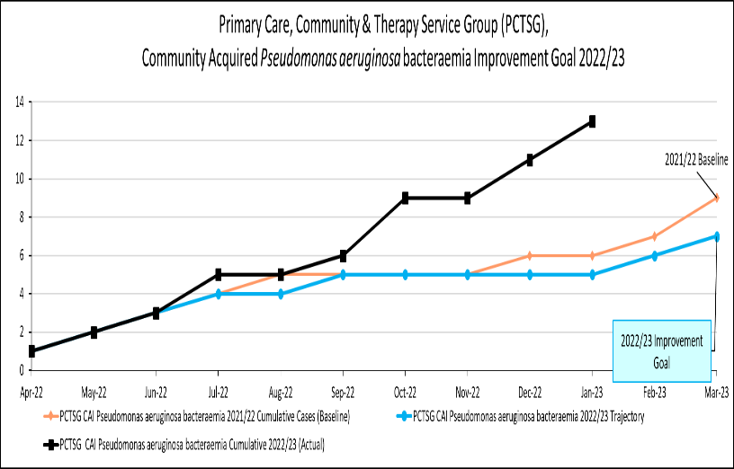 | 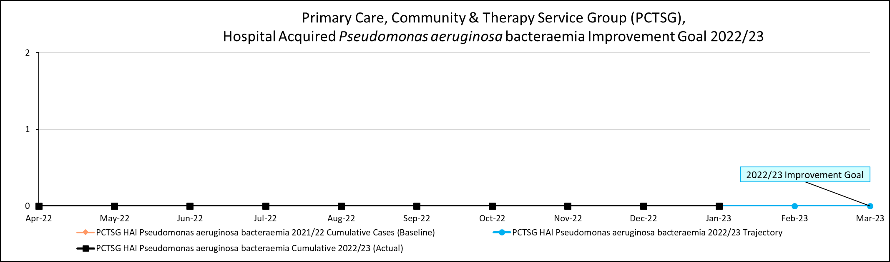
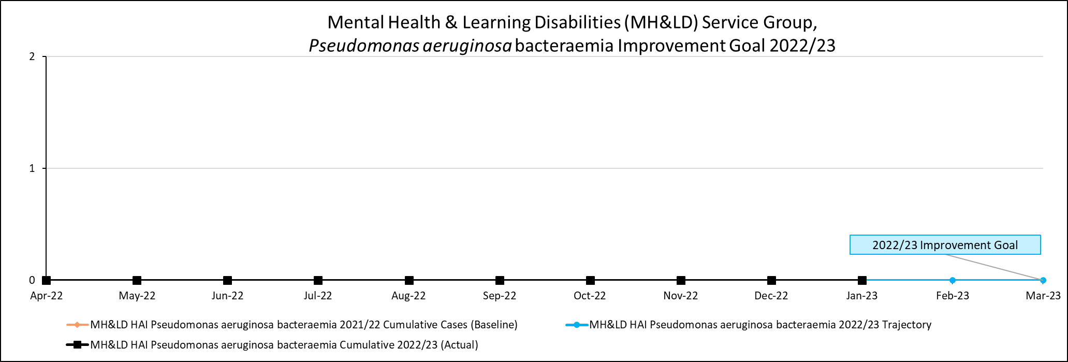 | 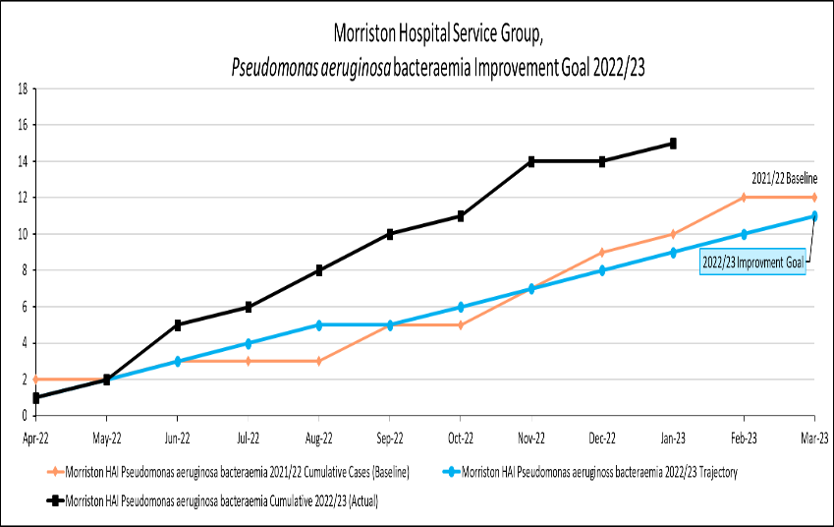
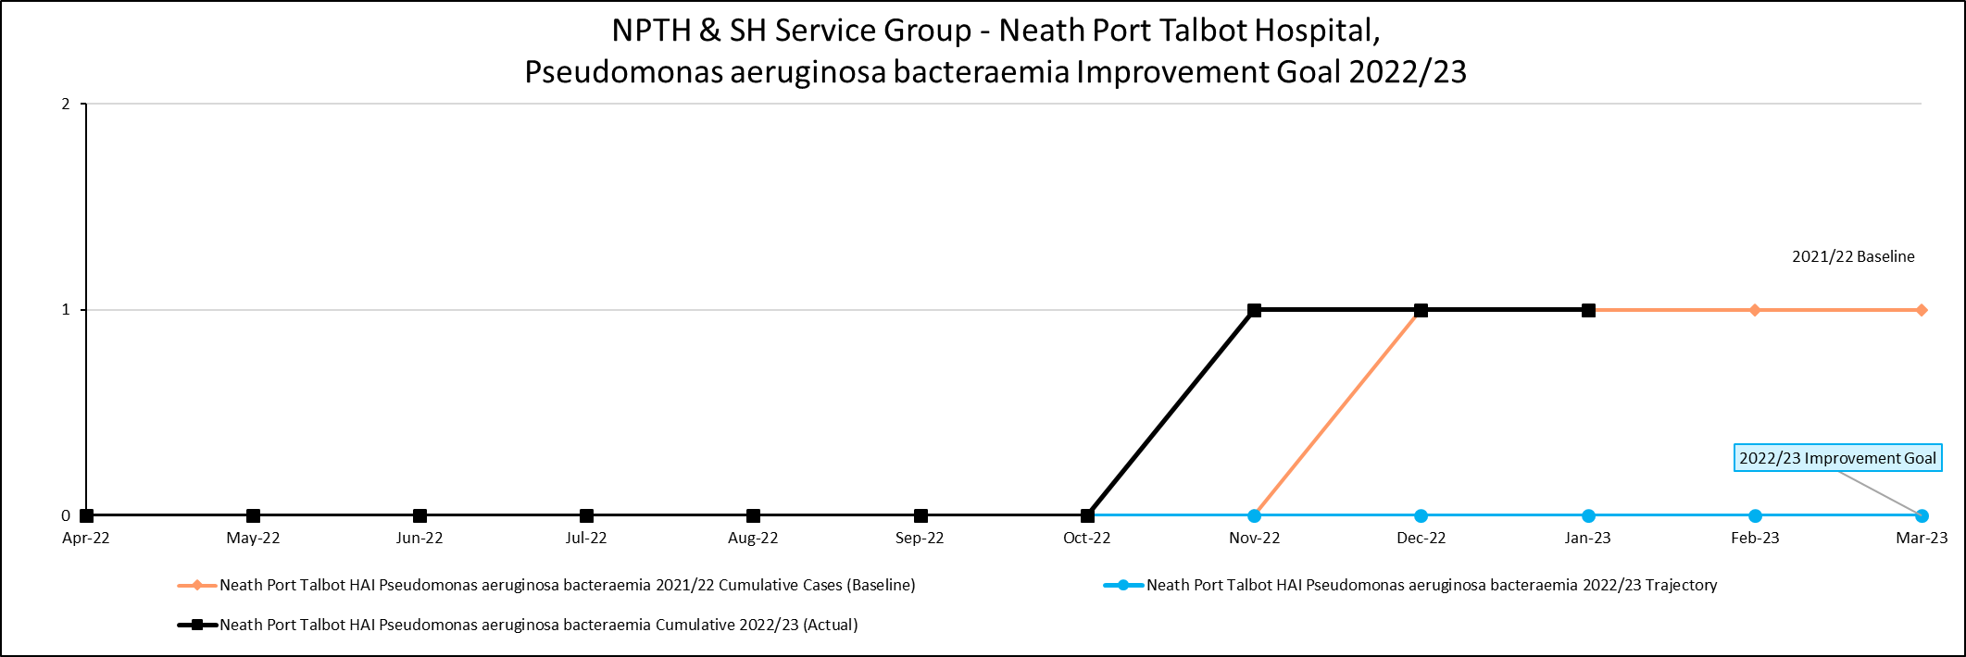 | 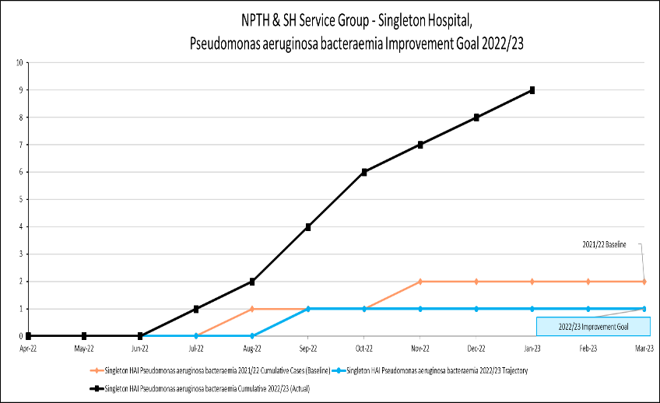

Staph. aureus bacteraemia
Liz Baker Renal Unit:
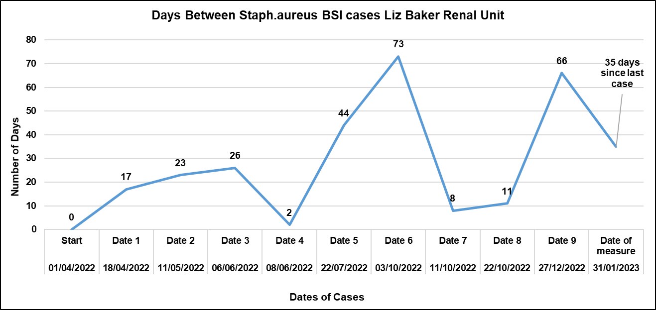

West Renal Unit:
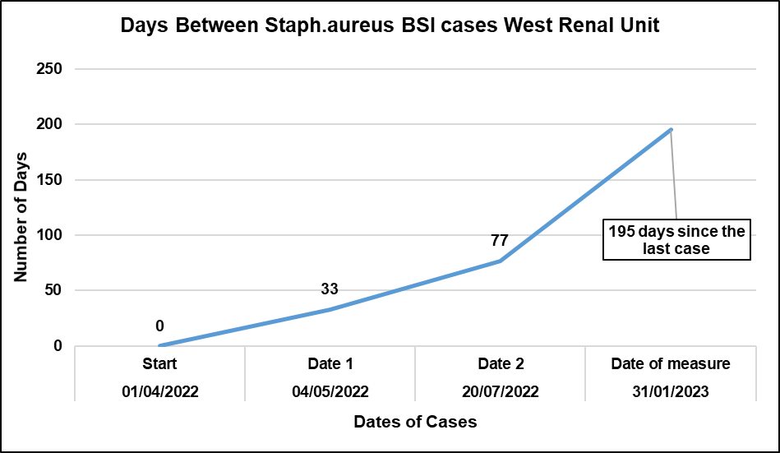

Cyril Evans Ward:
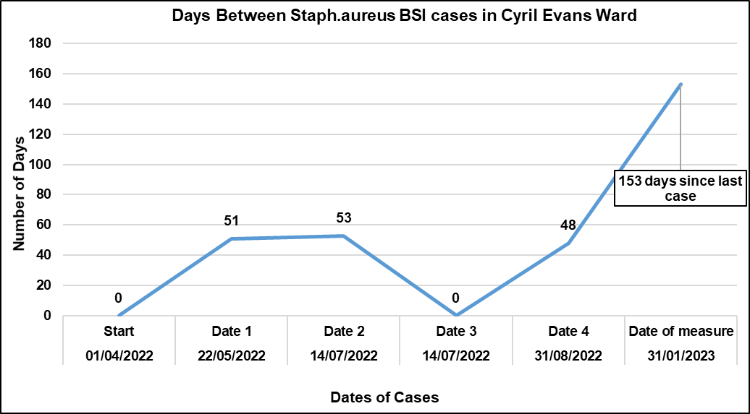

Staph. aureus bacteraemia
ITU:
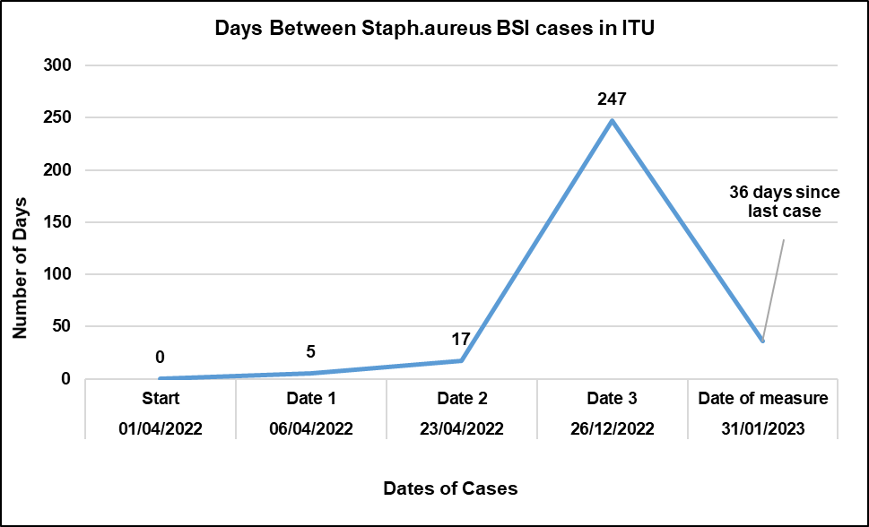

Ward V:
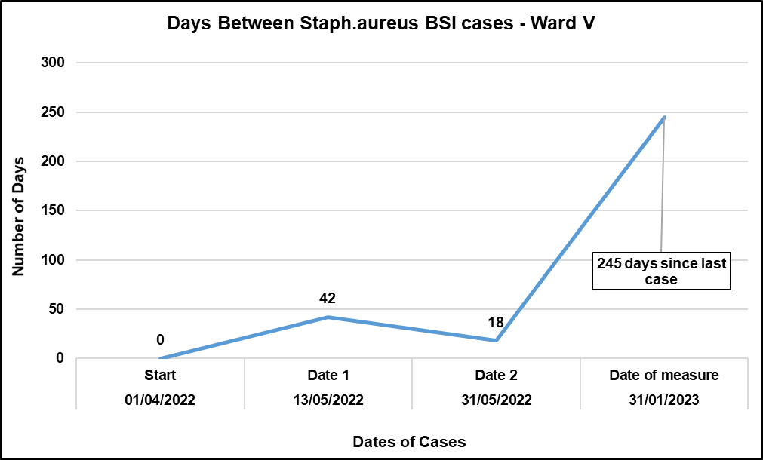

C. difficile Infection
ITU:
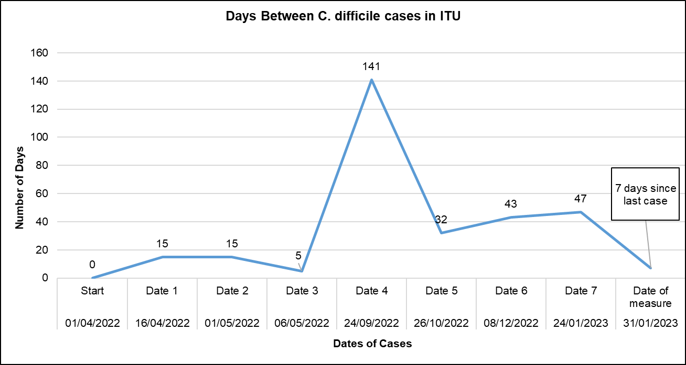
Ward D:
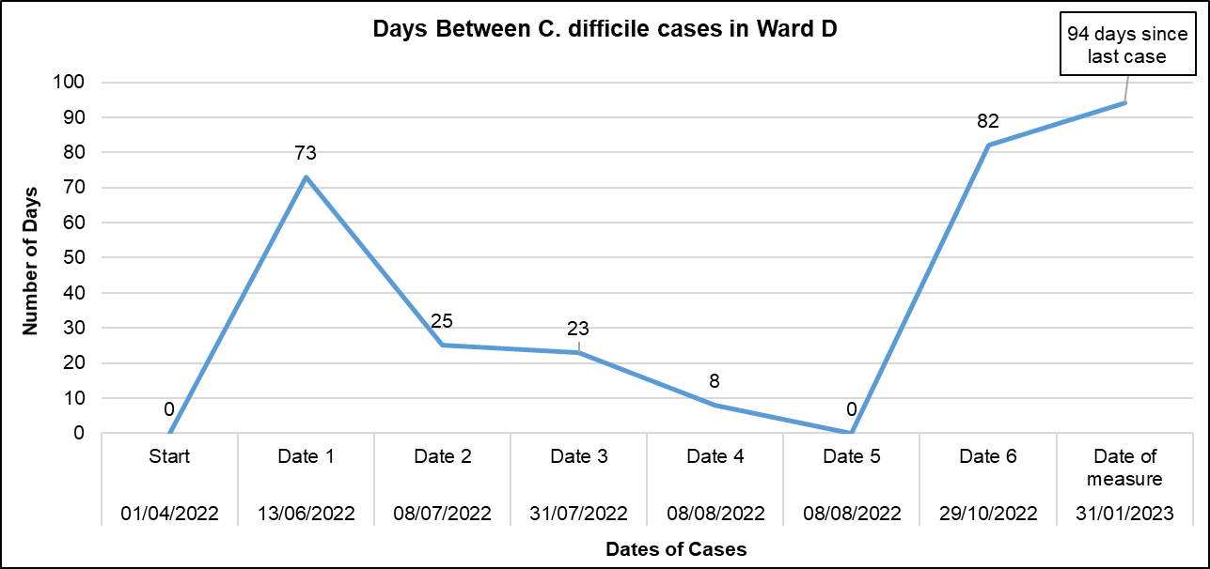
Ward T:
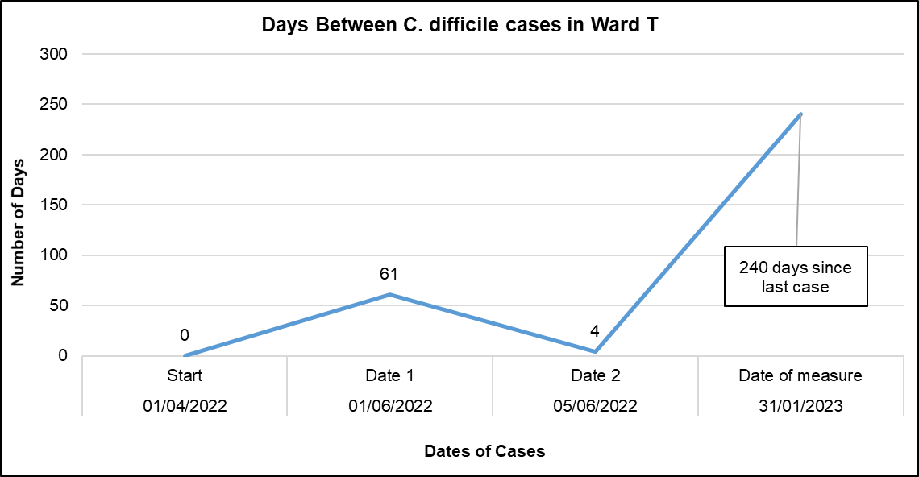
Ward C:
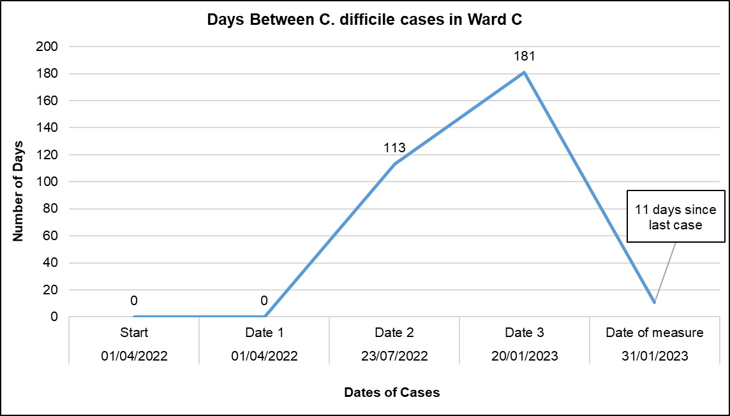
RAU:
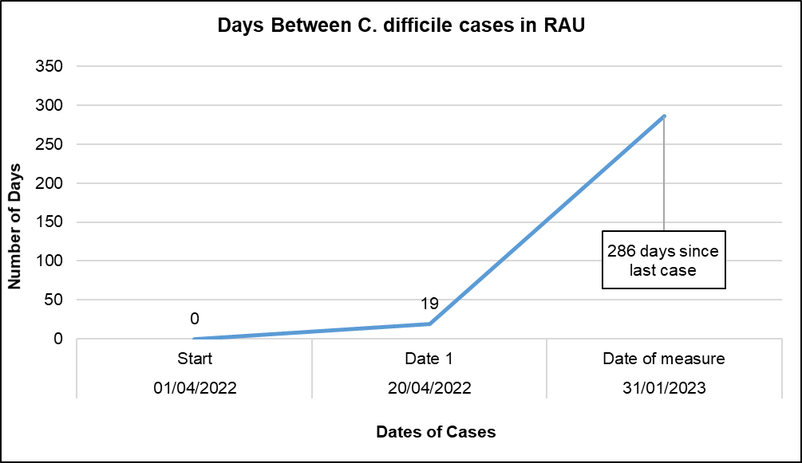
Ward S:
