
Morriston Service Group Highlight Report for
Quality and Safety Committee

Meeting Date: | 23rd February 2023
Service Group: | Morriston Service Group
Author: | Suzanne Holloway  Group Head of Quality, Safety and Patient Experience
Sponsor: | Kate Hannam, Interim Group Service Director  Dr. Mark Ramsey, Group Medical Director  Ceri Matthews, Interim Group Nurse Director
Presenter: | TBC
Summary of Quality and Safety issues since last report to the Committee
(Reporting period: 01/10/2022 to 31/12/2022)
- As the Health Board are reaching the conclusion of its review and implementation of a revised governance structure to support the delivery of the Quality, Safety & Patient Experience (QS&PE) agenda, there has been positive progress in mapping these governance structures within Morriston Service Group. The QS&PE Group have “mirrored” this review and developed an operational QS&PE structure supported by a terms of reference and operational work programme. This also includes the introduction of a revised assurance reporting template to support “Ward to Board” reporting, which is being piloted from November 2022 and will be fully implemented by March 2023. A review of resources to support these revised structures is in progress.

- There has been an increase in the expected number of Serious Incidents notified within Morriston Service Group during Qtr2 and Qtr3; 11 and 12 notifications compared to 4 and 5 notifications for the previous two questers. This is as a result of a change in reporting process, where the 7day window to establish the degree of harm caused is being enforced (since July 2022). However, once harm is established (routinely in conjunction with the Medical Examiner and/or His Majesty’s Coroner), there is an approximate 50% downgrade rate, which reflects observed historical levels.

- There has been 1 Never Event reported during Qtr3 (November 2022), which involved a wrong-sided block being administered intra-operatively. The patient involved was not harmed as a result of the event. Immediate action was taken within Theatres to mitigate any future occurrence. In January 2023, a revised National Standards for Surgical Interventional Procedures (NatSSIP2) was issued, implementation of these revised will be progressed in Qtr4 2022/23.

- The consistent delivery of Tier 1 targets for Infection Prevention & Control remains a challenge for the Morriston Service Group specifically in relation to C. difficile (63 against a target of 36) and staph aureus bacteraemia rates (49 against a target of 18). A dedicated clinical improvement lead has been in place since November 2022 with weekly multi-disciplinary case review established to support a comprehensive evidence based improvement programme. Key improvement work is being undertaken within the Renal Service in order to prevent infection associated to the use of access lines in a vulnerable patient population.

- Positive progress has been made in addressing the wide ranging Health Inspectorate Wales (HIW) action plan developed following their unannounced visit in early September 2022. A comprehensive update was submitted in December 2022, with a programme of assurance work started to ensure that all change and improvement made are embedded in practice and are sustainable.

- There is a continued increase in the number of patients presenting via unscheduled care in poor physical health and with pre-existing pressure damage. This post COVID-19, increase in presentation has meant an increase in the challenges related to further skin deterioration whilst in hospital. Focused fact finding work relation to in-hospital causative factors related to heel damage is in progress

- Access to services is the primary theme within formal patient complaints. There has been positive reduction in the numbers of patient waiting for treatment within services managed by Morriston Service Group, within Qtr3; reductions have exceeded agreed trajectories. with regards to planned care and cancer services, with work continuing within surgical, theatre and diagnostic services to further improve access

- Our patient experience feedback (December 2022) is telling us that 84% of our patients surveyed (1,355) rate our services as good or very good. This outcome is influenced by feedback from access services into the hospital, where waiting times is the primary issue. Patient experience feedback from inpatient ward locations is 94%

- Significant improvement work has been undertaken in Qtr3 (aligned with Health Inspectorate Wales Action Plan) within the Emergency Department (ED) to address negative patient experience. Examples include the allocation of a registered nurse and HCSW (healthcare support workers) to support the Emergency Department waiting room and provision of hot and cold food to long-waiting patients. Whilst this will not address the ongoing demand for emergency care it does provide a level of mitigation in relation to the safety and quality of service.

- Development of evidence based improvement planning, in line with the Health Board’s Quality Priorities and high risk patient safety events is in progress. A focus for Qtr4 is exploring the relationship between patient reported pain (negative feedback) and an observed prevalence of failure to administer medication incidents.
Challenges, Risks, Mitigation and Action being taken relating to Quality and Safety issues noted above (what, by when, by who and expected impact)
Challenge | Risks | Action/Mitigation | Status
Increase in the number of Serious Incidents and Never Events reported in Qtr3 | Avoidable patient harm as a result of a failure to provide clinically appropriate treatment and care in line with recognised clinical practice | - Fortnightly Director led meeting in place to review all new cases and progress in relation to all current cases – established with future dates  - Developed links with both the Medical Examiner and HMC in order to ensure probity within all investigations – links well established via the Care After Death Team  - Emergency Theatres meeting following the reporting of 2 events in November – immediate change to ensure presence of senior staff in theatre for checklist  - Rate of reported incidents monitored in conjunction with NHS Wales Delivery Unit – benchmarking to be established during 2023/24 with the implementation of Duty of Candour | During Qtr3 there have been 2 Never Events and 11 Serious incidents reported to the NHS Wales Delivery Unit by Morriston Service Group  Following review this number has been reduced to 1 Never Event and 6 Serious Incidents  There is currently no HB process to formally acknowledge (within scorecard) downgraded Serious Incidents  NatSSIP2 – published January 2023
Tier1 Infection Prevention & Control  (Risk Score 20) | Avoidable patient harm as a result of healthcare acquired infection  Failure to achieve infection control targets set by Welsh Government could impact on patient and family experience of care.  Nosocomial transmission in hospitals could cause patient harm and create wider system pressures | - Dedicated Snr IPC Improvement Lead – appointment extended to 31/03/2023  - Use of assurance audit in place at Front Door locations & Theatres – in place  - Development of Quality Improvement Project to include Medical Staff – in progress  - Matron Development Days to improve incident investigation skills – programme of days in place  - Recruitment of additional medical ANTT Assessors – in progress  - Re-launch Mandatory Study Day events – educational study days in place and available to book  - Review Patient Education/Information Leaflets to support co-production in infection prevention– in progress and support by HB IP&C colleagues  - Renal Benchmarking to support prevention of infection related to the management of temporary lines – in progress | 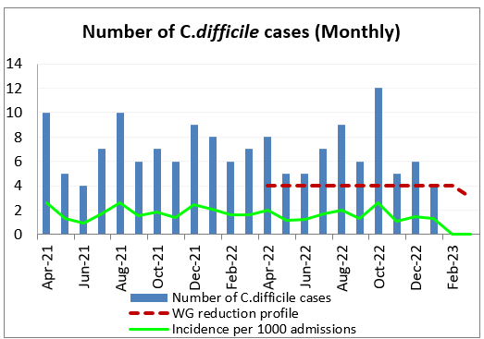  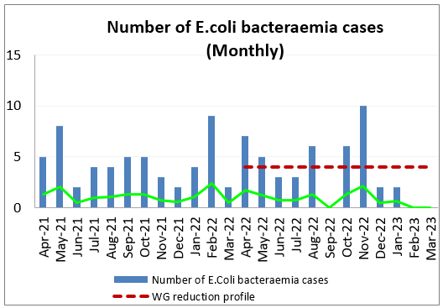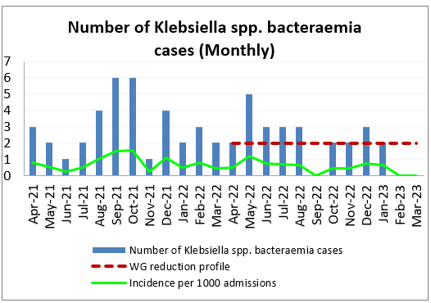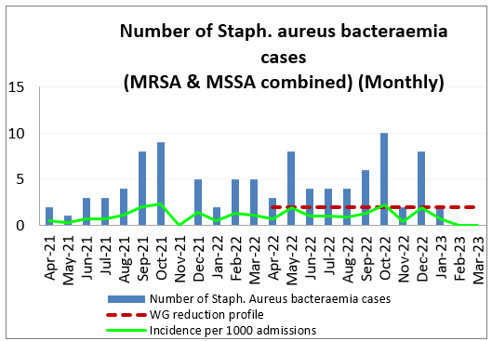  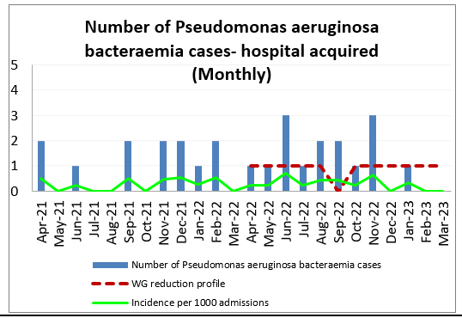  Number of COVID-19+ admissions = 119  (as at 02/02/23)  Infection Control Training – 79%  Hand Hygiene Training – 89%  (Dec22 Performance Scorecard)
Excess demand across unscheduled care pathways  (Risk Score 25)  Risk score in line with confirmed HB risk score | Access to Unscheduled Care Services  If we fail to provide timely access to Unscheduled Care, then this will have an impact on quality & safety of patient care as well as patient and family experience and achievement of targets.  Linked to Patient Experience Feedback and Access to Services | HIW unannounced assurance visit to the Morriston Emergency Department  (05/09/2022 to 07/09/2022)  Full Report published 08/10/2022  Progress report on implementation of both the Immediate Action Plan and Full Action Plan provided to HIW 22/12/2022  Implementation of Acute Medical Service Redesign from 05/12/2022 – key milestone related to admission avoidance  - Diversion of minimum of 6 patients per day from Emergency Dept. into Acute hub  - Total estimated bed day reduction equates to 8-10 patients per day  - 85% discharge rate from Older Persons Assessment Service (OPAS)  Further work required in relation to Stroke and Fractured Neck of Femur timelines which were not achieved | Performance as at 31/12/2022.  Ambulance Handover >1hr = 592  95% within 4hrs =  49.3%  Number of patients waiting >12hrs = 1632  Data Source: Weekly Performance Data 02/02/2023
Planned Care Recovery  (Risk Score 20)  Risk score in line with confirmed HB risk score  Planned Care will be impacted by Industrial Action taken by healthcare professionals | Access to Planned Care  There is a risk of harm to patients if we fail to diagnose and treat them in a timely way.  Access to Theatre Capacity  Competing Priorities  Delivery of Stage1 (outpatient) 52wk target  Delivery off All Stage 104wk target  Linked to Patient Experience Feedback and Access to Services | Waiting List Management Process  - Weekly Service Group and specialty specific meetings to ensure focus and achievement of targets – in place  - Focus on “treat in turn” and long waiters – in place  - Robust patient pathway management aligned to WG RTT guidance - further work required to improve staff training and ensure accurate  Linked to Over-Arching Service Re-design:  - Ring-fenced Orthopaedic bed capacity opened - November 2022  - Transfer of Trauma & Orthopaedic Service management from Morriston to NPTSSG – April 2023  - Transfer of Theatre & Anaesthetic Service from Morriston to NPTSSG – April 2023 | Health Board 3yr Recovery and Sustainability Plan in place  Performance as at 31/12/2023  Significant reduction seen in numbers of patient waiting in Qtr3  Patient waiting > 26wks for first OP = 15,379 (reducing)  Patient waiting >36wks (all stages) = 23,631 (reducing)  Patient waiting >104wks (all stages) = 6,740 (reducing)  Data Source: Weekly Performance Data 02/02/2023
Access to Cancer Services  (Risk Score 25)  Risk score in line with confirmed HB risk score  Access to Cancer Services will be impacted by Industrial Action taken by healthcare professionals – 2days of action taken in December  Noted that further Industrial Action is currently suspended within NHS Wales | There is a risk of delay in diagnosing patients with cancer, and consequent delay in treatment, which could lead to poor patient outcomes and failure to achieve targets.  Insufficient “green” bed capacity at Morriston Hospital  Consideration of post COVID-19 Response pathways and bed allocations  Insufficient Morriston Theatre capacity for complex Morriston only patients  Workforce risks in Radiology and Endoscopy  Linked to Patient Experience Feedback and Access to Services | Tumour Site Improvement Groups feeding into Cancer Board established;  - Targeted focus on long waiting patients with trajectories in place to eradicate waits >100 days in particular – in place  - Cancer pathway reviews for >145 days – formal process in place  - Maximising use of funded Endoscopy sessions across all Units – routinely monitored  - Utilisation of insourced Endoscopy sessions per month within NPTH - – routinely monitored  - Monitoring of CT USC (urgent suspected cancer) 7day performance – continued improvement in place  - Development of Theatre Capacity requirements including for cancer work for 23/24 - in progress | 53% compliance against the Single Cancer Pathway  (target 75%)  Data Source: Weekly Performance Data 02/02/2023  The delivery against the cancer standards remains a significant challenge across all specialties and is driven by:  - Lack of capacity to meet the demand at a sustainable level  - The long-term impact of Covid which has resulted in significant backlog across all elements of the pathway  - Diagnostics remains a constraint due to competing demands from emergency, urgent and RTT recovery priorities
Competing Demands for Key Resources | Inability to provide treatment and care within national standards and timeframes – across both planned and unscheduled care pathways  (links to risk of increased Mortality and poor clinical outcomes)  Impacting on and creating delays in pathways such as:  - Fracture Neck of Femur Pathway  - Stroke Pathway  - Cardiology/Cardiac Pathways  Linked to Patient Experience Feedback and Access to Services | Directly Linked to work programme and actions for:  - Access for Unscheduled Care  - Planned Care Recovery  - Transfer of Clinically Optimised patients  To note:  COVID-19 has continued to have an impact on service delivery – particularly where ward closures mean that patients are placed outside of specialty/service ward areas  Number of COVID-19+ admissions = 119  (as at 02/02/23) | Fractured Neck of Femur currently outside of 36hr to surgery national standard  (risk score 25)  Stroke pathway currently outside of 4hr admission to Stroke Unit  (risk score 20)  Acute Cardiology pathway currently outside of 48hrs for inpatient transfer to Specialist Unit  (risk score 20)
Delayed transfer in Clinically Optimised Patients  (Risk Score 20) | Inability to Transfer Patients  Avoidable harm as a result of patient placement within an inappropriate healthcare setting.  Compromised patient safety including clinical decompensation, nosocomial infection, inpatient falls, pressure damage  Lack of beds to support acutely unwell patients and support effective flow from the assessment units | - Weekly multi-disciplinary clinically optimised review – led by Deputy Head of Hospital Operations  - Development of an integrated discharge team on site to support complexity and the flow demands associated with the clinically optimised patient cohort – in place  - Daily/Weekly escalation of complex cases to relevant partners/agencies – identification of 3 “red” patients weekly | Appointment of resource to support nurse liaison and patient co-ordination – Completed  110 COP patients at Morriston Hospital – 06/02/2023  Longest waiting patient 244 days – subject to legal case

Progress Against Annual Plan Quality and Safety Priorities 2022/23 (as applicable)
Quality Priorities: reduction in healthcare acquired infections; improving end-of-life care; sepsis; suicide prevention; and reducing injurious falls.

 | Current Status
Reduction of healthcare acquired infections  In line with nationally set reduction targets (20%) | See Update Above
Implementation of a bereavement service in line with the National Framework for the Bereaved – linked to EOLC/NACEL  All bereaved families/friends contacted within 48hrs of bereaved to offer tier1 practical support | Phase 1 Established  WG non-recurring funding received - £120k over two years
Implementation of the NHS Wales Medical Examiner Service (MES) from 01/04/2023, across secondary care.  All secondary care in-hospital independently reviewed by Medical Examiner Service | Achieved  from 16/01/2023
HB-wide Recognition of Acute Deterioration and Resuscitation (RADAR) Group – established  Health Board Clinical Lead appointed with the development of Sepsis KPI framework in progress | Morriston Sepsis Lead  Pending development of HB wide KPI Framework
Active promotion of Suicide Awareness Training with links into Care after Death/Bereavement Support  All families bereaved as a result of suicide across the Health Board (primary & secondary care) offered bereavement support | Morriston Lead in place  Ongoing roll-out of Awareness Training
Morriston In-patient Falls Prevention Group – established with monthly monitoring by ward/ dept. in place  Morriston Hospital 4.29 inpatient falls per 1000 bed days against a Royal College of Physicians standard of 6.63 | Monthly Falls Improvement Group in place  “Bay Watch” Falls Prevention Programme progressing to pilot phase
To Note: Project work underway to review existing quality & safety key performance indicators and the development of a SBUHB Quality & Safety Performance Dashboard, in line with Health Board Long-term Quality Strategy, it is anticipated that this will enable additional reporting capabilities in the future – Health Board 5yr Quality Strategy to be launched on 02/03/2023

Healthcare Acquired Pressure Damage
As the Health Board’s 5yr Quality Strategy, pressure damage prevention will become a Health Board Quality Priority from 2023/2024.

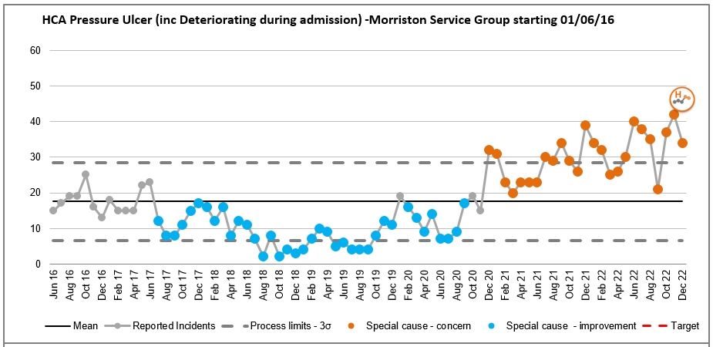 | The observed long-term change in the number of Healthcare Acquired pressure ulcers reported at Morriston Service Group, post pandemic (October 2020) has continued during 2022/23  This level of sustained change in “process”, post Oct 2020, would suggest that there has been a “step-change” in causal factors and the drivers which influence healthcare acquired pressure ulcers, reported at Morriston Hospital.
Primary Causal Factor
Increased acuity within the Community - there continues to be a significant increase in the number of patients presenting at hospital with existing pressure damage and thus an increased risk of in-hospital deterioration. This has been a feature since April 2020 and coincides with the beginning of the COVID-19 pandemic.

35% (305) of all incidents reported at Morriston in Dec 2022 were pressure/moisture related; of the 305 incident reported 42% (129) occurred prior to attending hospital
Actions
- Risk related to a lack of on-site tissue viability nurse (TVN) professional, has been highlighted via the Morriston risk register – current score of 20
- Fact finding work based on outcomes related to Damage to Heels – outcomes to be shared at health Board Pressure Ulcer Prevention Strategy Group on 20/02/2023
- Review impact of change in patient pathways linked to Acute Medical Redesign – initial impact is an approximate 20% in patients presenting with pre-existing skin damage

Progress Against Health and Care Standards 2022/23
End of Year Position: 2021/2022
A formal process for completing the assessment against the Health and Care Standards has now been agreed for 2022/2023.
In a change to previous arrangements, it has been agreed that the requirement for service groups to complete individual self-assessments for each of the standards is removed. Instead Service Groups will contribute to Health Board wide assessments co-ordinated by the relevant Health Board Leads. Where there is no nominated Health Board Lead, Service Groups will submit evidence directly within the following areas;
- Standard 3.1 Safe and Clinically Effective Care
- Standard 3.2 Communicating Effectively
- Standard 4.1 Dignified Care
- Standard 4.2 Patient Information
- Standard 6.1 Planning Care to Promote Independence
- Standard 6.2 Peoples Rights

Progress is being made in completing the required submission proforma for each of the 6 dimensions and a detailed Service Group update on both its submission will be provided at end of Qtr4
Patient Experience Update
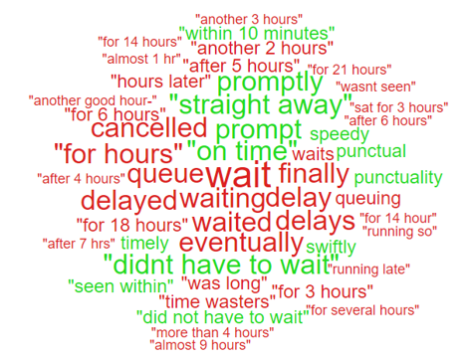 | In December 2022, 84% of patients, friends and family surveyed rated the services they received at Morriston as good or very good. (1,355 responses)  (Source: Civica Dec2022)
Access Times within the Emergency Dept. continue to drive poor patient experience. If the Emergency Dept. feedback was excluded from the overall total the feedback response would be 94% rather than 84%.

Thematic Review: Medication Incidents related to Patient Experience with Pain
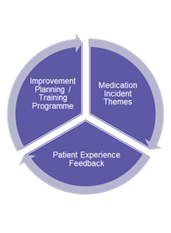 | 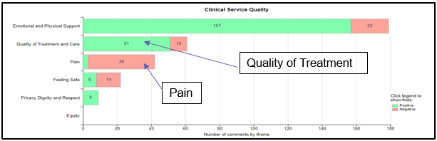
Outcomes based on Controlled Drug Desk-Top Review & Biannual Review (19/01/2023)
In general, Morriston SG medication incidents relate to administration, within a ward environment do not involve controlled drugs and do not result in harm
Patient Experience Outcomes – December 2022
Increasing number of patient reporting negative clinical experience with pain.
Improvement Scoping by 28/02/2023:
Relationship between failure to administered medication and reported patient feedback around failures in pain management
Identification of locations for PDSA scoping
Training:
Initial awareness session for matrons on medicines management (08/02/2023)

Formal Complaint Performance
*rolling performance | As with survey based patient experience feedback, the primary themes within formal complaints focus on access times, to both planned and emergency care and outcomes associated to delays in access.
   | 01/10/2022 to 31/12/2022
  Number of formal complaints | 139
  % of responses sent within 30 working days*  (75% National Target) | 77%
  Number of Trusted to Care complaints | 0

Any Other Issues to Bring to the Attention of the Committee
- Secondary care implementation of the NHS Wales Medical Examiner Programme is hosted by Morriston Service Group. The programme will achieve its objective of Health Board wide secondary care implementation by 01/04/2023 – Phase 1 completed and moving to Phase 2 focusing on outreach service for patient who die in the community during Qtr4 and into 2023/24
- Transfer of Morriston Clinical Audit Plan 2022/23 onto AMaT – to support the monitoring of National, Health Board and Local quality improvement workstreams – completed with quarterly review and monitoring in place
- Hospital e-Prescribing and Medicines Administration (HEPMA) - rolled out across Morriston is ongoing and due for completion in March 2023, however challenges to timescales noted
- Poor reported compliance linked to MCA/DOLS (Mental Capacity Act/Deprivation of Liberty) training for nurses 37% for December 2022 – review of gaps in order to develop a robust recovery plan linked to service based Educational Supervisors
- Launch of Morriston Staff Well-Being – quarterly meetings in place with outcome newsletter.
- 1 patient safety incidents reported as a result of industrial action undertaken in December 2022 – senior investigation and review completed with a conclusion that no harm was caused to the patient has a result of industrial action
- Impact of service transition within the Acute Medical Unit, has had a negative impact on the completion of discharge advice letters (DALs) within General Medicine – performance in December 2022 was 34% compared to a historical completion rate of approximately 70% - issue reviewed at AMSR Board with clear actions related to process and digital systems put into place to rectify the position.
- Introduction of the Duty of Candour linked to The Health and Social Care (Quality and Engagement) (Wales) Act 2020 - the Health Board are required to fully implement the duty of candour process from 01/04/2023. This introduction has not been funded nationally. The impact of this introduction will have significant workload implications for both the Quality & Safety Team and Senior Clinical Staff – in December 2022, 88 patient reported safety events would have been subject to scrutiny against Duty of Candour principles, with an estimated 30% (26 incidents) requiring formal management under National Health Service (Concerns, Complaints and Redress Arrangements) (Wales) Regulations 2011. The represents an increased workload of 40-45% in addition to prevailing formal complaint numbers - Implementation plan under development pending national training materials

External Reports
- HIW Assurance Review: Emergency Dept (Sept2022) – formal update submitted 22/12/2022
- HIW Assurance Review: Dan Danino Ward (May2022) – formal update submitted 19/01/2023
Internal Reports
- Biannual Controlled Drug Review – 19/01/2023 – formal feedback pending

Pending Reports
- HIW Assurance Review: Morriston Hospital IR(ME)R Review (Imaging) – 23/02/2023 and 24/02/2023 (Pre-visit evidence submission provided 02/02/2023, in line with request)
Recommendations
Members are asked to note progress taken to address quality & safety issues, challenges and risk facing Morriston Service Group and acknowledge ongoing work to ensure dignified, individualised care to patients whilst in the care of Morriston Service Group.

