Swansea Bay University Health Board

Patient Experience
&
Concerns Report
Quarter 2 2023/24

CONTENTS

Report Summary | Page 2
Complaints | Page 4
Complaint Themes | Page 6
Highlight Areas | Page 11
Morriston Service Group | Page 25
Neath Port Talbot Singleton Service Group | Page 30
Mental Health & Learning Disabilities Service Group | Page 35
Primary and Community Service Group | Page 38
Medical Examiners Compliments | Page 43
Ombudsman Cases | Page 44
Report Summary and Overview
COMPLAINTS | Jul | Aug | Sep
Total number of complaints received | 179 | 209 | 226
Complaints acknowledged within set timescale | 100% | 100% | 100%
Number of re-opened complaints | 10 | 11 | 4
 | Jun | Jul | Aug
Complaints responded to within agreed timescale - formal | 71% | 64% | 71%
OMBUDSMAN | Jul | Aug | Sep
Number of Ombudsman Investigations received | 0 | 0 | 0
Number of actions outstanding (within timescale) | 7 | 0 | 1
Number of actions overdue | 2 | 3 | 2
PATIENT EXPERIENCE | Jul | Aug | Sep
No. of Friends & Family surveys received | 3,466 | 4,646 | 4084
Recommendation score | 91% | 92% | 92%
New Bespoke Surveys | 0 | 3 | 0
NATIONAL REPORTABLE INCIDENTS | Jul | Aug | Sep
Number of National Reportable Incidents reported | 5 | 9 | 5
Number of Never Events | 1 | 1 | 0

Successes | Priorities
- National A&E, Nosocomial and End of life surveys are now in the Civica patient feedback system. The local feedback will automatically populate the National NHS Executive reporting tool.  - The NHS National Digital Story Toolkit has been launched. SBU has been instrumental working with the NHS executives to develop this National toolkit. | - Integration of SALT areas from Pims and Pims+ into the SMS platform. The Mapping and script has been agreed by Civica. We are waiting for SBU IT to agree start date.  - Development of Maternity Staff Thank you bulletin to share the positive feedback we receive.
Opportunities | Risks & Threats
- SBU have been asked to join the National Editorial board for the development of surveys. Meeting monthly to review request for national surveys. Inaugural national meeting held 29th September with all PE leads.  Integrated working with the Once for Wales team to develop:  National Survey Principles, Flow chart, Process document. These have been shared with the NHS executive’s team.  - The next NHS Executive national surveys are Mental health 111 # 2 and Maternity. | - WG are reviewing/refreshing the All Wales core questions. A company called Cedar have deployed survey for participants interested to take part in the review.  This survey has been sent to Insights, Communications and Engagement team to send out to SBU stakeholders.  - Once the new questions are agreed we will need to change our surveys. We will add this to our work plan. There is an understanding that this will have an impact on the current department workload.

- COMPLAINTS

1. Complaints performance –
The Health Board is committed to supporting patients, relatives, and carers in resolving their concerns. Our service is visible, accessible, and impartial, with every issue taken seriously. Our aim is to provide honest and open responses in a way that can be easily understood by the recipient.

1.1 Total complaints received

The Health Board received 614 complaints in quarter 2 (Q2) of 2023/24 (July, August, September). This compares with 652 complaints in quarter 1 (Q1) of 2023/24 (April, May, June). The totals include complaints received and managed via either formal, early resolution and any re-opened complaints. Graph 1 provides a long-term view of complaints received per month.
Graph 1: Total number of complaints per month

Graph 2: Formal v Early resolution complaints per month

Graph 2 (above) shows complaints dealt with via the Formal Putting Things Right (PTR) investigation process compared with those dealt with via the early resolution investigation process, over the same period. We continue to deal with a higher proportion of complaints via the formal process, this is due to the tight timescale of two working days for early resolution complaints. Any early resolution that is not resolved within two working days, converts to a formal following guidance issued by Welsh Government.
1.2 Complaint responses within agreed timescale
Whenever a complaint is managed through the formal PTR process, the Health Board is required to investigate the complaint and write to the complainant with our findings, within 30 working days. If this target is not achievable, it is essential that the complainant is kept up to date throughout and any delays are explained.

1.2.1 Formal Investigations
The Health Board’s target is to respond to at least 80% of formal complaints within the agreed timescale. Welsh Government also issue a target for all Health Board’s to achieve at least 75% each month.

Graph 3 shows the Health Board’s performance in responding to complaints since September 2022. The Health Board performance for August 2023 was 71%.
Graph 3: Percentage of formal complaints responded to within agreed timescale

1.2 Re-opened complaints
The Health Board aims to resolve all complaints within the first response however, there are times when the complainant remains dissatisfied or needs further clarification. If the complainant writes back to the Health Board expressing their dissatisfaction, the correspondence will be reviewed by the Corporate Complaints Team and a decision made as to whether the complaint should be re-opened. This may be when the complainant feels not all issues raised in the initial complaint have been addressed or if a meeting is required.

Graph 4 shows the number of re-opened complaints per month since October 2022.
Graph 4: Number of re-opened complaints by Service Group per month

A review of the re-opened cases for Morriston identify that they relate to General Medicine, General Surgery and Orthopaedics. The main theme highlighted from these is delayed/lack of treatment.

2. Complaints Themes

2.1 – Themes - Health Board overview
Every complaint received by the Health Board is coded in the Datix Once for Wales system against the relevant subject codes. This allows the Health Board to identify any themes in the complaints received.

Table 1 provides a breakdown of complaints received by primary subject in Q1 2023/24 compared with Q4 for 2022/23.

Table 1: Complaints by primary subject
Subject/Theme | Q1 2023/24 | Q2 2023/24
Communication Issues | 100 | 98
Appointments | 86 | 79
Clinical treatment/Assessment | 150 | 118
Admissions | 52 | 45
Attitude and Behaviour | 58 | 30
Medication | 57 | 35
Test and Investigation Results | 34 | 26
Referral | 14 | 13
Discharge Issues | 13 | 20
Environment/Facilities | 8 | 9
Monitoring/Observation Issues | 15 | 22
Equipment | 7 | 5
Personal Property/Finance | 7 | 8
Assault | 0 | 2
Confidentiality | 2 | 2
Consent | 2 | 0
Record Keeping | 3 | 5
Access (to Services) | 11 | 6
Accident/Falls | 3 | 0
Catering | 2 | 0
Cleanliness | 5 | 2
Infection Control | 2 | 4
Nutrition/Hydration Issues | 4 | 2
Other | 0 | 1
Patient Care | 7 | 4
Resources | 6 | 2
Skin Damage | 2 | 3
Privacy and Dignity | 2 | 1

During Q2, 177 complaints were received relating to clinical treatment. A breakdown of the clinical treatment sub-subjects are below – please note, some complaints include more than one of these issues.
Top theme; Clinical Treatment;
Clinical Treatment;
Delay/Lack of treatment or Assessment | 127
Reaction to procedure/ treatment | 31
Incorrect/insufficient treatment or Assessment | 23
Delay/Lack of diagnosis | 17
What we are doing about this?
- Outsourcing of patients to other Healthcare providers to help reduce waiting times.
- OCP theatres opened in NPT to reduce waiting times.
- Continuous Flow Model to help reduce delays and improve patient and staff experience.
- Patients waiting/delays comments for Gynaecology.
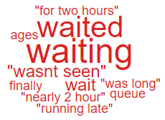
‘Waiting’.
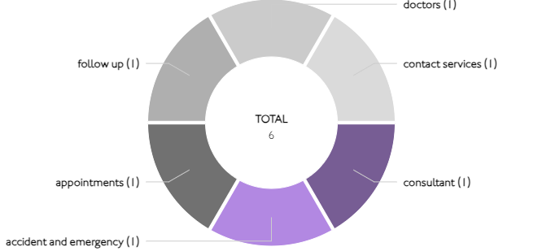

Theme 2; Communication;
Communication Improvement Plan;
- Ombudsman Trainer has delivered communication training & soft skills for the past 2 years – new sessions to be arranged for 2024
- Regular Complaints & Ombudsman training sessions delivered on request.
- New training prospectus advertised on intranet.
- Complaints & Ombudsman training being available for all staff to book via SharePoint page.
- Training during consultant development programme where the importance of good and clear communication is discussed.
- Improvement plan being developed and will be shared in the next quarterly report.

AMU Morriston. Patient Experience feedback for Quarter 2. The overall score was 69%. As you can see from the wordle below, there are only positive comments for communication:


During Q2, 171 complaints were received regarding communication. A breakdown of the sub-subjects are below – please note, some complaints include more than one of these issues.
Communication;
Insufficient/Incorrect information | 144
Communication with family | 24
Communication with patient/service user | 10
Communication between Services/Departments | 6
Concerns relating to DNR decision | 5

Theme 3; Appointments;
What we are doing about this?
- Outsourcing of patients to other Healthcare providers to help reduce waiting times;
- Rapid Diagnostic Centre expansion.
- Developments for patients to check themselves in for appointments (Radiotherapy)
All Wales questions do not have ‘appointments’ as a question set. Therefore, we searched the words delay/delays/appointment for the areas mentioned.
Here are some comments we found relating to ‘appointments’ for these areas:
- The appointment was on time and the nurse was lovely, she gave me some good advice.
- My outpatient appointment was on time, friendly and informative.
- Waiting time was very good. It was around 15 minutes. The consultant was helpful and explained everything.
- I got my appointment when I wanted it and the staff in the hospital were very helpful.

- The amount of waiting time! if the appointments are running late then patients need to be informed or arrive an hour later than the designated appointment time. Having recently had a knee operation, I was extremely uncomfortable waiting an extra 30 minutes after my arrival.

- I did wait nearly an hour past my appointment time. Any improvement on this would be good. I have experienced this length of delay on previous appointments.

During Q3, 99 complaints were received regarding appointment issues. Many of these complaints will have more than one sub-subject, see breakdown below;
Appointments;
Delay in appointment/waiting time/transport | 66
Appointment cancelled | 22
Cancelled appointment/transport | 9
Patient lost to follow-up | 7
Continuity of staff | 2
Location of appointment unsuitable | 1

- HIGHLIGHT AREAS

As part of the Health Board’s focus on Urgent Care, Planned Care and Cancer Services the following section highlights complaints received in:
- Orthopaedics
- A & E
- General Surgery
- Cancer Services
Graph 1 below shows the number of complaints for each of these areas received per month since July 2022.
Graph 1: Complaints per month
As Orthopaedics has the highest number of complaints, a breakdown of the issues raised can be found below compared with Q1. It is envisaged with the new OCP changes Orthopaedic waiting time complaints will reduce.

3.1 – Orthopaedic Complaint themes
Orthopaedics Themes | Q1 2023/24 | Q2 2023/24
Admissions | 21 | 17
Communication Issues | 6 | 6
Clinical treatment/Assessment | 23 | 9
Appointments | 6 | 12
Attitude and Behaviour | 0 | 2
Referral | 2 | 2
Accident/Falls | 0 | 0
Medication | 0 | 1
Nutrition/Hydration Issues | 0 | 0
Discharge | 1 | 2
Infection Control | 0 | 0
Patient Care | 1 | 0
Post Death Issues | 0 | 0
Test and Investigation Results | 2 | 1
Personal Property/Finance | 0 | 1
Record Keeping | 0 | 1

Patient Experience Feedback: Orthopaedic Services
As Orthopaedics is classed as a ‘High Risk Area’, the Patient Experience Team have investigated the feedback for Orthopaedic Services. In total, Orthopaedic Services received 529 responses to the Friends and Family Survey during Quarter 2.
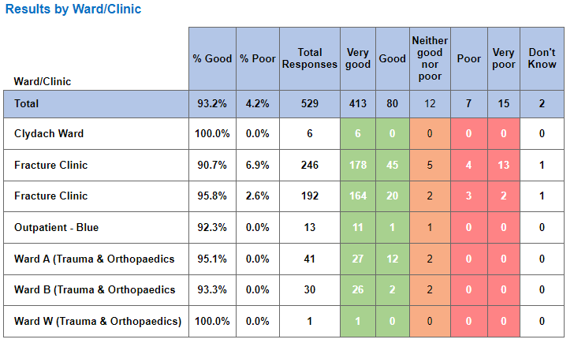
Below are the top themes for Orthopaedic services:
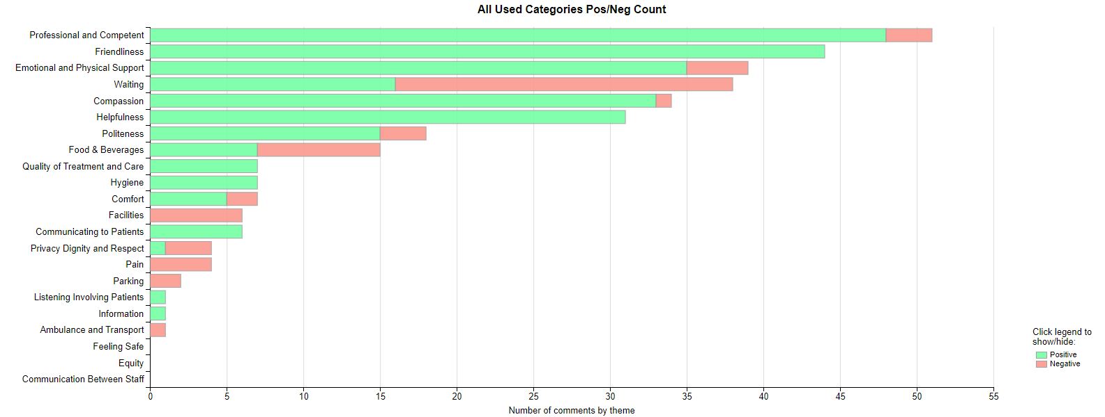

NB: We have been informed that the word ‘Pain’, is oversensitive and the wordles, charts are taking any word with Pain as a negative. Civica are aware and are rectifying. This is across Wales.
Positive Themes
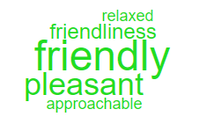
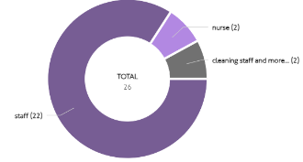
‘Friendliness’

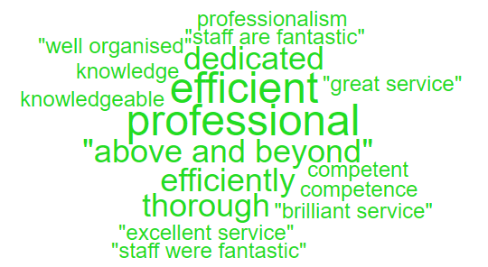
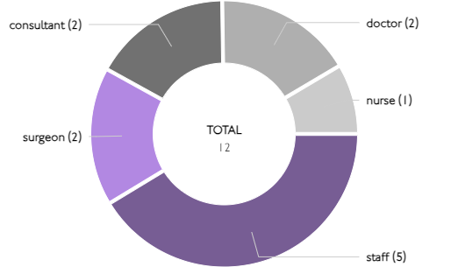
‘Professional & Competent’

Here are some of the positive comments we’d like to share:
- During a busy period, I was seen to quickly and efficiently by the healthcare team.
- Friendly staff. Efficient system. No time wasting.

- Kindness and competence of doctors, nurses, anaesthetists, and cleaners.

- All staff went out of their way to accommodate me. All were polite and helped make the appointment a good experience.

- Everyone was very helpful and informative regarding my condition, were very happy to answer my questions. Gave me full confidence in their ability going forward in the treatment I require.

- Efficient, even when having to use different departments, it was all coordinated. Professional and friendly staff. Minimal waiting time in all departments.

Negative Themes

The chart above highlights a few areas relating negative feedback. Here is an in-depth breakdown of these areas.

‘Waiting’
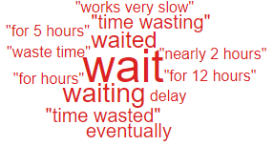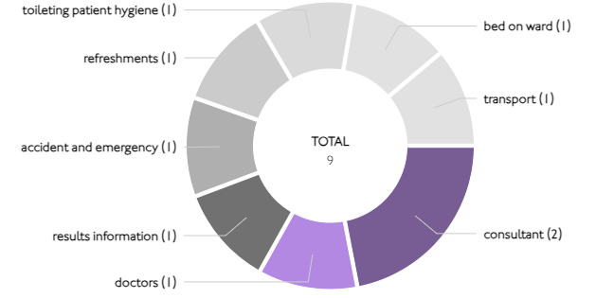

These are the comments highlighted in the above ‘Wordle’. Please note, the ’12 hours’ is a nice comment.

  - – A&E Complaints
During Q2 of 2023/24, A&E received 31 complaints, a breakdown of the issues is below;

The 8 ‘clinical treatment/assessment’ complaints all relate to delays in treatment or assessment.
Patient Experience Feedback: A&E Services
As A&E is classed as a ‘High Risk Area’, the Patient Experience Team have investigated the feedback for A&E Services. In total, A&E Services received 1,003 responses to the Friends and Family Survey during Quarter 2.
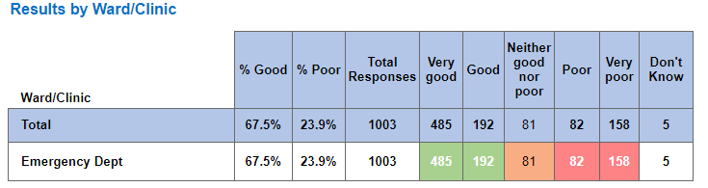

Below are the top themes for A&E services:
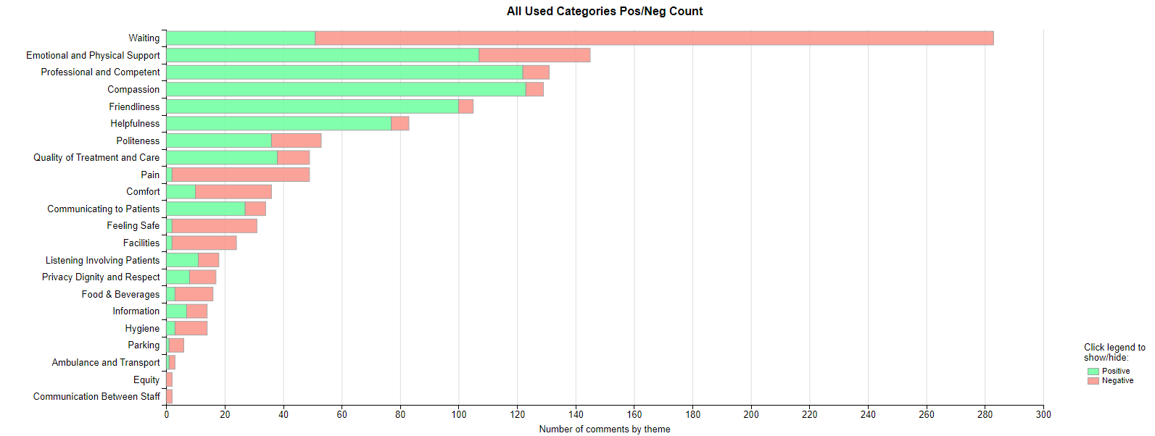
Positive Themes
‘Compassion’
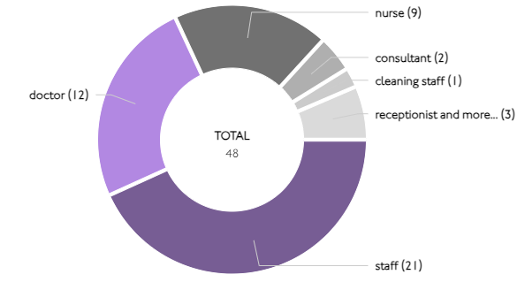
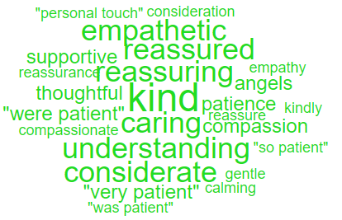

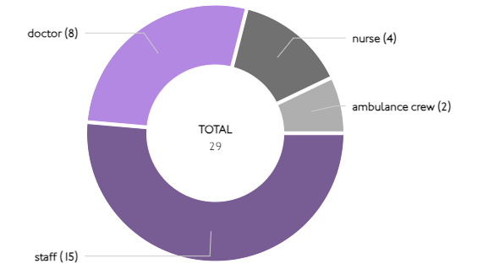
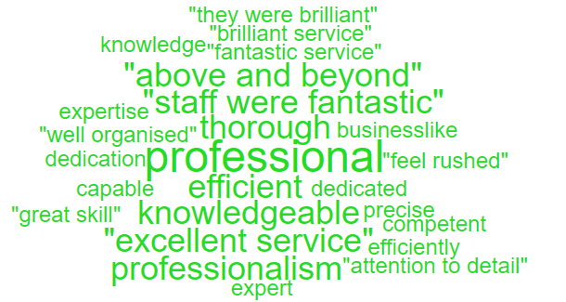
‘Professional & Competent’

Here are some of the positive comments we’d like to share:
- Doctor that stitched my head wound was very professional and efficient and did a great job including questioning me about nature of fall and potential for other issues. Once she’d got to bottom of it, I was dealt with promptly and professionally
- Nurses went above and beyond to help me with my pain. They were very friendly polite and respectful. I felt that they really want to help, and I trust them in every step.
- The staff went out of their way to support and care for me on arrival and stayed in the unit all night due to delays in getting an ambulance to transfer me to Morriston hospital. I feel that they all went above and beyond the call of duty and should be recognised at the highest level for their dedication and professionalism
- The professionalism of staff within the NHS is truly remarkable. The service is one of the UK’s best national institutions and must be commended. Keep up the excellent work.
- The staff were incredibly helpful, courteous, thoughtful, considerate, and professional.
Negative Themes
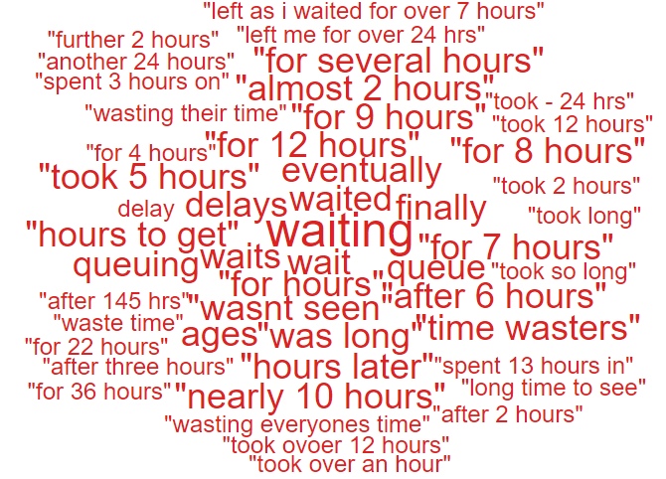
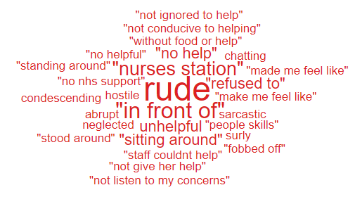
‘Emotional & Physical Support’ ‘Waiting’

Here are the negative comments relating to A&E:

- Waiting for 9 hours, more staff on duty would help.
- Waiting a long time to see doctor but worth the visit.
- Waiting times for my results, as it took 5 hours to get my blood results back.
- The doctor who saw my elderly father was quite rude and condescending.
- Waiting room was so hot it made me feel worse, air conditioning would have helped a lot.
- The waiting time was so long. I was there for 13hours. I wasn’t allowed to eat. I had to remind them twice that I was still there, and they had forgotten. Triage nurses were rude to me.
  - – General Surgery Complaints
During Q2 of 2023/24, General Surgery received 30 complaints, a breakdown of the issues is below;

Patient Experience Feedback: General Surgery
As General Surgery is classed as a ‘High Risk Area’, the Patient Experience Team have investigated the feedback for General Surgery Services. In total, General Surgery Services received 1,458 responses to the Friends and Family Survey during Quarter 2.
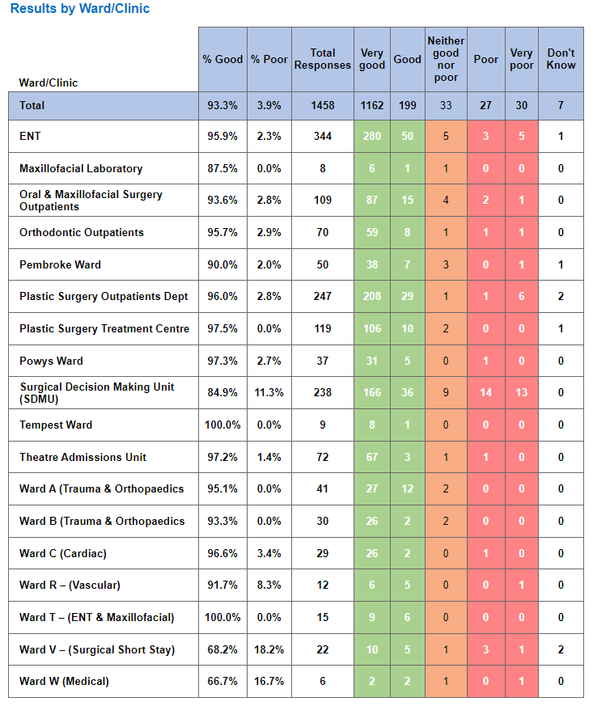

Below are the top themes for General Surgery services:
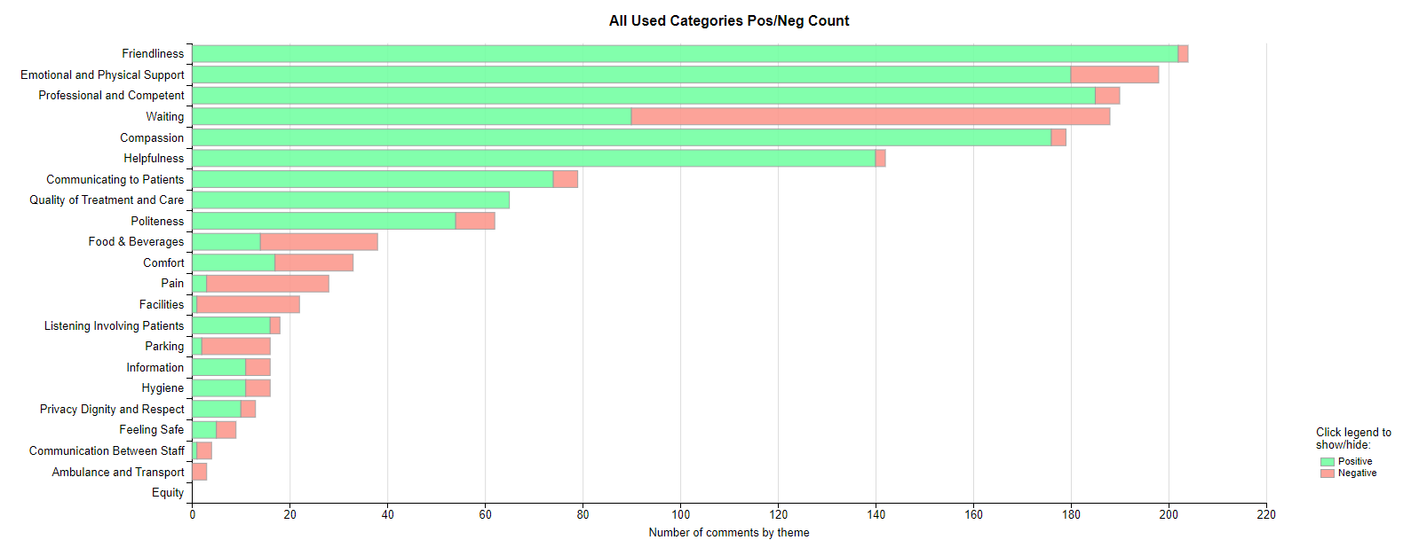
Positive Themes
‘Friendliness’
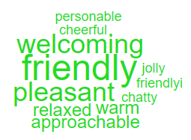
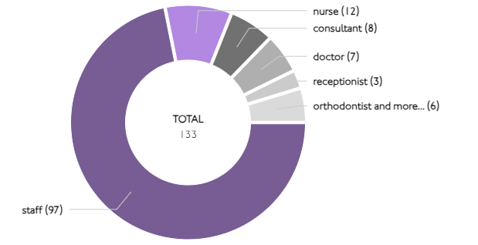

‘Helpfulness’
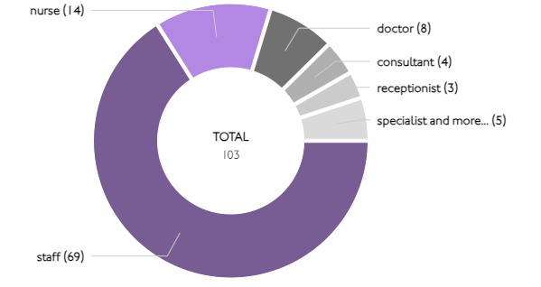
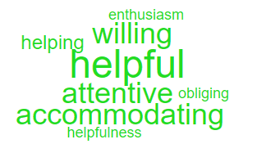

Here are some of the positive comments we’d like to share:
- Excellent service, high level of care kind and attentive nurses, and medical team. Friendly and kind kitchen and cleaning staff.
- The staff were all kind, attentive, and efficient. Working well as a team to provide an excellent level of care.
- Everyone was very good. Explained what they were doing and why. Staff very pleasant and helpful.
- The nurses are very efficient and friendly. They are very cheerful, and it was the same at SDMU. The doctors have been great at explaining things in a way I can understand.
- Everyone was friendly and helpful, the department was obviously well run, cheerful decor and very clean. Very fast referral from my GP to ENT in one week, fantastic.

Negative Themes
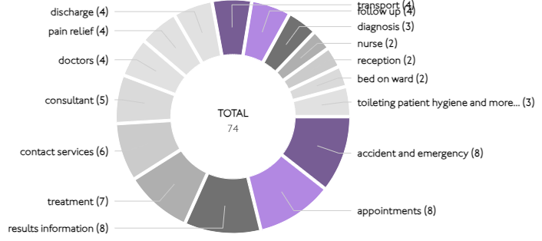
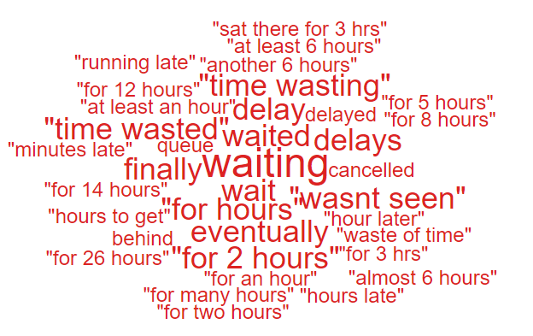
‘Waiting’

‘Comfort’

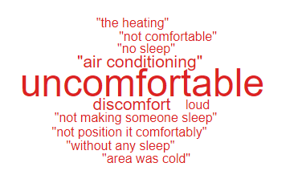
Below are some Negative comments relating to General Surgery:
- Waiting for over an hour to see the consultant.
- Communication to patients waiting for operations and time scales involved. Not informing patients that the operation was not scheduled to go ahead.
- Do not keep us waiting for so long when there is no queue,
- The chairs in the waiting area for SDMU are hard plastic and very uncomfortable. As I was in significant pain, I found it difficult being on these chairs for hours.
- I felt the treatment was quite quick and efficient, but the SDMU area was cold and uncomfortable.
- Something very small but the heating was on, and it was really hot for all, it was an unusually warm day but that is a very minor thing.

  - – Cancer Services Complaints
As cancer waiting times are currently a concern for the health board, a breakdown of the 12 complaints received in Q2 is below.

Patient Experience Feedback: Cancer Services
As Cancer is classed as a ‘High Risk Area’, the Patient Experience Team have investigated the feedback for Cancer Services. In total, Cancer Services received 682 responses to the Friends and Family Survey during Quarter 2.
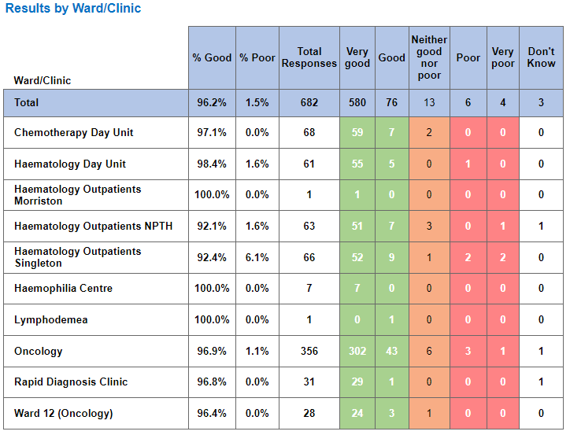
Below are the top themes for Cancer services:
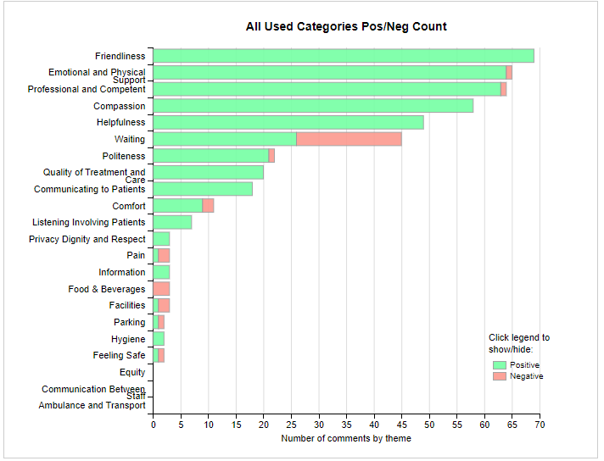

Postive Themes
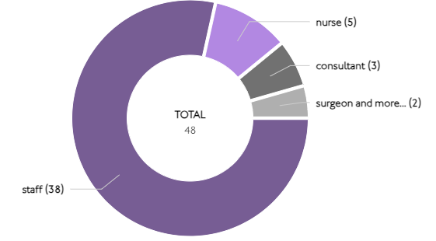
‘Friendliness’
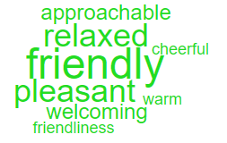

‘Compassion’
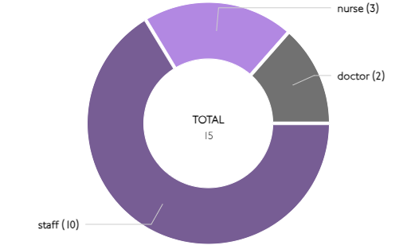
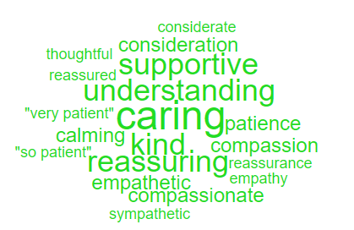

Here are some of the positive comments we’d like to share:
- Consultant and her staff weve very informative and reassuring throughout, explaining procedures, testing, medication, prognosis and self help.
- Everyone very professional, helpful, and patient explaining all the procedures.
- Food and drinks were above and beyond expectation. Nursing care was excellent.
- Everybody that has dealt with me in the oncology department and in the chemotherapy unit have been exemplary. I couldn't ask for a more helpful and friendly service. The attention provided by the nurses was outstanding also by the assistants. I think this was due to their superior colleagues.

Negative Themes
Looking at the chart above it highlights comments specifically related to ‘waiting’ negative feedback. Here are some examples of the comments written to give context.
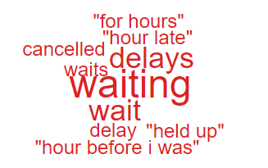
‘Waiting’

- SERVICE GROUP COMPLAINTS, INCIDENTS, COMPLIMENTS AND PATIENT FEEDBACK HIGHLIGHTS

MORRISTON SERVICE GROUP
8.1 – Morriston Service Group complaints
Morriston Service Group received a total of 276 complaints during Q2 2023/24. Graph 1 below shows the total number of complaints received relating to Morriston Service Group since October 2022. The graph breaks the total number received down by Formal PTR, Early Resolution and Re-opened complaints.
Graph 1: Morriston Service Group complaints by month and type

Graph 2 shows the top five services that had the most complaints since October 2022. As seen in the graph, Orthopaedics received the highest number of complaints but since March 2023, appear to be steadily decreasing. General Medicine appears to have received an increase during August 2023 with 17 received during the month.
Graph 2: Top 5 Services by month

8.2 – Morriston Service Group Incidents
Morriston Service Group reported 2714 incidents in quarter 2 (Q2) of 2023/24 (July, August, September). This compares with 2717 incidents in quarter 1 (Q1) of 2022/23 (April, May, June). Graph 1 shows the number of incidents per month broken down by severity.
Graph 1: Morriston Incidents by Severity and month

Graph 2 shows the top 5 incident types, of all incidents reported by Morriston Service Group since July – September 2023. As you can see from the graph, the number of falls decreased during September.
Graph 2: Top 5 incidents per month
8.3 – Morriston Service Group National Reportable Incidents
Morriston Service Group reported 7 Nationally Reportable Incidents (NRI’s) during Q2 2023/24, this compared to 11 reported during Q1 of 2023/24. Of the NRI’s reported, 2 x failed diagnosis, 2 x unexpected deaths, 1 x consent for procedure issue, 1 x delay acting on results, 1 Never Event – retained screw. Graph 1 shows the number of NRI’s reported per month.
Graph 1: Nationally Reportable Incidents reported per month by Morriston Service Group

8.4 – Morriston Service Group Compliments
Morriston received 162 compliments during Q2 of 2023/24. Graph 1 shows the number received per month since October 2022.
Graph 1: Morriston compliments per month

Graph 2: Morriston compliments – Top 5 Services

Since the Acute Medical Services Redesign, Morriston Service Group now manage Minor Injuries Unit.
8.5 Morriston Service Group Patient Experience Feedback
Overall, during quarter two there were 64,404 number of patients seen under Morriston Service Group (This includes ED).

There were 6638 Friends and Family survey returns which equates to 10% responding to the survey. Out of the 10% who responded, 89% of people stated they would highly recommend the Health Board to Friends and Family.

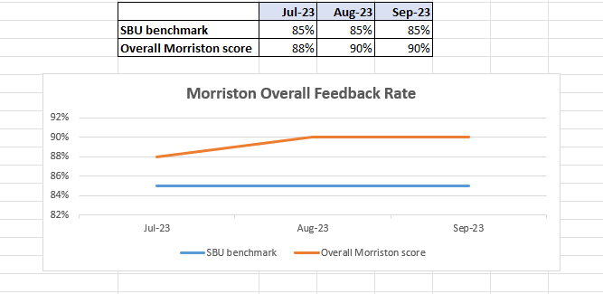

Below are the number of responses in a line graph:

Below are the main themes mentioned for Morriston:
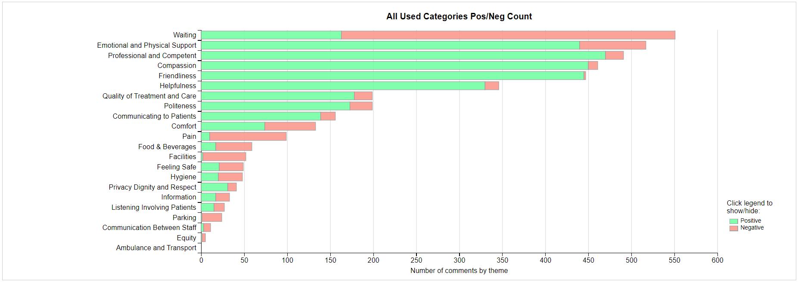
NEATH PORT TALBOT SINGLETON SERVICE GROUP
8.6 – NPTSSG Complaints
NPTSSG received a total of 153 complaints during Q2 2023/24. Graph 1 below shows the total number of complaints received relating to NPTSSG since October 2022. The graph breaks the total number received down by Formal PTR, Early Resolution and Re-opened complaints.
Graph 1: NPTSSG complaints by month and type

Graph 2 shows the top five services that had the most complaints since October 2022. As seen in the graph, Gynaecology appear to have had a decrease in June but have increased again within the last quarter. There also appears to have been an increase in complaints relating to Dermatology and Rheumatology.
Graph 2: Top 5 Services by month

As Gynaecology receive the most complaints, a breakdown of the 33 complaints received during Q2 can be found below;

Out of the 33 complaints, 26 are recorded against outpatients department due to delays and cancellations of appointments and treatment.
8.7 – NPTSSG Incidents
NPTSSG reported 1233 incidents in quarter 2 (Q2) of 2023/24 (July, August, September). This compares with 1240 incidents in quarter 1 (Q1) of 2023/24 (April, May, June). Graph 1 shows the number of incidents per month broken down by severity.
Graph 1: NPTSSG Incidents by Severity and month

Graph 2 shows the top 5 incident types, of all incidents reported by NPTSSG since July to August 2023.
Graph 2: Top 5 incidents per month

8.8 – NPTSSG National Reportable Incidents
NPTSSG reported 5 Nationally Reportable Incidents (NRI’s) during Q1 2023/24, this compares to 6 being reported during Q4 of 2022/23. Of the NRI’s reported 3 related to Pressure Ulcers and 2 Neonatal incidents. Graph 1 shows the number of NRI’s reported per month.
Graph 1: Nationally Reportable Incidents reported per month by NPTSSG

8.9 – NPTSSG Compliments
NPTSSG received 102 compliments during Q1 of 2023/24. Graph 1 shows the number received per month since October 2022.
Graph 1: NPTSSG compliments per month

Graph 2: NPTSSG compliments – Top 3 Services

8.10 NPTSSG Patient Experience Feedback
Overall, during quarter two there were 47,240 number of patients seen under Neath Port Talbot and Singleton Service Group (This includes Minor Injuries Unit).

There were 4501 Friends and Family survey returns which equates to 10% responding to the survey. Out of the 10% who responded, 95% of people stated they would highly recommend the Health Board to Friends and Family during this quarter.

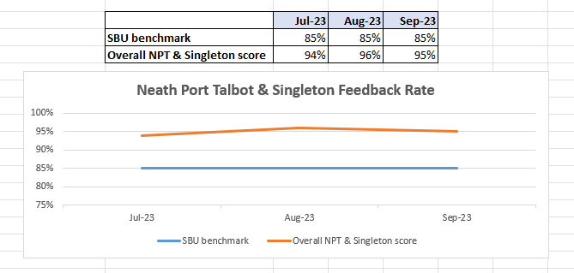

Below are the number of responses in a line graph:

Below are the main themes mentioned for NPT & Singleton:
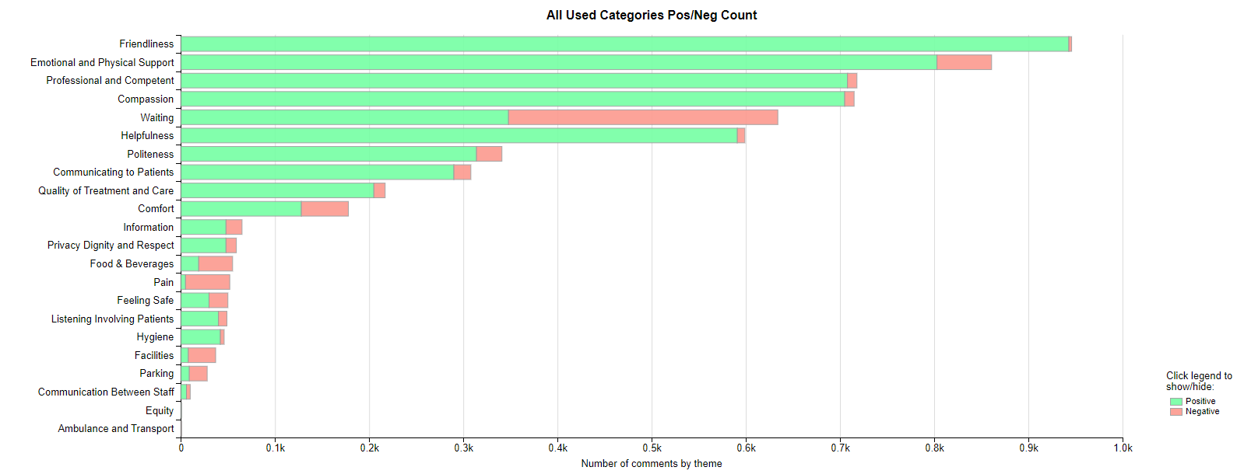
MENTAL HEALTH AND LEARNING DISABILITIES SERVICE GROUP
8.11 – MH&LD Complaints
MH&LD received a total of 61 complaints during Q2 2023/24. Graph 1 below shows the total number of complaints received relating to MH&LD since October 2022. The graph breaks the total number received down by Formal PTR, Early Resolution and Re-opened complaints.
Graph 1: MH&LD complaints by month and type

Graph 2 shows the top five areas within MH&LD that had the most complaints since October 2022. As shown in the graph, Central Clinic appear to have had an increase in complaints during September 2023.
Graph 2: Top 5 Services by month

8.12 – MH&LD Incidents
MH&LD reported 1081 incidents in quarter 2 (Q2) of 2023/24 (July, August, September). This compares with 1067 incidents in quarter 1 (Q1) of 2023/24 (April, May, June). Graph 1 shows the number of incidents per month broken down by severity.
Graph 1: MH&LD Incidents by Severity and month

Graph 2 shows the top 5 incident types, of all incidents reported by MH&LD since July - September 2023.

Graph 2: Top 5 incidents per month

8.13 – MH&LD National Reportable Incidents
MH&LD reported 2 NRI’s during Q2 of 2023/24, both of which were falls. This compares to none being reported during Q1 of 2023/24.

8.14 – MH&LD Compliments
MH&LD received 5 compliments during Q2 of 2023/24. This compares to 6 compliments during Q1 of 2023/24. Graph 1 shows the number received per month since October 2022.
Graph 1: MH&LD compliments per month

8.15 MH&LD Patient Experience Feedback
This data is from Quarter Two.

The Mental Health and Learning Disabilities Service Group are using a different set of survey questions. The role out of the semi structured interview surveys have been managed in stages. Roll out, awareness posters and meetings with managers and teams continues.

PRIMARY AND COMMUNITY SERVICE GROUP
8.16 – P&C Complaints
P&C received a total of 103 complaints during Q2 2023/24. Graph 1 below shows the total number of complaints received relating to P&C since October 2022. The graph breaks the total number received down by Formal PTR, Early Resolution and Re-opened complaints.
Graph 1: P&C complaints by month and type

Graph 2 shows the top five services that had the most complaints since October 2022. As seen in the graph, HMP Swansea appear to have received the most complaints however, these have started to decrease during the last quarter.
Graph 2: Top 5 Services by month

8.17 – P&C Incidents
P&C reported 872 incidents in quarter 2 (Q2) of 2023/24 (July, August, September). This compares with 879 incidents in quarter 1 (Q1) of 2023/24 (April, May, June). Graph 1 shows the number of incidents per month broken down by severity.
Graph 1: P&C Incidents by Severity and month

Graph 2 shows the top 5 incident types, of all incidents reported by P&C since July – September 2023.
Graph 2: Top 5 incidents per month

8.18 – P&C National Reportable Incidents
P&C reported 6 Nationally Reportable Incidents (NRI’s) during Q2 2023/24, this compares to 1 being reported during Q1 of 2023/24. The 6 NRI’s reported included 4 x Pressure Ulcers, 1 x Prison Death and 1 x Delayed Referral.
Graph 1: Nationally Reportable Incidents reported per month by P&C

8.19 – P&C Compliments
P&C received 37 compliments during Q2 of 2023/24. Graph 1 shows the number received per month since October 2022.
Graph 1: P&C compliments per month

Graph 2: P&C compliments – Top 5 Services

8.20 P&C Patient Experience Feedback
Overall, during this quarter there were 2,437 number of patients seen under Primary and Community Service Group.

There were 1061 Friends and Family survey returns which equates to 44% responding to the survey. Out of the 44% who responded, 95% of people stated they would highly recommend the Health Board to Friends and Family during this quarter.

Patient Experience Team are currently working with I.T to automate SMS messages from the PIMS, PIMS+ platform to automate SMS survey messages to Primary Care and Therapies patients. This will increase the number of returns.

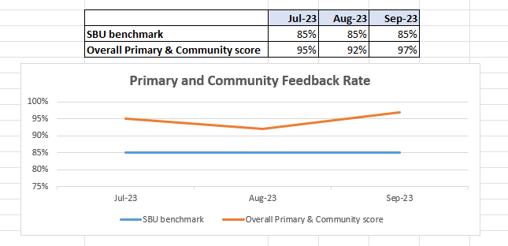

Below are the number of responses in a line graph:

Below are the main themes mentioned for Primary & Community:
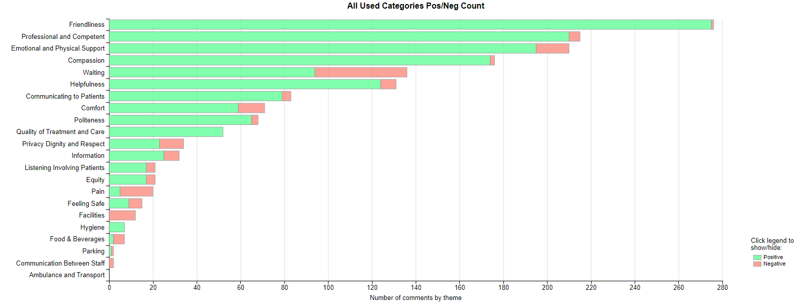

- MEDICAL EXAMINER COMPLIMENTS

9.1 ME Compliments
The Health Board has received a number of compliments from families through the Medical Examiner. This evidences the good work being done when treating these end of life patients. During Q2, approximately 172 compliments were received. A few examples are shown below;

Wonderful care, cannot fault the care. Thankful that the ward arranged for the chaplain to visit and for mum to have her wish to be christened before she passed.
Ty Olwen

Could not do enough for her, great care, no problems whatsoever. Nothing but praise for care given to pt and dad. Very thankful – Ward B2, NPT

Very happy with care received for husband and herself, thankful for the care and compassion showed to her whilst he was passing away and afterwards. Can't thank them enough, nothing but praise for all involved.. – Ward 12, Singleton

- OMBUDSMAN CASES

10.1 Ombudsman investigations
No new Ombudsman investigation was received during Q2 2023/24, this compares to 2 in Q1 2023/24. Graph 1 shows the number of investigations received per month;

Graph 1: Number of Ombudsman investigations per month

Although the Health Board did not receive any new investigations, it did receive 7 new enquiries and 5 early settlement proposals.
The Health Board has also received 16 decisions not to investigate from the Ombudsman during Q2. Graph 2 below shows these by month.

Graph 2: Ombudsman decisions not to investigate

There are a number of different reasons why the Ombudsman decided not to investigate these complaints, a few of these reasons are detailed below;

- Complainant advised to take legal route
- Complaint out of time
- No evidence of service failure by Health Board

