


Meeting Date | 20 October 2023 |  | Agenda Item |  |  | 06a
Report Title | Infection Prevention and Control
Report Author | Nicola Lewis, Interim Matron, Infection Prevention & Control
Report Sponsor | Lesley Jenkins, Assistant Director of Nursing
Presented by | Nicola Lewis, Interim Matron, Infection Prevention & Control
Freedom of Information | Open
Purpose of the Report | This is an assurance report that provides an update on prevalence, progress and actions for healthcare associated infections (HCAIs) within Swansea Bay University Health Board for the reporting period to the end of September 2023.
Key Issues | - The Health Board has exceeded the maximum annual number of cases of C. difficile infection and Staphylococcus aureus bacteraemia required to achieve the infection reduction goal.  - E.coli bacteraemia & Klebsiella spp bacteraemia have continued to increase above trajectory however; the number of cases of Pseudomonas aeruginosa bacteraemia are currently on track to achieve the reduction goal.  - IPC Level 2 and ANTT training continue to be significantly below the national target of 85% compliance in all staff groups however, compliance has improved during quarter 2.  - Within the Datix system there are 62 overdue management reviews, 312 overdue incidents under investigation and 55 overdue incidents awaiting closure, although it is acknowledged that a proportion of these may be associated with the COVID-19 Nosocomial Mortality Review process.  - Service pressures on acute sites continue to preclude the ability to decant bays and clinical areas affected by periods of increased incidence of C. difficile. Consequently, it has not been possible to undertake the level of 4D cleaning required.
Specific Action Required (please choose one only) | Information | Discussion |  | Assurance | Approval
Specific Action Required (please choose one only) | ☐ | ☐ |  | ☒ | ☒
Recommendations | The Infection Control Committee is asked to NOTE progress to 30th September 2023 detailed in this assurance report and AGREE the following:  - ACTION: Service Groups to continue to drive improved compliance to achieve 85% compliance over 2023/24, ensuring the distribution of the “How to access IPC Level 2 training via ESR” Guide to all clinical staff.  - ACTION: Service Groups to drive improvements in the number of all groups of clinical staff who have completed ANTT e-learning and practical competency assessment, to achieve 85% compliance over 2023/24. A ‘How to guide for staff to access the ANTT e-learning’ is provided to support staff.  - ACTION: Service Groups to drive improved compliance with hand hygiene competence.  - ACTION: All Service Groups are asked to review and update the infection-related risks on the Risk Register.  - ACTION: Service Groups are asked to review all overdue incidents.  - NOTE progress on the Internal Audit Management Action Plan to 30th September 2023.  - NOTE progress on Infection Prevention Improvement Plan to 30th September 2023.  - NOTE progress on the Infection Prevention & Control Audit Programme for 2023/24.

INFECTION PREVENTION AND CONTROL

- INTRODUCTION
This report aims to provide an update on prevalence, progress and actions for HCAIs within SBUHB for the period 1st April 2023 – 30th September 2023 in relation to the following healthcare associated infections (HCAI):
- Clostridioides difficile infection
- Staphylococcus aureus bacteraemia
- Gram negative bacteraemia (Escherichia coli, Klebsiella spp., Pseudomonas aeruginosa)
An update in relation to COVID-19 to 30th September 2023 is provided also.
The report provides a retrospective overview of the activities carried out to progress the prevention, control and management of infection within SBUHB.
It also aims to identify key risks, making recommendations to address any areas requiring action or improvement.

- PROGRESS TO TIER 1 INFECTIONS
Healthcare Associated Infections (HCAIs): 1st April 2023 – 30th September 2023
Welsh Government AMR & HCAI Improvement Goals for 2023-24 were published in August (WHC 2023/031). Improvement goals for C. difficile and Staphylococcus aureus are to achieve rates of 25 per 100,000 population and 20 per 100,000 population respectively. For Klebsiella and Pseudomonas spp. bacteraemia, a reduction of 10% compared to 2017/18 figures is expected. The expectation for E. coli bacteraemia is a rate of no more than 67 per 100,000 population; as the Health Board achieved the 2022/23 reduction expectation, there will be an internal improvement goal of an additional 10% reduction during 2023/24.
A summary position for the Health Board is shown in Table 1 below, identifying the cumulative position and the infection reduction trajectory to 30th September 2023, and the average monthly goal.
Table 1: Health Board Summary Cumulative Position to end of September 2023
Infection | Cumulative Cases to end of September 2023 | Improvement Goal trajectory to end of September 2023 | Average monthly reduction goal (max.)
C. difficile (CDI) | 114 | 53 | <8 (annual maximum: <95 cases)
Staph. aureus bacteraemia (SABSI) | 73 | 38 | <6 (annual maximum: <71 cases)
E. coli bacteraemia (EcBSi) | 148 | 123 | <19 (annual maximum: <234 cases)
Klebsiella spp. bacteraemia (Kl BSI) | 49 | 43 | <6 (annual maximum: <71 cases)
Ps. aeruginosa bacteraemia (PAERBSI) | 12 | 13 | <2 (annual maximum: <24 cases)
A summary position for Service Groups is shown in Table 2, identifying the cumulative number of cases up to the reporting month with annual increase or reduction shown in brackets for the financial year to date.
Table 2: Service Group Annual Comparison to 30th September 2023
 | CDI | SABSI | EcBSI | KlBSI | PAERBSI
SBUHB - Total | 114 (24% ) | 73 (6% ) | 148 (8% ) | 49 (4% ) | 12 (40% )
PCTSG - CAI | 35 (21% ) | 36 (9% ) | 71 (7% ) | 23 (10% ) | 4 (1 case )
PCTSG - HAI | 1 (equal to) | 0 (equal to) | 2 (1 case ) | 0 (equal to) | 0 (equal to)
MH&LD – HAI | 0 (equal to) | 0 (equal to) | 0 (1 case ) | 0 (equal to) | 0 (equal to)
MORR – HAI | 59 (31% ) | 21 (40% ) | 50 (28% ) | 20 (equal to) | 6 (57% )
NPTH - HAI | 2 (50% ) | 1 (67% ) | 5 (1 case ) | 2 (equal to) | 0 (equal to)
SH - HAI | 13 (equal to) | 14 (56% ) | 15 (1 case ) | 4 (43% ) | 1 (67% )
Other HB Cases Identified in SBUHB | 4 (N/A) | 1 (N/A) | 5 (N/A) | 0 (N/A) | 1 (N/A)

Charts showing the position of the Health Board and Service Group progress against the infection improvement trajectories, up to 30th September 2023, are detailed in Appendix 1.
A number of wards have had more than 100 days between HCAI cases. These are summarised in Appendix 2.

- Clostridioides difficile
There has been a 24% increase in C. difficile cases compared with the same period in 2022/23 and the number of cases to 30th September has exceeded the annual maximum number of cases to achieve the 2023/24 infection reduction goal. Of the 114 cases, 69% were categorised as hospital-acquired infections (HAI). Four occurred in patients who reside outside this Health Board’s boundaries, but who were tested and found to be positive on admission to our services. 52% of cases occurred at Morriston Hospital. Whole genome sequencing results continue to indicate that there are few confirmed transmission events within the Health Board.

The challenge of tackling C. difficile in Wales has been a focus of the Wales C. difficile Infection Focus Forum for the last 18 – 24 months. The publication of the Clostridioides difficile Strategy and Action Plan for Wales 2023-2025 is anticipated.
- Staph. aureus bacteraemia

Although, there has been a 6% reduction in Staphylococcus aureus bacteraemias compared with the same period in 2022/23, the number of cases to 30th September has exceeded the annual maximum number of cases to achieve the 2023/24 infection reduction goal. Of the 36 cases, 51% were categorised as hospital-acquired infections and of these, 35% appear to be vascular line- or cannula-associated infections. There remains a targeted focus on monitoring and reducing the prevalence of unnecessary vascular lines, promoting chlorhexidine skin decolonisation, and improving ANTT training and competence assessment.
- Gram negative bacteraemia (E. coli, Klebsiella spp., Pseudomonas aeruginosa),
The incidence of E. coli bacteraemia is currently above the trajectory profile for quarter 2, and there has been an 8% increase compared with the same period in 2022/23. Of the 148 E. coli bacteraemia cases in SBUHB between April 2023 and the end of September 2023, 48% of the cases were community-acquired infections. For both community-acquired and hospital-acquired cases, the most frequent source of infection was urinary, with 62% and 49% of cases respectively. Hepatobiliary disease was the second most frequent source of hospital-acquired cases and accounted for 19%.

The incidence of Klebsiella spp. bacteraemia is currently above the trajectory profile for quarter 2 however, there has been a 4% reduction in the number of cases compared with the same period of 2022/23. Of the 49 cases of Klebsiella spp. bacteraemia cases between April 2023 and the end of September 2023, 53% were hospital-acquired cases. For both community-acquired and hospital-acquired cases, the most frequent source of infection was urinary, with 57% and 34% of cases respectively. Hepatobiliary disease was the second most frequent source of hospital-acquired cases and accounted for 23%.

The incidence of Pseudomonas aeruginosa is below the trajectory profile for quarter 2 with a 60% reduction in the number of cases compared with the same period of 2022/23.

- Infection Prevention & Control Improvement Plan
Overarching 2023/24 Infection Prevention Improvement Plan
The 2023/24 Infection Prevention Improvement Plan with progress updated to 30th September has been attached as Appendix 3. A summary of progress is provided below:
- An antimicrobial audit tool has been developed in the AMaT system and is currently being piloted by a group of junior Doctors following discussion in the Antimicrobial Stewardship Group.
- As agreed at the Infection Prevention & Control Group meeting in June, the IPC team has commenced a proactive programme of audit, using a standard infection control precautions practice audit tool, and a standard infection control precautions environment audit tool. These audits have been undertaken in Morriston, Singleton, Neath, Cefn Coed and Gorseinon hospitals. Discussions with Service Groups are underway to identify wards which will participate in a programme to pilot the tools as part of their monthly Nursing Metrics reporting.
- IPC training compliance for Level 1, Level 2 and ANTT has improved compared to quarter 1. Full details of training compliance are available in Section 5 of this report.

- Outbreaks and clusters, untoward incidents, Periods of Increased Incidence (PIIs), and ward/bay closures from diarrhoea and vomiting
COVID-19 (SARS-CoV-2) associated outbreaks
The Health Board continues to manage nosocomial clusters and outbreaks of infection associated with COVID-19. The Service Groups hold regular internal COVID-19 incident management meetings, supported by the Infection Prevention & Control Team (IPCT).

Clostridioides difficile Period of Increased Incidence (PII):
WGS analysis indicates that the majority of C. difficile cases in SBUHB are not associated with transmission events. Transmission events are categorised as probable, (where patients overlap in time and place), and possible (where patients have at some point been in the same ward but not had an overlap in time).
During July 2023, August 2023 and September 2023, 22 separate incidents relating to PII were reported on Datix and monitored. The Whole Genomic Sequencing (WGS) analysis of the positive isolates are pending for a number of these incidents. Of those that have returned to date, the genomic sequencing results indicated that there had been probable transmission in four incidents as shown in table 3, below;
Table 3: C.difficile transmission events to 30th September
Date Reported | Ward/Department | Whole Genome Sequence | Number of patients affected
04/09/2023 | Morriston Hospital Emergency Department | WG23-00456_1456 | 2
05/09/2023 | Morriston Hospital  Cardiac Short Stay Unit | WG20-00656 | 2
05/09/2023 | Morriston Hospital  Wards A and W | WG23-00512_1484 | 3
06/09/2023 | Morriston Hospital General ITU/CCU | WG23-00481_338 | 3

During scrutiny of C. difficile cases it has been identified frequently that it has not been possible to isolate cases at the first onset of loose stool. In some cases, wards have been unable to isolate patients diagnosed with C. difficile infection for a number of days. Additionally, due to an inability to decant bays, 4D cleaning processes have not been used.

Other significant infection incidents/outbreaks:

Acute Respiratory Infections (ARI)

During the reporting period, acute respiratory infections (ARI) specifically COVID-19, have continued to result in clusters/outbreaks on a number of wards/units however, most of these results have been incidental findings with very few patients clinically unwell due to symptoms. COVID cases were rising in the community at this time also, impacting on hospital admissions, staff sickness and potential clusters of inpatient transmission. In previous years, the Health Board has seen an increase in the numbers of C. difficile cases approximately 8 to 12 weeks after the peak of the respiratory viruses.

A summary of inpatient areas currently affected by clusters, outbreaks, incidents and Periods of Increased Incidence of infections is reported via an Outbreak Summary located on the IPC SharePoint “Daily update” page.

Tuberculosis (TB)

In August, a patient on Ward J in Morriston hospital was diagnosed with TB. The patient had seven hospital admissions during the infective period resulting in the potential exposure of a number of staff and patients. Incident meetings have been held including representation from the Health Protection Team. Patient contacts have been identified and are being followed up by the respiratory team while managers have passed staff details to Occupational Health for assessment. To date, no further cases have been identified.

Carbapenemase Producing Enterobacteriaecae (CPE)

In August, a patient on AMU in Morriston hospital was found to have a Carbapenemase producing Klebsiella pneumoniae. Contacts were identified and screened, and a further two patients were also found to have the same organism with transmission confirmed by organism typing. Contacts of all positive cases were screened, with no further cases detected. Environmental sampling also returned negative results. An outbreak management team was convened including representation from Public Health. The affected areas of AMU were decanted and 4D cleaned, as were all bathrooms, toilets and sluices. There was regular communication with staff throughout AMU and Health Board-wide communications reiterating the importance of hand hygiene and providing information about CPE. An outbreak closure meeting is due to be held on 27th October.

- Education & Training
Training compliance
The IP&C Team, along with local training practice leads, continues to deliver IPC training and updates, alongside the online training, to both clinical and non-clinical staff employed by the Health Board.
Recording face-to-face IPC training for the entire Health Board is undertaken by one temporary member of IPC administration staff. This compromises timely reporting of training compliance. An additional member of staff joined the IPC administration team on 2nd October 2023. After their initial induction period, they will be supporting the recording of the IPC training on ESR.

Level 1 – Infection Prevention and Control Training compliance to 30th September 2023
Staff Group  Infection Prevention and Control –  Level 1 – 3-yearly | % Compliance  to end of September 2023 | Increase () or decrease () in compliance from previous report
Add Prof Scientific and Technic | 92.95% | (90.02%)
Additional Clinical Services | 89.52% | (86.34%)
Administrative and Clerical | 90.64% | (89.58%)
Allied Health Professionals | 92.93% | (94.44%)
Estates and Ancillary | 81.76% | (83.57%)
Healthcare Scientists | 88.02% | (84.47%)
Medical and Dental | 60.52% | (52.44%)
Nursing and Midwifery Registered | 91.90% | (90.12%)
OVERALL COMPLIANCE | 88.23% | (86.30%)

Level 2 - Infection Prevention and Control Training compliance to 30th September 2023
Staff Group  NHS|CSTF|Infection Prevention and Control - Level 2 – Annual | % Compliance  to end of September 2023 | Increase () or decrease () in compliance from previous report
Add Prof Scientific and Technic | 12.95% | (15.08%)
Additional Clinical Services | 32.16% | (27.45%)
Administrative and Clerical | 7.17% | (6.79%)
Allied Health Professionals | 46.56% | (41.91%)
Estates and Ancillary | 2.98% | (2.46%)
Healthcare Scientists | 19.50% | (13.90%)
Medical and Dental | 12.98% | (11.51%)
Nursing and Midwifery Registered | 40.10% | (34.44%)
OVERALL COMPLIANCE | 26.28% | (22.74%)
A paper proposing that the Health Board mandates Level 2 IPC training for all staff was submitted for consideration and approval to Management Board on 7th July 2023. A decision was made to approve this recommendation and ESR will be updated for all Swansea Bay UHB staff to ensure IPC Level 2 training is part of the mandatory training list. This will be implemented by 1st December 2023.
ACTION: Service Groups to continue to drive improved compliance to achieve 85% compliance over 2023/24, ensuring the distribution of the “How to access IPC Level 2 training via ESR” Guide to all clinical staff.
The table below shows the number of staff within each Service Group who have received Hand Hygiene Training between 1st April 2023 and 30th September 2023. This information is provided directly from Infection Prevention & Control manual records, not via ESR.

Service Groups | Number of staff completed Hand Hygiene Training
Morriston | 410
NPT & Singleton | 267
Primary Care & Community | 50
Mental Health & Learning Disabilities | 224
Support Services | 34
Corporate | 16
GRAND TOTAL | 1001
ACTION: Service Groups to drive improved compliance with hand hygiene competence.

Aseptic non - touch Technique (ANTT)
Staff Group  Aseptic Non Touch Technique  Assessment - 3 Yearly e-Learning - once only | % Compliance to end  of September 2023 |  | Increase () or decrease () in compliance compared to previous report
 | e-Learning  (3 yearly) | e-Learning  (once only) | e-Learning  (3 yearly) | e-Learning  (once only)
Add Prof Scientific and Technic | 3.15% | 1.80% | (3.94%) | (1.39%)
Additional Clinical Services | 13.15% | 16.07% | (13.35%) | (11.18%)
Allied Health Professionals | 9.99% | 10.47% | (12.02%) | (6.36%)
Healthcare Scientists | 4.44% | 8.89% | (4.63%) | (6.30%)
Medical & Dental | 4.31% | 4.31% | (4.23%) | (4.31%)
Nursing & Midwifery Registered | 32.42% | 25.22% | (33.99%) | (17.91%)
OVERALL COMPLIANCE | 14.45% | 12.78% | (15.05%) | (9.56%)
COMBINED COMPLIANCE | 27.23% |  | 24.61%
ESR has an ANTT Practical Competency Assessment 3-yearly certificate available alongside the e-learning certificate, notifications are available to remind individuals when they need to be re-assessed. Support is being offered to upload any backlog of competency assessments. Training reports from ESR are not reliable currently, therefore, the IPCT continues to hold ANTT Competency Assessor training records received from each Service Group. An ANTT Task and Finish Group has been set up to drive improvements in ANTT training and competence assessments.
ACTION: Service Groups to drive improvements in the number of all groups of clinical staff who have completed ANTT e-learning and practical competency assessment, to achieve 85% compliance over 2023/24. A ‘How to guide for staff to access the ANTT e-learning’ is provided to support staff.

- Internal Audit Report
Infection Prevention & Control: Service Group Governance Arrangements
NHSWSSP Audit and Assurance Services undertook an internal audit to review the effectiveness of the governance arrangements in place within the Service Groups to manage the risks relating to Infection Prevention and Control. The associated Management Action Plan, with progress to 30th September 2023, is available as Appendix 4. All actions have been completed to the agreed time frames.

- Assurance
Reporting
- The Quality & Safety Group receives quarterly assurance reports relating to the Infection Prevention Improvement Plan.
- Weekly performance tracker reports against the Tier 1 infection reduction expectations are submitted to the Executive Team and Service Group Directors.
- Senior IP&C staff attend each Service Group Infection Control Committee. The IP&C Matrons and the Matron, Decontamination Operational Lead, together with Band 7 Infection Control Nurses, ensure support is provided to the Service Group Triumvirate.
- The IP&C team actively participates in scrutiny of healthcare associated infections within Service Groups, liaising closely with clinical staff from each ward/department.
- The IPC Matrons, along with other Corporate Nurses, participate in Quality & Safety assurance visits across the HB to review Safe & Effective Care provision.

Audit
In accordance with the IPC Audit plan that was agreed in June, during quarter 2 all inpatient areas in Morriston, Singleton, Neath and Gorseinon hospitals have been audited using a nationally recognised Environment and Practice audit tool. Progress has also been made towards auditing Mental Health and outpatient areas. Table 4 shows the number of audits undertaken in each service group since the programme’s commencement.
Table 4: Summary of audits undertaken by the IPC Team
Service Group | Number of Audits Undertaken by the IPC Team
Service Group | In-patient areas | Out-patient areas
Morriston Hospital | 58 | 20
Neath Port Talbot and Singleton Hospital | 18 | 36
Mental Health and Learning Disabilities | 8 | 0
Primary Care and Community Services | 1 | 0
Sub-totals | 85 | 56
Total Number of Audits Completed | 141

Immediate verbal feedback of findings continues to be provided, followed by an email containing the completed audit and recommendations. An action plan template has been developed and will be sent to Ward Managers and Matrons with each completed audit. Audit findings are discussed in local governance meetings and going forward, Service Groups will be able to monitor progress using the action plans created by the Ward Managers. The IPC team offers support and training to the clinical areas to assist in driving improvement.
Audit tools have been entered into the AMaT system however, there is background work to be undertaken by the AMaT team to ensure all ward and department locations are within the system enabling audit feedback to be sent to the correct individuals.

- Infection-related Incidents and Risks in DATIX
Risk Register
At 12th October there were 21 accepted infection-related risks on the Risk Register.
Of these, 6 are Health Board-wide risks; 12 are risks reported by Morriston Hospital Service Group; 2 are risks reported by Neath Port Talbot & Singleton Hospital Service Group; and 1 risk is reported by Mental Health & Learning Disabilities.
At 12th September 2023, 10 of the 21 infection-related risks on the Risk Register had passed the review date. These are broken down as follows:
 | Overdue Review | Risk Register ID
Mental Health and Learning Disabilities Delivery Unit | 1 | 2520
Morriston Hospital Service Delivery Unit | 7 | 35, 797, 948, 963, 2358, 3012, 3112
Neath Port Talbot & Singleton Hospitals Service Delivery Unit | 2 | 478, 2381

There has been email communication with all relevant Risk Handlers to request a review and update of these risks.
At 12^{h} October, there were the following two new risks on the Risk Register:
Risk ID | Title | Date opened | Service Group | Risk Rating
3515 | Risk of healthcare acquired infection as a result of patient overcrowding within the Acute Medical Unit | 30/08/23 | Morriston Hospital Service Group | 20
3530 | Infection control risk as Cardiac Short Stay Unit unsuitable for inpatient stay over 24 hours | 11/09/23 | Morriston Hospital Service Group | 9

ACTION: All Service Groups are asked to review and update the infection-related risks on the Risk Register.

Infection-related incidents
At 12th October 2023, the RLDatix system identified the following infection-related incidents:
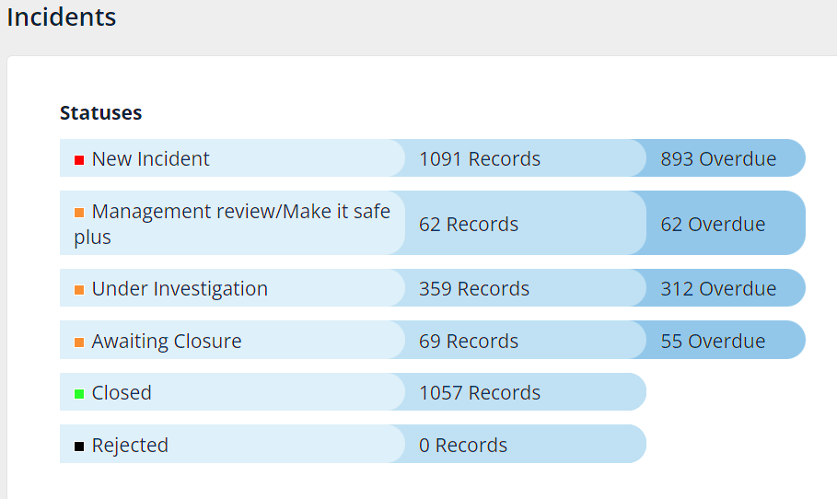
Many of the new incidents reported are associated with COVID-19 incidents from Waves 1 – 4 that have been retrospectively entered by the COVID-19 Nosocomial Mortality Review Team. These are currently being worked through and will be updated as part of the case reviews undertaken by the team, and subsequently, they will be closed.
From the Datix Incidents graphic above, there are 62 overdue management reviews, 312 overdue incidents under investigation and 55 overdue incidents awaiting closure, although it is acknowledged that a proportion of these may be associated with the COVID-19 Nosocomial Mortality Review process.
ACTION: Service Groups are asked to review all overdue incidents.

- CHALLENGES, RISKS AND MITIGATION
HCAI
- Service pressures on acute sites continue to preclude the ability to decant bays and clinical areas affected by periods of increased incidence of C. difficile. Consequently, it has not been possible to undertake the level of 4D cleaning required in bay areas, which is the standard within the Health Board. This particularly affects risks associated with those infections caused by extremely antibiotic-resistant infections and by C. difficile. 3D cleaning is undertaken using disinfectants and all single rooms, bathrooms and toilets are reactively & proactively 4D UV-C cleaned.
- Current pressures on Health Board services, both in the community and in hospitals, is extreme, as are the pressures on providing social care packages. The results of these pressures are that numbers of clinically optimised patients, who no longer require secondary care, have increased. The demand for unscheduled acute care remains, leading to increased demand for inpatient beds. Surge capacity is being utilised when necessary.
- The increasing inpatient population occurs at a time of increased staff shortages, which leads to an increasing patient-to-staff ratio.
- Bed spacing and ventilation within the majority of wards in inpatient settings poses an ongoing risk in relation to transmission of COVID-19 and other seasonal viral infections, including influenza, Respiratory Syncytial Virus, parainfluenza, and Norovirus. The risk assessment in relation to bed spacing has been completed and measures to mitigate risk have been implemented.
- Across the Health Board (as is the case across NHS Wales) there are increasing numbers of those living with high-risk co-morbidities and risks for C. difficile.

GOVERNANCE AND RISK ISSUES
Healthcare associated infections are associated with poor patient outcomes, and are significant quality and safety issues. Continuing failure to achieve the infection reduction improvements is an unacceptable position for our patients, for the Health Board and Welsh Government and is likely to be a consideration in a decision to escalate to Special Measures.

- FINANCIAL IMPLICATIONS
A Department of Health impact assessment report (IA No. 5014, 20/12/2010) stated that the best estimate of costs to the NHS associated with a case of Clostridioides difficile infection is approximately £10,000. The estimated cost to the NHS of treating an individual cost of MRSA bacteraemia is £7,000 (the cost of MSSA bacteraemia could be less due to the availability of a wider choice of antibiotics). In an NHS Improvement indicative tool, the estimated cost of an E. coli bacteraemia is between £1,100 and £1,400, depending on whether the E. coli is antimicrobial resistant. Estimated costs related to healthcare associated infections, from 01 April 2023 to the end of September 2023 is as follows: C. difficile - £1,140,000; Staph. aureus bacteraemia - £511,000; E. coli bacteraemia - £171,200; therefore, a total cost of £1,822,200.

- RECOMMENDATION
The Infection Control Committee is asked to NOTE progress to 30th September 2023 detailed in this assurance report and AGREE the following:
- ACTION: Service Groups to continue to drive improved compliance to achieve 85% compliance over 2023/24, ensuring the distribution of the “How to access IPC Level 2 training via ESR” Guide to all clinical staff.
- ACTION: Service Groups to drive improvements in the number of all groups of clinical staff who have completed ANTT e-learning and practical competency assessment, to achieve 85% compliance over 2023/24. A ‘How to guide for staff to access the ANTT e-learning’ is provided to support staff.
- ACTION: Service Groups to drive improved compliance with hand hygiene competence.
- ACTION: All Service Groups are asked to review and update the infection-related risks on the Risk Register.
- ACTION: Service Groups are asked to review all overdue incidents.
- NOTE progress on the Internal Audit Management Action Plan to 30th September 2023.
- NOTE progress on Infection Prevention Improvement Plan to 30th September 2023.
- NOTE progress on the Infection Prevention & Control Audit Programme for 2023/24.

Governance and Assurance

Link to Enabling Objectives  (please choose) | Supporting better health and wellbeing by actively promoting and empowering people to live well in resilient communities
Link to Enabling Objectives  (please choose) | Partnerships for Improving Health and Wellbeing |  | ☐
Link to Enabling Objectives  (please choose) | Co-Production and Health Literacy |  | ☐
Link to Enabling Objectives  (please choose) | Digitally Enabled Health and Wellbeing |  | ☐
Link to Enabling Objectives  (please choose) | Deliver better care through excellent health and care services achieving the outcomes that matter most to people
Link to Enabling Objectives  (please choose) | Best Value Outcomes and High Quality Care |  | ☒
Link to Enabling Objectives  (please choose) | Partnerships for Care |  | ☐
Link to Enabling Objectives  (please choose) | Excellent Staff |  | ☐
Link to Enabling Objectives  (please choose) | Digitally Enabled Care |  | ☐
Link to Enabling Objectives  (please choose) | Outstanding Research, Innovation, Education and Learning |  | ☐
Health and Care Standards
(please choose) | Staying Healthy |  | ☐
(please choose) | Safe Care |  | ☒
(please choose) | Effective Care |  | ☐
(please choose) | Dignified Care |  | ☐
(please choose) | Timely Care |  | ☐
(please choose) | Individual Care |  | ☐
(please choose) | Staff and Resources |  | ☐
Quality, Safety and Patient Experience
Effective infection prevention and control needs to be everybody’s business and must be part of everyday healthcare practice and be based on the best available evidence so that people are protected from preventable healthcare associated infections.
Financial Implications
A Department of Health impact assessment report (IA No. 5014, 20/12/2010) stated that the best estimate of costs to the NHS associated with a case of Clostridioides difficile infection is approximately £10,000. The estimated cost to the NHS of treating an individual cost of MRSA bacteraemia is £7,000 (the cost of MSSA bacteraemia could be less due to the availability of a wider choice of antibiotics). In an NHS Improvement indicative tool, the estimated cost of an E. coli bacteraemia is between £1,100 and £1,400, depending on whether the E. coli is antimicrobial resistant. (Trust and CCG level impact of E.coli BSIs accessed online at:
https://improvement.nhs.uk/resources/preventing-gram-negative-bloodstream-infections/ ).
Estimated costs related to healthcare associated infections, from 01 April 2023 to the end of September 2023 is as follows: C. difficile - £1,140,000; Staph. aureus bacteraemia - £511,000; E. coli bacteraemia - £171,200; therefore, a total cost of £1,822,200.
Legal Implications (including equality and diversity assessment)
Potential litigation in relation to avoidable healthcare associated infection.
Staffing Implications
None identified.
Long Term Implications (including the impact of the Well-being of Future Generations (Wales) Act 2015)
A healthier Wales: preventing infections
Report History |  | Previous meeting 29th June 2023

Appendices | Appendix 1: Health Board & Service Group progress against the Tier 1 Infection reduction goals.  Appendix 2: Days between HCAI cases  Appendix 3: Infection Prevention Improvement Plan 2023_24 v2 Q2 update 05.10.23  Appendix 4: IPC SG Gov Arrangements_updated 19.10.2023

C. difficile
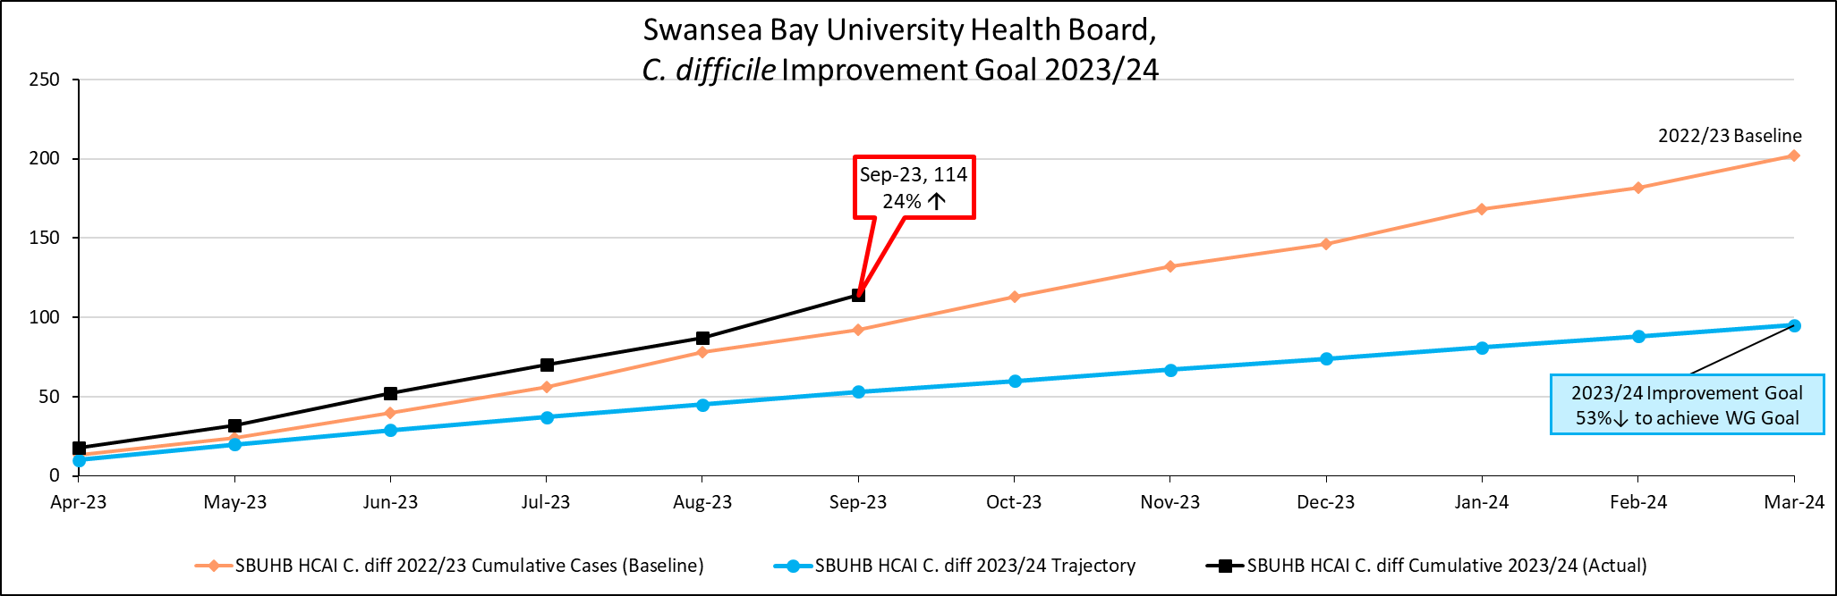
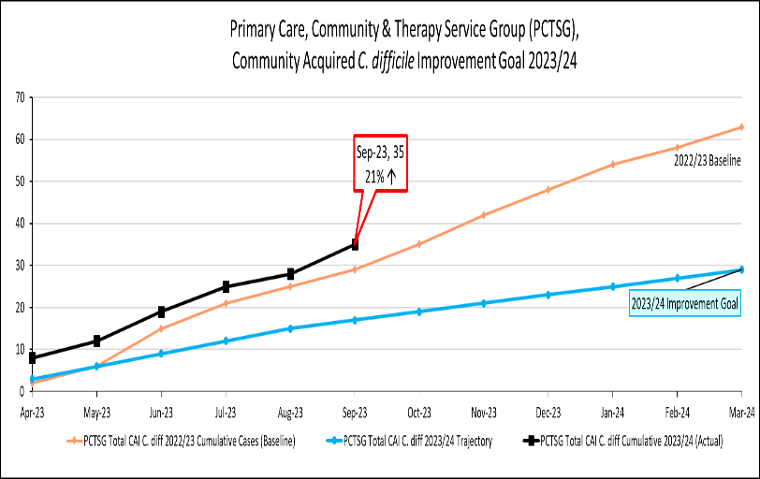 | 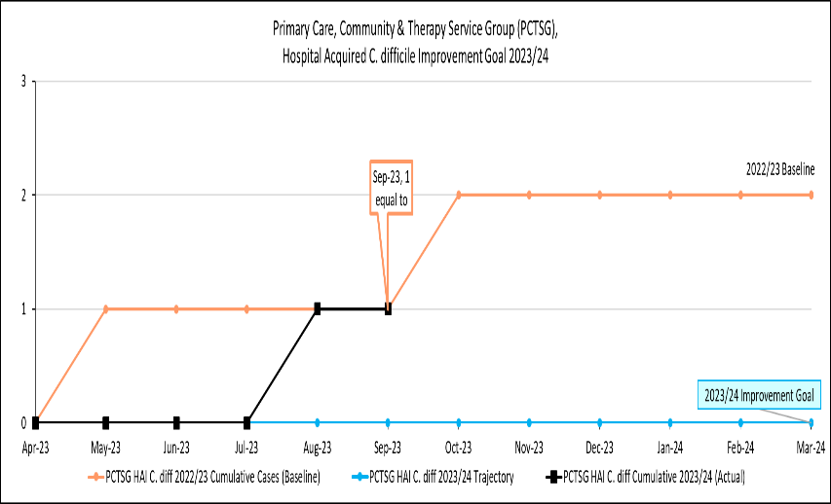
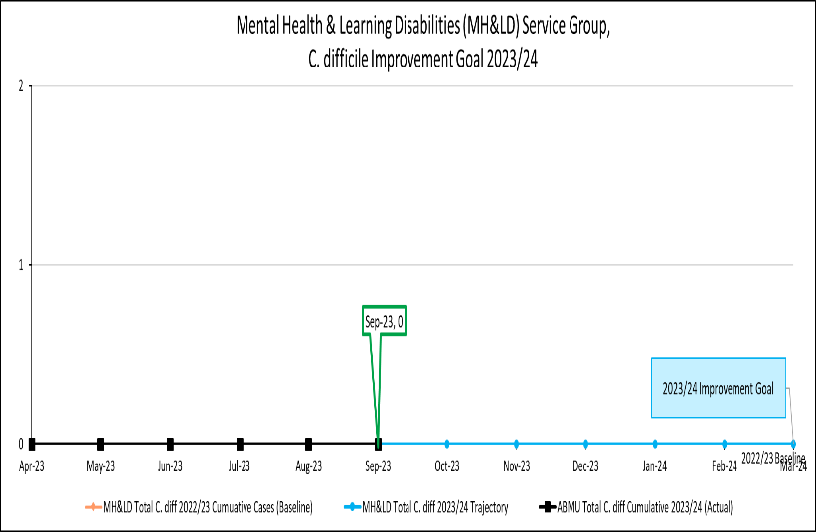 | 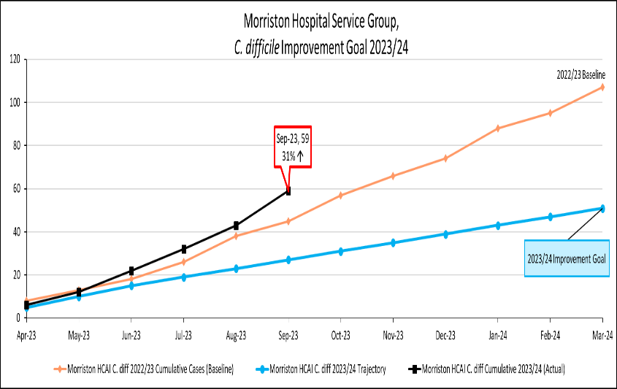
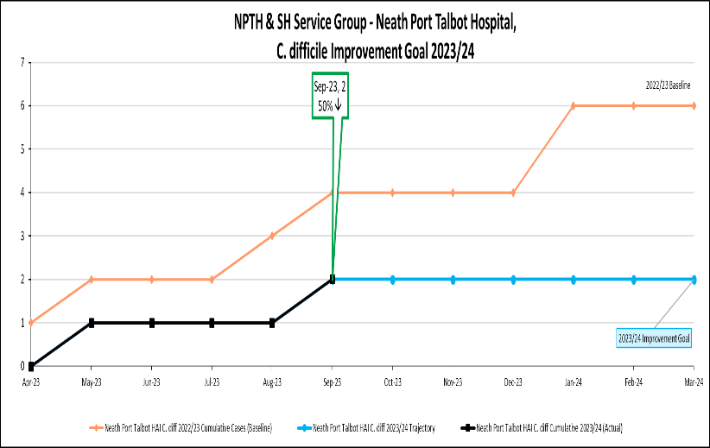 | 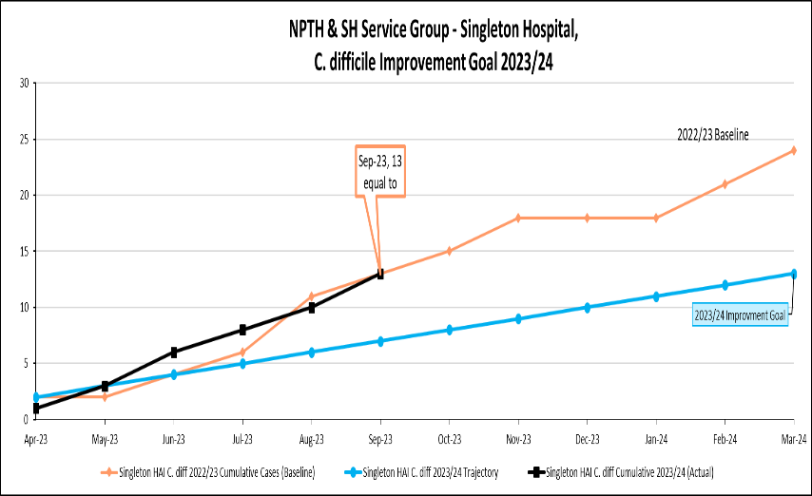

Staph. aureus bacteraemia
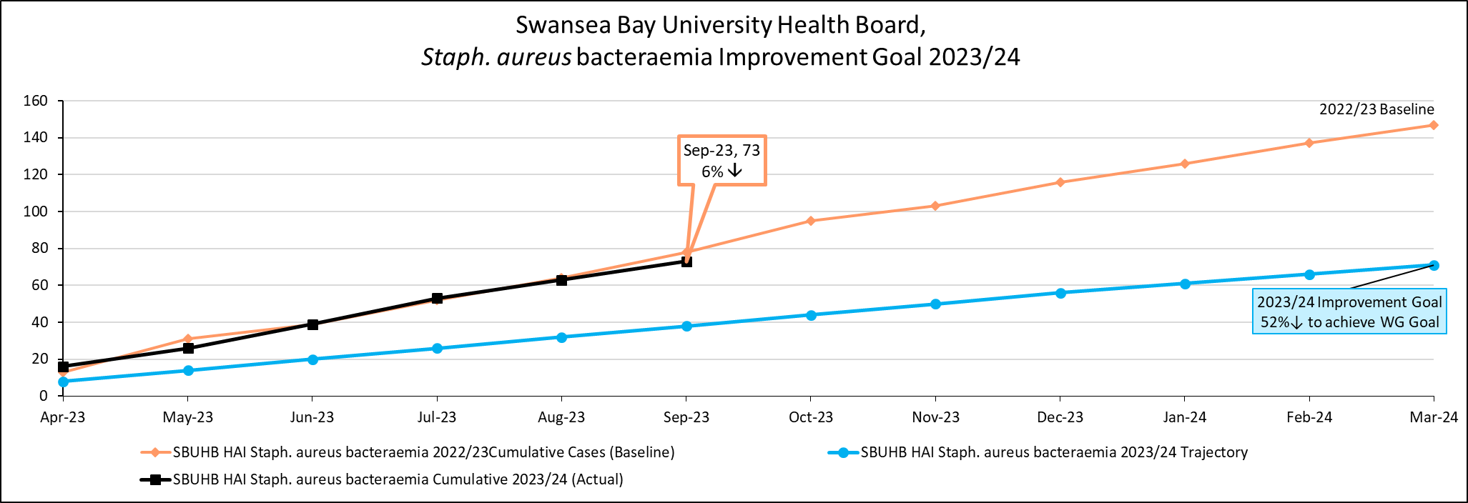
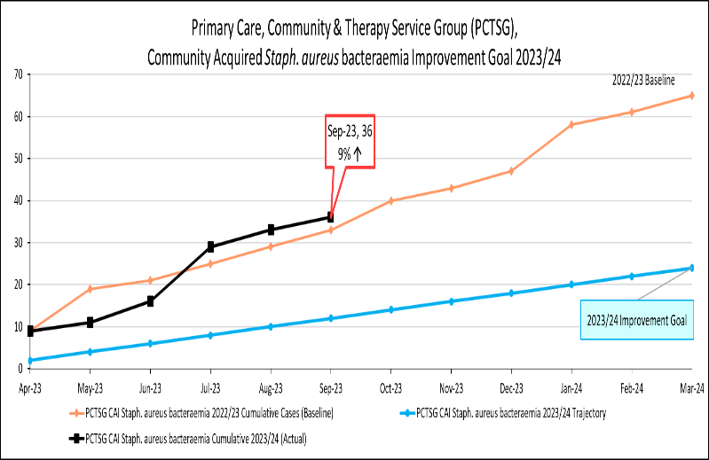 | 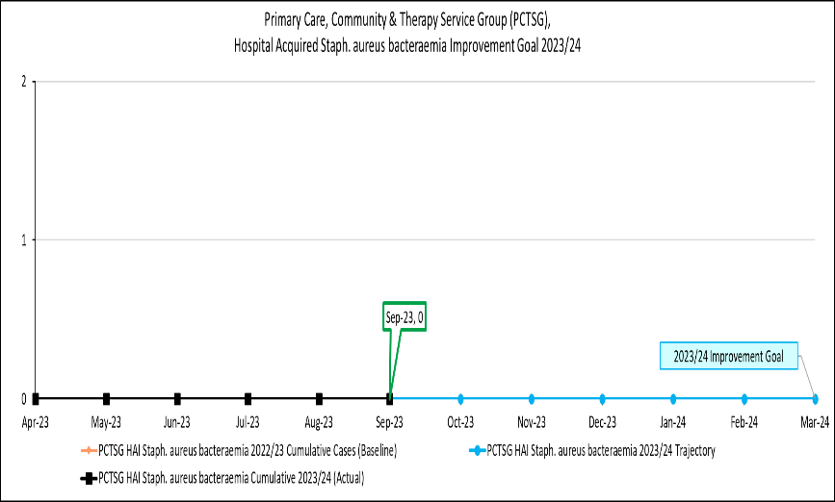
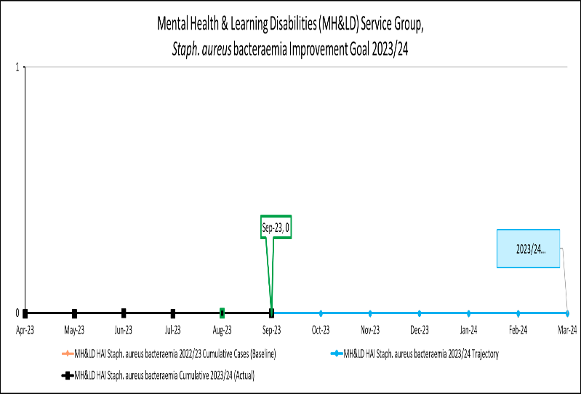 | 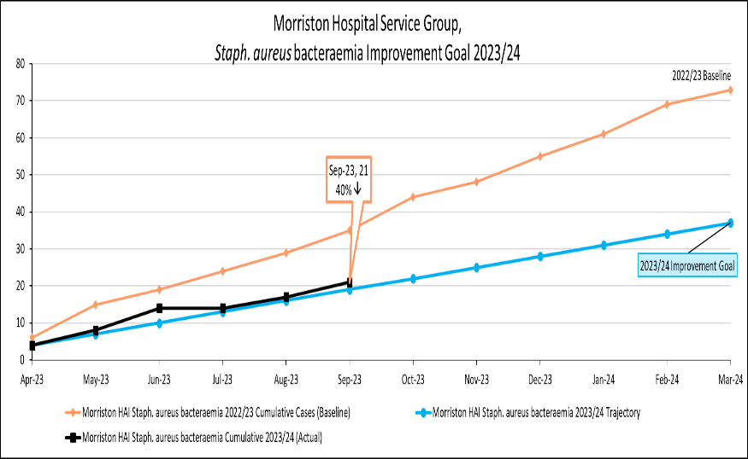
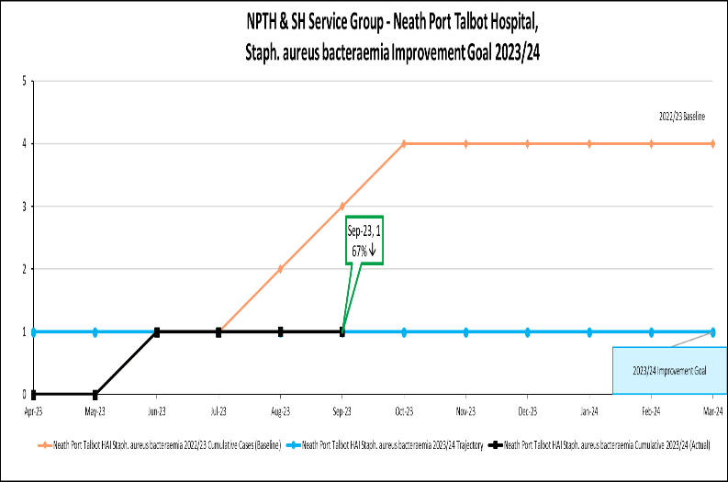 | 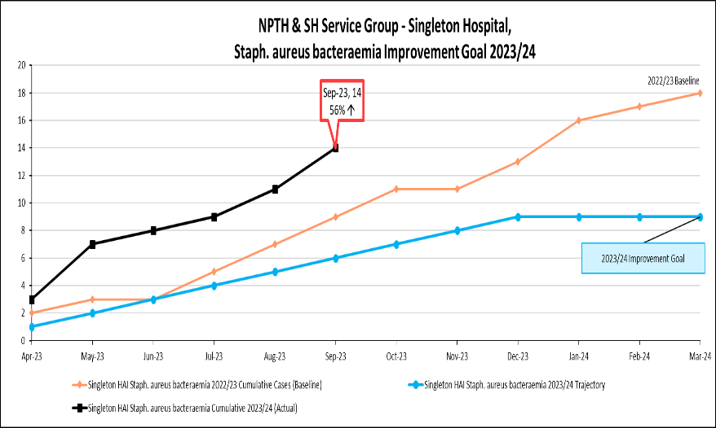
E. coli bacteraemia
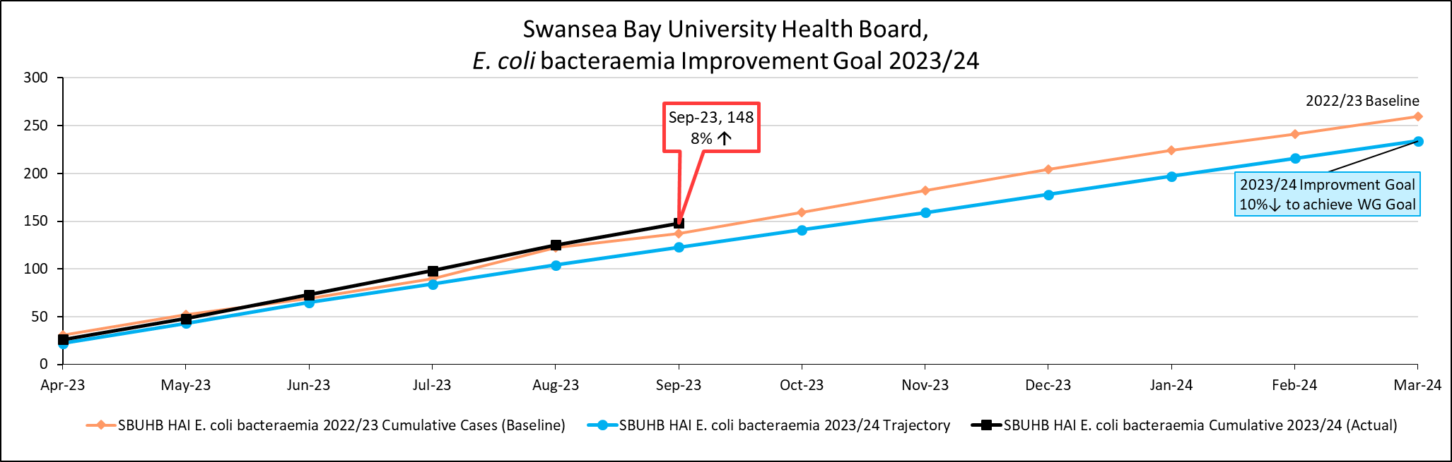
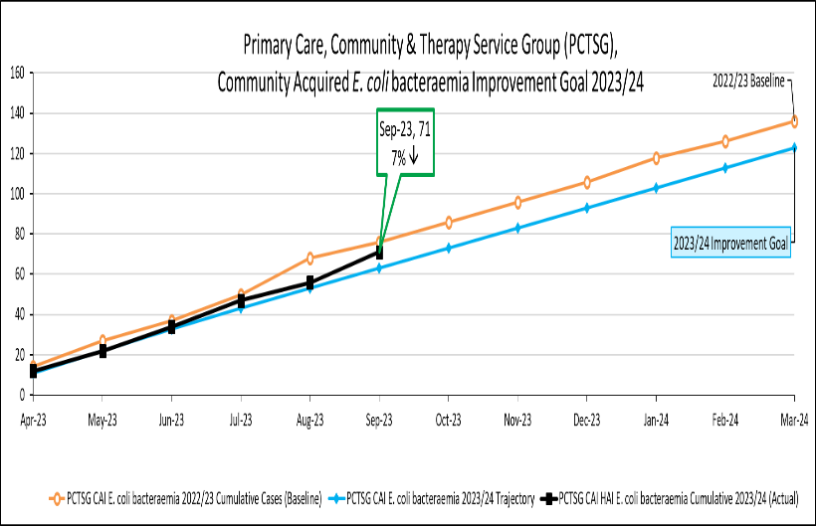 | 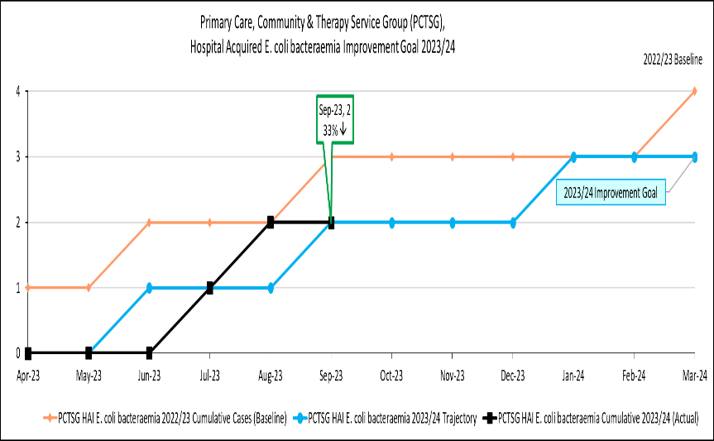
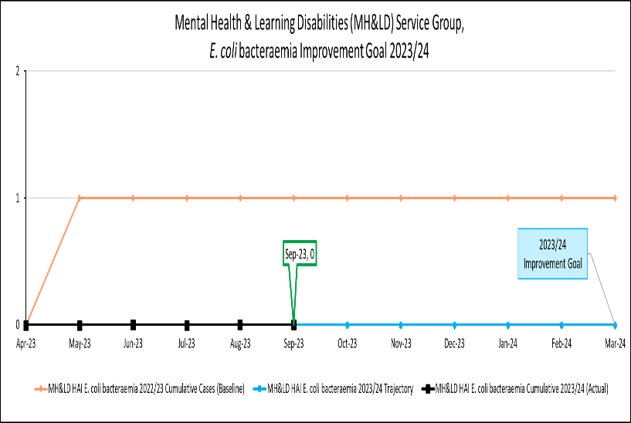 | 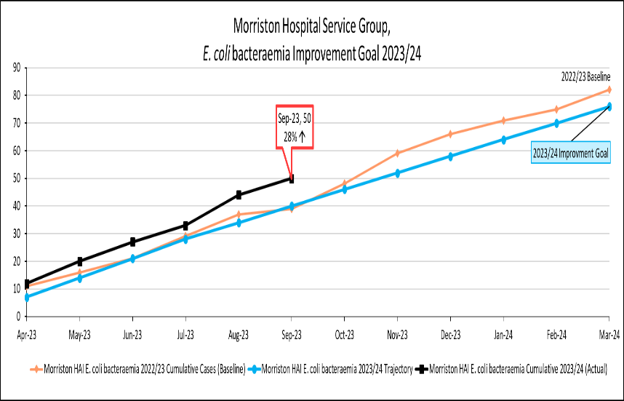
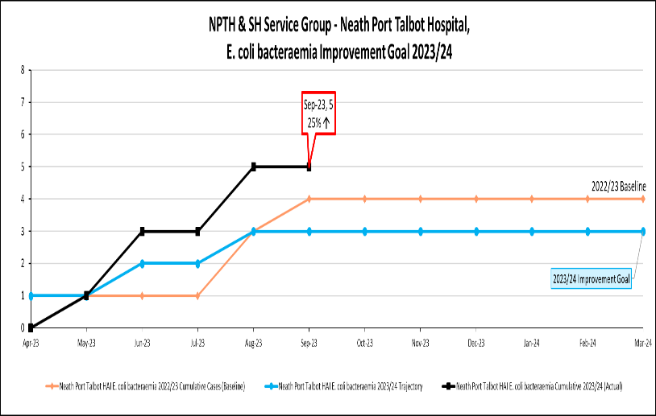 | 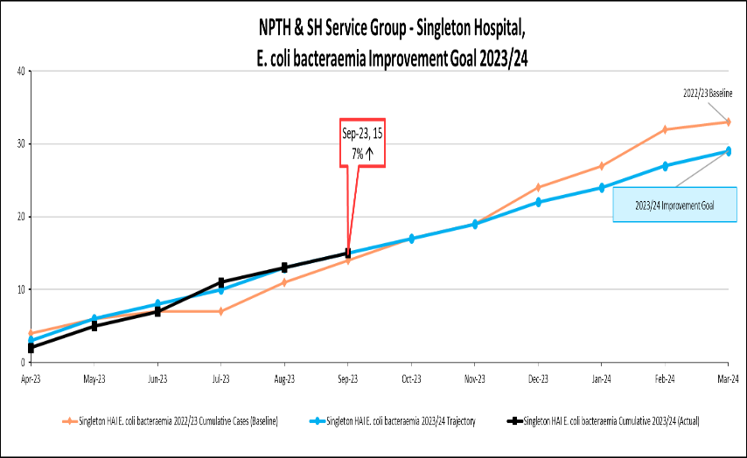

Klebsiella spp. bacteraemia
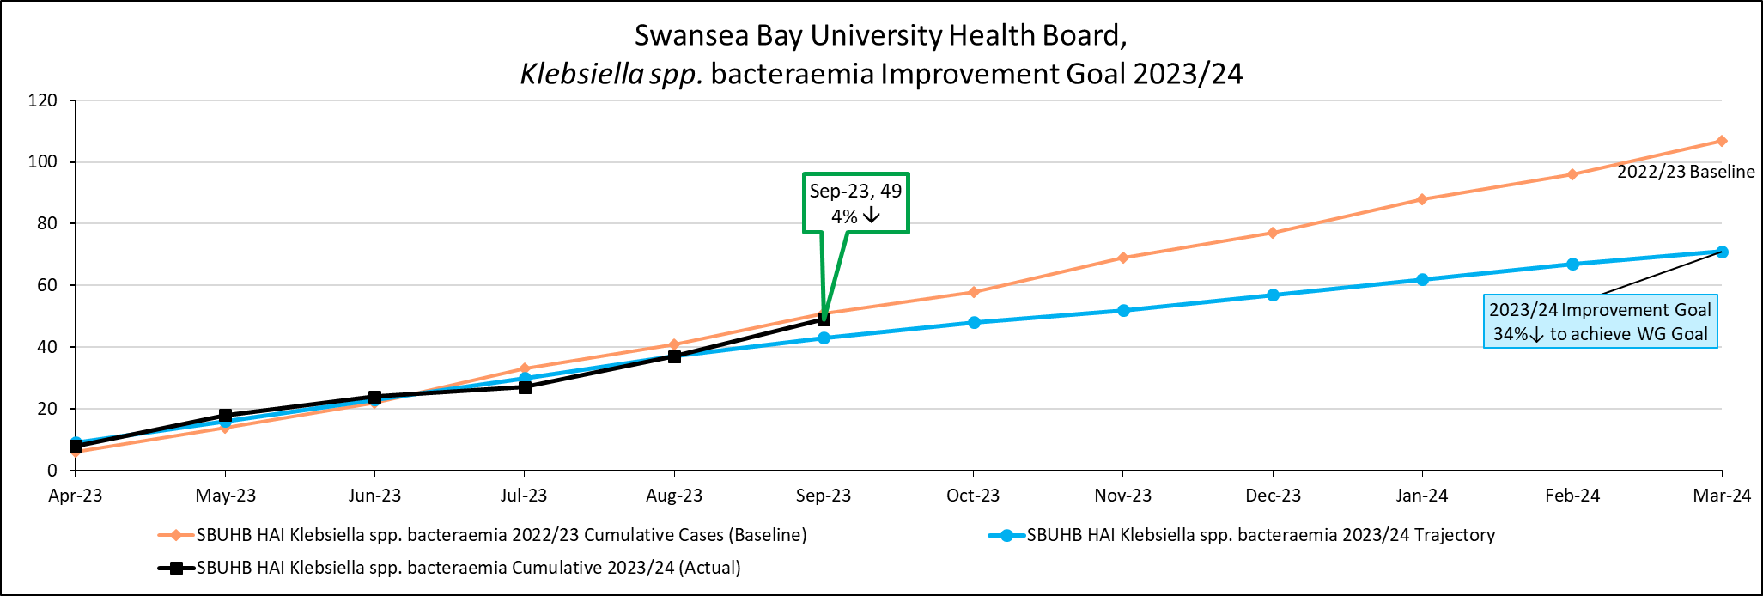
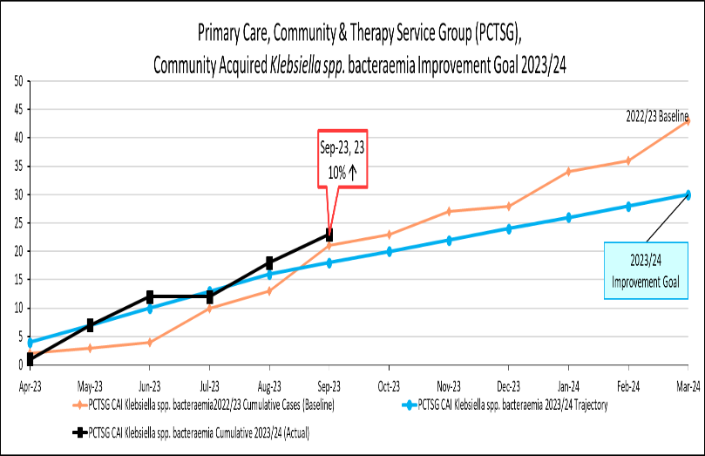 | 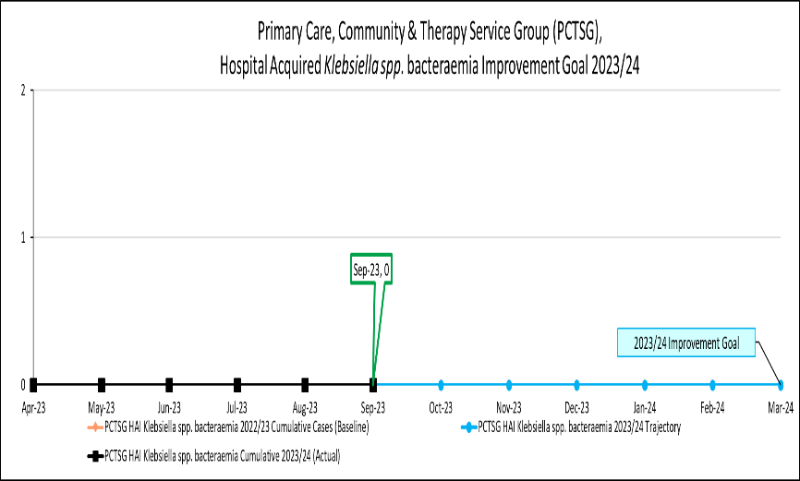
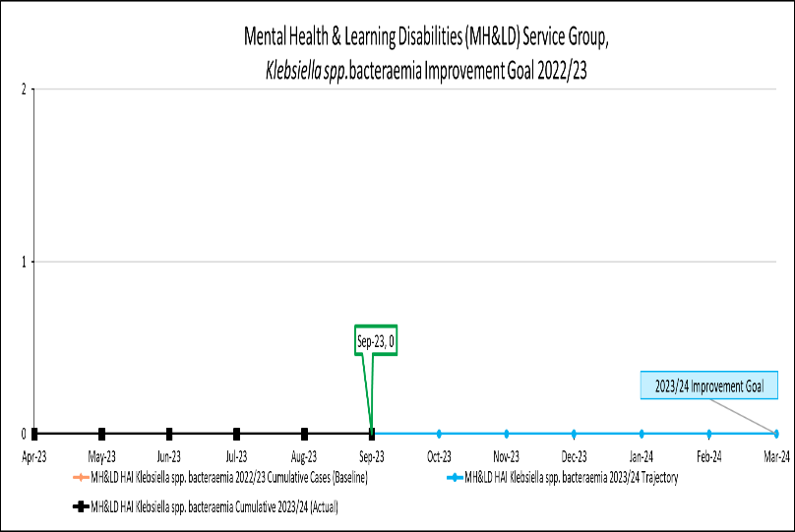 | 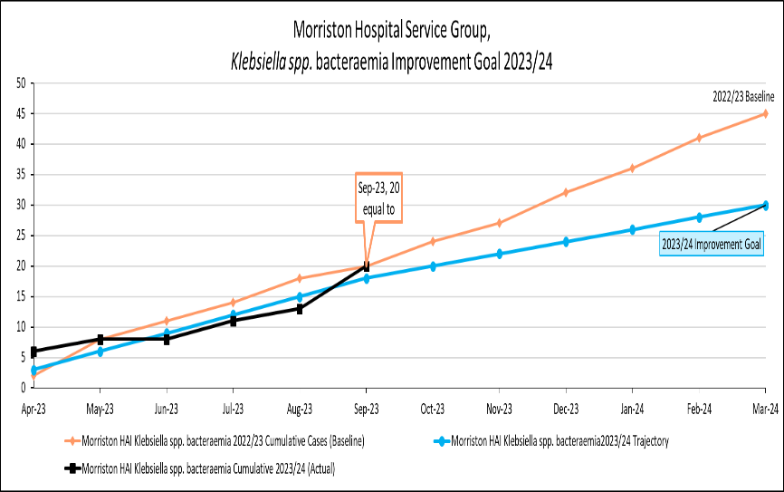
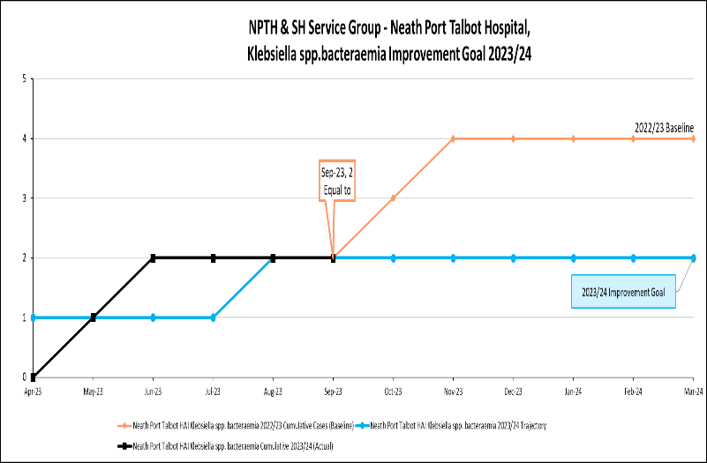 | 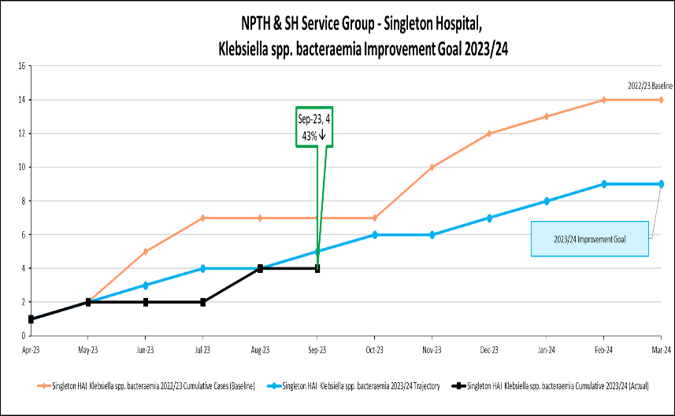

Pseudomonas aeruginosa bacteraemia
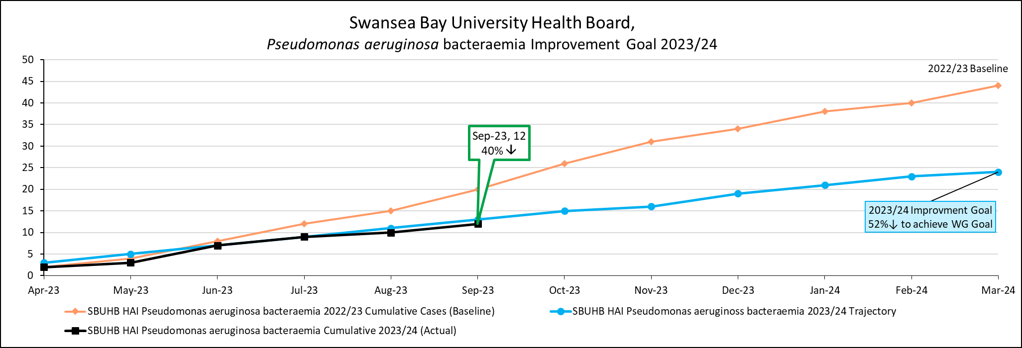
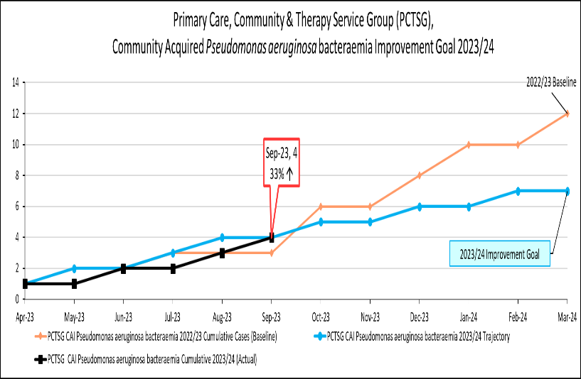 | 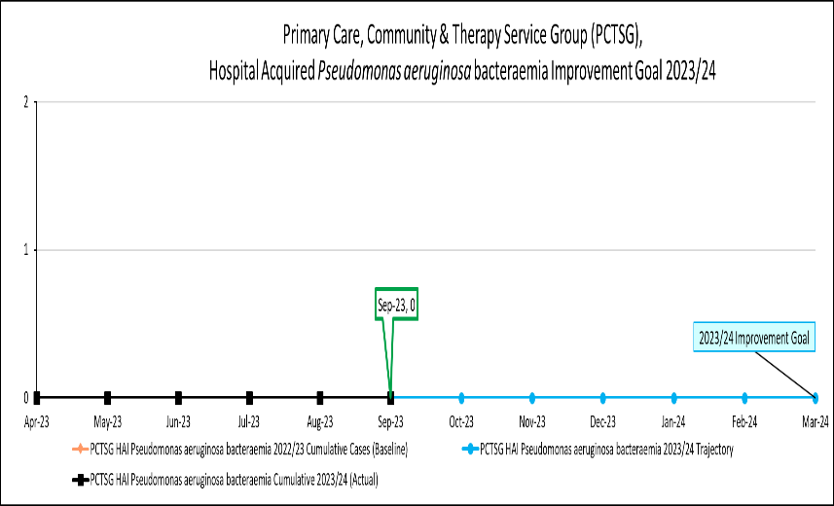
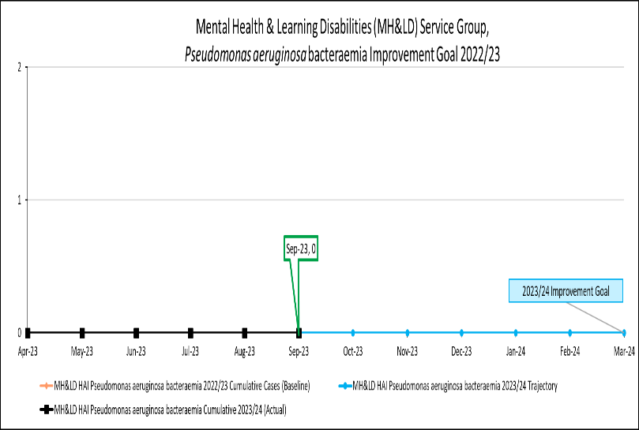 | 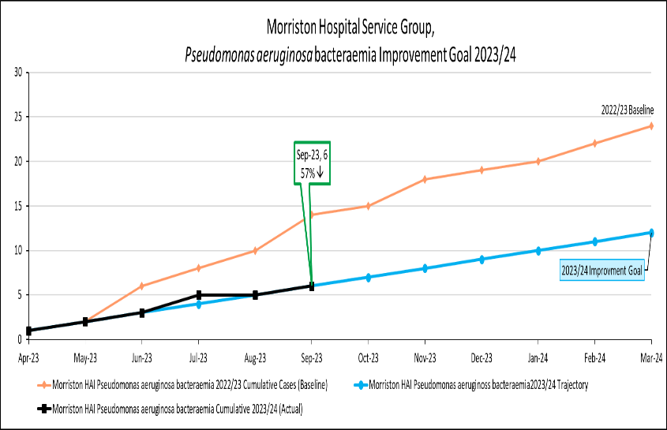
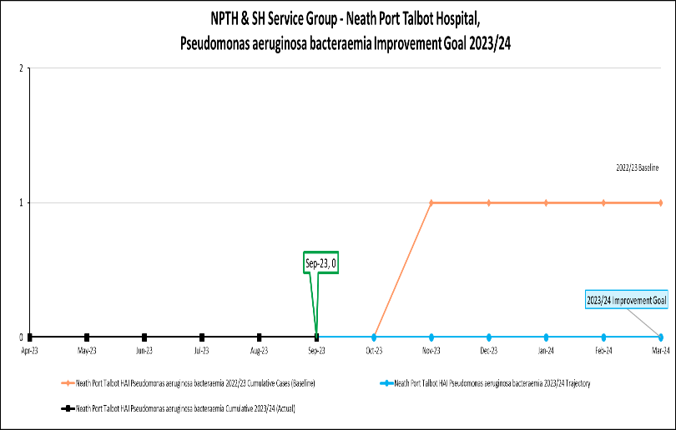 | 