Meeting Date | 06 August 2026 | Agenda Item | 3.6
Name of Meeting | Quality & Safety Committee
Report Title | Health, Safety & Fire
Report Author | Tim Harrison, Head of Health, Safety and Fire
Report Sponsor | Executive Director of Finance
Presented by | Mark Parsons, Assistant Director of Capital Planning and Health and Safety
Freedom of Information | Open
FoI Closed detail | If closed, choose detail
Impact Assessment Summary Outcome |  | IA Completion date
N/A |  | Click or tap to enter a date.
Purpose of the Report | For Assurance
Report Summary; detailing any action required
This report provides the Quality & Safety Committee with assurance on the Health Board's health, safety and fire performance, highlighting key areas of compliance risk including COSHH management, fire safety, staff safety responsibilities, inspection activity and RIDDOR reporting. The report outlines current performance, identifies areas requiring improvement and describes mitigation actions being implemented to reduce regulatory, operational and reputational risks. Members are asked to receive the report for assurance and discuss the findings.
Key Issues
This report highlights key health, safety and fire compliance risks across SBUHB. The identified risks have potential regulatory, operational and reputational implications if not effectively managed. The proposed mitigation actions support the Health Board’s objectives of delivering safe, high-quality care, protecting staff and patients, strengthening governance and improving organisational resilience and compliance assurance.
Decision / Action required | No
Recommendations
Members are asked to:
Take cognisance of the mitigation actions required to improve assurance and discuss the findings in the report.

Health, Safety and Fire Management

- INTRODUCTION
This report provides an overview of the Health Board's current health, safety and fire performance and highlights areas of compliance risk requiring ongoing management attention. The report seeks to provide assurance regarding current arrangements whilst identifying areas requiring further improvement to reduce regulatory, operational and reputational risks.

- BACKGROUND
Health and Safety Compliance
The Health Board continues to operate within an increasingly challenging regulatory environment. Whilst progress has been made in several key areas, reviews, site inspections, incident investigations and external audits (Fire & Rescue Services) continue to identify compliance gaps requiring improvement.

The approval of Phase 1 of the Health, Safety and Fire restructuring programme will strengthen operational capacity through the introduction of additional advisory resources and enhanced training capacity.

Corporate Risk 64 health and safety resource and capacity of the health, safety and fire function has been revised as a result of phase 1 resource approval. The re-assessment of the risk in accordance with the risk matrix and its compliance with legislation risk domain has resulted in a revaluation of the consequence reducing the overall risk score from 20 to 16.

- COSHH Compliance
The management of hazardous substances remains an area of concern.
Reviews undertaken across clinical areas have identified inconsistencies in:
• COSHH risk assessments.
• Staff awareness and understanding of hazardous substances.
• Safe storage arrangements.
• Control measures and exposure controls.
• Monitoring and review arrangements.
• Local management oversight.

A programme of targeted COSHH inspections, audits and training is being developed to improve compliance and strengthen assurance arrangements.

Mitigation Actions
- COSHH procedure has been approved by the Health and Safety Operations Group and Quality and Safety Group.
- The Head of Health and Safety & Health and Safety Adviser will promote the use of the new COSHH Procedure as part of the targeted COSHH inspections.
- COSHH has been added to the categories of Deep dives within the Health and Safety Operations Group at each meeting.

- Fire Safety Compliance Risk
Fire safety management involves the following aspects:
- Leadership and Governance (Fire Safety Policy)
- Fire Risk Assessment (Action plans to address risks)
- Fire Prevention (control of ignition sources, good housekeeping and waste management, smoking controls)
- Fire Protection Measures (detection and alarm systems, fire doors, compartmentation)
- Staff Training and Awareness (Induction, refresher training, Fire wardens)
6. Emergency Response (Progressive horizontal evacuation plans)
7. Testing and Maintenance (Routine checks of alarms, doors and extinguishers, planned maintenance programme)
8. Drills and Exercises

Basic fire safety training is provided via an e-learning module. When analysing 14,253 completed learner records over 57% of learners completed the module in under 20 minutes with 29% in less than 10 minutes. It is mandated that all Health Board staff complete it on Induction and to repeat every two years.

Table 1 shows the whole Health Board compliance at 90.60% the compliance figure consistently shows performance above the 85% target which is clearly positive. Although this provides the Board with assurance in terms of national performance indicators. It may not provide the appropriate assurance in terms of our ability to effectively manage in the event of a fire.

Table 1
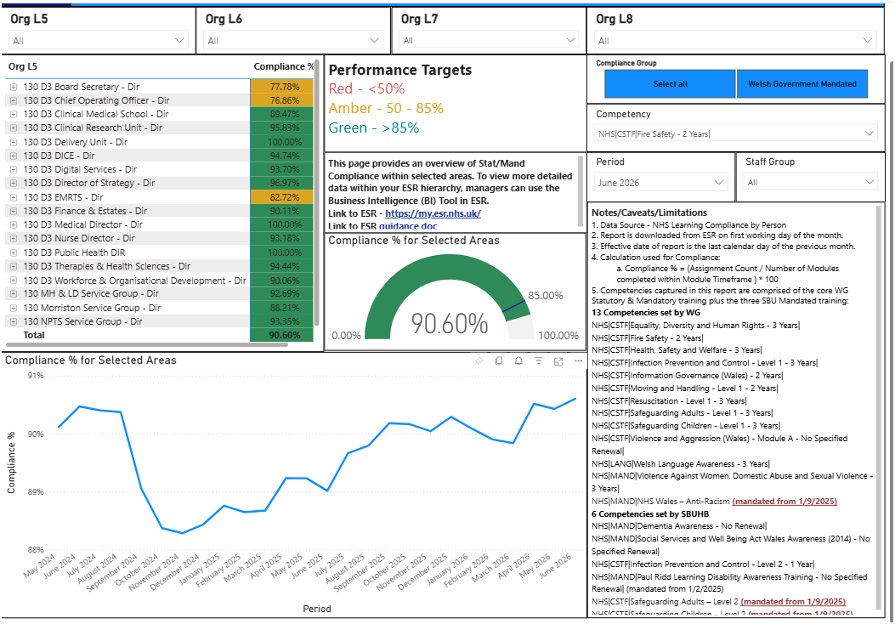

The only additional training delivered by the Fire Safety Team is a 1-hour Fire Warden training session. This is not mandated to specified staff working in higher risk environments. Therefore, a considerable number of staff who would be expected to take a lead role with regard ward evacuation are likely to have only completed the on-line e-learning package. Although records exist of the numbers of staff trained and their location, no formal training needs analysis has been undertaken that would identify other key personnel that would enhance the health board fire safety assurance.

The success of any of the mitigation measures are reliant on the capacity of the Fire Safety team to deliver. Currently the team consist of 2 wte with the vacant Fire Safety Managers post expected to be advertised shortly.

Mitigation Actions (following Fire Safety Manager appointment)
- Undertake a training needs analysis of fire training, proportionate to the existing environmental hazards.
- Prioritise practical fire response training within high-risk clinical environments.
- Report to Mandatory Training Group with proposal to allocate mandatory training to key professional groups.
- Assign Fire Safety mandatory training to key individuals ESR record.

Expected Outcome
Improved competence in emergency response and reduced risk to patients, staff and visitors.

Fire Risk Assessment Compliance

FRA Position July 2026
Service Delivery Unit | Total In Date | Total Overdue (Including Sleeping Risk) | Overdue Sleeping Risk | Total Areas | Total Compliance Percentage | Total Overdue Percentage
Morriston | 60 | 57 | 8 | 108 | 56% | 53%
Singleton | 29 | 57 | 9 | 86 | 34% | 66%
Neath PT | 46 | 11 | 2 | 57 | 81% | 19%
MH LD | 38 | 12 | 2 | 50 | 76% | 24%
PC & C | 22 | 8 | 0 | 30 | 73% | 27%
Other | 2 | 4 | 0 | 6 | 33% | 67%
Total Area | 197 | 149 | 21 | 337 | 58% | 44%

Overall First Risk Assessment (FRA) compliance stands at 58%, with 197 of 337 assessments in date. Compliance remains strong within Neath Port Talbot (81%), Mental Health & Learning Disabilities (76%) and Primary Care & Community (73%).

The Fire Safety Advisers have focussed attention on Morriston recently which has seen an improved 56% compliance, it has however had a negative effect to Singleton which has now fallen to 34% compliance, with 57 overdue assessments, including 9 sleeping risk assessments. Indicating the need for the additional approved Fire Safety Manager who will support improvement.

The immediate focus will therefore be on Singleton, with targeted work to reduce the overdue backlog, improve compliance, and increase the percentage of assessments completed within date.

Fire Safety Compliance Dashboard
A fire safety dashboard has been created to highlight fire risk assessment compliance as well as fire safety training. This has initially been shared with the Fire Safety Group but it is hoped this can form part of the overall Health and Safety Dashboard and therefore provide live data on performance, we are working with Digital Intelligence to better qualify the data in the health and safety dashboard.

3. Fire Safety Enforcement Risks
Mid and West Wales Fire & Rescue Service continue to show interest in SBUHB sites and are currently focussing attention on Singleton Hospital. Recent visits have resulted in ‘Letters of Fire Safety Matters’ for a breach in compartmentation in the Theatre environment.

Outstanding Fire Safety Matters remain capable of escalation to formal Enforcement Notices should sufficient progress not be demonstrated.

Mitigation Actions
- Awaiting appointment of Fire Safety Manager that will provide additional support to the team.
- Monthly review meetings for all outstanding Fire Safety Matters with key stakeholders and responsible persons.
- Implement executive oversight for high-risk fire safety actions.
- Actions have responsible leads and defined completion dates.
- Continue proactive engagement with Mid and West Wales Fire and Rescue Service.
- Health and Safety/Fire Team to undertake verification inspections to confirm completion of actions.
- Service Groups to undertake regular safety tours.

Expected Outcome
Closure of outstanding Fire Safety Matters, reduced likelihood of enforcement action and strengthened fire safety assurance.

4. Staff Understanding of H&S Responsibilities Risk
Failure to understand individual health and safety responsibilities contributes to poor incident reporting, delayed action on hazards and inconsistent compliance with Health Board procedures. A number of examples of poor safety cultural practices have been identified as part of fire safety, health and safety and security related walk rounds recently.

These often relate to basic health and safety management such as blocked fire exits or escape routes, poor housekeeping and demonstrate a gap in compliance with basic safety standards. These observations indicate that staff may require further supervision, training, or reinforcement of expectations as well as the need for Managers to improve monitoring and corrective action.

Mitigation Actions
- Introduce mandatory Health and Safety responsibilities training for supervisors and managers to improve the organisational safety culture and accountability.
- Implement a structured programme of safety briefings and local awareness campaigns using 7-minute briefings.
- Strengthen communication following incidents and learning events.
- Include external safety tours as part of the weekly inspections.
- Work with CTMUHB and adapt the Managing Safely on-line training package to be used within SBUHB.

Expected Outcome
Improved safety culture, increased accountability and greater staff engagement in risk management activities.

5. Lack of Proactive Inspection and Audit Programme
Risk
The Health Board currently lacks sufficient capacity to deliver a comprehensive risk-based inspection programme, reducing assurance that compliance risks are being identified before incidents occur, e.g. COSHH, staff being more aware of hazards within their own environment.

Mitigation Actions
- Recruit the additional Health and Safety Advisor approved through Phase 1 of the service redesign.
- Implement a Health Board-wide risk-based inspection framework.
- Establish inspection schedules for all high-risk departments and clinical services.
- Strengthen reporting of inspection outcomes through governance structures.

Expected Outcome
Improved organisational assurance, earlier identification of compliance failures and reduction in reactive enforcement-driven activity.

- RIDDOR Reporting Compliance Risk
Table 2 shows the RIDDOR Reporting Timescales (UK)
Table 2
Incident Type | Reporting Requirement
Fatality, specified injury, dangerous occurrence, or injury to a member of the public requiring hospital treatment | Notify HSE without delay and submit the report within 10 days of the incident.
Over-7-day injury to a worker | Report within 15 days of the incident.
Occupational disease | Report as soon as the diagnosis is received by the responsible person

Table 3 shows RIDDOR reporting for Q1 2026/27
Table 3
No. | Timescale | In Time | Injury Severity | Cause | Hospital | Location | SDU
1 |  | Yes | Fracture | Slip Trip Fall | NPTH | Rheumatology Entrance | SGHNPTH
2 |  | Yes | Over 7 Day Injury | Manual Handling Patient Load | Ty Samlet | Health Records | Health records
3 |  | No | Over 7 Day Injury | Slip Trip Fall | Lletty Newydd | Shower room | MH&LD
4 |  | Yes | Over 7 Day Injury | Assault Patient to Staff | Caswell Clinic | Caswell Clinic | MH&LD
5 |  | Yes | Asbestos Exposure | Accidental Exposure | Cefn Coed | Grounds of Hospital | Estates
6 |  | No | Fracture | Struck by Object | Meadow Court | Meadow court | MH&LD
7 |  | No | Fracture | Struck by moving Object | Cefn Coed | Clyne ward corridor | MH&LD
8 |  | Yes | Over 7 Day Injury | Assault Patient to Staff | Ty Garth Newydd | Ty Garth Newydd | MH&LD
9 |  | No | Over 7 Day Injury | Manual Handling Patient Load | NPTH | Ward E | SGHNPTH
Late reporting of RIDDOR incidents exposes the Health Board to regulatory criticism and indicates weaknesses in incident management processes.

SBUHB reported 31 RIDDOR incidents during 2025/26, with 11 submitted within the required timescale, giving a compliance rate of 35.5%.

This places the organisation ninth out of ten NHS Wales bodies and significantly below the all-Wales average of 52.4%.

Twenty incidents were reported late, indicating a need to strengthen incident escalation, notification processes and managerial oversight to ensure statutory reporting deadlines are met.

Table 3 shows comparative data from across NHS Wales for the reporting financial year 2025/26.

Table 3
Organisation | Total RIDDORs | Reported On Time | % On Time
A | 97 | 66 | 68.0%
B | 83 | 32 | 38.6%
C | 77 | 31 | 40.3%
D | 74 | 26 | 35.1%
E | 55 | 37 | 67.3%
F | 42 | 29 | 69.0%
Swansea Bay UHB | 31 | 11 | 35.5%
G | 10 | 9 | 90.0%
H | 10 | 8 | 80.0%
I | 8 | 6 | 75.0%

Swansea Bay UHB Position
The table shows SBUHB being of having 7th highest number of RIDDOR reports in NHS Wales (31 incidents), 9th out of 10 organisations for reporting on time (35.5% compliance) whilst reporting 20 of 31 RIDDORs late.

Mitigation Actions
- Review and simplify RIDDOR escalation pathways have taken place with guidance written and displayed on H&S Webpage.
- Delivery of targeted training for managers is ongoing and has had a positive impact in driving up operational practice.
- Explore whether the Datix system can provide automated notifications for potential RIDDOR incidents.
- Explore with Workforce and OD triangulating sickness absence data when related to a workplace incident.
- Monitoring through Health and Safety Operations Group.
- Benchmark performance against other NHS Wales organisations has taken place.
- Potential to set compliance improvement targets for each Service Group.

Expected Outcome
Improved statutory reporting compliance, enhanced regulatory assurance and improved organisational learning.

- GOVERNANCE AND RISK ISSUES
The principal risks identified within this report arise from insufficient assurance activity, workforce capability gaps, inconsistent compliance management and challenges in implementing corrective actions at departmental level.

The Health Board has committed to phase 1 of a structured workforce realignment which will strengthen our ability to implement these mitigation measures to improve staff and patient safety and strengthen overall Board assurance.

Risk Area | Key Issue Identified | Current Position | Risk Score (1-25) | RAG | Rationale
COSHH Compliance | Inconsistent assessments, hazardous substance management deficiencies, Formalin concerns, weak oversight | Organisation-wide compliance concerns identified | 16 | 🔴 | Exposure to harmful substances. Known serious deficiencies identified. Limited assurance currently available.
Fire Safety Competence & Training | Reliance on e-learning; no formal Training Needs Analysis; limited practical evacuation training | 90.6% compliance but questionable competence assurance | 15 |  | Training compliance good, but effectiveness and competency assurance remain uncertain.
Fire Safety Enforcement Activity | Multiple active Letters of Fire Safety Matters across sites | 12 active matters across several hospital locations | 16 |  | Formal enforcement remains a realistic possibility if progress stalls. Previous enforcement history increases risk.
Staff Understanding of H&S Responsibilities | Poor housekeeping, blocked exits, unsafe practices observed | Multiple examples identified during inspections | 15 |  | Direct impact on fire safety and incident prevention. Indicates cultural and behavioural weaknesses.
Inspection & Audit Capacity | Insufficient resource for risk-based inspection programme | Reactive rather than proactive assurance | 15 |  | Weak assurance arrangements increase likelihood of unidentified compliance failures.
RIDDOR Reporting Compliance | Only 35.5% of reports submitted on time during 2025/26 | 9th of 10 NHS Wales organisations | 12 |  | Significant statutory compliance failure and regulatory concern.
Incident Escalation & Governance | Weaknesses in notification and reporting processes | Large proportion of late RIDDOR submissions | 12 |  | Governance process weaknesses identified but improvement actions underway.
Overall Health, Safety & Fire Assurance | Multiple compliance themes with regulatory, operational and reputational implications | Mitigations in progress but assurance gaps remain | 16 |  | Aggregated risk profile indicates significant residual risk requiring executive oversight.

- OPEN AUDIT RECOMMENDATIONS
There are no open audit recommendations. Internal Audit are undertaking a review of violence and aggression management during Q2 2026/27.

- FINANCIAL IMPLICATIONS
There are no financial implications arising from this report.

- RECOMMENDATION
Take cognisance of the mitigation actions required to improve assurance and discuss the findings in the report.

Governance and Assurance
Strategic Objectives
Strategic Objectives  (please choose which is impacted) | People of Swansea Bay live healthier, fairer and more prosperous lives | ☐
Strategic Objectives  (please choose which is impacted) | Care is high quality, safe, efficient and delivers the best possible outcomes for people in partnerships | ☐
Strategic Objectives  (please choose which is impacted) | Care is delivered in partnership with our communities in safe and appropriate setting, supported by innovation | ☐
Strategic Objectives  (please choose which is impacted) | The health board is a great place to work where staff feel valued and work together towards a common goal | ☐
Strategic Objectives  (please choose which is impacted) | The health board is a resilient, sustainable and responsible organisation | ☐
Health and Care Standards
Standards (please choose which applies) | Safe Care | ☐
Standards (please choose which applies) | Timely Care | ☐
Standards (please choose which applies) | Effective Care | ☐
Standards (please choose which applies) | Efficient Care | ☐
Standards (please choose which applies) | Equitable care | ☐
Standards (please choose which applies) | Person-centred Care | ☐
Standards (please choose which applies) | Staff and Resources | ☐
Enablers (please choose which applies) | Whole Systems Approach | ☐
Enablers (please choose which applies) | Leadership | ☐
Enablers (please choose which applies) | Workforce | ☐
Enablers (please choose which applies) | Culture | ☐
Enablers (please choose which applies) | Information | ☐
Enablers (please choose which applies) | Learning, Improvement and Research | ☐
Quality, Safety and Patient Experience
The quality, safety and patient experience implications of this paper are that it identifies areas where weaknesses in health, safety and fire management could adversely affect patients, staff and visitors if left unaddressed.
Financial Implications
There are no additional financial implications arising directly from this report.

Legal Implications (including equality and diversity assessment)
The mitigations support the Health Board's statutory duties under health and safety, fire safety, COSHH and RIDDOR legislation, and align with the Health Board Governance Framework. Failure to address the identified risks could result in regulatory action, legal challenge and reputational harm. No adverse equality or diversity impacts have been identified, and the proposed actions will support a safer environment for all staff, patients and visitors
Staffing Implications
The report identifies workforce capacity, competence and compliance challenges across health, safety and fire management. Implementation of the approved Phase 1 service redesign will strengthen staffing resources through additional specialist capacity and enhanced training provision.
Long Term Implications (including the impact of the Well-being of Future Generations (Wales) Act 2015)
The report supports the Well-being of Future Generations (Wales) Act 2015 by promoting prevention, workforce development and long-term organisational resilience through improved health, safety and fire management. No adverse impacts on the Welsh Language or its speakers have been identified, and bilingual communication will continue to be supported.
Report History
Health, Safety and Fire performance reports are presented to the Quality & Safety Committee to provide assurance on compliance, risk management and regulatory matters. This report builds on previous updates regarding health and safety governance, fire safety compliance, enforcement activity and RIDDOR performance.
Appendices
N/A

