Swansea Bay University Health Board

Patient Experience
and
Concerns Report

Quarter 1, 2023/24

CONTENTS

Report Summary | Page 2
Complaints | Page 4
Complaint Themes | Page 6
Service Group Highlight Reports | Page 19
Morriston Service Group | Page 20
Neath Port Talbot Singleton Service Group | Page 24
Mental Health & Learning Disabilities Service Group | Page 30
Primary and Community Service Group | Page 33
Ombudsman Cases & Learning | Page 39
Report Summary and Overview
COMPLAINTS | Apr | May | Jun
Total number of complaints received | 198 | 234 | 220
Complaints acknowledged within set timescale | 100% | 100% | 100%
Number of re-opened complaints | 4 | 5 | 11
 | Feb | Mar | Apr
Complaints responded to within agreed timescale - formal | 67% | 72% | 77%
OMBUDSMAN | Apr | May | Jun
Number of Ombudsman Investigations received | 2 | 0 | 0
Number of actions outstanding (within timescale) | 4 | 7 | 6
Number of actions overdue | 4 | 4 | 1
PATIENT EXPERIENCE | Apr | May | Jun
No. of Friends & Family surveys received | 3,577 | 4,438 | 2,503
Recommendation score | 92% | 90% | 89%
New Bespoke Surveys | 1 | 2 | 2
NATIONAL REPORTABLE INCIDENTS | Apr | May | Jun
Number of National Reportable Incidents reported | 6 | 9 | 4
Number of Never Events | 0 | 1 | 0

Successes | Priorities
- 100% formal complaints acknowledged within target.  - Increase in complaints performance achieving 77% in June.  - The Head of Complaints Standards for the Ombudsman, will be attending the Q&S Meeting on 25th July to discuss Annual Letter Data.  - Implementation of the BSL videos for the F&F survey  - The Board story 25th May, called Palliative Paramedic was also shared with WAST colleagues, they are using the story to highlight the importance of Value based health care. | - Produce themes and learning reports for Service Units relating to Ombudsman cases  - Maintain complaints performance  - Contribute to the development of a toolkit for dealing with complex challenging complainants  - The NHS executive has asked all director of nursing across HBs to use the All Wales questions for patients attending ED. SBU currently use the All Wales questions and there should not be any impact for us to undertake this. Method we currently use is SMS after discharge from A&E. We also have posters with QR codes in the ED area.
Opportunities | Risks & Threats
- Concerns Redress Assurance Group (CRAG) meetings with each Service Group are arranged monthly to ensure feedback, learning and improvement by reviewing complaint responses – feedback reports are now provided following each meeting to share the learning wider throughout the Service Group.  - The Complaints Network with other Health Boards is an opportunity to discuss issues relating to concerns and share learning.  - A number of Task & Finish Groups have been set up by the overall Once for Wales Team who manage the Datix system. These meetings are an opportunity to discuss and improve the current system with input from each Health Board.  - Early discussions with Children and Adult Mental Health Teams team to develop a bespoke survey for the cohort of patients they care for. | - Number of dissatisfied and complex complaints.  - The Ombudsman is currently recruiting a new Trainer, we have had very positive feedback from the Ombudsman training previously delivered twice monthly by the previous Ombudsman Trainer who has now left the Ombudsman’s Office.  - There was an All Wales IT issue on the 18th April. Our SMS was not able to be sent until 29th April. Missing 10 days of patient feedback. This is why the numbers are low for April.

- COMPLAINTS

1. Complaints performance –
The Health Board is committed to supporting patients, relatives and carers in resolving their concerns. Our service is visible, accessible and impartial, with every issue taken seriously. Our aim is to provide honest and open responses in a way that can be easily understood by the recipient.

1.1 Total complaints received

The Health Board received 652 complaints in quarter 1 (Q1) of 2023/24 (April, May, June). This compares with 586 complaints in quarter 4 (Q4) of 2022/23 (January, February, March). The totals include complaints received and managed via either formal, early resolution and any re-opened complaints. Graph 1 provides a long-term view of complaints received per month.
Graph 1: Total number of complaints per month

Graph 2: Formal v Early resolution complaints per month
Graph 2 (above) shows complaints dealt with via the Formal Putting Things Right (PTR) investigation process compared with those dealt with via the early resolution investigation process, over the same period. We continue to deal with a higher proportion of complaints via the formal process, this is due to the tight timescale of two working days for early resolution complaints. Any early resolution that is not resolved within two working days, converts to a formal following guidance issued by Welsh Government.
1.2 Complaint responses within agreed timescale
Whenever a complaint is managed through the formal PTR process, the Health Board is required to investigate the complaint and write to the complainant with our findings, within 30 working days. If this target is not achievable, it is essential that the complainant is kept up to date throughout and any delays are explained.

1.2.1 Formal Investigations
The Health Board’s target is to respond to at least 80% of formal complaints within the agreed timescale. Welsh Government also issue a target for all Health Board’s to achieve at least 75% each month.

Graph 3 shows the Health Board’s performance in responding to complaints since July 2022. The Health Board saw an increase in performance last month with 77%. The Corporate team are working closely with the Service Groups to monitor and increase performance.
Graph 3: Percentage of formal complaints responded to within agreed timescale

1.2 Re-opened complaints
The Health Board aims to resolve all complaints within the first response however, there are times when the complainant remains dissatisfied or needs further clarification. If the complainant writes back to the Health Board expressing their dissatisfaction, the correspondence will be reviewed by the Corporate Complaints Team and a decision made as to whether the complaint should be re-opened. This may be when the complainant feels not all issues raised in the initial complaint have been addressed or if a meeting is required.

Graph 4 shows the number of re-opened complaints per month since July 2022.
Graph 4: Number of re-opened complaints by Service Group per month

Although Morriston appear to have had a significant increase in re-opened complaints, there is no specific service, these were spread over a number of services including Orthopaedics, Burns & Plastics and Spinal. The main theme highlighted from these are further delays in surgery or surgery being cancelled.

2. Complaints Themes

2.1 – Themes - Health Board overview
Every complaint received by the Health Board is coded in the Datix Once for Wales system against the relevant subject codes. This allows the Health Board to identify any themes in the complaints received.

Table 1 provides a breakdown of complaints received by primary subject in Q1 2023/24 compared with Q4 for 2022/23.

Table 1: Complaints by primary subject
Subject/Theme | Q4 2022/23 | Q1 2023/24
Communication Issues | 95 | 100
Appointments | 79 | 86
Clinical treatment/Assessment | 120 | 150
Admissions | 60 | 52
Attitude and Behaviour | 57 | 58
Medication | 54 | 57
Test and Investigation Results | 24 | 34
Referral | 21 | 14
Discharge Issues | 26 | 13
Environment/Facilities | 7 | 8
Monitoring/Observation Issues | 5 | 15
Equipment | 2 | 7
Personal Property/Finance | 3 | 7
Assault | 0 | 0
Confidentiality | 4 | 2
Consent | 2 | 2
Record Keeping | 6 | 3
Access (to Services) | 6 | 11
Accident/Falls | 1 | 3
Catering | 0 | 2
Cleanliness | 1 | 5
Infection Control | 1 | 2
Nutrition/Hydration Issues | 5 | 4
Other | 2 | 0
Patient Care | 3 | 7
Resources | 1 | 6
Skin Damage | 1 | 2
Privacy and Dignity | 0 | 2

During Q1, 199 complaints were received relating to clinical treatment. A breakdown of the clinical treatment sub-subjects are below – please note, some complaints include more than one of these issues.
Top theme; Clinical Treatment;
Clinical Treatment
Delay/Lack of treatment or Assessment | 150
Reaction to procedure/ treatment | 32
Incorrect/insufficient treatment or Assessment | 23
Delay/Lack of diagnosis | 16
Incorrect diagnosis | 16
What we are doing about this?
- Virtual clinics to continue to help reduce clinic waiting times
- Outsourcing of patients to other Healthcare providers to help reduce waiting times;
- OCP theatres opened in NPT to reduce waiting times
- Discharge Lounge at Morriston to support patient movement across site.
- Rapid Diagnostic Centre expansion.
- Patients waiting/delays comments for Orthopaedics (Fracture Clinic) and Outpatients Department in Morriston and Neath Port Talbot Hospital.
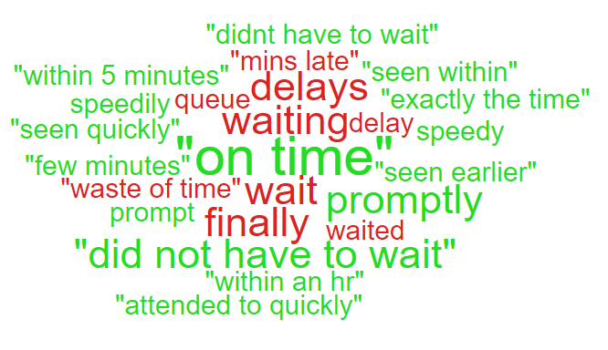
‘On time’;
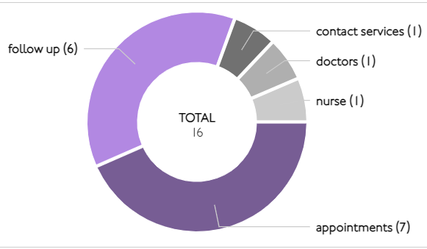

Theme 2; Communication;
What we are doing about this?
- Communication training sessions well attended throughout 2022 and 2023 – plans being considered to roll out further training
- Rolling training programme for complaints to be progressed throughout 2023
Rheumatology Department, across all sites. Patient Experience feedback for Quarter 1. The overall score was very good at 92%. As you can see from the wordle below, there were mainly positive comments. Please see below:
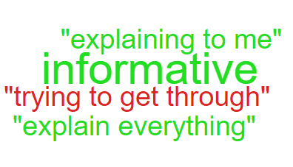
Comments breakdown for Rheumatology.
- Communicating to Patients 4 positive, 1 negative

During Q1, 152 complaints were received regarding communication. A breakdown of the sub-subjects are below – please note, some complaints include more than one of these issues.
Communication Issues
Insufficient/Incorrect information | 125
Communication with family | 23
Communication with patient/service user | 13
Concerns relating to DNR decision | 3
Communication between Services/Departments | 1
Communication with External Agencies or Other NHS Organisations | 1

Theme 3; Appointments;
What we are doing about this?
- Virtual clinics to continue to help reduce clinic waiting times
- Outsourcing of patients to other Healthcare providers to help reduce waiting times;
- Attendance at Service Unit Group meetings to provide feedback on concerns received for specific areas in relation to clinical treatment themes
- Rapid Diagnostic Centre expansion.
All Wales questions do not have ‘appointments’ as a question set. Therefore we searched the words delay/delays/appointment for the areas mentioned.
Here are some comments we found relating to ‘appointments’ for these areas:
- Out-patient appt was punctual, staff friendly and helpful. The doctor's attitude was also friendly and she allowed time to discuss my medical problem as equals, showing respect for my opinions. A plan was made for an urgent follow up appt.
- I had 2 calls from waiting list about the same appointment. Letter did not arrive until the day of the appointment by which time I had called the waiting list to check the details.
- First of all I was directed to head and neck clinic but the nurse came out to say I was in the wrong clinic but she was very helpful and went to find out where I should be eventually she was very pleasant and take me to the correct clinic but I must praise the nurse the only complaint I have was there is not enough directions for the evening clinics.
.

During Q1, 103 complaints were received regarding appointment issues. Many of these complaints will have more than one sub-subject, see breakdown below;
Appointment Issues
Delay in appointment/waiting time/transport | 59
Appointment cancelled | 29
Patient lost to follow-up | 7
Cancelled appointment/transport | 3
Continuity of staff | 3
Capacity of clinics | 2
Patient booked into wrong outpatient clinic | 2
Location of appointment unsuitable | 1

- HIGH RISK AREAS

As part of the Health Board’s focus on Urgent Care, Planned Care and Cancer Services the following section highlights complaints received in:
- A & E
- Orthopaedics
- General Surgery
- Cancer Services
Graph 1 below shows the number of complaints each of the Health Board ‘High Risk’ areas has received per month since July 2022.
Graph 1: High risk area complaints per month
As Orthopaedics has the highest amount of complaints, a breakdown of the issues raised can be found below compared with Q4. As you can see from the graph above, there appears to have been an increase of Orthopaedic complaints during Q4 however, these now appear on the decrease. It is hoped that this is due to the recent changes within services and the new theatres will support this downward trend in Orthopaedic waiting time complaints.

3.1 – Orthopaedic Complaint themes
Orthopaedics Themes | Q4 2022/23 | Q1 2023/24
Admissions | 19 | 21
Communication Issues | 5 | 6
Clinical treatment/Assessment | 18 | 23
Appointments | 12 | 6
Attitude and Behaviour | 0 | 0
Referral | 2 | 2
Accident/Falls | 0 | 0
Medication | 1 | 0
Nutrition/Hydration Issues | 1 | 0
Discharge | 1 | 1
Infection Control | 0 | 0
Patient Care | 1 | 1
Post Death Issues | 0 | 0
Test and Investigation Results | 0 | 2
Personal Property/Finance | 0 | 0

3.2 – Cancer Services Complaints
As cancer waiting times are currently a concern for the health board, a breakdown of the 11 complaints received in Q1 is below;
Patient Experience Feedback: Cancer Services
As Cancer is classed as a ‘High Risk Area’, the Patient Experience Team have looked into the feedback for Cancer Services. In total, Cancer Services received 156 responses to the Friends and Family Survey during Quarter 1.
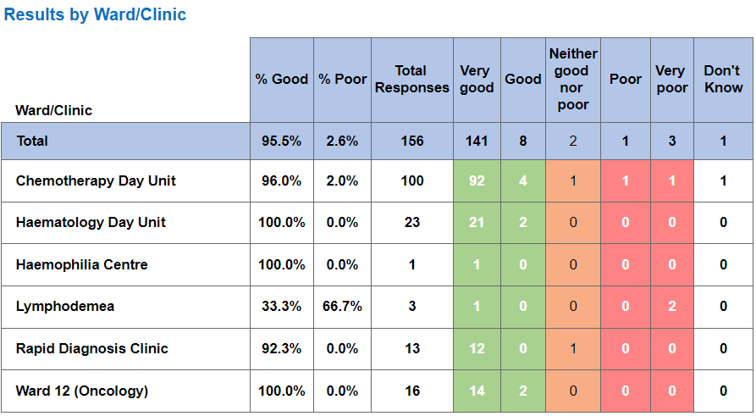
Below are the top themes for Cancer services:
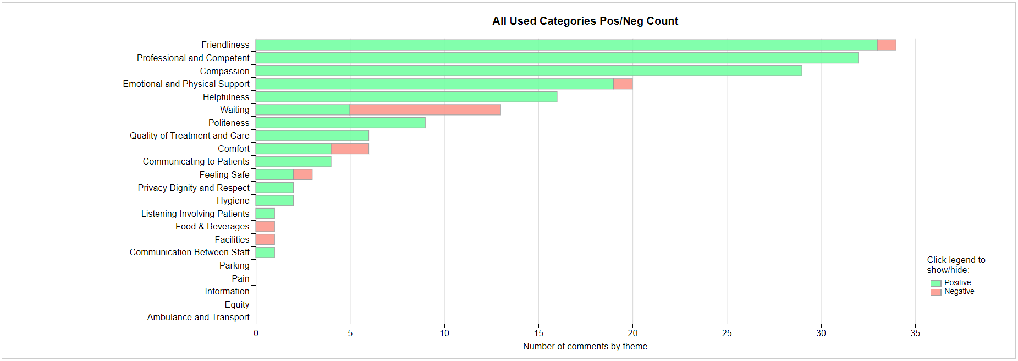
We have looked into ‘Waiting’ as this has a lot of negative responses. As you can see below, there the majority of comments are positive on the other categories.
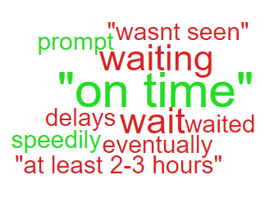

- HMP SWANSEA

During Q1 of 2023/24 (April, May, June) the Health Board has received 49 complaints from HMP Swansea. Regular meetings have been held with the Prison to discuss and agree the best way forward in regards to recording feedback and complaints received directly by the Prison.
Most of the complaints received are dealt with in the Prison prior to sending to the Health Board for recording. It was agreed that in order to identify themes and trends, these should be sent to the complaints team for recording.
Graph 1 below shows the number of complaints received per month from the Prison since July 2022.
Graph 1: HMP Swansea Complaints

As shown in the graph, there appears to have been an increase in complaints received since January 2023. This was following the meetings held with the prison where it was agreed that every complaint received needed to be forwarded to the Health Board to ensure accurate reporting.
Graph 2 shows the top themes from the complaints received during Q1 of 2023/24 (April, May, June)

Graph 2: Top Themes from HMP Swansea complaints

As shown in the graph, 31 complaints related to medication issues. A further breakdown of these medication issues is below;
Medication Issues;
Medication not prescribed | 18
Incorrect dosage given | 7
Poor pain control | 5
Delay in appointment/waiting time/transport | 1
Delay/Frequency in providing medication | 1

Patient Experience Prison Survey Feedback
The Prison service are providing feedback, which sits within Primary Care. For Quarter four, there were 19 responses. These responses were from May. We were not provided with the feedback surveys for April and June. Discussions are taking place with the Prison Service to agree a consistent pathway.

- MATERNITY

During Q1 of 2023/24 (April, May, June), Maternity Services have received 19 complaints. This compares with 17 in Q4 of 2022/23 (January, February, March). Graph 1 below shows the number received per month since April 2023.

Graph 1: Maternity complaints per month

Graph 2 below shows the themes identified from the 19 complaints.

During Q1, Maternity Services have reported 347 incidents. Graph 3 below shows the themes from these incidents.
Graph 3: Maternity Incident Themes
As seen in the graph, the majority of these incidents relate to Neonatal incidents.
Graph 4 breaks these 347 incidents down by severity. As shown in the graph, there has been 10 severe incidents since April 2023.
Graph 4: Maternity Incidents by severity

4.10 Maternity Patient Experience Feedback
Overall, during quarter one there were 187 responses for the Friends and Family survey with an overall score of 90% and a poor score of 6%.

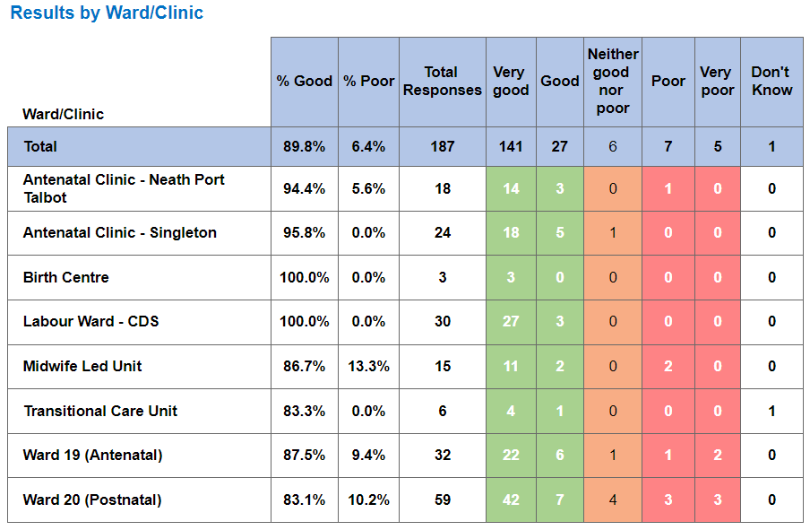
Below are some comments that were left regarding maternity services.
- Went in to be induced was there for 9 days altogether all the staff made my stay very welcoming and I couldn’t thank ward 19, Labour ward and special care unit enough for everything they did for me and my baby.
- Accessibility to advice from supportive staff. When arriving in the hospital everyone was welcoming and caring to me, and baby’s needs. Staff all worked incredibly well together, and I felt reassured and supported during a vulnerable time. Procedures were explained well, and I always felt I was given choice in my care.
- Been sitting with my partner for nearly 27 hours, been told she needs a c section, but midwife said someone else in theatre. Been told to wait it’s been nearly 3 and a half hours, and asked nicely with how long as and they told me they don't know or keep on relaying it. Also been told that the little one will arrive at a point and not is quite upsetting.
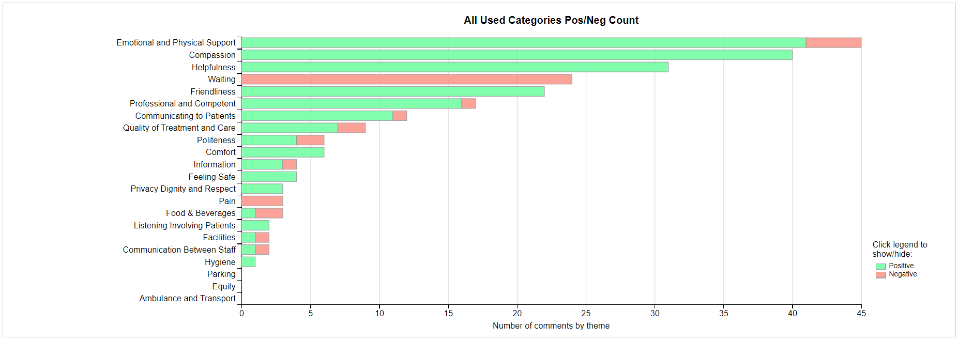

Emotional and Physical Support Waiting

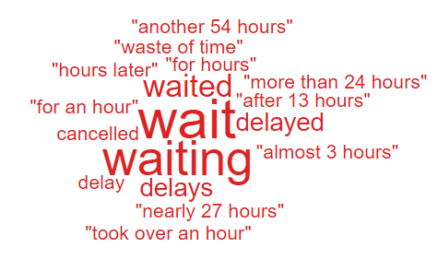
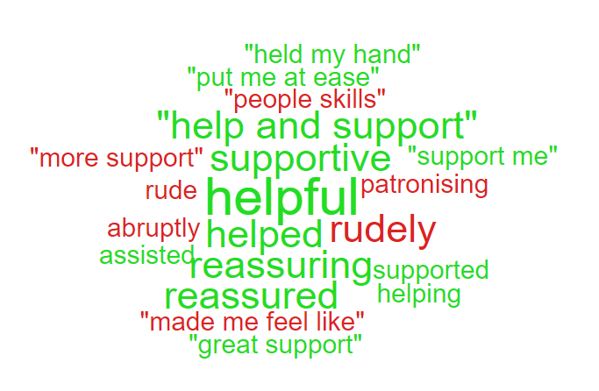

- SERVICE GROUP COMPLAINTS, INCIDENTS, COMPLIMENTS AND PATIENT FEEDBACK HIGHLIGHTS

MORRISTON SERVICE GROUP
6.1 – Morriston Service Group complaints
Morriston Service Group received a total of 290 complaints during Q1 2023/24. Graph 1 below shows the total number of complaints received relating to Morriston Service Group since July 2022. The graph breaks the total number received down by Formal PTR, Early Resolution and Re-opened complaints.
Graph 1: Morriston Service Group complaints by month and type

Graph 2 shows the top five services that had the most complaints since July 2022. As seen in the graph, Orthopaedics received the highest number of complaints but since April 2023, appear to be decreasing. General Medicine appears to have received a slight increase during June 2023 with 12 received during the month.
Graph 2: Top 5 Services by month

6.2 – Morriston Service Group Incidents
Morriston Service Group reported 2717 incidents in quarter 1 (Q1) of 2023/24 (April, May, June). This compares with 2576 incidents in quarter 4 (Q4) of 2022/23 (January, February, March). Graph 1 shows the number of incidents per month broken down by severity.
Graph 1: Morriston Incidents by Severity and month

Graph 2 shows the top 5 incident types, of all incidents reported by Morriston Service Group since April – June 2023. As you can see from the graph, the Pressure Damage incidents appear to have decreased during June.
Graph 2: Top 5 incidents per month

4.3 – Morriston Service Group National Reportable Incidents
Morriston Service Group reported 11 Nationally Reportable Incidents (NRI’s) during Q1 2023/24, this compared to 10 reported during Q4 of 2022/23. Of the NRI’s reported, 6 related to patient falls, 2 clinical treatment/diagnostic, 2 monitoring/observation and 1 Never Event, wrong site surgery in Burns & Plastics. Graph 1 shows the number of NRI’s reported per month.
Graph 1: Nationally Reportable Incidents reported per month by Morriston Service Group

4.4 – Morriston Service Group Compliments
Morriston received 111 compliments during Q1 of 2023/24. Graph 1 shows the number received per month since July 2022.
Graph 1: Morriston compliments per month

Graph 2: Morriston compliments – Top 5 Services

Since the Acute Medical Services Redesign, Morriston Service Group now manage Minor Injuries Unit.
4.5 Morriston Service Group Patient Experience Feedback
Overall, during quarter one there were 62,398 number of patients seen under Morriston Service Group (This includes ED).

There were 5,540 Friends and Family survey returns which equates to 9% responding to the survey. Out of the 9% who responded, 87% of people stated they would highly recommend the Health Board to Friends and Family.

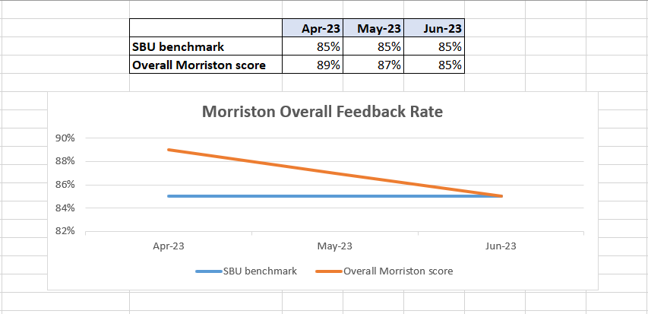

Below are the number of responses in a line graph:

Below are the main themes mentioned for Morriston:
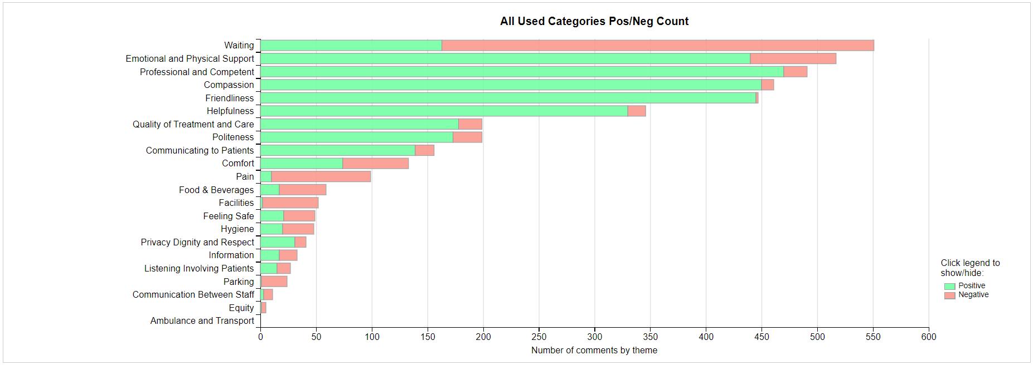
NEATH PORT TALBOT SINGLETON SERVICE GROUP
6.6 – NPTSSG Complaints
NPTSSG received a total of 157 complaints during Q1 2023/24. Graph 1 below shows the total number of complaints received relating to NPTSSG since July 2022. The graph breaks the total number received down by Formal PTR, Early Resolution and Re-opened complaints.
Graph 1: NPTSSG complaints by month and type

Graph 2 shows the top five services that had the most complaints since July 2022. As seen in the graph, Gynaecology appear to have had a decrease in January and February 2023, increasing again in March but decreasing again in June.
Graph 2: Top 5 Services by month

Although Gynaecology complaints appear on the decrease, on average they do receive the highest number. During Q1, they received 23 complaints therefore, a breakdown of the top themes are shown below;

Out of the 23 complaints, 17 are recorded against outpatients department due to delays and cancellations of appointments and treatment.
WFI Service Complaints
The WFI service have received 9 complaints during Q1. These mainly relate to delays in receiving treatment and the lack of communication or difficulties contacting the service.
During Q1 WFI have reported 13 incidents, the incident types are highlighted below;

6.7 – NPTSSG Incidents
NPTSSG reported 1240 incidents in quarter 1 (Q1) of 2023/24 (April, May, June). This compares with 1217 incidents in quarter 4 (Q4) of 2022/23 (January, February, March). Graph 1 shows the number of incidents per month broken down by severity.
Graph 1: NPTSSG Incidents by Severity and month

Graph 2 shows the top 5 incident types, of all incidents reported by NPTSSG since April to June 2023.
Graph 2: Top 5 incidents per month

6.8 – NPTSSG National Reportable Incidents
NPTSSG reported 5 Nationally Reportable Incidents (NRI’s) during Q1 2023/24, this compares to 6 being reported during Q4 of 2022/23. Of the NRI’s reported 3 related to Pressure Ulcers and 2 Neonatal incidents. Graph 1 shows the number of NRI’s reported per month.
Graph 1: Nationally Reportable Incidents reported per month by NPTSSG

6.9 – NPTSSG Compliments
NPTSSG received 43 compliments during Q4 of 2022/23. Graph 1 shows the number received per month since April 2022.
Graph 1: NPTSSG compliments per month

Graph 2: NPTSSG compliments – Top 3 Services

4.10 NPTSSG Patient Experience Feedback
Overall, during quarter one there were 48,082 number of patients seen under Neath Port Talbot and Singleton Service Group (This includes Minor Injuries Unit).

There were 3,227 Friends and Family survey returns which equates to 7% responding to the survey. Out of the 7% who responded, 94% of people stated they would highly recommend the Health Board to Friends and Family during this quarter.

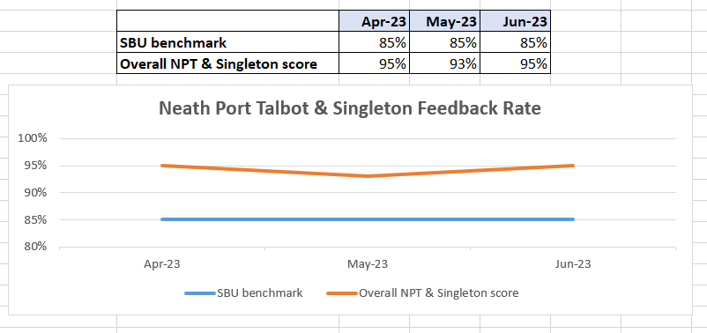

Below are the number of responses in a line graph:

Below are the main themes mentioned for NPT & Singleton:
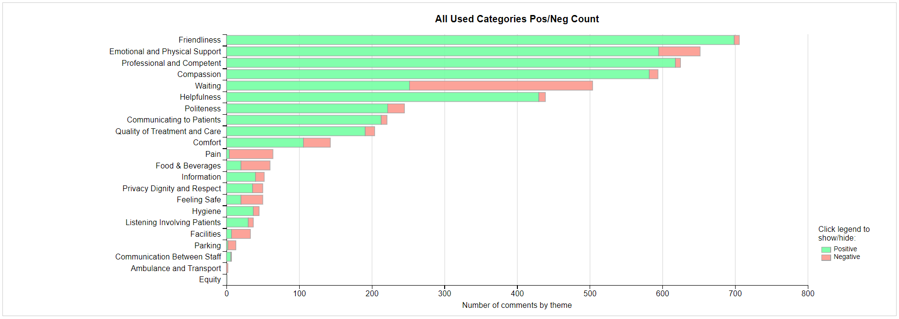
MENTAL HEALTH AND LEARNING DISABILITIES SERVICE GROUP
6.11 – MH&LD Complaints
MH&LD received a total of 52 complaints during Q1 2023/24. Graph 1 below shows the total number of complaints received relating to MH&LD since July 2022. The graph breaks the total number received down by Formal PTR, Early Resolution and Re-opened complaints.
Graph 1: MH&LD complaints by month and type

Graph 2 shows the top five areas within MH&LD that had the most complaints since July 2022. As shown in the graph, Central Clinic appear to have had an increase in complaints during June 2023.
Graph 2: Top 5 Services by month

6.12 – MH&LD Incidents
MH&LD reported 1067 incidents in quarter 1 (Q1) of 2023/24 (April, May, June). This compares with 944 incidents in quarter 4 (Q3) of 2022/23 (January, February, March). Graph 1 shows the number of incidents per month broken down by severity.
Graph 1: MH&LD Incidents by Severity and month

Graph 2 shows the top 5 incident types, of all incidents reported by MH&LD since April – June 2023.
Graph 2: Top 5 incidents per month

6.13 – MH&LD National Reportable Incidents
MH&LD reported no NRI’s during Q1 of 2023/24. This compares to 4 reported during Q4 of 2022/23. Of these, there were 3 falls, and 1 behaviour incident.

6.14 – MH&LD Compliments
MH&LD received 6 compliments during Q1 of 2023/24. This compares to 4 compliments during Q3 of 2022/23. Graph 1 shows the number received per month since April 2022.
Graph 1: MH&LD compliments per month

4.15 MH&LD Patient Experience Feedback
This data is from Quarter One.

The Mental Health and Learning Disabilities Service Group are using a different set of survey questions. The role out of the semi structured interview surveys have been managed in stages. Roll out, awareness posters and meetings with managers and teams continues.

PRIMARY AND COMMUNITY SERVICE GROUP
6.16 – P&C Complaints
P&C received a total of 135 complaints during Q1 2023/24. Graph 1 below shows the total number of complaints received relating to P&C since July 2022. The graph breaks the total number received down by Formal PTR, Early Resolution and Re-opened complaints.
Graph 1: P&C complaints by month and type

Graph 2 shows the top five services that had the most complaints since July 2022. As seen in the graph there appears an increase in complaints relating to HMP Swansea since January 2023. This was following a meeting with the prison where it was agreed that any complaint received and resolved in the prison, would be forwarded to the Health Board’s complaints team for logging on Datix.
There has been an increase in complaints regarding GP Practices in the NPT area. There has been a rise in complaints regarding the Health Board’s managed practice – Cymmer/Cwmavon, that has been highlighted. The majority of these complaints relate to communication and attitude of staff therefore, training has been offered to staff at the practice.
Graph 2: Top 5 Services by month

6.17 – P&C Incidents
P&C reported 879 incidents in quarter 1 (Q1) of 2023/24 (April, May, June). This compares with 970 incidents in quarter 4 (Q4) of 2022/23 (January, February, March). Graph 1 shows the number of incidents per month broken down by severity.
Graph 1: P&C Incidents by Severity and month

Graph 2 shows the top 5 incident types, of all incidents reported by P&C since April – June March 2023.
Graph 2: Top 5 incidents per month

6.18 – P&C National Reportable Incidents
P&C reported 1 Nationally Reportable Incidents (NRI’s) during Q1 2023/24, this compares to 3 being reported during Q4 of 2022/23. This NRI related to a pressure ulcer.
Graph 1: Nationally Reportable Incidents reported per month by P&C

6.19 – P&C Compliments
P&C received 38 compliments during Q1 of 2023/24. Graph 1 shows the number received per month since July 2022.
Graph 1: P&C compliments per month

Graph 2: P&C compliments – Top 5 Services

4.20 P&C Patient Experience Feedback
Overall, during this quarter there were 2,390 number of patients seen under Primary and Community Service Group.

There were 935 Friends and Family survey returns which equates to 39% responding to the survey. Out of the 39% who responded, 96% of people stated they would highly recommend the Health Board to Friends and Family during this quarter.

Patient Experience Team are currently working with I.T to automate SMS messages from the PIMS, PIMS+ platform to automate SMS survey messages to Primary Care and Therapies patients. This will increase the number of returns.

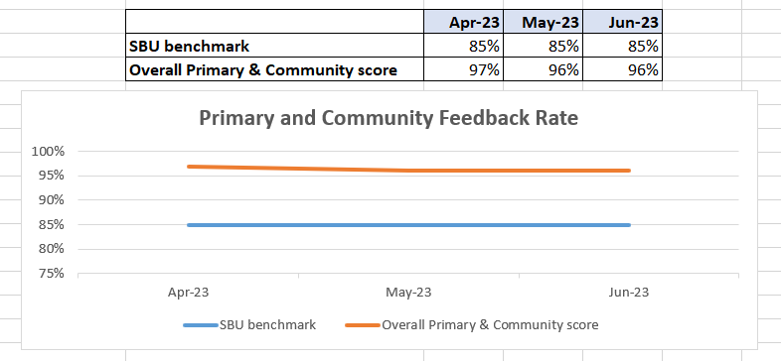

Below are the number of responses in a line graph:

Below are the main themes mentioned for Primary & Community:
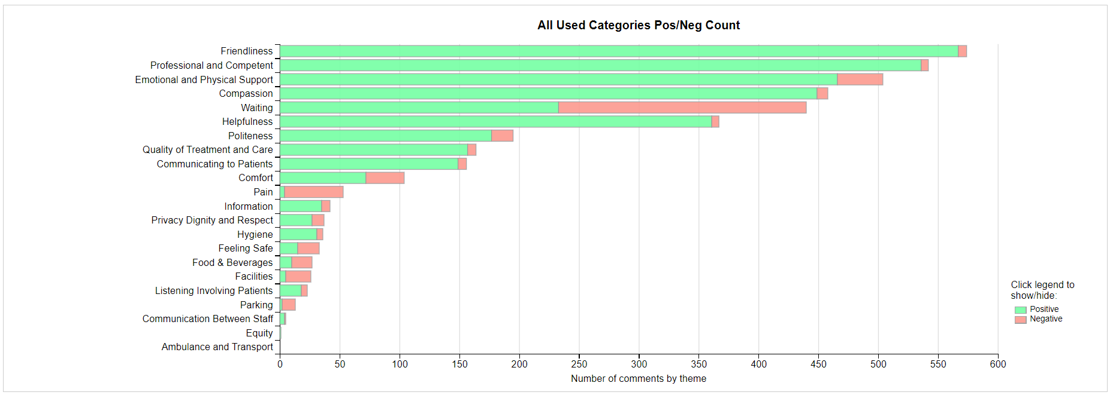

- MEDICAL EXAMINER COMPLIMENTS

7.1 ME Compliments
The Health Board has received a number of compliments from families through the Medical Examiner. This evidences the good work being done when treating these end of life patients. During Q1, approximately 80 compliments were received. A few examples are shown below;
Thanks to Ty Olwen for excellent care. He said they could not praise the doctors and nurses enough. They made sure their mum was comfortable, pain free, and helped all the family deal with it all. – Ty Olwen

They could not speak highly enough of the ITU team, she said they were every good and treated patient with the utmost dignity and kept them well informed at all times. Nurse …… was especially kind. – ITU, Morriston

Care and treatment was amazing, …. told me Nurse …… on AMAU blue side was fantastic. Although mum was only there for a short time, they were wonderful.. – AMU, Morriston

- OMBUDSMAN CASES

8.1 Ombudsman investigations
2 new Ombudsman investigation was received during Q1 2023/24, this compares to 1 in Q4 2022/23. Graph 1 shows the number of investigations received per month;

Graph 1: Number of Ombudsman investigations per month

The Health Board has also received 26 decisions not to investigate from the Ombudsman during Q1. Graph 2 below shows these by month.

Graph 2: Ombudsman decisions not to investigate

There are a number of different reasons why the Ombudsman decided not to investigate these complaints, a few of these reasons are detailed below;

- Complainant advised to take legal route
- Complainant not provided further information required by Ombudsman
- Health Board response thorough and addressed each point

- The Health Board received a notification from the Ombudsman regarding a Press Release called ‘Groundhog Day 2: An Opportunity for Cultural Change in Complaint Handling?’ received on 13th June 2023, and published on 15th June 2023.
The report is in relation to NHS complaints handling on an All-Wales basis and is critical of the handling of a complaint by Swansea Bay. An accompanying letter was sent to the Chief Executive on 15th June 2023 in accordance with the Public Services Ombudsman for Wales Act 2019.
The report includes a number of general recommendations to all Health Boards in Wales which the Ombudsman advises will be helpful as the Health Board implements the Duty of Candour.

- The Ombudsman’s annual data has been received and we are awaiting the annual letter.

- There is one overdue action for the Ombudsman at present – this relates to a Mental Health cases where the work is ongoing. The Ombudsman are aware of this and have been kept up to date.

