

Meeting Date | 29 August 2023 |  | Agenda Item |  |  | 3.1 (ii)
Report Title | Neath Port Talbot and Singleton Service Group Infection Prevention Improvement Plan
Report Author | Sharron Price, Interim Group Nurse Director
Report Sponsor | Ceri Gimblett, Interim Service Group Director
Presented by | Sharron Price, Interim Group Nurse Director
Freedom of Information | Open
Purpose of the Report | To present an update to the Quality & Safety Committee of the Service Group Improvement Plan including:  - Progress against the 2022 / 2023 Welsh Government HCAI Improvement Targets  - Confirmation of Service Group governance processes  - Actions and Plans for service Group infection reduction programme for 23/24
Key Issues | - The Service Group has an overarching bi-monthly infection control meeting in place, with delegation of responsibilities to Divisional Level. Each Division has set up and embedded an Infection Control Meeting where progress against the Health Care Acquired Infection (HCAI) improvement plan is monitored.  - The Service Group has a robust HCAI Improvement Plan which is a co-produced live document reviewed at the bi-monthly Infection Prevention and Control (IPC) meeting.  - There is Director led, high level scrutiny in place for Tier 1 Infections where all cases will be presented by the responsible divisions  - There has been a significant improvement in E-Coli Bacteraemia (87% reduction) on the Neath Port Talbot Site  - For 2022 / 23 the Service Group has not met the improvement targets with all infections. However there has been an improvement compared to the 21/22 performance with C-Difficile infections (13% NPTH and 20% Singleton Hospital)  - The Service Group has made significant progress with the decontamination agenda and improvement plan, with assurance of location of devices, appropriateness of decontamination and training received into Divisional and Service Group IPC meetings.
Specific Action Required  (please choose one only) | Information | Discussion |  | Assurance | Approval
Specific Action Required  (please choose one only) | ☐ | ☐ |  | ☒ | ☐
Recommendations | Members are asked to:  - Receive the service group’s infection control update

Neath Port Talbot and Singleton Service Group Infection Prevention Improvement Plan 2023 / 24

INTRODUCTION
This report will provide the update on the Service Group’s improvement plan detailing progress against the 22/23 Welsh Government Improvement targets, and outlines priorities for the next 12 months in order to reduce hospital acquired infections.

BACKGROUND
The provision of safe effective and efficient care requires the delivery of evidence based-best practice on the management and prevention of healthcare associated infections.

Against the backdrop of significant service changes with the implementation of the Acute Medical Services Redesign, along with continued surges in COVID-19 and Influenza outbreaks, the Service Group had not succeeded in achieving a sustained reduction in associated infections in 2022/23.

2.1. TIER 1 INFECTION OUTCOMES 2022 / 2023
It should be noted that there have been notable improvement in terms of E-Coli Bacteraemia at Neath Port Talbot Hospital (NPTH) with an 87% improvement from 21/22.

Whilst both Hospital sites have exceeded the improvement goal for 22/23 there has been an improved performance with C-Difficile infections from the previous year with Singleton reporting an 8% improvement from 21/22 and Neath Port Talbot 20%.

The Group has exceeded its Quality Priority reduction goal for Staph Aureus Bacteraemia with a total cases of 14 at Singleton and 2 at Neath Port Talbot at year end, there has been am 8% improvement from 21/22 at Singleton and whilst NPT is reporting a 100% increase this relates to only 2 cases in total

There was a significant increase in Pseudomonas Bacteraemia 2022 / 2023 on the Singleton Hospital Site, the site team, clinical teams and Group Directors have worked closely with the estates team to review and scrutinise these with work and improved education around Water Safety linked with this.

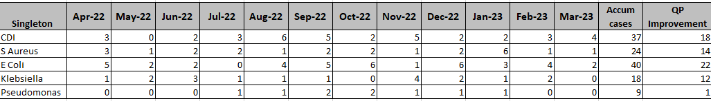

HCAI Current Position (Q1 April 2023 – June 2023)
Whilst NPTH is on its improvement target trajectory Ward D has had incidence of E-Coli and Klebsiella bacteraemia.

The ward has been escalated as a “hot spot” and focused review is underway

The group is already over its improvement trajectory for Staph aureus and E-Coli bacteraemia, with NICU and cases on Ward 12, Chemotherapy Day Unit and Ward 8.

Cancer Services has had escalated measures introduced as an area of concern and director-led scrutiny implemented as a result

The Service Group has an overarching Infection Control meeting which runs bi-monthly and there is delegation of responsibilities for Infection Prevention and Control to the Divisions. Each Division has set up and embedded an Infection Control meeting where progress against the Improvement Plan is reported and delivered.

Each Division has a scrutiny process for any reported HCAI, once investigation and scrutiny is been completed this is then reported into a Director led scrutiny where common themes are discussed and shared.

HCAI Improvement Plan 2023 – 2024
- Improvement Plan workshop held 1st June 2023 to develop and support robust clinical leadership
- Multi-professional Attendance at the workshop
- Representation from Adult, Childrens and Maternity Services – Service Wide agreement and engagement
- Incomplete actions from 21/22 to be carried forward
- Divisional tabs have been added to the plan to support divisional ownership and accountability – the overarching plan has been drafted, divisions are working through their individual plans, with excellent engagement from all divisional team.
- Confirm and refresh of Service Group and Divisions Governance structures
- This improvement plan is in draft format and will be confirmed in a further workshop and approved through the Service Group Governance Structures
- Agreement and sign up to development of Divisional plans, monitored and updated live at local IPC meetings

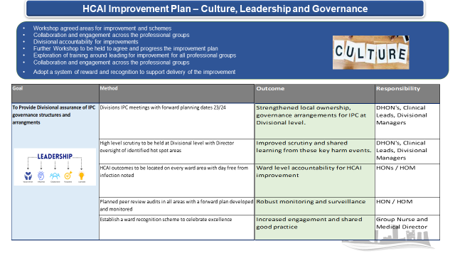
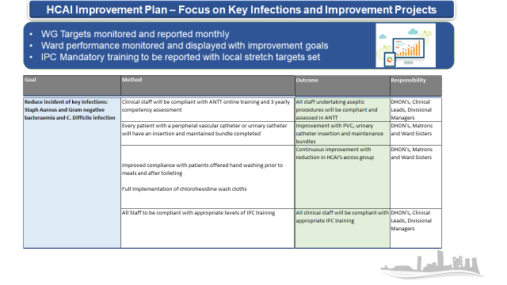
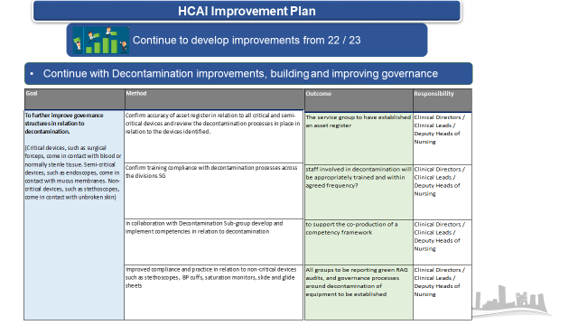
The Service Group Infection Control meetings and divisional processes have been established, and have been running throughout the year.

Director led HCAI review meetings are in place and embedded.

Infection Prevention and Control Training Figures

Performance with mandatory training has dropped in all areas since the last reporting period.
Level 1 training across most ward areas is in excess of 90%, there have been some reduction in performance. However, this data is for all staff groups, further work to be completed to establish true baseline of relevant staff compliance for each training module.

ESR data not reflective of locally held records. Validation work by Divisions on going.

 | May 2022 | June 2023
NHS|CSTF|Infection Prevention and Control - Level 2 - 1 Year| | 37.18% | 24.48%
NHS|CSTF|Infection Prevention and Control - Level 1 - 3 Years| | 84.16% | 88.01%
NHS|MAND|Aseptic Non Touch Technique - 3 Years| | 22.58% | 18.90%
NHS|MAND|Hand Hygiene - 1 Year| | 15.29% | 11.12%

GOVERNANCE AND RISK ISSUES

3.1. Service Group Governance Processes
There are a number of factors that have impacted on the governance arrangements within the Service Group.

- The new Health Board Quality Framework
- Acute Service Redesign and changes to the Divisional Structures
- New Interim arrangements within the Triumvirate team

The Service Group Quality Structure has reviewed and updated its Quality Safety and Risk Framework in line with the new Health Board Framework.

The current Terms of Reference for Infection Prevention and Control meeting will need to be reviewed and updated to reflect the changes

The Service Group has embedded leadership accountability to Divisional Level and the current framework is designed to drive leadership at a local level

The Medical Director supports and chairs high level scrutiny panels

The Service Group Medical and Nursing Directors provide joint leadership in delivering the Infection Prevention and Control agenda.

Neath Port Talbot and Singleton Service Group
Infection Prevention and Control Accountability Structure

FINANCIAL IMPLICATIONS
There are no financial implications for this paper

Recommendations
To note the HCAI improvement plan and gain assurance the relevant actions are being taken to reduce infection rates in line with identified targets

Governance and Assurance

Link to Enabling Objectives  (please choose) | Supporting better health and wellbeing by actively promoting and empowering people to live well in resilient communities
Link to Enabling Objectives  (please choose) | Partnerships for Improving Health and Wellbeing |  | ☐
Link to Enabling Objectives  (please choose) | Co-Production and Health Literacy |  | ☒
Link to Enabling Objectives  (please choose) | Digitally Enabled Health and Wellbeing |  | ☐
Link to Enabling Objectives  (please choose) | Deliver better care through excellent health and care services achieving the outcomes that matter most to people
Link to Enabling Objectives  (please choose) | Best Value Outcomes and High Quality Care |  | ☒
Link to Enabling Objectives  (please choose) | Partnerships for Care |  | ☐
Link to Enabling Objectives  (please choose) | Excellent Staff |  | ☒
Link to Enabling Objectives  (please choose) | Digitally Enabled Care |  | ☐
Link to Enabling Objectives  (please choose) | Outstanding Research, Innovation, Education and Learning |  | ☐
Health and Care Standards
(please choose) | Staying Healthy |  | ☒
(please choose) | Safe Care |  | ☒
(please choose) | Effective Care |  | ☒
(please choose) | Dignified Care |  | ☐
(please choose) | Timely Care |  | ☒
(please choose) | Individual Care |  | ☐
(please choose) | Staff and Resources |  | ☐
Quality, Safety and Patient Experience
The Health Board fully recognises its duty of care to ensure that both individual patients and the needs of the population that it services, in relation to infection prevention

Financial Implications
There are significant opportunity costs being borne by the Health Board on a daily basis in relation the extended care of those patients’ subject to a healthcare acquired infection.
Legal Implications (including equality and diversity assessment)
On the 1st June 2020, the Health and Social Care (Quality and Engagement) (Wales) Act became law; it will come into force in Spring 2023. The Act will introduce the principle of Duty of Quality. Health services will be required to demonstrate a “system-wide way of working to provide safe, effective, person-centred, timely efficient and equitable health care in the context of a learning culture.

Staffing Implications
Linked to wider existing staffing pressures.

Long Term Implications (including the impact of the Well-being of Future Generations (Wales) Act 2015)
Prevention of infection will contribute to public health and wellbeing in the community and contribute to the objectives of wider public bodies.
Report History |  | March 2022 Health Board IPC Improvement Plan  April 2022 NPTSSG 2022 / 23 HCAI improvement plan
Appendices

