
Service Groups’ Highlight Report for
Quality and Safety Committee

Meeting Date: | 29th August 2023
Service Group: | Neath Port Talbot & Singleton Service Group
Author: | Jayne Hopkins, Service Group Head of Quality, Safety & Risk
Sponsor: | Sharron Price, Service Group Interim Nurse Director
Presenter: | Sharron Price, Service Group Interim Nurse Director, & Jayne Hopkins Service Group Head of Quality Safety & Risk
Summary of Quality and Safety issues since last report to the Committee
This paper provides the Quality and Safety Committee with an update on matters of Quality and Safety overseen by the Service Group. This is the sixth report of the Neath Port Talbot and Singleton Service Group (NPTSSG).

Key Quality and Safety Issues

- Welsh Fertility Institute (WFI) Human Fertilisation and Embryology Authority (HFEA) Inspection
The Human Fertilisation and Embryology Authority (HFEA) inspection for Welsh Fertility Institute (WFI), Neath Port Talbot Hospital was undertaken on 18 January 2023 and seven areas of improvement identified. An action and improvement plan has been implemented with scheduled information submission dates as per HFEA requirements. Task and finish groups were established to manage each of the recommendations and required actions. A number of the actions required are now completed with evidence submitted, there are some outstanding actions which the team are working through and reporting regularly to the HFEA. To provide Group and Executive oversight a WFI Improvement Board chaired by the Medical Director and Head of Nursing for Adult Services has been established, and a Gold Command chaired by the Director of Therapies and Health Sciences
- Cellular Pathology
Cellular Pathology has a histology block and slide backlog, there is an increasing demand and build up in numbers of USC specimens resulting in increased turnaround times. In the past this turnaround time only existed with routine samples and not USC specimens.

- Critical midwifery staffing levels
Critical midwifery staffing remains on a risk score rating of 25 on the risk register as challenges continue in achieving the baseline midwifery staffing levels in both the Obstetric Unit and community setting. Progress continues and is being made with regard to workforce redesign.

- Radiation Physics resourcing
Actions to mitigate challenges to ensure sufficient medical physics expert cover. The service is outsourcing services for Laser Protection Advisors.

Challenges, Risks, Mitigation and Action being taken relating to Quality and Safety issues noted above (what, by when, by who and expected impact)

Quality Assurance Framework Audits
The Service Group has reviewed and refreshed the Quality Audit Plan setting out the infrastructure for monitoring, assurance and governance. Part of this framework are unannounced reviews of clinical areas, with a multi-disciplinary team approach to those reviews.

Within the Service Group Ward D and E at Neath Port Talbot hospital have been reviewed, with a subsequent Safety Summit and improvement plans developed

There have been 3 unannounced audits from the corporate governance team (Neuro-rehabilitation, Ward 6 at Singleton Hospital and within Midwifery Services Wards 19 and 20).

The Neuro-rehabilitation improvement plan has been completed, the Service Group are awaiting the formal reports from Ward 6 and Wards 19 and 20 however the ward teams are working through improvement plans from the feedback given on the day.

Health Inspectorate Wales

Following the Inspection in January 2023 and subsequent report (April 2023) a request for further assurance has been received and responded to. Following the request the Head of Nursing and Divisional manager undertook an unannounced inspection alongside a Fifteen Step Challenge carried out by BaYouth. The BaYouth feedback was that:

- Oakwood is a clean ward, the bins were kept contained, and most items had the daily cleaning tag attached to them.
- There is clear information which is presented in different languages
- Rubbish is disposed of correctly however one bin was overflowing
- Tags are displayed on cleaned items and most items are cleaned to a good standard

Risks
New high level risks (20+) reported in Quarter 1 are summarised in the table below;

Risk | Score | Current controls/mitigation
Risk 3370  Limited capacity for Pharmacy Technical Services and wider Pharmacy teams to provide current & future SACT in SBU. | 20 | - Limits put on patient numbers & new treatments. Consider referral of patients to other HBs for treatment if capacity available  - Pathway in place to ensure SACT prescribing follows an agreed process to ensure Pharmacy can manage current workload safely.  - Review workforce model to include additional training to expand role of Pharmacy Technicians and non-registrant healthcare scientists  - Locum pharmacist employed to perform clinical verification of Rx remotely.  - Alternative supply routes for non-sterile meds/ co-meds/ oral regimens & bisphosphonates and maximise medicines homecare usage where appropriate.
Risk 3298  Automated H&E stainer for Singleton Histology- Manual staining required | 20 | - The equipment will be on a bronze contract from April due to its age, and parts are becoming scarce for this now out dated technology. Staff regularly have to stain by hand to prevent huge backlogs of unstained slides.  - All automated stainers are serviced regularly by a service contractor, and their filters are changed as required, plus they are maintained in-house regularly (either weekly or bi-weekly).  - Staff are trained in both use and maintenance of the stainers, with competency assessments in place.  - Fume levels are monitored regularly, and spill kits are in place.
Risk 3115  Lack of CCTV / adequate security in SBUHB Mortuaries affecting ability to comply with audit requirements | 20 | - Enhanced DBS checks for all Mortuary staff in place  - All entrances and exits have a form of security in place (coded door etc.)  - Signing-in registers on both sites and Salto locks at Morriston facilitate some auditing of visitors  - Porters have bespoke HTA training  - Estates and external contractors only attend when a member of the mortuary team is present  - PTW and confidentiality agreements in place  - Students supervised at all times  - SOP’s / training protocols in place  - Premises and procedures audited by HTA inspectors, UKAS assessors, & HSE  - Internal audits carried out.

Health & Care Standard Standard 6.3 - Listening and Learning from Feedback

The Service Group’s concerns compliance with PTR 30 working day target and the management of overdue incidents due to staff sickness (both Q&S teams and matron teams) and staffing shortages (clinical), increasing numbers of AM enquiries | - Review the potential impact of service redesigns  - Share projected improvement targets with divisions  - Deputy Head of Nursing holds weekly meetings with team to monitor and improve compliance  - Quality, Safety and Risk team support the service Divisions by running monthly (more frequently on request) Datix concerns reports to assist with improving compliance  - Implementation of Divisional level Quality, Safety and Risk groups  - Complete the recruitment to vacancies in QS&R team | - 90% performance compliance  - Timely investigations completed to allow for timely patient feedback and early learning  - Shared learning integrated into practice | Improved performance rates;  April 2023- 75%

Serious Incidents (SI) and Never Events

The Service Group has two overdue SI’s. Both are complex paediatric cases with multi agency involvement. There are four pressure ulcer incidents under investigation which are potentially reportable.
There are two Never Events reported by Obstetrics (1 in February 2023, 1 in August 2023) which are currently under investigation.
Progress Against Annual Plan Quality and Safety Priorities 2022/23 (as applicable)
Quality Priorities: reduction in healthcare acquired infections; improving end-of-life care; sepsis; suicide prevention; and reducing injurious falls.

Reducing Injurious Falls
There has been a significant reduction in falls at Singleton Hospital which can be linked to the transfer of medical services to Morriston Hospital. There has been a recent upward trend in Neath Port Talbot Hospital which is being monitored as services have changed, a notable reduction since Quarter 4. The Memory Impairment Advice Team (MIAT) has worked with clinical teams in introducing activities, reducing expressive behaviour and supporting staff to de-escalate and support distressed patients. Ty Olwen and Ward 12 are piloting the “Baywatch Hands” initiative and working with the Morriston Hospital team.

The table below shows the actions the Service Group’s taking to reduce inpatient injurious falls;

Goal | Method | Outcome | Responsibility
Appropriate training and education in relation to falls prevention with 85% compliance. | Undertake a training needs analysis and identify gaps.  Signpost clinical teams to new ESR training for falls.  PDN has provided a presentation to all wards which has highlighted falls training. | 80% training compliance for ward staff (ESR Falls Module) staged improvement trajectory 20% | Practice Development team  Clinical Leads  Lead Advanced Clinical Practitioner
Hot debrief is uploaded to Datix for all falls in all ward areas. | Hot Debrief added to Datix.  Spot Audit via Datix to monitor compliance. | A hot debrief compliance audit is completed as a spot check.  Spot check – some areas excellent uploading to Datix (ward C NPT) still some work to do with the Singleton Wards | Deputy Heads of Nursing / Matrons
Standardised approach to post falls management across both NPT and Singleton Site. | Secure post falls equipment for Singleton site.  Undertake a training needs analysis and identify gaps.  Site based procedure chart for post falls management. | Standardised approach to post falls management.  Falls equipment has been ordered for Singleton and is awaiting delivery. | Practice Development team  Lead ANP  Health and Safety team (Manual Handling)
10% annual reduction in harmful falls. | Identify specific Quality Improvement projects for falls reduction.  Action all above methodologies for falls improvement. | Annual reduction in harmful falls (10%). | Practice Development team  Lead ANP  Health and Safety team (Manual Handling)

Reducing Health Acquired Infection
The Service Group has seen an increase in Klebsiella and E coli at Neath Port Talbot Hospital since Quarter 4 (although numbers are small). Ward D has been identified as a hotspot area, increased surveillance and monitoring has been introduced to improve standards of Infection Prevention & Control (IP&C) in this area. The Service Group is above trajectory with Staph Aureus at Singleton Hospital with 7 reported incidents in Quarter 1. It is noted that there has been an impact from closure of Singleton Assessment Unit (SAU) and the Acute Oncology & Haematology Service (AOHS) implementation, with previous SAU infection rates now attributed to Cancer Services.

Actions which are being taken for IP&C improvements;
- Workshop agreed areas for improvement and schemes
- Collaboration and engagement across the professional groups
- Divisional accountability for improvements
- Further Workshop to be held to agree and progress the improvement plan
- Exploration of training around leading for improvement for all professional groups
- Collaboration and engagement across the professional groups
- Adopt a system of reward and recognition to support delivery of the improvement

Divisional accountability for improvements
To provide divisional assurance for IP&C governance structures and arrangements the Divisional IP&C meetings will set up forward planning dates for 2023/24. There will be high-level scrutiny of divisions with Director oversight on hot spot areas. HCAI outcomes will be located on every ward area with “day free from infection” noted. A ward recognition scheme to celebrate excellence will be established.

Sepsis
Across the Service Group, Sepsis training within the Sepsis Sticker trial has been successful and very well received. The AOHS are undertaking specific sepsis training within Cancer Services at Singleton Hospital. Sepsis training will be introduced as part of the 10 and 10 initiatives (10 minutes at 10am educational session) within Cancer Services. There is specific ward based training available in response to incidents relating to sepsis.

Improving end of life care
The table below shows the improvements for the Improving end of life care Quality Priority;

Current position | Forward Action
Champion study days attended, most ward have now sent staff. Both RN and HCA encouraged to attend. | Champion programme to continue with attendance encouraged
NEWS audits and part of this discussions around the deteriorating patient and end of life care decisions | Audits
Oral care training put in place, and supporting comfort in EOL patients. | Continue with training in relation to nutrition and hydration and oral care to support comfort at end of life.
EOF care competency added into the HCA competency booklet.

Suicide prevention
The table below shows the improvements for the Suicide prevention Quality Priority;

Current position | Forward Action
Ligature Risk Assessments have been updated across the group, will need a review for outpatient and public areas and refresh of ward areas within this Quarter Maternity Services still have some outstanding assessments | Set review date for all other risk assessments  100% of ligature risk assessments to be reviewed and updated within clinical areas
REACT support available for all staff and is being utilised across the service Group, signposting to Crisis team and GP’s have taken place to support individual staff members
Lack of TRiM practitioners / Supporters within Singleton and Neath | TRiM Leads identified within group, set up TRiM training sessions

Prevention of Health Acquired Pressure Damage (HAPU)
Singleton Hospital has a reduction in pressure ulcer incidents due to the transfer of services as part of AMSR. Ward 9 reported an unstageable pressure ulcer; which has been deemed as avoidable, this ward is now closed with the transfer of services. The learning identified has been shared across the Service Group.

Neath Port Talbot hospital has had a small increase in incidents in May and June 2023 (numbers are small). Ward D reported unstageable pressure damage which is currently under investigation but initial findings deem the pressure damage was likely to have been present prior to admission.

Safeguarding

Across the Service Group there is a focus on recovering mandatory training compliance particular in relation to Level 2 and Mental Capacity Act Training. The transfer of services as part of AMSR have given some challenges in accurate reporting of figures and work continues in moving staff to their correct areas of work on ESR to address this.

The Lead Midwife for Safeguarding highlighted an increased workload for supporting attendance at case conferences, strategy meetings and highlighted delays in information sharing and statement writing within the community midwifery teams. To support improvement all community midwifes have been offered one to one supervision to in relation to safeguarding processes.

Following on from the Born into Care work being carried out within Swansea Local Authority and JIGSO, Local Authorities in England are interested in the changes of the pre-birth work that has been undertaken. A Workshop has been arranged with Local Authorities in England to share and look at pre-birth work and focus on working more closely with multi-agency systems and in particular closer working relationships between Midwifery and Social Services that is currently working in Swansea.

Patient Experience Update
For the month of July, there were 1,171 Friends and Family (F&F) survey returns with overall score of 94%.

Heat map below showing F&F scores; when asked the question ‘Overall, how was your experience of our service’.

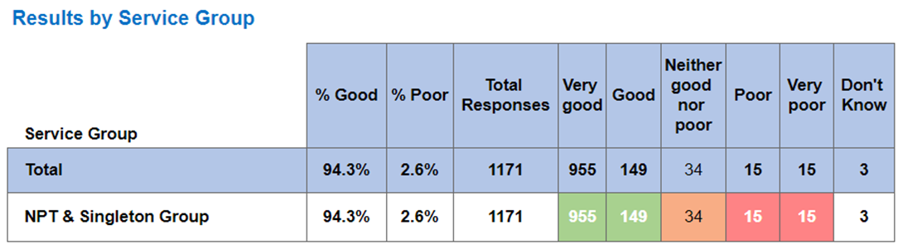

Some positive feedback from F&F survey returns

Clinic B1
Doctors, nurses and receptionist were all so friendly and welcoming. Everything was explained clearly and loads of reassurance was given. I was made to feel relaxed and encouraged to talk to take my mind off the procedure. The thing I really liked was the doctor would tell me what to expect before she did anything.

Outpatient Dept - Red
The surgeon was straight talking, down to earth, made me feel like a human being and that I was being treated as a fellow human being, really edifying and explained thoroughly the problems I’m experiencing using diorama, has helped provide a variety of solutions as to what’s best by me.

Breast Care Unit
The staff were absolutely brilliant. They made me feel so comfortable and at ease. They were very smiley and friendly and professional. Appointments that involve examinations of intimate areas can be daunting and I was quite nervous prior to the examination. I’m grateful that they were all so brilliant!

Transitional Care Unit
My midwife when I was on ward 19 on the night shift in July, and was so reassuring and honest, I felt listened to, knew my options at every step and felt my wishes were respected. I felt I could ask her anything and her bedside manner was second to none! There is so much anxiety for first time mums due to fear of the unknown - words cannot express how incredible she made the whole experience for myself, as well as my partner. I am a neonatal nurse and went into the birth with every single thing that could go wrong swimming in my head. But all of my anxieties melted away thanks to the way she managed my labour. Thank you so, so much for everything!

Ophthalmology
It was a really good experience for me. The Specialist I saw was so good at her job professional caring, and explained in detail all about the condition I'm suspect to having. I was so grateful I had this apt. It has put my mind at rest. As I was worried. Thank you again.
Service Group Learning from patient experience
Children & Young People
- Business case to be developed to include better facilities for parents / carers
- Inpatient menus developed and discussed at Youth Board meetings.
- Risk assessment completed of the essential work needed for each house.
- Business case presented with patient story at Divisional Business Meeting
- Seeking Grant opportunities to part fund project
Maternity
- Reintroduce all four choices for place of birth in line with Birthplace study (2012)
- Two new Midwife sonographers in training to achieve sustainable service for third trimester scanning One sonographer has deferred training due to long term sickness. USS for all smokers.
- MVP annual report and actions for 2023-24 to include patient stories, 15 steps and You Said, We Did
- Development of Maternity Transformation Board, to review workforce models.

Adult
- Weekly review of new concerns within Adult services
- Share learning / themes at Professional Nurse Forum, Annual patient safety summit,
- Increase and monitor training in EOL care
- Continue to support the clinical services redesign & theatre expansion

Themes from F&F surveys
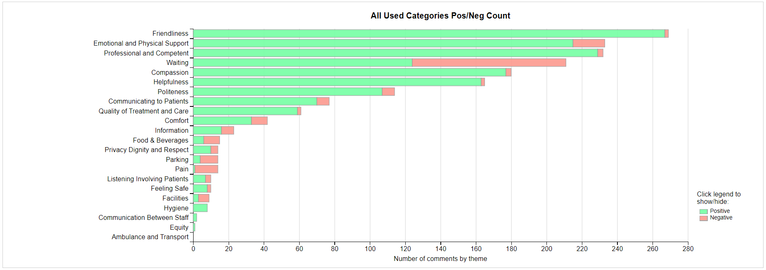

Any Other Issues to Bring to the Attention of the Committee
Duty of Candour (DoC)
There were 33 incidents reported as triggering DoC in Quarter 1. The Service Group compliance with statutory duty in Quarter 1 was 33%. Work has commenced to address key issues identified as affecting compliance;
- staff knowledge
- patients who may be affected by more than one adverse incident
- administrative housekeeping (ensuring Datix record updated)
- further training at ward level

Table below shows the 33 incidents by themes

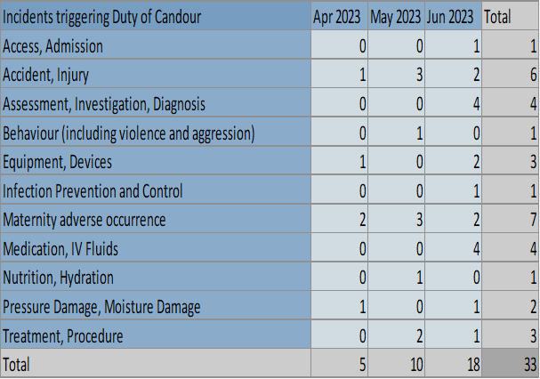

Improving incident management
There were 403 incidents were reported in June 2023. The graph in the Appendices highlights the type of incidents reported. The top incident themes were;
- Medication & IV Fluids
- Accident/Injury (predominantly falls)
- Treatment & Procedure
- Maternity Adverse Occurrence
- Assessment, investigation & diagnosis

The severity (reporters view)of the incidents reported were;
- 13 Severe - 9 of which were patient incidents. 6 downgraded to low or no harm on review. 2 downgraded to moderate. 1 awaiting review. 1 deemed to meet DoC.
- 75 Moderate – 56 of which were patient incidents. 1 grading increased (intrauterine death), 13 deemed to be moderate following initial review.

There were 503 incidents closed in June 2023. The Service Group has approximately 1556 open incidents of which 1060 (↓31) are overdue for investigation. The Service Group continues to experience challenges in completing incident investigations.

Medication Incidents
To ensure there is shared learning from medication incidents the Service Group Medical Director chairs a monthly Controlled Drug and Medication Group to review and scrutinise incidents. Matrons and ward managers review medication incidents within 24 hours to increase compliance with medication errors in line with Administration of Medicines policy and procedure.

Recommendations
Members are asked to note the report.

Appendices

