Meeting Date | 05 September 2024 |  | Agenda Item |  |  | 3.4
Report Title | Substance Misuse Services Update
Report Author | Hannah Roan, Acting Assistant Director of Strategy (Commissioning & Sustainability)
Report Sponsor | Nerissa Vaughan, Interim Director of Strategy
Presented by | Hannah Roan, Acting Assistant Director of Strategy (Commissioning & Sustainability)
Freedom of Information | Open
Purpose of the Report | This report provides an overview of the work undertaken via the Western Bay Area Planning Board (APB) to improve Substance Misuse services within Swansea and Neath Port Talbot.
Key Issues | Substance Misuse Services for the population of Swansea Bay University Health Board (SBUHB) are commissioned through a collective commissioning arrangement via the Western Bay Area Planning Board (APB).  Timely access to Substance Misuse services has been an area of concern for many years with the SBUHB footprint having the highest prevalence of drug related deaths in Wales. Good work has been undertaken to date by the APB to strengthen the commissioning of Substance Misuse Services and improve service delivery however, in 2020 the APB recognised that the best way to make significant improvements was through a new commissioning model. SBUHB, along with the other statutory partners, approved the adoption of a new Alliance based commissioning model. Work is being undertaken in 2024/25 to move towards the Alliance model with a proposed operational start date of April 2025.
Specific Action Required  (please choose one only) | Information | Discussion |  | Assurance | Approval
Specific Action Required  (please choose one only) | ☐ | ☐ |  | ☒ | ☐
Recommendations | Members are asked to:  - Take assurance from the progress made to date in improving the commissioning and delivery of substance misuse services.  - Receive the work planned during 2024/25 to move to an Alliance based commissioning model for substance misuse services from 2025/26.

SUBSTANCE MISUSE SERVICES UPDATE

- INTRODUCTION
Substance Misuse Services for the population of Swansea Bay University Health Board (SBUHB) are commissioned via a collective commissioning arrangement overseen by the Western Bay Area Planning Board (APB).

This report provides an overview of the work undertaken via the APB to improve substance misuse services within the SBUHB footprint.

- BACKGROUND
Substance misuse services in Western Bay are commissioned by Swansea Bay University Health Board (SBUHB), Police and Crime Commissioner, Policing, Swansea Local Authority and Neath Port Talbot County Borough Council, and via the APB Welsh Government Substance Misuse Action Funding (SMAF).

The APB is responsible for delivering the Welsh Government Substance Misuse Strategy across the SBUHB footprint. An APB Team is employed by Neath Port Talbot County Borough Council on behalf of the commissioners to provide the secretariat for the Western Bay APB and oversee the allocation of funding and the delivery of substance misuse services in the area.

SBUHB Health Board delivers a range of substance misuse & alcohol services, some of which are funded by the Substance Misuse Alcohol Fund (SMAF) via the APB. SBUHB also commissions substance misuse services via Primary Care and from Voluntary Sector organisations which is managed via the APB arrangement.

Substance Misuse services in Wales have been an area of concern for many years with Health Inspectorate Wales’s report in 2018 highlighting that “We believe there are significant weaknesses in oversight around the quality and safety of services. This means commissioners may not be able quickly identify, monitor and act on emerging themes and issues across all services in order to protect people’s safety.”

The European Age Standardised Rate (EASR) for drug misuse deaths registered in 2021 in Wales was 7.2 deaths per 100,000 population compared with 5.1 deaths per 100,000 population in 2020. The latest figures available show that in 2021, the highest EASR of drug misuse deaths was recorded in SBUHB with a rate of 11.3 per 100,000 population (Chart 1).

Whilst there has been a reduction in the rate of deaths in the SBUHB footprint since 2018, the rate remains an area of concern. Therefore, the continued focus of the APB is to ensure services are configured correctly to improve access times and to also ensure that the right services are available to meet the needs of the population.

Chart 1: Age standardised rate (EASR) for drug misuse deaths registered in 2021 in Wales by Health Board
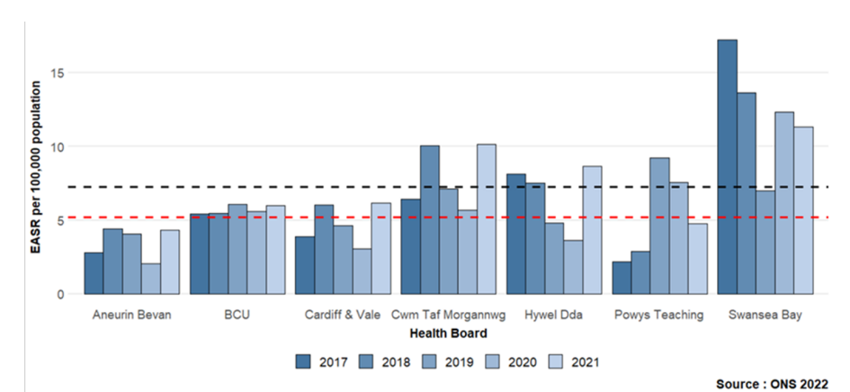

- PROGRESS TO DATE
SBUHB continues to be an active partner in the APB and the following are some examples of work recently undertaken to strengthen the way the commissioning of Substance Misuse Services.

- Governance arrangements
The APB is required to have robust governance arrangements in place in order to meet its obligations under the National Core Standards for Substance Misuse. A governance framework has been developed for the Western Bay APB which outlines the role of APB Board Members, a Code of Conduct and a Memorandum of Understanding that will ensure that decisions are clear and transparent and there is clear accountability for the Board’s work.

In addition, the chair of the formal APB meetings became vacant following the departure of the SBUHB’s Director of Public Health. From September 2024, the HB’s Chief Operating Officer (COO) will take over as chair. This provides a great opportunity to ensure that the APB is functioning effectively and will improve the oversight of the provider arm of SBUHB in ensuring that it is delivering services in a timely manner. Furthermore, the chair for the Commissioning, Finance and Performance Subgroup of the APB also became vacant in 2024. The HB’s Assistant Director of Strategy was voted in as the next chair with the deputy chair being from South Wales Police and Crime Commissioner’s Office. Again, these new appointments will provide added assurance to the HB that the work of the APB will be focused on the needs of the population.

- Clinical governance sub-group
A new clinical governance subgroup has been established with a purpose of providing assurance to the APB that there is a robust framework for the clinical management of all substance use services and processes.

This is a framework through which the APB is accountable for continuously
improving the quality of services and safe-guarding high standards of care by creating an environment in which excellence in clinical care will flourish. It includes systems for, but not limited to:
- Clinical quality improvement of established services and in the design and development of new services.
- Clinical Audit: high standard care, which is safe, effective and promotes positive service user experience
- Maintaining clinical competence
- Compliance with essential standards and guidelines of quality and safety
- Clinical effectiveness, including Research and Development

The Group is co-chaired by SBUHB’s Clinical Director of Pharmacy & Medicines Management and Primary Care’s Clinical Lead for Secure Environments and Substance Misuse. The Group is in its infancy however, good progress has already been made in drafting a clinical governance framework which will be utilised as the standard to monitor services against. Once the framework is agreed, the Group will then be responsible for monitoring services against the framework and providing assurance to the APB regarding the quality and safety of the services that are being commissioned.
- Co-Occurring Mental Health and Substance Use Strategy (2023-2026)
A strategy has been developed which sets out how the APB aims to improve services for individuals with a co-occurring mental health and substance use needs. It applies to SBUHB, Local Authority, Criminal Justice Service, other statutory services and Voluntary Sector organisations that provide mental health and substance use services to individuals over the age of eighteen within the West Glamorgan Region, in both inpatient and community settings. The strategy has been designed to inform and shape the delivery of integrated and collaborative practices and services across the region. An action plan has been developed to implement the strategy and a group has been established to oversee the implementation, updates against the action plan are reported into the APB.

- Western Bay Drugs Commission
In response to the concerns around the prevalence of drug related deaths, the APB launched an independent Western Bay Drugs Commission to look at the root causes of the high rates in Swansea and Neath Port Talbot. Since the summer of 2023, the Commission has carried out public facing sessions and has also visited services across Western Bay engaging with staff/service users. The Commission’s recommendations will be made around key challenges focusing on:
- Culture and Governance.
- Data.
- Housing.
- Mental Wellbeing.
- Prescribing.
- Primary/Shared Care.

Initial feedback from the Commission is that the most concerning issue is the speed of access into treatment and that service users feel they need to enter the criminal justice system in order to access treatment quickly, as services are at capacity/have challenging landscapes. In addition, there are currently a variety of different pathways to access services/treatment. A report was expected in June 2024 however, the final report is now expected in September 2024 and an extraordinary APB meeting has been arranged for 12th September to consider the findings.

- FORWARD LOOK
The good work outlined in section 3 of this report shows the commitment from all the partners in improving Substance Misuse services across SBUHB footprint however, there is more work that its planned over the next 12 months that will further strengthen the commissioning and delivery of services.

In 2018, the level of drug-related deaths and severe infections amongst people injecting drugs in Neath Port Talbot and Swansea was an increasing concern. As a result, in 2020 the APB agreed to adopt a Public Health approach to tackling substance misuse by framing substance misuse as a health and social issue as a way of enabling community responses and lowering barriers to help.

A new mechanism for the commissioning of services was proposed that also requires new ways of working by providers. The APB, including all partners, agreed that an Alliance commissioning model will be adopted for Swansea and Neath Port Talbot. The Alliance model will involve a whole system transformation which includes planning of new clinical and support services, designing new drug and alcohol treatment pathways and commissioning services jointly using a pooled budget.

The objectives of the transformation programme are:
- To design, develop and implement a comprehensive and seamless service for the people of Swansea and Neath Port Talbot who are at risk of, or experiencing physical, psychological or social harms involving substance use.
- Services will be re-commissioned to drive whole system change in the treatment service landscape in Swansea and Neath Port Talbot. This will require the development of an ‘Alliance Mandate’ and a Commissioning Strategy
- An ‘Alliance contract’ will be used as the contractual method to enable pooled commissioning budgets that will support the development and delivery of the integrated, person-centred whole system approach.
- A co-produced outcomes framework will be developed that can show progress and encourage learning and continuous improvement across the substance treatment system.
- To deliver substance services that focus on promotion of early intervention, resilience and self-care to improve people’s health and well-being and reduce health inequalities.
- Services will be responsive to local needs, and where possible services will be co-located with statutory and voluntary partners to strengthen pathways and deliver interventions in a holistic person-centred way which represents value for money.

The original timeline for the programme is outlined in Table 1.

Table 1: Timeline for Transformation Programme
Dates | Stage | Description | Current Status
September 2023 - January 2024 | Alliance Readiness Stage | In this stage the Outline Business case has been agreed, which will ensure all partners are on board with the continued development of the Commissioning of an Alliance. The development of the initial vision, purpose, objectives, financial envelope and overall commissioning strategy will be developed as part of the business case. | Complete
January 2024- July 2024 | Alliance Commitment Stage | In this stage the alliance mandate/specification of the new service model, commissioning strategy, Key Performance Indicators and Outcome framework will be developed, with scope, schedule, finance, invoicing, performance schedule, expectations, service standards schedule) etc. It will be co-produced with people who have lived and living experience, as well as frontline staff and subject matter experts. | Near completion
From July 2024- March 2025 | Alliance Formation Stage: | In this stage the contract is issued out to the market and an evaluation of the bidder group is initiated, with the preferred bidder announced. | Due to start September/ October 2024
April 2025- September 2025 | Alliance Operational Stage | The contract is awarded and the move to operational delivery is progressed | Not Started

To date significant progress has been made against the timeline including:
- Consultation through workshops with commissioners, frontline staff, providers of services and people with lived experience on what the new service should look like. This has informed a service specification for the Alliance model.
- Establishment of a Commissioning Subgroup to work through how the Alliance model will be commissioned.
- Competitive Dialogue procurement process for the Alliance model has been approved by APB. Due to the novel approach that is being taken, the Commissioning Sub Group felt that a competitive dialogue process would yield better results instead of traditional tender process.
- Establishment of Clinical Services T&F Group to design the health element of the model.
- Development of service specifications for existing service provision as this will inform the work of the Clinical Services T&F Group as it sets a baseline for what is already being provided.
- GP Shared Care arrangements are being designed.
- Draft Alliance contract has been developed.

The next few months will be critical to ensuring remain on track for completion by April 2025.

A formal update on the outcome of the procurement process will be taken through Health Board when available.

- Governance and risks
Governance- as outlined above, a robust governance framework is now in place with the APB reporting into the Public Services Boards (PSBs).

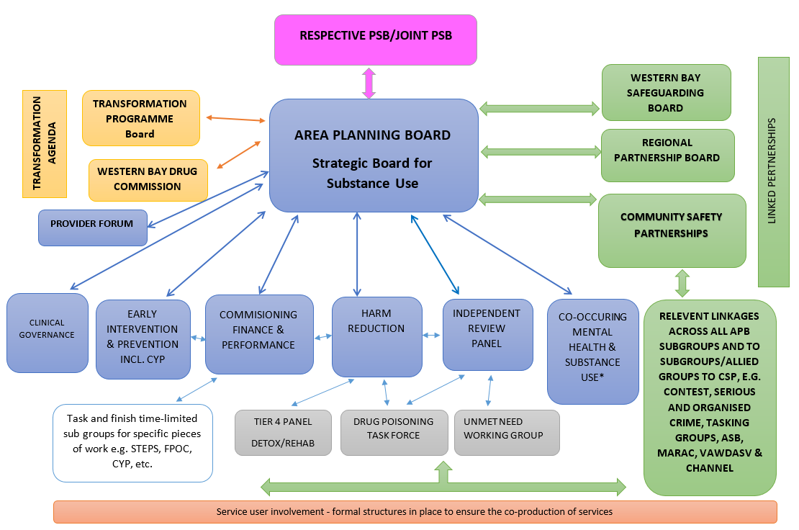Figure 1: Governance Structure of the Western Bay Area Planning Board

Risks
- Risk 1: The new commissioning model is not aligned with the Drugs Commission report’s recommendations
- Mitigation- To date, development of the Alliance model has incorporated the ongoing feedback from the Drugs Commission as the new model is being designed with the aim of increasing access times to treatment in the community and streamlining pathways. The APB team have maintained a close relationship with the Drugs Commission to ensure that the transformation programme is aligned with the recommendations from the Commission therefore, there should be no surprises when the formal report is issued in September 2024. However, the programme has built in a level of flexibility should the model need to be tweaked in light of the final recommendations.

- Risk 2: The ambitious timeline for the transformation programme (i.e. Alliance model) will not be achieved by April 2025
- Mitigations:
  - Robust project plan in place to ensure project stays on track.
  - All statutory partners are committed to the programme and are fully engaged with requests for information, attending meetings etc. SBUHB has shown its commitment to delivering the timeline by ensuring that any requested information relating to HB provided services has been submitted on time and there are representatives (clinical and managerial) in all of the subgroups and on the evaluation panels.
  - In the event that the timeline is not achieved, current contracting arrangements will be rolled over to ensure no gap in service provision.

- FINANCIAL IMPLICATIONS
There are no financial implications associated with this paper. The Alliance model is being developed within the current financial envelope from the statutory partners.

- RECOMMENDATION
Members are asked to:
- Take assurance from the progress made to date in improving the commissioning and delivery of substance misuse services.
- Receive the work planned during 2024/25 to move to an Alliance based commissioning model for substance misuse services from 2025/26.

Governance and Assurance

Link to Enabling Objectives  (please choose) | Supporting better health and wellbeing by actively promoting and empowering people to live well in resilient communities
Link to Enabling Objectives  (please choose) | Partnerships for Improving Health and Wellbeing |  | ☒
Link to Enabling Objectives  (please choose) | Co-Production and Health Literacy |  | ☒
Link to Enabling Objectives  (please choose) | Digitally Enabled Health and Wellbeing |  | ☐
Link to Enabling Objectives  (please choose) | Deliver better care through excellent health and care services achieving the outcomes that matter most to people
Link to Enabling Objectives  (please choose) | Best Value Outcomes and High Quality Care |  | ☒
Link to Enabling Objectives  (please choose) | Partnerships for Care |  | ☒
Link to Enabling Objectives  (please choose) | Excellent Staff |  | ☐
Link to Enabling Objectives  (please choose) | Digitally Enabled Care |  | ☐
Link to Enabling Objectives  (please choose) | Outstanding Research, Innovation, Education and Learning |  | ☒
Health and Care Standards
(please choose) | Staying Healthy |  | ☒
(please choose) | Safe Care |  | ☒
(please choose) | Effective Care |  | ☒
(please choose) | Dignified Care |  | ☒
(please choose) | Timely Care |  | ☒
(please choose) | Individual Care |  | ☒
(please choose) | Staff and Resources |  | ☐
Quality, Safety and Patient Experience
Implementing an Alliance approach is intended to improve the alignment of services with individuals’ and our communities’ needs and thus improve the effectiveness of services in reducing the harm from substance use and misuse. Action is aimed at providing a more wrap around range of services that reduce the need for patients to move between providers.

Financial Implications
There will be a need to establish a mechanism to pool funding between different agencies involved in the commissioning and delivery of substance misuse services.
The new commissioning entity of arrangements should allow for better risk share between partners involved.
The Alliance model is being developed within the current financial envelope of the statutory partners; no additional funding is being requested.

Legal Implications (including equality and diversity assessment)
The Alliance contracting framework has been trailed in England and legal aspects of this have been worked through. An alliance approach for substance misuse has been operational for some time in Cardiff & Vale University Health Board and the APB team have linked in closely to learn lessons from them.

SBUHB has sourced expert advice from NHS Wales Shared Services Partnership - Legal & Risk Services regarding the proposed Alliance Contract.
Staffing Implications
Staffing implications are being worked through as there may be changes in the roles and numbers of staff involved in delivering substance misuse services but these are not yet known or quantified. TUPE information is being collated as part of the procurement process.
Long Term Implications (including the impact of the Well-being of Future Generations (Wales) Act 2015)
- Long Term – The Alliance model is intended to deliver better services to minimise the harm associated with substance misuse and to reduce the legacy of substance misuse issues in our communities.
- Prevention – Acting to prevent substance misuse will form a central part of the overall approach.
- Integration – Substance misuse affects the whole community and impacts on physical, social and mental well-being, crime, and the environment. It also has economic impacts. Tackling substance misuse effectively delivers on a wide range of well-being objectives for partner agencies.
- Collaboration – The Alliance approach brings together agencies and the community to develop appropriate responses tailored to local situation.
- Involvement – The Alliance model has been developed through co-production with people with lived experience

Report History |  | Delivering an Integrated Public Health Model for Substance Misuse in Swansea Bay- September 2020.
Appendices |  | None

HIW Review of Substance Misuse Services in Wales -Joint thematic report p8

