Meeting Date | 5th September 2024 |  | Agenda Item |  |  | 3.3
Report Title | Children & Young People’s Services
Report Author | Michelle Davies, Head of Strategic Planning & Partnerships
Report Sponsor | Nerissa Vaughan, Interim Director of Strategy
Presented by | Michelle Davies, Head of Strategic Planning & Partnerships
Freedom of Information | Open
Purpose of the Report | The purpose of this report is to:  - Highlight the need for a strategic and co-ordinated approach to planning Children & Young People’s services across the Health Board;  - Provide an overview of the feedback received from the recent Children & Young People’s Summit, held on 6th June 2024 and the proposed next steps.
Key Issues | The following report sets out some of the key issues discussed at the recent Children & Young People’s Summit. A strategic and co-ordinated approach to the planning of Children & Young People’s services is required to:  - Improve the sustainability of services in the medium to long-term;  - Improve visibility for Children & Young People’s Services across the Health Board;  - Improve the Health Board’s response to national and regional policy  - Improve collaboration and integration for system working, with a greater focus on early intervention and prevention, including the social determinants of health for all children, young people and families within the region.
Specific Action Required  (please choose one only) | Information | Discussion |  | Assurance | Approval
Specific Action Required  (please choose one only) | ☒ | ☐ |  | ☒ | ☐
Recommendations | Members are asked to:  - Take assurance from the progress made to improve the strategic approach to children & young people;  - Receive the Feedback received from the Summit and the proposed next steps;

Children & Young People’s Summit

- INTRODUCTION

This report provides a summary of the feedback received from the recent Children & Young People’s Summit held at Margam Orangery on the 6th June 2024 and the proposed next steps in developing a SB UHB CYP (Children & Young People’s) Strategy.

- BACKGROUND

The Health Board’s Children & Young People’s Strategy launched in 2018 is now out of date and feedback received from colleagues is that the Health Board lacks focus on the medium and long term aspirations for children & young people. A copy of the current Strategy can be found as Annex 1.

The Children & Young People’s Strategic Board chaired by the Executive Director of Nursing was temporarily stood down in February 2024, recognising that the agenda was primarily focussed on operational matters as this was the one forum that professionals working within Children & Young Peoples services had to work collaboratively.

2.1 Strategic Drivers and Policy Context

Corporately in Swansea Bay UHB, existing plans are inclusive of Children & Young People, and we have great leaders in our services who lead and manage their services successfully and effectively every day. However, this work and energy is often undertaken in silos, and lacking in a Health Board strategic position. Please note the following:

- Annually, the Recovery & Sustainability plan is updated and each service will produce a set of Goals, Methods and Outcomes;
- The Clinical Services Plan is due to be refreshed, and there is clearly an opportunity to make the visibility for children & young people more robust;
- To understand the needs of children & young people is critical, and the role the Health Board plays in the wider determinants of health is set-out in the Population Health Strategy. Specifically, the Marmot principles 1 and 2 include to ‘Give every child the best start in life’ and ‘Enable all children, young people & adults to maximise their capabilities & have control over their lives’ and are SB UHB strategic objectives.
- The Children’s Rights Charters is a big success for the Health Board, developed by the Children’s Rights Unit on behalf of Children’s Services.

There are a number of National policies and strategies that apply specifically to children & young people. The following are a few of those national documents:

Figure 1
Healthy Child Wales | Early Years Framework |  | Childrens Commissioner for Wales | NEST Framework
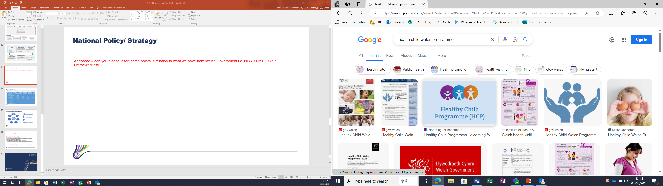 |  | 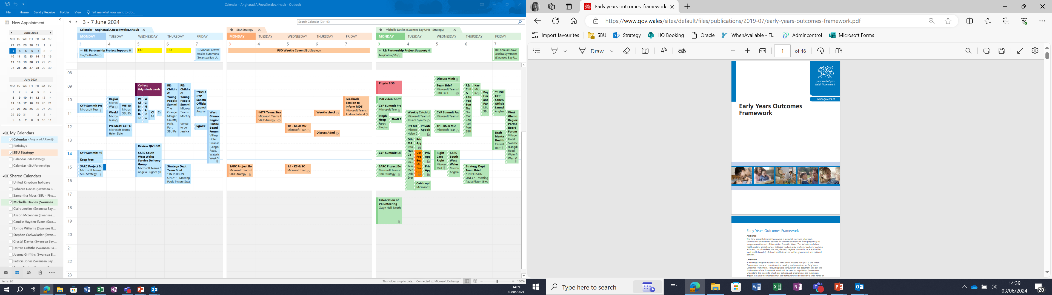 | 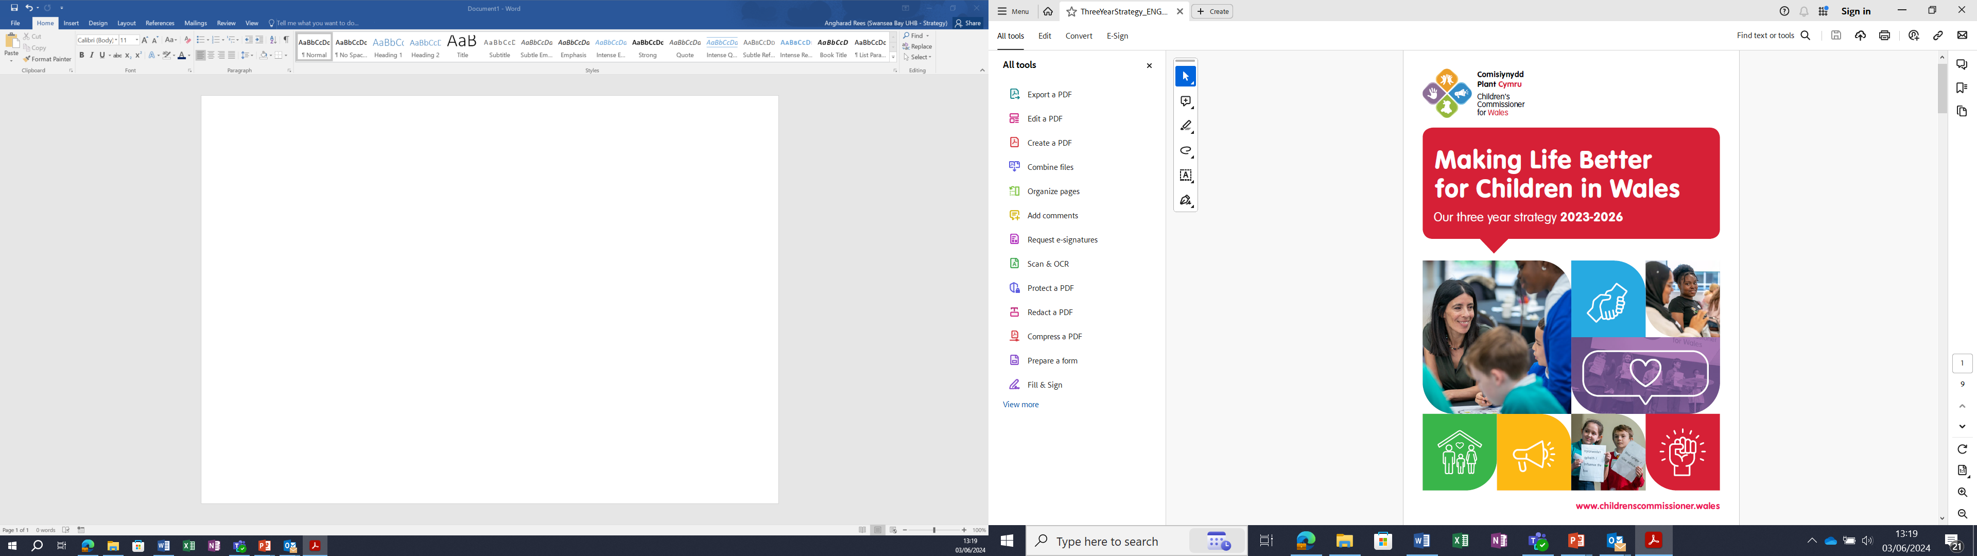 | 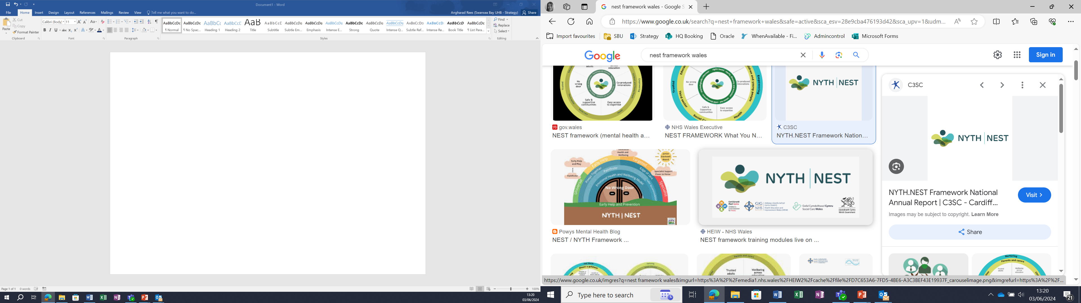

As a Health Board, we are unable to effect the changes required to tackle the drivers of health inequalities without collaborating with other agencies. There are two pieces of legislation that are unique to Wales that set-out the expectations – the Social Services and Wellbeing (Wales) Act 2014 and the Well-being of Future Generations (Wales) Act 2015.
Local authorities, health boards and NHS trusts must work closely to ensure better integration of health and social care.
Partnership Boards, Local Authorities and Health boards must work together to assess care and support needs (and carer support needs) of the population in their area. As a result they will identify what services are needed.
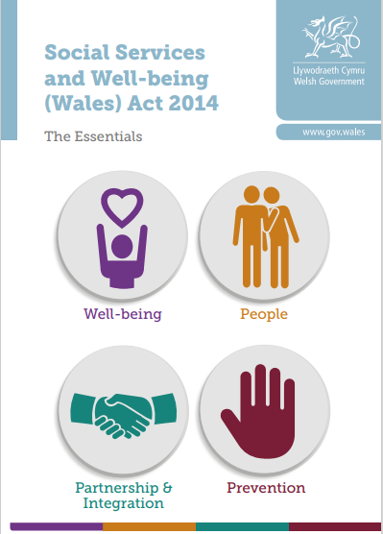
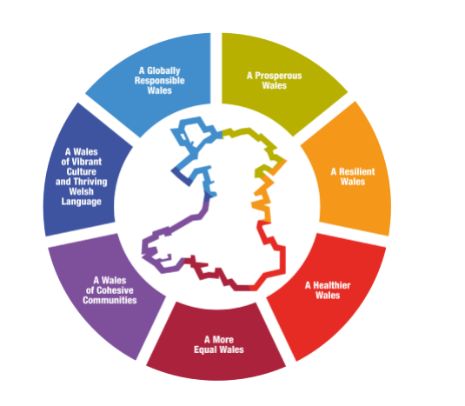
The Well-being of Future Generations (Wales) Act is about improving the social, economic, environmental and cultural well-being of Wales. It will make the public bodies listed in the act think more about the long term, work better with people and communities and each other, look to prevent problems and take a more joined-up approach.

In Swansea Bay, the Neath Port Talbot and Swansea Public Services Boards and the West Glamorgan Regional Partnership Board are the formal partnerships developing plans for a range of service provision to support the delivery of both Acts. The Health Board is the strategic lead for Early Years on behalf of the Public Services Boards and we provide leadership for the Emotional & Mental Wellbeing work-stream within the regional partnership board governance.

2.2 Challenges and Opportunities

2.2.1 SBU HB Children & Young People Services

Whilst children & young people are represented in our corporate plans, the implementation is undertaken in silos. Diagram 1 highlights the scope of children & young people’s services across the breadth of the Health Board. Operationally there are opportunities for staff to work together and those opportunities are maximised, however, different digital systems and management structures can cause barriers.

Figure 2
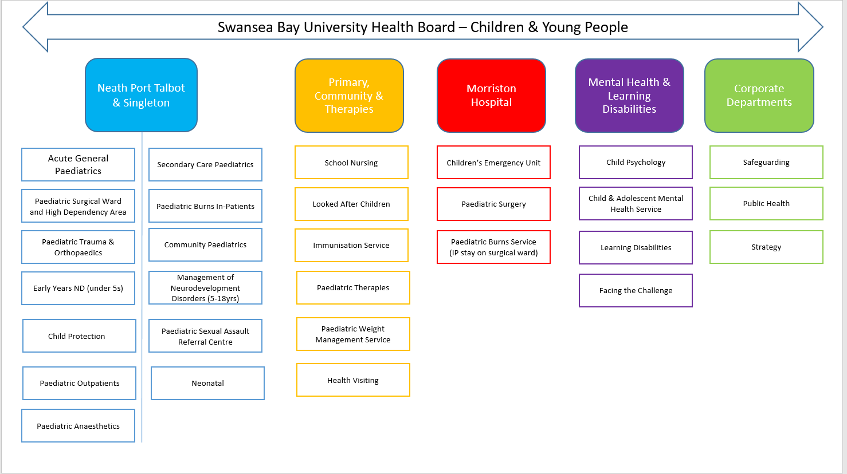

2.2.2 Partnerships & Collaboration

Working in partnership with external agencies is a statutory requirement for the Health Board and demonstrates many benefits to agencies and children & young people. There are many opportunities to working in collaboration to tackle some of the complex issues in our communities.

The West Glamorgan Area Plan sets out how the West Glamorgan Regional Partnership Board (WGRPB) will respond to the findings of the West Glamorgan Population Needs Assessment published in 2022 through the various work-streams. Whilst the way in which we work collaboratively with the Regional Partnership Board has improved, the lack of a strategic approach can make discussions challenging. The WGRPB work-programme for children & young people is tackling some complex issues as follows:

- Strategy Development - Regional vision for Children & Young People Transformation, clear priorities and implementation of regional CYP Programme​
- Children's Service Review
Agreement on the funding for the packages of care for children and young people with complex needs
- Accommodation Solutions
Deliver a new regional model for safe, secure accommodation and wraparound support for Children and Young People with complex needs, with a focus on prevention and early Intervention
- Children & Young People Emotional Health and Well Being
Develop a regional Emotional Well-Being and Mental Health Strategy
- Transition
Co-produce, pilot and implement a Regional Transition Policy for Children, Young People with learning disabilities and complex care needs to ensure smooth transition into adult services at the right time

2.2.3 Swansea Bay Population Health

The Swansea Bay Population Health Strategy sets out a ‘Better Future for All’, highlighting that action is required to tackle the wider determinants of health, and specifically the Health Board’s role in line with the four pillars, not only as a healthcare provider, but as an employer, an anchor institution and a productive partner. To give every child the best start in life and to enable all children, young people & adults to maximise their capabilities and have control over their lives are two of the policy objectives as highlighted below in figure 3. The Population Health Strategy highlights that we have a duty to the whole of the population in Swansea Bay to improve health and reduce inequities. We have high numbers of children growing up in poverty in our region. It was highlighted by the Public Health team at the summit that 3 in 5 households in Neath Port Talbot are defined as poor housing; and 1 in 4 in Swansea and 1 in 3 in Neath Port Talbot school pupils are eligible for free school meals. The region has the lowest attainment at Foundation Phase and Key Stage 2 in Wales. Life expectancy at birth for males and females is significantly lower than the Wales average. Poverty is a major cause of ill health and drives inequalities in health outcomes, leading to an increased pressure on health services. However, only 10% of the determinants of health are created by health services. This is why we must look at the wider determinants and our responsibility as a Health Board is more than services.

Figure 3
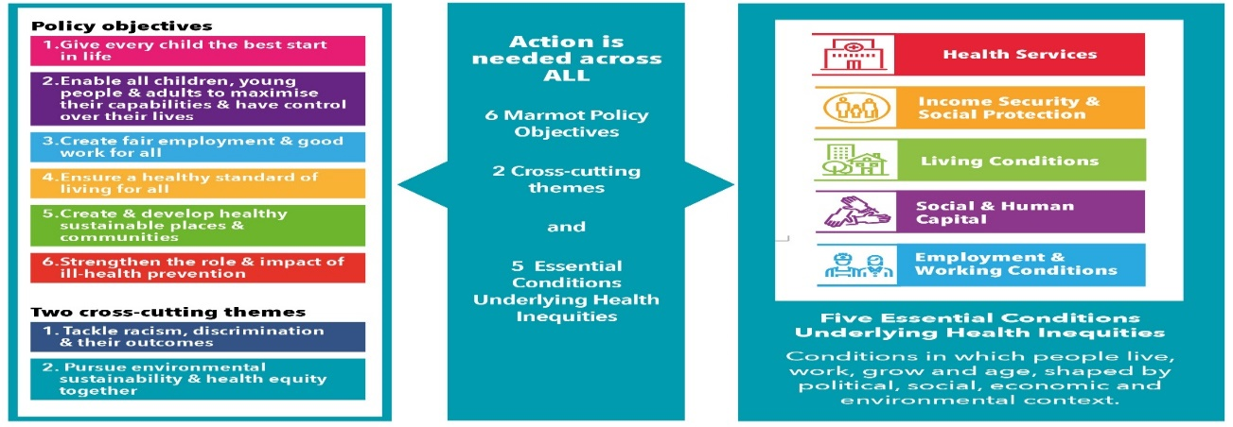

    - General Paediatric Ward Facilities

There was a recurring theme at the summit from services who strive to meet the health care needs of children and young people either through therapy, surgical specialists or general medical paediatric service reflecting on the poor facilities where acute care is delivered.
As an organisation, SBU HB have a moral responsibility to improve the inpatient services for children and young people as part of the Children’s Right Charter. The Children’s Right Charter sets out the human rights of every person under the age of 18, highlighting the need for a child and parent friendly environment that is fit for a modern paediatric service. Whilst Moriston Hospital continues to be the hub of a comprehensive managed care network for children and their families, the current facilities are inadequate for a large district general hospital and are incompatible with a satisfactory experience for our young patients and their families’. The risk of the environment is reported on the service groups risk register at a score level of 20 but has a potential of increasing to 25 due to the constraints within the template at Morriston.
Health Inspectorate Wales (HIW) visited the paediatric wards at Morriston January 2023. The report highlighted the constraints that the current environment poses to infection prevention and control, storage provision for equipment and a poor family facility and additionally a significant impact on patient experience.
Standards for accommodation for children and young people are required to provide principles of considerations for environment designed to meet the child and family’s immediate wellbeing and provide a positive outcome. The refurbishment of the children’s wards at Morriston hospital is identified as a GMO within the Health Boards approved annual plan together with digitalisation of systems within the Children’s Service, which was also prominent feature of discussions at the summit.

  - Children & Young Peoples Summit

The summit held in June was an opportunity to listen to a range of services provided across the Health Board in order to understand how we can enhance our offering to the children and young people of the region by improving our strategic approach.

The overall purpose of the event was to:

  - Celebrate the range of children and young people’s services delivered across the Health Board;
  - Have a conversation and listen to colleagues about what’s going well and what’s going not so well;
  - Defining and improving our strategic approach;
  - Describe what the future looks like, how we get there and what do we need to do to deal with our challenges along the way.

Individuals from various services across all service groups were invited to present and were asked to tailor their presentation to include:

  - What is working well?
  - What is not working so well?
  - What is the aspiration?

A copy of the agenda for the day outlining the services which presented at the summit is attached as Annex 2.

The final part of the day focused on how the Health Board can improve its approach to working more in the strategic envrionment.

Round table discussions at the event centred on three main questions:

- Do you agree we need a Health Board Strategy for Children & Young People?
- What mechanism do we need to develop and implement Plans and Strategies for Children & Young People?
- Where does the leadership sit for Children & Young People Services in the Health Board?

The main themes from the conversations are identified in the table below:

Do you agree we need a Health Board Strategy for Children & Young People?​ | - The consensus was that a strategy was needed for children and young people  - The Strategy must be developed from the bottom up and co-produced with CYP, parents, and the workforce, with a focus on highlighting the voice of children and young people.  - An importance was placed on a strategy or framework being fully evidence based and driven by data and outcomes.  - It was suggested that the strategic direction be influenced by the health board’s 10-year vision, as well as the Population Health Strategy.  - The objectives within the Strategy must be aligned to Welsh Government Policy – we must use Welsh Government strategically to make progress
What mechanism do we need to develop and implement Plans and Strategies for Children & Young People?​ | - A continuous theme within the feedback from the CYP summit was the need for a strategic board to ensure effective governance.  - It was felt that a strategic board should include representation from all services including supporting functions such as finance and digital to allow for a system wide view.  - Workshops were a key theme within the feedback, particularly in the early stages of developing a strategy.
Where does the leadership sit for Children & Young People Services in the Health Board?​ | - It was felt that there is a requirement for an executive lead/SRO with insight into all services that provide support for CYP services, working closely with everyone involved to ensure decisions are made by the correct people.  - It has also been suggested that any SRO/executive lead role should be specifically focussed on CYP and not an ‘add on’ to another role.

Other prominent feedback to note was:
- CYP is often not seen as a priority area in terms of allocation of funding. Developing a strategy will give the Organisation an opportunity to consider joint funding of services
- Services that predominantly see adults should be labelled as adult services in the same way that paediatrics are labelled i.e. children would access ‘Paediatric Neurology’ and adults would access ‘Adult Neurology’, as opposed to ‘Paediatric Neurology’ and ‘Neurology’.
- Adolescent health sometimes slipped through the gap and was different to children’s services.

A full summary of feedback to the questions can be found attached as Annex 3.

86 people attended the event and positive feedback has been received from those in attendance.

Discussions are now progressing for this to be the first of a series of events in relation to developing a Health Board wide CYP Strategy taking into account that additional services need to highlight the important part they play in supporting CYP. It is proposed that future similar events be held inviting our GP Clusters, third sector and our partners to better understand the offering available from partner agencies in helping to strengthen the Health Board’s strategic approach to the children and young people of the region whilst also ensuring that the child’s voice is heard.

2.4 Conclusion and Next Steps

Overall, colleagues from across the Health Board were appreciative of the event, and fully supported a robust strategic approach to planning services for children & young people. It was agreed that collectively we need to do more for children & young people to prevent ill health in the future, and that working strategically to focus on the long term as highlighted in the diagram below is the way forward.

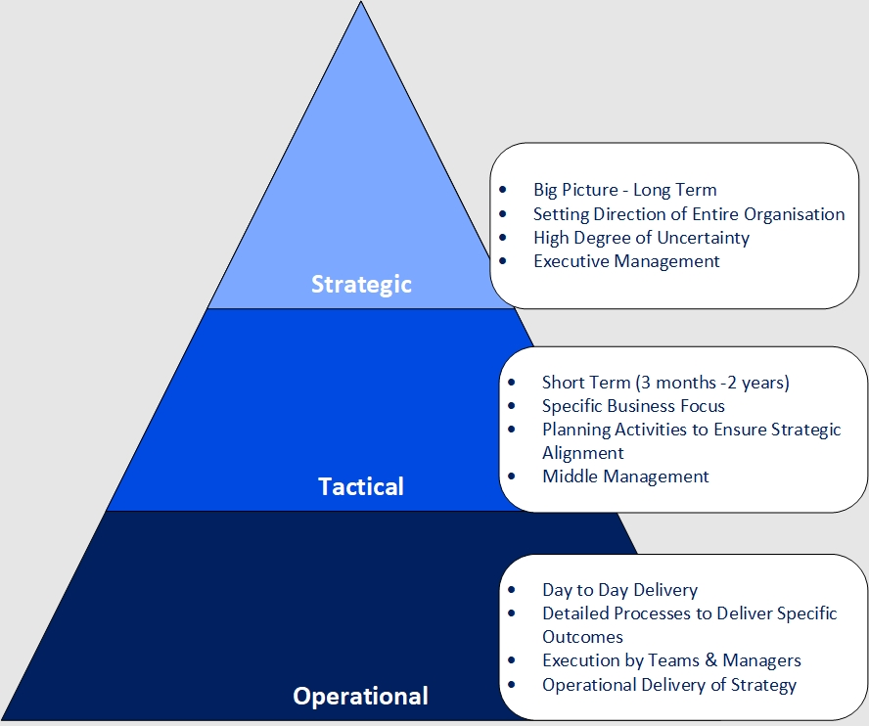

It was not possible to include every service in the event, and it is clear that further engagement is required before a definitive decision is made around a Strategy, and how we improve as a Health Board. The immediate next steps therefore as follows:

- An additional summit, to have the discussions with GP Clusters, Partner agencies and the third sector;
- Ensure that the outcome of the summit(s) are aligned within the Health Boards Clinical Service Plan
- Set-up a Steering Group to take forward the additional events, including support services such as digital and to take forward the actions identified. If the decision is to develop a Strategy, the Group will oversee the development of the Strategy and implementation

- RECOMMENDATION

Members are asked to:
- Take assurance from the progress made to improve the strategic approach to children & young people;
- Receive the Feedback received from the Summit and the proposed next steps.

Governance and Assurance

Link to Enabling Objectives  (please choose) | Supporting better health and wellbeing by actively promoting and empowering people to live well in resilient communities
Link to Enabling Objectives  (please choose) | Partnerships for Improving Health and Wellbeing |  | ☒
Link to Enabling Objectives  (please choose) | Co-Production and Health Literacy |  | ☐
Link to Enabling Objectives  (please choose) | Digitally Enabled Health and Wellbeing |  | ☐
Link to Enabling Objectives  (please choose) | Deliver better care through excellent health and care services achieving the outcomes that matter most to people
Link to Enabling Objectives  (please choose) | Best Value Outcomes and High Quality Care |  | ☐
Link to Enabling Objectives  (please choose) | Partnerships for Care |  | ☒
Link to Enabling Objectives  (please choose) | Excellent Staff |  | ☐
Link to Enabling Objectives  (please choose) | Digitally Enabled Care |  | ☐
Link to Enabling Objectives  (please choose) | Outstanding Research, Innovation, Education and Learning |  | ☐
Health and Care Standards
(please choose) | Staying Healthy |  | ☒
(please choose) | Safe Care |  | ☐
(please choose) | Effective Care |  | ☐
(please choose) | Dignified Care |  | ☐
(please choose) | Timely Care |  | ☐
(please choose) | Individual Care |  | ☐
(please choose) | Staff and Resources |  | ☐
Quality, Safety and Patient Experience
There are no quality, safety and patient experience include in this report
Financial Implications
There are no Financial Implication with this report.
Legal Implications (including equality and diversity assessment)
There are no legal implications associated with this report.

Staffing Implications
There are no staffing implications to this report
Long Term Implications (including the impact of the Well-being of Future Generations (Wales) Act 2015)
The actions outlined in the report support the five ways of working outlined in the Act. SBU Health Board are working with all partners to identify improved ways of working.
Report History |  | This is the first report on this matter.
Appendices
  Annex 1 – 2017 CYP Strategy
  Annex 2 – CYP Summit Agenda
  Annex 3 – CYP Summit Round Table Exercise Summary

