

HEALTH BOARD RISK REGISTER

RISKS ASSIGNED TO THE
POPULATION HEALTH & PARTNERSHIPS COMMITTEE
April 2024

Datix ID Number: TBC  Health Care Standards: Leadership & Whole Systems Approach |  | HBR Ref Number: 99  Target Risk Date: See Rationale |  | Current Risk Rating  5 x 4 = 20
Objective: People of Swansea Bay live healthier, more equal, prosperous lives |  | Director Lead: Jennifer Davies, Interim Director of Public Health  Assuring Committee: Population Health & Partnerships
Risk: Failure to implement the population health strategy approaches at the required scale.  This arises from risk of a failure of the organisation to understand and act on the provisions of the strategy for building whole of system actions across the 4 pillars; and the consequent lack of systems and processes to support the delivery of population health improvements.  Currently identified contributors to this risk include the absence of the tactical level planning required to design and deliver cross-cutting programmes within a federated operational delivery system; lack of systematic review and capture of population health contributions of existing services; limited behaviour change to adopt a population health focus at service and corporate level; uncertainty about the financial commitment to support Population Health Strategy Implementation as well as a lack of clear processes for accessing available funding; a limited focus on prevention; and a lack of consideration of how to act to influence the wider determinants that affect the population’s health and how the Health Board might contribute to addressing these. The outcome if the risk is not addressed is worsening health in our population with widening health inequities. |  | Date last reviewed: April 2024
Risk Rating  (consequence x likelihood):  Initial: 5 x 5 = 25  Current: 5 x 4 = 20  Target: 4 x 2 = 8 | 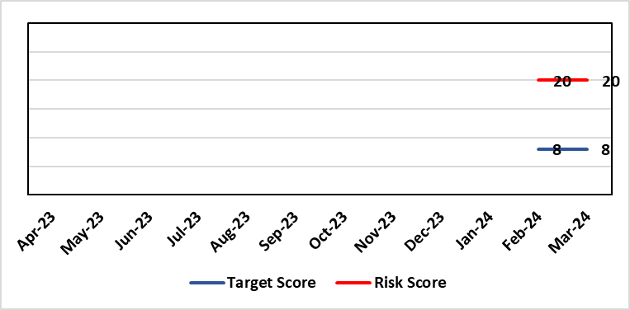 | Rationale for current score:  Within SBUHB there is a limited focus on prevention; and a lack of consideration of how to act to influence the wider determinants that affect the population’s health. The Population Health Development Board governance mechanism to enact population health is being reviewed and is not currently operational. We are not in a position where marginal investment is available to begin to develop population health activity. The organisation is unable to confirm the financial allocation to support population health strategy implementation. The public health team have been unable to establish budgetary control or governance processes for utilisation of funding held in the population health reserves affecting implementation of priorities agreed through the Population Health and Partnerships Committee.Developing a transformative approach to how we conduct our business is dependent upon the ability of SBUHB to: better understand our population’s needs and address them; focus on actions which foster and maintain health and wellbeing; design services that incorporate prevention and tackle inequities; and develop robust partnerships that tackle the wider determinants of health that ultimately drive demand for healthcare.  Currently there is a lack of capacity and capability in the wider organisation to deliver on this agenda.
Date added to the risk register  14/03/24 |  | Rationale for target score:  Given the system wide changes required to mitigate this risk and the requirement to works across organisational boundaries achievement of this target has been be a long term consideration.  Target Risk Date will be reviewed as part of gateway checkpoint on risk/actions.
Controls (What are we currently doing about the risk?) |  | Mitigating actions (What more should we do?)
- Population Health Strategy adopted by SBUHB Board 30/03/23.  - Population Health Strategy aligned to organisational strategic objective 1. Population health integrated into planning infrastructure through R&S plan 24/25 process.  - Population Health and Partnerships Committee and Population Health Development Board established as governance mechanisms for Population Health.  - Mandate through governance to progress on key strategic workstreams:  - Capability & Capacity building  - Anchor Institution baselining  - Anti-poverty  - Strategic Indicators Population Health  - Repurposing SBUHB financial resource to support population health  - Behavioural change resource identified to develop behavioural change framework for SBUHB to develop capability and capacity in support of required cultural change.  - Health Intelligence resource identified to lead organisational work to build health intelligence infrastructure.  - Local population health measures in development with SDGs to be reported quarterly through Annual Plan Oversight Group (APOG). |  | Action | Lead |  | Deadline
 |  | Gateway review of progress on governance actions:  Population Health Board re-jig;  SDG reporting changes;  Capability and capacity review and development work. | Executive Director of Public Health / Director of Corporate Governance (support) |  | 31/06/2024
Assurances (How do we know if the things we are doing are having an impact?)  An approach to capturing activity through the quarterly performance reviews is being piloted with the aim of identifying at Service Delivery Group level how population health gain is being addressed. In addition these will then be reviewed at the APOG as appropriate.  The Population Health Development Board is being reformed to bring in appropriate senior representation from SDGs to enable it to act as a governance forum for population health activity. |  | Gaps in assurance (What additional assurances should we seek?)  SDG reporting will allow for development of a view of service group level activity and creation of monitoring framework but this is a development journey and there will be a delay of several quarters while this matures.  No mechanism to develop approaches which sit across more than one SDG or which are not directly related to SDG responsibilities.  Available data are fragmented due to federated operational delivery structures in support of population health. Work is underway to identify ‘strategic indicators’ which will provide a framework to monitor the impact of action on population health.
Additional Comments
Given the complexity of the requirements to enable system change at scale the implementation of the population health strategy the organisational journey to becoming population health focused and competent has to be viewed as a long term objective.

Risk Score Calculation

For each risk identified, the LIKELIHOOD & CONSEQUENCE mechanism will be utilised. Essentially this examines each of the risks and attempts to assess the likelihood of the event occurring (PROBABILITY) and the effect it could have on the Health Board (IMPACT). This process ensures that the Health Board will be focusing on those risks which require immediate attention rather than spending time on areas which are, relatively, a lower priority.

