Meeting Date | 03 December 2024 |  | Agenda Item |  | 3.2
Report Title | Strategic Partnerships Group
Report Author | Michelle Davies, Head of Strategic Partnerships
Report Sponsor | Karen Stapleton, Deputy Director of Strategy
Presented by | Karen Stapleton, Deputy Director of Strategy
Freedom of Information | Open
Purpose of the Report | The purpose of this report is to provide an update on the work undertaken by the Strategy Directorate to develop a Swansea Bay approach to Strategic Partnerships and Collaboration including the establishment of the Strategic Partnerships Group. Specifically the report aims to do the following:  - Present the Collaborative and Partnerships Framework for consideration;  - Provide an update on the work that has been undertaken to address the recommendations in the Internal Audit report on the Health and Social Care Regional Integration Fund (RIF).
Key Issues | Improving how the Health Board manages and achieves oversight of external partnership arrangements has been an area of focus for Strategy over the last 18 months, including visibility and information sharing. Understanding the challenges and opportunities of Partnership working and how we embed Partnership priorities into our Health Board Plans is critical. There are good working relationships at an operational level, however to be a productive partner the Health Board must be working efficiently at all levels, particularly strategically.  The Introduction of the Strategic Partnerships Group has been key in facilitating information and knowledge sharing and is an environment where colleagues can escalate any issues or concerns and seek advice and support.
Specific Action Required  (please choose one only) | Information | Discussion | Assurance | Approval
Specific Action Required  (please choose one only) | ☐ | ☒ | ☐ | ☒
Recommendations | Members are asked to:  - RECEIVE an update on the work programme of the Strategic Partnerships Group  - RECEIVE an update on the Shared Services Partnership Audit of the Health and Social Care Regional Integration Fund (RIF  - ENDORSE the Collaborative Framework  - DISCUSS and AGREE the need for regular reporting between the SPG and the Committee

STRATEGIC PARTNERSHIPS GROUP

- INTRODUCTION

The following report provides an update on the establishment of the Strategic Partnerships Group and the work programme progressed, including the following:

- Development of the Collaborative Partnerships Framework and the Health Board approach to Partnerships and Collaboration
- Delivery of the recommendations made by Shared Services Partnership and the audit undertaken in 2023 of the Health and Social Care Regional Integration Fund (RIF).

- BACKGROUND

Partnerships can be complicated and challenging and this report sets out the work programme progressed to improve the interface between the Health Board and its external partnerships.

Historically, the Health Board has participated in partnership forums and there are some areas in the Health Board where partnership working is evident, for example in mental health services, the home first programme, and children & young people services. However, whilst this work has seen some successful programmes of work, governance has been ad hoc and un-coordinated, with no central interface, particularly at a strategic level. There are a number of work programmes and priority areas that the Health Board are committed to as follows:

- In 2023, the Health Board approved and signed up-to the West Glamorgan Regional Partnership Board (WGRPB) Area Plan and the Public Service Board Wellbeing Plans, in both Swansea and Neath Port Talbot. Action plans are already in development and require Health Board participation to move into the implementation phase.
- The Health Board must move to a much more transformational space with our partners, shifting models of care.
- The Swansea Bay Population Health Strategy sets out the Health Board’s objectives for improving the health of the local population. The Strategy’s objectives will require a collective effort from all partner agencies.

2.1 SBUHB Strategic Partnership Development

In 2023, the governance in relation to Partnerships was developed considerably with a new Strategic Partnerships Group and the Population Health and Partnerships Committee. Strategy also held a series of workshops with colleagues to identify how as a Health Board we can improve partnership working. The following points were the main themes identified as a result of those workshops:

Theme | Recommendation
Theme 1: Strategic approach to be strengthened - Distinguish between – tactical, operational and strategic. | Development of a Collaborative Framework
Theme 2: Collaborative working and prioritisation – Understanding of individual shared goals and plans. | Mapping of roles and responsibilities
Theme 3: Skills and Competence  Increased recognition and training for partnerships | Consider the development of the skills and competencies required for staff working in partnerships and to include in an overarching Framework for staff
Theme 4: Knowledge and Information sharing – establish internal governance processes to facilitate cross Health Board discussion, preparedness, strategic position, information sharing. | Set-up of an internal forum to increase internal governance and oversight, engagement and knowledge and information sharing

  - Strategic Partnerships Group (SPG)

The establishment of the SPG was one of the first actions progressed as a result of the development workshops, and the work programme for the SPG incorporated the recommendations of the workshops and the matters arising identified as part of the Audit. The roles and responsibilities of the Strategic Partnerships Group (SPG) include;

- Provide an interface between the Health Board and external Partnerships - collating and sharing intelligence on local government and partnership issues;​
- Oversee financial partnership relationships, both revenue and capital monies including the Welsh Government Regional Investment Fund (RIF), ensuring that financial work streams are aligned to Health Board strategic vision, plans and priorities and GMOs.

Membership of the SPG includes representatives from the Service Delivery Groups and those Strategic Leads who work within the formal partnership arrangements including the West Glamorgan Regional Partnership Board (WGRPB), the Public Services Boards (PSBs) and more recently the Western Bay Area Planning Board (WB APB). The full terms of reference are attached as appendix 1.

    - Strategic Partnerships Group Work Programme

The work programme for 2024/25 and a summary of the progress made is set-out below:

2.2.2 Health Board approach to Partnerships and the Collaborative Framework

Over the last 18 months the Strategic Partnerships Team have worked on the outcomes of the development workshops, specifically with the aim to develop a Collaborative framework that identifies a Health Board approach to Partnerships and Collaborative working as follows:
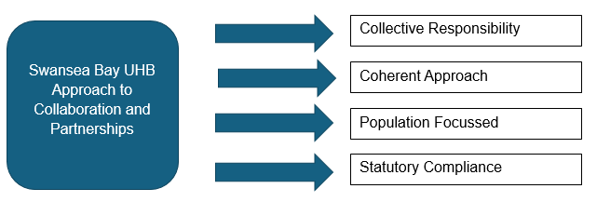
The Collaborative and Partnerships Framework was considered and ratified by the SPG in November, and is attached as appendix 2. Please note the following specifically:

- Principles – colleagues across the Health Board developed and agreed a set of Partnership Principles as a result of the Development workshops; these Principles underpin what the framework must support to allow partnerships to thrive:
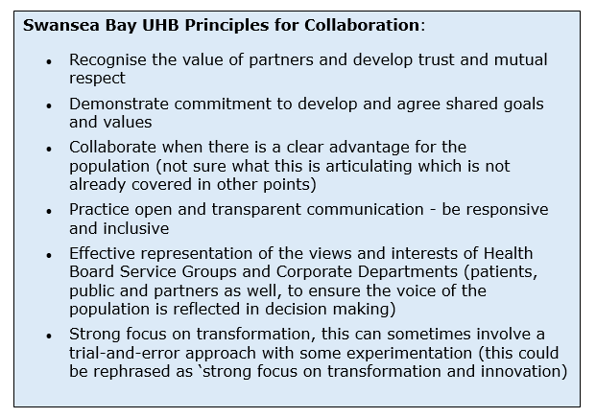

- Skills and competencies – discussions internally with organisational development have concluded that there is currently no framework locally or nationally to recognise specifically the skills and competencies required for partnership working. Based on evidence shared widely within NHS Wales the following skills and competencies are acknowledged in the Framework:

- Facilitating informal networks: Involves networking and network management, diplomacy, communication, negotiation and influencing without formal power
- Building and sustaining interpersonal relationships: Involves appreciating diversity. At the heart of this role is the ability to build and sustain effective interpersonal relationships using skills of communication, listening, empathy, negotiation, conflict management and consensus seeking
- Identifying and resolving any issues: Involves developing new solutions to complex problems evidencing creativity, opportunism and innovation, using a range of particular skills including problem solving, whole systems thinking, communication, risk taking and managing meanings.

The main purpose of the Framework is to raise awareness in relation to the importance of partnership and collaborative working, and to be an aide memoire for colleagues and to ensure that there is a basic level of understanding of the formal partnerships we work within, the Health Board governance in place and the statutory legislation.

The framework will be reviewed regularly and will mature to reflect the development of the Strategic Partnerships Group and the Population Health & Partnerships Committee.

2.2.3 Partnership Governance

The diagram below highlights the governance for partnerships including where the Strategic Partnerships Group (SPG) feeds into the governance of the Health Board. The SPG aligns to the Population Health and Partnerships Committee, and whilst several papers have already been submitted to the Committee by the Partnership Team, members should consider the need for more regular reporting.

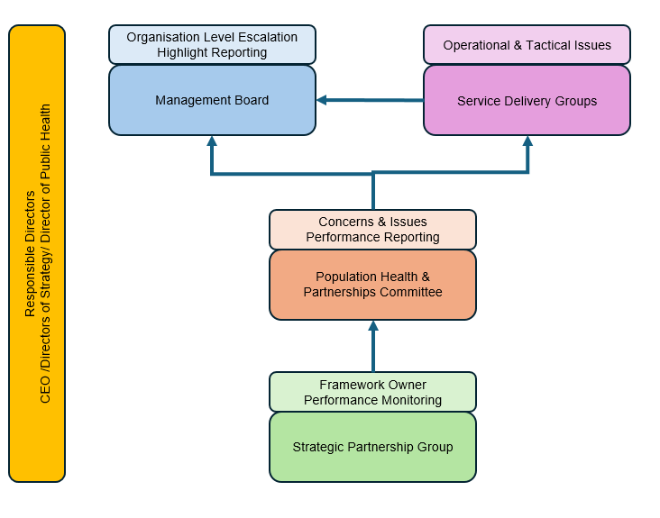

2.3 Shared Services Partnership Audit

In addition to the development workshops held in the summer of 2023, the Shared Services Partnership undertook an audit of the Health and Social Care Regional Integration Fund (RIF). The purpose of the Audit is set out below:

To review the arrangements the health board has in place to engage with the projects and initiatives supported by the Health and Social Care Regional Integration Fund (RIF), and to ensure projects are being used effectively to deliver sustainable services that achieve better outcomes for service users.

The matters arising within the Audit are set-out below and the full report is attached as appendix 3:

- Memorandum of Understanding - The memorandum of understanding between Regional Partnership Board partners has not been updated to reflect the change to RIF from the Integrated Care Fund.
- Collaborative Working Framework - The health board has refreshed its approach to partnership working, but the Collaborative Working Framework is yet to be drafted.
- Formalisation of Strategic Partnerships Group reporting arrangements - A new Strategic Partnership Group has been established and enhancing its reporting arrangements could address previous gaps in monitoring and reporting on RIF schemes.
- Health Board representative feedback on the evaluation process - Health board representatives have identified enhancements to the current evaluation process, and the health board should engage with partners to consider these.
- Action to develop a Health Board partnership risk ​​

Good progress has been made to address the matters arising and all have been progressed, attached as appendix 4 is the latest summary provided to the Audit Committee. There are two areas that require further attention as follows:

- Memorandum of Understanding (MOU). The MOU has been updated by the West Glamorgan Regional Partnership Board (WGRPB) and the Health Board contributed to that update providing feedback. Subsequently the Health Board as banker of the RIF has updated its own Standing Operating Procedure. There is an outstanding action to take the updated documents through the Health Board’s Management Board and arrangements are being made for this to be completed in December
- Health Board representative feedback on the evaluation process. As this is a West Glamorgan Regional Partnership Board (WGRPB) process, it is challenging to influence outside of the WGRPB governance and so the priority has been to ensure good visibility on the Programme Boards where the evaluation takes place and that this information is shared via the SPG. The membership of the WGRPB Programme Boards now includes senior representation from the Health Board – see attached as appendix 5, and the RIF is included on the SPG as a regular agenda item. It is acknowledged that this is a process that requires further development.

- GOVERNANCE AND RISK ISSUES

The report sets out an approach to Partnerships and Collaborative working that has been progressed over the last 18 months and is supported by colleagues across the Health Board.

Poor partnership relationships is a risk included on the risk register, and the work programme set-out in this report provides some mitigation to that risk.

It is important that the Framework has visibility and socialised within the corporate teams and the service delivery groups.

- FINANCIAL IMPLICATIONS

There are no direct financial implications as a result of this report, however the work programme in relation to Partnerships is a key enabler to the Health Board becoming a productive partner. In the longer term this will add value to the investment decisions, particularly in relation to the Regional Investment available via the WGRPB.

- RECOMMENDATIONS

Members of the Committee are asked to:

- RECEIVE an update on the work programme of the Strategic Partnerships Group
- RECEIVE an update on the Shared Services Partnership Audit of the Health and Social Care Regional Integration Fund (RIF
- ENDORSE the Collaborative Framework
- DISCUSS and AGREE the need for regular reporting between the SPG and the Committee

Governance and Assurance

Link to Enabling Objectives  (please choose) | Supporting better health and wellbeing by actively promoting and empowering people to live well in resilient communities
Link to Enabling Objectives  (please choose) | Partnerships for Improving Health and Wellbeing |  | ☒
Link to Enabling Objectives  (please choose) | Co-Production and Health Literacy |  | ☐
Link to Enabling Objectives  (please choose) | Digitally Enabled Health and Wellbeing |  | ☐
Link to Enabling Objectives  (please choose) | Deliver better care through excellent health and care services achieving the outcomes that matter most to people
Link to Enabling Objectives  (please choose) | Best Value Outcomes and High Quality Care |  | ☐
Link to Enabling Objectives  (please choose) | Partnerships for Care |  | ☒
Link to Enabling Objectives  (please choose) | Excellent Staff |  | ☐
Link to Enabling Objectives  (please choose) | Digitally Enabled Care |  | ☐
Link to Enabling Objectives  (please choose) | Outstanding Research, Innovation, Education and Learning |  | ☐
Health and Care Standards
(please choose) | Staying Healthy |  | ☐
(please choose) | Safe Care |  | ☐
(please choose) | Effective Care |  | ☒
(please choose) | Dignified Care |  | ☐
(please choose) | Timely Care |  | ☐
(please choose) | Individual Care |  | ☐
(please choose) | Staff and Resources |  | ☒
Quality, Safety and Patient Experience
There are no direct impacts, however responding to the needs of the communities of Neath Port Talbot and Swansea as set-out in partnership plans such as the Area Plan and the PSB Wellbeing Plans, will in the long term have a positive impact on meeting the needs of our population and patient experience.

Financial Implications
There are no direct financial implications as a result of this report, however the work programme in relation to Partnerships is a key enabler to the Health Board becoming a productive partner. In the longer term this will add value to the investment decisions, particularly in relation to the Regional Investment available via the WGRPB.

Legal Implications (including equality and diversity assessment)
There are no legal implications as a result of this report.

Staffing Implications
There are no staffing implications as a result of this report, however clarify in relation to the Health Board approach to Partnerships and Collaboration will support staff in the day to day work.

Long Term Implications (including the impact of the Well-being of Future Generations (Wales) Act 2015)
Working in partnership both internally within the Health Board and externally with other agencies is key to the delivery of the Well-being of Future Generations (Wales) Act 2015, and specifically Collaboration.

Report History |  | This is the first report to the Committee specifically in relation to the Strategic Partnerships Group and the Collaborative Framework.
Appendices |  | Appendix 1 – SPG Terms of Reference  Appendix 2 - Collaborative and Partnerships Framework  Appendix 3 – Shared Services Partnership Audit Report  Appendix 4 – Audit Committee Summary  Appendix 5 – Health Board Membership – WGRPB Programme Boards

