Meeting Date | 03 December 2024 |  | Agenda Item |  |  | 3.1
Report Title | Partnership Governance Arrangements
Report Author | Michelle Davies, Head of Strategic Planning & Partnerships  Hannah Roan, Acting Assistant Director of Strategy-Commissioning and Sustainability
Report Sponsor | Karen Stapleton, Deputy Director of Strategy
Presented by | Karen Stapleton, Deputy Director of Strategy
Freedom of Information | Open
Purpose of the Report | This report provides a summary of the governance arrangements in place for those partnerships where the Health Board is a Statutory Partner including, the Area Planning Board, Regional Partnership Board and Public Service Board. In addition, the report highlights how these statutory partnerships are managed internally and the challenges and opportunities for the Health Board.
Key Issues | The Health Board has specific roles and responsibilities as a statutory partner, and it is important that those roles and responsibilities are fulfilled effectively, particularly in relation to the West Glamorgan Regional Partnership Board Area Plan and the Public Service Board Wellbeing Plans.  Historically, relationships with partners have been good, and partnerships must continue to have good visibility across Health Board Structures. The Health Board must look for opportunities to improve that visibility with a co-ordinated and corporate response to partners.
Specific Action Required  (please choose one only) | Information | Discussion |  | Assurance | Approval
Specific Action Required  (please choose one only) | ☐ | ☐ |  | ☒ | ☐
Recommendations | Members are asked to:  - ACKNOWLEDGE the partnerships where the Health Board is a Statutory Partner and the governance arrangements that support them;  - ENDORSE the work undertaken to improve oversight of Partnerships within the Health Board and the Opportunities and Challenges.

PARTNERSHIP GOVERNANCE ARRANGEMENTS

- INTRODUCTION

This report aims to:
- Provide a summary of the governance arrangements in place for those partnerships where the Health Board is a Statutory Partner including, the Area Planning Board, Regional Partnership Board and Public Service Board.
- Highlight how these statutory partnerships are managed internally and the challenges and opportunities for the Health Board.

- BACKGROUND

  - Statutory Guidance and formal partnerships

In Wales, as a statutory organisation, the Health Board is fortunate to have specific legislation to support the development of integrated and sustainable services. The legislation outlines an expectation that statutory organisations work together in partnership and in collaboration for the benefit of our communities. There is strong alignment with this guidance and policy with the Health Board’s Population Health Strategy and the need to fulfil its responsibilities within the four-pillar model, particularly in relation to becoming a productive partner and its role as an anchor institution.

The Health Board is a Statutory Partner in a range of partnerships, however for the purpose of this report, the focus will be on the West Glamorgan Regional Partnership Board, Public Service Boards, and the Western Bay Area Planning Board. The table below provides a summary of the Welsh Government legislation and corresponding formal partnership.

Table 1
Formal Partnership | Welsh Government Legislation |  |  | Product/ Plan
Formal Partnership | Well-Being of Future Generations (Wales) Act (2015) | Social Services and Well-being (Wales) Act 2014 | Other | Product/ Plan
Public Service Boards |  |  |  | Local Wellbeing Plans
West Glamorgan RPB |  |  |  | Area Plan
Western Bay Area Planning Board |  |  | - Substance Misuse Strategy ‘Working Together to Reduce Harm’ 2010  - Crime and Disorder Act 1998  - Housing Wales Act | Drug and Alcohol Commissioning Strategy

    - Public Service Boards

The Public Service Board (PSB) is an organisation established at local authority level, to improve joint working across all public services, and deliver the Well-Being of Future Generations Act. A PSB does not have a budget aligned to the delivery of their agenda. There are two PSBs within Swansea Bay, one in Neath Port Talbot and one in Swansea. Swansea Bay UHB is one of four statutory members of the Public Service Board. The others are the respective local authorities, Natural Resources Wales and respective Fire and Rescue Services. In addition to the Statutory Partners there are also invited participants, and those are; Welsh Government; South Wales Police; South Wales Police and Crime commissioner, Probation Services and Voluntary Organisations.

Each PSB is required to carry out an Assessment of Local Well-being to understand current levels of well-being; and Local Well-being Plans have been developed by both PSBs (Swansea & Neath Port Talbot). The Plans identify local wellbeing objectives which set priorities for collective action to be taken forward by one or more of the PSB Partners. The table below shows how the PSB objectives align with the Health Board’s Strategic Objectives:

Table 2
Neath Port Talbot PSB Objective | Swansea  PSB Objective | Swansea Bay UHB  Strategic Objectives
Best Start in Life | Early Years | People of Swansea Bay live healthier, equitable and more equal and prosperous lives
Secure, green and well-paid jobs and improved skills | Live Well, Age Well | The health board is a great place to work where staff feel valued and work together towards a common goal
Thriving and Sustainable Communities | Strong Communities | Care is delivered in safe and appropriate settings supported by innovative digital solutions  The health board is a resilient, financially sustainable and responsible organisation
Environment, Culture and Heritage | Climate Change and Nature

The Chief Executive Officer and the Chair of the Health Board are formal members, however this responsibility is discharged via the Director of Strategy who has the executive level responsibility for Strategic Partnerships, the Well Being of Future Generations Act (WFGA) and Sustainability and Decarbonisation strategies. In addition, the Director of Public Health, and an Independent Member, also represent the Health Board at PSB meetings.

Please note the following points in relation to the governance specifically:

- A Joint-Committee of both PSBs exists to discuss issues in common that would be better managed as a region.
- Informal PSB Steering Boards have been set-up to oversee the development and delivery of PSB Wellbeing Plans
- In Swansea a separate Delivery Group is supporting work to improve performance and governance frameworks. This area of work is also being supported by the West Glamorgan Regional Partnership Board Programme Team.
- The Health Board is leading the Regional Early Years work programme via an existing regional steering group that oversees the development and monitoring of the action plan.

A full list of where colleagues from the Health Board are engaged with the work streams set-up to deliver the wellbeing objectives, is attached as appendix 1:

2.1.2 West Glamorgan Regional Partnership Board (WGRPB)

SBUHB, Council of the City and County of Swansea and Neath Port Talbot County Borough Council are all statutory partners of the WGRPB and have specific statutory responsibilities in line with the Welsh Government Statutory Guidance Social Services and Well-being (Wales) Act 2014.

The WGRPB works in co-production with partners from the public sector, voluntary sector, private sector and citizens to secure more seamless care in communities. The WGRPB has developed an area plan to help ensure that people live healthier and happier lives, with the key elements of changing the way that we work with citizens away from paternalistic care to shared responsibility and co-production. Plus, managing common resources collaboratively and pool resources wherever possible.

In 2023, the governance for the WGRPB was updated in line with the priority areas identified – see appendix 2. As part of the updated governance the Health Board was keen to see the Programme Boards focus on transformational action and to shift away from an operational focus. Visibility and influence is key and the Health Board has been pro-active to ensure that senior managers are visible in the governance structure of the RPB – see attached a list of those involved in the Programme Boards - as appendix 3. The priority areas have been agreed as Strengthening Communities, Transforming Health and Care Services at Home, Transforming Mental Health Serviced and Transforming Complex Care.

Whilst priorities have been identified based on Welsh Government guidance and the needs set out in West Glamorgan Area Plan, all programme boards have taken the opportunity to re-set and ensure that their work plans are based on local needs. In line with this approach each programme board has either developed a specific strategy or has one in development. Table 3 provides a summary of the approved Strategies.

Table 3: West Glamorgan RPB Approved Strategies
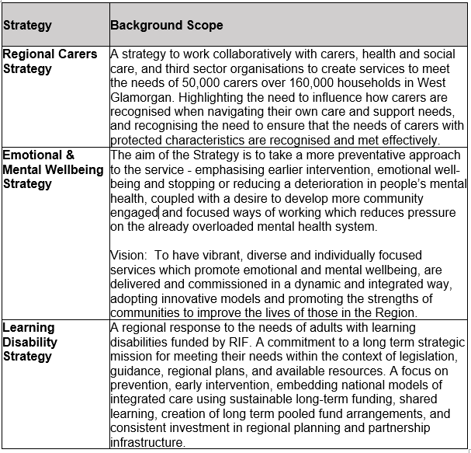

2.1.3 Western Bay Area Planning Board (WBAPB) - Substance Misuse

The Area Planning Board (APB) structure was established by the Welsh Government in 2010 to enable agencies to respond to their statutory responsibilities and support the implementation of the Welsh Governments substance misuse strategy. There is a need for agencies involved in tackling and reducing the harms associated with substance misuse, to do more to plan treatment services and to pool resources at a regional level. The membership of the APB includes representatives from all the responsible authorities, to enable statutory responsibilities in respect to substance misuse to be discharged at a regional level.

The Welsh Government Strategy was developed in response to the Crime and Disorder Act 1998, and there is also alignment with the Social Services and Well-being Act, and the Well-Being of Future Generations Act. Each Local Authority has a Community Safety Partnership which are accountable for the delivery, and consequently any failure, of the local substance misuse service. The CSPs report into the governance of the Public Service Boards.

The APB have a Governance Framework which provides clarity of roles for APB Board Members, a Code of Conduct and a Memorandum of Understanding that ensures that decisions are clear and transparent and there is clear accountability for the Board’s work. All statutory partners have signed up to the Governance Framework. In June 2024, the WBAPB updated the Framework to reflect changes in membership of the APB. The key changes for SBUHB were that the Chief Operating Officer is now the chair of the APB and the Director of Strategy is a full voting member. The governance structure for the APB is contained in Appendix 4 of this report.

In October 2024, the APB discussed how the responsibilities of the APB can be discharged more effectively and the board considered whether the sub group structure needed to be strengthened further. It was agreed that the APB team, in conjunction with the chairs of the sub-groups, would review the current structure and bring back options to a future APB for consideration. Therefore, the structure as described in Appendix 4 reflects the current arrangements.

The Health Board has strong clinical and management representation on a number of key APB forums which will be further strengthened by the Chief Operating Officer chairing the formal APB meeting. Whilst the APB team have a clear governance/ reporting structure in place, it’s recognised that internal reporting for the Health Board can be improved. Regular reporting via the Population Health and Partnerships Committee commenced in September 2024 however, there are further opportunities to strengthen the arrangements one option being via the Strategic Partnerships Group, as outlined in section 2.2 of this report.

  - Health Board oversight and governance

Working collaboratively is an integral part of the Health Board’s core business, and work has been progressed over the last 12 months to develop a Health Board approach to collaboration and partnership working.

In 2023, the governance in relation Partnerships within the Health Board was strengthened with the addition of the Population Health & Partnerships Committee and roles within the Corporate Strategy Team were adapted to have a specific focus in relation to partnerships and collaboration. A series of development workshops were held in 2023 to listen to senior managers across the Health Board in relation to how we can improve our approach to collaboration and partnerships, and it was agreed that to support the development of a Health Board approach to Partnerships a Framework was required. In addition, information sharing was highlighted as a specific need and to support that an internal Strategic Partnerships Group was set-up to support. Below in diagram 3 is how Partnerships are currently managed within the Health Board.

Diagram 3 - SBUHB’s partnership arrangements
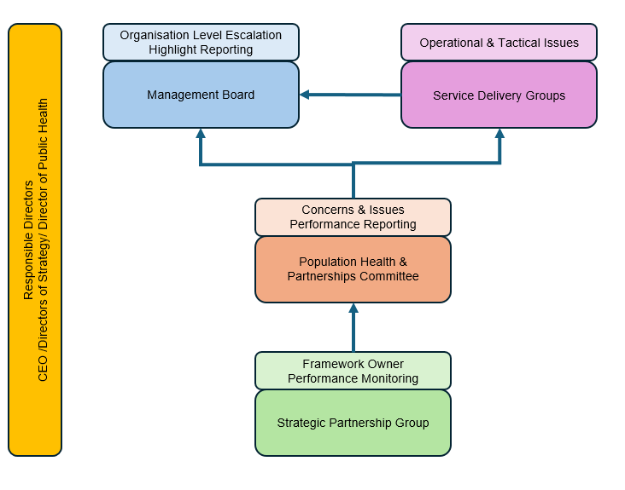
In the last 12 months the Population Health & Partnerships committee have received a range of papers in relation to Partnerships including updates on the the formal partnerships (RPB, PSB and APB), and a position paper on Children & Young People.

Whilst Service Delivery Groups now have an opportunity to discuss any concerns at the Strategic Partnership Group, efforts have also been made to increase visibility at Service Delivery Group (SDG) level. The partnership team produce a highlight report each month which is provided to SDGs, and specific items for discussion are flagged as appropriate by the Partnership Team. In addition, SDGs have the opportunity to flag issues or concerns via the performance review process, and the Strategy Directorate encourage more visibility of the work we do in partnerships via the performance reviews and via management board where appropriate.

The role of the Strategic Partnerships Group is to share information and knowledge in relation to formal Partnerships – to date the focus has been on the Public Services Board and the Regional Partnership Board, however more recently it has been agreed that the Area Planning Board will also be included within the scope. In addition to sharing of information and knowledge it creates an environment for colleagues across the Health to escalate any concerns and also to discuss any potential opportunities.

  - Opportunities and Challenges

There are many opportunities within the partnership environment and the Health Board are making efforts to embrace these opportunities, however there are challenges that can make this difficult, please note the following:

Opportunities | Challenges
- Often a system wide response is required in order to make a difference/ implement large scale change. Working in partnership means that everyone has the same goal.  - Improved value for money.  - More informed decision making as decisions are based on a range of information not just health intelligence.  - Helps organisations to meet their legal responsibilities/ duties  - The WGRPB regional Strategies provide a platform for the Health Board to engage with all staff on areas that historically have a lower profile or managed by a specific Service Delivery Group such as Learning Disabilities and Carers.  - Both the PSBs and the WGRPB provide an opportunity to engage with people with lived experiences and key stakeholders in developing plans and strategies. This informal engagement is extremely valuable to agencies. | - Volume of work streams presents a challenge for staff, especially within service groups. The SPG somewhat mitigates this, providing a bi-monthly forum to share information.  - Potential for overlaps in priorities but also gaps. An example of a gap identified in 2024, was the need for more regional leadership in relation to suicide & self-harm  - A corporate approach to Partnership working can be difficult, particularly within children & young people’s services where the child or young person access services across all Service Delivery Groups.  - Differences in corporate priorities across all agencies, which makes it difficult to reach agreement and can have an impact on trust.  - A need for improved accessibility of digital systems across agencies and sharing of information can be restrictive.

- GOVERNANCE AND RISK ISSUES

The ongoing improvements made by the Health Board to work collaboratively with partners, including improved visibility and greater information and knowledge sharing via the Strategic Partnerships Group is mitigating the risk of poor relationships as set-out in the specific risk on the Health Board’s risk register.

Significant progress has been made over the last 12months to improve governance in relation to Partnerships and how we collaborate internally and externally, however more consideration is required to a standard process for decision making made within the formal partnerships and how that is processed in the Health Board.

- FINANCIAL IMPLICATIONS

There are no financial implications as a result of this paper. The investment available via the WGRPB is an opportunity for the Health Board however greater co-ordination of this is required at service delivery group level and corporately.

- RECOMMENDATION

Members are asked to:
- ACKNOWELDGE the partnerships where the Health Board is a Statutory Partner and the governance arrangements that support them;
- ENDORSE the work undertaken to improve oversight of Partnerships within the Health Board and the Opportunities and Challenges.

Governance and Assurance

Link to Enabling Objectives  (please choose) | Supporting better health and wellbeing by actively promoting and empowering people to live well in resilient communities
Link to Enabling Objectives  (please choose) | Partnerships for Improving Health and Wellbeing |  | ☒
Link to Enabling Objectives  (please choose) | Co-Production and Health Literacy |  | ☐
Link to Enabling Objectives  (please choose) | Digitally Enabled Health and Wellbeing |  | ☐
Link to Enabling Objectives  (please choose) | Deliver better care through excellent health and care services achieving the outcomes that matter most to people
Link to Enabling Objectives  (please choose) | Best Value Outcomes and High Quality Care |  | ☐
Link to Enabling Objectives  (please choose) | Partnerships for Care |  | ☒
Link to Enabling Objectives  (please choose) | Excellent Staff |  | ☐
Link to Enabling Objectives  (please choose) | Digitally Enabled Care |  | ☐
Link to Enabling Objectives  (please choose) | Outstanding Research, Innovation, Education and Learning |  | ☐
Health and Care Standards
(please choose) | Staying Healthy |  | ☐
(please choose) | Safe Care |  | ☐
(please choose) | Effective Care |  | ☒
(please choose) | Dignified Care |  | ☐
(please choose) | Timely Care |  | ☐
(please choose) | Individual Care |  | ☐
(please choose) | Staff and Resources |  | ☒
Quality, Safety and Patient Experience
There are no implications in relation to Quality, Safety and Patient Experience to declare as part of this report.

Financial Implications
There are no financial implications to declare as part of this report.

Legal Implications (including equality and diversity assessment)
There are no legal implications as a result of this report.

Staffing Implications
There are no staffing implications as a result of this report.

Long Term Implications (including the impact of the Well-being of Future Generations (Wales) Act 2015)
The development of the PSB Wellbeing Plans and the RPB Area Plan are an integral part of public service organisations delivering against their statutory duties.

Visibility and influence is critical for the Health Board to effectively deliver its roles and responsibilities as a statutory partner.
Report History |  | A report on PSB and RPB governance was presented to the Committee in June 2023.
Appendices |  | Appendix 1: PSB Membership  Appendix 2: West Glamorgan Regional Partnership Board Governance Structure  Appendix 3: West Glamorgan Regional Partnership Board Membership  Appendix 4: Western Bay APB Governance Structure

Appendix 1: Public Service Board Membership
Swansea  Wellbeing Objective | Work Stream Group | Health Board  Membership
Early Years | Early Years Integrated Steering Group | Michelle Davies | Head of Strategic Partnerships
Early Years | Early Years Integrated Steering Group | Lynnette Thomas | Consultant in Public Health
Early Years | Early Years Integrated Steering Group | Children & Young People Service & Strategic Leads
Strong Communities | Human Rights City Steering Group | Nicola O'Sullivan | Head of Engagement
Strong Communities | Strong Communities Working Group | Nicola Edwards  Michelle Davies | Head of Nursing – Safeguarding  Head of Strategic Partnerships
Climate Change and Nature | Climate Change and Nature Recovery Signatories Group | Hayley Beharrell  Marc Davies | Sustainability Planning Manager  Consultant in Public Health Medicine
Live Well, Age Well | Culture, Tourism and Leisure Partnership | Tbc – not set-up yet | Tbc
NPT Wellbeing Objective | Work Stream Group | Health Board  Membership
Best Start in Life | Children and Young People's Partnership | Luke Jones & Michelle Davies | Designated Education Clinical Lead Officer
Best Start in Life | Early Years Integrated Steering Group | Michelle Davies | Head of Strategic Partnerships
Best Start in Life | Early Years Integrated Steering Group | Lynnette Thomas | Consultant in Public Health
Thriving and Sustainable Communities | Community Safety Partnership | Nicola Edwards  Michelle Davies | Head of Nursing – Safeguarding  Head of Strategic Partnerships
Environment, Culture and Heritage | Climate and Nature | Hayley Beharrell | Sustainability Planning Manager
Environment, Culture and Heritage | Culture and Heritage Partnerships | Johan Skre | Arts Co-ordinator
Secure, green and well-paid jobs and improved skills | Cost of living and poverty prevention partnership | Jennifer Davies | Director of Public Health

Appendix 2: West Glamorgan Regional Partnership Board Governance Structure
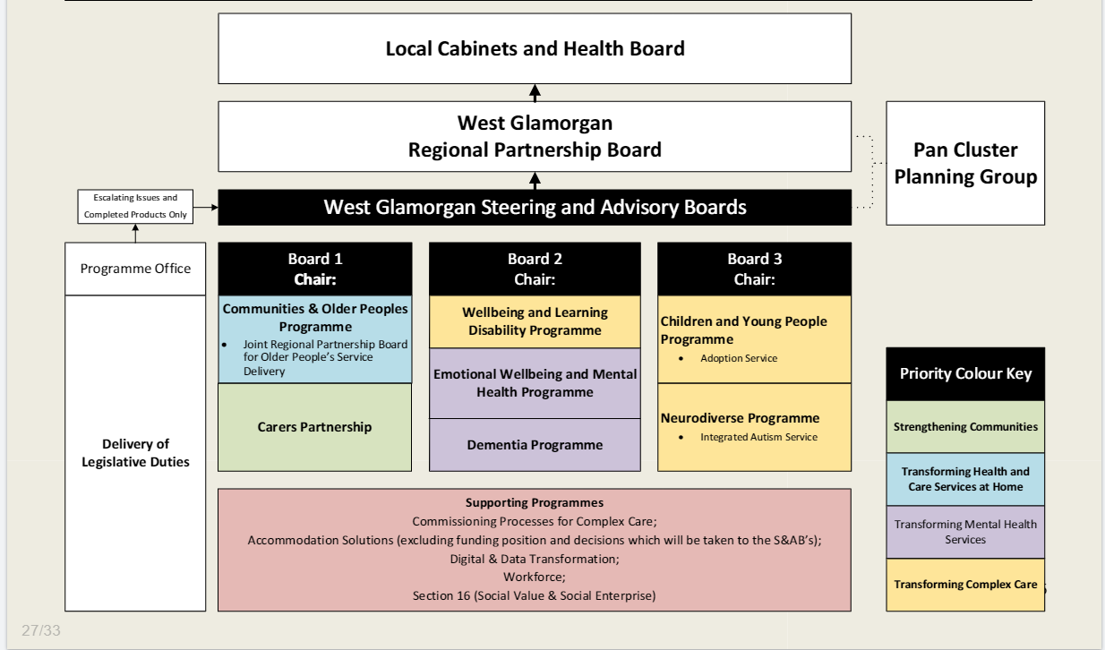

Appendix 3: West Glamorgan Regional Partnership Board – Health Board Membership
S&A Board Chair | Priority for the RPB |  | Population Programme | Lead / Chair | Organisation | Deputy / Vice Chair |  | Organisation |  | Strategy Rep
Dave Howes, Director of Social Services | Transforming health and Care Services at Home |  | Communities and Older People | Anjula Mehta, Acting Executive Medical Director | Swansea Bay University Health Board | Angela Thomas, Head of Adult Services Service |  | NPT Council |  | Heledd Bingham, Senior Strategic Planning Manager
 |  |  |  |  |  | Helen St John, Head of Integrated Community Services |  | Swansea Council and Swansea Bay University Health Board |  | Heledd Bingham, Senior Strategic Planning Manager
 |  |  |  |  |  | Amanda Carr, Director, SCVS |  | SCVS |  | Heledd Bingham, Senior Strategic Planning Manager
Andrew Jarrett, Director of Social Services | Transforming Complex Care |  | Children and Young People | Keri Warren, Head of Childrens Services | Neath Port Talbot Council | Ceri Gimblett, Interim Group Director, Neath Port Talbot and Singleton Service Group |  | Swansea Bay University Health Board |  | Angharad Rees, Strategic Planning Manager
 |  |  |  |  |  | Julie Davies, Head of Child and Family Services |  | Swansea Council |  | Angharad Rees, Strategic Planning Manager
Dave Howes, Director of Social Services | Strengthening Communities |  | Carers Partnership | Gaynor Richards, Director, NPT CVS | Neath Port Talbot CVS | To be recruited |  | Carer |  | Heledd Bingham, Senior Strategic Planning Manager
Nerissa Vaughan, Interim Director of Strategy | Transforming Complex Care |  | Wellbeing and Learning Disabilities | Amy Hawkins, Head of Adult Services | Swansea Council | To be recruited |  | LD Liaison Forum |  | Michelle Davies, Head of Partnerships & Strategic Planning
 |  |  |  |  |  | Janet Williams, Service Director, Mental Health & Learning Disabilities |  | Swansea Bay University Health Board |  | Michelle Davies, Head of Partnerships & Strategic Planning
Nerissa Vaughan, Interim Director of Strategy | Transforming Emotional Wellbeing and Mental Health Services |  | Emotional Wellbeing and Mental Health | Karen Stapleton, Deputy Director of Strategy | Swansea Bay University Health Board | Amy Hawkins, Head of Adult Safeguarding |  | Swansea Council |  | Michelle Davies, Head of Partnerships & Strategic Planning
 |  |  |  |  |  | Amanda Carr Director, SCVS |  | Swansea CVS |  | Michelle Davies, Head of Partnerships & Strategic Planning
Andrew Jarrett, Director of Social Services | Transforming Complex Care |  | ND & Autism Programme | Julie Davies, Head of Child and Family Services | Swansea Council | Ceri Gimblett, Interim Group Director, Neath Port Talbot and Singleton Service Group |  | Swansea Bay University Health Board |  | Angharad Rees, Strategic Planning Manager
Supporting Programmes |  | Lead |  | Organisation | Deputy / Vice Chair |  | Organisation
Commissioning Processes for Complex Care |  | Kerry Broadhead, Assistant Director of Strategy |  | Swansea Bay University Health Board | Amy Hawkins, Head of Adult Services |  | Swansea Council
 |  |  |  | Swansea Bay University Health Board | Angela Thomas, Head of Adult Services Service |  | NPT Council
 |  |  |  | Swansea Bay University Health Board | Dermot Nolan, Associate Service Group Director for MH and LD |  | Swansea Bay University Health Board
Accommodation Solutions |  | Chele Howard, Head of Housing & Communities |  | NPT Council | Karen Stapleton, Deputy Director of Strategy |  | Swansea Bay University Health Board
Digital and Data Transformation |  | Gareth Westlake, Assistant Director of Digital Services - Business Management and Information Governance |  | Swansea Bay University Health Board | TBC |  | Swansea Council
Workforce |  | Andrew Jarrett, Director of Social Services |  | Neath Port Talbot CBC | Sharon Vickery, Assistant Director of Workforce and OD |  | Swansea Bay University Health Board
Coproduction |  | Nicola O’Sullivan, Head of Engagement |  | Swansea Bay University Health Board | Service User |  | Service User
Social Value Forum |  | Roxanne Dacey  Carys Richards |  | Swansea CVS  NPT CVS | Rotating Chairs
Social Enterprise |  | Lisa Banks |  | Swansea Council

Appendix 4: Wester Bay Area Planning Board (APB) Governance Structure
- 