Swansea Bay University Health Board  Standard Operating Procedure | Right Care, Right Person  Phase 2 – AWOL/Absconding Patients

Contents
Version Control Log 2
Approval 2
1. Background to Right Care Right Person 2
1.1. Implementation of Right Care Right Person 2
1.2. Changes to South Wales Police deployment process 3
2. Purpose of the Standard Operating Procedure 3
3. Roles & Responsibilities 4
4. Procedure to be Followed 5
4.1. Action Card Detail 5
4.2. Flow 5
4.3. Recording of Incidents 5
5. Escalation Process to be Followed 6
6. Governance 6
7. SOP review timeline 6
8. Glossary of Terms 6
Appendices 8
Appendix 1. Action Card 8
Appendix 2. Flow Chart 9
Appendix 3. Related Documents/Sites 10

Version Control Log
Version Number | Version Name | Date Updated | Detail
Version 1 | First draft | 07.10.24 | Created
Version 2 | Second draft | 14.10.24 | Updated as per requests from RCRP T&F Group
Version 3 | Third draft | 22.10.24 | Updated as per requests from RCRP T&F Group
Version 4 | Fourth Draft | 28.10.24 | Updates as per requests from RCRP T&F Group

Approval
Approved by: | Names…

1. Background to Right Care Right Person
“Right Care Right Person” [RCRP] is a new police policy, implemented in 2024, where restrictions will be applied to the police response to calls relating to the wellbeing and mental health of healthcare service users. Some of the key drivers for this policy are as follows: ​

- Police forces frequently deal with a wide variety of incidents and calls for assistance. Some of these are policing matters, others are in relation to mental health, concern for welfare and social care issues. ​
- The police role often overlaps various parts of the NHS and other agencies. The police are often seen by the public as a ‘do all’ service. ​
- Consequently, substantial demand is placed on police resources to deal with calls for service that may be better suited to other agencies and diverting officers away from core policing functions ​

1.1. Implementation of Right Care Right Person
The implementation of the RCRP policy will be phased into operation as outlined below:

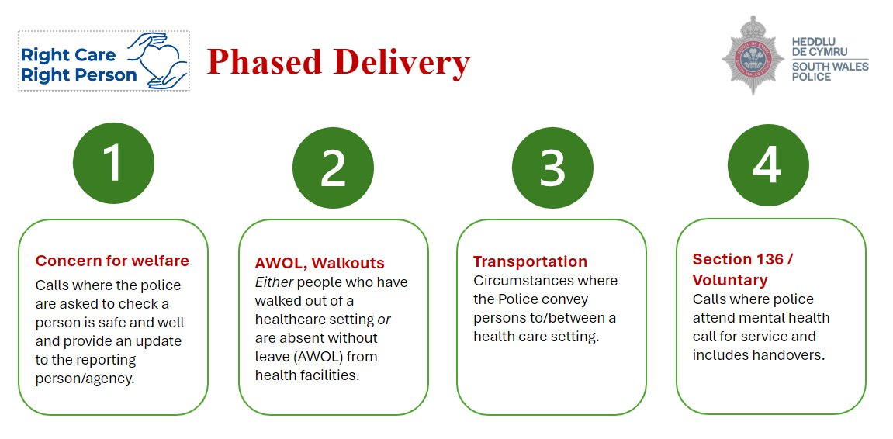

1.2. Changes to South Wales Police deployment process
If a patient walks out of a healthcare facility without leave granted, police officers will not be deployed unless one or all of the following apply:

- There is an article 2 or 3 ECHR risk present (Immediate Risk to Life or Immediate Risk of Serious Harm)​. The police will also take into account the patient’s history and current risks. ​
- The patient’s whereabouts are known, but they cannot be returned without a S.135(2) warrant.​
- The patient’s behaviour is so violent or aggressive towards hospital staff that they are unable to return them without police support.​

From a Health Board standpoint, the patient must be assessed and meet the criteria of a missing person. This will only be considered following all possible enquiries and efforts by the hospital to establish the whereabouts of the patient.

If there is immediate risk to self or others, the police will respond as a high-risk case.

2. Purpose of the Standard Operating Procedure
The scope of this Standard Operating Procedure [SOP] is Health Board-wide, acknowledging that there will be an impact for each Service Delivery Group, at some point. Therefore, all staff should have an awareness. However, based on the review of Datix incidents in 2024 there is likely to be a greater impact for Mental Health & Learning Disabilities service areas and emergency departments.
This SOP is ‘age blind’ and applies to all age demographics including children and young people.
This SOP is to be utilised by Swansea Bay University Health Board [SBUHB] staff in relation to Phase 2 of the RCRP policy “AWOL Walkouts” and focuses on the process for reporting to police when a patient (adult or child) is missing from a healthcare facility, where:
- The patient is deemed to be particularly vulnerable – according to the Office for Health Improvement & Disparities (2022), this includes patients who require special care, support, or protection because of age, disability, risk of abuse, or neglect.
- The patient is subject to restrictions under the Mental Health Act 1983.
- There is a risk of imminent harm to self or others.
- There is a risk to life.

Extra detail for the Health Board to consider would be if the patient:
- Leaves hospital without section 17 leave being granted.
- Fails to return to hospital at the expiration of any period of leave or when recalled from leave.
- A full vulnerability/MCA/DOLS/Adult at risk/Child at risk/Safeguarding assessment has not yet been completed or returned, so the patient should be classed as vulnerable in the meantime.

3. Roles & Responsibilities
The SOP provides guidance to all staff employed by Swansea Bay University Health Board. Including, but not limited to the following health board groups and sites:

- General hospital wards
- Emergency departments
- Hospital based assessment and admission units
- Mental Health hospital wards
- Mental Health secure units
- Mental Health assessment units
- Learning Disabilities units
- Outpatient settings in hospital or community (including health visiting, district nursing, and therapies)
- Hospital based GP Out of Hours

All staff working within these environments should follow this SOP when patients are notified as missing in line with the three descriptions above in section 2.

*If concerned, seek advice from your line manager or relevant clinician*
*If there is a concern or incident out of hours staff should refer to silver on-call*

4. Procedure to be Followed

4.1. Action Card Detail
Due to the time-critical nature of a potentially vulnerable or at-risk patient being AWOL / Absconding / Walking-out of a health care setting, the most appropriate tool for guidance in this situation is the ‘Action Card’ attached in appendix Item 1.
The action card is designed to assist staff in the gathering of all relevant information required when reporting an incident to the police.
The Action card is designed as a guidance tool to follow and is not an exhaustive list of steps.
South Wales Police call centre staff have been trained specifically on RCRP Phase 2 and given a specific set of questions to ask on the call, in order to assess vulnerability. These questions are therefore reflected in the action card.
Key Points in Action Card:
- Steps to identify that a patient has absconded
- Steps that South Wales Police will have expected us to complete prior to calling for police assistance
- The information which needs to be collected in order to be best prepared to answer the call handler’s questions.
- Escalation process in the instance that South Wales Police make the decision not to deploy
- The process for recording an incident of AWOL / Absconding

4.2. Flow
For convenience, a high-level flow chart has been created as a visual representation of the procedure flow. This can be found in Appendix Item 2.

4.3. Recording of Incidents
AWOL incidents must be recorded on Datix. As much detail as possible is to be noted regarding the content of the notification to police and, if known, whether the police were deployed or not. This data should be recorded on Datix under the “Case Management” section – all fields to be completed:

- Were Police Contacted? (already captured)
- Police incident and Crime Numbers
- Did you receive contact from the Police?
- Time Police made contact
- Did the police attend in person?
- Were security teams contacted?
- Is there Case Management involvement?
- Case manager
- Immediate action by the Case Manager

5. Escalation Process to be Followed
- Initial escalation for all staff is to seek advice from your line manager or relevant clinician in the first instance
- If there is a concern or incident out of hours staff should refer to silver on-call

6. Governance
For the purpose of Right Care, Right Person the health board’s quality and safety structure will be utilised to monitor and review incidents. This includes quality and safety groups at both service delivery group level, and corporate.
In addition, any learning as a result of the reported incident will be discussed at the Patient Stakeholder Experience Group (PSEG).

7. SOP review timeline
This SOP will be reviewed between 6 and 12 months

8. Glossary of Terms
Term / Abbreviation | Definition
Section 135(2) | This allows the police to enter a property to search for and remove a person who is already liable to be detained under the Mental Health Act but has either absconded or is being kept in a place where they should not be
Section 17 | This allows a responsible clinician to grant a detained patient leave of absence from a hospital or health care setting
MCA (Mental Capacity Act 2005)  (See Appendix 3) | This is a key piece of legislation that provides a framework for making decisions on behalf of individuals who lack the capacity to make decisions for themselves
DoLS (Deprivation of Liberty Safeguards)  (See Appendix 3) | These are a set of legal protections under the MCA (2005). Designed to ensure that individuals who lack capacity to consent to their care arrangement are not deprived of their liberty unlawfully

Appendices

Appendix 1. Action Card
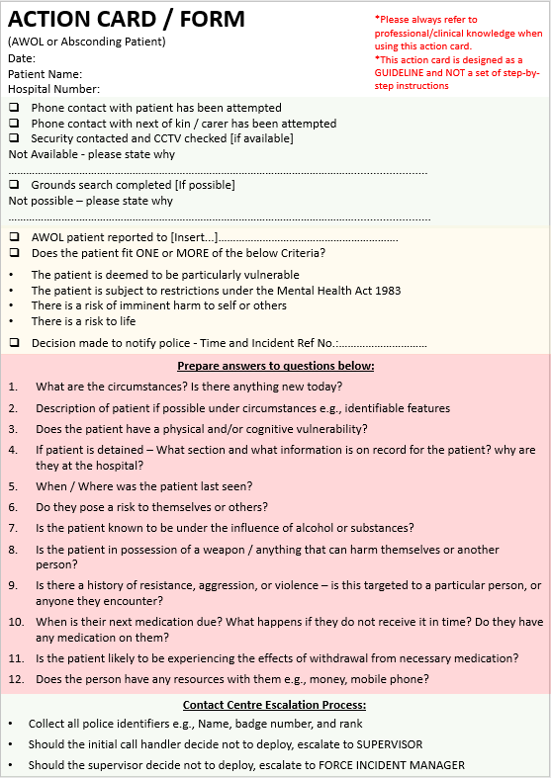

Appendix 2. Flow Chart
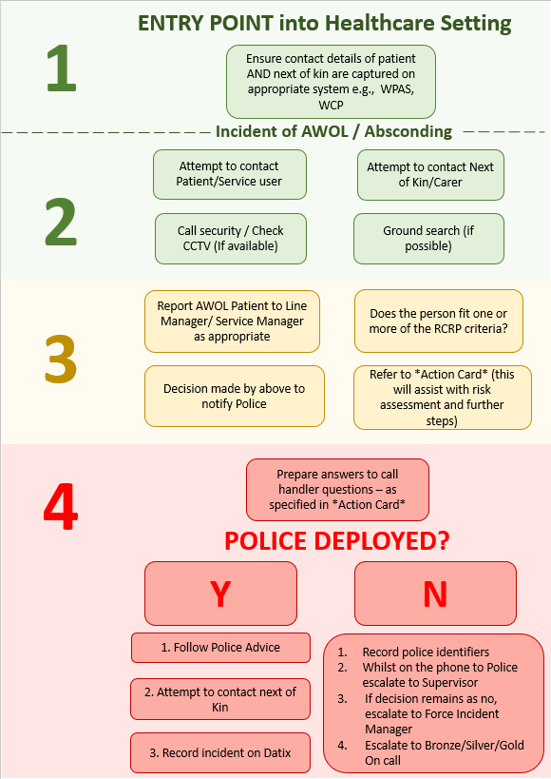

Appendix 3. Related Documents/Sites
- Mental Capacity Act 2005 (legislation.gov.uk)
- MENTAL HEALTH & LEARNING DISABILITIES DELIVERY UNIT - Policy for Missing Service Users (not including Caswell) May 2024
- NPCC - Advice to Police Forces on Restricted Patients under S37 and S41 Mental Health Act 1983 who Abscond
- The Royal College of Emergency Medicine - Best Practice Guideline
- Office for Health Improvement & Disparities – detail re: vulnerable patients
- The Human Rights Act | EHRC (equalityhumanrights.com)

