Right Care, Right Person Phase 2: Walk out of Hospital/AWOL

Summary Health Impact Assessment (HIA) Report
DRAFT: Working Discussion Document 19.07.24

This report summarises the current findings from the first phase of a Health Impact Assessment on the Right Care, Right Person policy, based on engagement with the Swansea University Health Board Right Care, Right Person Task and Finish group chaired by Malcolm Jones and supported by the Strategy and Public Health Teams. It is a working document and will be updated with further evidence as engagement and data becomes available.

- Policy for Assessment: Right Care, Right Person

South Wales Police are implementing a series of changes to how they respond to welfare calls, and calls that involve responding to vulnerable persons. This policy is called “Right Care Right Person”. This policy is designed to initiate an opportunity to work together and enhance multi agency responses to vulnerable persons. It is intended that the policy will support a collaborative and compassionate approach and ensure that individuals receive appropriate care to meet their needs and minimise the reliance on the police service where other services may be more appropriate. There are recognised synergies with the Welsh Government “Six Goals for Urgent and Emergency Care”.

South Wales Police are working to the following 4 phases and timetable:

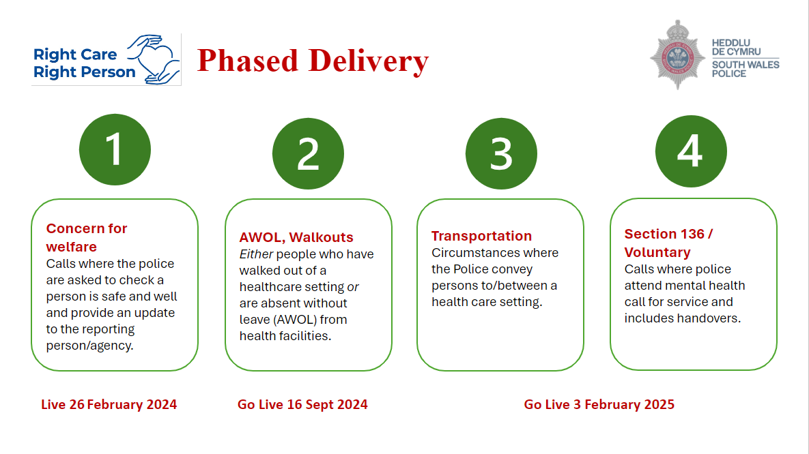

This HIA is focused on Phase 2 of the change programme which is how the police respond to people, absconding, walking out of any hospital or healthcare site or going “Absent without leave” (AWOL) from inpatient settings.

This is due to be implemented in from 16th September 2024

- Evidence used to inform the HIA

Current findings based on:
- Participatory workshop to gather expertise from health care professionals and representatives from relevant health board teams e.g. mental health, LD, safeguarding, children's services, ED, older adults.
- Learning / evidence of impact from across England and Wales
- Expert opinion from key national stakeholders e.g. NHS Confed, professional bodies, third sector

To be added in:
- Evidence from Datix incidents that involve AWOL/walk outs from hospital from across Swansea Bay Health Board Service Groups.

There is no current national evaluation of impact on health and wellbeing outcomes and patient safety. DHSC have recently commissioned a short-term evaluation. It is not known if Welsh Government have commissioned an evaluation or impact assessment (See Appendix 1).

- Scale, severity, timescales and duration of impact

3.1 Scale

Right Care Right Person is a new approach, that is being incrementally rolled out across England and Wales. The Right Care Right Person approach is a phased programme that is being rolled out across the South Wales Police Swansea Bay region with the intention of changing the threshold of police engagement in scenarios where the needs of the individual can be (more) appropriately met by another agency. It is a highly dynamic situation.

- There is currently a lack of evidence, and no national evaluation on the scale of impact on patient safety and health and wellbeing outcomes.
- NHS, local government and third sector leaders are in support of the principles of the Right Care, Right Person policy, but there are significant concerns over the quality and safety of implementation as it is scaled across different police forces and health systems (House of Commons Health and Social Care Committee, 2023, Association of Ambulance Chief Executives, 2024) (See Appendix 1).
- The policy potentially creates additional pressures on healthcare staff with no new resources know available to date to support the implementation and management of complex scenarios. There are implications for patient safety, security provision, clinical policies, roles and responsibilities of staff, and training.
- The impact will be across a range of hospital and service sites, primarily the Emergency Department and Mental Health and Learning Disability services. Only the Morriston site has security, and this is usually only 2 staff.
- There will be system wide impacts including on WAST.

3.2 Severity

- The policy is likely to impact on the response to impact on several of the most vulnerable groups in our community including people with identified and non-identified mental health problems, people at risk of suicide and self-harm, people with learning disability, people with cognitive impairment, and vulnerable children and young people.

- To date the HIA has found that the impact of incidents of people walking out of hospital or going AWOL are varied and range from no or low harm, to very severe harm, for example, there are instances where a walk out of hospital leads to self-harm, completed suicide or severe harm to others. This can include mortality. In England, there is some reporting of serious adverse incidents associated with the policy implementation (See Appendix 1).

- The introduction of this policy will potentially create an additional pressure on healthcare staff to undertake dynamic risk assessment and navigate a new police response policy whilst managing complex scenarios which may include absconding, risk of self-harm, violence and aggression and restraint.

- Severity of impacts will be impacted by implementation factors including communications, training, escalation process and policy review and development, resources available to fill gaps in police response, and effective multi-agency partnership working.

- There are also opportunities for positive impacts and improving the quality and safety of patient care (see below)

3.3 Possible unintended consequences:

- Clarity on the new scope and threshold for police response are essential to avoid unintended consequences whereby staff may not contact the police when needed in a high-risk situation. This could result in avoidable harm. Mitigating actions include a clear co-ordinated communications plan across SBU, close joint work with the police, clarity on the language and policies between agencies, and staff training.

3.4 Timescales

- The policy is due to be implemented from 16th September 2024. The duration of impact is unknown at present. Impacts are anticipated in the short, medium and long term.

- Summary of potential impacts

4.1 Potential population groups impacted

Potential negative impacts identified on:

- Older people: may be very physically vulnerable if they walk out of hospital. May have cognitive impairment.
- Children & young people: the NHS Confederation (2024) identify children and young people as a “vulnerable group that could slip through the gaps in this policy”.
- “Children in need”, young carers, and those in the Looked After System: “LGA, ADASS and ADCS have highlighted safeguarding concerns for younger children living in a household with an adult in crisis and for older children who themselves maybe in crisis, particularly children in care or 16- and 17-year-olds transitioning to independence”.
- People with mental health problems: most walk outs and AWOL occur in mental health and learning disability services. Some scenarios include risk of self-harm, suicide, and harm to others. There are pre-existing challenges in managing high risk acute mental distress and suicide risk in Emergency Dept.
- People with learning disability and neurodevelopment disorders: most walk outs and AWOL occur in mental health and learning disability services. NHS Confederation (2024) identify people with autism as a “vulnerable group that could slip through the gaps in this policy”.
- Birthing and pregnant mums: SBU staff identify that walk outs occur in Maternity Unit, and there is no security in place at Singleton site. Concern around future response to family conflict/domestic abuse.
- Homeless people
- Carers: may be left anxious and worried by a patient walking out/going missing. Expectation from families that hospitals is somewhere safe and protected.
- People that are acutely unwell: people may not have been fully assessed yet e.g. in A&E, so their needs / status / level of vulnerability might be unknown. This may create challenges with communicating risk with the police.
- People with a history of adverse childhood experiences; Research shows that people who have experienced 4 or more ACES have lower comfort in accessing healthcare settings and lower trust in healthcare professionals. This group may be more likely to walk out of healthcare and be more exposed to the impact of this policy.
- Healthcare staff: Additional pressure to implement a new policy and having to manage complex scenarios with health and safety implications without the existing “back up” of police on top of existing duties and resource constraints.

4.2 Examples of negative impacts:

- There may be a gap in response to those people who walk out, or abscond, from hospital. This may lead to a delay in finding and supporting the person who may be (known or unknown) very vulnerable and at increased risk of harm and other safety concerns.
- People may miss out on essential medical and health care.
- Condition may deteriorate if people leave and are not located.
- Impacts on physical health and recovery
- Impacts on mental health and recovery
- Impacts on patient safety
- Risk of suicide, self-harm
- Staff placed in vulnerable situations/additional pressure
- Risk taking behaviour: patients are known to leave hospital to engage in risk taking behaviour such as harmful drug and alcohol use.
- Raising anxiety: carers or family members may be concerned when a vulnerable person leaves hospital unexpectedly.
- Redirection of NHS staff and resources from other aspects of care

4.3 Potential positive impacts or opportunities to improve health outcomes:

Police are often not the most appropriate agency to respond to vulnerable patients and this is an opportunity to improve preventative intervention and patient outcomes:

- Developing a collaborative and compassionate approach
- Ensuring that individuals receive the appropriate care tailored to their needs and minimising the involvement and reliance on law enforcement.
- Reducing stigma that can occur due to police involvement
- Increasing training for all healthcare staff and reviewing and developing policies.
- A review of security provision across hospital sites.
- Improving the response to people who have self-harmed or at risk of self-harm or suicide
- The coordination and planning for populations at greater risk of needing urgent care.
- Optimal hospital care and discharge practice from the point of admission.

- Summary of actions required:

Action |  | Progress
Seek Police clarification on level of continuing support | Invite Police representative to task and finish group
Seek Police clarification on scope with regards to children | Invite Police representative to task and finish group
Define ‘missing person’ and “vulnerable” and agree common scope and language with the Police. | Invite Police representative to task and finish group  Request made to access Police policy
Conduct a policy mapping and review across SDGs: reviewing absconding patient policy / missing patient / safeguarding policy etc. | T&F members asked to locate relevant policies and share with Strategy team  Review Royal College of Emergency Medicine Best Practice Guideline on Absconding Patients.
Are staff across SDGs confident in the Mental Capacity Act? This change may require more staff to need to make a rapid assessment in order to asses vulnerability. | T&F members asked to identify training needs
Training and support strategy for staff needed  Training needs identified on restraint, prevention and management of violence and aggression in ED and other wards.  Also suicide and self-harm.  Need to consider the role of trauma informed practice in prevention of walk outs. | T&F members asked to identify training needs  Training plan required
Communications plan needed | tbc
Review communications with families. | tbc
Utilise initial Datix report request to understand rate of walk outs/AWOL from different sites. This will strengthen insight and evidence of possible impacts | Strategy Team
Utilise Datix report to create a baseline of incidents of walk out/AWOL to monitor impact of policy | Public Health / Digital team
Develop common scenarios | T&F representatives from each SDG

Appendix 1: Summary of current assessment by national organisations of the impacts of RCRP

NHS, local government and third sector leaders are in support of the principles of the Right Care, Right Person policy, but there are significant concerns over the quality and safety of implementation as it is scaled across different police forces and health systems (House of Commons Health and Social Care Committee, 2023, Association of Ambulance Chief Executives, 2024). The implementation of RCRP has been the subject of a short inquiry by the House of Commons Health and Social Care Committee in Sept. 2023, which included questioning of those involved in implementing the Humberside model.
Summary of issues raised nationally in the public domain (primarily England/UK wide):
- Growing concerns from across the health and care system and local government about the speed at which RCRP is being implemented without adequate oversight, evaluation, monitoring and resources (House of Commons Health and Social Care Committee, 2023, NHS Confed , April 2024; Local Government Association, 2024; Association of Ambulance Chief Executives, 2024)
- The introduction of the model by Humberside Police was over a three-year period supported by a multi-agency task and finish group that involved all local authorities and other key partners House of Commons Health and Social Care Committee, 2023; LGA, 2024).
- There is a view that health and social care have not been allocated sufficient time, nor additional resources, to respond to the additional demand (NHS Confed, April 2024; House of Commons Health and Social Care Committee, 2023; Hayes and Sparkes, 2023)
- Training needs identified include security services and ED staff needing training in trauma informed care, mental health and safe restraint (Royal College of Emergency Medicine; Hayes and Sparkes, 2023)
- Health leaders in England have estimated the cost to the NHS in England could be around £260 million .
- House of Commons Health and Social Care Select Committee (2023) has raised concerns over what appears to be ‘a total lack of evaluation in terms of impact on health outcomes or services’. Although the Department of Health and Social Care in England have now commissioned a short-term evaluation. MPs and doctors and the Royal College of Emergency Medicine are calling for robust, transparent monitoring and evaluation to be put in place to ensure patient safety and that people don’t fall through the gaps. Incidents of harm and near misses, as well as positive outcomes need to be tracked and reported.
- Clarity is needed on the new threshold for response: when can the police safely not respond? There is a concern that the threshold for police intervention could be set too high, in particular in relation to mental health emergencies and suicide risk (Hayhurst and Sparkes, 2023) and ambulance calls (Association of Ambulance Chief Executives, 2024).
- Other experience from England suggests that RCRP changes and behaviours in some areas are being implemented ahead of the agreed date with partners and before health systems have developed capacity, creating unsafe situations (Association of Ambulance Chief Executives, 2024).
- There is some reporting of serious adverse incidents associated with the policy implementation (Royal College of Emergency Medicine, 2024; Association of Ambulance Chief Executives, 2024; Rethink, 2024). Association of Ambulance Chief Executives (2024) report eight Coroner’s inquests concerning incidents where RCRP has been applied (and the Coroner has also raised significant concerns about gaps in service provision relating to welfare calls).

Nerys Edmonds and Claire Fauvel. SBU Public Health Team 19.07.24

See Appendix 1: Summary of current assessment by national organisations of the impacts of RCRP

