

Meeting Date | 07 December 2023 |  | Agenda Item |  |  | 4.3
Report Title | Tackling poverty across Swansea Bay for population health gain
Report Author | Jennifer Davies, Deputy Director of Public Health;
Report Sponsor | Keith Reid, Executive Director of Public Health
Presented by | Keith Reid, Executive Director of Public Health
Freedom of Information | Open
Purpose of the Report | Following discussion at the Population Health and Partnerships Committee meeting, this paper:  - Makes the case for why action on financial security / anti-poverty is a cornerstone of our strategic intent within our partnerships;  - Clarifies the breadth of the agenda to aid better understanding of the totality of the approach and focus required (how);  - Considers / reflects on current thinking/approach with regards this agenda across the partnerships and outlines/suggests what is needed to achieve our ambition of improved financial security / poverty reduction in support of population health outcomes (the what).
Key Issues | - The Population Health Strategy and 4 pillar model make an explicit case for the vital contribution of productive partnerships to achieving population health gain. Whilst high quality, easily accessible healthcare also contributes to health gain, the likely overall benefit/impact to overall population health is relatively small in comparison to action tackling the root causes e.g. education, employment, income, housing, transport, built & natural environment.  - Financial insecurity is the biggest contributor to inequalities in population health outcomes. There are numerous ways of measuring ‘poverty’ but at its heart it is when people lack financial resources to afford to meet their basic needs.  - Wales has the highest poverty rate among the four nations and estimates indicate that in 2020-21 it stood at 33% for Swansea and 34% in Neath Port Talbot local authorities.  - Whilst people are able to move out of different categories / types of poverty, the rate at which they do varies by different groups of people and certain life events and circumstances greatly increases the likelihood. This is linked to what we understand as the causes of poverty in the UK which include:  - This agenda is not simply one that is faced by our population. Our staff are equally impacted directly or indirectly.  - ‘Prevention’ of poverty is often misunderstood to mean providing relief for those who are already ‘poor’ in order to prevent them from becoming ‘poorer’ or ‘destitute’ when in fact, ‘prevention’ is about taking action that tackles the root causes and stops people from becoming ‘poor’ in the first place.  - There is often a tension between these two perspectives which manifest themselves unhelpfully as ‘either’ ‘or’. If we only focus on the immediate needs of those who are already in poverty, we are failing to act on the root causes that are driving people, in increasing numbers, into poverty.  - Poverty arises as a consequence of collective decisions made on how we structure our society and communities and how we control access to resources and opportunities within them. Consequently, effective action on the causes of poverty will always have a political element.  - As an NHS organisation we are not powerless and there are practical actions we can take which are highlighted in our PHS as a provider & commissioner of services, employer as well as an economic and social actor, in line with our 4-pillar model. However, it requires active leadership and strong partnership working with other sectors, communities and individuals in or at risk of poverty. However, it also requires use of advocacy approaches to highlight the need for action in those areas which are beyond our direct control but which nonetheless are identified objectively as having impact on poverty related health.  - Reflecting on learning from elsewhere and our starting point, indicates there is a need to consider our purposeful intent both internally as an organisation as well as externally through our partnerships. We are already active in this arena to differing levels but there is a need to re-frame and set out what approaches are needed that prevent an over-reliance / focus on mitigation (relief) measures and to consider the prevention agenda, recognising the population health approach needed to be impactful.  - Currently, there is no coherent narrative or understanding of this agenda nor fora that exist to consider and agree collective action – either internally or externally. This poses risks in fragmentation of potential effort and a dilution effect of the resources currently being deployed to address the agenda. There are also risks to not acting given the local economic challenges which will lead to increased demands for healthcare services.  - The imminent launch of the PHS provides a catalyst for dialogue with our partners, advocating for bold action in support of the anti-poverty agenda.
  - Unemployment and low-paid jobs lacking prospects and security (or a lack of jobs) | - Low levels of skills or education
  - High costs | - Discrimination
  - Weak relationships | - Abuse, trauma or chaotic lives
  - An ineffective benefit system
Specific Action Required  (please choose one only) | Information | Discussion |  | Assurance | Approval
Specific Action Required  (please choose one only) | ☐ | ☒ |  | ☐ | ☐
Recommendations | Members are asked to:  The Committee is asked to:  - Note the case for why we need to address poverty & the impact on our population’s health  - Recognize the different approaches and actions needed in relation to relief (mitigation) and prevention of poverty.  - Note the situational assessment (starting point) of this agenda and that  - Consider options for taking this work forward including:  - The relative priority to be given to this work and commitment to action on poverty  - Whether our approach to tackling poverty will be adequately addressed through emergent approaches to developing population health competence or whether a specific programme is required  - The impact of the expected response to the Tata Steel developments and developing our organisation’s position in relation to advocacy.

Tackling poverty across Swansea Bay for population health gain

- INTRODUCTION
The Population Health Strategy (PHS) has identified that the way we work with and through others matters, both in our internal and external partnerships,. Whilst we have an important role to play in achieving improved health and wellbeing for our population, the NHS cannot achieve this on its own. It is not enough to focus solely on providing better quality and more easily accessible healthcare services. Bold and disruptive action is needed at scale to address the key drivers of health inequalities and inequities, which goes beyond any one single organisation. It is also true to say that whilst some of the levers and drivers are outside of our control e.g. taxation, planning policy etc., there is much we are able to shape and change that will make a significant difference to the lives of our communities and help build a ‘Better future for all’.

Following discussion at the Population Health and Partnerships Committee meeting in October, the ask was to bring a paper to this meeting which sets out the Health Board’s intent / role in partnership within the PSBs and CJC through the lens of achieving financial security for our population. This was agreed/suggested as it is a common agenda for all partnerships and it is the single biggest contributor to inequality in health outcomes.

The paper:
- Makes the case for why action on financial security / anti-poverty is a cornerstone of our strategic intent within our partnerships;
- Clarifies the breadth of the agenda to aid better understanding of the totality of the approach and focus required (how);
- Considers / reflects on current thinking/approach with regards this agenda across the partnerships and outlines/suggests what is needed to achieve our ambition of improved financial security / poverty reduction in support of population health outcomes (the what).

- BACKGROUND
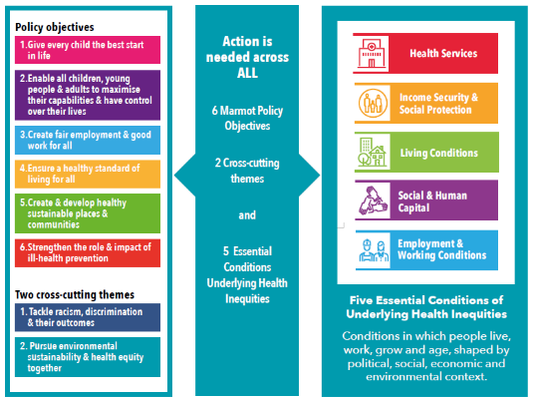
The PHS points to the evidence informed actions (Marmot & WHO) needed to tackle health inequities (Figure 1: Evidence informed action to tackling health inequalities, Population Health Strategy, 2023). The evidence base makes it clear that action is needed across all these policy objective areas and 5 essential life conditions to deliver population health gain at scale. It widens the Health Board focus from solely healthcare provision and explicitly recognises not only the significant contribution of others to the agenda but also the actions we can take as part of our wider corporate and anchor organisational responsibilities / roles. This requires us to work with and through others, on mutually agreed action that is bold, disruptive, collective and long-term / sustainable if we are truly to achieve a ‘Better future for all’.

‘Why’ do we need to act to tackle poverty?
The evidence base consistently highlights that a lack of financial resources (income & wealth), with people not financially ‘coping’ day to day, has a direct and significant impact on people’s physical & mental health. Not being able to afford the basics, persistently, leads to chronic stress which has a physiological impact on the body leading to a variety of health conditions. There is much debate about different measurements of poverty (e.g. relative vs absolute vs overall; childhood; fuel; food; digital; social etc.) as well as other emergent concepts/terms such as persistent poverty which means someone who has lived in poverty for 3 out of the past 4 years; or deep poverty which is defined by households who are below 40% of median income. In 2020-21, a single adult in very deep poverty would be living on ≤£109 / week (after housing costs). People generally will move in and out of these groups over time but sometimes in a cyclical manner.

In Wales, the main measures are:
- Relative income poverty (the key measure in Wales) – where the total household income from all sources is less than 60% of the average UK household income (as given by the median). This is captured as before and after housing costs (i.e. mortgage interest payments/rent, water rates and structural house insurance payments) and is subdivided as people; children; working-age adults; pensioners.
- Absolute income poverty – where the total household income is below 60% of the 2010-2011 median income adjusted for inflation. This is also reported as before and after housing costs and subdivided as described above. It is produced by DWP and is designed to assess how low incomes are faring with reference to inflation.
- Material deprivation – designed to capture consequences of long-term poverty on households rather than short term financial strain.
- Destitution – where you can’t afford the basics such as shelter, heating and clothing.

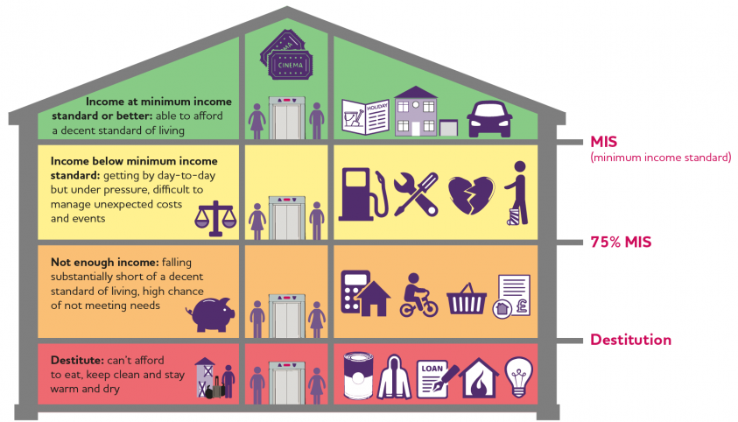
JRF have come up with an additional measure of Minimum Income Standard (MIS) which is not a measure of poverty in itself but is based on what the public have told them is sufficient income to afford a minimum acceptable standard of living. Shown here. Source: Joseph Rowntree Foundation

The purpose of this paper isn’t to debate the merits of different measurements or dimensions of ‘poverty’. Ultimately, the concept of poverty means different things to different people and to some extent, requires a judgement call to be made as to where to draw the poverty line or whether to focus on different dimensions and definitions. For the purposes of this paper, the importance is that when we use the term poverty, we are talking about when people lack financial resources to afford to meet their basic needs.

In Wales between 2019-20 and 2021-22, 21% of all people in Wales were living in relative income poverty (after housing costs were paid). We also know that between 2020-2022, 28% of children in Wales were living in relative income poverty which equates to approximately 190,000 dependent children under the age of 19yrs.

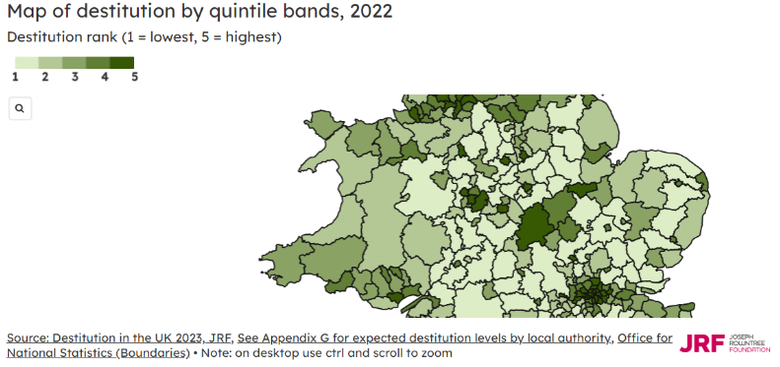
If we look at destitution, we see that there are higher rates in major cities and former industrial areas. For Swansea and Neath Port Talbot, they are ranked 4 and 3 respectively in terms of destitution by quintile bands, 2022 (shown here)

In September 2023, the Bevan Commission snapshot survey of poverty found:
- More than one in seven households in Wales (15%) sometimes, often or always struggle to afford essential items while around 3% live in destitution.
- Large numbers of people are going without essentials including more than one in four (26%) eating smaller meals or skipping meals in their entirety.
- Debt is a significant problem with 29% of people borrowing money between April 2023 and July 2023 and 13% being in arrears on at least one bill for at least one month.
- More than four in ten people who have cut down on the size of meals or skipped meals entirely have borrowed money from friends and family (45%) or on a credit card (42%) since April 2023.
- People’s health is being negatively affected by their financial position. 45% of people report this in respect of their mental health and 28% report this in respect of their physical health.

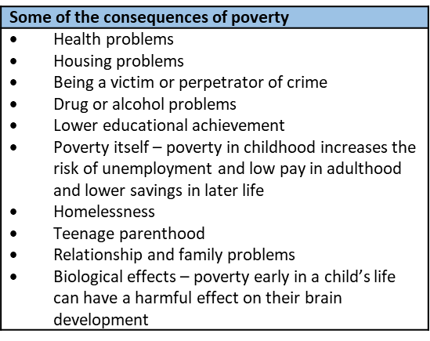
Poverty is not just the absence of money that people require to meet their needs. It is also the consequences of this lack of resources and how this impacts them in ways that those not in poverty often find hard to comprehend. Some of these consequences are listed below. However, some e.g. social isolation, exclusion, powerlessness, physical and emotional wellbeing, can extend and perpetuate poverty, making it difficult, if not impossible, for people to escape its impact. Often the way policies and services are set and delivered can make the situation far more challenging.

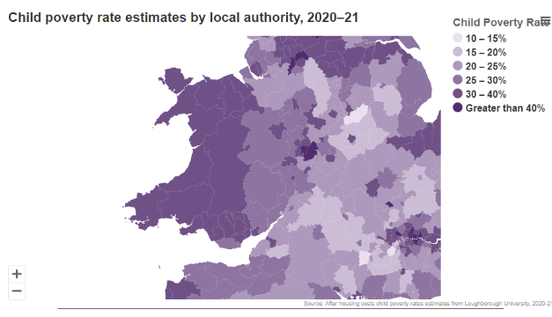
Wales has the highest poverty rate among the four nations. Estimates by local authority indicate in 2020-21 it stood at 33% for Swansea and 34% in Neath Port Talbot. (See figure shown here Source: 2023 UK Poverty report, JRF). Wales has also seen substantial increases in child poverty rates over the last six years of between 3-6%.

Children living in a household where no adult is working remain at higher risk of relative income poverty (43%) compared to children living in a working household (26%). However, 81% of children who were living in relative income poverty lived in working households. Lone parent households were most likely to be in relative income poverty (38%). There was a 40% likelihood of people whose head of household comes from a Black, Asian or minority ethnic group living in relative income poverty. This compares to a 22% likelihood for those whose head of household comes from a white ethnic group. 31% of children who lived in a family where there was a disabled person were in relative income poverty compared with 26% of those in families where no-one was disabled.

‘How’ do we tackle poverty?
Going beyond being able to describe levels of poverty by whatever ‘measure’, the causes of poverty in the UK are well documented and include:
- Unemployment and low-paid jobs lacking prospects and security (or a lack of jobs)
- Low levels of skills or education
- An ineffective benefit system
- High costs
- Discrimination
- Weak relationships
- Abuse, trauma or chaotic lives

In essence, money matters so anything that increases income has a protective effect. In addition, having savings to fall back on or having people to call on for support can also protect people from some of the worst effects of poverty. Whilst people are able to move out of different categories / types of poverty, the rate at which they do varies by different groups of people and certain life events and circumstances greatly increases the likelihood.

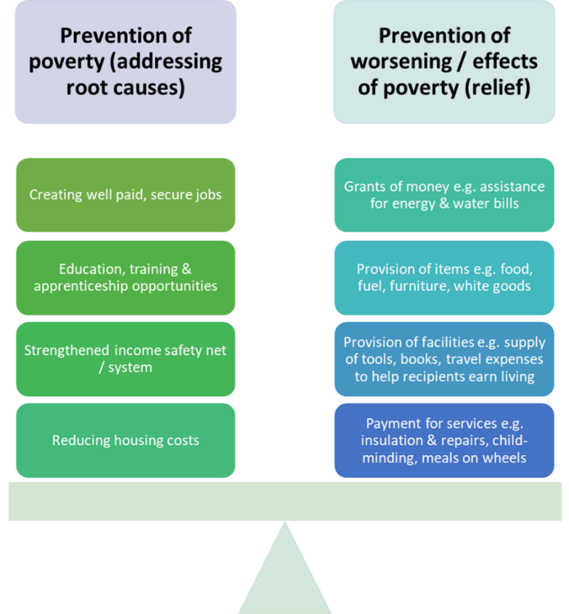
When thinking about ‘prevention’ of poverty, it is maybe helpful to recognise that there are different points along a continuum of financial need and that broadly prevention actions are usually focused on tackling the root causes, relieving the effects of and/or preventing those who are ‘poor’ becoming ‘poorer’. Some examples are shown here.

There is often a tension between these two perspectives or approaches. Those living in poverty face immediate problems as a result of not having enough money and balancing multiple, competing expenses e.g. ‘heating’ or ‘eating’. However, we know that poverty is subject to ‘churn’ with people moving in and out of poverty from one year to the next. If poverty is to be reduced, then preventing these poverty entries is as important as providing relief at the point of crisis.

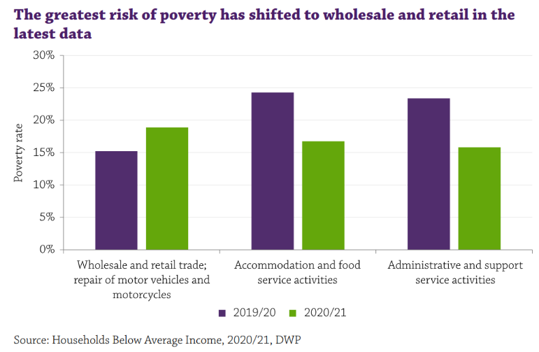
While work reduces the risk of poverty, incomes are often not sufficient to allow someone to escape from poverty. This is reflected in the high rates of in-work poverty, with Wales and the North of England seeing the highest rises outside of London in 2021. This is in part fuelled by the proliferation of precarious work, especially amongst the young. In 2020-21, 61% of working-age adults in poverty lived in a household where at least one adult was working. Poverty rates for part time workers was double that for full time workers (18% vs 9%) and self-employed workers were twice as likely to be in poverty than employees (21% vs 10%).

When looking by sector, workers in the wholesale and retail trade / repair of motor vehicles has the highest rates at 18% followed closely by accommodation and food services 16% and administrative and support activities 15%. Wales had one of the highest rates of poverty for working age adults across all four nations at 1 in 6.

These trends demonstrate that more needs to be done but we cannot neglect the role that paid work does and should have in lifting people out of poverty and maintaining living standards above the poverty line. There are a number of people for whom work fails to lift them above the poverty line and for some taking on more paid work simply isn’t an option e.g. they are in fulltime work; looking after children or other family members etc. Hence, whilst it cannot be the only pathway out of poverty, supporting the creation of well-paid jobs is of fundamental importance, especially as an ‘anchor’ institution with a large footprint and the role we can play in shaping local labour markets.

Several of the challenges faced by people living in poverty or social exclusion in Wales relate to where they live. Local costs of living, affordability of good quality housing, levels of crime, adequate employment, education and training all affect people’s quality of life, can entrench social exclusion and pose challenges to escaping poverty. Hence anti-poverty interventions need to consider how to foster enabling environments, tackling barriers to progression and improving conditions and opportunities where people live.

The idea that place-based policies are important to tackle poverty is not new. Interventions aimed at boosting local economies, improving physical environments, or revitalising town centres have not always benefitted those most in need. It has sometimes led to unintended consequences of gentrification of deprived areas and displacement of disadvantaged residents and local businesses. Yet their local community, including family and friends, is a vital source of both financial and non-financial support. Disrupting these networks can make people more vulnerable and exacerbate the hardships that they experience.

Fostering an enabling environment requires a range of interconnected policy areas e.g. addressing the availability, affordability and accessibility of transport. Policies need to focus on public transport and integration of different types of transport provision. Housing is another key area as the cost of housing is the single largest regular outgoing for the majority of households and any increases can impact heavily on already stretched finances. Prioritising social housing provision to ensure it is affordable, secure and high quality and promoting regulation, quality standards and tenant protection in the private sector are actions that show promise in preventing poverty.

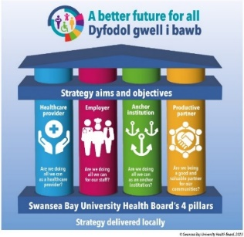
‘What’ can we do to tackle poverty?
As an NHS organisation we are not powerless in the face of poverty. There are practical actions we can take which are highlighted in our PHS and include as a provider & commissioner of services, employer as well as an economic and social actor, in line with our 4-pillar model (shown here). However, it requires active leadership and strong partnership working with other sectors, communities and individuals in, or at risk of, poverty.

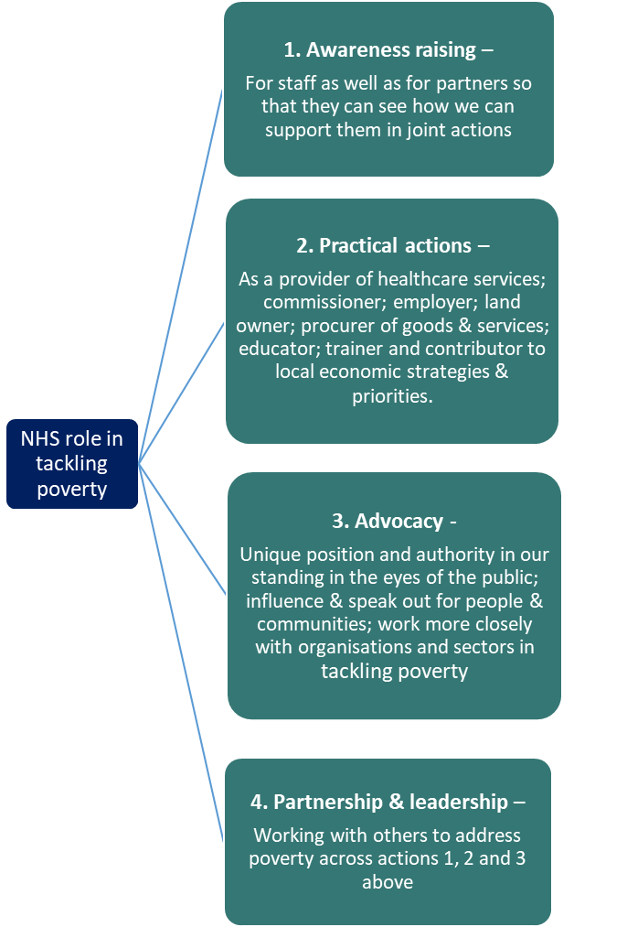
In 2021, the King’s Fund’s ‘The NHS’s role in tackling poverty – Awareness, action and advocacy’ report highlighted the key roles for the NHS as being: raising awareness among staff; developing concerted action to meet the needs of those experiencing poverty; and using its voice to advocate for tackling poverty (shown here).

ABUHB was one of the case studies highlighted showing the impact through a fiscal multiplier effect. It showed, based on 2009/10 figures, that through the way ABUHB considered it’s expenditure, it induced further spending in the Welsh economy of £746 million (a multiplier of 1.78); a further 8,754 FTE jobs (a multiplier of 1.82); and a further £324 million of value-added (a multiplier of 1.80). Source: Morgan et al 2017

There has been increasing focus on the need to tackle poverty in Wales, picked up through the Welsh NHS Confederation Health and Wellbeing Alliance and the Royal College of Physicians (RCP) as well as the role of Welsh government & local authorities by Audit Wales (‘Time for Change’ – Poverty in Wales, November 2022). Both these are helpful in providing some indication of the levels of expectations of us as an NHS trust and of the public sector more broadly in tackling the root causes.

- POTENTIAL APPROACH / OPPORTUNITIES TO TACKLING POVERTY
The ask arising from the discussion at the October Population Health & Partnerships Committee was to consider tackling poverty and financial insecurity as a unifying agenda for the Health Board to take into our partnerships spaces given it is the biggest contributor to inequality in health outcomes.

In line with the King’s Fund report findings and the evidence base within the PHS, we recognise that to tackle poverty, we need to take action across a number of areas, drawing on good practice. Appendix I outlines some potential actions that could be explored / arise from pursuing this agenda using the Kings Fund model. These equally map well onto our 4 pillars.

Looking at the learning/research, this would indicate that to be impactful we need to:
- Internally – agree actions we can take, in line with our 4-pillar model i.e. as a healthcare provider, employer and anchor institution, being clear on what actions we intend to take, including having greater clarity on the impact that poverty has on the health outcomes for our population.
- Externally – recognise our role as a system leader, becoming more active in our leadership and partnership role, engaging with and seeking collaboration with our partners to agree bold action that challenges us and them.
- Our approach – needs to involve co-production with those with lived experience and to recognise the importance of place & place-making.

The table aims to summarise current strengths, barriers and some reflections on the current approach:

Strengths / Opportunities | Barriers / Concerns | Reflection
- Long-standing agenda in Swansea – council has an anti-poverty strategy which it is currently refreshing.  - NPT Council are actively seeking to engage with partners on how do we address poverty & cost-of-living issues.  - Both LA areas have active anti-poverty forum/partnerships  - First ever Wales Poverty Truth Commission in Swansea – we are active partners  - Interest from partners & recognition within both PSBs of role of economic / poverty issues as part of development of Wellbeing plan  - Shared prosperity funds (in both LA areas - reporting into CJC) recognise role in anti-poverty agenda  - Active Celtic Freeport agenda & re-emergent concerns over Tata Steel means the conversations are currently active  - Health Board is strategic lead on early years – opportunity to focus on childhood poverty  - Impact of poverty on our population, patients and staff are explicitly recognised in our PHS – which has led to an appetite and recognition of the need to act – including recognition of what we are already doing.  - Audit Wales recommended Wellbeing Plans need to provide comprehensive focus on tackling poverty & for local authorities to have a champion and senior officer to lead the agenda. | - Focus of work in Councils are on mitigation actions – perception that all action to tackle poverty lies in the hands of government  - Employment agenda is limited to workability elements  - Limited connectivity between the ‘anti-poverty’ labelled fora that exist and the PSB. Where economic prosperity / focused fora exist, not connected to the anti-poverty remit/role.  - No forum currently that enables dialogue  - Tension between relief (mitigation actions) and prevention. Seen as competing  - We have no coherent, considered, purposeful statement of intent to support action internally nor support or challenge partners in their or our collective efforts. | - This is a live agenda for all partners – affecting us all in terms of the impact on our staff and core-business in terms of population ‘needs’  - No coherent narrative that helps to catalyse conversations across partners to illicit and agree actions as a collective (creating a tactical response)  - PHS launch offers opportunity to engage internally and externally with staff and partners on what action we intend / seek or wish to explore to tackle the causes and consequences of poverty.

The above indicates a clear active partnership and leadership opportunity & role/remit. In being purposeful in tackling poverty for our population, the questions we need to consider as a Health Board are:
  - What is it that we as a Health Board and NHS organisation can and do contribute to this agenda?
  - What are we seeking to agree / co-produce / negotiate with & through our partnerships that will have a demonstrable impact, that can only be achieved by working with and through others?
  - What are we seeking to advocate / lobby for at a national level?
  - What are our options / what is needed to take this forward?

There are opportunities arising from the imminent publishing of the PHS internally with staff and externally with our partners/stakeholders. This offers an opportunity to catalyse/instigate a more direct conversation to test out and develop our collective thinking and appetite for action.

- GOVERNANCE AND RISK ISSUES
A governance structure has been articulated for supporting the progression and implementation of the Population Health Strategy. There are ongoing discussions on how the existing structures and processes may be adapted to improve our ability as a system to consider our tactical response to strategic issues such as poverty and to support the operational delivery of effective interventions and programmes of work. The ongoing development of ‘population health ways of working’ and supporting infrastructure within the Health Board to design purposefully (commissioning) and deliver effectively (co-ordinating) will determine our ability to make progress for our population in addressing the impacts of poverty. The Director of Public Health considers that the internal approach to developing population health competence should provide a suitable foundation for effective actions against poverty and that a specific programme is not required. However, recent developments in relation to the workforce at Tata Steel and the external expectations around the response from the health sector create added urgency to the need for resolution around how work aimed at achieving population health is directed and supported within SBUHB.

Overall, assuring the work related to progressing the partnerships agendas sits with the Population Health and Partnerships Committee due to the explicit linkage with the ambition to be a population competent and focussed organisation.

There is a need to consider, in addition to support for measures that mitigate the impact of poverty, whether and how SBUHB undertakes advocacy in relation to measures required to address the root causes of poverty. Whether we will choose to speak out on structural drivers for poverty and, if so, how this will be undertaken. Advocacy may involve speaking out alone, as part of an alliance or confederation (formal and informal) and in supporting others to speak out as individuals or collectively. There is the potential that such actions will be seen as party political and so it will be important that any advocacy undertaken is framed appropriately, is directed at issues and not individuals, and that those directing or undertaking advocacy approaches are held accountable.

- FINANCIAL IMPLICATIONS
There will be financial implications related to the above, beyond investment of staff time. These are not yet quantifiable but some of the population health reserved funds could meet some of the initial costs of the development of the work. What falls out of the work is what is not possible to predict or quantify currently as not yet agreed. The work in reorientating the totality of the SBUHB’s budget to better achieve population health gains also offers opportunities into this space.

- RECOMMENDATION
The Committee is asked to:
- Note the case for why we need to address poverty & the impact on our population’s health
- Recognize the different approaches and actions needed in relation to relief (mitigation) and prevention of poverty.
- Note the situational assessment (starting point) of this agenda and that
- Consider options for taking this work forward including:
  - The relative priority to be given to this work and commitment to action on poverty
  - Whether our approach to tackling poverty will be adequately addressed through emergent approaches to developing population health competence or whether a specific programme is required
  - The impact of the expected response to the Tata Steel developments and developing our organisation’s position in relation to advocacy.

Governance and Assurance
Link to Enabling Objectives  (please choose) | Supporting better health and wellbeing by actively promoting and empowering people to live well in resilient communities
Link to Enabling Objectives  (please choose) | Partnerships for Improving Health and Wellbeing |  | ☒
Link to Enabling Objectives  (please choose) | Co-Production and Health Literacy |  | ☒
Link to Enabling Objectives  (please choose) | Digitally Enabled Health and Wellbeing |  | ☒
Link to Enabling Objectives  (please choose) | Deliver better care through excellent health and care services achieving the outcomes that matter most to people
Link to Enabling Objectives  (please choose) | Best Value Outcomes and High Quality Care |  | ☒
Link to Enabling Objectives  (please choose) | Partnerships for Care |  | ☒
Link to Enabling Objectives  (please choose) | Excellent Staff |  | ☐
Link to Enabling Objectives  (please choose) | Digitally Enabled Care |  | ☒
Link to Enabling Objectives  (please choose) | Outstanding Research, Innovation, Education and Learning |  | ☐
Health and Care Standards
(please choose) | Staying Healthy |  | ☒
(please choose) | Safe Care |  | ☐
(please choose) | Effective Care |  | ☒
(please choose) | Dignified Care |  | ☐
(please choose) | Timely Care |  | ☐
(please choose) | Individual Care |  | ☒
(please choose) | Staff and Resources |  | ☒
Quality, Safety and Patient Experience
The paper outlines the approach needed in terms of prevention of poverty as one of the biggest contributor to health inequalities. Taking action to address poverty through all aspects of our provision and interactions with our patients, will have a direct beneficial effect on their experience, quality of care and health outcomes. In particular it will mean a more bespoke, tailored approach to our services which will improve their well-being.
Financial Implications
To progress this work, it is likely there will be financial implications. These are not yet quantifiable. There may be financial implications in any options identified to taking this forward for us internally and through our partnerships.
Legal Implications (including equality and diversity assessment)
No legal implications identified. The incorporation of a population health approach to the prevention of poverty will allow for the identification of equality and diversity issues and development of appropriate responses.
Staffing Implications
Poverty impacts on our staff directly and through their interactions with patients. Taking action across our 4-pillars will identify where we can strengthen existing approaches to address the implications for our staff. Development of the implementation plan will also identify the skills and workforce requirements.
Long Term Implications (including the impact of the Well-being of Future Generations (Wales) Act 2015)
Population health approaches incorporate a prevention ethos and delivery is contingent on collaboration among partners to deliver better outcomes for our population. A coproduction approach is integral to public health practice and seeks to involve communities and staff in designing services and programmes.
Report History |  | No previous reports
Appendices |  | Appendix 1 - Potential actions / role for the Health Board as an NHS organisation in tackling poverty across Swansea Bay

