

Meeting Date | 07 December 2023 |  | Agenda Item |  |  | 4.2
Report Title | Internal capability & capacity to progress our population health aspirations/priorities
Report Author | Jennifer Davies, Deputy Director of Public Health
Report Sponsor | Keith Reid, Executive Director of Public Health
Presented by | Keith Reid, Executive Director of Public Health
Freedom of Information | Open
Purpose of the Report | This report updates the Management Board on:  - The discussions related to factors impacting on our ability to implementing our Population Health Strategy at the Population Health and Partnerships Sub-Committee.  - The proposed approach that was endorsed/approved by the Sub-Committee to developing our capability and capacity.  - Addressing the action arising from the discussion to bring the thinking to the Management Board for awareness and approval  - Agree mechanisms for the work to be developed, timescales, governance and resourcing.
Key Issues | On approval of the Population health Strategy (PHS) by Board, there was a recognition that this is the start of the journey and there are some risks identified around progressing implementation. These risks fall broadly into two areas. Firstly, a lack of understanding of the strategic, tactical and operational perspectives of strategy implementation at scale; and secondly and linked, a lack of current capability within SBUHB to design and deliver a coherent coordinated whole of organisation response within and across our current federated structures (corporate and service delivery groups).  - Capability and capacity are limited. That the PHS and its implementation are owned by us all (ie it is a whole of organisation / whole of system strategy) is not well understood or appreciated. This is shown in poor engagement and how the strategy is talked about, which indicate that this is seen as a ‘public health team’ agenda as opposed to a whole of organisation strategic intent with reputational and population health risks to non-delivery.  - Given the new organisational vision, there is a need to knit together the different strategic narratives through the development of the appropriate supporting infrastructure & delivery mechanisms as part of developing our tactical response / narrative – the ‘how’ we deliver change. A failure to do so will create perceived additional burden on the system and fragmented approach to actions arising from competing ‘asks’.  - Embedding and adopting a population health approach requires different behaviours across all parts of the system. Behavioural science indicates the need to understand these behaviours in context, in order to be successful in achieving change.  - This is reinforced by the fact that where progress has been made, this is limited to areas of ‘service based’ activity aimed at ‘lifestyle factors’ e.g. weight management, smoking cessation services. These have only marginal impact on population health but the paradigm is familiar (doing things to individual people) and therefore not challenging to current thinking and ways of working.  - There remains a need to shift our ways of thinking and working – embedding population health principles and priorities into our business as usual processes & mindset.  - Having communicated our intentions and actions internally and externally, expectations will be raised and hence there are reputational risks in failing to deliver progress.
Specific Action Required  (please choose one only) | Information | Discussion |  | Assurance | Approval
Specific Action Required  (please choose one only) | ☐ | ☒ |  | ☐ | ☒
Recommendations | Members are asked to:  - Note the challenges to implementation of the PHS highlighted / identified  - Approve the suggested approach to addressing our capability and capacity challenges highlighted and the investment of £60K for 2023-24 and £125K/annum for 2024-25 onwards to progress the work.

Internal capability and capacity to progress our population health aspirations

- INTRODUCTION
The Population Health Strategy (PHS) was approved by the Board in March 2023 along with year one priorities based on the recognition of where we are starting from as an organisation in terms of our internal infrastructure, capability and capacity. These were in line with the 4 pillars model that characterises how the functions of the Health Board can be tuned to deliver population health gain.

At the Population Health and Partnerships Committee meeting in October 2023, a proposal to progress our capability and capacity development through a developmental programme of work was endorsed. The ask was to:
- Outline the programme and approach
- Detail the resourcing needed to progress the work / programme

This paper details the case for a proposed approach, based on behavioural science, to addressing the key issues underpinning our capability and capacity in order to implement the PHS at scale.

- BACKGROUND
The case has been accepted that inequalities in health arise because of inequalities in society and the conditions in which people are born, grow, live, work and age – leading to differential levels of vulnerabilities. These inequalities may be amplified by how healthcare is organised and delivered.

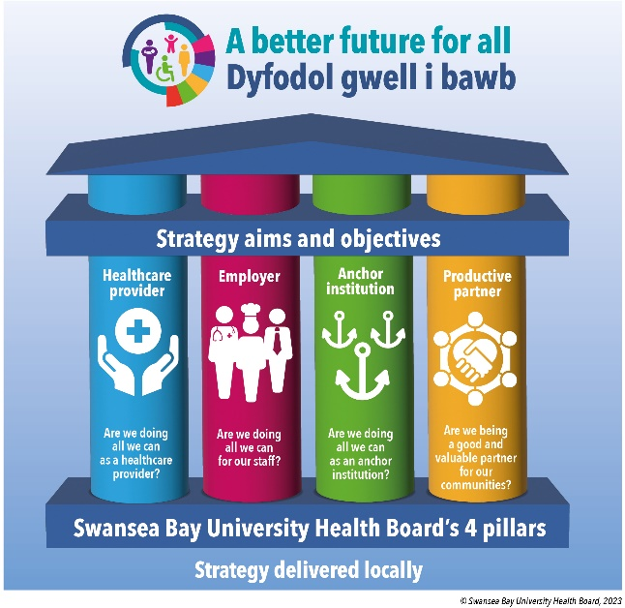
Our PHS describes the evidence informed actions (collated in the Marmot & WHO reports) needed to tackle health inequities. The 4 pillar model (see figure 1 below) has been developed to enable the translation of the evidence base into our corporate functions.

Implementation of the PHS requires an ability to develop our understanding of population health approaches and to act on those as a whole or organisation and system. For successful delivery of population health gain these new ways of working require behaviour change at scale across all parts of our organisation.

Through our engagement with different parts of the organisation, we have recognised that capability in relation to population health (knowledge and technical skills) is currently limited and spread unevenly through the system. What we are seeking is to develop a programme of work that builds capability and capacity, from our existing starting point, in order to achieve sustainable delivery of population health approaches, within our current operational machinery.

- DEVELOPMENT OF A SYSTEM-WIDE APPROACH
The implementation of PHS at scale requires concerted and coordinated action across strategic (why), tactical (how) and operational (what) perspectives of the organisation and externally. Extensive organisational engagement activities have highlighted a number of limiting factors or challenges we face that limit our ability to implement our PHS strategy and ambitions. These include:

- The narrative, whilst broadly welcomed, is poorly understood in terms of how it must be interpreted and used to inform action across all parts of the business / in real terms. This directly impacts on the capability & also capacity to progress this agenda, resulting in a reliance on a small number of individuals, leading to much slower progress than we would like to see. [Capability related factors]
- Population health, consequently, is not consistently viewed as being ‘my role’ or incorporated into corporate agendas, which has led to highly variable engagement internally, leading to missed opportunities to take forward the required work. [Opportunity & Motivation related factors]
- There is an expectation currently that the SDGs will be able to do the interpretation of how the population health strategy could / would best be taken forward across their various service level activities, in a consistent way that will lead to the intended population level outcomes. But the tactical thinking underpinning this (the ‘how’ element of implementation) has not been undertaken. [Capability, Opportunity & Motivation related factors]
- This lack of a tactical framework to guide the required approaches to delivery reflects that absence of a forum or infrastructure to support tactical thinking at a system level within SBUHB. Consequently the apparently competing various strategic narratives (perceived ‘asks’ and expectations of the organisation) are not integrated into appropriate, impactful and evidence based actions at SDG level and across the breadth of the organisation’s activities. The impact & value lies in acting at scale which requires joined up approaches/thinking. This represents a departure from the current approach where strategy is reflected largely in compendia of operational responses. [Opportunity & Motivation related factors]

The emergent learning is that the development of relationships within our system that enable collaboration and partnership working is vital to SBUHB realising its ambition to be population health competent. However, these relationships need to operate in a way that supports the need for whole organisation cultural, behavioural and operational change. The required change will derive from the following activities:

- Create a strategic narrative within the PHS by translating / make sense of the evidence base, in context, for population health gain, across all aspects of the Health Board’s business. The expectation is that the Public Health Team (PHT) will drive much of this sense making. However, its capacity is limited due to the size of the team and the capability therein.
- Agree ownership / leadership of agreed population health priorities at a strategic & tactical level. The Board requested & approved a set of initial PHS priorities to be proposed as a starting point on the journey. Failure to make progress reflects that there is no mechanism in place to take these into the organisation’s business because they do not feature currently in delegated responsibilities. There is a need to identify who will undertake and how can actions identified in the PHS be taken forward, recognising existing structures & capability. This requires a process of negotiation across the system because the current processes and structures have not delivered this requirement.
- Support value creation, recognising the different ‘asks’ / demands on the system and ensure a coherent interpretation of these, dynamically managing the necessary trade-offs and judgement calls inherent in a complex, adaptive and dynamic system. This needs to be cognisant of the existing structures / collaborative spaces / governance mechanisms.

Achieving behavioural change:
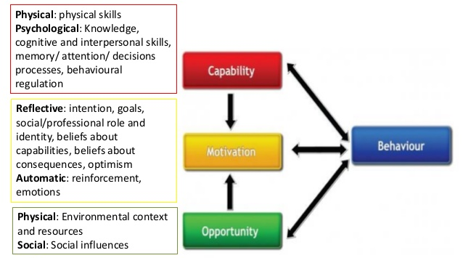
Within the extensive field of behavioural science, there are numerous behaviour change theories, models and techniques that have been studied over time. A consensus model was developed, uniting much of the literature at that time, encapsulated into the COM-B model (shown here). This is a well recognised and adopted model in the application of behavioural science.

This model helps explain why behaviours occur and indicates what the focus of the intervention could/should be to change that behaviour. Source: Michie et al., 2011

When applied to capability and capacity development, some examples of potential drivers of behaviours might be:
- Psychological Capability – lack of understanding of what actions/behaviours are needed, cognitive abilities to know how to act.
- Reflective motivation – lack of confidence, fear of consequences, seeing it as ‘my role’
- Automatic motivation – rewards / acknowledgements, punitive action
- Physical opportunity – systems, processes and resources to support behaviours, environmental cues
- Social opportunity – stigma, judgement of others, leadership/role model behaviours

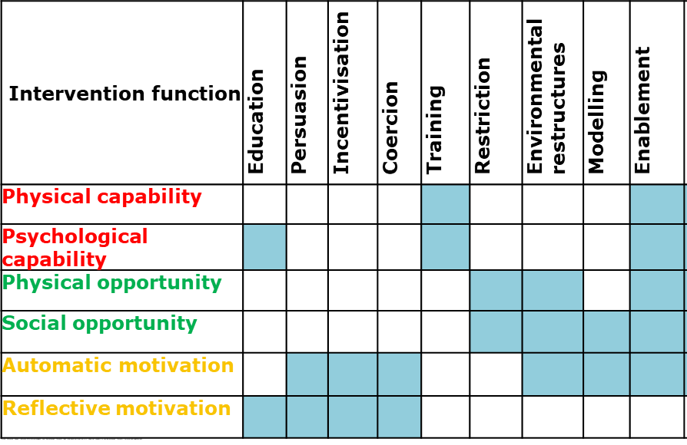
The starting point of applying behavioural science is to understand the behaviours in context. This then allows the application of relevant interventions based on behaviour change techniques known to be effective in influencing the factors that lead to the behaviours.

The type of interventions that impact on different factors leading to behaviours is shown here. Applying this thinking and approach increases our likelihood of being successful.

The desire to progress the PHS and engagement to date, has uncovered higher levels of motivation than previously understood for this agenda. Engagement and joint working with colleagues and teams have, for the most part, led to a shift in thinking, working and/or practice. However, this has been small scale to date, due in part to the work context which reinforces existing behaviours. We know that changing behaviours, even at a small scale, requires significant effort. Behaviour change is often unsuccessful if understanding of current behaviour is poor and drivers to perpetuate that behaviour are not uncovered, understood and planned for in terms of intervention design, at all levels of the COM-B model.

With that in mind and given our starting point, the proposal presented to & approved by the Population Health & Partnerships Sub-Committee is to scope out and develop a process of organisational change supported by a development programme that grows our population health capability at all levels of the Health Board, drawing on behavioural science approaches. Recognising that to be successful requires both top down and bottom up thinking and coherent action. A potential framework/approach is outlined below:

Why | What | Who | How
- Strengthen the strategic narrative and leadership capability internally & externally | A development programme that knits together the different strategic narratives, makes sense of them and helps to synergise and consider our commitments & appropriate tactical response – working with and through others. | This will focus on the Executive Directors, Independent Members, Service Group Directors | Board Development;  Executive Directors fora  Senior Leadership / Management fora in SDGs and Corporate
- Strengthen the ability and agility to mount an appropriate tactical response to an agile/adaptive strategic context | A development programme that creates the capability and capacity to consider and provide an appropriate tactical level response to multiple & seemingly competing demands / asks, shifting strategic context using experiential judgement underpinned by evidence based, prevention, person centred and equity. | This will focus on those with the responsibility for enacting strategic intent through setting of targets / development of annual plans etc. Likely to be direct reports to middle / senior management & leaders across the organisation including direct reports to Exec & Service Directors | Existing fora e.g. LTP; IPG; CSOG; Management Board BCAG / BCSG; VBHc; One Bay Way, SDG SMTs. There may be a need to create additional/complementary mechanisms for capacity development, appropriate to the given context.
- Support the development of capability to operationalise population health approaches & evidence based / informed practice | A development programme that works with the tactical leads / senior managers responsible for overseeing and developing services to provide support / knowledge & skills transfer. | Due to current capacity to support the organisational development programme, likely that this will involve coaching / support to the above cohorts?? | Existing fora where applicable. Opportunistically as the need arises, esp where there is a common or cross cutting capability issue/need identified. Development of resources, signposting to training etc.

- TAKING THIS FORWARD / NEXT STEPS
Given our starting point and to be successful in achieving behaviour change there is a need to use a systematic planned approach. The proposal is to buy in the technical expertise, funded using the ‘population health’ reserves, to apply a Social Marketing Planning Process, used extensively by WHO and USAID. This will need to be an adaptive process leading to an emergent programme of work. However, the proposed planning process and stages to provide the evidence base to enable us to use the COM-B model and achieve transformation in terms of capability and capacity are as follows:

1. Creating a baseline using secondary evidence and primary research. Enabling us to answer the Where are we now? (Capability/Opportunities and Motivation). What are existing behaviours and how are they likely to impact on change? (This leads to a baselining through a combination of quantitative and qualitative research such as through a simple survey)
2. Development of behavioural goals (based on baseline and organisational needs and outcomes). This enables us to answer the following questions: What behaviours do we need to encourage to change and in what segments of staff? How do we expect these behaviours to impact on outcomes?
3. Insight and segmentation (from primary research - interviews/focus groups/observational analysis) then used to understand existing attitudes, behaviours and actions in segmented groups of employees. Enabling us to answer the question of what are the current barriers that are blocking change and motivators that could encourage change?)
4. Co-design (with segmented target groups of employees) of interventions to tackle barriers and promote motivators. These interventions are likely to be focused around the following mechanisms - education, support, re-design, control, incentives.
5. Creation and operation of a monitoring & evaluation framework - to test if we are achieving our behavioural objectives and effectively outcomes.

This process would allow us to develop a deep understanding of present attitudes and behaviours but also a process to understand how we could change them.

The initial investment required is £60K this financial year, rising to an estimated £125K/annum for 2024-25 onwards. This will need to be reviewed in line with the adaptive, developmental nature of the programme of work and any further investment that may be needed arising from this work will need to be quantified. As stated above, the intention is that this would draw on the ‘population health reserves’ to support this work. If/once approved, this work could start immediately. We have built in review points which allow us maximum flexibility to adapt and amend or cease in light of the findings/insights.

- GOVERNANCE AND RISK ISSUES
A proposed governance structure has been established to take forward and provide assurance for the delivery against the Population Health Strategy aims and aspirations. Initiatives, approaches and actions in service of the PHS naturally sit across all service groups and in partnership spaces. As has previously been commented, the structures are designed for a mature system. They are not appropriate to guide a developmental / transformational phase of establishing and embedding the PHS. Identifying and creating appropriate supporting structures to facilitate the required cultural and behavioural change forms a necessary part of the underpinning work to implementation of the strategy.

A proposal based on the current structures, is that the development work would report into the Population Health Development Board during its design phase/stage. This would require a change in the role and membership of the PH Development Board – mandating attendance by senior management from all Service Delivery Groups and linking with Corporate functions. As the work becomes systematised and operationalised, the intention would be to embed the reporting on progress and performance through the appropriate existing performance & governance structures, where these exist.

- FINANCIAL IMPLICATIONS
The initial financial commitment to progress this work is outlined above and is in addition to the investment of staff time (which is uncosted here). The intention is to draw on the population health reserved funds to meet these initial costs of the development of the work leading to the creation of a programme to support behaviour change and skills development. The extent of this programme emerging from the insights work is not possible to predict or quantify currently. The insights & proposal arising from this work will be aimed at enhancing our ability to consider & re-orientate SBUHB’s activity better to achieve population health gains.

- RECOMMENDATION
Members are asked to:
- Note the challenges to implementation of the PHS highlighted / identified.
- Approve the suggested approach to addressing our capability and capacity challenges highlighted and the investment of £60K for 2023-24 and £125K/annum for 2024-25 onwards to progress the work.

Governance and Assurance
Link to Enabling Objectives  (please choose) | Supporting better health and wellbeing by actively promoting and empowering people to live well in resilient communities
Link to Enabling Objectives  (please choose) | Partnerships for Improving Health and Wellbeing |  | ☒
Link to Enabling Objectives  (please choose) | Co-Production and Health Literacy |  | ☒
Link to Enabling Objectives  (please choose) | Digitally Enabled Health and Wellbeing |  | ☒
Link to Enabling Objectives  (please choose) | Deliver better care through excellent health and care services achieving the outcomes that matter most to people
Link to Enabling Objectives  (please choose) | Best Value Outcomes and High Quality Care |  | ☒
Link to Enabling Objectives  (please choose) | Partnerships for Care |  | ☒
Link to Enabling Objectives  (please choose) | Excellent Staff |  | ☐
Link to Enabling Objectives  (please choose) | Digitally Enabled Care |  | ☒
Link to Enabling Objectives  (please choose) | Outstanding Research, Innovation, Education and Learning |  | ☐
Health and Care Standards
(please choose) | Staying Healthy |  | ☒
(please choose) | Safe Care |  | ☐
(please choose) | Effective Care |  | ☒
(please choose) | Dignified Care |  | ☐
(please choose) | Timely Care |  | ☐
(please choose) | Individual Care |  | ☒
(please choose) | Staff and Resources |  | ☒
Quality, Safety and Patient Experience
The paper outlines what is needed to progress the population health strategy implementation and adoption. Implementation of an effective population health approach will lead to a more consistent approach to prevention.
Financial Implications
The paper notes that investment is required in order to progress this work. For 2023-24 this is £60K and for 2024-25 onwards it is estimated as £125K per annum. The intention is to draw on the population health reserves to support this work. Any further investment that may be needed arising from this work is not yet quantified.
Legal Implications (including equality and diversity assessment)
No legal implications identified. The incorporation of population health approaches will allow for the identification of equality and diversity issues and development of appropriate responses.
Staffing Implications
The proposed programme will offer an opportunity to significantly increase the organisation’s capacity and capability to adopt different / new ways of working and thinking in order to implement the PHS aspirations.
The Public Health Team remains small. Additional roles are being created and recruitments underway but progress remains slow. This is likely to impact on the speed & scale of delivery of the org programme. It may also require a different skills mix.
Development of the implementation plan will identify the skills and workforce requirements.
Long Term Implications (including the impact of the Well-being of Future Generations (Wales) Act 2015)
Population health approaches incorporate a prevention ethos and delivery is contingent on collaboration among partners to deliver better outcomes for our population. A coproduction approach is integral to public health practice and seeks to involve communities and staff in designing services and programmes.
Report History |  | No previous reports
Appendices |  | Nil

