

Meeting Date | 07 December 2023 |  | Agenda Item |  |  | 3.1
Report Title | Regional Partnership Board: Partnership Investment Evaluation
Report Author | Michelle Davies, Head of Partnerships and Strategic Planning  Karen Stapleton, Deputy Director of Strategy
Report Sponsor | Nerissa Vaughan, Interim Director of Strategy
Presented by | Nerissa Vaughan, Interim Director of Strategy
Freedom of Information | Open
Purpose of the Report | The purpose of this report is to provide detail on the following:  - Description of the RIF evaluation process established by the West Glamorgan Programme Office to evaluate all schemes due for review  - Overview of Health Board participation in the evaluation process and an update on the internal work to improve the sharing of knowledge and information across the Health Board  - Summary of the schemes to be reviewed for Children & Young people
Key Issues | The Health and Social Care Regional Integration Fund (RIF) is a 5 year fund to deliver a programme of change from April to March 2027. The aim of the RIF is to create sustainable system change through the integration of health and social care services.  At the last meeting of the Committee in October, members received a report outlining the regional investment available via the West Glamorgan Regional Partnership Report, and members highlighted the importance of having an understanding of how the funding is utilised and ongoing assurance in relation to the review and evaluation of existing schemes in addition to future new allocations. Members highlighted the need to ensure value for money, appropriate use of resources and an understanding of the benefits.  It is critical that the Health Board are involved and contributing to the discussions happening in the updated RPB governance structure. The Health Board must ensure that we have the right people in the right place to increase visibility and to influence plans, including the allocation of regional investment. In addition to increased visibility, there is a need to improve the way the Health Board collaborate and work in partnership. The Strategy Team have progressed work internally with colleagues across the Health Board to understand what action is required to enable that improvement.
Specific Action Required | Information | Discussion |  | Assurance | Approval
Specific Action Required | ☐ | ☒ |  | ☒ | ☐
Recommendations | Members are asked to:  - NOTE the evaluation process in place and the Health Board participation.  - NOTE the work undertaken internally by the Strategy Team to improve the internal Health Board approach to working in collaboration.

Regional Partnership Board (RPB) – Partnership Investment Evaluation

- INTRODUCTION

At the last meeting of the Committee in October, members received a report outlining the regional investment available via the West Glamorgan Regional Partnership Report. The report set out the formal arrangements in place to support the allocation of funding, and members highlighted the importance of having an understanding of how the funding is utilised and ongoing assurance in relation to the review and evaluation of existing schemes in addition to future new allocations. This report sets out the following:

- Description of the evaluation process established by the West Glamorgan Programme Office to evaluate all schemes due for review
- Overview of Health Board participation in the evaluation process and an update on the internal work to improve the sharing of knowledge and information across the Health Board
- Summary of the schemes to be reviewed for Children & Young People

- BACKGROUND

2.1 Regional Investment Fund (RIF) allocated by Welsh Government via the West Glamorgan Regional Partnership Board arrangements

The Regional Integrated Fund (RIF) is the 5 year regional funding programme confirmed by Welsh Government to run from April 2022 to March 2027. Welsh Government have provided detailed RIF guidance, and remains static over the 5 year period. The RIF funding model approach is as follows:

- New projects are developed and tested over a 2 year period and form part of the Acceleration Fund.
- If the project is evaluated as having had good impact on the population (via evidence from the performance measures captured) and is agreed by all partners as meeting regional needs then the region will have a further 3 years to embed and mainstream and this forms part of the Embedding Fund.
- Once embedded if proven to be a regional service which has a pooled fund then there is an option whereby Welsh Government could contribute 50% towards the sustainable solution.
Regional Partnership Boards (RPBs) must ensure that the right infrastructure is in place to support the delivery of its statutory requirements as set out in the Social Services and Well-Being (Wales) Act 2014. As a minimum RPBs are expected to ensure their regional infrastructure arrangements are in place. These arrangements include specific roles and responsibilities to be carried out, and include integrated business intelligence and performance management, and facilitating joint commissioning/ planning.

The West Glamorgan Programme Office (WG Programme Office) undertakes this role on behalf of partners in Swansea and Neath Port Talbot, and have facilitated the development of the updated governance structure. The WG Programme Office is responsible for the overall monitoring of the RIF schemes and will co-ordinate the reporting and monitoring process, to ensure proposals are on target to spend the allocated funding and achieve the expected outcomes as outlined in the original proposal.

2.2 West Glamorgan Programme Office Evaluation Process

The West Glamorgan Programme Office have established an evaluation process, and the process has been shared with the Regional Partnership Board and agreed with all partners - full details are attached as appendix 1.

There are 49 schemes currently in the process of being evaluated and these schemes total £6.4m. Some of this investment sits under the Communities and Older People’s Programme and are subject to a Section 33 for Integrated Community Services for Older People. Development of a robust evaluation process had been established by the WG Programme Office. There are three elements to the review process:

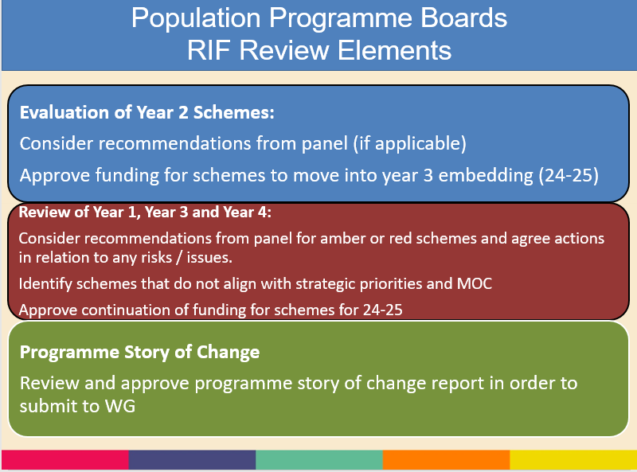

Evaluations are due for all RIF funded schemes currently under acceleration year 2 in quarter 3, 2023, after which decisions will need to be made as to whether schemes move into the embedding stage or are stopped which could release existing funding to allocate in 24-25. The evaluation template developed for the Year 2 Acceleration schemes includes the following information:

    - Summary of Evaluation Review
    - Project overview
    - Finance
    - Story of Change template (narrative)
    - Performance / Impact: RBA Measures

All schemes are reviewed to ensure alignment with strategic priorities included in Area Plan / Action Plan, themes within strategies, and national models of care. A completed evaluation template for a Children & Young People’s Service is attached as appendix 2.

The evaluation will be undertaken by a Panel, and the membership of those panels will mirror the Population Programmes already established. Please see a diagram below outlining the process:

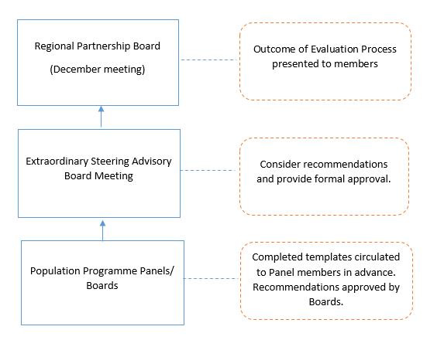
A summary of the RIF funded allocations in year 2 acceleration due formal evaluation to decide whether schemes are moved into the embedding stage is as follows:

The review of those schemes in year 1, year 3 and year 4 will be done on an exception basis as part of the same process, but the level of detail will be different. An assessment of activity will be undertaken on each scheme, and those that are not closely aligned to their original proposal will be reviewed by the Panels.

There are a number of schemes included within the section 33 for Intermediate Care Services in addition to the above, and it is currently not possible to evaluate this proportion of the funding given it is part of the wider system. There is a plan to produce a one story of change template and performance data for section 33 Intermediate Care Services, and the governance for that is through the regional Joint Partnership Board and then through the Communities and Older Persons Board.

2.3 Health Board Participation in the Evaluation Process

The RPB is responsible for agreeing and managing the overall strategic direction and ensuring effective governance of the use of the Regional Integration Fund (RIF). The governance structure has recently been updated, and is attached as appendix 3. The RIF Evaluations will be undertaken aligned to Population Programme Boards and this is why good Health Board visibility throughout the RPB governance is critical to inform this type of process. Health Board leads have now been agreed for the programme areas as follows:

- Deb Lewis, Chief Operating Officer, Chair, Communities & Older People
- Ceri Gimblett, Service Group Director, Vice Chair, Children & Young People and ND & Autism programmes
- Karen Stapleton, Deputy Director of Strategy, Chair, Emotional Wellbeing and Mental Health and Vice Chair of Accommodation Solutions
- Janet Williams, Service Director, Mental Health & Learning Disabilities, Vice Chair, Wellbeing and Learning Disabilities
- Helen St John, Head of Integrated Community Services, Vice Chair, Communities & Older People
- Kerry Broadhead, Assistant Director of Strategy, Chair, Transforming Complex Care
- Dermot Nolan, Associate Service Group Director for MH and LD, Vice Chair, Transforming Complex Care
- Gareth Westlake, Assistant Director of Digital Services - Business Management and Information Governance, Chair, Digital and Data Transformation
- Nicola O’Sullivan, Head of Engagement, Coproduction

As part of the Partnership Development work undertaken by the Strategy Team, and following a series of workshops held over the summer 2023 it has been identified that knowledge and information sharing needs to be improved across the Health Board. A new Strategic Partnerships Group has been established where the main objective is to share knowledge and information in relation to the RPB and the PSB, however it is also an environment where opportunities and challenges can be discussed in detail. Engaging and empowering colleagues from across the Health Board will enable the following:

- Collective responsibility
- Coherent approach
- Patient/ citizen focussed
- Statutory Compliance

The first meeting of the Strategic Partnerships Group was held on the 8th November, and colleagues in attendance appreciated the work ongoing to improve how we collaborate with our partners and there was a strong appetite for continuation of the Group. The Terms of Reference of the Strategic partnership group are attached as appendix 4.

2.3 Focus on Children & Young people – Evaluation of Schemes

A practical example of how the evaluation process is being undertaken can be illustrated by a focus on the CYP. The Panel and Programme Board for Children & Young People is scheduled for the 24th November, and members of the Panel/ Board will be asked to undertake the following:
- RIF Evaluations for year 2 funded schemes – 4 projects with templates completed
- RIF Quarter 2 Review for all other funded schemes (year 1, 3 and 4) – includes 19 RIF funded projects.

The four projects for formal review are as follows, and an example is attached as appendix 2.

- Y-Hub – YMCA Swansea
Y-Hub is a direct response to the needs of young people in Swansea who may be engaged in or vulnerable too; County Lines, Antisocial Behaviour and Exploitation as well as young people who may be not in education or employment.
- Brighter Futures – Faith in Families
Brighter Futures will target children who have experienced often multiple ACE’s and are struggling with big emotions such as anger and anxiety, this is often displayed in unwanted behaviors meaning that they find school, friendships, and life in general difficult.
- Special Guardianship Orders (SGO) / Kinship care project – Swansea CVS
The project meets the needs of children and young people subject to Special Guardianship Orders (SGO's) and similar kinship orders. As a group, the children are likely to have experienced trauma and neglect. There is an entitlement to a support needs review, but the reach and ability to offer associated services is limited.
- Glantawe Riverside Park - Glantawe Outdoor Education Academy
Most of the young people who access the service are struggling with mainstream school. Some are on the autistic spectrum, or have literacy difficulties, emotional or behavioural, or mental health issues such as anxiety or depression. We have had lots of reports of improved behaviour and career prospects because of our intervention.

The year 2 funded schemes due a formal evaluation in line with the RIF model will have provided the following information:

- Project overview – for information (included in the original application)
- Finance Update (end of quarter 2)
- Story of Change (narrative)
- Performance (RBA measures: How much, how well, difference made)

In addition to the above, a summary of the evaluation has been included in the front end of the document, members will be asked to score in relation to:

- Alignment of schemes to the strategic priorities and RIF models of care
- Scoring of the RBA measures
- Deliverability of the project – RAG

Panel members will need to approve (or not) funding for schemes to move into year 3 embedding.

Quarter 2 returns for the other schemes (year 1, 3 & 4) will be reviewed and a RAG rating is included. It is proposed that only the amber and red RAG schemes are reviewed by the panel to discuss the identified issues.

Panel members will approve continuation of funding for another year and agree actions to resolve any issues - this may include consideration of withdrawing funding from April 2024 if the issues are critical.

3 FINANCIAL IMPLICATIONS

There are no direct financial implications for the Health Board as a result of this paper, however it should be noted that investment made into Health Board services is now in the embedding stage and the future value of these services needs to be evaluated.

4 RECOMMENDATIONS

Members of the Committee are recommended to note the following:
- NOTE the evaluation process in place and the Health Board participation.
- NOTE the work undertaken internally by the Strategy Team to improve the internal Health Board approach to working in collaboration.

Governance and Assurance
Link to Enabling Objectives  (please choose) | Supporting better health and wellbeing by actively promoting and empowering people to live well in resilient communities
Link to Enabling Objectives  (please choose) | Partnerships for Improving Health and Wellbeing |  | ☒
Link to Enabling Objectives  (please choose) | Co-Production and Health Literacy |  | ☐
Link to Enabling Objectives  (please choose) | Digitally Enabled Health and Wellbeing |  | ☐
Link to Enabling Objectives  (please choose) | Deliver better care through excellent health and care services achieving the outcomes that matter most to people
Link to Enabling Objectives  (please choose) | Best Value Outcomes and High Quality Care |  | ☐
Link to Enabling Objectives  (please choose) | Partnerships for Care |  | ☒
Link to Enabling Objectives  (please choose) | Excellent Staff |  | ☐
Link to Enabling Objectives  (please choose) | Digitally Enabled Care |  | ☐
Link to Enabling Objectives  (please choose) | Outstanding Research, Innovation, Education and Learning |  | ☐
Health and Care Standards
(please choose) | Staying Healthy |  | ☒
(please choose) | Safe Care |  | ☐
(please choose) | Effective Care |  | ☒
(please choose) | Dignified Care |  | ☐
(please choose) | Timely Care |  | ☒
(please choose) | Individual Care |  | ☒
(please choose) | Staff and Resources |  | ☐
Quality, Safety and Patient Experience
There are no implications in relation to Quality, Safety and Patient Experience to declare as part of this report.

Financial Implications
There are no financial implications to declare as part of this report.

Legal Implications (including equality and diversity assessment)
There are no legal implications as a result of this report.

Staffing Implications
There are no staffing implications as a result of this report.

Long Term Implications (including the impact of the Well-being of Future Generations (Wales) Act 2015)
The development of the RPB Area Plan is an integral part of public service organisations delivering against their statutory duties.

Report History |  | This is the first report to be considered by the Committee, specifically on Partnership funding.
Appendices |  | Appendix 1 – RPB Slides – Evaluation Process  Appendix 2 - CYP Completed Evaluation Template  Appendix 3 – RPB Governance Structure  Appendix 4 – Terms of Reference – Strategic Partnerships Group

