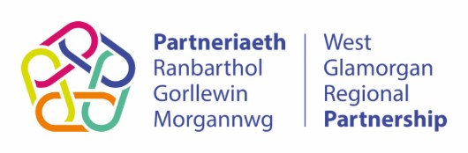
West Glamorgan Partnership
Summary Of Evaluation Review
Project Title: Y-Hub – YMCA Swansea
Project Reference Number: 11PC
Project Start Date: 01/08/2022

Alignment with Strategic Priorities and Models of Care
Aligns with CYP Action Plan/Area Plan Priorities | YES | Identify and implement transformative prevention and early intervention services: Improved awareness of prevention and early intervention services.  EWBMH: Increased awareness in the preventative services and schemes across the region
Supports ‘National Models of Integrated Care | YES | Prevention & community Co-ordination  Promoting good emotional health & wellbeing

Delivery of Impact / Performance: | Scoring |  |  |  | Scoring Criteria
How much (reference baseline from original proposal) Good level of measures provided.154 CYP supported 275 expected for the full year. High number of activities provided 54 and evidenced in the story of change. | 1 | 2 | 3 | 4 | 1 – Very poor  2 – Poor  3 – Good  4 – Excellent
How well? Number of individuals satisfied with the Early Help and Support (Targeted) provided = (100%) | 1 | 2 | 3 | 4 | 1 – Very poor  2 – Poor  3 – Good  4 – Excellent
Difference made? Number of Individuals reporting they are less Isolated = 93%  Number of Individuals maintaining improving emotional health & wellbeing = 100%  Number of individuals whose independence has improved or remained the same with the support of the project = 96% | 1 | 2 | 3 | 4 | 1 – Very poor  2 – Poor  3 – Good  4 – Excellent

Deliverability | RAG | RAG rationale
Is the project on track?  Are all posts recruited?  Has delivery of the project been delayed? |  | Green: Project on track  Amber: Some risks to delivery of project, with mitigations in place  Red: Issue to delivery project with limited or no resolution in place
Information provided in the Story of Change Template: Are there any cost avoidance, savings, or wider financial efficiencies you wish to demonstrate? | Project lead did not understand the question.  Guidance to be developed | Included in SOC template below - We are committed to prudent financial management and maximizing the value of every pound invested in our project. While our primary focus is on delivering high-quality services to young people, our financial practices also emphasize cost efficiency and responsible resource allocation. We demonstrate financial efficiency by meticulously planning and adhering to the budget we apply for. This disciplined approach ensures that funding is used effectively, with minimal wastage. We continuously monitor our expenditures, seeking cost-effective solutions without compromising the quality or impact of our services. Our collaborations with local partners and stakeholders enable us to access shared resources and leverage additional support. This not only reduces the financial burden on our project but also fosters a sense of community and collective responsibility for the well-being of young people.  As we move forward, we are committed to exploring innovative funding opportunities, cost-saving strategies, and partnerships that can help us sustain our services while remaining efficient in our financial operations. By doing so, we aim to ensure that every pound invested in Y-Hub creates a positive and lasting impact on the lives of the young people we serve.

SECTION ONE: Overview of Project (Information from Original Project Proposal)
 | What is the need you are trying to address with your project? Is there any evidence of demand? | Y-Hub is a direct response to the needs of young people in Swansea who may be engaged in or vulnerable too; County Lines, Antisocial Behaviour and Exploitation as well as young people who may be not in education or employment. YMCA Swansea work in partnership with the Contextual Safeguarding Team at Swansea Council that focuses on supporting young people that have been involved in Criminal and Sexual Exploitation.  Swansea and South-West Wales rank highly among the Welsh Indices of Multiple Deprivation, with many wards featuring in the top 20% of most deprived communities in Wales. The key issues affecting those we work with include homelessness, debt, poor wages and living standards, poor diets, health, lack of opportunity, lack of hope and aspiration, as well as a disbelief in the concept of social mobility. Directly, and indirectly, these circumstances manifest as issues such as drug and alcohol misuse, unsettled family life, poor relationships and interpersonal skills, making poor or misinformed life choices, poor educational attainment and ultimately young people failing to reach or even consider their true potential. Y-Hub's main aim is to provide a safe environment to support young people in our community and neighbourhood; to empower them, to support them to make positive life choices and so much more.  The majority of the young people who engage with YMCA Swansea state that they have nowhere else to go. They are vulnerable. Y-Hub is not only a safe space but a source of hope, education, and empowerment. It is of paramount importance that Y-Hub is able to continue to serve the community and impact as many young people as possible in Swansea.  Y-Hub is a catalyst for more in depth, vital and long-term work with Young People. The relaxed and safe atmosphere, a warm meal and other opportunities provide an attractive gateway for youth workers to engage with young people. Y-Hub also has strong links with our employability team who spend time with Young People providing information and hope for their potential futures. Many of those who engage with Y-Hub are also LGBTQ+ or Young Carers.  At YMCA Swansea and in particular through the work of Y-Hub we prioritise improving the social, economic, environmental, and cultural well-being of not only those who directly engage with the project(s) but of those in the community as a whole.  The key issues affecting those we work with include homelessness, debt, poor wages and living standards, poor diets, health, lack of opportunity, lack of hope and aspiration, as well as a disbelief in the concept of social mobility. Directly, and indirectly, these circumstances manifest as issues such as drug and alcohol misuse, unsettled family life, poor relationships, and interpersonal skills, making poor or misinformed life choices, poor educational attainment and ultimately young people failing to reach or even consider their true potential.
 | What long-term outcome/change are you hoping to achieve? | We recognise that the benefits of Y-Hub stretch further than the Young People who engage with us. The community as a whole benefits due to not only a potential reduction of anti-social behaviour, exploitation and so forth but also as Young People are receiving support and being empowered to participate in training and/or employment.  Y-Hub has a proven track record of empowering Young People to consider positive life choices, engage with other projects as well as training and employment. This has a long-lasting impact on not just the individual but on the community as a whole including unemployment rates, drug use, anti-social behaviour and more. We use our strong partnerships, forums, and networks to not only signpost Young People to other projects, organisations and services inside YMCA Swansea but also external as well such as intensive one-to-one support, construction training courses, multi-agency social football skills training sessions, intensive employment support, intensive wellbeing support, counselling, resilience programs, accredited training courses and more.  We believe the monitoring and evaluation of our services and progress is a priority. The majority of feedback is collated from the Young People who attend Y-Hub as we have young people centred processes in place. We run specific planning sessions with the Young People where they reflect on previous sessions and guide the next series of sessions. Feedback forms are analysed by youth workers and senior management. After every session our youth workers reflect and record what worked well and what could be improved upon.  Participation in our programs is recorded using a register and we also document all contact made to us, including referrals, phone calls, social media contact and so forth. This ensures we can identify if any particular methods are more successful at engaging with the community but also helps us gauge where the needs are and evaluate how to meet them. It also provides information on the growth of a project which is indicative of its impact and success. Additionally, we use a wellbeing wheel to evaluate and assess progress made relating to several areas of Young People’s lives and how our project improves on these.  It is important to us that young people progress whilst connecting with us. A main focus of Y-Hub is for Young People to build and develop effective, trusting and positive relationships. This is not only with peers but also with Youth Workers and other adults who support the project. Many Young People who attend Y-Hub have experienced trauma or low levels of social bonding as well as bullying and other negative relationships; Y-Hub provides protective factors that can help to break down personal and other barriers in Young People’s lives. From this Young People are able to not only build healthy relationships with others but this also enables further emotional maturity and connections.  To track development and progression Young People we use registers, action plans, activity logs, young person feedback forms, observations and generic information including sign-up, referral, and consent forms. Young people are encouraged to undertake accredited learning.
 | Please describe which cohort of people the project will work with?
 | How will you reach this cohort of people? What is your referral process? | A huge strength of our Y-Hub project is the correlation between the two streams; the outreach and the youth group. Simultaneously engaging with young people in the community and then signposting them to the youth group is proving extremely successful. The Project Lead, who we hope to appoint as part of this grant, will be responsible for leading a weekly Outreach session in key areas of Swansea City Centre where Young People are identified as being exposed to possible dangers of exploitation. They will then signpost Young People to Y-Hub Youth Group on a Friday evening. Another key strength of Y-Hub is that young people can also self-refer rather than relying on professionals to do so.  However, as well as this, we are already working in partnership with the Swansea Community Policing Team and the Local Authority CMET Team who direct young people off the streets to Y-Hub as well as with Media Academy Cymru both operationally and strategically, supporting two-way referrals for young people involved in knife crime and county lines.  We are fortunate to have an incredibly talented marketing team who use a vast array of skills and platforms to inform Young People of our projects. We engage with events in the community where we publicise our projects as well as signpost Young People to Y-Hub from our other projects and services.  Additionally, our vast array of networks and connections lead to Young People being referred to us on a regular basis and Young People who already attend Y-Hub are recommending it to their peers as well.
 | What additional resources are available to support? | Young People are the centre of what we do and are involved in every aspect of our services to ensure that they are relevant, meet need and are fit for purpose.  Our holistic approach to Youth Work provides a diverse range of services to approximately 1,500 people per week in Swansea. YMCA Swansea has a long-standing track record of successful community engagement offering diverse, accessible services; it has a dynamic, entrepreneurial approach and commitment to social justice. Our listed building is home to our:  - Celebrated Young Carers service.  - Award-winning, pioneering LGBTQ+ project, GoodVibes.  - Inspiring music project, Y-Talent.  - Effective Employment Team.  - Numerous smaller projects.  We have a strong community presence and work in partnership with over fifty agencies across the third sector, statutory sector, and private sector. We have established links with schools, youth organisations, social services, organisations working in the criminal justice system, homelessness organisations, health boards, the NHS, faith groups, BAME organisations, LGBTQ+ specific organisations and more. Additionally, we are highly respected members of a vast and diverse array of forums, networks and consortiums. Our presence and our strong, positive reputation lead to young people being referred to us on a daily basis. At YMCA Swansea there are areas of our work which are pioneering; Y-Hub is one of these. YMCA Swansea plays a part in the wider community to both empower and represent Young People. We are active partners in a variety of local and national bodies and forums. Our work has been cited as exemplar by the EWC and in December 2021 we were again awarded the Bronze Youth Mark.  After 175 years, Swansea still needs us; we will not let them down and Y-Hub is one of our most vital and impactful projects under our roof.
 | Describe the activities that will be delivered as part of the project, which will bring about the change? | There are two strands: the drop-in youth club which runs on a Friday evening and an outreach provision which also runs on a Friday evening. Our foundation, our aim and our drive is to create communities where young people truly belong, contribute and thrive and in just a few months we have witnessed what an invaluable tool Y-Hub is in achieving this. This is a genuinely life-changing and at times life-saving project.  As part of the Y-Hub project, YMCA Swansea delivers Street-Based Youth Work responding to areas where young people are vulnerable to exploitation and more. Outreach has filled a desperate need within the town centre for Youth Workers to be in the area to give direct support to young people.  During Y-Hub's drop-in Youth Club all young people are given a safe and warm space on a Friday evening, off the streets, which has consequently led to the young people forming relationships with experienced and professional Youth Workers and other peers. Y-Hub offers a hot, nutritional balanced meal weekly ensuring the young people are getting at least one hot meal on a weekly basis. However, via both the outreach and the club elements we are able to identify those who might be in more need, and we are able to support them as required to.  Y-Hub offers a large room that creates a safe space for the young people to undertake various activities including art and crafts, music making, karaoke and a selection of games. Every week there is a topic-based activity such as sexual health, county lines, healthy relationships, substance use, boundaries, risk taking, exploitation and more.  Young people are given the opportunity to join the YMCA gym which has given them a space to improve their health and wellbeing and an additional positive activity that will provide more chances for them to stay away from the risk of county lines and other similar risks. The impact demonstrates young people are feeling safer, better supported, and listened too. Y-Hub gives young people the safe space they truly need on a Friday evening.  As part of this grant, we wish to employ a Y-Hub Project Leader who will be a qualified and experienced Youth Worker to not only lead this project but this person will also attend key regional meetings relating to Y-Hub such as (but not exclusively):  - CMET (Contextualised Missing Exploitation Trafficked).  - Outreach Contextual Safeguarding Team.  - Partnership Meetings.  - School Visits.  - Other relevant Forum meetings.  - Outreach Events.  We also need to employ sessional workers to for both the streams of Y-Hub (Outreach and Youth Group). We are hoping this fund will cover the entirety of the costs for Y-Hub including room hire, activity costs, marketing and more.
Performance RBA Measures included in original application
 | Proposed How Much? (outputs) | E.g., Number of days waiting for service/Number of families supported.  - Y-Hub Youth Group (sign-up 75 new members).  - Y-Hub Outreach (engage with 200 Young People).
 | Proposed How Well? (Quality) | E.g., % of parents who waited 5 weeks of more for a service % of families receiving intensive support – 2 visits a week or more.  - 48 sessions per year (sign-up 75 new members).  - 48 sessions per year (engage with 200 Young People).
 | Proposed Difference made? (Impact) | E.g., % less child behaviour problems/% reduction in CP referrals.  - Engage with at least 200 Young People via our Outreach and Detached Youth Work strand of Y-Hub.  - Sign-up at least 75 new members to Y-Hub Youth Group.  - Refer 20 Young People from Y-Hub to YMCA Swansea’s Employability Team - These Young People will have to be 16+ and not in education (NEET).  - Refer 20 Young People to other projects within YMCA Swansea, such as our LGBTQ+ Provision (GoodVibes) or Y-Talent (Creative Arts program which uses music and other skills as a gateway to Youth Work).  - Through our holistic approach within Y-Hub:  - Young people are more confident to lead independent lives.  - Young People feel less isolated.  - Young people become more involved in social networks and activities.  - Young People are more informed on issues that affect them and their futures.  - Young People become aware of more opportunities.

SECTION 2 – Finance Information
How many years has the project been funded for? Provide start and end dates.
Start Date of Project |  | 01/08/2022
Number of Years Project has been running |  | 1 year 1 month
Total funding allocated for the project in 23-24 |  | £48,833
What is the spend to date compared to the budget profile for 23/24, up to quarter two?
Quarter | 1 | 2 | 3 | 4 | Total
Budget | £12,208.25 | £12,208.25 | £12,208.25 | £12,208.25 | £48,833
Actual | £11,864 | £12088.44 |  |  | £24,416.50
Variance | £344.25 | £191.81 |  |  | £464.06

SECTION THREE: Story of Change
Welsh Government National Models of Integrated Care
Provide an explanation as to how the project activities are meeting the statements.
*NB not all statements will be appropriate to all projects, but each project should align to at least 1 model of care and at least 1 statement within the model of care.
Prevention & Community Co-ordination
1. People's well-being is improved through accessing coordinated community-based solutions | The Y-Hub project is designed as a community-based initiative that focuses on preventing issues that may lead to poorer health and wellbeing outcomes among young people. The project supports the implementation of the following ‘Models of Care’:  - Community level wellbeing and self-care opportunities.  - Befriending.  - Information and advice.  Y-Hub offers a range of services and activities that are centred around health and wellbeing, reducing isolation, and building peer and supportive networks, providing essential information and advice, and having a safe space to feel accepted.  Street-based Youth Work (Outreach) is a fundamental element of the approach we use in engaging with young people. It involves, building rapport and relationships with young people in ‘their’ environments and spaces, taking vital preventative support to them.  Photos of Outreach:  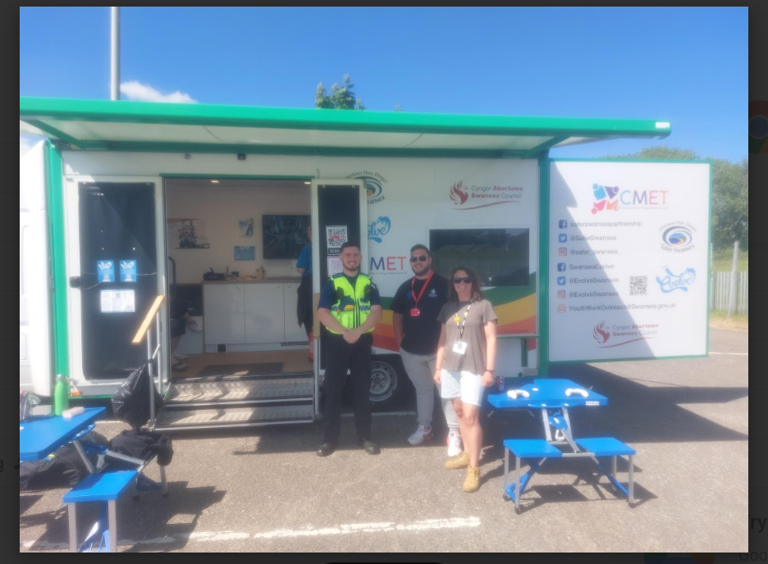  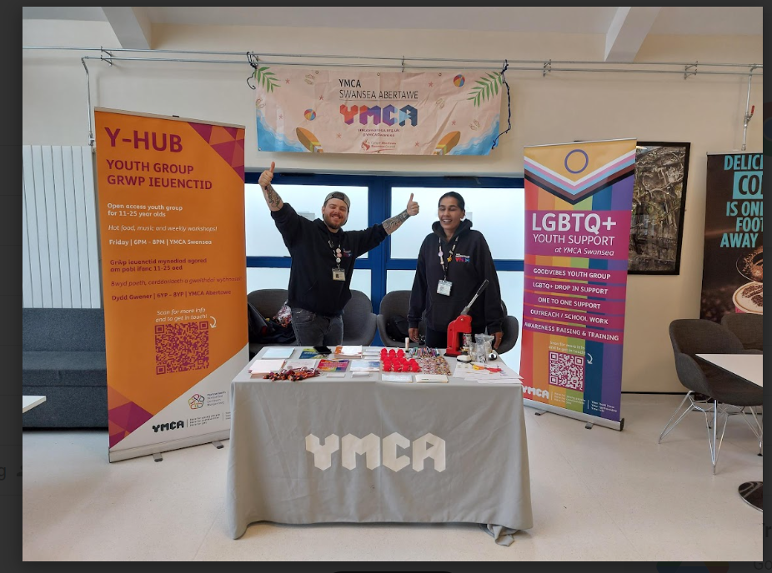  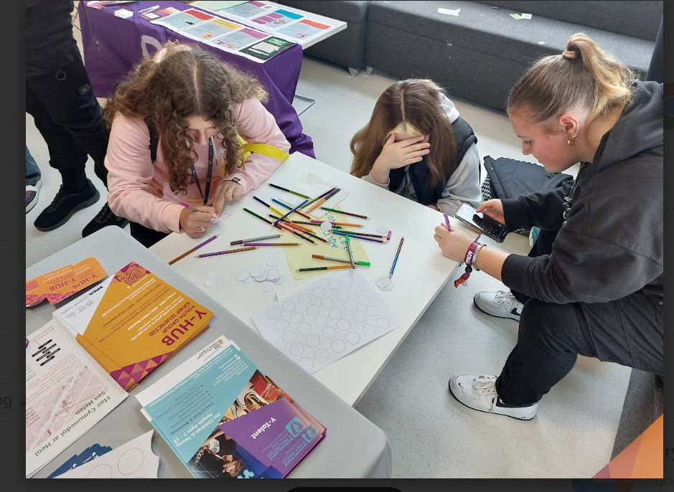  Our professional and experienced youth workers target various locations around Swansea that include; schools, colleges, other youth groups, local communities as well as responding and engaging with young people in areas of risk, that have been identified in Swansea’s Multi-agency CMET meetings. By addressing vulnerabilities that can lead to criminal or sexual exploitation, anti-social behaviour, knife crime, and peer-on-peer abuse, the project acts as a preventative measure. It equips young individuals with the skills, knowledge, and resources to make informed life choices and build resilience against these risks.  Through a combination of targeted workshops, educational sessions, and community engagement, the Y-Hub project empowers young people to recognise and navigate potential dangers. By fostering a sense of belonging and purpose within the community, it reduces the chances of young people engaging in risky behaviours. As a result, the project helps decrease the demand for intervention services such as law enforcement, social services and enhancing overall wellbeing, reducing the strain on healthcare resources. Young individuals who participate in activities and services offered by the project are more likely to maintain good physical and mental health. This leads to fewer health-related emergencies, hospital admissions, and the need for rapid response services. In essence, the Y-Hub project represents a preventative approach that invests in the wellbeing and resilience of young people. By addressing vulnerabilities early on and providing essential support, it reduces the future demand for intervention and health services while creating a safer and more supportive community for all its members.  The aim of outreach is to identify young people that are falling through gaps in provision, in need of intervention, nowhere to go for support, experiencing personal barriers or challenges, are not safe, and/or experiencing issues with their wellbeing. By building relationships with young people in their environments, is acts as a catalyst to identify young people who may be more vulnerable to exploitation and are off services radars. By building relationships with these young people, it gives them the opportunity for more in depth, vital and long-term support at our open access Friday Night Youth Club based at YMCA Swansea. The youth club enables us to provide more intensive support to those individuals and network with other specialist services and agencies as necessary.  List of Partners, Networks, Forums and Funders that Y-Hub and YMCA Swansea work in partnership with.  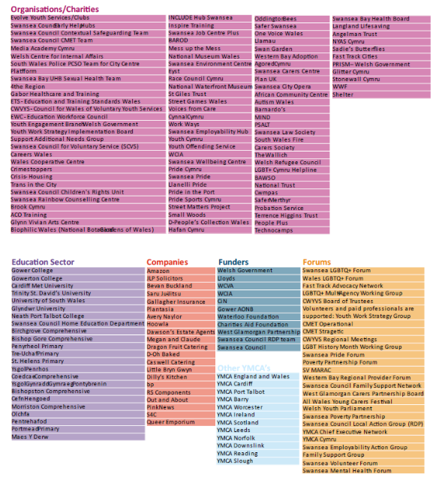  By building strong and trusting relationships with young people on the streets and in youth club, it encourages young people into YMCA Swansea’s doors where they are provided with a relaxed and safe atmosphere, a warm meal and other opportunities that provide an attractive gateway for youth workers to engage with them in various activities and educational opportunities, centred around young people’s personal growth and progression. Since January 2023, we have begun using, a specialist CRM system called Upshot, this is now being used daily by all youth workers, to store all young people’s personal information, activities, distance travelled, feedback, consultations, and photos. Since January to September 2023, we have recorded that Y-Hub has engaged with 432 young people on Outreach alone and 85 young people have attended Youth Club – this is not including young people engaged with between October to December 2022.  The impact of our work extends beyond the immediate young people we support. By empowering young people and addressing their specific needs, we contribute to building a stronger and more inclusive community. Y-Hub promotes social cohesion, reduces stigma and discrimination, and encourages positive relationships among young people from diverse backgrounds.
2. Local prevention and early intervention solutions support people to avoid escalation and crisis interventions | Y-Hub plays a pivotal role in addressing the need for local prevention and early intervention solutions. Our youth-focused initiatives are strategically designed to support young people in avoiding crisis situations and achieving better health and well-being outcomes. Through a comprehensive range of programs, we empower young people with essential life skills and knowledge, enabling them to make informed decisions and choices. Topics such as healthy lifestyles, personal boundaries, and financial literacy are addressed to equip them with the tools needed to navigate life's challenges successfully. Our emphasis on soft skill development, including confidence, teamwork, and creativity, fosters resilience among young individuals. This not only helps them steer clear of negative situations but also encourages positive personal growth and mental well-being. Y-Hub's commitment to local prevention and early intervention aligns with the broader goal of building resilient communities and minimising the need for crisis interventions. Through our programs, we strive to empower young people to lead healthier, more fulfilling lives, ultimately contributing to the well-being of our community as a whole.  We recognise that addressing the diverse needs of young people requires collaboration with a range of stakeholders. We work in partnership with local schools, statutory agencies, community organisations, and other service providers to create a coordinated and integrated support network. These collaborations enable us to leverage resources, share expertise, and provide a seamless continuum of care for young people, ensuring they receive the comprehensive support they need. Our dedicated staff actively engage with specific organisations, services, and religious groups within our community. Some of the most important collaborations include, Barod, Evolve Services, CMET, Social Services, Media Academy Cymru, CAMHS, Exchange, Barnardos and the Youth offending Service. By building collaborative opportunities, we extend our reach and strengthen our partnerships and add value to the support we provide to vulnerable young people. More recently, we have been working on reaching out to smaller local youth groups that provide targeted support to young people from ‘communities of interest’. The organisations include the Mixed-Up Project for young people with disabilities, the ADHD Youth Club in Swansea, a BAME Mental Health Charity, the Saturday Youth Club, the Chinese Youth Group as well as local church youth groups. This comprehensive network of referrals enhances our ability to address a wide spectrum of needs and circumstances effectively.  Y-Hub plays a critical role in the lives of many young people, often serving as the first point of engagement, providing a great gateway to accessing more services and agencies. Young people who may have felt discouraged or disheartened by previous experiences with seeking support, find Y-Hub to be an approachable and non-judgmental environment. The presence of positive role models among Y-Hub staff and volunteers inspires young people. They see individuals who have overcome difficulties and are now giving back to the community. This can be highly motivating and restorative for young people who may have lost confidence in their own potential. From this staff are able to encourage and empower young people to access other types of support, which results in weekly referrals to other support services. With our close working relationships and partnerships this allows us to share valuable information with different youth-serving organisations enabling all professionals and agencies to gain more comprehensive understandings of each young person's needs, strengths, and challenges. This holistic view enables us to tailor preventative support plans and interventions more effectively, ensuring that young people receive consistent and well-coordinated support. This can also prevent duplication of services and gaps in provision. Working closely with other professionals in a multi-disciplinary approach provides us and other services with a better understanding of a young person's background and history, so that service providers can offer more personalised and relevant services. This increases the likelihood of positive outcomes in a young person’s life.  The most common organisations that our workers connect with around coordinating support plans for young people are social services for young people on the register, CMET for young people on protocol for exploitation, Barod for young people needing specialist support around substance use and Media Academy Cymru for young people at risk or involved in ASB. When feeding into a young person’s support plan Y-Hub focuses on increasing young people’s mental and physical health looking deeper into a young person’s protective factors and how these can be increased. In addition, we actively encourage young people to engage in volunteering and training opportunities, fostering personal growth, and reinforcing a sense of community involvement. This multifaceted approach to collaboration, signposting, and empowering young individuals underscores our commitment to local prevention and early intervention, ultimately working towards a more resilient and supported community. Y-Hub's unique qualities, including accessibility, trustworthiness, comprehensive support, and a focus on early intervention, position it as a beacon of hope and a reliable source of support for young people who may have been let down by other services or systems. It plays a vital role in rebuilding their trust, confidence, and resilience on their journey to a brighter future.
Complex Care
1. People are more involved in deciding where they live while receiving care and support | N/A.
2. Complex care and support packages are better at meeting the needs of people and delivered at home or close to home | N/A.
Emotional Health and Wellbeing
1. People are better supported to take control over their own lives and well-being | Y-Hub significantly contributes to the empowerment of young people, supporting them in taking control of their own lives. The project supports the implementation of the following ‘Models of Care’:  - Support individuals to take more responsibility for their own EH&WB  - Support communications and engagement around good EH&WB  The project empowers young individuals to become aware of their health and wellbeing using a holistic approach, ensuring they receive the right support at the right time. The project delivers a range of activities, workshops and opportunities that provides young people with the tools and resources to make positive life choices, build resilience, and address potential challenges before they escalate. Y-Hub offers a range of personal development workshops covering topics such as self-esteem, resilience, goal setting, and decision-making. These workshops equip young people with valuable life skills, fostering their ability to make informed choices and take control of their personal development.  As professionals, our youth workers continuously reflect and identify areas of development in young people that are addressed through a range of activities and opportunities. In each youth club session, our approach is multifaceted. We strive to offer a well-rounded mix of activities designed to achieve various learning outcomes. These include topic-based learning covering areas such as music therapy, healthy relationships, sexual and mental health, personal boundaries, healthy lifestyles, self-preservation, responsible money management, and awareness regarding drug, alcohol, and vaping. Additionally, we focus on nurturing essential soft skills like confidence and self-esteem through engaging activities such as teambuilding games, art and crafts, board games, and jewellery making. Our aim is to provide a holistic experience that blends skill and character building with enjoyable opportunities for young people to grow and learn.  Photos of activities  Knife Crime Awareness:  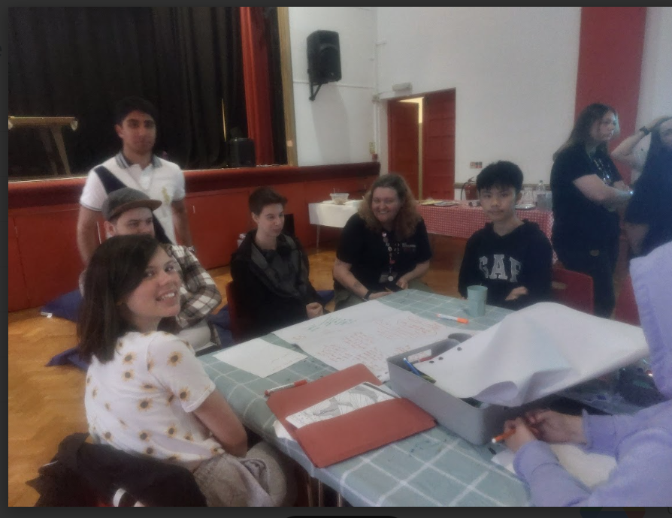  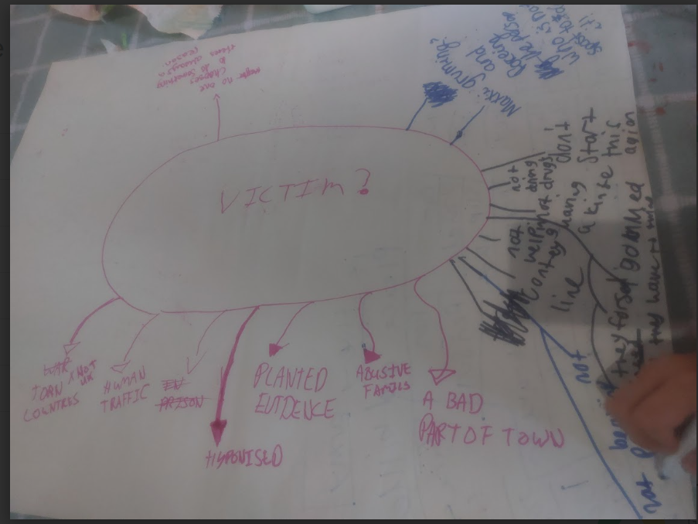  Y-Hub Hair Cuts  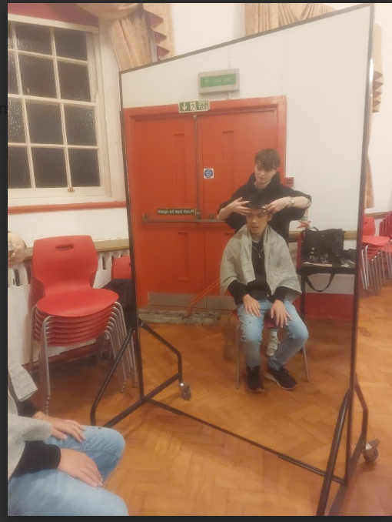  Yoga  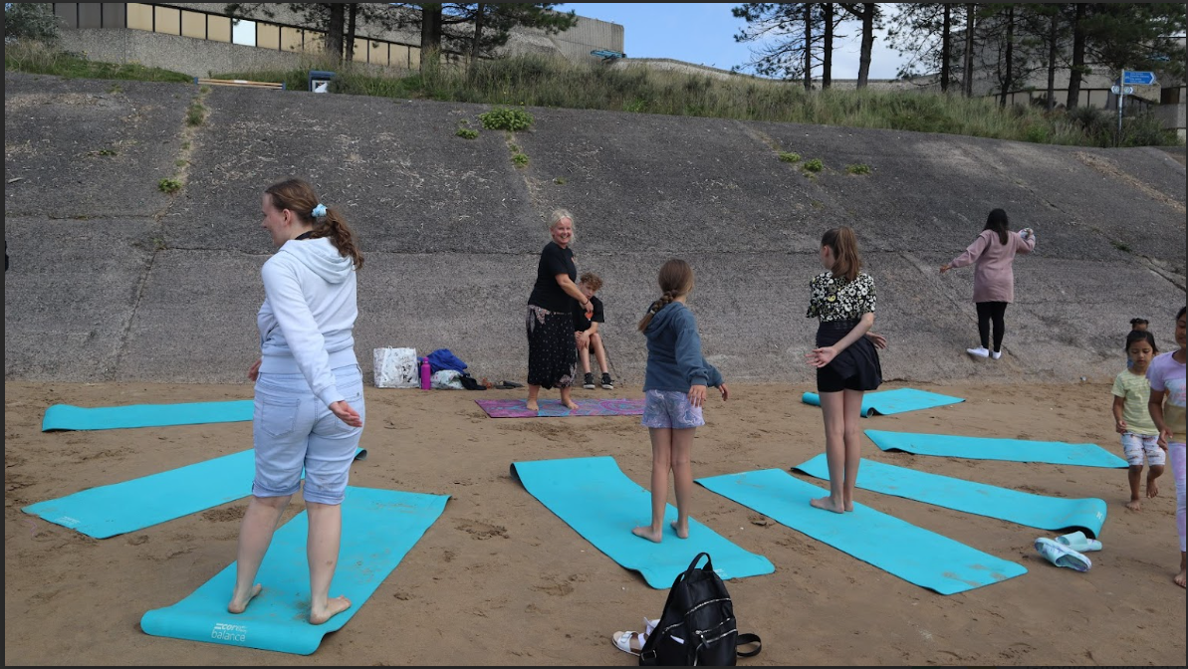  Through ongoing monitoring, evaluation, and collaboration, we ensure that young people's voices are not only heard but are at the forefront of our decision-making processes, enabling us to provide services and opportunities that truly meet their needs and aspirations. Y-Hub encourages young people to take the lead in planning and organising events, projects, and activities through the Y-Hub Youth Forum. This involvement in decision-making and project management cultivates leadership skills and a sense of ownership among participants. The forum has most recently been:  - Choosing Trips and Activities.  - Establishing a Cooking Club.  - Marketing – designing a banner.  - Defining a Code of conduct.  - Collaborating on the club's operations.  - Fundraising.  - Fundraising initiatives.  Y-Hub also provides a range of peer mentoring, volunteering, senior member, and career development opportunities for young people. We have young people completing their gold level Duke of Edinburgh award, their GCSE Welsh School-back hours and using Y-Hub as their placement. Other young people that have joined as a young person in need of support and are now taking on more senior roles and some are even youth worker trainee’s completing their professional level 2 and 3 qualifications in Youth Work and are now employed members of staff. Resulting in Y-Hub, providing access to positive role models and mentors, often individuals who have overcome challenges similar to those faced by the young people they serve. These mentors inspire and guide participants, showing them that they can take control of their lives and achieve their goals. Y-Hub fosters peer support networks where young people can share experiences, challenges, and strategies for success. This peer support empowers individuals to learn from one another and take charge of their own life journeys.  Y-Hub assists young people in setting and working towards their personal and academic goals. Whether it's educational attainment, career aspirations, or personal development objectives, Y-Hub offers support, resources, and guidance to help young people chart their paths to success. Y-Hub provides training in practical life skills such as budgeting, cooking, and independent living. These skills enhance young people's selfsufficiency and prepare them for adulthood. A Free hot meal is provided every week at Y-Hub, that is also an additional attraction for young people coming in from the streets. Young people take full ownership over deciding the meals, recipes, budgeting, shopping, and cooking. Young people even help with the cleaning up – learning essential life skills. Many young people when they first come to Y-Hub have never used an oven or prepared a home cooked meal from scratch. Young people love this so much, that the forum have even now requested a weekly cooking club which they are in the process of planning.  Photos of cooking in Y-Hub  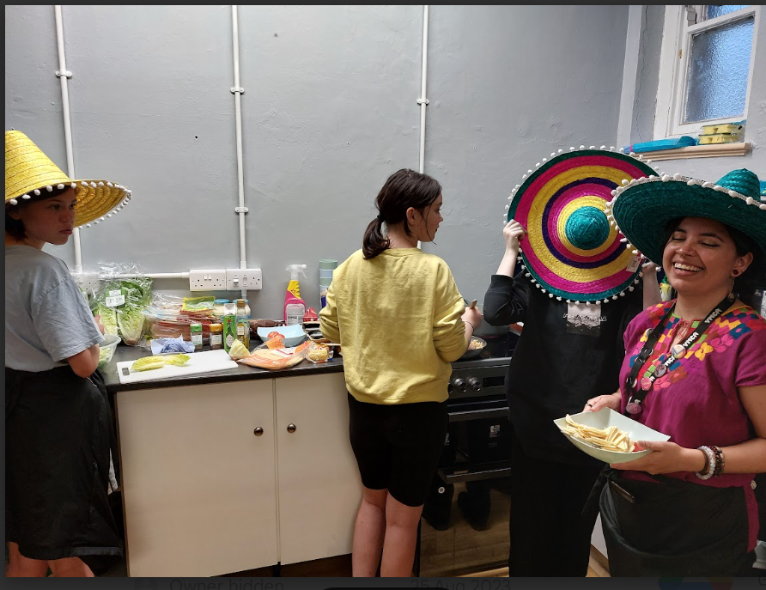  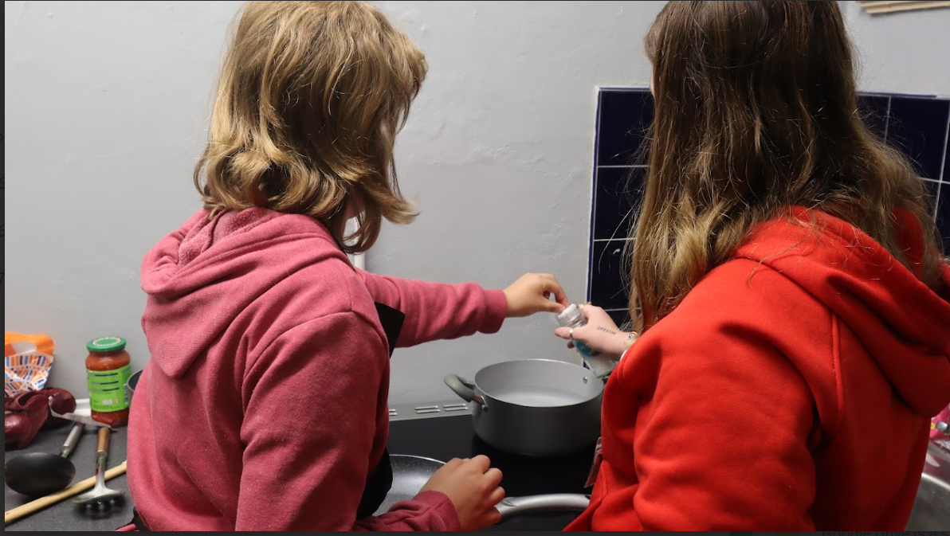  Additionally, another benefit to our outreach is Y-Hub acts as a community hub, serving as a central point where young people can access a variety of services and resources provided by YMCA Swansea, (outlined in our YMCA Swansea Youth Work Strategy), whilst engaging with professional and experienced Youth Workers. The majority of young people that attend our Y-Hub project, are disengaged from other services, experiencing multiple barriers, have complex needs and are vulnerable to needing crisis interventions in their future. Y-Hub also offers identified young people tailored one-to-one intensive support to meet their needs and addressing issues such as financial debt, inadequate wages and living standards, limited opportunities, diminished hope, and aspiration, as well as a disbelief in the concept of social mobility. Directly, and indirectly, these circumstances contribute to issues such substance use, strained relationships, unsettled and family breakdowns, low interpersonal skills, risk-taking behaviour, uninformed life choices, limited academic progress, and ultimately young people who have not had the opportunities to consider or reach their potential. We provide a safe environment to support young people in our community and neighbourhood; to equip them, to support them to make positive life choices and provide experiential learning opportunities that focuses on developing their personal, social, emotional, and educational skills.
2. People have improved skills, knowledge, and confidence to be independent in recognising their own well-being needs | Y-Hub plays a significant role in enhancing the skills, knowledge, and confidence of young people to recognise and address their well-being needs independently. Y-Hub conducts various educational sessions and workshops on topics such as mental health, healthy lifestyles, personal boundaries, resilience and overcoming challenges. These sessions equip young people with valuable knowledge and practical skills to manage their well-being effectively. In all the activities and sessions that the project facilitates we ensure that the possibility and potential for learning and positive outcomes is maximised. Even when building a relationship with a young person over something simple as a game of pool youth workers will engage in purposeful and meaningful conversations to enhance self-awareness, confidence, self-esteem and also to identify a young person’s learning or support needs.  Y-Hubs actively aims to meet the following project outcomes:  - Young people are more confident to lead independent lives.  - Young People feel less isolated.  - Young people become more involved in social networks and activities.  - Young People are more informed on issues that affect them and their futures.  - Young People become aware of more opportunities.  We often collect the views of young people around the positive outcomes achieved from attending our services, here is our most recent one for Y-Hub- Y-Hub Outcomes Survey. When asking young people how much Y-Hub support their independence 90% responded with very helpful.  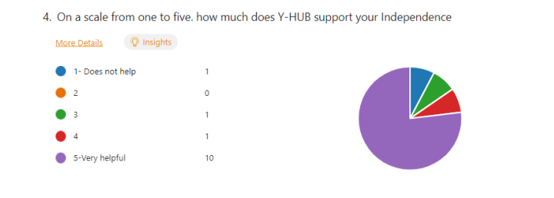  When asking young people how Y-Hub improves their confidence, young people responded with:  - It helps me make friends.  - There is no pressure to do or be anything it's just a comfortable place with comfortable people.  - Help me be confident talking to others.  - It helps me communicate.  - Gives me opportunity to meet and interact with new people.  When asking young people how Y-HUB has helped you get involved in social groups and activities, young people responded with:  - Without Ymca y hun I wouldn’t really be involved in social groups.  - Goodvibes LGBT introduced me to Y-HUB who introduced me to platform and possibly surfability which all help me in their own way.  - Without y hub I wouldn’t get to do social activities apart from school.  - Lots of activities to get involved with.  As well as offering direct support through Y-Hub and engagement through outreach, Y-Hub has facilitated numerous additional services to provide an extra layer of intensive wellbeing support.  Woodland Wellbeing – We transported young people to Penllergaer Woods over a 6-week programme, where they participated in numerous woodland activities centred around wellbeing.  Photos of Woodland Wellbeing  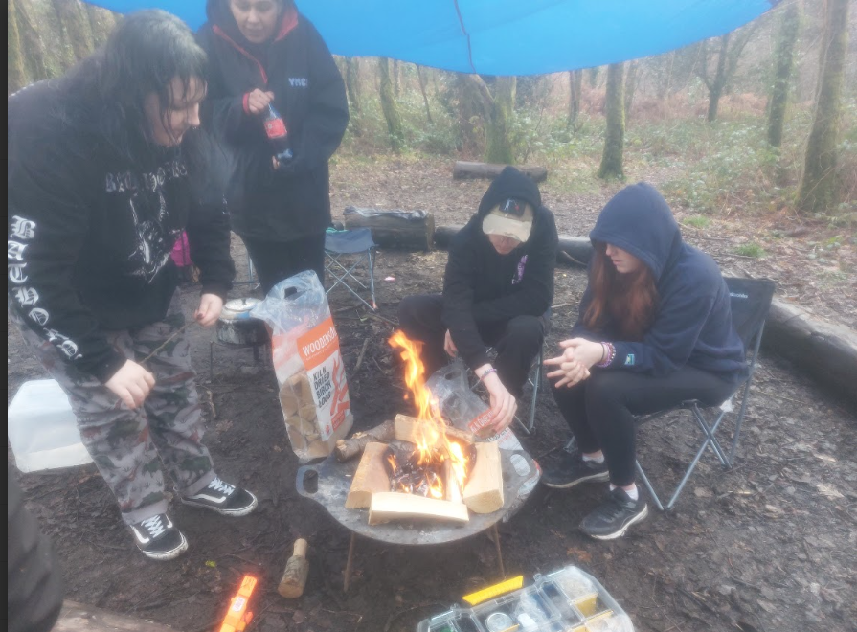  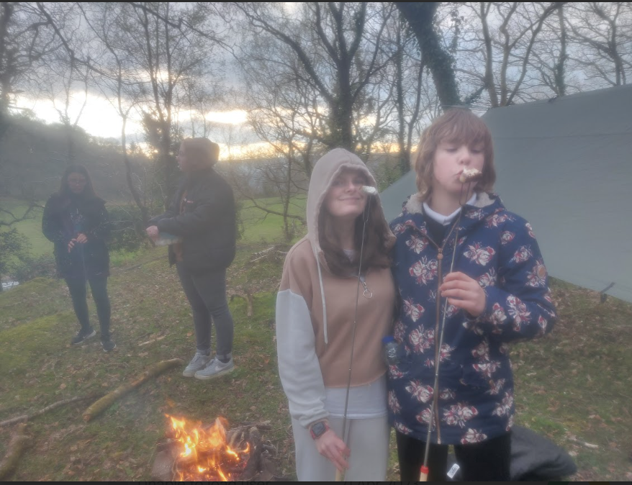  Community Silk Printing Workshop – Over 3 weeks young people engaged in a community project led by St Helens Road, Street Matters project. They focused on creating art on silk around issues such as in-justice, discrimination, climate action.  Y-Hub Trips – Young people that have asked for some sessions on a Friday night they can go on different trips. The trips we have run are cinema, bowling, climbing, and for meals. To the majority of young people accessing Y-Hub this is a luxury that they wouldn’t often experience because of different personal barriers.  We measure our impact through various indicators, including the number of young people engaged in our programs, changes in their well-being and self-confidence, improvements in educational outcomes, and feedback from young people and their families. Feedback To help us track our impact and measure distance travelled in young people, Y-Hub uses the Wellbeing Wheel indicators, from the Social Services and Wellbeing Act 2014; ensuring that young people are supported around Physical, Mental and Emotional Health and Wellbeing, Protection from Abuse and Neglect, Education, Training and Employment, Domestic Family and Social Relationships, Contribution made to Society, Securing Rights and Entitlements, Social and Economic Wellbeing and Suitability of Living Accommodation. This tool helps us assess young people’s protective factors and empowers our staff to collaborate with young people in identifying personal development goals. There are seven indicators included in the matrix we use that help us identify areas for development in the following:  - Level of social bonding  - Response to opportunities for involvement  - Response to recognition and praise  - Level of social and learning skills  - Development of healthy values and standards  This strategic approach ensures that our interventions are not only responsive but also focused on fostering resilience, autonomy, and holistic well-being. Y-Hub has proven that it makes real positive differences in the lives of young people from a diverse range of backgrounds, helping them to discover new passions, develop essential skills, gain a sense of achievement, encouraging personal growth and opening up alternative pathways for their future.
Successes/Barriers
Top 3 Successes of the Scheme. | - Using a multi-agency approach to respond to young people in need – supporting them to increase their protective factors and reducing their vulnerabilities.  - Providing essential and accessible support to young people who otherwise are not likely to access support.  - Building effective and trusting relationships with young people and encouraging them to access a wide range of other preventative services.
Top 3 Challenges or Barriers to Progress. | - Sessional Staff costs – with the success of Y-Hubs outreach our demand for providing quality youth work support to the large numbers in club and one-to-one is increasing and we each week have to ensure we have the correct ratio of experienced staff working.  - The project leads fulfilling all their duties in 30 hours a week – as above with project demand rising the worker needs to work 5 days a week.  - Additional full-time members of staff to support the project lead in full-fulling all the projects needs and demands.
Next Phase
Next Phase of the Project.  For example:  If funding continues, do you have enough workforce to continue?  If you wished to scale up how would you do this? | If the funding continues, then we have enough workforce to continue as we are delivering currently. It is however our aspiration to expand and develop the project further.  YMCA Swansea conducted a consultation with 122 young people. 73 that already accesses YMCA Swansea services and 48 that have not accessed our services. The consultation investigates what services people need and where the gaps may be. However, we already see in the growing demand of our Y-Hub provision tht the findings are reflected in practice. Please find the survey results here: YMCA Swansea Young Peoples Consultation  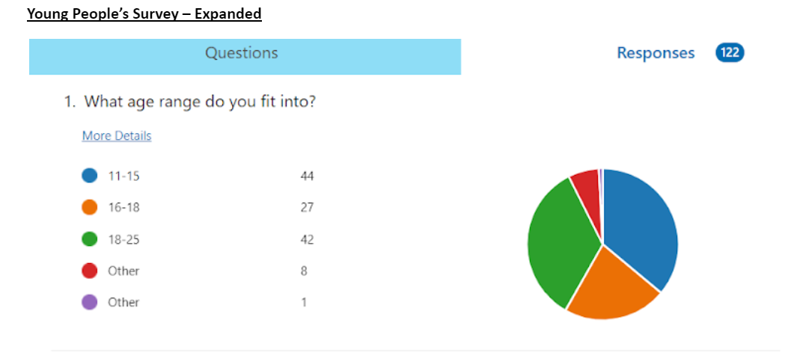  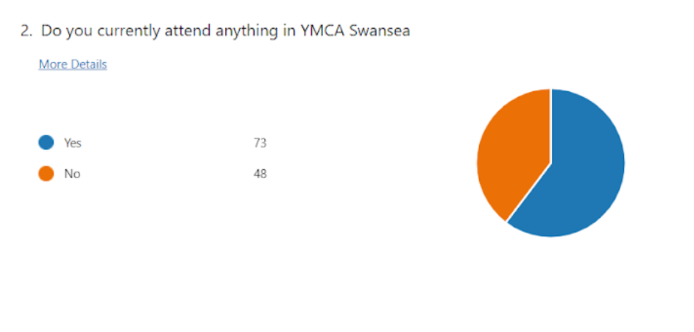  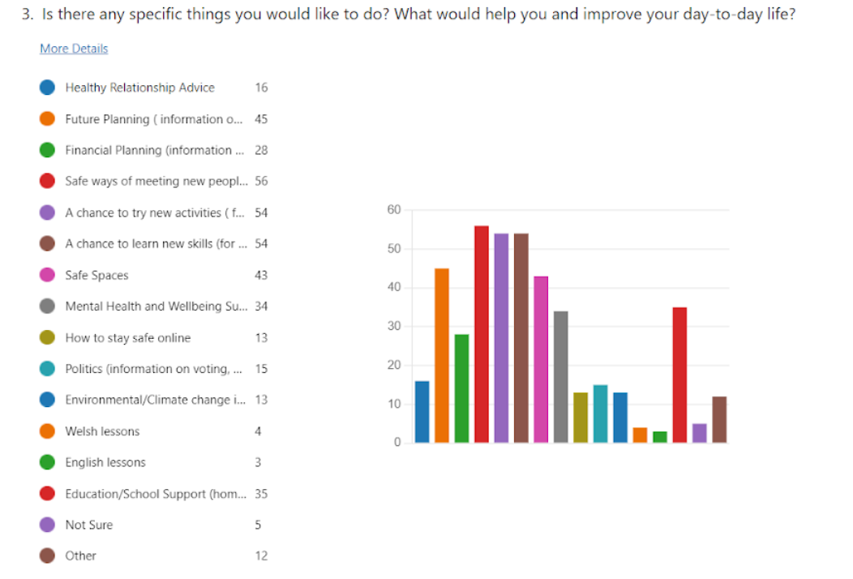  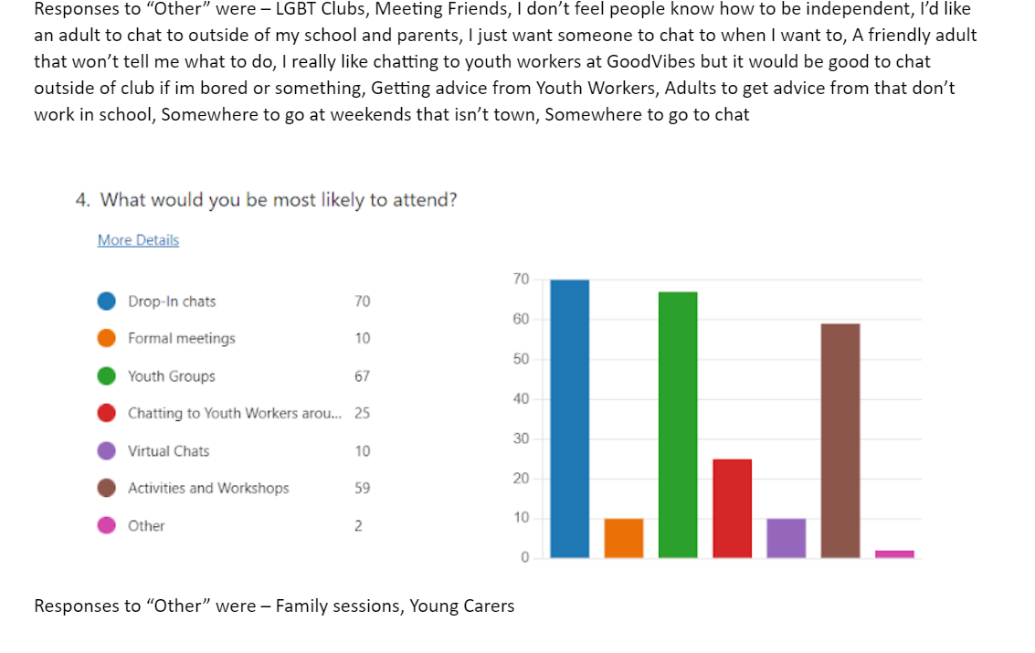  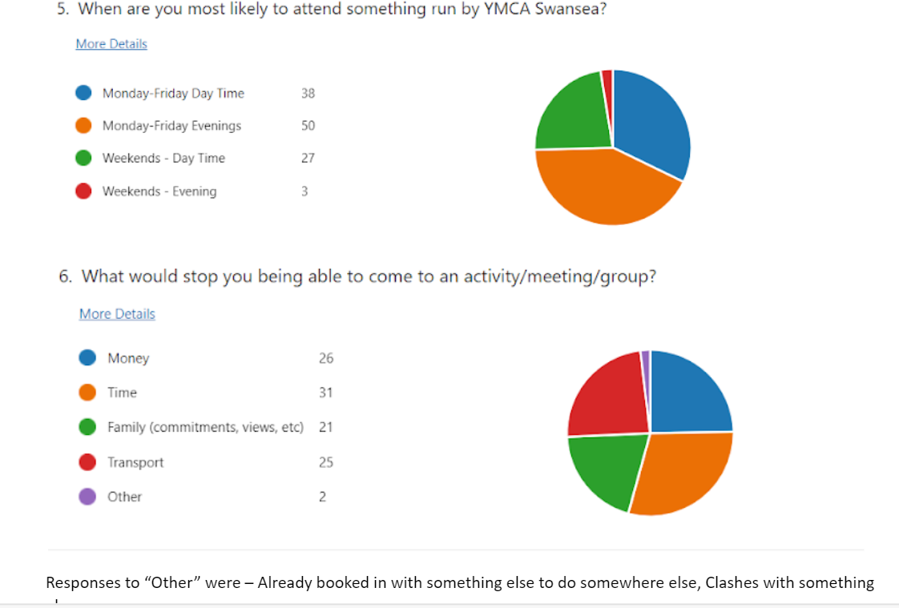  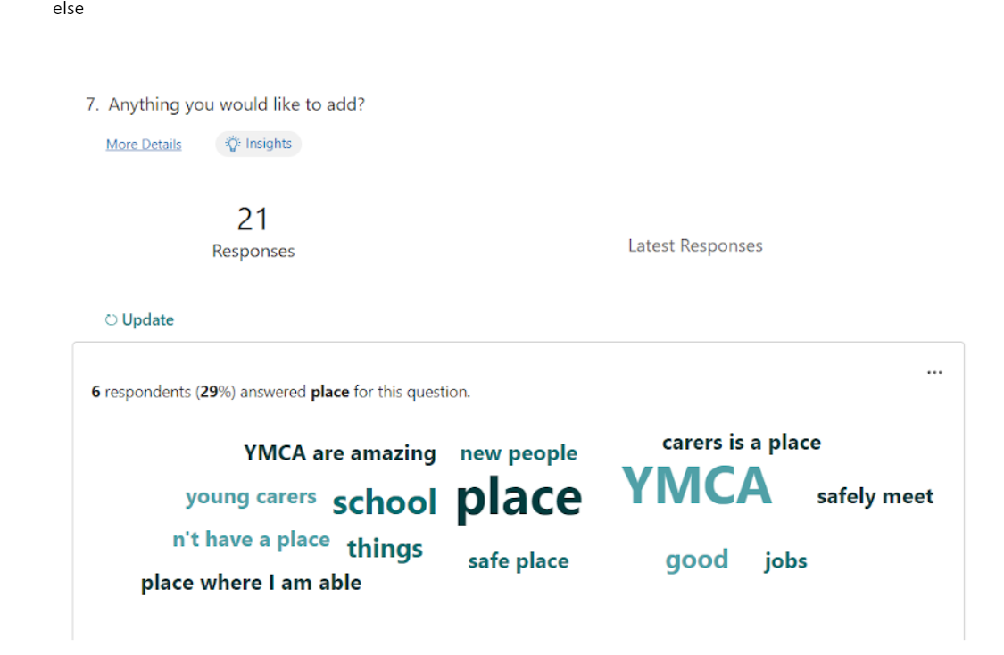  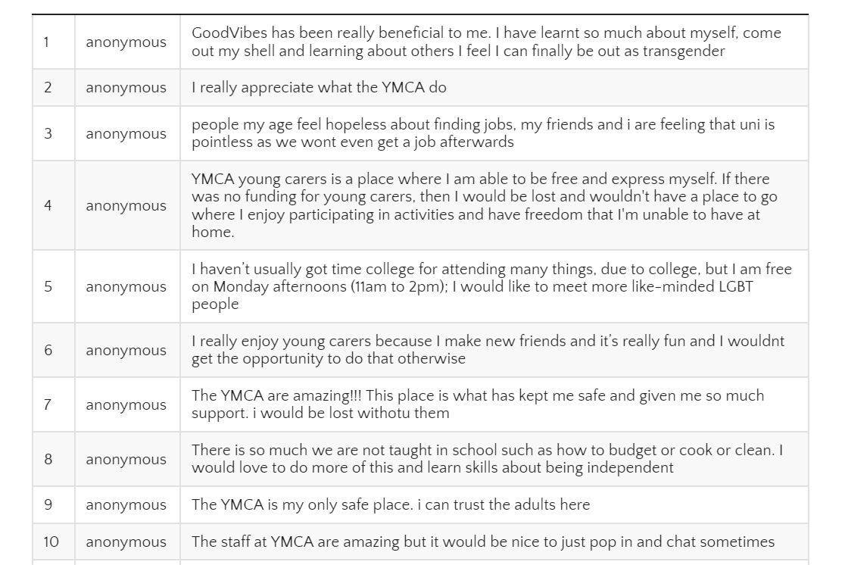  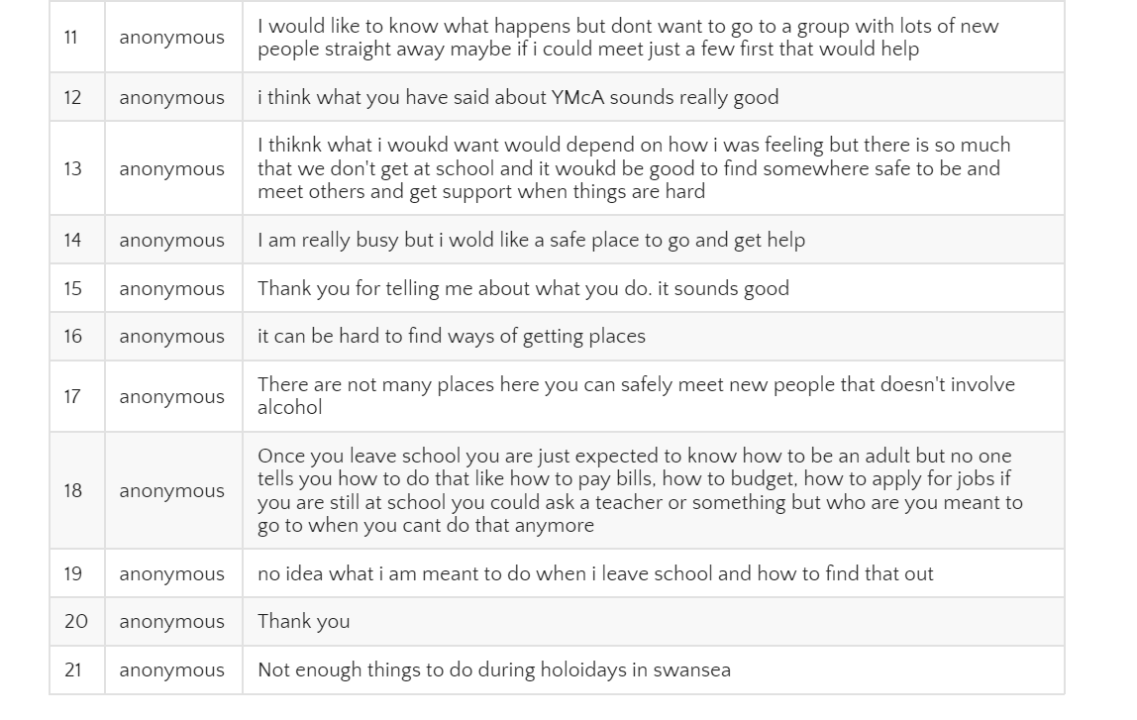  The finding have shown us that young people require more accessible intensive support around any issues that they may be facing. One night per week is not enough youth provision for young people living in city centre and surrounding areas. The majority of young people have asked for more support that is available and accessible at more times during the weekdays and each week day evening.  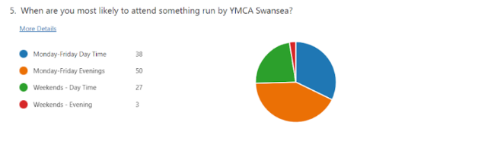  Based on the results from our consultation process, we wish to build on Y-Hubs delivery model and expand it to a multi-faceted, holistic program which supports young people to achieve more positive outcomes through:  - A unique & innovative 5-day Drop-In for Young People which will not only provide a consistent, accessible safe place for Young People to receive support, but it will also enable continuous consultation to ensure our service is fit for purpose and delivering the priorities of the community.  - Youth Clubs – Open access Youth Clubs has numerous outcomes within itself. It will provide an attractive, safe place to Young People who are highly vulnerable to antisocial behaviour, trafficking and exploitation. We will prioritise improving the social, economic, environmental & cultural well-being of not only those who directly engage with the project but of those in the community as a whole.  - Outreach - This will see qualified and experienced Youth Workers connected with Young People on the streets of Swansea and signposting them to various services including the Y-Hub provision.  - One-to-One Intensive Support - This is something that is very much needed for Young People in our area, especially if they are not in education or employment. This support will offer advice, signposting, wellbeing support, financial advice, role models and so much more. It will enable Youth Workers to build reliable, trustworthy, and professional relationships with those Young People when they really need it, many of whom have no one else to turn to and nowhere else to go.  - Training/Education Advice & Support- Using our networks to connect young people not in education, employment or training to potential volunteering opportunities, placements, training or supporting them into employment.  - Full- Time Youth and Community Wrap-Around Provision - this will include school outreach, more trips and activities, holiday programmes, partnership working & more.  As a part of this project, we aim to employ a Project Co-Ordinator (37 hours a week) as well as two part time (30 hours a week) Youth Workers. We will also employ sessional workers to support the evening and outreach provision.
Are there any major changes you would like to make to the project? | We do not wish to make changes to the project, as you can see from our plan to expand and develop the project, it is extremely successful and supporting over 135 young people. In our last quarterly monitoring return Y-Hub had reported that 74 young people had accessed the Friday night youth club. Since May 1st, 2023, a further 61 young people have signed up and attended Youth Club giving us the total of 135 young people that have attended Y-Hub since October 2022.
If you are looking to stop the project or funding was unavailable, what impact would this have on the communtiy, service users and staff? | The continuation of the Y-Hub project is vital for the well-being of the community, service users, and staff. If the project were to stop or funding became unavailable, it would have several significant and negative impacts:  - Impact on Young People - Y-Hub serves as a lifeline for many young people in the community. It provides them with a safe and supportive environment where they can access essential services, acquire life skills, and build positive relationships. The sudden cessation of the project would leave a void in their lives, potentially leading to feelings of isolation, a lack of support, and limited access to resources that help them make positive life choices.  - Disrupted Support Networks - Y-Hub has established strong support networks for young people, which include staff members, peers, and external organisations. Closing the project would disrupt these networks, leaving many young people without crucial emotional and practical support systems.  - Loss of Educational Opportunities - Y-Hub offers educational workshops and sessions that help young people acquire important life skills, from financial literacy to mental health awareness. Without access to these opportunities, young people may miss out on valuable knowledge and tools for personal development.  - Impact on Staff - The dedicated staff at Y-Hub are experienced and passionate about their work. A cessation of the project would not only result in job losses but also drain the community of the expertise and commitment of these professionals.  - Community Well-Being - Y-Hub contributes to the overall well-being and safety of the community by providing targeted support to young people. A loss of this service could lead to increased community challenges related to youth well-being and anti-social behavior.  - Reduced Prevention and Early Intervention - Y-Hub is an example of a preventative and early intervention program that aims to reduce the need for more intensive crisis interventions. Its closure could potentially increase the demand on other services, including health and social care, law enforcement, and support agencies.  In summary, the discontinuation of the Y-Hub project or a lack of funding would have far-reaching and detrimental effects on the community, service users, and staff. It is crucial to recognise the project's importance in providing support, education, and a sense of belonging for young people while contributing to the overall well-being of the community.
Information/Evidence
How do you collect and review information to evidence the achievement of outcomes, service users experience and impact? | At YMCA Swansea, we believe that monitoring and evaluating our services and progress is of paramount importance. We have implemented robust systems to measure the impact of our work and ensure that we are continually improving and meeting the needs of the young people we support. Our approach to measuring success is comprehensive and multifaceted, involving various methods of data collection and evaluation.  Feedback from Young People: The voices of the young people we serve are at the heart of our evaluation processes. Through regular feedback forms and opportunities for participation, we encourage young people to share their thoughts on our provision. We value their input and use it to inform the development and improvement of our services.  Data Collection and Analysis: We use a variety of data capture methods to gather information for our projects' outcomes and outputs. Our recently implemented CRM platform, Upshot, allows us to streamline data collection and analysis. It enables us to track and measure service provision, contact, impact, and case studies effectively. The statistics provided by Upshot serve as a valuable resource for assessing the effectiveness of our projects, improving performance, and reporting against outcomes.  Distance Travelled: To measure progress and achievements within our projects, we utilise a measuring distance travelled tool called the Wellbeing Wheel (Social Services Wellbeing Act 2014). The wheel enables youth workers to measure and track young people’s levels of social bonding, response to opportunities, response to reignition and praise, social and learning skills, and development of healthy standards. Each of these domains have seven indicators that score young people according to exact differences we can see and evidence in young people, making it easy to identify areas for development and individual progress. This allows us to record the whole journey a young person takes within our services and the differences we can see.  Observations and Case Studies: Our youth workers conduct observations on young people's progress and development. This qualitative data, along with case studies, provides valuable insights into the positive changes experienced by young people as a result of our programs. We gather both qualitative and quantitative data to gain a holistic understanding of their journeys and the outcomes achieved.  Number of Beneficiaries: We track the number of young people we engage with, identify, and support across our projects. This data helps us assess the reach and scope of our services.  At YMCA Swansea, we are committed to continuous improvement. We regularly review and adapt our provision to ensure that we are meeting the needs of the community and achieving outcomes efficiently and proficiently. Through ongoing monitoring and evaluation, we identify areas for enhancement and implement necessary adjustments to maximise the positive impact of our work. By employing these comprehensive measurement strategies, we are able to assess the success of our projects, monitor progress, and make informed decisions about service improvements. We utilise the data collected to shape our services, demonstrate our impact to stakeholders, and ensure that we are consistently meeting the needs of the young people we serve.
Please explain how service users hear about the project, and highlight organisations that refer to your project from both Statutory and Third Sector organisations? | Young people hear about the Y-Hub project through a combination of outreach efforts and referrals from various organisations.  Local Schools: Y-Hub regularly collaborates with local schools to reach young people. We provide numerous school initiatives across that include our young carers service and LGBTQ+ service. We work together, across projects to provide lunchtime drop in’s, PSE lessons, training for staff and more. Additionally, school staff may inform students about the project through their own PSE lessons, assemblies, counseling sessions, or educational workshops.  Community Events: The project participates in and hosts various community events, workshops, or open houses to raise awareness among young people and their families. The most recent ones being YMCA Swansea’s 3 Beach Community Days, held purposely on Fridays to encourage young people to stay and try the Y-Hub youth club.  Social Media and Online Presence: Y-Hub maintains an active presence on social media platforms, websites, and forums. This digital outreach helps young people discover the project online and access relevant information. Referring Organisations:  - Local Authorities: Social workers, youth workers, and other professionals within local authorities may refer young people to Y-Hub when they identify a need for support and intervention. (Swansea Early Help hubs, Evolve services, CMET workers, Social Workers)  - Health Services: Health professionals, including mental health practitioners and nurses, can refer young people who require mental health and well-being support to Y-Hub.  - Schools: Besides informing students, schools can also officially refer students to Y-Hub when they recognise specific challenges that the project's services can address.  - Local Charities: Charitable organisations that focus on youth, mental health, or well-being may refer individuals to Y-Hub when they believe that the project's services align with the needs of their clients. (Plattform, EYST, Barod, Swansea Mad, Barnardos and other YMCA Swansea internal projects).  - Homeless Provision: Organisations working with homeless young people may refer individuals to Y-Hub to access support related to housing, mental health, or life skills.  - Youth Offending Service: Professionals working with young people involved in criminal justice have referred them to Y-Hub as part of rehabilitation and support efforts.  - Police: Local PSCO’s have Y-Hubs cards and leaflets that they distribute around the community and will quite often walk young people into our building to show them where we are and who to ask for.  Y-Hub's collaboration with a diverse range of organisations, both statutory and third sector, helps ensure that young people with various needs and backgrounds can access its services. These referral networks are essential in reaching vulnerable young people who may benefit from the project's preventative and supportive interventions.
Have you discovered any unexpected or unintended benefits for service users because of the project? | Y-Hub has exceeded the initial expectations in terms of popularity and impact. This unexpected success has indicated that the project is fulfilling a crucial role in the community. The strong response from young people and partners can be seen as a testament to Y-Hub's relevance and effectiveness in meeting the needs of its target audience. It reflects the project's ability to create a safe and supportive environment where young people feel valued, engaged, and empowered. This unexpected success and community support indicate that Y-Hub has the potential to continue thriving and serving as a vital resource for young people in the city center and beyond. It's a clear indicator of the project's importance and the positive change it brings to the lives of young people and the community.
Have you discovered any unexpected or unintended risks since the start of the project? | No.
Are there any cost avoidance, savings, or wider financial efficiencies you wish to demonstrate? | We are committed to prudent financial management and maximizing the value of every pound invested in our project. While our primary focus is on delivering high-quality services to young people, our financial practices also emphasize cost efficiency and responsible resource allocation. We demonstrate financial efficiency by meticulously planning and adhering to the budget we apply for. This disciplined approach ensures that funding is used effectively, with minimal wastage. We continuously monitor our expenditures, seeking cost-effective solutions without compromising the quality or impact of our services. Our collaborations with local partners and stakeholders enable us to access shared resources and leverage additional support. This not only reduces the financial burden on our project but also fosters a sense of community and collective responsibility for the well-being of young people.  As we move forward, we are committed to exploring innovative funding opportunities, cost-saving strategies, and partnerships that can help us sustain our services while remaining efficient in our financial operations. By doing so, we aim to ensure that every pound invested in Y-Hub creates a positive and lasting impact on the lives of the young people we serve.

SECTION FOUR: Performance / Impact – Quarter 2 reporting
Actual How Much? – Q2 | Number of People Supported = 154  Number of new individuals accessing the project for the first time = 80  Number of individuals accessing the project = 154  Number of individuals receiving Early Help and Support (Targeted) = 154  Number of new CYP accessing service = 80  Number of Activities Provided = 54  Number of CYP accessing the service (total per quarter) = 46  No of Professionals/volunteers accessing training = 6  Number of people completing a survey or any other tool that has gathered qualitative information = 30
Actual How Well? (quality) | Number of individuals satisfied with the Early Help and Support (Targeted) provided = 30 (100%)
Actual Difference made? (impact) | Number of Individuals reporting they are less Isolated = 28 (93%)  Number of Individuals maintaining improving emotional health & wellbeing = 30 (100%)  Number of individuals whose independence has improved or remained the same with the support of the project = 29 (96%)
RAG Status as at Q2 Reported by Project Lead  Red/Amber/Green | Green
Rationale for RAG (if provided) | The Y-Hub project has undergone a significant transformation, marked by the introduction of a new lead worker who has brought fresh vision and enthusiasm to the initiative. The formation of a youth forum, where members are actively involved in the planning and management of the Friday night youth club, reflects the commitment to youth participation. The addition of a new kitchen area has enhanced the project's ability to offer a wide range of activities, including cultural diversity initiatives, and provide hands-on culinary experiences for the young people. These efforts have broadened the project's scope and impact, promoting inclusivity and a sense of belonging for young people. The lead worker's proactive role in coordinating community outreach events has facilitated valuable connections and has increased awareness of YMCA Swansea’s and other organisations services for young people and has expanded Y-Hub's reach considerably in engaging with young people.

