

HEALTH BOARD RISK REGISTER
October 2023 (V2)
POPULATION HEALTH & PARTNERSHIPS COMMITTEE



Datix ID Number: 1763  Health & Care Standard: Staff & Resources 7.1 Workforce |  |  | HBR Ref Number: 52  Risk Target Date: TBC |  | Current Risk Rating  4 x 3 = 12
Objective: Focus on Population Health Needs |  | BAF Ref: 4 | Director Lead: Richard Thomas, Director of Communications and Engagement  Assuring Committee: Performance and Finance Committee
Risk: The Health Board does not have sufficient skills & resource in place to undertake impact assessments in line with strategic service change and policy development. |  |  | Date last reviewed: October 2023
Risk Rating  (consequence x likelihood):  Initial: 4 x 4 = 16  Current: 4 x 3 = 12  Target: 4 x 2 = 8 | 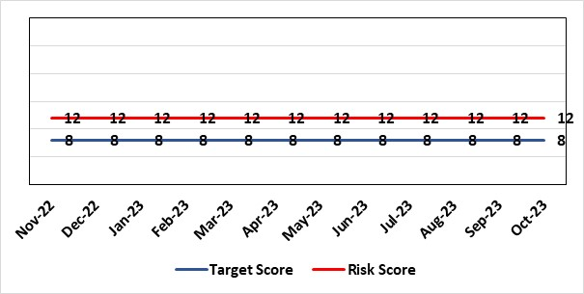 |  | Rationale for current score:  - Current lack of required skills / staff to deliver requirements.
Level of Control  = 50% |  |  | Rationale for target score:  - All of these areas need to have adequate resourcing and robust processes / policies in place for the organisation to make robust plans, engage public confidence and meet our statutory and public duties.
Date added to the HB risk register
November 2018
Controls (What are we currently doing about the risk?) |  |  | Mitigating actions (What more should we do?)
- Head of EDI to be appointed to support equality impact assessment – funding previously agreed, paper going to Management Board in mid-November and then Board on 30th November 2023. Recruitment planned by Q1 2024-25.  - Creation of DICE has led to some additional capacity within Engagement Team but alongside a significant increase in demand for activity.  - Robust policies and processes to be in place for Impact Assessment going forward.  - EIA responsibilities incorporated into wider Impact Assessments.  - Development of Strategic Equality Group across organisation to support processes. |  |  | Action | Lead |  | Deadline
 |  |  | Appoint Head of EDI  Delayed due to need to confirm budget | Assistant Director of Insight, Engagement & Fundraising - DICE |  | 31/03/2024
 |  |  | Review of the current process for developing Equality Impact Assessments around service change, engagement and consultation. | Assistant Director of Insight, Engagement & Fundraising - DICE |  | 31/03/2024  In progress
 |  |  | Robust policies and processes to be in place for Impact Assessment going forward. | Assistant Director of Insight, Engagement & Fundraising - DICE |  | 30/06/2024  In progress
 |  |  | Roll out Impact Assessment process across organisation. | Assistant Director of Insight, Engagement & Fundraising - DICE |  | 30/09/2024
Assurances (How do we know if the things we are doing are having an impact?)  Advice on Equality Impact Assessment and then wider Impact Assessments available across organisation supported by robust policies and procedures, overseen by Strategic Equality Group. |  |  | Gaps in assurance (What additional assurances should we seek?)  Participation from across organisation in Strategic Equality Group.
Additional Comments / Progress Notes
24.07.2023: Action closed - Establishing HB-wide Strategy Equality Group.
03.11.2023: Controls & Action targets refreshed

Datix ID Number: 3571  Health & Care Standard: Safe Care 2.1 Managing Risk & Promoting Health & Safety |  |  | HBR Ref Number: 96  Target Date: 31st March 2025 |  | Current Risk Rating  4 x 5 = 20
Objective: Demonstrating Value and Sustainability NEW RISK |  | . BAF Ref: 6 | Director Lead: Nerissa Vaughan, Interim Director of Strategy  Assuring Committee: Performance and Finance Committee
Risk: Failure to Develop an Approvable IMTP (statutory compliance)  Failure to have an approvable (Integrated Medium Term Plan) IMTP for 2024/5 then we will lose public confidence and breach legislation. |  |  | Date last reviewed: October 2023
Risk Rating  (consequence x likelihood):  Initial: 4 x5 = 20  Current: 4 x 5 = 20  Target: 4 x 2 = 8 | 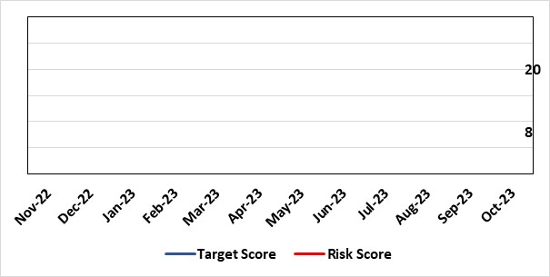 |  | Rationale for current score:  The Health Board does not have a WG approved IMTP and has been placed in enhanced monitoring for Finance and Planning following the inability of the HB to submit a balanced IMTP in March 2023. An Annual Plan was submitted for 2023/24. Given the all Wales financial context the HB is not expecting to submit an IMTP in March 2024 and will instead be developing an Annual Plan 24/25 set in a three year context.
Level of Control
= 70%
Date added to the HB risk register
October 2023
Date added to the HB risk register  October 2023 |  |  | Rationale for target score:  The target remains to develop a financially balanced IMTP so that we meet our statutory duties.
Controls (What are we currently doing about the risk?) |  |  | Mitigating actions (What more should we do?)
- An Annual Plan was submitted to WG in March 2023 with further detailed supporting information provided in July 2023.  - An integrated process is in place to develop the Annual Plan 2024/25.  - The existing IMTP Executive Steering Group will provide oversight of the R&S Plan, Performance and Finance Plans assured by P&F Committee. W&OD Committee reviews the workforce plan, Q&S Committee the Q&S elements. JET meetings with WG |  |  | Action | Lead |  | Deadline
 |  |  | Development of a robust Annual Plan for 2024/25 and continued work to set out a timeline for financial recovery. | Dir of Strategy & Dir of Finance |  | 31/03/2025
Assurances (How do we know if the things we are doing are having an impact?)  Robust arrangements are in place to execute the Annual Plan and for 23/24 these arrangements have been strengthened with updated reporting and monitoring arrangements through the newly established Annual Plan Oversight Group chaired by the COO. |  |  | Gaps in assurance (What additional assurances should we seek?)
Additional Comments / Progress Notes

Risk Score Calculation

For each risk identified, the LIKELIHOOD & CONSEQUENCE mechanism will be utilised. Essentially this examines each of the risks and attempts to assess the likelihood of the event occurring (PROBABLILITY) and the effect it could have on the Health Board (IMPACT). This process ensures that the Health Board will be focusing on those risks which require immediate attention rather than spending time on areas which are, relatively, a lower priority.

