

Meeting Date | 19 June 2023 |  | Agenda Item |  |  | 4.1
Report Title | Next steps for our Population Health Strategy for SBUHB
Report Author | Jennifer Davies, Deputy Director of Public Health;  Keith Reid Executive Director of Public Health
Report Sponsor | Keith Reid, Executive Director of Public Health
Presented by | Keith Reid, Executive Director of Public Health
Freedom of Information | Open
Purpose of the Report | This report:  - Presents the final version of the Population Health Strategy (PHS) for Swansea Bay that was approved by the Board on 30th March 2023.  - Notes the year 1 priorities that were accepted & approved by the Board and the initial steps towards delivery.  - Highlights issues & risks in being able to provide assurances on the organisation’s progress and ability to implement.  The final versions of the Population Health Strategy (PHS) approved by the Board on 30th March are attached (see Appendix 1 (resource section)). The PHS is intended to act as a framework for action across the health system, including our work in external partnerships, as laid out in our 4-Pillar model/approach to delivery.  Following engagement with our Stakeholder Reference Group, further Easy Read versions in both languages are being commissioned. These will be used as part of our planned communication activity and ongoing engagement within the Health Board and with our external stakeholders as we progress the development of actions emerging out of the Strategy to be delivered with and through others, including those approved and committed to by the Board as year 1 priorities for 2023-24.  The year 1 priorities for SBUHB are detailed in Appendix 2, mapped against the Population Health GMOs for 2023/24 along with a short summary of what we believe to be the current position in terms of progressing implementation.  A number of engagement events have been undertaken to date including a Leadership Touch Point session (May 2023) and meetings with the Senior Management Teams of both Primary, Community and Therapies Service Group and Neath Port Talbot/Singleton Service Group with further sessions planned with other SMTs. The intention through these proactive sessions is to:  - Raise awareness of the organisational commitment & expectations in relation to the year 1 priorities in particular;  - Highlight existing action and priorities that support the implementation of the PHS, including year 1 priorities;  - Elicit / recognise what further work can, should and will be undertaken in year to progress the implementation of the PHS with particular regard to year 1 priorities
Key Issues | The PHS was warmly welcomed and celebrated at the Board, recognising the value of the journey of co-design and the final product. However, it also recognised that this is that start of the journey and there are some key areas of risk to note in terms of progressing the implementation. These risks derive largely to questions on how to organise delivery against a whole organisation population health strategy within our current federated structures:  - The current infrastructure and ways of working do not lend themselves to driving forward the implementation of these year 1 priority actions. This needs to be recognised and addressed – including development of capacity to ensure collective and sustained progress across all parts of the organisation (PMO),  - Recognition of the PHS being owned by us all and as such, requires different ways of thinking and working – embedding it into our business as usual processes and thinking. This includes consideration of how we use the totality of our budget; whole organisation capability/capacity in order to achieve population level outcomes.  - Our ways of working with and through partnerships – recognising the value of these partnerships as they relate to each of the 4-pillars and not only those within the healthcare services space.  - In communicating our intentions and actions internally and externally, expectations will be raised and hence there are reputational risks in failing to demonstrate progress during this first, developmental year for the PHS.
Specific Action Required  (please choose one only) | Information | Discussion |  | Assurance | Approval
Specific Action Required  (please choose one only) | ☒ | ☐ |  | ☐ | ☐
Recommendations | Members are asked to:  - Note the issue of the final version of the Population Health Strategy and that there will be a process of engagement as part of the launch of the strategy.  - Endorse the initial steps for action towards delivering on the Population Health Strategy for Swansea Bay, acknowledging that this is a transformational agenda  - Note the changes in business delivery and performance reporting required to support effective delivery of population health approaches.  - Restate the Board’s commitment to becoming a population health competent organisation

Next steps for our Population Health Strategy for SBUHB

- INTRODUCTION
The Population Health Strategy (PHS) sets out the evidence base for and overall approach by which SBUHB and its partners will seek to improve the overall health and wellbeing of the local population whilst reducing the gap between our least and most deprived communities. It focuses on prevention and tackling the ‘causes of the causes’ of ill-health. As a whole of Health Board Strategy its success is contingent on it being owned by and delivered through the actions of the entire Health Board.

The objectives of the Strategy are to:
- Provide an overview of the current context and challenges that we face as a population and society in Swansea Bay
- Highlight evidence-based action, in line with the eight Marmot policy objective areas, that could be translated into practice and what has been learnt to date on how to tackle health inequalities
- Provide an enabling framework in the form of the ‘4-pillars’ to act as a bridge between the evidence base and practical action.
- Present a consensus/collective view of areas for action that will help to guide decision making and purposeful partnership working including knowing how that will be achieved and measured
- Propose a framework for practical implementation that will contribute to the development of a range of policies, service developments and improvements as individual organisations, public service bodies and collectively to achieve population level health gains

A co-design approach was adopted to the development of the PHS recognising that delivery of the strategic priorities for the population will require coordinated action across a wide range of partners.

Whilst the strategy recognises that SBUHB holds a statutory responsibility for the health and wellbeing of the whole population and not just those that come into contact with healthcare services, there is considerable evidence highlighting the limited impact of health care service provision in addressing health inequalities and improved population level health outcomes. Hence to deliver on this responsibility, the actions set out reflect the need for a preventative, holistic approach to health and wellbeing acting on the social determinants (‘root causes’) of health.

The PHS sets out actions required aligned to the agreed Marmot policy objective areas. In addition, attention has been given to what actions SBUHB will look to take this work forward (see Appendix 1) and a supporting governance and infrastructure has been proposed to drive forward and assure implementation (see Appendix 2).

Progress to date is outlined along with a situational analysis of factors that are risks for the organisation in terms of implementation of the PHS.

- BACKGROUND
The Population Health Strategy (PHS) (see Appendix 1 – resource section) sets out the evidence base for an overall approach by which SBUHB will seek to improve the overall health and wellbeing of the population and reduce inequities in health. It has the objective of presenting an agreed view of collective action that will help to deliver improved health. It also supports a transformational change in our approach as a health board, to one that embeds population health gain in all our activities and undertakings.

The development of the PHS arose out of the SBUHB’s aspiration to become a population health competent organisation. The co-design process has highlighted the key issues to be addressed in achieving this. These include the need for a significant cultural (behavioural and attitudinal) shift in how we view all aspects of the organisation as a vehicle for achieving population health gain. This requires a significant change programme in terms of planning and development of pathways of care; how SBUHB operates in partnership; and business process change to enable a population health lens to planning, developing and delivering business. There is recognition that this change will take several years to realise fully and of the importance of an agreed and appropriate governance structure to support these changes.

The documents are intended to be the initial starting point for wider and ongoing communication internally with our staff, externally with partners and with our communities.

- INITIAL PRIORITIES FOR ACTION & PROGRESS TO DATE
Identified priorities for improving population health and reducing health inequalities in Swansea Bay
The case has been made that excellence in the provision of health care is a necessary but not a sufficient requirement for improving the health of the local population. Also, that inequalities in health arise because of inequalities in society and the conditions in which people are born, grow, live, work and age – leading to differential levels of vulnerabilities. These inequalities may be amplified by how healthcare is organised and delivered.

In its development, the PHS drew on the significant evidence base of how to tackle health inequalities and in particular the 6 (+2) Marmot themes and 5 WHO (World Health Organisation) policy areas (see fig below) as a framework to organise our response to poor health and inequalities in our population. These approaches are supported by the Welsh legislative and policy environment.

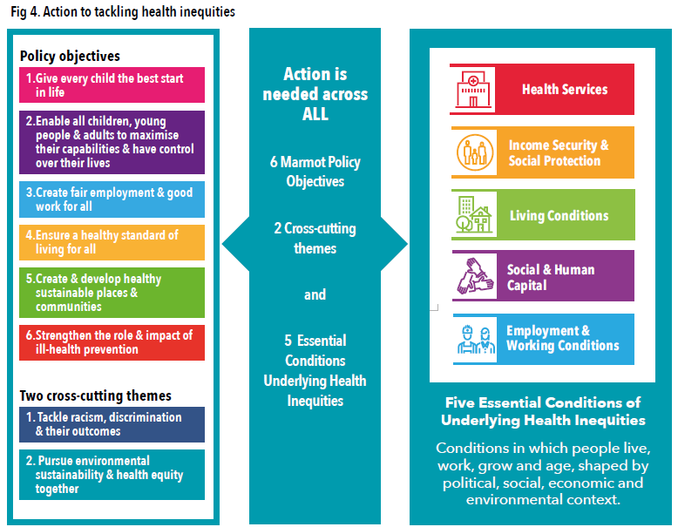

There have been several rounds of engagement both internal to SBUHB and with external stakeholders and partners as well as with external partnership forums. Overall, there is strong support for the Strategy as a statement of intent from SBUHB amongst our partners, recognising that there is considerable synergy with partners’ existing strategic intentions and delivery.

An initial, high-level mapping of existing partnership structures has highlighted a plethora of fora, indicative of the considerable effort & resource already being invested by partners in driving forward actions aligned to many aspects of this work. There is a need for us to recognise these current ‘delivery’ mechanisms and to agree how we contribute to ensure our collective efforts across the system intentionally focus on and lead to improvements in population health and greater equity. This consideration may lead to identification of a need for structural change but it will lead to a change in our relationships with partners: how we approach partnerships, the resources deployed to act in the partnership space, and the range of partnership spaces in which we are active.

Initial actions to progress the strategy within SBUHB
This engagement alongside data and policy analysis, led to a number of emerging local population health priorities for Swansea Bay, which are reflected in the Strategy. In determining our initial focus, we also reflected on our starting point in terms of our organisational capacity and capability to take forward a population health agenda requiring change at scale and across a complex and adaptive system. Hence our initial focus is on:
- working to build trust between partners;
- developing a common agenda; and
- building system capability and capacity.

These actions are the building blocks and are essential foundations for the next phase of development aimed at changing ways of working to deliver population health action that is both sustainable and also at a scale for population impact. These are therefore reflected in the organisation’s Population Health R&S Plan intentions for 2023-24.

The strategy supports the ‘4-Pillars’ approach to the role of SBUHB as a population health-focussed organisation (see fig below). This sets out the contribution that SBUHB can make to population health as: (1) a healthcare provider; (2) an employer; (3) an anchor institution; and (4) through productive partnerships. The Strategy describes some examples of actions that SBUHB could take from each perspective to help distinguish between them.

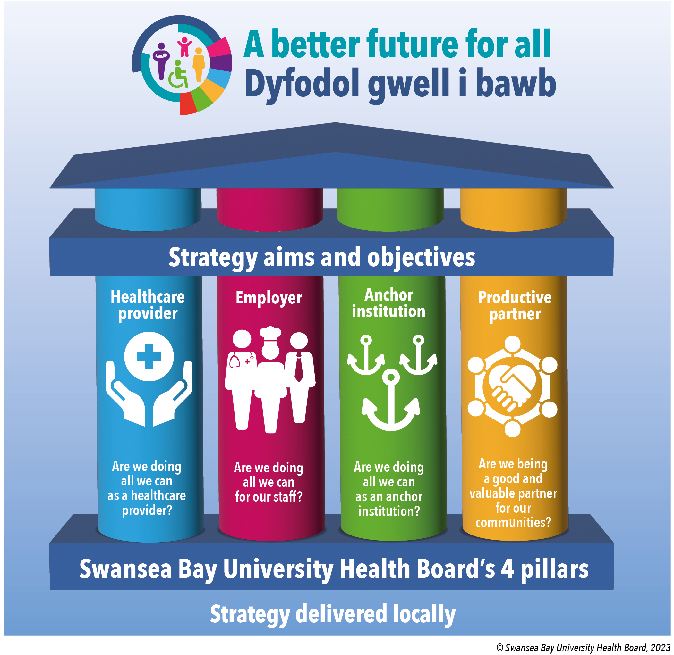
In light of our starting position across the system, we have looked to rationalise the actions we prioritise for the coming year as we move to developing our understanding and ability to work differently as a population health focused organisation. This recognises that capability in relation to population health (knowledge and technical skills) is limited and spread unevenly through the system. Also that we wish to ‘start from where we are now’ in developing confidence in our approaches and as much as possible, to foster sustainable delivery of population health approaches, building from our current operational machinery.

We have further developed these agreed priorities, in line with the GMO methodology, as outlined in the accompanying driver diagrams (see Appendix 2).

Governance of Delivery
Discussions have taken place during 2022-23 over the governance arrangements for oversight of delivery of population health leading to a proposed structure (see Appendix 3). A Population Health Development Board has been established and is intended to act as a forum where cross-organisational developmental and problem-solving conversations could happen. This was highlighted as a need by colleagues and in recognition that there already exists other well-established formal reporting and governance arrangements for performance monitoring & management.

The Population Health, Planning and Partnerships Sub-Committee is now also established to provide Board level governance of population health. The Management Board arrangements have similarly been reconfigured to provide an appropriate decision making forum for population health matters.

Progress to date:
There are currently no mechanisms established that routinely and systematically capture and record progress against each of the actions highlighted. An attempt has been made in appendix 2, to highlight progress where it is known. To date this has been reliant on the Public Health Team’s awareness of activity. However, this cannot be delegated to the Public Health Team as it is a whole of system response and responsibility. Indeed, it is highly likely, given the engagement to date across the organisation, that there are significant areas of work to support this agenda being taken forward which are unsighted.

The PHS requires a whole of system response. As such, there is a requirement to be clear on how whole of system activity is captured and performance managed, in line with establishing / established responsibilities. To be able to provide assurance on progress, there is therefore a need for a discussion about what are the appropriate mechanisms for performance managing against the PHS objectives/actions given that this may be fundamentally different to healthcare delivery.

- IMPLICATIONS FOR OUR ORGANISATION’S ABILITY TO IMPLEMENT
Development of System-wide approach
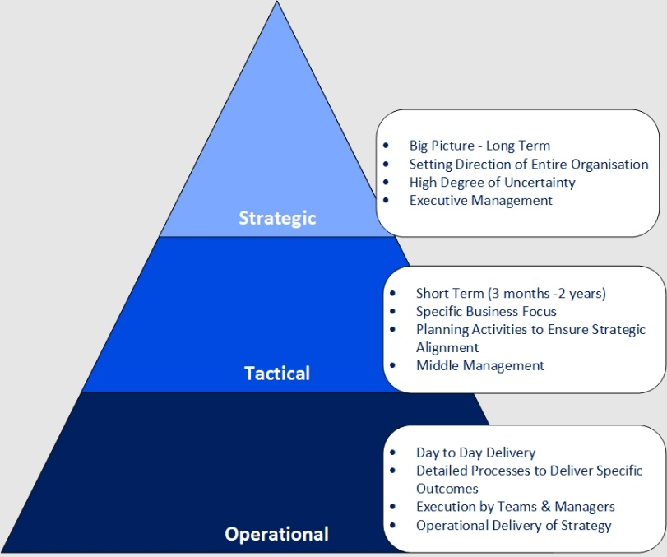
The implementation of PHS at scale requires concerted and coordinated action across strategic, tactical and operational perspectives of the organisation and externally. The various engagement activities over the last year and more recently have highlighted that there is currently no established way of working on cross-cutting initiatives within SBUHB other than by setting up bespoke or ad hoc working groups. The need to identify ways in which to systematically and sustainably support the development of a population health approach which involves whole organisational cultural, behavioural and operation change is recognised as an area for us to develop over 2023-24.

Development of cross cutting business cases (Tobacco Control & Weight Management) has led to innovative approaches to partnership working to agree solutions that navigate the federated arrangements required to scope, scrutinise, agree and implement services. This has sought to use existing processes and responsibilities for service delivery, reporting and performance management, through collaborative discussions. The learning emerging is that development of the relationships to enable collaboration and partnership working are a key vehicle to SBUHB realising its ambition to be population health competent.

Work has also been undertaken to ensure population health implications and impact are considered as part of business case approval and scrutiny processes internal to the organisation, as part of shifting our usual ways of working. Early conversations with Strategy & Planning colleagues have highlighted a need and appetite to build on this as part of the practical and routine incorporation of population health principles & practice into our business processes and operational delivery.

The need for further development of the SBUHB approach to health intelligence has been previously highlighted. Generation of strategic level population health needs assessments will assist in identifying priorities for action, alongside more focused health needs assessments for specific pathway developments. This will enable the organisation to identify the level and the distribution of need in the population and the evidence base for effective interventions. It will also help us to better tackle the inequities within and across our communities.

There is an opportunity to use existing expertise in the public health team to develop and use Population Health Management approaches that are already being used in other health boards, ahead of any nationally determined solution. These approaches would inform the methodology to support existing commitments/aspirations around better understanding the needs of the population in relation to the high levels of demand contributing to our current financial plans.

Strategy dissemination & communication
To date the communication and dissemination of the PHS has been limited due to awaiting the Welsh versions of the Strategy. Whilst we are in the process of commissioning Easy Read versions, now that we have the PHS and Executive Summaries in both languages (appendix 1 – resources section), the intention is to use the Strategy documents to facilitate ongoing & broader engagement as part of a communications campaign. We know that success will require collective corporate action and a long-term commitment across a wide range of stakeholders to develop the trust, understanding and partnerships needed to utilise the strategy as a lever for change.

Initial conversations have recognised the need for the development of a communications and engagement strategy to support segmentation of stakeholders and target action specific to each segment. Stakeholders can be described broadly as falling into the following categories:
- Internal SBUHB colleagues
- External partners
- Public & communities

Segmentation of the stakeholders and the development of baseline positions for each segment are key actions required to develop the foundations for strategy communication & implementation. The detail of this, including resource implications, are yet to be fully developed into proposals and will need to involve colleagues from across different departments and directorates. The development of this work will require input from a wide range of subject matter experts and mapping into organisational planning processes.

We have recognised the need to bring the PHS closer to our staff in a way they are able to engage with. We will look to do this through building in calls to action that help us to take the practical, initial steps to implementation. An example might be to build on existing practice such as the collection or confirmation of the determinants of health such as postcode, ethnicity, occupation etc. as part of every patient contact in a bid to develop the data fundamentals that support our population heath approach.

- SUMMARY
This report provides an update on the development of the Population Health Strategy for Swansea Bay, which is using the Marmot conceptual framework to describe an approach for the health board to organise its population health directed activities. However, in parallel there is a need for transformation in how SBUHB goes about its business to incorporate purposeful planning for population health gain and reduction of inequities into operational delivery. Additionally, current performance measurement approaches are not yet in place to capture work which is not delivered in a transactional manner.

The strategy documents highlight a range of medium to long-term priorities for population health in the local population which will require action from partners across the Swansea Bay area. Appendix 2 (attached) sets out the initial actions that have been approved by the Board from the perspective of SBUHB, along with a high-level summary of some areas of progress.

The Committee is asked to note the final Population Health Strategy for Swansea Bay and the collective action and ways of working called for in the plan and to note the shorter-term priorities for action by SBUHB. Also, to acknowledge the commitment to implement the strategy as a shared responsibility across the organisation and the risks and issues highlighted above. The approaches set out in the strategy provide a population health lens to apply to all aspects of our organisation’s work and capabilities.

- GOVERNANCE AND RISK ISSUES
There has been concern raised that ‘Public Health’ (‘Population Health’) initiatives or approaches, which naturally sit across all service groups or in partnership spaces, are not governed effectively at present. While there has been a willingness and enthusiasm to engage in discussions on becoming a population health-focussed organisation, there has been limited progress in the coordination of delivery of population health activities and system planning.

This led to the development of a proposed governance structure (appendix 3). Whilst this has been established, it is important to be mindful that it has been designed for a mature system and has not been tested for its appropriateness during this transformation phase of establishing and embedding the PHS.

This poses a potential risk and highlights the need for an adaptive and agile approach to enable governance arrangements to evolve in light of experience gained through the system transformation phase.

- FINANCIAL IMPLICATIONS
As highlighted previously, there will be financial implications of the required investment in staffing and infrastructure to support the population health strategy. These are not yet quantified but are unlikely to be met by additional external funding. A limited amount of Welsh Government money is available to support delivery of specified programmes on a grant-funded basis. This money is insufficient to fund Welsh Government priorities in full. The business case development and investment decision-making processes will provide the appropriate level of control. Early conversations have been started to further understand and enhance our ability to consider the totality of the SBUHB’s budget to better achieve population health gains.

- RECOMMENDATION
The Committee is asked to:
- Note the issue of the final version of the Population Health Strategy (appendix 1 – resource section) and that there will be a process of engagement as part of the launch of the strategy.
- Endorse the initial steps for action towards delivering on the Population Health Strategy for Swansea Bay (appendix 2), acknowledging that this is a transformational agenda
- Note the changes in business delivery and performance reporting required to support effective delivery of population health approaches.
- Restate the Board’s commitment to becoming a population health competent organisation.

Governance and Assurance
Link to Enabling Objectives  (please choose) | Supporting better health and wellbeing by actively promoting and empowering people to live well in resilient communities
Link to Enabling Objectives  (please choose) | Partnerships for Improving Health and Wellbeing |  | ☒
Link to Enabling Objectives  (please choose) | Co-Production and Health Literacy |  | ☒
Link to Enabling Objectives  (please choose) | Digitally Enabled Health and Wellbeing |  | ☒
Link to Enabling Objectives  (please choose) | Deliver better care through excellent health and care services achieving the outcomes that matter most to people
Link to Enabling Objectives  (please choose) | Best Value Outcomes and High Quality Care |  | ☒
Link to Enabling Objectives  (please choose) | Partnerships for Care |  | ☒
Link to Enabling Objectives  (please choose) | Excellent Staff |  | ☐
Link to Enabling Objectives  (please choose) | Digitally Enabled Care |  | ☒
Link to Enabling Objectives  (please choose) | Outstanding Research, Innovation, Education and Learning |  | ☐
Health and Care Standards
(please choose) | Staying Healthy |  | ☒
(please choose) | Safe Care |  | ☐
(please choose) | Effective Care |  | ☒
(please choose) | Dignified Care |  | ☐
(please choose) | Timely Care |  | ☐
(please choose) | Individual Care |  | ☒
(please choose) | Staff and Resources |  | ☒
Quality, Safety and Patient Experience
The paper outlines progress to date around the production of the population health strategy and progress against the approved short-term priorities approved by the Board. Implementation of an effective population health approach will lead to a more consistent approach to prevention. The expectation is that opportunities for patients to be supported to make changes that will reduce their risk of ill-health and which will lead to improved well-being will be offered in a more systematic way across the sector.
Financial Implications
The paper notes that investment is required in order to make progress in a number of areas of priority for Welsh Government or where there is already an identified high level of need in our communities. However, that investment is not quantified.
A process for development of business cases in support of population health investment has been created and is being used in support of WG grant-funded areas of activity.
Legal Implications (including equality and diversity assessment)
No legal implications identified. The incorporation of population health approaches will allow for the identification of equality and diversity issues and development of appropriate responses.
Staffing Implications
Developments in support of Ministerial Priorities will require additional staffing and this will be addressed through the emergent business cases.
The Public Health Team restructure intends to alter the skill-mix compared with the funded establishment and is likely to result in fewer staff of higher banding being employed.
This of itself will be insufficient to support the developments required to fulfil the requirements of the population health. Development of the implementation plan will identify the skills and workforce requirements.
Long Term Implications (including the impact of the Well-being of Future Generations (Wales) Act 2015)
Population health approaches incorporate a prevention ethos and delivery is contingent on collaboration among partners to deliver better outcomes for our population. A coproduction approach is integral to public health practice and seeks to involve communities and staff in designing services and programmes.
Report History |  | No previous reports
Appendices |  | Appendix 1 – Swansea Bay Population Health Strategy – final versions (resource section)  Appendix 2 – Population Health Strategy Year 1 Priority Recommendations  Appendix 3 – Population Health Strategy Governance Structures

