

Meeting Date | 19 June 2023 |  | Agenda Item |  |  | 3.2
Report Title | Public Service Board – Wellbeing Plans
Report Author | Michelle Davies, Head of Strategic Partnerships & Planning
Report Sponsor | Nerissa Vaughan, Interim Director of Strategy
Presented by | Nerissa Vaughan, Interim Director of Strategy
Freedom of Information | Open
Purpose of the Report | The purpose of the following report is to highlight the alignment between Health Board Plans and the Wellbeing Objectives of the Public Service Boards, of which the Health Board is a Statutory partner.  The report sets out the governance that will manage the work programmes as the partnerships move into the implementation phase and how the Health Board will contribute and interact within that governance.
Key Issues | The Health Board needs to understand and respond to the needs of the populations of Swansea and Neath Port Talbot, and ensure that the assessments undertaken feed into the Health Board’s Plans. The Health Board will have an active role in the implementation phase to be initiated by the PSBs.
Specific Action Required | Information | Discussion |  | Assurance | Approval
Specific Action Required | ☐ | ☒ |  | ☒ | ☐
Recommendations | Members are asked to:  - NOTE the alignment between Health Board and PSB Wellbeing Plans;  - NOTE the contribution that the Health Board will make to the governance and implementation of Partnership Plans.

Public Service Board – Wellbeing Plans

- INTRODUCTION

The report sets out the following:

- The statutory requirements for partnership working, and the current status of Plans. Further information on the statutory requirements can be found in the Social Services and Well-being (Wales) Act 2014 document attached as appendix a.
- Alignment between Health Board Plans and those of the Public Service Boards), of which the Health Board is a statutory partner.
- Governance in place to manage the different work programmes as the partnerships move into the implementation phase and how the Health Board will contribute and interact within that governance.

- BACKGROUND

2.1 Public Services Boards (PSBs) – Local Wellbeing Plans

The Well-being of Future Generations (Wales) 2015 Act (WFG Act) sets out a well-being duty to be met by individual public bodies such as Swansea Bay UHB. The WFG Act also sets out a collective well-being duty to be discharged via Public Services Boards. These are distinct but complementary duties.

The Local Well-being Plans identify Local Well-being Objectives which set priorities for collective action to be taken forward by one or more of the Public Services Board’s partners. It also sets out steps to achieve these objectives and how they maximise contribution to the national well-being goals in line with the WFG Act’s five ways of working. The actions underpinning these steps and who will deliver them will be set out in an Action plan following the Plan’s publication.

Both plans developed separately for the communities of Neath Port Talbot and Swansea are primarily driven by matters raised in the Assessment of Local Well-being undertaken in 2022. The Plans take into account recommendations made by the Future Generations Report, and Welsh Government’s Future Trends Report. The Plans have been developed working closely with the West Glamorgan Regional Partnership Board and the Partnership developed the Population Assessment and Area Plan draft. In addition, Swansea and Neath Port Talbot PSBs have worked closely together throughout the process. Plans were subject to extensive three-month engagement periods with involvement from citizens, partners, and staff and Council leaders

  - Alignment with Health Board Plans

The Plans are structured around four Local Well-being Objectives, and whilst Swansea Bay UHB covers the communities of both Neath Port Talbot and Swansea there are strong similarities between the two plans, and the objectives set.

The Strategy Team have reviewed the Wellbeing objectives against the Health Board’s Recovery & Sustainability Plan. The purpose of the review was to undertake a stocktake of existing work, ongoing work programmes, and any potential opportunities and implications aligned to the priority areas. Table 1 below includes a summary of this alignment with some examples of the existing work programmes that have the greatest alignment with the PSB Wellbeing Objectives.

Table 1
Swansea Bay UHB | Swansea  Wellbeing Objectives | Neath Port Talbot Wellbeing Objectives | Alignment with Health Board
Give every child the best start in life   | Early Years: To ensure that children in Swansea have the best start in life to be the best they can be | All children have the best start in life | - Early Years Pathfinder schemes (Welsh Government funding)  - Tier 2 & 3 Weight management programme  - Increased offer for school staff via CAMHS School In-reach  - Embed Children’s Rights in line with our Children’s Rights Charter and SBUHB ‘Promises’
Provide opportunities to support every adult to be healthier and age  Seek to allocate our resources to meeting the needs of, and improving the population’s health   | Live Well, Age Well: To make Swansea a great place to live at every stage of life | All our communities will be thriving and sustainable | - Increased community provision of services  - Provision of public health technical expert guidance & support – including the pan-cluster planning group  - Pre-diabetes cluster implementation  - 24/7 mental health assessment hub- operational  - Deliver whole system approach to healthy weight  - Implement year 1 priorities within the SBUHB Tobacco control plan  - Roll out MSK community pathway and prehab
Nurture and use the environment to improve health and wellbeing   | Climate Change and Nature Recovery: To restore and enhance biodiversity, tackle the causes, and reduce the impact of climate change | Our local environment, culture and heritage can be enjoyed by future generations | - Decarbonisation Action Plan  - Development of a Community Supported Agriculture project, Cae Felin, on Health Board land.  - Local Energy Plans – NEW 23/24
Plan, commission, deliver and promote equitable, inclusive and accessible health and wellbeing  Apply ethical recruitment practices and support health and care workers to be healthy   | Strong Communities: To build cohesive and resilient communities with a sense of pride and belonging | There are more green, secure and well-paid jobs and skills across the area are improved | Swansea Bay Commissioning Framework supports:  - Commissioning of services to ensure that best value outcomes are achieved for our population by challenging and improving the use of our core resources.  - The Framework will be applied to the Health Board’s activities as a direct external commissioner of services for the population it serves including other non NHS organisations for example third sector, local authorities etc.

Overall, it is recognised that working collaboratively with partners has multiple benefits including the following:

- Access to multi-agency and multi-professional advice and support to inform plans​
- Fulfilling our responsibilities as set-out in the Population Health Strategy, particularly the role we have as a productive partner and an anchor institution​
- Access to partnership resources, including financial investment​

As part of the review undertaken the following specific opportunities and challenges were identified:

Opportunities

- Engage with partners who have received feedback/shared experiences to develop and/or change services ensuring the population’s needs are met.
- Work with partners to invest in communities, third sector partners to further build an asset and strengths-approach to developing local solutions to population needs.
- Opportunity to collaborate on actions – particularly on environmental and sustainability issues to secure funding and to identify links with service provision.

Challenges

- The need for multi-agency alignment of timescales and strategic vision
- The need for pooled funds for some services and to provide integrated service provision
- Green infrastructure - the challenges faced by teams are, especially in primary care sites – is land ownership. It is often unclear who owns and maintains the land. The challenge is identifying the landowner / manager and then gaining the permission to take proposals further.
- Co-ordination of a coherent approach to Partnerships in the Health Board

  - Governance and next Steps

The Wellbeing Plans identify the action the PSBs will take, setting out the steps which underpin each of the objectives and how we will use the ways of working to implement them. The objectives included in the Swansea & Neath Port Talbot Wellbeing Plans are closely aligned, and where possible the implementation plans will utilise existing groups to progress plans. Whilst Swansea is further ahead with the development of their plans, the same methodology has been applied to date and will continue to be used by both PSBs to follow through the development and implementation of plans.

2.3.1 Swansea PSB

In Swansea, Strategic Leads have already been identified for each of the eight steps – table 2 below sets out those steps and the identified leads. Each of the leads will be responsible for identifying Delivery Groups, who will then develop action plans for each step. Every effort is being made to align interdependencies and ensure connections are maximised. Progress against the action plans will be reported via the Public Service Board meetings.
Table 2
Wellbeing Step | Strategic Lead | Operational Lead | SBUB Representation
Step 1: To support the transformation of Early Year Services in Swansea to provide better support for children to have the best start in life. | Karen Stapleton, SBUHB | Alison Williams/Gary Mahoney, Swansea Council | Strategy, Public Health and CYP therapy service leads
Step 2: To build on Swansea’s 2022 declaration of being a Human Rights City | Ness Young, Swansea Council | Adele Dunstan, Swansea Council | Department of Insight, Communication and engagement (DICE)
Step 3: Working towards Swansea’s net zero target and nature recovery | Martyn Evans, Natural Resources Wales | TBC | Strategy - Sustainability
Step 4: Making Swansea safer, more cohesive, and prosperous | Roger Thomas, Mid and West Wales Fire and Rescue Service | Amanda Carr, Swansea Council for Voluntary Services | Delivery Group tbc
Step 5: Developing Swansea’s Integrated Cultural Offer | Mark Wade, Swansea Council | Tracey McNulty, Swansea Council | Delivery Group tbc
Step 6: To Influence and connect with other governance arrangements across the Swansea Bay region | Ness Young  Swansea Council | Richard Rowlands  Swansea Council | Strategy
Step 7: To improve data quality and accessibility across the Swansea Bay region | Ness Young  Swansea Council | Richard Rowlands  Swansea Council | Strategy
Step 8: To Develop Swansea PSB performance management arrangements which measure and monitor the PSB’s progress | Ness Young  Swansea Council | Richard Rowlands  Swansea Council | Strategy

Plans in Swansea are marginally more advanced, and we can already see opportunities emerging via the 8 steps as described below:

- Step 1: - As the strategic lead for Early Years the Health Board, has been asked to nominate an Exec lead who has responsibility for Early Years. There is a well-established Early Years Regional (Swansea &NPT) Group who will be asked to develop a comprehensive Early Years Strategy for the Swansea Bay region
- Step 2: - focus of this work is mapping and engagement , with links to the Swansea Safer Partnership, this is an area where the Health Board needs to ensure we are visible as a stakeholder
- Step 3: - focus is mapping who is doing what in the climate change space, getting improved collaboration in some areas, establishing one overarching Group to lead an action Plan which is informed by our key risks
- Step 4: - focus is on engagement with communities. Opportunity for Health Board and other partners to ensure consistent messaging.
- Step 5: - focus on establishing a Creative Network that promotes health, community cohesion, and organisations having a common offer on wellbeing, sports and physical activity and increasing participation
- Step 6-8: - focus is on mapping partnership landscape clarifying governance, roles and responsibilities, using the wellbeing assessment to inform partner decision making, developing common data sets and developing a Swansea Bay region digital data portal, and a Performance Management Framework for the PSB.

Swansea PSB have developed a Plan on a Page, with details of the Wellbeing Objectives and the eight steps – this is attached as appendix b. Swansea have developed an action plan, incorporating the 8 steps above – the draft action plan is attached as appendix c. The action plan has a strong focus on expectations and what the expected outcomes and success factors are. The Action Plan sets out the actions to be delivered, milestones, outcomes and success measures.

2.3.2 Neath Port Talbot PSB

In Neath Port Talbot, the work programmes will be managed via the existing governance structure, utilising the Partnership groups already in place – see diagram below.
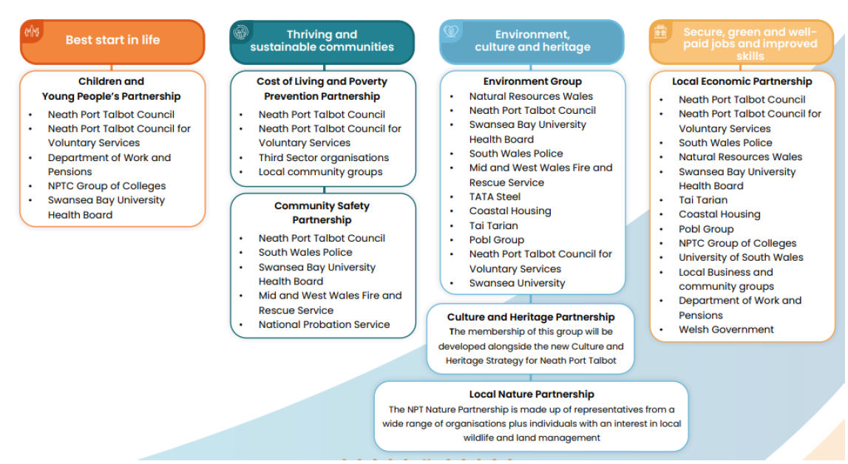

A Steering Group has been set-up to oversee the development of plans, and following a meeting at the end of May, with representation from Strategy and Public Health.
The Health Board must ensure that there is good representation within the above structure, and historically the Health Board has had representation on the Children & Young People’s Partnership and the Community and Safety Partnership. Members of the Groups will be considered at the workshop planned for June.
Delivery Plans will be developed using a Theory of Change methodology. Following advice from the Swansea Bay Public Health team it is proposed that plans will be developed as Logic Models. The Logic Models will support the understanding of the complexities of the issues we are facing, ensuring that all our stakeholders will be involved in the process of identifying existing evidence, assumptions, and associated risks. As this methodology is relatively new to partners, an example will be presented to PSB members at a workshop on the 27th June.
The Health Board are leading the Early Years work programme, and this fits well with the work already underway with the Pathfinder Projects. There is an existing steering group that will be utilised to develop the action plan, and in addition, the Health Board have set-up an internal monthly meeting to meet with leads across the Health Board to maintain momentum.
The development of action plans remain in an early stage, and the priority currently is to ensure robust governance is in place.

- FINANCIAL IMPLICATIONS

There are no direct financial implications for the Health Board.

- RECOMMENDATION

- NOTE the alignment between Health Board and Partnership Plans;
- NOTE the contribution that the Health Board will make to the governance and implementation of Partnership Plans.

Governance and Assurance
Link to Enabling Objectives  (please choose) | Supporting better health and wellbeing by actively promoting and empowering people to live well in resilient communities
Link to Enabling Objectives  (please choose) | Partnerships for Improving Health and Wellbeing |  | ☒
Link to Enabling Objectives  (please choose) | Co-Production and Health Literacy |  | ☐
Link to Enabling Objectives  (please choose) | Digitally Enabled Health and Wellbeing |  | ☐
Link to Enabling Objectives  (please choose) | Deliver better care through excellent health and care services achieving the outcomes that matter most to people
Link to Enabling Objectives  (please choose) | Best Value Outcomes and High Quality Care |  | ☐
Link to Enabling Objectives  (please choose) | Partnerships for Care |  | ☒
Link to Enabling Objectives  (please choose) | Excellent Staff |  | ☐
Link to Enabling Objectives  (please choose) | Digitally Enabled Care |  | ☐
Link to Enabling Objectives  (please choose) | Outstanding Research, Innovation, Education and Learning |  | ☐
Health and Care Standards
(please choose) | Staying Healthy |  | ☒
(please choose) | Safe Care |  | ☐
(please choose) | Effective Care |  | ☒
(please choose) | Dignified Care |  | ☐
(please choose) | Timely Care |  | ☒
(please choose) | Individual Care |  | ☒
(please choose) | Staff and Resources |  | ☐
Quality, Safety and Patient Experience
There are no implications in relation to Quality, Safety and Patient Experience to declare as part of this report.

Financial Implications
There are no financial implications to declare as part of this report.

Legal Implications (including equality and diversity assessment)
There are no legal implications as a result of this report.

Staffing Implications
There are no staffing implications as a result of this report.

Long Term Implications (including the impact of the Well-being of Future Generations (Wales) Act 2015)
The development of the PSB Wellbeing Plans are an integral part of public service organisations delivering against their statutory duties.

As set out in the Well-being of Future Generations (Wales) Act 2015, Public Service Boards (PSBs) have a statutory duty to prepare and publish a local well-being plan.

Report History |  | This is the first report to be considered by the Committee.
Appendices |  | Appendix a – Social Services and Well-being (Wales) Act 2014 Accessed online 19/04/23 - *statutory-guidance-in-relation-to-area-plans-under-section-14a.pdf (gov.wales)  Appendix b - Swansea PSB - Plan on a Page  Appendix c – Swansea PSB – Action Plan

