

Meeting Date | 12 October 2023 |  | Agenda Item |  |  | 4.2
Report Title | Internal capability & capacity to progress our population health aspirations/priorities
Report Author | Jennifer Davies, Deputy Director of Public Health;  James Rodaway, Associate Director of Population Health Programme Development;  Keith Reid Executive Director of Public Health
Report Sponsor | Keith Reid, Executive Director of Public Health
Presented by | Keith Reid, Executive Director of Public Health
Freedom of Information | Open
Purpose of the Report | This report considers the three areas of focus for 2023-24, which were discussed and agreed at the last Committee meeting in May. These were agreed based on the recognition of the need to move from a focus on operational delivery to building capacity & capability that is distributed across the system to avoid over-dependence on a small number of individuals. The priorities being:  - Establishing the right mechanisms to enable us as an organisation to progress the work – infrastructure, capability, processes etc.  - Ability to monitor what we’re doing under the 4 pillars and highlight our progress & challenges  - Maintaining progress against WG population health priorities (which currently are tobacco control & weight management) to enable us to focus on our PHS priorities
Key Issues | On approval of the PHS by Board, there was a recognition that this is the start of the journey and there are some risks identified around progressing implementation. These risks derive largely from a lack of understanding of the strategic, tactical and operational perspectives of strategy implementation at scale and SBUHB’s ability to navigate these perspectives to enable a coherent coordinated whole of organisation response within and across our current federated structures:  - Capability and capacity are limited. The awareness and recognition of the PHS and its implementation being owned by us all is not well understood or appreciated. This is shown in levels of engagement and language used which indicate a sense that this is a ‘public health team’ agenda as opposed to a whole of organisation strategic intent which has reputational and population health risks to non-delivery.  - Given the new organisational vision, there is a need to knit together the different strategic narratives through the development of the appropriate infrastructure & supporting mechanisms as part of developing our tactical response / narrative. A failure to do so will create perceived additional burden on the system and fragmented approach to actions with seeming competing ‘asks’.  - There are currently no mechanisms by which:  - Year 1 priorities are allocated senior level ownership or identification of mechanisms for sustained delivery across the organisation. This has led to a lack of progress & momentum across some of the priorities.  - No mechanisms for routine monitoring of activity or progress that can provide insight or assurance.  - No forum / way of bringing together those who can operate at a tactical level – translating strategic intent into a coherent tactical response that can be used to drive/inform operational delivery through existing appropriate operational governance mechanisms.  - Existing governance and performance reporting mechanisms for delivery of the R&S plan do not lend themselves to the whole of organisation delivery and actions indicated in the PHS.  - Existing GMO contributions captured through the planning process do not enable operational delivery and the tactical response required to deliver strategy in a coordinated manner. The GMO contributions describe activity at different scales making read across, joint working and aggregated contribution difficult to understand.  - Where progress has been made, this is limited to areas of existing / familiar ‘service based’ activity e.g. weight management, smoking cessation services which have limited/little impact on population health.  - There remains a need to shift our ways of thinking and working – embedding population health principles and priorities into our business as usual processes & mindset.  - Having communicated our intentions and actions internally and externally, expectations will be raised and hence there are reputational risks in failing to demonstrate progress during this first, developmental year for the PHS.  - Work has progressed on the development of business cases in support of Welsh Government priorities for both tobacco control and weight management. The progress has been hampered by the need for WG approval of proposals and agreement of operational governance and oversight for the development of services that are prioritised as a R&S deliverable in one area (Population Health) with operational implementation residing elsewhere (Primary, Community & Therapies)
Specific Action Required  (please choose one only) | Information | Discussion |  | Assurance | Approval
Specific Action Required  (please choose one only) | ☐ | ☒ |  | ☐ | ☒
Recommendations | Members are asked to:  - Recognise the emergent learning from work to date and learning  - Acknowledge the progress made in terms of the Welsh Government ministerial priorities on tobacco control & weight management services  - Note the challenges to implementation of the PHS highlighted / identified  - Approve the suggested approach to addressing the challenges highlighted.

Internal capability and capacity to progress our population health aspirations & priorities

- INTRODUCTION
The Population Health Strategy (PHS) was approved by the Board in March 2023 along with year one priorities based on the recognition of where we are starting from as an organisation in terms of our internal infrastructure, capability and capacity. These were in line with the 4 pillars model that reflect the functions of the Health Board.

At the Population Health and Partnerships Committee meeting in May 2023, the stated focus for this year were as follows:
- Identify, develop and embed mechanisms to enable us as an organisation to progress the work – infrastructure, capability, processes etc.
- Be able to monitor what we’re doing under the 4 pillars and highlight our progress & challenges
- Ensure we maintain progress against WG population health priorities (which currently are tobacco control & weight management) to give us the space to focus on our PHS priorities

This was predicated on the recognition that we need to move from a focus on operational delivery to building capacity and capability that is distributed across the system to avoid over-dependence on a small number of individuals. This fits well with the quality improvement and distributed leadership agendas.

This paper provides a narrative on the current position in relation to these internal areas of focus to stimulate a discussion on how to address the challenges presented and next steps.

- BACKGROUND
The case has been made that excellence in the provision of health care is a necessary but not a sufficient requirement for improving the health of the local population. Also, that inequalities in health arise because of inequalities in society and the conditions in which people are born, grow, live, work and age – leading to differential levels of vulnerabilities. These inequalities may be amplified by how healthcare is organised and delivered.

In recognition of this, the PHS describes of the evidence informed actions (Marmot & WHO) needed to tackle health inequities. The evidence base makes it clear that action is needed across all these policy objective areas to deliver population health gain at scale. To enable the evidence base to translate into functional actions the 4 pillar model (see figure 1 below) was designed to ensure that it was effective at delivering strategy locally.

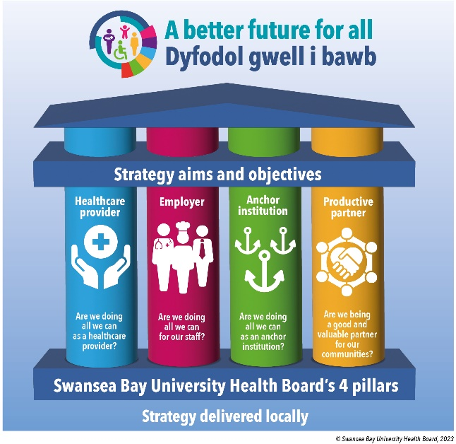
In light of our starting position across the system, we have looked to rationalise the actions we prioritise for the coming year as we move to developing our understanding and ability to work differently as a population health focused organisation. This recognises that capability in relation to population health (knowledge and technical skills) is limited and spread unevenly through the system. Also that we wish to ‘start from where we are now’ in developing confidence in our approaches and as much as possible, to foster sustainable delivery of population health approaches, building from our current operational machinery.

Figure 1: Strategy delivered locally, Population Health Strategy 2023
- DEVELOPMENT OF A SYSTEM-WIDE APPROACH
The adoption of innovation/strategy at scale lends itself to the development of strategic narratives to enable coordination of a set of related events/actions that unfold over time and allow a story around the journey from current to future state to be told. The evidence base around narratives in public sector tells us that in a sector that is resistant to innovation that narratives:
- Matter;
- Enable people to make sense, share experiences and develop meaning through storytelling;
- Evoke emotions and drive actions in a way that statistics do not.

The implementation of PHS at scale requires concerted and coordinated action across strategic, tactical and operational perspectives of the organisation and externally. Extensive organisational engagement activities have highlighted that there is currently no established way of working on cross-cutting initiatives within SBUHB other than by setting up bespoke or ad hoc working groups. The need to identify the narratives which will systematically and sustainably support the development of a population health approach enabling whole organisation cultural, behavioural and operation change is recognised as an area for us to develop over 2023-24.

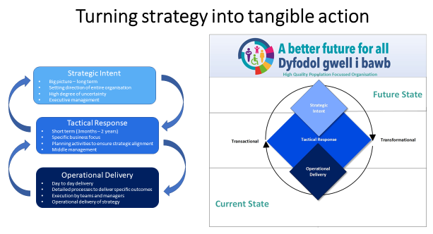

Some examples of areas where we have started to develop this thinking have been:
- Development of cross cutting business cases (Tobacco Control & Weight Management). This has led to innovative approaches to partnership working to agree solutions that navigate the federated arrangements required to scope, scrutinise, agree and implement services, using existing processes and responsibilities for service delivery, reporting and performance management.
- Population health implications and impact are considered as part of business case approval and scrutiny processes internal to the organisation (BCAG / BCSG) as part of shifting our usual ways of working. There is a need to build on this as part of the practical and routine incorporation of population health principles & practice into our business processes and operational delivery.
- Proposal developed with finance colleagues and approved by Management Board to develop our capability and capacity to re-orientate the whole of organisation resourcing – revenue & capital – to focus on maximising the potential population health gain in how it is deployed/allocated.
- Working with colleagues to consider the implications of how we use the strategic narratives from both the organisational vision and PHS in the development of the R&S Plan for 2024-25. This has led to a recognition of the need for the Integrated Planning Group (IPG) to move from operational oversight of the development of the annual plan, to being the tactical space where strategic narratives are knitted together and the collective expertise is used to inform appropriate operational level objectives/goals. These will then feed into plans & GMOs for the coming year.
- Contributing to the development of the underpinning capability to be able to deliver on the One Bay Way aspirations & approach to pathway redesign/delivery, focused on driving up efficiencies within the identified broad clinical areas. This aligns with the development of a localised solution to the implementation of a Population Health Management model.

Whilst the emergent learning is that relationship development that enables collaboration and partnership working is vital to SBUHB realising its ambition to be population health competent, what must not be overlooked is the need for capacity, capability, processes and infrastructure to:

- Translate / make sense of the evidence base & strategic narrative within the PHS, in context, for population health gain, across all aspects of the Health Board’s business. The expectation is that the Public Health Team (PHT) will drive much of this sense making. However, its capacity is limited due to the size of the team.
- Facilitate / agree ownership / leadership of agreed population health priorities at a strategic & tactical level. The Board requested & approved a set of initial PHS priorities to be proposed as a starting point on the journey. It is unclear what mechanism exists or is intended, to take these into the organisation’s business. There is a need to identify who and how actions identified in the PHS will / can be taken forward, recognising existing structures & capability.
- Support value creation, recognising the different ‘asks’ / demands on the system and ensures a coherent interpretation of these, dynamically managing the necessary trade-offs and judgement calls inherent in a complex, adaptive and dynamic system. This needs to be cognisant of the existing structures / collaborative spaces / governance mechanisms.

Challenges and options for progressing:
Some of the challenges faced include:
- The narrative, whilst broadly welcomed, is poorly understood in terms of how it should/could be interpreted and used to inform action across all parts of the business / in real terms. This directly impacts on the capability & also capacity to progress this agenda, resulting in a reliance on a small number of individuals, leading to much slower progress than we would like to see.
- Not consistently viewed as being ‘my role’ or in keeping with others’ agendas which has led to highly variable engagement internally, leading to missed opportunities to take forward the agenda.
- Expectation currently that the SDGs will be able to do the interpretation of how the existing / broad/high level asks could / would best be taken forward across their various service level activities, in a consistent way that will lead to the intended population level outcomes
- No tactical response forum/infrastructure exists to help with the translation of the various strategic narratives (perceived ‘asks’ and expectations of the organisation) into appropriate, impactful and evidence based actions at SDG level and across the breadth of the organisation’s activities. The impact & value lies in acting at scale which requires joined up approaches/thinking.

The desire to progress the PHS and engagement to date, has been from a diversity of business/organisational areas including SDGs and corporate teams/functions. These have, for the most part, led to a shift in thinking, working and/or practice. However, this has been small scale to date. Alongside the increased awareness of the ‘why’ and ‘what’ the Health Board should/could be doing, there is less clarity or understanding of ‘how’ to go about operationalising this. The ‘ask’ is for a guiding mind/hand that helps develop the ‘most appropriate & beneficial response’ within the given context but also to ensure the collective efforts across the whole of organisation, are coherent & managed in such a way to bring about the intended population level outcomes.

With that in mind and given our starting point, the proposal is to scope out and develop an organisational change / development programme / process that develops our population health capability at all levels of the Health Board. Recognising that to be successful requires both top down and bottom up thinking and coherent action. Whilst this needs to be worked through, a potential framework/approach is outlined below:

Why | What | Who | How
- Strengthen the strategic narrative and leadership capability internally & externally | A development programme that knits together the different strategic narratives, makes sense of them and helps to synergise and consider our commitments & appropriate tactical response – working with and through others. | This will focus on the Executive Directors, Independent Members, Service Group Directors | Board Development;  Executive Directors fora  Senior Leadership / Management fora in SDGs and Corporate
- Strengthen the ability and agility to mount an appropriate tactical response to an agile/adaptive strategic context | A development programme that creates the capability and capacity to consider and provide an appropriate tactical level response to multiple & seemingly competing demands / asks, shifting strategic context using experiential judgement underpinned by evidence based, prevention, person centred and equity. | This will focus on those with the responsibility for enacting strategic intent through setting of targets / development of annual plans etc. Likely to be direct reports to middle / senior management & leaders across the organisation including direct reports to Exec & Service Directors | Existing fora e.g. LTP; IPG; CSOG; Management Board BCAG / BCSG; VBHc; One Bay Way, SDG SMTs. There may be a need to create additional/complementary mechanisms for capacity development, appropriate to the given context.
- Support the development of capability to operationalise population health approaches & evidence based / informed practice | A development programme that works with the tactical leads / senior managers responsible for overseeing and developing services to provide support / knowledge & skills transfer. | Due to current capacity to support the organisational development programme, likely that this will involve coaching / support to the above cohorts?? | Existing fora where applicable. Opportunistically as the need arises, esp where there is a common or cross cutting capability issue/need identified. Development of resources, signposting to training etc.

- MONITORING OF PROGRESS / ACTIONS TO SUPPORT POPULATION HEALTH GOALS / GAINS
Monitoring and reporting mechanisms within SBUHB are programme based and aligned to providing assurance around service delivery, national targets and compliance metrics. From a PHS perspective, there are currently no mechanisms established that routinely and systematically capture and record progress against each of the year 1 priority actions highlighted. Any attempts to date to try and highlight progress where it is known has been reliant on the Public Health Team’s awareness of activity. This cannot be delegated to the Public Health Team as it is a whole of system response and responsibility. Engagement to date across the organisation indicates that there are areas of work to support this agenda being taken forward which are unsighted.

As such, there is a requirement to develop the narratives that enable activity contributing towards PHS delivery across the whole system to be captured and performance implications and cultural shift to be understood. To be able to provide assurance on progress, there is a need to consider and agree what are the appropriate mechanisms for performance managing against the PHS objectives/actions given that this may be fundamentally different to healthcare & service delivery as indicated in the year 1 priorities listed below (attached):

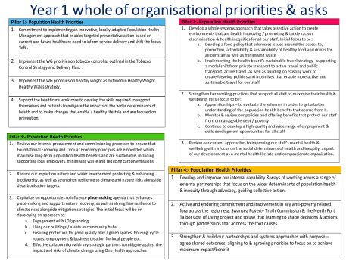

Addressing these reporting issues highlighted, given the existing reporting structures, is a developmental process. Our proposal is that the organisational development programme indicated above will enable us to consider what is the most appropriate mechanisms and processes for reporting on progress, for what audience & intended actions/behaviours. In so doing it is likely that the current processes will not be fit-for-purpose. This will enable a co-design process to ensure an ability to provide a system that can:
- Report on the progress against the transformational agenda as the organisation matures & develops its competency;
- Provide timely feedback & insight that can be used to adapt the tactical / operational response accordingly in an agile & responsive manner;
- Measure progress against population level indicators with a particular focus on the root causes and inequities.

- GOVERNANCE AND RISK ISSUES
A proposed governance structure has been established to take forward and provide assurance for the delivery against the Population Health Strategy aims and aspirations. Initiatives, approaches and actions in service of the PHS naturally sit across all service groups or in partnership spaces. As previously highlighted, the structures are designed for a mature system and what the paper highlights is that we remain very much in the developmental / transformational phase of establishing and embedding the PHS. Hence we do not yet have the necessary infrastructure needed to be able to co-ordinate the delivery of population health activities and system planning nor be able to monitor / assess progress and hence provide assurances to the Board.

This poses potential risks in terms of population health outcomes; impact on the system having to respond to the significant health needs experienced in our population; reputational damage amongst partners if we remain solely focused on healthcare provision/services at the expense of collaborative opportunities to impact on the drivers of inequity and poor health outcomes.

Given the impending launch of the PHS and the socialisation of the strategic narratives, there is a need to address the issues raised which requires an adaptive and agile approach to enable governance arrangements to evolve in light of experience gained through the system transformation phase.

- FINANCIAL IMPLICATIONS
There will be financial implications related to the above, beyond investment of staff time. These are not yet quantifiable but some of the population health reserved funds could meet some of the initial costs of the development of the work. What falls out of the work is what is not possible to predict or quantify currently as not yet agreed. The conversations & proposal arising from those of enhancing our ability to consider & reorientate the totality of the SBUHB’s budget to better achieve population health gains offers opportunities into this space.

- RECOMMENDATION
The Committee is asked to:
- Recognise the emergent learning from work to date and learning
- Acknowledge the progress made in terms of the Welsh Government ministerial priorities on tobacco control & weight management services
- Note the challenges to implementation of the PHS highlighted / identified through the first quarter activity
- Approve the suggested approach to addressing the challenges highlighted.

Governance and Assurance
Link to Enabling Objectives  (please choose) | Supporting better health and wellbeing by actively promoting and empowering people to live well in resilient communities
Link to Enabling Objectives  (please choose) | Partnerships for Improving Health and Wellbeing |  | ☒
Link to Enabling Objectives  (please choose) | Co-Production and Health Literacy |  | ☒
Link to Enabling Objectives  (please choose) | Digitally Enabled Health and Wellbeing |  | ☒
Link to Enabling Objectives  (please choose) | Deliver better care through excellent health and care services achieving the outcomes that matter most to people
Link to Enabling Objectives  (please choose) | Best Value Outcomes and High Quality Care |  | ☒
Link to Enabling Objectives  (please choose) | Partnerships for Care |  | ☒
Link to Enabling Objectives  (please choose) | Excellent Staff |  | ☐
Link to Enabling Objectives  (please choose) | Digitally Enabled Care |  | ☒
Link to Enabling Objectives  (please choose) | Outstanding Research, Innovation, Education and Learning |  | ☐
Health and Care Standards
(please choose) | Staying Healthy |  | ☒
(please choose) | Safe Care |  | ☐
(please choose) | Effective Care |  | ☒
(please choose) | Dignified Care |  | ☐
(please choose) | Timely Care |  | ☐
(please choose) | Individual Care |  | ☒
(please choose) | Staff and Resources |  | ☒
Quality, Safety and Patient Experience
The paper outlines progress on the population health strategy implementation and adoption. Implementation of an effective population health approach will lead to a more consistent approach to prevention. The expectation is that opportunities for patients to be supported to make changes that will reduce their risk of ill-health and which will lead to improved well-being will be offered in a more systematic way across the sector.
Financial Implications
The paper notes that investment is required in order to make progress in a number of areas of priority for Welsh Government or where there is already an identified high level of need in our communities. However, that investment is not quantified.
A process for development of business cases in support of population health investment has been created and is being used in support of WG grant-funded areas of activity.
The organisational development programme may require additional funding. This has not be quantified at this stage.
Legal Implications (including equality and diversity assessment)
No legal implications identified. The incorporation of population health approaches will allow for the identification of equality and diversity issues and development of appropriate responses.
Staffing Implications
The proposed programme will offer an opportunity to significantly increase the organisation’s capacity and capability to adopt different / new ways of working and thinking in order to implement the PHS aspirations.
The Public Health Team remains small. Additional roles are being created and recruitments underway but progress remains slow. This is likely to impact on the speed & scale of delivery of the org programme. It may also require a different skills mix.
Development of the implementation plan will identify the skills and workforce requirements.
Long Term Implications (including the impact of the Well-being of Future Generations (Wales) Act 2015)
Population health approaches incorporate a prevention ethos and delivery is contingent on collaboration among partners to deliver better outcomes for our population. A coproduction approach is integral to public health practice and seeks to involve communities and staff in designing services and programmes.
Report History |  | No previous reports
Appendices |  | None

