

Meeting Date | 12 October 2023 |  | Agenda Item |  |  | 3.1
Report Title | The role of the PSBs in population health gain
Report Author | Jennifer Davies, Deputy Director of Public Health;  James Rodaway, Associate Director of Population Health Programme Development
Report Sponsor | Keith Reid, Executive Director of Public Health
Presented by | Keith Reid, Executive Director of Public Health
Freedom of Information | Open
Purpose of the Report | This report:  - Notes/acknowledges the role the PSBs can / should make to population health gain  - Provides a situational assessment of the relationship/functioning of each of the PSBs  - Proposes a way forward based on the above situational assessment  - Outlines our aspirations / priorities for the PSBs this year; how will we achieve that; and where our collective efforts can be deployed to best effect to support population health gain  - Recommendations to strengthen governance and accountability around partnerships
Key Issues | The PHS and 4 pillar model makes an explicit case for the vital role that productive partnerships make to achieving population health gain. Whilst high quality, easily accessible healthcare contributes to this, the likely overall benefit/impact to the overall population health gain is relatively small in comparison to the wider determinants of health i.e. education, employment, income, housing, transport, built & natural environment etc.  This issues that are raised in this paper are:  - Partnership working is everyone’s business and is a way of working. They represent multiple perspectives of a dynamic system. The skills & capabilities needed to maximise the opportunities they present should not be underestimated and have been identified as a capability gap within the Health Board.  - Not all partnerships are the same or constituted on the same basis. Hence across the plethora that currently exist, some will be operating at a strategic, tactical or operational level and will have different levels of accountability, authority and responsibility to act. An inability to understand the differences is likely to lead to wasted effort and a failure to progress against the challenges highlighted in the PHS.  - There are important and significant differences between the PSBs and the RPB which is worth noting in terms of who and what we take into those partnerships.  - What they do have in common, are the characteristics, behaviours and underpinning principles (e.g. trust, respect, authenticity, authority, mutuality) that set them up for success or failure. In looking at the PSBs in particular, these elements have not been in place and hence they have not been productive. This has been highlighted through local scrutiny and at a national level. We need to therefore recognise this and use the learning to shape new ways of working.  - Given our starting point, we have much to do to build the foundations of good partnership working. We are currently not set up to do this well in a consistent way that achieves impact at scale. If we do not learn the lessons of the past, we will get more of the same.  - There are reputational risks in how we present, act and what we bring into partnerships for productive collaboration in terms of narratives, skills, expertise and commitment to joint, bold & disruptive action. Failing to do so undermines our credibility as experts in this arena, which is fundamental to being able to enact our statutory duty towards the health of all of our population, not simply those accessing our healthcare services.  - The imminent launch of the PHS will further add to this risk and ultimately mean inequities in our population will widen and the impact will be felt/seen within our health system in terms of demands.  - The PSBs efforts/work would be best categorised currently as transactional when in fact there is a need (and an opportunity) for transformational approaches / work. In bolstering our effectiveness as a productive strategic partner, we have the potential to move the PSBs into a transformational way of working, through using the particular expertise / skills set that underpin population health approaches.
Specific Action Required  (please choose one only) | Information | Discussion |  | Assurance | Approval
Specific Action Required  (please choose one only) | ☐ | ☒ |  | ☐ | ☐
Recommendations | Members are asked to:  - Note the role of PSBs and CJC and their vital role in achieving / delivering on the PHS aspirations  - Recognize the differences between partnerships and the importance of this in how we consider what is needed and our approach to them accordingly.  - Note the situational assessment (starting point) for each of the partnerships  - Endorse the approaches and opportunities to be pursued with each of the named partnerships with regards to the PHS and the proposed governance arrangements to progress towards SBUHB being a productive partner.

The role of the PSBs in population health gain

- INTRODUCTION
The Population Health Strategy (PHS) has identified the way we work with and through others, either in our internal or external partnerships, matters. Whilst we have an important role to play in achieving improved health and wellbeing for our population, the NHS cannot achieve this on its own. It is not enough to focus solely on providing better quality and more easily accessible healthcare services. Bold and disruptive action is needed at scale to address the key drivers of health inequalities and inequities, which goes beyond any one single organisation. It is also true to say that whilst some of the levers and drivers are outside of our control e.g. taxation, planning policy etc., there is much we are able to shape and change that will make a significant difference to the lives of our communities and help build a ‘Better future for all’.

Following discussion at the Population Health, Planning and Partnerships Committee meeting in May, the ask was to bring a paper to this meeting which sets out:
- How do we engage with the Public Service Boards (PSBs)?
- What should be the focus of our intent?
- How might we internally support our partnership working to drive forward population health?

The paper:
- Outlines the role and remit of the PSBs, as laid out in the Wellbeing of Future Generations Act
- Articulates a high-level situational assessment of the current state (level and nature) of engagement and partnership working from a population health strategy perspective.
- Reflects the strengths and weaknesses of the differential starting points and proposes potential opportunities to maximise our partnerships to progress the population health agenda.
- Outlines/suggests how we need to consider our approach, involvement and ways of working internally in order to be impactful, purposeful and create lasting/enduring change to ensure we progress to a position of strengthening our relationships to tackle health inequities.

- BACKGROUND
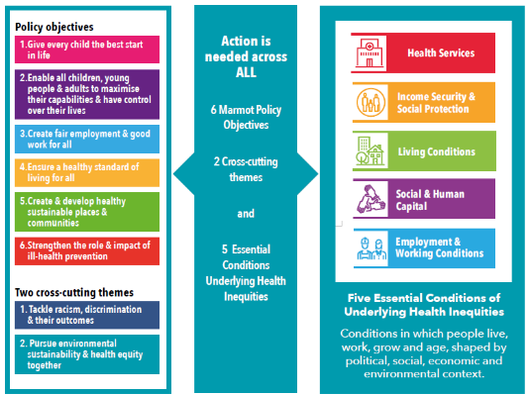
The co-production of the Population Health Strategy (PHS) engaged a number of partners and partnerships, creating a narrative to act as a starting point for further dialogue on what might be the priorities for collective and purposeful action to address health inequities.

It widens the Health Board focus from solely healthcare provision and explicitly recognises not only the significant contribution of others to the agenda but also the actions we can take as part of our wider corporate and anchor organisational responsibilities / roles.

The PHS points to the evidence informed actions (Marmot & WHO) needed to tackle health inequities (Figure 1: Evidence informed action to tackling health inequalities, Population Health Strategy, 2023). The evidence base makes it clear that action is needed across all these policy objective areas to deliver population health gain at scale. This requires us to work with and through others, on mutually agreed action that is bold, disruptive, collective and long-term / sustainable if we are truly to achieve a ‘Better future for all’.

To enable the evidence base to translate into functional actions the 4 pillar model (Figure 2: Strategy delivered locally, Population Health Strategy 2023) was designed to ensure that it was effective at delivering strategy locally.

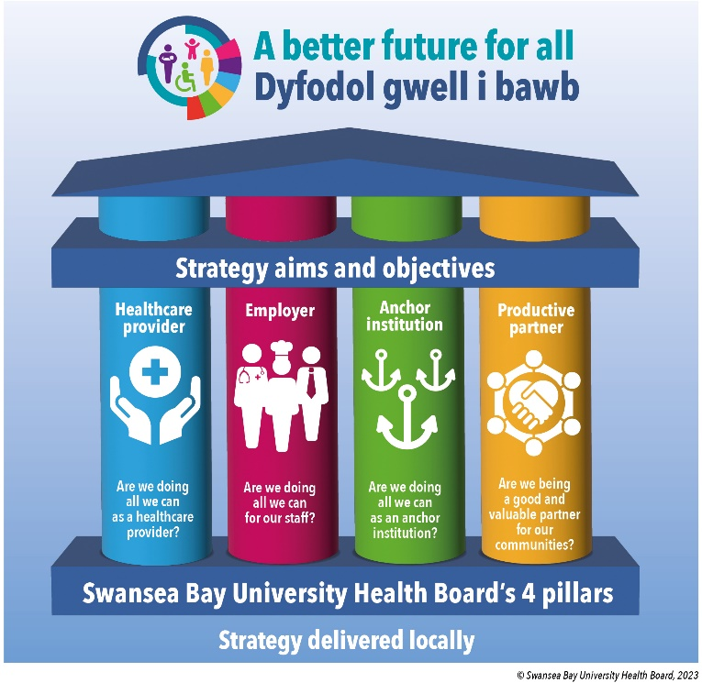
Within each of these pillars, we have agreed a set of year 1 priorities which helps move us towards becoming a population health focused organisation.

The importance & benefits arising from productive partnerships are highlighted in the Strategy. However, partnerships are not intended to be seen as an activity/end in themselves.

The intention in drawing them out as one of our 4 pillars is to recognise their vital role in achieving impactful change at scale. It also recognises that many of the drivers of health inequalities, are not within our direct control to change but we however, have an important statutory role in championing and driving action/change, advocating for our population.

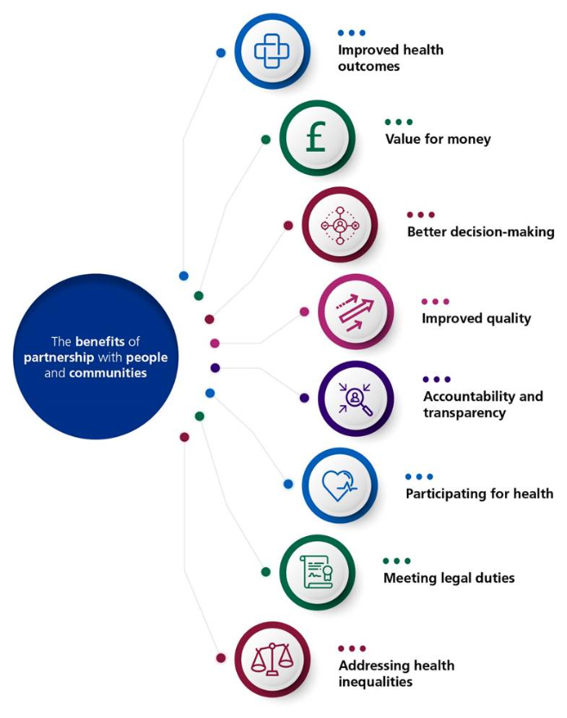
This means that purposeful and productive partnership working is integral and needs to be embedded into ways of working as it underpins our responsibilities across all pillars. It is not the domain of a few. It must become part of routine practice and the impact we will achieve for our population will be proportionate to our effectiveness as a partner.

The co-production process for the PHS developed a high level and indicative map which highlighted some of the plethora of partnerships that already exist and are actively involved in taking action on many of the issues articulated in the Strategy. It was not intended to be a comprehensive mapping of all partnerships. It was however, intended to draw out that within the busy landscape of partnerships and recognising, they operate at different levels and for different purposes.

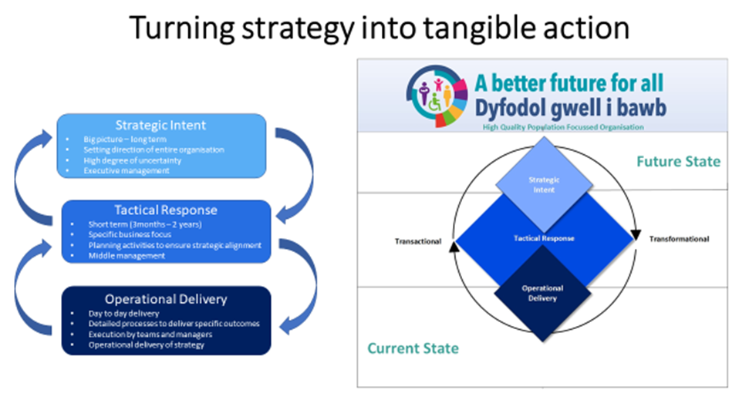
Strategic Intent
There are some partnerships that are intended to act at a strategic level, responsible for setting the strategic direction for regional transformation. The change involving large, anchor organisations coming together to act as a collective for outcomes that are unachievable as single organisations and where there is little or limited pre-defined ‘programmes of work’ or ways of achieving the longer term goal. From a population health perspective, there are two key strategic partnerships of note, namely the Public Service Boards (PSBs) and the Corporate Joint Committee (CJC).

Tactical Response
Other partnerships exist to enact / drive forward collective efforts in response to policy / strategic intent primarily set by others. An example of this would be the Regional Partnership Boards (RPBs), which were established with a focus on improving co-operation between the local authorities and their partners, particularly the local health boards in relation to adults with needs for care and support, carers and children. They therefore are looked to enact the Health and Social Care legislative and policy directives, oversee allocation of resource in support of these ministerial expectations and ensure operationalisation accordingly to meet set/agreed targets and healthcare needs. Hence, whilst the RPBs have licence and are expected to agree between partners how best to respond to the ask/defined outcomes, including prioritisation based on the starting point, this is within a pre-defined set of intentions/future state to be achieved.

Whilst they offer opportunities to consider a population health lens in the way the service/care is delivered, to avoid a further widening of inequities, given their focus is on highly vulnerable groups within the population, they have limited potential to deliver on the PHS priorities at scale.

The WBFG Act established the Public Service Boards (PSBs) to bring together a range of partners that plan for the well-being of their area, whilst the RPBs focus is on the joint planning and delivery of services to support the well-being of individuals with health and care needs. As such, PSBs have a broader remit focusing on improving the economic, social and cultural and environmental well-being of an area on a ‘whole population’ scale. PSBs also operate on a more local footprint than RPBs, although over time some PSBs have combined to mirror their regional area.

Given both the PSBs and RPB have a remit to promote the well-being of the population it is essential that we understand the key differences and what opportunity they present in terms of progressing the population health agenda. Hence their importance and relevance in progressing the aspirations in the PHS.

- SITUATIONAL ASSESSMENT
When we look at our partnership working, we are not starting from a blank sheet / and work has been ongoing across a number of partnerships. This paper focuses on three key partnerships that have important roles to play in progressing our PHS aspirations and commitments, namely:
- Swansea Public Sector Body (Swansea PSB)
- Neath Port Talbot Public Sector Body (NPT PSB)
- South West Wales Corporate Joint Committee (CJC)

Appendix A provides a short summary of the above partnerships.

National review of PSBs functioning
It is worth noting the findings from a recent review by Bangor University that looked at the PSB experience across Wales as it has resonance for our experience locally. It highlighted that despite a clear desire to collaborate and a real pride in the quality of their Board’s engagement with local communities, PSB members identified three main dilemmas as they tried to work together:
- 1st – members contributed high levels of strategic expertise but also needed to develop an understanding of each other’s fields to create joint plans. The timetable of the Act created pressure that limited time for in-depth discussion. Creating sub-groups with specialist fields of expertise enhanced the focus on delivery but further restricted the opportunities for dialogue between different organisations.
- 2nd – members attempted to include each other’s aims and local communities’ needs equally in their plans but without mutual understanding and under time pressure, they had to choose between conflicting priorities. By distinguishing between ‘statutory’ and ‘invited’ members, the Act implicitly gave the former greater influence over the choice of well-being objectives.
- 3rd – sub-groups were aligned to single well-being objectives for accountability but had to gain approval, ‘commissioning’ by the full PSB. The lack of understanding of each PSB partner’s strategic aims resulted in delays to agreement. Consequently, the PSB risked losing legitimate authority over its local objectives, as sub-groups began to align their strategies to regional and national policies to gain authority to act.

In essence, highlighting the absence of the ‘tactical’ response needed that creates value from ‘strategic’ intent through enabling ‘operational’ delivery.

The following provides a short reflective summary of our involvement and impact/effectiveness to date in the above 3 key strategic partnerships from a population health perspective. It is intended to reflect the experiences to date and help inform a potential way forward.

Swansea PSB
Historically a challenging environment. Pre-COVID, the involvement & engagement within this forum was at best minimal and ad-hoc. Our contribution was not clear and when offered, not necessarily welcomed or well received. Often it was not prioritised from within the Health Board, in part due to the fact we had no clear strategic narrative or tactical intent to bring into the partnership and as such our efforts resulted in little/limited impact/benefit for our population.

Being in attendance allowed the partnership to be quorate, allowing the PSB to conduct its business and this was seen as being a good partner. We have been the organisational ‘lead’ for the Best Start in Life objective which has focused primarily on taking a ‘service’ / healthcare provision view to improving outcomes for our children & young people. This is a narrow representation of the actions / role the PSB should be taking. Historically, our involvement has had limited visibility within the Health Board and not been seen/deemed a priority, compounded by a narrative that there are ‘no resources’ attached, accessible or available to pursue or support the PSB work/agenda.

More recently, a different relationship has been fostered with the main statutory partners with more regular informal conversations and interactions outside set meetings, at an Executive level, as well as our involvement in other core related work e.g. Swansea Poverty Truth Commission. We have brought additional challenge and discourse that has demonstrated a depth of knowledge, understanding, expertise and commitment to the entirety of the PSB agenda, given its core function as a delivery mechanism for population health and wellbeing. This has helped to foster a greater sense of trust, confidence and an ability to offer up and influence different agendas.

The different behaviours alongside the contribution of specialist technical expertise and true engagement has been valued and puts us in a better position as a starting point. This requires further nurturing.

We, as a health board, are broadly welcomed and need to continue to build our reputation as good partners in order to be able to challenge and get collective agreement and discourse that is needed on the challenging topics.

Neath Port Talbot PSB
Historically, pre-COVID, our engagement in the PSB has been viewed similarly both internally and by our external partners. Whist the approach to our contribution was similar, we were previously the organisational lead for the work & wellbeing objective area. However, it did not progress in any meaningful way, due to similar issues of how the work of the PSB was viewed, its relative priority given the focus on healthcare service provision, lack of any strategic intent or tactical narrative and lack of an appropriate internal governance or infrastructure to act with purpose within the PSB.

Whilst we have historically been welcomed, our contribution has been viewed as lacking at Board level. As with the Swansea PSB, Health Board colleagues have been involved and engaged in various operational level partnerships/sub-groups supporting or reporting to the PSBs.

Currently, the PSB is seen by the NPT Council as a delivery mechanism for the Council’s corporate objectives and agendas. There is an increasing sense across the statutory partners of not being heard and an unwillingness to engage in discourse that seemingly is at odds with the Council’s leadership views/agendas. Differences of approach/opinion have been viewed negatively as has our intentions and desire to pursue actions that address the health inequalities, across all 4 pillars, as laid out in the PHS, which is seen as the domain of the council.

This has meant that whilst pre-covid the relationship was better, this partnership needs a different approach and is likely to take longer to build back up to one where there is mutual respect and a willingness to engage in a discourse with the intention of co-creating mutually agreed, collective action for better population health outcomes.

South West Wales Corporate Joint Committee (CJC)
The CJC is a recent addition to the strategic landscape, arising out of the Local Government and Elections (Wales) Act 2021.

The South West Wales CJC includes Pembrokeshire, Carmarthenshire, Swansea and Neath Port Talbot. Having been established in June 2022, they remain relatively untested and continue to develop and mature. Since January 2023, the Health Board and other partners have been invited as co-opted members and is represented on the CJC by the Health Board Chair.

As a partnership primarily working on regeneration, economic development & transport for the region, it is an important vehicle for the delivery of many of the actions needed as outlined in the PHS. Some examples include:
- Placemaking and its relationship to e.g. air quality; natural & built infrastructure; walkability & cyclability of the environment impacting on physical activity levels; modal shifts in transport for work/business; social connectedness & community resilience; community safety etc.;
- Economic regeneration and its role in e.g. the type & quality of work; current and future training & skills requirements of the workforce; future workforce needs; housing needs; anti-poverty drivers etc.

Autumn sees a shift in the CEO lead/chair from NPT to Pembrokeshire.

We have proactively connected with the CJC programme manager to create links and awareness of the PHS. We have also had good engagement with some of the officers, teams and partnerships/fora that report into the CJC and its agenda who have contributed to the PHS in co-production.

Below is an attempt to capture a high-level, subjective, summary of the current position within these partnerships. No attempt has been made to triangulate this with other partners’ views at this stage. That may however, be a useful exercise to consider.

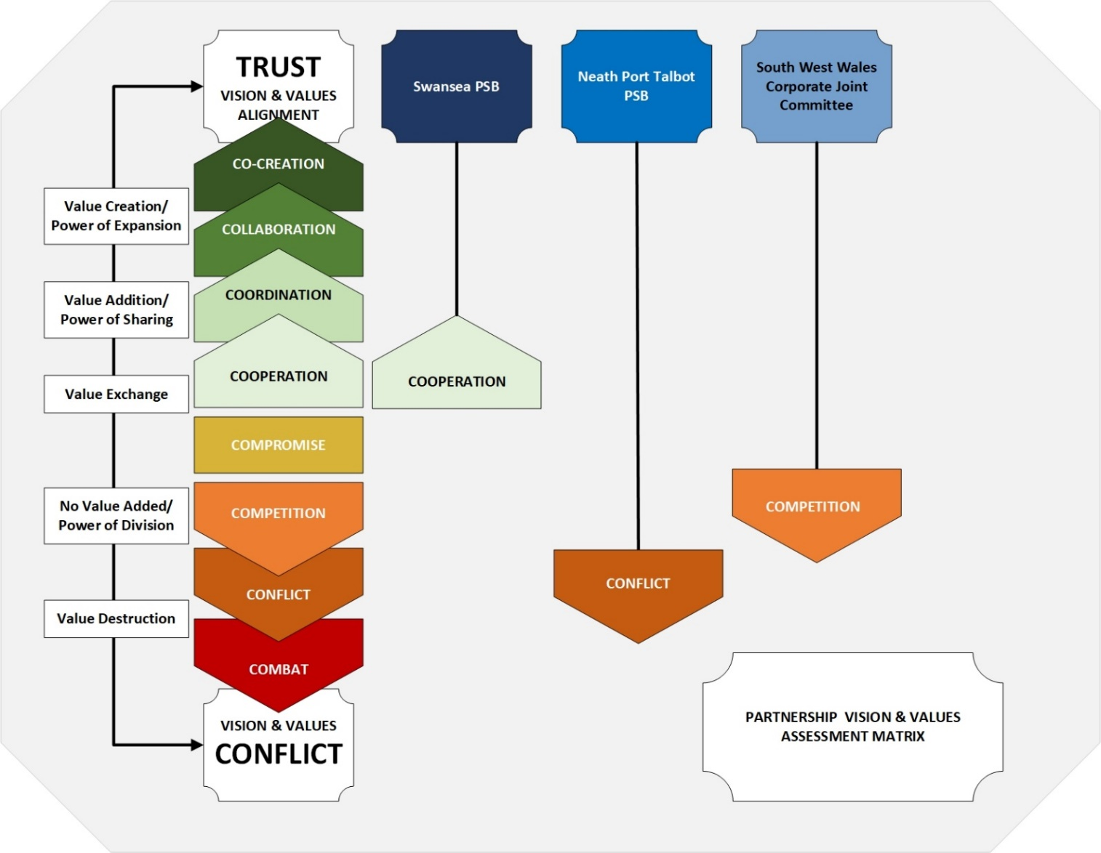

- POTENTIAL APPROACH / OPPORTUNITIES
The discussion at the last Population Health & Partnerships Committee suggested we may want to focus on where there is energy and a willingness to engage in meaningful and purposeful discussions / partnership working. This was predicated on the narrative above of the challenges that currently exist with our ability to have meaningful engagement with the NPT PSB.

We recognise the value of focusing our efforts into where we are likely to have better success and traction in return for our efforts. However, from a population health perspective, on most indicators available to us, the populations within Neath Port Talbot are those most likely to be experiencing the worst outcomes and greatest inequities, fuelled by issues such as poverty / unmanageable debt, poor air quality etc.

As such, we would be failing in our duty to not recognise this and hence below we are proposing a way forward for both PSBs. The imminent launch of the PHS also gives us an opportunity to catalyse some of this activity.
Swansea PSB:

Approach | Opportunities
Continue to work collaboratively, co-producing and not over engineering our agenda but co-develop – in order to build the requisite trust required to develop the relationship further. | - Health Board as the lead for early years/best start in life provides opportunities to shape the agenda beyond the current narrow focus on services to adopting a population health approach addressing the root causes e.g. child poverty; living spaces / community assets; economy  - Anti-poverty strategy refresh – the council have initiated the refresh of the strategy, which primarily focuses on mitigating actions. Early conversations, with senior leaders, have indicated an appetite to use this opportunity to jointly craft a tactical response as a partnership across the region. Given the current economic climate, there is a lot of energy around this and a welcoming of us having catalysed the conversation.

Neath Port Talbot PSB:

Approach | Opportunities
Continued active engagement in the whole of PSB agenda, offering appropriate challenge as an equal partner and creating opportunities to develop the relationships, in partnership with other partners | - Data, insight & intelligence – these are areas where there has been a historical and ongoing interest from the leadership to developing their capability and capacity to generate population level intelligence. This aligns with our strategic intent around population health intelligence function development. We are the source of the expertise needed and there would be mutual benefit from data shared across partners to fully understand the inequities in our population, in the way we are seeking, in order to re-orientate our resource allocation, as a whole of organisation. A proposal to develop this capacity and capability is being progressed through the relevant structures.  - Celtic Freeport development – this covers Milford Haven & Port Talbot with a focus on low carbon technologies and is expected to bring in significant investment and creation of jobs through to 2050. This is increasingly an area of focus of discussions locally. Whilst this aligns to the economic agenda, it cuts across all aspects of the evidence base and hence all 4 pillars.

Corporate Joint Committee

Approach | Opportunities
This partnership is still early stages and developmental and it is unclear how much involvement or engagement we have had to date to know how this is developing and the potential for influence and joint working at a strategic level. Hence a need to scope out opportunities, develop understanding of the agenda & drivers and consider this as part of creating our offering/narratives based on the PHS | - Areas of potential exploration, engagement & influencing would link with employment (pillar 2); anchor institution (pillar 3); anti-poverty agenda; estates strategy etc.

- MAXIMISING OPPORTUNITIES AROUND PRODUCTIVE PARTNERING
Partnership working in the public sector has a long history and continues to be seen as vital to achieving significant and long-lasting change for population health gain. Despite their long history, the effectiveness of partnerships within the public sector, in tackling areas of common agreement, has been shown to be highly variable.

Work previously done by the NHS Institute for Innovation and Improvement which sought to identify how ‘breakthrough’ change could be achieved in relation to tackling specific areas of joint working, revealed that barriers to joint working were often less to do with resources and processes and more critically to do with the necessary collaborative behaviours required to effect changes in the delivery of services via partnership working, which were frequently absent. The active process of partnering i.e. productive partnering where partners are ‘totally responsible’ for improving jointly agreed goals is, in many instances, yet to be achieved.

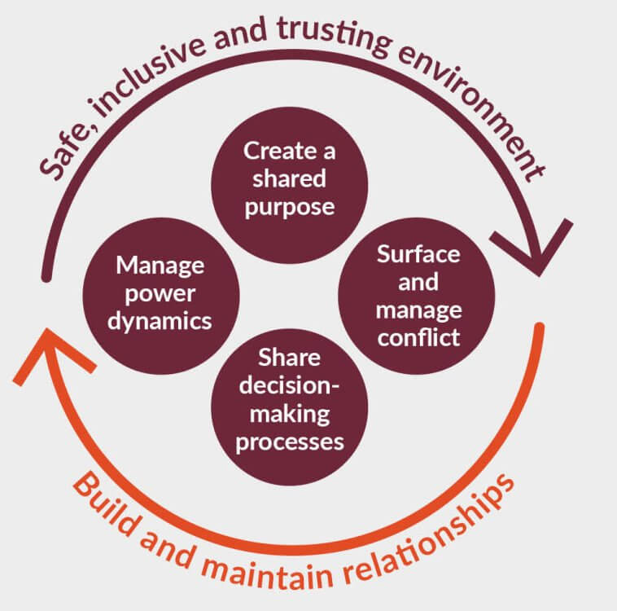
A recent King’s Fund publication has highlighted the six key leadership practices needed by health and social care staff to successfully work collaboratively across organisational and professional boundaries. This is in recognition of the changing population health needs requiring more coordinated care and collaborative leadership with a broader range of local organisations as well as communities. Source: The Practice of Collaborative Leadership, Kings Fund 2023 - Key practices for effective collaborative leadership.

The six leadership practices are:
- creating a safe, inclusive and trusting environment in which everyone can contribute fully – leaders need to look at problems from perspectives beyond their own. This means leaders need to be open and trusting, to connect with others and create different spaces in which people feel safe to contribute and be heard; to listen to and value others’ contributions and ensure others do the same.
- building healthy relationships – this requires sustained effort but adopting a more relational way of working based on humility, respect and trust strengthens connections between organisations and individuals leading to increased staff engagement and more co-ordinated services.
- developing a shared purpose and shared group identity. It is important to clearly set out the shared purpose around why organisations or/and professional groups are working together and create a shared group identity to promote engagement across the collaboration and to address any power differentials.
- actively managing any power dynamics – so no organisation or professional group dominates. Introducing processes that create a more open and participatory environment can also be useful to enable individuals to think differently.
- surfacing and managing any conflict – in collaborations you are working with different views and ideas, sometimes these will turn into conflict. It is important to approach any conflict with an open and curious mind, rather than turning away from it.
- developing shared decision-making processes – designing transparent processes that enable all key organisations or groups to contribute to a decision produces a range of benefits, although it takes longer. Benefits include greater ownership over the decisions adopted and strengthening trust across a collaborating group.

Work being undertaken within the Health Board has highlighted that partnerships are everyone’s business, that there are skills needed to be good partners & to be successful requires an ability to act with purpose, being clear on what we bring into the partnership and what we want to achieve through the partnership.

To date, this has been deemed to sit within a single executive role which has had a focus on trying to manage the collective effort or ‘impact/effect’ of partnerships as opposed to recognising the dynamic nature of partnerships. They are a microcosm of complex systems and it is the interrelationship and connected parts, that change and shift over time, that requires a dynamic & agile response.

Therefore to be effective requires, as a minimum:
- A mindset of curiosity & openness
- A recognition that we don’t have/own the solutions
- A willingness to agree a negotiated position to achieve the best possible outcome
- Agency/licence to act
- Necessary technical skills / expertise to achieve the desired change
- An ability to enter into disagreements & conflict, whilst maintaining the integrity, honesty and trust of partners
- Mutual respect for partners and the purpose & power of partnerships

For PSBs & CJC we are proposing that given their critical role in terms of population health outcomes, that the Health Board’s representation & contribution to these should be enacted through the Executive Director with responsibility for population health. This would also ensure that the highest level of technical expertise is taken into these strategic environments where influence can be brought on what commitments are made, how the agendas can and should be shaped in line with the evidence base and hence ensure consistency of narrative and messaging on behalf of the Health Board. This helps to avoid an inappropriate or misdirected focus on action that is likely to have limited or no impact on achieving the health gains required and inadvertently causing harm, through wasted effort / unintentional harms. This also helps to avoid the potential reputational risks given the need for the Health Board to be seen a credible in the population health space, requiring a high level of ‘population health’ literacy.

This does not sit out-with other Health Board Executive level representation.

- GOVERNANCE AND RISK ISSUES
The governance around the developing partnerships agenda should be the responsibility of the Population Health and Partnerships Committee given the explicit linkage with the ambition to be a population competent and focussed organisation.

- FINANCIAL IMPLICATIONS
There will be financial implications related to the above, beyond investment of staff time. These are not yet quantifiable but some of the population health reserved funds could meet some of the initial costs of the development of the work. What falls out of the work is what is not possible to predict or quantify currently as not yet agreed. The conversations & proposal arising from those of enhancing our ability to consider & reorientate the totality of the SBUHB’s budget to better achieve population health gains offers opportunities into this space.

- RECOMMENDATION
The Committee is asked to:
- Note the role of PSBs and CJC and their vital role in achieving / delivering on the PHS aspirations
- Recognize the differences between partnerships and the importance of this in how we consider what is needed and our approach to them accordingly.
- Note the situational assessment (starting point) for each of the partnerships
- Endorse the approaches and opportunities to be pursued with each of the named partnerships with regards to the PHS and the proposed governance arrangements to progress towards SBUHB being a productive partner.

Governance and Assurance
Link to Enabling Objectives  (please choose) | Supporting better health and wellbeing by actively promoting and empowering people to live well in resilient communities
Link to Enabling Objectives  (please choose) | Partnerships for Improving Health and Wellbeing |  | ☒
Link to Enabling Objectives  (please choose) | Co-Production and Health Literacy |  | ☒
Link to Enabling Objectives  (please choose) | Digitally Enabled Health and Wellbeing |  | ☒
Link to Enabling Objectives  (please choose) | Deliver better care through excellent health and care services achieving the outcomes that matter most to people
Link to Enabling Objectives  (please choose) | Best Value Outcomes and High Quality Care |  | ☒
Link to Enabling Objectives  (please choose) | Partnerships for Care |  | ☒
Link to Enabling Objectives  (please choose) | Excellent Staff |  | ☐
Link to Enabling Objectives  (please choose) | Digitally Enabled Care |  | ☒
Link to Enabling Objectives  (please choose) | Outstanding Research, Innovation, Education and Learning |  | ☐
Health and Care Standards
(please choose) | Staying Healthy |  | ☒
(please choose) | Safe Care |  | ☐
(please choose) | Effective Care |  | ☒
(please choose) | Dignified Care |  | ☐
(please choose) | Timely Care |  | ☐
(please choose) | Individual Care |  | ☒
(please choose) | Staff and Resources |  | ☒
Quality, Safety and Patient Experience
The paper outlines progress to date around the production of the population health strategy and progress against the approved short-term priorities approved by the Board. Implementation of an effective population health approach will lead to a more consistent approach to prevention. The expectation is that opportunities for patients to be supported to make changes that will reduce their risk of ill-health and which will lead to improved well-being will be offered in a more systematic way across the sector.
Financial Implications
The paper notes that investment is required in order to make progress in a number of areas of priority for Welsh Government or where there is already an identified high level of need in our communities. However, that investment is not quantified.
A process for development of business cases in support of population health investment has been created and is being used in support of WG grant-funded areas of activity.
Legal Implications (including equality and diversity assessment)
No legal implications identified. The incorporation of population health approaches will allow for the identification of equality and diversity issues and development of appropriate responses.
Staffing Implications
Developments in support of Ministerial Priorities will require additional staffing and this will be addressed through the emergent business cases.
The Public Health Team restructure intends to alter the skill-mix compared with the funded establishment and is likely to result in fewer staff of higher banding being employed.
This of itself will be insufficient to support the developments required to fulfil the requirements of the population health. Development of the implementation plan will identify the skills and workforce requirements.
Long Term Implications (including the impact of the Well-being of Future Generations (Wales) Act 2015)
Population health approaches incorporate a prevention ethos and delivery is contingent on collaboration among partners to deliver better outcomes for our population. A coproduction approach is integral to public health practice and seeks to involve communities and staff in designing services and programmes.
Report History |  | No previous reports
Appendices |  | Appendix A

