

Meeting Date | 12 October 2023 |  | Agenda Item |  |  | 3.2
Report Title | Public Service Boards
Report Author | Michelle Davies, Head of Strategic Partnerships & Planning  Karen Stapleton, Deputy Director of Strategy
Report Sponsor | Nerissa Vaughan, Interim Director of Strategy
Presented by | Nerissa Vaughan, Interim Director of Strategy
Freedom of Information | Open
Purpose of the Report | The purpose of this report is to provide detail on the following:  - The statutory requirements for partnership working as outlined in the Well-Being of Future Generations (Wales) 2016) Act.  - Governance and Health Board representation on Public Service Boards and the work streams that support.  - Inter-relationships between Partnership Priorities
Key Issues | The Health Board needs to understand and respond to the needs of the populations of Swansea and Neath Port Talbot, and ensure that the assessments undertaken feed into the Health Board’s Plans. The Health Board will have an active role in the implementation phase to be initiated by the PSBs.
Specific Action Required | Information | Discussion |  | Assurance | Approval
Specific Action Required | ☐ | ☒ |  | ☒ | ☐
Recommendations | Members are asked to:  - NOTE the statutory requirements outlined in the WFG Act and specifically the detailed requirements set-out for partners in the collective role;  - NOTE the Health Board representation on the PSB and its work streams.

Public Service Boards

- INTRODUCTION

The report sets out the following:

- The statutory requirements for partnership working as outlined in the Well-Being of Future Generations (Wales) 2016) Act.
- Governance and Health Board representation on Public Service Boards (PSBs) and the work streams that support them.
- Inter-relationships between Partnership Priorities

- BACKGROUND

At the first meeting of the Population Health & Partnerships Committee in June, a paper was presented to members highlighting the alignment between the PSB Wellbeing Plans and Health Board Plans. In addition, the paper set-out the proposed governance arrangements to manage the implementation phase and how the Health Board will contribute and interact within that governance – the paper is attached as appendix 1. Members of the Committee requested further detail in relation to the statutory requirements that govern the PSBs, Health Board membership of the work streams and the inter-relationships between partnership priorities.

2.1 Current Arrangements

There are two Public Service Boards (PSBs), one in Neath Port Talbot and one in Swansea. Swansea Bay UHB is one of four statutory members of the Public Service Board. The others are the respective local authorities, Natural Resources Wales and respective Fire and Rescue Services.

Local Well-being Plans have been developed by both PSBs, and the Plans identify Local Well-being Objectives which set priorities for collective action to be taken forward by one or more of the PSB partners. Both plans developed separately for the communities of Neath Port Talbot and Swansea are primarily driven by matters raised in the Assessment of Local Well-being undertaken in 2022. A paper was presented to the Health Board in March 2023 and the Board approved the Plans – the paper presented to Board is attached as appendix 2.

2.2 Statutory Requirements – Public Service Boards (PSBs)

The Well-being of Future Generations (Wales) 2016 Act (WFG Act) sets out a well-being duty to be met by individual public bodies such as Swansea Bay UHB. The WFG Act sets out specifically, a collective well-being duty to be discharged via Public Services Boards. Further detailed statutory guidance has been issued in relation to the collective role facilitated by PSBs titled the Shared Purpose: Shared Future – the full guidance in relation to the collective role is attached as appendix 3.

The guidance that describes the collective role is the core guidance, as described below:

- Core Guidance - guidance to public bodies and public services boards on key definitions, how to carry out sustainable development, understanding the well-being goals, applying the sustainable development principle, an explanation of the individual duties (public bodies and public services boards) and collective duties

As outlined above the guidance is underpinned by the seven Wellbeing Goals and the Five Ways of Working with a focus on delivering sustainable development as the over-arching principle. The Act describes sustainable development as follows:

“Sustainable development” means the process of improving the economic, social, environmental and cultural well-being of Wales by taking action, in accordance with the sustainable development principle, aimed at achieving the well-being goals.

The Seven Wellbeing Goals and the Five Ways of working are set out below, Committee members may recognise them from formal documents, and the Five Ways of Working also feature in the Governance and Assurance section right at the very end of Committee papers:

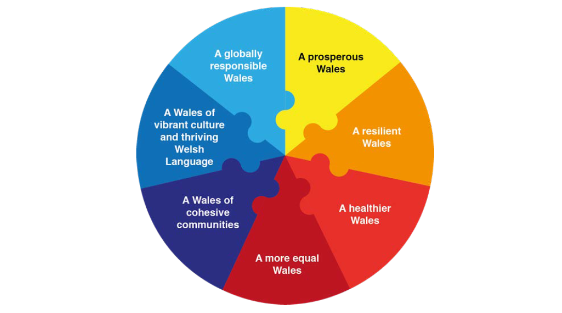

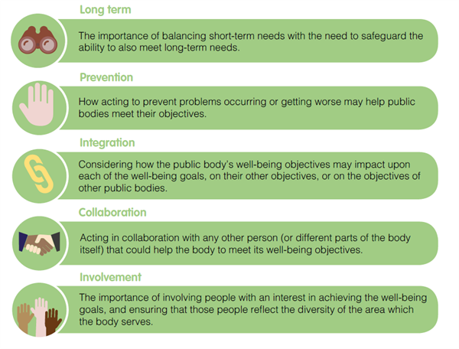

As part of the development of the Population Health Strategy, Public Health have decided to use the Marmot Policy Objective areas as guiding principles for the Health Board, in order to tackle health inequalities, and these are attached as appendix 4.

The Terms of Reference of the PSBs mirror the guidance, and the main tasks of the Boards are listed below:

The Boards have the following main tasks to be achieved within timescales as specified in the Well-being of Future Generations Act - the NPT PSBs TOR are below for illustrative purposes

- To prepare and publish an assessment of economic, social, environmental and cultural well-being in Neath Port Talbot.
- To prepare and publish a Local Well-being Plan for Neath Port Talbot setting out local objectives and the steps it proposes to take to meet them.
- To prepare and publish an annual report that sets out the Board’s progress in meeting the local objectives
- To invite participants to attend and participate in the business of the Board as appropriate
- To review and revise its local objectives and if it has revised its local objectives it must amend the Well-being Plan.
- To review its local objectives if directed to do so by Welsh Ministers and then amend the Well-being Plan in consequence of such a review.
- To attend Neath Port Talbot Council’s relevant scrutiny committee to provide information and assistance that enables the committee to discharge its responsibilities to scrutinise the work of the Public Services Board as defined in the Well-being of Future Generations (Wales) Act 2015.

Both PSBs have recently published their Wellbeing plans, and a formal response has been received from the Future Generations Commissioner for Wales – the letter has been sent to all PSBs. The letter is attached as appendix 5, and the main points are as follows:

- Clear that PSBs have played an important role in enabling responsive joint working across Wales, critical for our longer-term resilience.
- Common themes across Wales relate to the climate and nature emergencies, the impact of poverty, and community well-being.
- Recognise the importance to focus on ‘what’ the plans contain, but also ‘how’ to deliver them.
- One of the critical success factors that will support the delivery of the local well-being plan is the effectiveness of the Board’s collaboration.
- The importance of establishing a culture within a PSB (and other strategic partnerships) where every partner has equal influence, open discussions are encouraged, and decisions take account of the membership’s diversity.

The Health Board recognises that working in collaboration can be challenging and that as an agency we need to improve the internal approach to partnerships. The Strategy Team have scheduled a number of workshops with colleagues across the Health Board to consider how we can improve partnership working and as a result of a workshop in June a set of principles have been developed along with the development of a Productive Partnership Framework. The Framework will outline our statutory duties along with our roles and responsibilities as officers. The draft principles are attached as appendix 6. The PSBs also recognise the need to improve how agencies work collaboratively, and it has been agreed that this will form part of the work programme specifically.
Currently PSBs receive no formal funding to develop or implement their Wellbeing Plans and this has been recognised and the letter acknowledged that PSBs would require a level of support in order to deliver the commitments set out within the well-being plans. Some of the support already underway is outlined below:
- Providing a regional support grant for PSBs for the new cycle of well-being plans focused on building capacity and capability for engagement and involvement. Offering a range of learning and development opportunities.
- Working with our research colleagues in the Wales Centre for Public Policy to support the use of evidence in PSBs. This includes building research capacity and preparing briefings for PSBs on high priority topics of common interest.
- Continuing to run the national network meetings, topic focused webinars and online meetings, enriched by external speakers.
- Working with public service partners and networks such as Natural Resources Wales, Public Health Wales, and Co-Production Network for Wales to ensure join-up and provide a coordinated support package on areas of delivery and ways of working

2.3 Health Board Membership on the PSB and work-streams

Swansea Bay University Health Board is a statutory member of the PSB, and the Chief Executive Officer and the Chair of the Health Board are formal members, however this responsibility is discharged via the Director of Strategy who has the executive level responsibility for Strategic Partnerships, the Well Being of Future Generations Act (WFGA) and Sustainability and Decarbonisation strategies. In addition the Director of Public –and an Independent Member, also represent the Health Board at PSB meetings. Please note the following points in relation to the governance specifically:

- A Join-Committee of both PSBs exists to discuss issues in common that would be better managed as a region.
- Informal PSB Steering Boards have been set-up to oversee the development and delivery of PSB Wellbeing Plans
- In Swansea a separate Delivery Group is supporting work to improve performance and governance frameworks. This area of work is also being supported by the West Glamorgan Programme Office.
- As Lead for Early Years, the Health Board are leading the Regional Early Years work programme. There is an existing steering group that will be utilised to develop the action plan, and in addition, the Health Board have set-up an internal monthly meeting to meet with leads across the Health Board to maintain momentum.

The points above are illustrated in the diagram below:

Public Service Board Joint Committee
(Swansea and NPT)

Public Service Board
(Individual Boards – 1 in Swansea & 1 NPT))

Public Service Board
(Informal Steering Groups in both Swansea & NPT)

Work Stream Groups set-up for both PSBs to deliver the Wellbeing Objectives

Below are the work streams that have been established to take forward the Wellbeing Objectives outlined in each PSBs Wellbeing Plans and the associated Health Board membership:

Swansea  Wellbeing Objective | Work Stream Group | Health Board  Membership
Early Years | Early Years Integrated Steering Group | Michelle Davies | Head of Strategic Partnerships
Early Years | Early Years Integrated Steering Group | Kimberley Cann | Consultant in Public Health
Early Years | Early Years Integrated Steering Group | Children & Young People Service & Strategic Leads
Strong Communities | Human Rights City Steering Group | Nicola O'Sullivan | Head of Engagement
Strong Communities | Strong Communities Working Group | Joanne Abbott-Davies | Assistant Director of Insight, Engagement & Fundraising
Working with Nature | Climate Change and Nature Recovery Signatories Group | Hayley Beharrell | Sustainability Planning Manager
Live Well, Age Well | Culture, Tourism and Leisure Partnership | Tbc | Tbc
NPT Wellbeing Objective | Work Stream Group | Health Board  Membership
Best Start in Life | Children and Young People's Partnership | Luke Jones | Designated Education Clinical Lead Officer
Best Start in Life | Early Years Integrated Steering Group | Michelle Davies | Head of Strategic Partnerships
Best Start in Life | Early Years Integrated Steering Group | Kimberley Cann | Consultant in Public Health
Thriving and Sustainable Communities | Cost of living and poverty prevention partnership | Jennifer Davies | Deputy Director of Public Health
Thriving and Sustainable Communities | Community Safety Partnership | Nicola Edwards  Joanne Abbott-Davies | Head of Nursing - Safeguarding
Thriving and Sustainable Communities | Community Safety Partnership | Nicola Edwards  Joanne Abbott-Davies | Assistant Director of Insight, Engagement & Fundraising
Environment, Culture and Heritage | Climate and Nature | Hayley Beharrell | Sustainability Planning Manager
Environment, Culture and Heritage | Culture and Heritage Partnerships | Tbc
Secure, green and well-paid jobs and improved skills | Local Economic Partnership | Jennifer Davies | Deputy Director of Public Health

The specific observations from a Swansea Bay UHB perspective are as follows:

- There is strong alignment with Strategy and Public Health Directorates and their associated work programmes/responsibilities for wellbeing and population health
- The Health Board play a key role in delivering Early Years services across the Pathway in collaboration with partner agencies. There are opportunities to improve access to services and outcomes working in an integrated way as set-out in the Early Years Maturity Matrix.
- Both PSBs are tackling the economy, and the Health Board must consider its role as anchor institution and play an active role in this area. A new group has been set-up in Swansea to focus on strong communities and an economic group with updated terms of reference in NPT. The HB needs to make sure it is appropriately represented in these new forums.
- The Health Board already works in collaboration with the local authorities, and relationships are established in relation to sustainability. These relationships will be further enhanced by formal representation of Strategy colleagues on the Climate and Nature Groups set up in both area.

  - Inter-relationships across the Partnership

The challenges in our communities are varied and require a multi-agency response to make improvements to people’s lives and the care they receive from our services. Whilst the work of the PSBs and the Regional Partnership have some alignment, as illustrated in the report prepared for the last meeting of the Committee in June 2022 they are primarily focussed on different levels of need in the community, as well as having a shorter and longer term focus as outlined in the following section.

2.4.1 Regional Partnership Board Priorities

The Welsh Government has specified that the Regional Partnership Board must focus on the Models of Care as highlighted in blue in diagram 1 below. However the population groups agreed by the partners within West Glamorgan are focussed on those people with a higher acuity of need including Children & Young People, Older People with Complex Needs and People with Emotional and Wellbeing needs and Carers.

Diagram 1
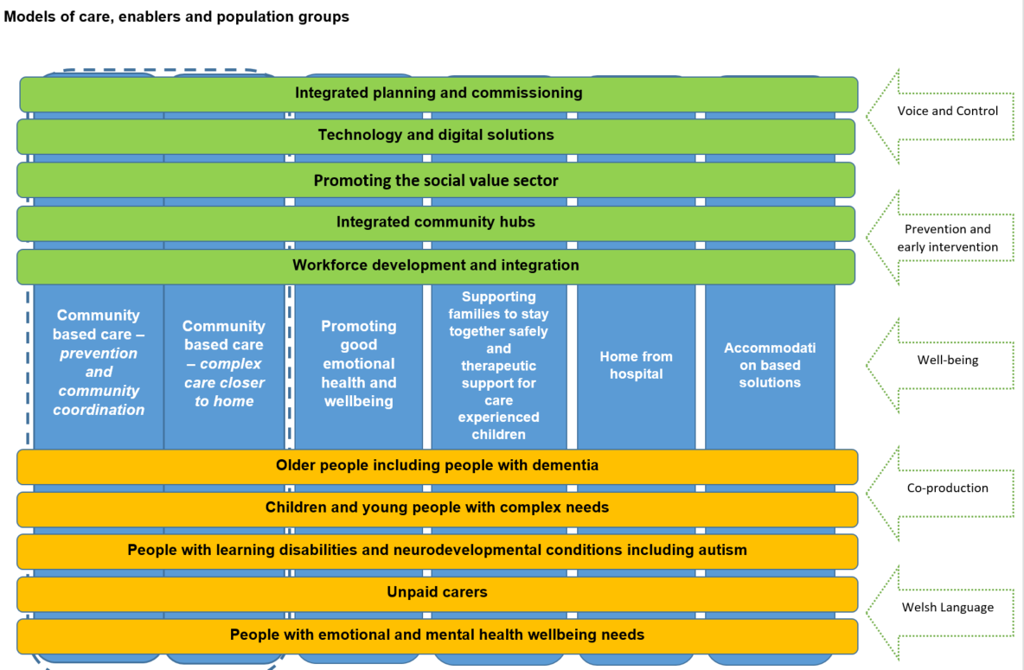
It is recognised that the RPB must deliver Transformation of the models of care above, and move away from supporting operational delivery, which has been the focus since the Covid Pandemic. As reported in the previous update, West Glamorgan RPB has signed off its 5 Year Area Plan which sets the direction of travel for transformation. The Health Board is currently in the process of reviewing its membership of the RPB and its various work streams to ensure appropriate and proportional representation to support delivery of the Area Plan and the Health Board priorities within in it.

2.4.2 Public Service Boards

The Welsh Government mandates that the PSBs deliver improvements in line with the Seven Wellbeing Goals and the Five Ways of Working as outlined in section 1 of this report and set-out in the Well-being of Future Generations (Wales) 2016 Act. PSBs must deliver against the core guidance in the Act and carry out sustainable development in the areas of economic, social, environmental and cultural well-being. This is reflected in the Wellbeing Objectives and the focus on the cost of living and poverty and the economy.

The Strategy Team have reviewed the Wellbeing objectives against the Health Board’s Recovery & Sustainability Plan. The purpose of the review was to undertake a stocktake of existing work, ongoing work programmes, and any potential opportunities and implications aligned to the priority areas. The paper presented to the Committee in June included the results of this work. The paper is attached as appendix 1.

  - IMPLICATIONS AND CONSIDERATIONS FOR THE HEALTH BOARD
It is important that the Health Board has visibility within the PSB governance with the appropriate representation and the ability to influence and contribute to plans. There are many benefits to be realised as a result of working collaboratively with partners as follows:
- Access to multi-agency and multi-professional advice and support to inform plans​
- Fulfilling our responsibilities as set-out in the Population Health Strategy, particularly the role we have as a productive partner and an anchor institution​
- Access to partnership resources, including financial investment​

In addition to external visibility within the PSB structure, it is important to have the right approach internally. The products of the workshops currently being progressed by Strategy will create an environment for partnership working with the aim to increase visibility at all levels of the organisation providing a Productive Partnership Framework – resulting in an improved strategic approach.

- FINANCIAL IMPLICATIONS

There are no direct financial implications for the Health Board.

- RECOMMENDATION

- NOTE the statutory requirements outlined in the WFG Act and specifically the detailed requirements set-out for partners in the collective role;
- NOTE the Health Board representation on the PSB and its work streams.

Governance and Assurance
Link to Enabling Objectives  (please choose) | Supporting better health and wellbeing by actively promoting and empowering people to live well in resilient communities
Link to Enabling Objectives  (please choose) | Partnerships for Improving Health and Wellbeing |  | ☒
Link to Enabling Objectives  (please choose) | Co-Production and Health Literacy |  | ☐
Link to Enabling Objectives  (please choose) | Digitally Enabled Health and Wellbeing |  | ☐
Link to Enabling Objectives  (please choose) | Deliver better care through excellent health and care services achieving the outcomes that matter most to people
Link to Enabling Objectives  (please choose) | Best Value Outcomes and High Quality Care |  | ☐
Link to Enabling Objectives  (please choose) | Partnerships for Care |  | ☒
Link to Enabling Objectives  (please choose) | Excellent Staff |  | ☐
Link to Enabling Objectives  (please choose) | Digitally Enabled Care |  | ☐
Link to Enabling Objectives  (please choose) | Outstanding Research, Innovation, Education and Learning |  | ☐
Health and Care Standards
(please choose) | Staying Healthy |  | ☒
(please choose) | Safe Care |  | ☐
(please choose) | Effective Care |  | ☒
(please choose) | Dignified Care |  | ☐
(please choose) | Timely Care |  | ☒
(please choose) | Individual Care |  | ☒
(please choose) | Staff and Resources |  | ☐
Quality, Safety and Patient Experience
There are no implications in relation to Quality, Safety and Patient Experience to declare as part of this report.

Financial Implications
There are no financial implications to declare as part of this report.

Legal Implications (including equality and diversity assessment)
There are no legal implications as a result of this report.

Staffing Implications
There are no staffing implications as a result of this report.

Long Term Implications (including the impact of the Well-being of Future Generations (Wales) Act 2015)
The development of the PSB Wellbeing Plans are an integral part of public service organisations delivering against their statutory duties.

As set out in the Well-being of Future Generations (Wales) Act 2015, Public Service Boards (PSBs) have a statutory duty to prepare and publish a local well-being plan.

Report History |  | This is the second report to be considered by the Committee.
Appendices |  | (All appendices are available within Resources on Admin Control)  Appendix 1– Population Health & Partnerships Committee Paper – June 2023  Appendix 2- Health Board Paper – approval of Wellbeing Plans  Appendix 3 – Shared Purpose: Shared Future  Appendix 4 – Health Board Wellbeing Objectives  Appendix 5 – Letter – response to Wellbeing Plan  Appendix 6 – Partnership Principles - SBUHB

