Appendix 3 SBUHB Communications

Patients educated and supported to help prevent developing diabetes
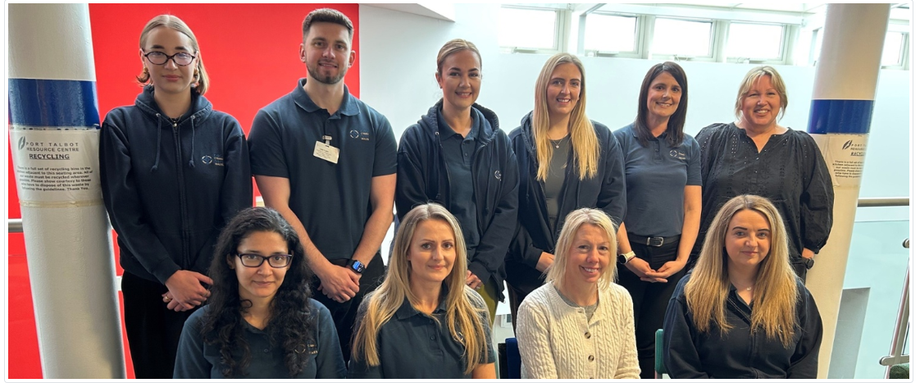

A man has managed to reverse having pre-diabetes after a 30-minute intervention with dietetic support worker.
David Weekes, from Swansea, received blood test results, for a separate issue, that identified him as being pre-diabetic.
This is when the glucose (blood sugar level) is higher than normal, but not considered high enough to be diagnosed with diabetes.
Type 2 diabetes causes the glucose level in the body to becomes too high.
Pictured (back row l-r): Dietetic support workers Kayleigh Smith, Luke Tucker, Carleen Enoch and Elinor Davies, Swansea Bay's dietetic lead for the All Wales Diabetes Prevention Programme Rachel Long, and Programme Manager for the All-Wales Diabetes Prevention Programme Keri Hutchinson. (Pictured front row l-r): Dietetic support workers Dissanayaka Paranathala and Melissa Stokes-Williams, dietitian Claire Godfrey and administrator Nicola Twomey.
While it can cause symptoms such as excessive thirst, tiredness and needing to pee a lot, the condition can also increase your risk of getting serious problems with your eyes, heart and nerves.
It can even lead to complications such as heart disease and stroke, retina damage, kidney disease and foot problems if it is not managed or treated correctly.

Regular checks including blood tests, urine tests, foot reviews are crucial for people with diabetes, even if you are feeling well, to help prevent future complications.
An increase in physical activity and having a healthy diet are just some of the steps people can take to help reduce the risk of developing the chronic condition.
After receiving his blood test result, David (pictured) was referred to the health board’s diabetes prevention team for a consultation with a dietetic support worker.
“I had gone for a blood test for a skin rash I’d had on my knees and it came back that I had pre-diabetes,” the 67-year-old said.
“They sent me for an appointment last year with the diabetes prevention team in Penclawdd.
“We talked about my diet and exercise and I went back for a follow-up appointment this year.
“In that time I have lost two stone and one pound. I stopped eating as many biscuits and cakes and I now go to the gym every day.
“I feel a lot better in myself for doing it and my glucose levels have come right down.”
The All-Wales Diabetes Prevention Programme is a national programme launched by Public Health Wales.
After being identified as being at risk of developing type 2 diabetes following a blood test, the programme offers patients a 30-minute intervention with a specially trained dietetic support worker.
The intervention discusses topics such as physical activity, healthy eating and promotes other lifestyle changes such as smoking cessation and alcohol reduction.
Keri Hutchinson, Programme Manager for the All-Wales Diabetes Prevention Programme, said: “It’s great to hear David’s story and the difference that this programme is making to him and so many other people across Wales.
“This evidence-based programme is being rolled out across Wales, to ensure that people are able to access effective support to prevent them from developing diabetes.”

In Swansea Bay, there is a dietetic support worker based in each of the eight Local Cluster Collaboratives, meaning appointments can be held closer to patients’ homes across Swansea and Neath Port Talbot.
Between September 2023 and January 2025, half of patients managed to reduce their blood sugar levels with support from the team.
Rachel Long, diabetes prevention dietitian, said: “Patients come in for a baseline appointment. We go through their glucose level result and lifestyle changes they could potentially make to try and help reduce that, particularly around diet and physical activity.
“A year later, we hold a follow-up appointment whereby the patient has had another blood test so we can compare the results.
“The dietetic support worker will discuss with the patient what went well for them and the changes they made.
“If the patient says they are finding anything difficult then staff can offer further support to try and help them further improve their dietary or physical activity levels for the next 12 months.
“We try to encourage patients to think of their own dietary and physical activity goals.”
To date, 8,000 patients have been invited for an intervention with a dietetic support worker.
Pictured: David lost weight thanks to support from staff.
David said: “The service was good. They provided me with good information about what to eat and what not to eat.
“I wasn’t unfit before, but this gave me the warning I needed.
“I now cycle seven days a week, for about 15-16 miles, and I do weightlifting in the gym.”
Rachel stressed the importance of booking an appointment with the team if you receive a letter from your GP practice to do so.
She added: “If you do receive a letter, it is so important to book in with us as soon as possible.
“We provide morning and afternoon sessions, and you can book into any of the clinics we have running across Swansea and Neath Port Talbot.
“We have received very positive feedback, with lots of patients saying they feel confident to make the lifestyle changes discussed in their appointments.
“We have seen 50 per cent of patients reduce their blood sugar level and many patients report an improved quality of life.”
Sioned Quirke, Swansea Bay’s Head of Nutrition and Dietetics, said: “We are extremely proud to be able to offer this preventative service to our patients.
“We know that prevention is better than cure and this service allows people to make changes before they become diabetic.
“Over the long term, about 70 per cent of people who have pre-diabetes become diabetic therefore this service is essential.”

